

Transport Strategy Discussion Paper

Reducing Traffic for Better Streets

This discussion paper is to inform a new City of Melbourne Transport Strategy to 2050. A draft strategy will be released for consultation in 2018. We are seeking your views on these issues and ideas.

Melbourne’s central city is congested. Footpaths are overcrowded while trams and buses are stuck in traffic. Driverless cars could increase the number of car trips significantly, making congestion worse. With a population growing from 4.5 million people today to 8 million by 2051, there will be more trips on all forms of transport and we will need more space on our streets for people. Increased congestion could erode what is great about Melbourne.

Melbourne’s economic success is vital to all Victorians and Australians. Road congestion costs Melbourne $4.6 billion per year, growing to $10 billion by 2030. Poorly-functioning public transport and congested roads undermine the city’s international reputation, liveability and economic prosperity.

Our current inequitable and outdated pricing system is poorly suited to managing transport demand. We need a new way of managing demand for street space, which is fairer, more transparent, incorporates smart city technology and benefits the city. Pricing is one of the few tools to manage transport demand.

# How we pay for transport today

### Private motor vehicles

Driving is paid for mainly through registration and fuel taxes (40.9 cents per litre fuel excise). While the amount of GST must be separately stated on receipts, the amount of fuel excise is undisclosed. Fixed, annual registration charges mean that frequent users pay less per kilometre than infrequent road users. Purchasing a motor vehicle also attracts State, Territory and Commonwealth taxes.

### Public transport

Public transport users generally pay fares based on how much and how far they travel (zones travelled in Melbourne’s case). Concession fares promote equitable access to the public transport network. ‘Early bird’ discounts are an example of how pricing is already used to manage demand during peak hours.

### Parking

The cost of providing car parking is often not paid by the driver: 96 per cent of trips in Greater Melbourne end in parking which is free (VISTA 2016). Some councils manage parking demand in busy areas through charges. The Victorian Government also charges a levy on inner city off-street parking to discourage vehicle commuting.

**The way we pay for transport influences our travel choices, including the number of trips, time of day, route, transport mode and where people work and live. The current system is not equitable, fails to deal with congestion and is not prepared for disruptive technology.**

# What are the current issues?

### Congestion and growth

### As Melbourne’s population rapidly grows, congestion will worsen. Building new roads is a huge cost to the community and will not eliminate congestion in the long term. Managing demand through road user pricing can relieve congestion and provide other community benefits.

Image of motor vehicle taffic, many cars not moving. 

Congestion will increase without better demand management

### Driverless cars

Driverless cars will transform how traffic functions. Empty cars could congest streets, won’t need to park in paid bays and be programmed not to incur traffic fines. This could eliminate $87 million in City of Melbourne parking revenue and $323 million in Victorian Government traffic fines. Without transport pricing reform, the arrival of driverless cars could have serious financial and congestion effects.

### Declining revenue

Commonwealth fuel excise revenue is $11 billion per year but in decline as people purchase new vehicles which use less fuel per kilometre. Drivers of electric cars already pay no fuel excise and these vehicles are becoming more popular. Lost revenue will need to be replaced by reformed road charges or through reduced government services and spending. This means that pricing reform is coming soon and we need to get it right.

### Inequity

The per-litre fuel excise costs the average household $1,060 per year. This impacts people on lower incomes most as they spend a greater proportion of their income on car costs, may have less fuel efficient cars and can be more dependent on cars due to limited public transport access.

# How to manage transport demand

Road user pricing encourages people to travel in different ways, at different times and combine multiple trips. It has been introduced in different ways in cities around the world. Smart city technology means charging by distance, by time of day or by type of road is now possible. Road user pricing can influence people with multiple transport options to choose alternatives to the car and keep our city moving.

# What are other cities doing?

More transparent pricing systems have been introduced in cities around the world. The objectives of these systems have included reducing congestion, improving environmental quality and to fund public transport.

Oregon- *Pay per mile*

* Opt-in trial participants pay per mile.
* 22 per cent less driving in peak periods.
* 91 per cent would rather continue to pay per mile instead of fuel tax.

London- *Pay to drive in zone*

* 14 per cent fewer trips in charging zone.
* 10 years of stable congestion while population grew by 1.3 million.
* Enabled public realm improvements.

Singapore- *Pay to enter zone*

* 20 per cent reduction in delays within the charging area.
* Prices adjusted regularly based on conditions and average speed targets.

Stockholm- *Pay to enter zone*

* 24 per cent fewer commuting trips by car, mostly switching to public transport.
* Significant increase in free flowing traffic conditions.

Milan- *Pay to enter zone*

* 15 per cent reduction emissions in 4 years.
* 16 per cent reduction in traffic volumes.
* 21 per cent reduction in road collisions.
* 12 per cent less public transport delay.

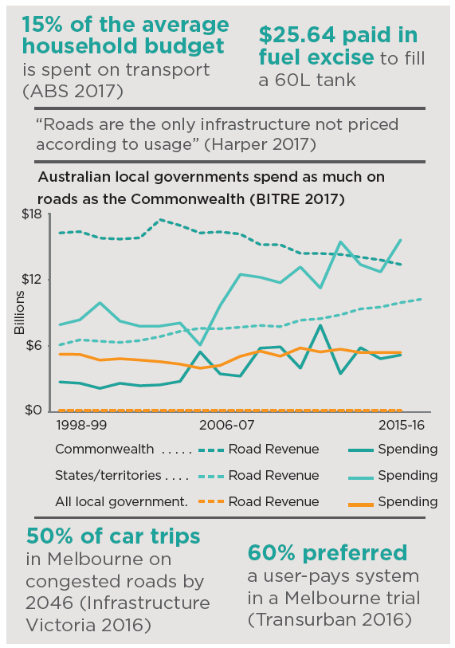

# What might transport pricing reform look like for Melbourne?

A road user pricing scheme in Melbourne will need to be carefully designed to meet the objectives of the *Transport Integration Act 2010*. An opt-in trial could provide opportunities to refine the design of a new pricing scheme. Key considerations include:

* Revenue should be reinvested in improving transport options. Investment in public transport, walking and cycling will be required to provide people with better alternatives to cars.
* Pricing reform should not be an additional charge, rather it should replace current charges and increase social equity. Concessions and exemptions for some road users will be required and should be carefully considered.
* In areas where motor vehicle impacts are the greatest, such as the central city and along tram/bus routes, road user pricing should be designed to encourage people to use alternatives to the car or use different routes.

Any reform should deliver community benefits aligned with City of Melbourne goals for a prosperous, sustainable and connected city for people. Road user pricing must also reduce delays to public transport and facilitate the reallocation of some road space to efficient transport and the creation of more pleasant streets.

To develop this new policy, everyone needs to participate including the community and the three levels of government. It is vital that all levels of government work together to ensure a future road user pricing system delivers benefits to all.

Many respected organisations have concluded that road pricing is needed and would deliver many benefits. They include the Productivity Commission, Infrastructure Victoria, Infrastructure Australia, the Australian Competition and Consumer Commission (ACCC), RACV and the Harper Competition and Henry Tax Reviews. In 2018 the Commonwealth will begin trials of road user pricing for trucks, which could inform a future system for all vehicles.

More work is needed to understand how pricing reform can make Melbourne a fairer city and avoids disadvantaging those with limited transport choices or poor access to public transport, walking and cycling.

# What if?

* You could opt-out of fuel excise and car registration fees and choose to pay less and drive less
* The roads were less congested at the times you needed to drive most.
* A road pricing scheme reduced through-traffic in sensitive areas like neighbourhoods, shopping strips, on public transport routes and in the central city
* Empty robo-taxis were discouraged by charging higher prices for empty vehicles to use the road.

# We want your thoughts!

**participate.melbourne.vic.gov.au/ transportstrategy**

**9658 9658**

**transport@melbourne.vic.gov.au**