Transport Strategy refresh
Background paper: Transport Pricing
July 2018
Dr. Meead Saberi – University of New South Wales
Ziyuan Gu – University of New South Wales

Contents
Executive Summary 5
1. Defining the problem 6
Congestion costs and productivity loss 6
Rapid population and employment growth 7
Reduced space for public and active transport 9
Increased transport emissions 9
Impact on freight transport 9
Issues of the current transport pricing system 9
Private motor vehicles 11
Public transport 13
Heavy vehicles (freight) 13
Emerging transport technologies 14
2. Effective transport pricing models 14
What is road user pricing? 14
Theoretical background 14
How should road user pricing be designed? 17
Privacy 17
Complexity 18
Uncertainty 18
Equity 19
3. How has transport pricing been applied in other cities? 20
Adopted road user pricing 20
Not adopted road user pricing 23
4. What could road user pricing look like for Melbourne? 24
Costs and benefits 25
Considerations and challenges 26
Policy options 28
5. Recommendations 31
Policy option and potential revenues 31
Political process and government cooperation 32
Glossary 34
Appendix A. Details of adopted road user pricing 35
Singapore 35
London, UK 36
Stockholm, Sweden 37
Milan, Italy 38
Oregon, USA 39
Appendix B. Details of not adopted road user pricing 42
New York, USA 42
Hong Kong 42
Edinburgh, UK 43
Greater Manchester, UK 44
References 46

About the authors
Meead Saberi, PhD
Dr. Saberi is a senior lecturer in the School of Civil and Environmental Engineering at University of New South Wales (UNSW), Sydney, Australia. Prior to joining UNSW, he was a lecturer at Monash University, Melbourne. He is leading the CityX research lab (www.cityxlab.com) which focuses on scientific understanding of cities through modeling, simulation, data analytics, and visualization. His research interests and experience cover a wide range of transportation areas including Traffic Flow Theory & Characteristics, Large-Scale Transportation Network Modeling, Network Science, Travel Behavior and Demand Modeling, Applied Choice Modeling, and Urban Data Analytics & Visualization.
Ziyuan Gu
Ziyuan is currently a PhD student in the School of Civil and Environmental Engineering at University of New South Wales (UNSW), Sydney, Australia. Prior to joining UNSW, he was a PhD student in Monash University, Melbourne. He completed his master’s degree in SEU-Monash Joint Graduate School in Suzhou, China. His main research interests include congestion pricing, network modelling, simulation, and optimization.

Executive Summary
As Melbourne’s population grows towards 8 million, road congestion is expected to worsen and its transport system needs to cope with the increasing demand. More congestion leads to further economic and productivity loss because road users have to spend more time travelling while experiencing significant delays. Congestion also reduces the livability of the city. The city space will be largely occupied by cars producing substantial vehicle emissions that affect the environmental quality and public health.
Building more road infrastructure without managing demand is financially and environmentally unsustainable. While it may reduce congestion and bring other benefits temporarily, the induced demand ultimately brings more road users to the transport system resulting in a return to congestion. Previous international experience has shown that a well-designed road user pricing policy can deliver multiple benefits to the community including reduced road congestion, economic and productivity gains, cheaper goods and services, and improved environmental quality. Australian national reform on road user pricing has recognized that the current transport pricing system is inefficient, unfair, and unsustainable that harms the sustainability, liveability, and productivity of the society. Users currently pay a combination of various implicit and fixed network access fees instead of a direct user charge that reflects how far and when they drive. Users are therefore unaware of their travel impacts on others and the environment, commonly known as externalities of trips.
Road user pricing has the potential to transform the way people currently pay for road use. It aims to integrate with the current transport pricing system to make it more efficient and fair (e.g. replacing some of the current vehicle charges such as registration fees and fuel excise), rather than introducing a new tax. Public transport improvements funded by the generated revenues are included as part of the policy to support the shift from private vehicle use to public transport.
Designing an efficient and equitable road user pricing policy requires cooperation across different levels of government and public engagement. Through open discussion with the community, consideration should be made to the objective, the price, exemptions and discounts, revenue allocation, and public transport improvements. Issues of privacy, complexity, uncertainty, and equity should also be addressed.

Defining the problem
With rapid population and employment growth, road congestion in Melbourne is expected to worsen causing significant economic and productivity loss. Building and expanding road infrastructure to meet the growing demand for transport is financially and environmentally unsustainable. Both theory and practice have shown that building more roads may result in a return to congestion due to induced demand (Sheffi, 1985). Transport networks are very sensitive to supply; the number and characteristics of trips tend to adjust to changes in supply. Increases in road capacity tend to be consumed as new and previously suppressed trips are enabled. A well-designed demand management strategy such as road user pricing, may benefit the community and help Melbourne achieve its multiple planning objectives set by the Victorian and local governments (City of Melbourne, 2012, 2016, Victorian Department of Environment, Land, Water and Planning, 2017). While transport pricing is currently implemented in a variety of ways in Melbourne, the current system is inefficient, unfair, and unsustainable, affecting the sustainability, liveability, and productivity of the city (Infrastructure Victoria, 2016b).

Congestion costs and productivity loss
Melbourne is ranked second only after Sydney in terms of congestion growth in Australia (See Figure 1). The cost of congestion in Melbourne is projected to reach $10.2 billion in 2030, an increase from $4.6 billion in 2015 because of increased demand for transport. This equates to every Melburnian paying the equivalent of an extra $1,700 per year or $7 per working day on average (Bureau of Infrastructure, Transport and Regional Economics, 2015b, Infrastructure Victoria, 2016b).
In 2016, 81 per cent of Victorians believed that congestion on Melbourne’s roads had worsened during the last 5 years (Infrastructure Victoria, 2016a). According to KPMG (2016), most of the major roads and public transport services in metropolitan Melbourne are indeed operating close to or at capacity. The resulting negative impacts include productivity loss, reduced travel speed and travel time reliability, and increased travel delay (see Figure 2). Half of the current road trips in inner Melbourne as well as one third in northern and western Melbourne are undertaken in congested conditions.
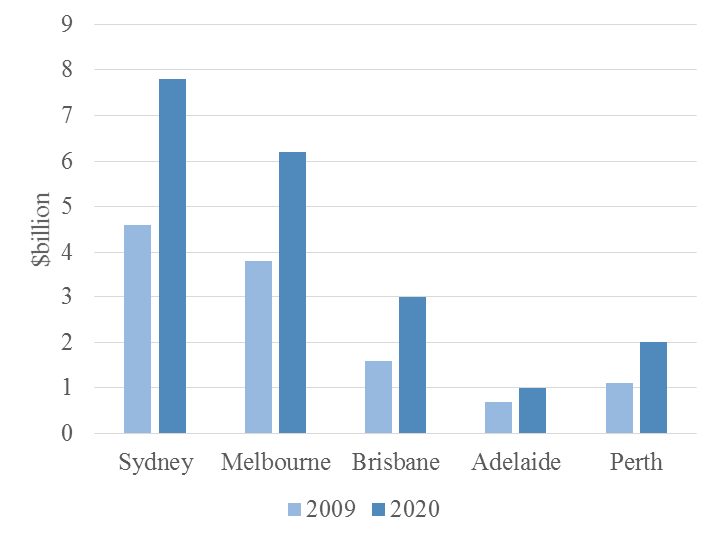
Figure 1 Projected social cost of congestion in Australian capital cities.
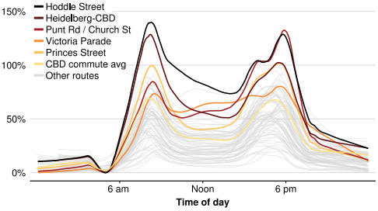
Figure 2 Arterial roads in inner Melbourne are already significantly delayed in 2017 compared with free-flow travel times (Terrill et al., 2017).

Rapid population and employment growth
With rapid population growth and urban sprawl, Melbourne’s transport system is struggling to deal with the increasing travel demand. The pressure from population growth is expected to worsen road congestion and conditions. During the past decade, over 800,000 new residents have come to Melbourne, the majority of whom are from interstate and overseas attracted by education, employment, and housing opportunities.
- There were approximately 903,000 people travelling to or being present in the city on an average weekday in 2016, 51,000 more than just two years ago (City of Melbourne, 2017b).
- Over 40 per cent of the 2015-16 weekday trips to the city were made by private vehicles (either as a driver or as a passenger) (City of Melbourne, 2017a).
- Car travel to the inner suburbs surrounding the central city has a very low car occupancy – less than 1.1 persons per vehicle (City of Melbourne, 2017c).
Greater Melbourne’s population is projected to grow by 3.4 million over the coming decades, reaching almost 8 million by 2051 (Infrastructure Victoria, 2016c, Victorian Department of Environment, Land, Water and Planning, 2016a). Victoria’s total population, during the same period, will reach 10.1 million requiring another 1.6 million dwellings and 1.5 million jobs (Victorian Department of Environment, Land, Water and Planning, 2016b). If traveller behaviours and preferences do not change, Melbourne’s road and transport system will need to handle an additional 10.4 million trips per day by 2050 on top of the current 12.5 million (Department of Economic, Development, Jobs, Transport and Resources, 2016). A study by KPMG (2016) further shows that by 2046:
- The number of daily trips made across the road network is projected to increase by 74 per cent compared with 2016.
- Almost half of the trips undertaken by car will be significantly affected by congestion even with the committed transport investments.
- The average road trip time is projected to increase by 23 per cent compared with 2016.
- 35 per cent of trips by public transport will be in crowded conditions compared with 20 per cent in 2011.
As a result, the already declining performance of public transport, particularly trams and buses that share roads with cars, will become even worse (see Figure 3).
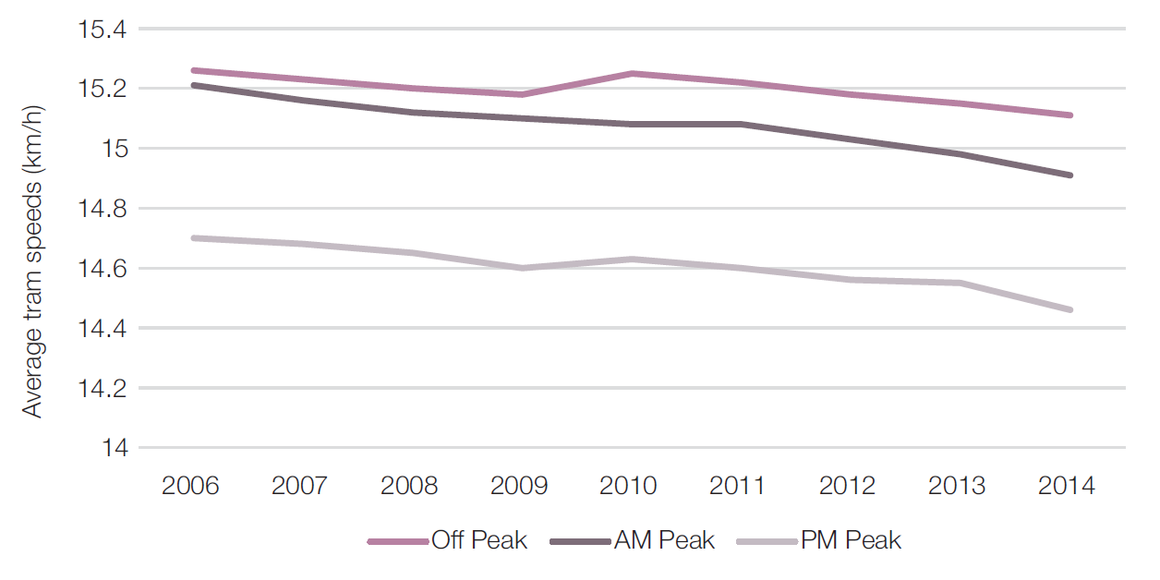
Average tram speeds
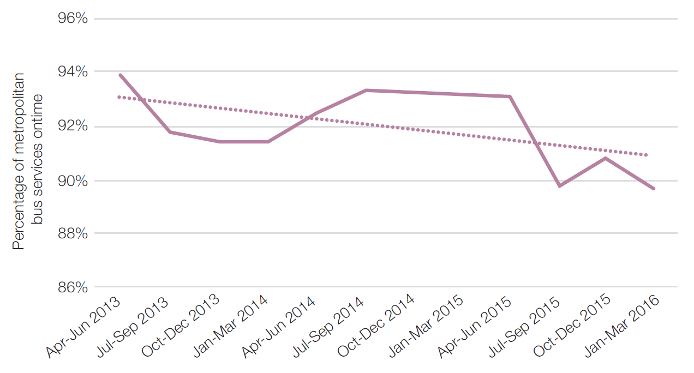
Punctuality of bus services
Figure 3 Declining performance of public transport in Melbourne.
While population and employment growth increases the demand for transport, the mismatch between where this growth is occurring is also an increasing pressure on the transport system. By 2046, almost half of population growth in Melbourne will occur in outer areas whereas employment growth will concentrate in the central city and inner suburbs, thereby creating an uneven distribution of jobs across Melbourne. Central Melbourne, for example, is projected to account for 48 per cent of the job growth but only 8 per cent of the population growth. West subregion, in contrast, is expected to experience 24 per cent of the population growth but only 9 per cent of the job growth (Infrastructure Victoria, 2016c). Although the outer suburbs generally have less access to jobs and services than the middle and inner areas, the majority of people are projected to live in these areas. The increasing spatial difference between where population and employment growth is occurring will eventually lead to an unsustainably high number of long-distance trips (Victorian Department of Environment, Land, Water and Planning, 2016b).

Reduced space for public and active transport
Congestion impacts negatively on Melbourne’s amenity and liveability. If no action is taken, road space in inner Melbourne will continue to be largely occupied by private motor vehicles, leaving significantly less space for public and active transport, and shared public use. This is in contrast with City of Melbourne and Victorian Government policy to develop a sustainable and liveable city for people (City of Melbourne, 2012, 2016, Victorian Department of Environment, Land, Water and Planning, 2017). With fewer cars on roads, we have the opportunity to transform the existing mixed traffic lanes into dedicated bus lanes, separated cycling corridors and footpaths. This can effectively increase the safety confidence of public and active transport users when travelling across the central city.

Increased transport emissions
To remain environmentally resilient, Melbourne needs to manage the increasing transport emissions and make the transition to a low-carbon city (Victorian Department of Environment, Land, Water and Planning, 2016a). Compared with 2015, an increase of 9 per cent transport emissions is projected to occur by 2020 (Department of the Environment and Energy, 2016). By 2030, this figure will rise to 19 per cent. Road transport will continue to be the dominant source accounting for about 85 per cent of the total transport emissions. Reducing the auto demand is vital to achieve liveability goals for Melbourne, including improving air quality and achieving environmental sustainability.

Impact on freight transport
Congestion also results in Victorians paying more for goods and services. In 2046, freight distance travelled in congested conditions is projected to double to 32 per cent compared with the 2011 level (KPMG, 2016). However, freight vehicles only account for a minor share of traffic and hence do not contribute significantly to congestion. The worsened travel conditions increase the costs of transporting freight across the state, which are ultimately passed onto households (i.e. increased prices for goods and services) resulting in a higher cost of living. There is a need to reduce the negative impact of car-incurred congestion on heavy vehicles and increase the efficiency of freight transport.

Issues of the current transport pricing system
Road transport in Victoria is funded through indirect and direct means. Indirect funding is provided through general Victorian Government revenue measures such as Stamp Duty, Payroll Tax, and the Goods and Services Tax (GST). As such, all Victorians pay regardless of whether and how they use transport infrastructure. Direct funding comes from various state and local government charges including vehicle registration fees, fuel excise, congestion levy, toll roads, public transport fares, and heavy vehicle charges (see Table 1).
The current pricing system is inequitable and is becoming less able to fund road expenditure. Current charges do not equitably reflect the characteristics of the user. Some changes in road pricing/funding have to be made and we need to decide and choose among different options. Without changes to direct charges, more funding over time will have to come from general revenue. Another issue of the current system relates to how the generated revenues are allocated across different levels of government. While about 75 per cent of road funding comes from state and local governments, most of the revenues are taken by the Australian Government (Terrill and Emslie, 2016). State and local governments are faced with a majority of the funding responsibility but only having a minority of the revenue share.
Table 1 Different types of fees in the current transport pricing system.
Vehicle type | Type of pricing | Objectives (abilities) | Targets | Issues
Private motor vehicles | Vehicle registration fees | To recover administration costs;  To raise revenues for any purposes. | Licenced private motor vehicles | Price only responds to vehicle type and location;  Not linked to when people drive and how they use the road network.
 | Fuel excise | To raise revenues for any purposes. | Licenced private motor vehicles travelling on roads and other consumers of fuel. | Price only responds to fuel type;  Not linked to when people drive and how they use the road network.
 | Congestion levy | To reduce road congestion in inner Melbourne;  To encourage more motorists to regularly use the city's trams, buses, and trains. | The owner and the operator of any off-street public car park, and the owner of any off-street private car park in two specified zones (see Figure 5). | Price only responds to zone.
 | Toll roads | To raise revenues for funding and managing road infrastructure. | Licenced private motor vehicles travelling on the toll roads. | Price only responds to vehicle type and distance travelled;  Do not respond to the changing travel conditions particularly during peak periods;  Users are discouraged from using the tolled freeways and switch to the arterial alternatives resulting in significant congestion externalities.
Public transport | Public transport fares | To recover administration, operating, and maintenance costs of the system  To raise revenues for improving transport services. | Public transport users | Do not always respond to demand by location or at different times;  The pricing structure is better connected to the frequency and intensity of use than to roads.
Heavy vehicles (freight) | Vehicle registration fees | To recover heavy vehicle related expenditure on roads;  To raise revenues for building and maintaining productive and safer roads. | Licenced heavy vehicle operators
 | Fuel-based road user charge
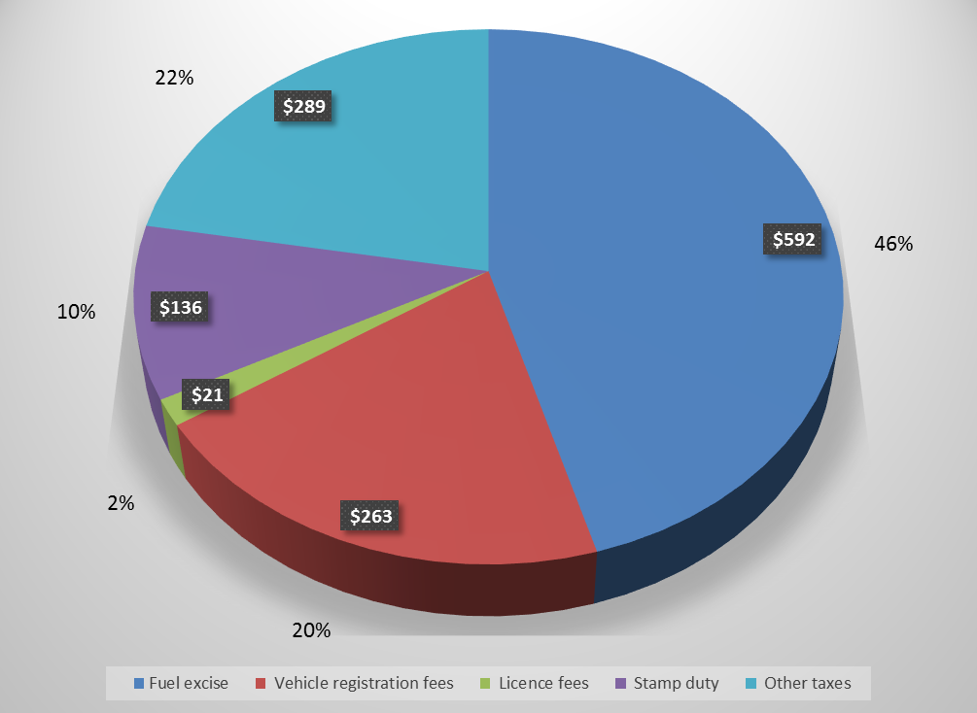
Figure 4 Estimated average annual government road bill per vehicle (Bureau of Infrastructure, Transport and Regional Economics, 2015a).

Private motor vehicles
The existing pricing system for private motor vehicles is complex, opaque, inefficient, and inequitable. Users pay a variety of implicit and fixed network access fees instead of a direct user charge that reflects how far and when they drive (see Figure 4). Vehicle registration fees and fuel excise are two main Victorian and Australian Government charges respectively. However, they are not directly linked to road use and are set to raise revenues for general purposes, not to reduce congestion or to achieve other social, economic, or environmental objectives. These charges provide no incentive for travellers to change behaviour and use transport infrastructure more efficiently. Road users are unable to see the actual costs of using the transport network (e.g. how much they pay in total for every kilometre travelled). Road users are also unaware of the impacts of their trips on others or the environment, commonly known as externalities.
The way people pay for road use is inequitable. Frequent and intensive users pay significantly less per trip than those who seldom use the road network. For example, Bob, who drives a small car over a long distance every day of the week, pays about AU$15 per week for vehicle registration fees. The same amount of fees, however, also applies to Jenny who owns the same type of car but drives only once a week. The fuel excise is regressive, since everyone pays the same amount depending on the fuel type. As the excise applies per litre of fuel, owners of newer and more efficient vehicles pay less per kilometre driven than owners of older and less efficient vehicles. Families who live in outer Melbourne generally have less access to and poorer choice of public transport and hence, need to drive more and over longer distances. As such, they tend to pay a larger proportion of incomes for fuel excise without receiving any allowances or compensations. Though fuel-efficient or electric vehicles (EVs) may help reduce the amount one needs to pay, these advanced cars are generally more expensive to purchase and more likely to be owned by those on high-incomes who have an ability to pay.
Melbourne has two toll roads on which users pay a distance-dependent toll: one is CityLink operated by Transurban and the other is EastLink operated by ConnectEast Group. Since these toll roads only serve as a means of financing road infrastructure rather than managing congestion or limiting vehicle emissions by inducing changes in behaviour through price signals, the toll rates are fixed at all times of day and do not respond to the changing travel conditions, particularly during peak periods. An off-street parking levy in inner Melbourne, also known as the Congestion Levy, is currently imposed by the Victorian Government with the objective of tackling road congestion by discouraging travellers from driving and encouraging the use of public and active transport. An amount of AU$7 million from the levy is allocated annually to the City of Melbourne for transport-related purposes. As a significant revenue source for funding transport services and infrastructure, parking fees and fines send a price signal to those who drive to the city centre and park.
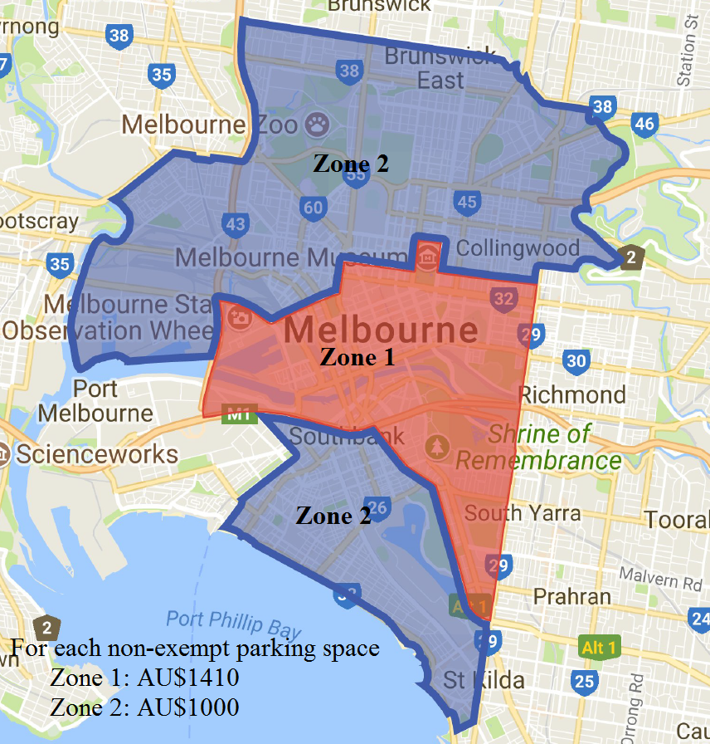
Figure 5 Melbourne’s congestion levy.

Public transport
Although there is no explicit user charge for cars except toll roads, we have clear public transport fares based on the level of use. The public transport system in metropolitan Melbourne covers three zones: a Free Tram Zone applicable in the city centre (see Figure 6), Zone 1 (inner Melbourne), and Zone 2 (outer Melbourne). When using public transport, users need to pay a fare based on in which zone(s) the travel occurs (Free Tram Zone excluded). While there is a flat fare for a two-hour travel anywhere within the metropolitan area, time-of-day pricing is applied in some circumstances. This includes free early bird train travel and off-peak V/Line (regional) fares to encourage off-peak travel by public transport. The fare for a V/Line journey depends on the distance travelled. A limitation of public transport pricing in Victoria is that the fare does not always respond to demand by location or at different times (Infrastructure Victoria, 2016b). While public transport pricing could more accurately reflect the distance and time-of-day demand of trips, its structure is better connected to the frequency and intensity of use than roads.
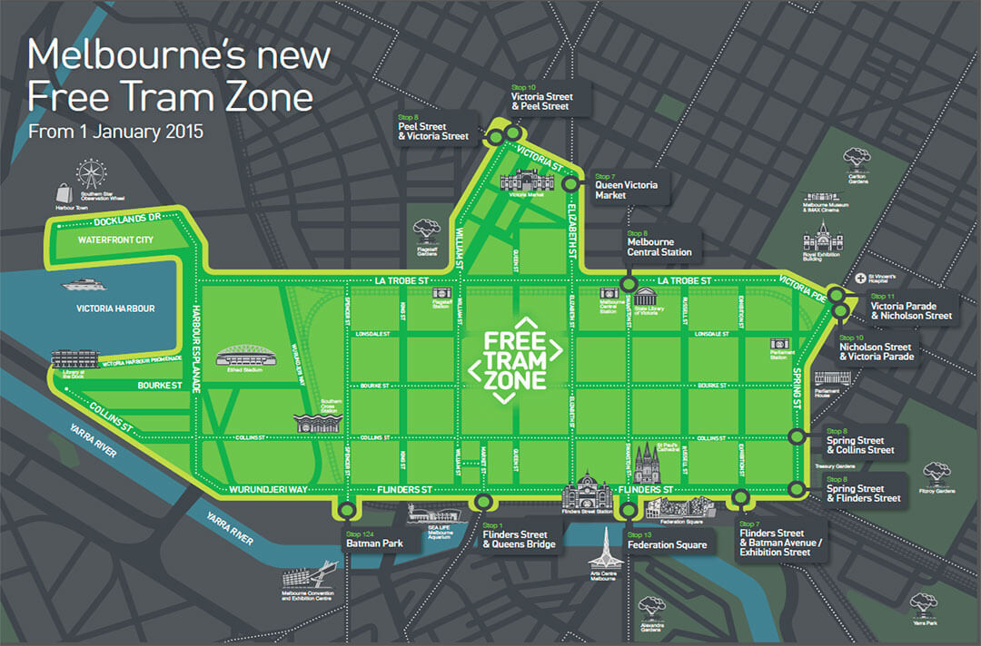
Figure 6 Melbourne’s Free Tram Zone.

Heavy vehicles (freight)
Heavy vehicles (freight) are also subject to registration fees. The major difference is that they are further subject to a direct user charge through a pay-as-you-go system. The charge applies to each litre of diesel used by heavy vehicles on public roads during the financial year. The generated revenues are mainly used to recover the costs of building and maintaining the road network as heavy vehicles generally cause more damage to roads than other vehicles. While subject to a direct user charge, heavy vehicles do not contribute significantly to congestion as they only make up a minor share of traffic on the majority of roads across the network (Infrastructure Victoria, 2016b). Congestion mainly comes from the increasing cars which are currently not subject to any direct user charges, and which in turn affect the operation of heavy vehicles. This clearly shows that the current pricing system is not consistent across different transport modes. The Australian Government is currently reviewing these prices with a view towards more responsive pricing based on use and external impacts.

Emerging transport technologies
Given the sources of road funding, emerging technologies could exacerbate revenue issues. With the advent of advanced vehicle technologies including EVs and connected and automated vehicles (CAVs), all levels of government may soon face a revenue shortfall due to decreasing parking and registration fees and fuel excise. There are multiple current and emerging issues surrounding the performance, funding, and pricing of roads. Reducing and replacing existing charges and taxes with a direct user charge may help address multiple issues at once, such as revenues, congestion, and disruption from emerging transport technologies.
More or less congestion in the era of CAVs?
CAVs, if privately owned, may significantly exacerbate congestion (without road user pricing) for a variety of reasons:
- Travel by groups such as young adults and seniors would be easier and safer, and may increase.
- Public transport could be less cost competitive losing its market share.
- Travellers may be willing to spend more time in their vehicles because without the need for human driving, they could do other things in their vehicles, which may reduce their value of time.
For more information, see the paper on emerging transport technology here.

Effective transport pricing models
Developing urban transport systems through road infrastructure investment and expansion has long been the traditional way to combat increasing levels of congestion. This approach has experienced limited success at reducing road congestion because of induced demand. Road user demand-oriented solutions, as an alternative approach, are more effective in changing user behaviours and do not require extensive infrastructure investment. Transport pricing is considered one of the most effective and efficient demand-oriented policies for congestion management by internalising costs. It can spread and reduce demand to maintain network productivity and efficiency. Rather than a compulsory rule for road users (e.g. traffic signal control), transport pricing serves as an economic lever to influence users’ travel choices including number of trips, mode of transport, time of day, route, and even their decisions on where to locate workplace and residence. The result is that effective pricing models allow infrastructure to be used more efficiently and generate congestion, economic, environmental and social benefits.

What is road user pricing?
Transport pricing comprises any charge that is related to people’s travel including vehicle registration fees, fuel excise, public transport fares, and different types of road user pricing. Road user pricing is a form of transport pricing that imposes direct charges on road use, such as toll roads (charging per use of a road), parking fees, and other forms of road charges (Jones and Hervik, 1992, Small and Gómez-Ibáñez, 1997). It has already been successfully implemented in cities around the world including Singapore, London, Stockholm, and Milan. As an important design consideration, the objectives of road user pricing can vary and may include managing demand for road infrastructure, reducing road congestion, increasing speeds, improving air quality, or raising revenues. For example, a policy designed to improve air quality could look different to a policy designed to raise revenues or increase the average vehicle speed.

Theoretical background
Road user pricing is an idea that dates back to 1920s. Since the seminal studies by Pigou (1920) and Knight (1924), a variety of pricing models have been proposed which can be classified into two broad categories: first-best pricing, also known as marginal-cost pricing, and second-best pricing (Yang and Huang, 2005). The first-best pricing theory requires that a charge be imposed on each link in the network to internalize externalities of trips. That is, motorists are charged based on the impact of their trips on society and the environment. Despite solid theoretical basis, practical applications of first-best pricing are limited because a whole-of-network charge generally leads to high operating costs for government and poor public support towards the policy.
Second-best pricing has been more effective in practice and are worthy of consideration. It only charges part of the network such as a set of congested roads or a congested subarea. Analysing the work on road user pricing results in a total of five alternative and effective pricing regimes (see Table 2 and Figure 7). Multiple types can be combined to create a mixed system. For example, a city may implement a joint distance- and cordon-based scheme as has been previously studied in Melbourne (Transurban, 2016), or a joint distance and time charge as has been proposed and studied in theory (Liu et al., 2014).
Table 2 A review of different pricing regimes.
Type | Definition | Strengths | Limitations | Examples
Link-based | Charges are imposed on specific roads or road segments. | - Easy to understand and implement  - Effective in addressing isolated bottleneck congestion | - Those who live and work close to the charged facilities are more affected and left with fewer options to travel, particularly when access to public transport is also limited.  - Can drive demand to nearby roads and shift congestion  - Can hardly address network-wide congestion | - CityLink and EastLink in Melbourne  - Sydney Harbour Bridge & Tunnel  - High-occupancy toll (HOT) and express lanes in the USA
Zonal | Vehicles pay a charge when entering or exiting a bounded area, or simply travelling within the area without crossing the boundary. Often the boundary is chosen based on network topology and urban layout. | - Effective in addressing network-wide congestion particularly in the city centre | - The charge do not distinguish between a trip that reaches the destination immediately upon entering the bounded area and a trip that traverses the whole area.  - Vehicles are not directly charged according to how they use the road network which reflects their actual contributions to road congestion. | - London congestion charge
Cordon-based | While being similar to zonal charging, cordon-based charging does not charge vehicles if only travelling within the bounded area. | - Effective in addressing network-wide congestion particularly in the city centre | - The charge does not distinguish between a trip that reaches the destination immediately upon entering the bounded area and a trip that traverses the whole area.  - Vehicles are not directly charged according to how they use the road network which reflects their actual contributions to road congestion.  - Vehicles simply travelling within the bounded area are not charged at all. | - Electronic Road Pricing (ERP) system in Singapore  - Stockholm congestion charge  - Area C in Milan
Distance-based | Vehicles are charged based on the total distance travelled in the network, which can be read from the vehicle odometer or obtained from a telematics device. | - Vehicles are charged explicitly based on road usage, i.e. vehicle kilometres travelled (VKT). | - Vehicles are likely to concentrate on routes with the shortest distance in order to minimise the charge.  - Clusters of congested roads (i.e. pockets of congestion) may affect network productivity and efficiency. | - European distance-based charging for heavy goods vehicles (HGVs)  - The opt-in user-pays system in the state of Oregon, USA
Time-based | Vehicles are charged based on the total time spent in the network, which can be retrieved from a telematics device or obtained through mobile and infrastructure communications. | - Vehicles are charged explicitly based on road usage (i.e. vehicle hours spent). | - The charge may result in safety and environmental concerns by encouraging vehicles to drive more aggressively and use minor roads (May and Milne, 2000) | N/A

Figure 7 Graphic representations of different pricing regimes.

How should road user pricing be designed?
The key design considerations of road user pricing include:
- What should be the priority objectives?
- Who should and should not be charged? (Concessions and exemptions)
- How much should be charged? Should the scheme be revenue neutral?
- When and where should the charge be applied?
- How should the revenue be allocated?
Why should people pay for road use that has always been free at the point of use?
Road infrastructure in Australia remains the last utility without a direct user charge: electricity, gas, and water have all transitioned to pricing based on usage. Due to the direct linkage between usage and cost, users are aware of how they actually consume resources and adjust their behaviours accordingly. However, if not priced well, consumption is generally inefficient and unsustainable. Cost-reflective road user pricing is consistent with other utilities that may help achieve an efficient road use and sustainability of road infrastructure.

Privacy
Privacy concerns result from the communications technologies associated with road user pricing recording personal information, which is one of the major reasons why the proposed charge was not adopted on a permanent basis in Hong Kong (Hau, 1990). Singapore’s ERP system and London’s congestion charge were both designed to address the privacy concern (Santos, 2005). For example, the smartcard used in Singapore’s ERP system carries no personal information about drivers or vehicles, and the charging facilities installed at different locations do not track travellers’ itineraries.
Addressing the privacy concern can be relatively simple through the use and design of technology. Telematics devices can be configured not to transmit data when a vehicle is only a few kilometres away from origins and destinations. This type of practice was already adopted in the previous pricing trial in Melbourne (Transurban, 2016). To avoid tracking a traveller’s itinerary, lessons from Singapore’s practice and experience can help prudently design the technology used.

Complexity
Road user pricing is still a relatively new transport policy in Australia. There is no explicit national, regional, or local regulation on road user pricing that may help guide its implementation. A road user pricing system can be relatively simple or highly complex. The ease of understanding has been of significant public interest in places where road user pricing has been proposed or implemented. Previous international experience has shown that a simple pricing system, particularly at the very first stage of implementation, may offer great help for gaining public support (Hensher and Li, 2013). Simplicity also largely facilitates governments’ monitoring and regulating the pricing system. A gradually evolving pricing system is more practical and advisable compared with the overnight implementation of a highly complex pricing system. This “big bang” type of complex pricing reform can struggle to gain public support. To further promote road user pricing, a self-selection process may be integrated with the pricing system, where people are offered multiple options for paying for road use, including the current system, and choose any one of them on a voluntary basis. For example, we can introduce a distance-based user-pays system as an alternative to vehicle registration fees and fuel excise, allowing people to voluntarily choose between the two options. Such an opt-in user-pays system is currently implemented in the state of Oregon, USA.

Uncertainty
Uncertainty should be a major consideration when introducing road user pricing in Australia. The uncertainty surrounds the effectiveness of road user pricing and revenue allocation (De Borger and Proost, 2012). Many people are not familiar with this policy and how it may potentially affect their lifestyle.
For most situations, the primary objective of introducing road user pricing has been to manage road congestion. There may be additional benefits due to fewer vehicles travelling on roads, including reduced vehicle emissions and noise. The question often asked is “do we really experience these potential benefits when road user pricing is implemented? And if so, to what extent?” The public must be confident that there will be benefits in order to support road user pricing. Previous international experience has shown that once people experience road user pricing, they tend to be more positive towards the policy (Hensher and Li, 2013). In this sense, a road user pricing trial that allows the public to experience the real benefits is of importance. An opt-in trial can be particularly effective in demonstrating the benefits to users and in resolving issues of system design. Proponents need to illustrate to the public that introducing their proposed road user pricing will benefit the community as a whole. Benefits can include improved travel conditions that significantly reduce people’s travel times across different modes of transport, increased use of sustainable travel, and improved environmental conditions that enhance the liveability of the city.
Road user pricing does not aim to increase people’s travel costs. Instead, it is a means of changing how people currently pay for road use. Although revenue collection may not be the ultimate goal of road user pricing, how the generated revenues are allocated has a significant impact on its implementation. Previous international experience has shown that using revenues for investing in roads and improving alternative transport modes as part of the policy may help increase public support. The public may become even more supportive if revenues are invested in improving public transport (De Borger and Proost, 2012). This is sensible given that road user pricing generally increases demand for public transport as a result of people shifting away from private motor vehicles. Earmarking revenues for transport explicitly addresses the common public concern about where revenue is allocated. Considering that road user pricing is more likely to be part of a wider urban policy shift, a comprehensive economic assessment is needed to justify earmarking revenues.

Equity
Equity is one of the most significant design considerations of road user pricing. While zonal and cordon-based charging perform poorly in addressing equity concerns, distance-based charging helps achieve a more equitable pricing system. Travellers are directly charged according to how much they use the road network (see Table 2 for further explanation). As discussed in Section 1, the current pricing system is suffering from inequality and a well-designed road user pricing policy offers a fairer option.
Analysing the Census shows that about 16 per cent of people who earn less than AU$26,000 per year drive to work in Melbourne LGA, while for those who earn more than AU$78,000 per year, the number is about 29 per cent. When road user pricing has been introduced, low-income families and people with mobility impairments are often faced with a greater travel burden and further limited travel options. A road user pricing system will benefit some people and not benefit others. The question is how to design a system that works for the majority and minimises the negative and equity impacts.
One potential solution is that a system can set different price rates based on vehicle classes in view of the current registration fees that have concessional rates and distinguish between private motor vehicles and heavy vehicles (freight). Charges can vary based on vehicle emissions to encourage more travel by fuel-efficient vehicles or EVs for air quality benefits. Since congestion is often more severe in the city centre (Liu et al., 2013), charges can also vary based on location. A vehicle travelling only in outer or less-congested suburbs can be charged with a lower price whereas a vehicle heading towards the city centre or congested areas pay more. For families living in outer suburbs and working in the city centre, a long-distance auto-dependent commute is often unavoidable, particularly when access to public transport is also limited. A mechanism whereby the price rate remains relatively high for the first few kilometres travelled per day but gradually diminishes for the rest of the distance travelled could help prevent those with a long-distance commute from being charged unacceptably high amounts for transport (see Figure 8). Under distance-based pricing, people on low-incomes could pay an unacceptably high proportion of their incomes for travel. This can be mitigated partially or fully by a concession system, similar to current registration discounts.
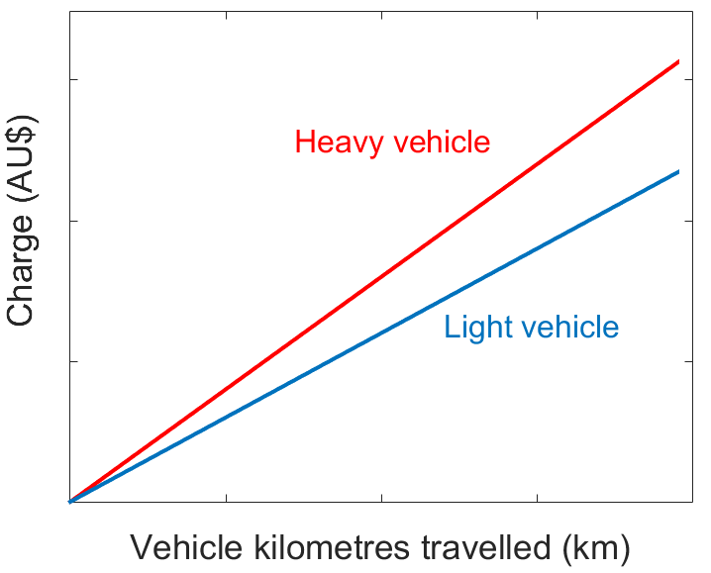 | 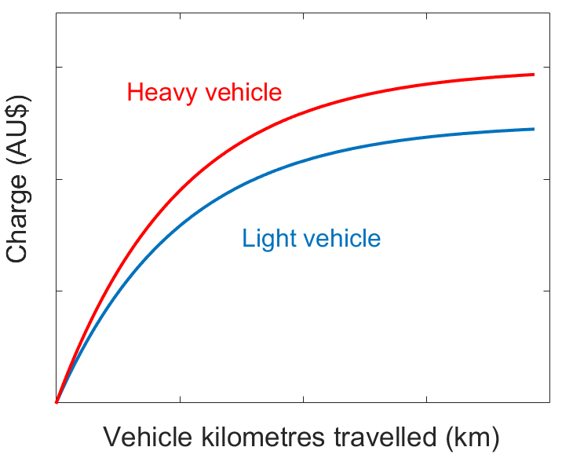
Linear distance charge | Nonlinear distance charge
Figure 8 A more equitable nonlinear distance charge as a replacement for the linear distance charge.
For vehicles used by people with mobility impairments, a full exemption could be included as part of the system. Infrequent vehicles to the city centre could be granted, for example, 10 free trips per year. Exemptions or discounts for other vehicle types could also be considered. Prudence should be used, as inappropriate or excessive exemptions or discounts could reduce the benefits of road user pricing, deteriorate road congestion, and jeopardise the equity of the pricing system.

How has transport pricing been applied in other cities?
The first road user pricing was the area licensing scheme (ALS), introduced in Singapore in 1975. Following Singapore’s success in managing road congestion, several attempts to introduce road user pricing have been made in other cities or areas around the world. Around 10 cities have adopted the policy on a permanent basis (although not necessarily for reducing congestion). Table 3 categorises a few typical road user pricing policies around the world.
Table 3 Road user pricing around the world.
 | Zonal charging | Cordon-based charging | Distance-based charging
Adopted | Singapore (ALS) | Singapore (ERP) | Oregon, USA
 | London, UK | Stockholm, Sweden
 |  | Milan, Italy (Ecopass and Area C)
Not adopted | New York, USA | Hong Kong
 |  | Edinburgh, UK
 |  | Greater Manchester, UK

Adopted road user pricing
Table 4 provides an overview of the adopted road user pricing policies around the world including their objectives, pricing mechanisms, and outcomes. A further detailed description of each case is provided in
Appendix A.
Table 4 A summary of the adopted road user pricing policies.
Location | Objective(s) | Pricing mechanism | Outcomes
Singapore | - To reduce road congestion | - The ALS was a zonal charge requiring vehicles purchase a paper-based area licence (see Santos (2005) for prices of different licences) when entering the restricted zone (RZ) and several expressways.  - The ERP system consists of three cordons and several expressways requiring vehicles pay a “shoulder price” type of entry fee when passing through the specified locations. | Bhatt et al. (2008):  - A 44 per cent reduction in traffic entering the RZ and a 20 per cent increase in speeds within the RZ (public transport included)  - A 24 per cent drop in weekday traffic entering the RZ and an increase in speeds within the RZ from 30-35 km/h to 40-45 km/h  - Commuting by car to the RZ by 1983 declined to 23 per cent despite large increases in car ownership and RZ employment.  - Public transport share of morning peak trips to the RZ increased to 69 per cent.  - Reductions in both CO concentrations and NO_{x} emissions
London, UK | - To reduce road congestion  - To raise funds for the transport system | - A zonal charge requiring users purchase a flat daily licence of £11.5 (AU$20) when entering or travelling within the charging zone | Transport for London (2007):  - There were 54,000 fewer vehicle trips in the charging zone during the charging hours in 2003, a 14 per cent reduction compared with the pre-charging situation in 2002.  - Although London’s population grew by over 1.3 million between 2003 and 2013, congestion in London in 2013 was about the same level as it was in 2003.  - Traffic emissions in the charging zone declined in 2003 compared with 2002, with a 13.4 per cent reduction in NO_{x}, a 15.5 per cent reduction in PM₁₀, and a 16.4 per cent reduction in CO₂.  - An almost 10 per cent increase in bus passengers in central London due to car drivers switching to public transport  - Reduced road traffic casualties
Stockholm, Sweden | - To reduce road congestion  - To improve environmental quality | - A cordon-based charge requiring vehicles pay an entry fee (10-20 Swedish kronor depending on time of day) when entering or exiting the cordon area, with a maximum 60 Swedish kronor per vehicle per day | Eliasson (2014):  - During the trial, there was a 24 per cent reduction in commuting trips by cars; virtually all (99 per cent) switched to public transport and the remainder (1 per cent) switched to different routes.  - When the charge became permanent, the level of reduction remained relatively the same fluctuating around 20 per cent.  - A 13 per cent reduction in PM₁₀ emissions and a 14 per cent reduction in CO₂ emissions during the trial
Milan, Italy | - The Ecopass aimed to reduce traffic emissions.  - The Area C aims to reduce congestion. | - The Ecopass is a cordon-based charge introduced in 2008 requiring vehicles pay an entry fee according to the European emission standards.  - The Area C is a cordon-based charge introduced in 2012 requiring vehicles pay a flat daily charge of €5 (AU$8) when entering the cordon area. | Croci (2016):  - Following the introduction of the Ecopass, traffic volumes, road accidents, and PM₁₀ emissions within the cordon area reduced by 16.2 per cent, 21.3 per cent, and 15 per cent between 2007 and 2011.  - Following the introduction of the Area C, traffic volumes, road accidents, and PM₁₀ emissions within the cordon area further reduced by 30.1 per cent, 23.8 per cent, and 18 per cent respectively between 2011 and 2012.  - Public transport use (the number of passengers exiting subway stations) and the average public transport speed within the cordon area increased by 12.5 per cent and 11.8 per cent respectively in 2012 compared with 2011.
Oregon, USA | - To replace the gas tax for revenue collection | - A whole-of-network distance-based charge whereby those who opt-in to the system pay 1.5 (will increase to 1.7 in 2018) cents per mile and receive credits for the gas tax | Whitty (2007):  - During the field test, those who paid the distance-based charge in lieu of the gas tax showed a 12 per cent reduction in total miles driven.  - The congestion pricing test in the pilot program produced a 22 per cent decline in driving during peak periods.  - 91 per cent of pilot program participants would agree to continue paying the mileage fee in lieu of the gas tax.

Not adopted road user pricing
Table 5 provides a synthetic overview on the introduced but not adopted road user pricing policies around the world including their objectives, pricing mechanisms, and reasons for not being adopted.
Table 5 A summary of the not adopted road user pricing policies.
Location | Objective(s) | Pricing mechanism | Why not adopted
New York, USA | - To reduce congestion | - A zonal charge requiring vehicles pay a flat daily charge when entering, leaving, or travelling within the charging zone  - US$8/21 (AU$10.4/27.3) for cars/trucks entering or leaving the charging zone; US$4/5.5 (AU$5.2/7.15) for cars/trucks travelling within the charging zone | Schaller (2010):  - Disagreement among local governments as the elected officials and the public in the four New York boroughs outside Manhattan saw the congestion charge as a means of penalizing their own residents
Hong Kong | - To reduce congestion | - A cordon-based charge requiring vehicles pay an entry fee when travelling across the boundary of the cordon area  - 13/6.5 Hong Kong dollar (AU$2.16/1.08) for peak/shoulder periods | Hau (1990):  - Congestion severity described by the government appeared to be exaggerated resulting in public mistrust of the government.  - The invasion of privacy and fear of a “big brother” government were foremost in people’s minds.  - The government did not provide enough information to the public, limiting their ability to support the project.  - Private car drivers felt singled out because taxis were exempt from the charge but contributed more to congestion.
Edinburgh, UK | - To reduce congestion  - To raise revenues for public transport investment | - A cordon-based charge requiring vehicles pay a flat daily charge of £2 (AU$3.49) when entering either of the two cordons | Rye et al. (2008):  - Perceptions from neighbouring areas of the congestion charge as a means of penalising them and the exemption for Edinburgh residents as unfair.  - Many people viewed the charge simply as a means of raising revenues and did not trust the government to spend the revenues correctly.  - There was disagreement on congestion in Edinburgh being severe enough to introduce the charge.  - The outer cordon added to the complexity of the charge making it difficult for the public to support.  - Press coverage, especially newspapers, was generally hostile to the price.
Greater Manchester, UK | - To reduce congestion  - To raise revenues for public transport investment | - A cordon-based charge requiring vehicles pay a flat daily charge of £2 (AU$3.49) when entering or exiting either of the two cordons  - Charging only inbound vehicles in the morning peak and only outbound vehicles in the evening peak | - A two-cordon pricing system was complex and difficult to understand.  - The government was perceived as out-of-touch with the problems people faced in the aftermath of an economic downturn and record fuel prices.

What is the role of a road user pricing trial from previous international experience?
People are usually reserved or even negative towards a new policy such as road user pricing, particularly when information about it is limited or unknown. Without experiencing the benefits themselves, people are more in favour of the status quo. This is known as the risk-averse behaviour (Christin et al., 2002). A road user pricing trial offers a unique opportunity to better understand and experience the real benefits of the policy and addresses people’s uncertainty about its potential impacts (Gu et al., 2018). A trial also provides an opportunity to improve the design of the system. Public feedback from the trial in turn is a valuable source of information to further improve the equipment, efficiency, equity, and acceptability of road user pricing. The current road user pricing systems in Stockholm, Milan, and Oregon all adopted a trial before introduction on a permanent basis. In contrast, there was no trial in New York, Edinburgh, and Greater Manchester where road user pricing was not adopted.

What could road user pricing look like for Melbourne?
Over the past few decades, road user pricing has been successfully implemented in cities around the world, providing benefits such as managing travel demand to reduce road congestion, raising revenues for transport investment and improved environmental outcomes. While some cities have not adopted road user pricing, most cities have embraced the system after successful implementation. Experience from these cities provides insight on what makes a system successful or unsuccessful.
Road user pricing has not been introduced at a large scale anywhere in Australia, except for a few individual toll roads in Melbourne, Sydney, and Southeast Queensland. Discussions over the concept have been ongoing for many years among government, academics, public policy organisations such as the Grattan Institute, the private sector, and the public. In 2007, the Australian Government released a report on introducing efficient road and rail freight infrastructure pricing to maximise net benefits to the community (Australian Government Productivity Commission, 2007). In 2015, in response to the Harper Review on Competition Policy, the Australian Government announced that it would accelerate its work with states and territories on heavy vehicle road reform and investigate the costs, benefits, and potential future options to introduce cost-reflective road pricing for all vehicles. In 2016, in response to the Australian Infrastructure Plan released by Infrastructure Australia, the Australian Government further announced that it would establish a study into the potential benefits and impacts of road user charging for light vehicles on road users (Department of Infrastructure and Regional Development, 2016). While road user pricing is already on the Australian Government’s agenda, the Victorian Government has stated it does not support introducing new charges to existing roads, in response to Infrastructure Victoria’s 30-year Infrastructure Strategy (Victorian Government, 2017). Options for demand management as part of long-term integrated transport planning have been recognised. The City of Melbourne has considered road user pricing as one of its priority actions in the Transport Strategy 2012 (City of Melbourne, 2012). As a means of managing demand, reducing congestion, and funding the transport system, road user pricing is an inevitable part of the future integrated transport network.
A recent study by the public policy-focused Grattan Institute recommended that the Victorian Government introduce a time-of-day pricing in the most congested central areas (Terrill et al., 2017). Between 2015 and 2016, the first test of road user pricing in Australia was undertaken in Melbourne, with the finding that 60 per cent of those who participated preferred a user-pays system over the current system (Transurban, 2016). The results suggest that Australians are generally willing to try different ways of using and paying for roads. Industry and business groups have expressed their support for the policy:
- Brian Negus, former General Manager Public Policy at the Royal Automobile Club of Victoria (RACV): “We need a review of the complete system to get fairer road user pricing that reflects how and when we travel, with all the revenue raised dedicated to improving our roads and public transport.”
- John Fullerton, a logistics industry expert and CEO of the Australian Rail Track Corporation (ARTC), voiced his support for use-based charging on Australian roads saying that “At the end of the day, infrastructure has to be priced on usage.”
- The Property Council of Australia has long supported the introduction of transport network pricing in response to Infrastructure (2016b).

Costs and benefits
As discussed in Section 2, a traditional way to deal with road congestion is through infrastructure investment and expansion. This is, however, not a sustainable solution due to limited urban space, high cost, and induced demand limiting the congestion benefits. While we could raise, for example, the vehicle registration fees and fuel excise in the current transport pricing system in an attempt to discourage private vehicle travel, such a practice makes the system even more inequitable and regressive (see the discussion in Section 1). Introducing road user pricing as an alternative approach may bring multiple benefits to Melbourne and help achieve planning objectives, such as of developing a sustainable and liveable city for people (City of Melbourne, 2012, 2016, Victorian Department of Environment, Land, Water and Planning, 2017). In general, benefits experienced by cities that have introduced road user pricing that could be applicable to Melbourne include:
- Reducing road congestion, achieving economic/productivity gains, and improving the performance of on-road public transport (buses and trams)
- A more efficient use of roads delaying the need for maintenance and renewal
- Balancing demand with supply where there is no space for additional private vehicle capacity
- Reducing transportation costs for freight and providing cheaper goods and services for people
- Allowing more space to be allocated for public and active transport which helps build a sustainable and integrated urban transport system
- New, sustainable government revenues for funding transport improvements
- Reducing vehicle emissions and noise, improving the environmental quality and public health (e.g. incidental exercise)
- Helping achieve long-term strategic land use plans
- An advance preparation for the potential impacts of emerging transport technologies
The costs of introducing road user pricing typically include:
- Initial set-up costs including those of installing communication facilities, equipping vehicles with telematics devices, and building up a central computer station
- Annual operating and maintenance costs which could be easily covered by the generated revenues based on previous international experience
The required technologies are no longer an obstacle to introducing road user pricing. Melbourne has the advantage of already having a number of toll roads which provides technological experience and support for further introducing a user-pays system. Many vehicles already contain devices for road user charging (“e-tags”). If introduced at a future point, the system could be built upon the existing pricing infrastructure to minimise the initial set-up costs, although cooperation between government and the toll operators is required. As discussed in Section 2, the biggest obstacle comes from people who are uncertain about the benefits of the system and perceive it as a new tax rather than a powerful tool to improve performance of the wider transport system. It also takes time and effort for people to familiarise with and adapt to the system, and for different levels of government to monitor and regulate the system.
Is road user pricing an additional cost for travellers?
Road user pricing aims to change how people pay for road use to create a more efficient and equitable transport pricing system. It could be introduced to replace the existing vehicle registration fees and fuel excise, and keep the system revenue neutral without imposing an additional cost for travellers. Therefore, it is not and should not be perceived as a new tax. A few people who drive frequently may argue that road user pricing increases their travel costs. However, these frequent drivers actually pay far less for their road usage and should pay more than those who seldom drive (although equity for people on lower incomes needs to be ensured). This is consistent with how we currently pay for electricity, gas, and water.

While part of the generated revenues are needed to cover the annual operating and maintenance costs of the system, the remainder could help ease the government’s financial pressure by funding transport services and infrastructure that benefit the community. Very few costs and downsides are associated with road user pricing. In general, one of the most substantial costs of not introducing road user pricing is that the benefits outlined in this paper will not be realised. These benefits, experience suggests, are likely to far exceed the implementation costs.

Considerations and challenges
While introducing road user pricing may deliver benefits to Melbourne, there are a number of challenges that need to be carefully addressed:
- Determining the objectives – The objectives of road user pricing largely determines how the system should be designed, particularly the price and exemptions and discounts. It also determines what the potential impacts might be. Sensible objectives set in accordance with the current major transport issues may improve public support towards the policy.
- Determining the price – An optimal price is the key to successfully implementing road user pricing. This should be done in a way that helps achieve the system’s objective and maximise benefits. Undercharging private motor vehicles may be ineffective in reducing traffic congestion to a desired level, whereas overcharging them may hold back network productivity and economic growth. While pricing models may be of help, a practical solution is to use a trial-and-error type of price adjustment, as has been adopted in Singapore’s ERP system. A cost-benefit analysis with rigorous modelling will assist justifying the price to be adopted.
- Designing an equitable user-pays system – Low-income families are most likely to be disadvantaged by road user pricing. The system should be designed in order to achieve the highest equity possible. Setting different prices based on time of day, location, distance travelled, and vehicle type is a possible solution. Improving public transport, particularly in suburban areas currently with limited services, may also be of help. Exemptions or discounts may be considered, but with prudence. Inappropriate exemptions or discounts may in turn jeopardise the equity and performance of the pricing system.
- Revenue allocation and earmarking – While part of the generated revenues would be used to cover the operating and maintenance costs of the system, the remainder should be spent on transport services and infrastructure to create a better functioning and integrated transport system for all. Consideration could be made to earmarking revenues, as has been adopted in London and Stockholm, to ensure that revenues generated are spent on improving the transport system. This should be justified by a comprehensive economic assessment. Attention should also be paid to how the generated revenues are allocated across different levels of government to ensure that all levels of government are sustainably funded to enable them to meet their obligations.
- Political cooperation and public support – Cooperation across different levels of government is critical, although it could be difficult to achieve. Conflicting objectives and positions on road user pricing by different governments may result in disagreement (examples include New York and Edinburgh). A possible and perhaps the only solution to resolve disagreement is to further introduce compensation measures along with road user pricing. Public and political support are key factors in ensuring that a road user pricing system is effective delivering equitable outcomes for the community. System designers must address concerns over privacy, complexity, uncertainty, and equity of road user pricing.
- Preparing for shared mobility and advanced vehicle technologies – The potential impacts of emerging and future vehicle technologies on road user pricing are significant but remain largely unknown. While exemptions or discounts may be granted to car-sharing vehicles and EVs for their abilities to reduce congestion and emissions, the induced demand (i.e. more travel by car-sharing vehicles and EVs) may create additional congestion on roads and offset benefits. Some technologies may also contribute to the issue of privacy which must be well addressed by government.
- Managing the long-term relationship between road user pricing and land use – Further investigation and evidence are needed regarding the impacts of road user pricing on land use. While being a means of reducing road congestion and raising revenues for transport services and infrastructure, road user pricing should also be structured in a way that may facilitate the desired long-term urban land use plan, such as Plan Melbourne (Victorian Department of Environment, Land, Water and Planning, 2016a). For example, due to fewer and shorter private vehicles trips in inner Melbourne as a result of road user pricing, spare parking space in the city centre might be reallocated for public shared use to increase the amenity and vitality of the city. More space in outer Melbourne might be reallocated for park-and-ride facilities to improve public transport accessibility.
- Public transport improvements to support the switch of vehicle users to public transport– Public transport improvements to create a viable alternative to private motor vehicles should be included as part of any road user pricing policy. Many of those who stop driving may switch to public transport, requiring that the public transport system have enough capacity to meet the increased demand. Consideration and decision should be made carefully on when and how to improve public transport services (lessons can be learned from the Stockholm congestion charge). Without public transport improvements, the gap between the growing demand for public transport and the actual public transport services may result in a malfunctioning transport system and negative public opinion towards the policy, jeopardising the benefits of road user pricing.

Policy options
When structuring road user pricing in Melbourne, determining which model will be used is the first step of the policy. Evaluation criteria for different models may include ease of understanding and implementation, effectiveness in addressing the priority objectives, and the capability of integrating with the current transport pricing system (Infrastructure Victoria, 2016b). Table 6 introduces a number of road user pricing policy options for Melbourne and Table 7 evaluates each of them.
Table 6 Alternative road user pricing policy options.
 | Pay-per-entry | Distance-based | Joint distance- and time-based | Joint distance-, time-, and location-based
Cordon/area | Model 1 | Model 2 | Model 3
Whole-of-network |  | Model 4 | Model 5 | Model 6

Table 7 Definition and pros and cons of each road user pricing policy option.
Option | Definition | Pros | Cons
Do-nothing | The current pricing system is maintained without introducing a new user-pays system. | - No implementation, operating, and maintenance costs of the system  - No need for a complicated political process involving considerable interaction and cooperation between the public and different levels of government | - A huge opportunity cost, i.e. a loss of multiple potential benefits such as reduced congestion and emissions  - An inefficient and inequitable pricing system  - A less sustainable and liveable city  - A decrease in government revenues
Model 1 | Vehicles are charged on a pay-per-entry basis when entering a specified charging zone. | - Simple to understand and implement  - Multiple benefits for the charging zone such as improved travel and environmental conditions | - Inefficient in reducing congestion as a single payment allows an unlimited distance travelled within the charging zone  - Inequitable as vehicles always pay the same regardless of their actual road usage within the charging zone  - Less effective in managing demand for road space as vehicles may adapt by changing their routes rather than switching to public transport or cancelling their trips  - Worsened travel conditions outside the charging zone as vehicles may detour  - Unable to reduce congestion in other areas
Model 2 | Vehicles are charged based on the distance travelled within a specified charging zone. | - Simple to understand and implement  - Multiple benefits for the charging zone such as improved travel and environmental conditions  - More efficient and equitable as vehicles pay in proportion to the VKT within the charging zone | - Less effective in managing demand for road space as vehicles may adapt by changing their routes rather than switching to public transport or cancelling their trips  - Worsened travel conditions outside the charging zone as vehicles may detour  - Unable to reduce congestion in other areas
Model 3 | Vehicles are charged jointly based on time of day and the distance travelled within a specified charging zone. | - Multiple benefits for the charging zone such as improved travel and environmental conditions  - Even more efficient and equitable as the charge not only depends on the VKT, but also becomes demand-reflective that varies by time of day | - Complicated to understand and implement  - Less effective in managing demand for road space as vehicles may adapt by changing their routes rather than switching to public transport or cancelling their trips  - Worsened travel conditions outside the charging zone as vehicles may detour  - Unable to reduce congestion in other areas
Model 4 | Vehicles are charged based on the distance travelled within the whole network. | - Multiple benefits for the entire network such as improved travel and environmental conditions  - Efficient and equitable as vehicles pay in proportion to the VKT within the entire network  - Effective in managing demand for road space as vehicles can no longer avoid the charge by changing their routes  - Having the potential to replace the existing pricing system including vehicle registration fees and fuel excise | - Complicated to understand and implement  - Likely to disadvantage people who live in suburban areas and also have limited access to public transport
Model 5 | Vehicles are charged jointly based on time of day and the distance travelled within the whole network. | - Multiple benefits for the entire network such as improved travel and environmental conditions  - More efficient and equitable as the charge not only depends on the VKT, but also becomes demand-reflective that varies by time of day  - Effective in managing demand for road space as vehicles can no longer avoid the charge by changing their routes  - Having the potential to replace the existing pricing system including vehicle registration fees and fuel excise | - Complicated to understand and implement  - Likely to disadvantage people who live in suburban areas and also have limited access to public transport
Model 6 | Vehicles are charged jointly based on time of day, location, and the distance travelled within the whole network. | - Multiple benefits for the entire network such as improved travel and environmental conditions  - Even more efficient and equitable as the charge not only varies by time and distance, but also depends on location  - Effective in managing demand for road space as vehicles can no longer avoid the charge by changing their routes  - Having the potential to replace the existing pricing system including vehicle registration fees and fuel excise | - Very complicated to understand and implement

There are a few other aspects that need to be carefully addressed to maximize the benefits and minimize the negative impacts:
- It has to be shown that road and public transport investments are insufficient in reducing congestion and that congestion in turn deteriorates public transport performance. This demonstrates that a new approach is needed to ensure a well-functioning transport system.
- Previous international experience has shown that simplicity or ease of understanding plays a significant role in introducing road user pricing. A gradually evolving pricing system is more practical and advisable compared with a one-off highly complex pricing system. The new user-pays system can be initially implemented on a voluntary basis so that people can compare between the new system and the existing one to see how it impacts them individually.
- Exemptions and discounts are an important means of addressing the distributional impacts of road user pricing that must be granted with caution. Certain vehicles should be fully exempt, such as emergency services vehicles and those used by people with mobility impairments. A discount or a limited number of free trips should be granted to people living in suburban areas who drive infrequently or have limited access to public transport. Since exemptions or discounts to alternative fuel cars and EVs may incur even more demand for these vehicle types which adds to congestion, it would be more sensible to set a higher price for high-polluting vehicles instead to improve urban air quality.
- While part of the generated revenues would be used to cover the operating and maintenance costs of the system, the remainder would ideally be spent on transport services and infrastructure that benefit Melburnians, particularly public and active transport related improvements. Earmarking revenues, which has already been adopted in London and Stockholm, may be advisable but has to be accompanied and justified by a comprehensive economic assessment.
- A continuous monitoring of the system and a decision-making process that engages with the public and users are required. A quarterly or annual report could be an effective means of monitoring what benefits have been achieved, whether the system could be improved, and how the generated revenues have been and will be spent. Public engagement on a regular basis would provide valuable feedback for further improving the system.

Recommendations

Policy option and potential revenues
Our recommendation for an efficient and equitable user-pays system is, in the long run, to introduce a whole-of-network charge that combines time of day, location, and the distance travelled (Model 6). This will replace other vehicle charges, such as registration fees and fuel excise (i.e. is not a new tax). Introducing such a user-pays system is complicated. Every vehicle on the road may be required to install a telematics device to enable calculation of the charge. According to Transurban (2016), 84% of the participants were comfortable with the telematics devices during the pricing trial in Melbourne and 82% felt that the devices accurately measured their road usage. Given that a few people may prefer to use the existing pricing system for a variety of reasons, a new user-pays system should be initially introduced on a voluntary basis (i.e. an opt-in user-pays system). Travellers who choose to stay in the existing system could observe and learn more about the new scheme over time and see the benefits. Some travellers would gradually and voluntarily shift from the existing system to the new one without any government intervention.
Since the charge jointly depends on time of day, location, and the distance travelled, the new user-pays system could initially seem complicated for travellers to understand. A possible solution, as previously discussed, is to introduce a gradually evolving or a multi-step pricing system rather than a rapid “big bang” change in order to gain more public support towards the policy. At the initial stage, a simple distance-based charge to facilitate the ease of understanding could be implemented. The charge does not necessarily need to be applied to the entire network. Rather, it could be initially focused on the central city, as various existing road user pricing policies discussed in Section 3 have done. Travellers could freely decide whether to stay in the existing system or not. A discount on the vehicle registration fees could be granted as an incentive and compensation for those who choose to switch to the new user-pays system. When travellers become familiar and comfortable with the distance-based charge, it would then be appropriate to consider making the system time- and location-dependent. As the final step, the system could be extended to cover the entire network and be considered a possible replacement of the vehicle registration fees and fuel excise. The final step could be hard to achieve because it requires quite some effort from all levels of government. This in turn explains why a few initial steps are necessary to formulate a multi-step road user pricing policy. Initial steps could be implemented without cooperation from all levels of government, allowing the benefits and public support to be demonstrated to other levels of government.
While a cordon-based or zonal charge may provide multiple benefits for the specified charging zone including reduced congestion and emissions, such a partial network charge would be difficult to replace or integrate with the existing pricing system to make it more efficient and equitable. Such a charge would likely be an additional charge on road users and insufficient to deal with the wider revenue issues and goals for Melbourne as the population grows towards 8 million. A whole-of-network charge has the potential to fully replace vehicle registration fees and fuel excise because the charge applies to the entire network regardless of where vehicles are travelling. Travellers may have the option to pay a direct user charge that reflects how far and when they drive instead of a variety of implicit and fixed network access fees. This is consistent with the pricing of other utilities in Australia.
The potential revenues generated from the new user-pays system depend on the price charged and the number of users in the system. If introduced as a means of replacing the existing pricing system, the new user-pays system could aim to generate roughly the same level of revenue as is currently generated by registration and other road charges. When the system is specifically designed to reduce congestion, the optimal price may be identified through a dynamic approach backed by continuous monitoring of the system performance. A portion of the generated revenues may be used to cover the operating and maintenance costs of the system while the rest are recommended to be spent on transport services and infrastructure that benefit Melburnians, particularly for public transport and walking and cycling improvements.

Political process and government cooperation
Currently, all levels of government are working closely to progress the heavy vehicle road reform, which could be a starting point for introducing a broader road user pricing policy. The political process of introducing road user pricing should be made simple and effective, which is a key learning from New York’s experience. A government-oriented political process as has been adopted in Singapore and London is case-specific and should not be perceived as a widely applicable policy template. A public-oriented political process should be considered that engages with the public and ensures smooth information sharing between the public and government. Although public engagement with road user pricing were held in Hong Kong, New York, Edinburgh, and Greater Manchester that helped convey public opinion towards the policy, inadequate knowledge or feedback on the potential consequences of road user pricing was provided back to the public by government. Stockholm, on the other hand, is a successful example that has adopted a public-oriented political process of introducing road user pricing.
Who should be levying the charge?
While all levels of government are involved when introducing road user pricing, a single government body is enough to be responsible for levying the charge. In Singapore and Stockholm, the national government is currently working as the charge collector. In Melbourne, however, the Australian Government need not to be the one to levy the charge, given the local context of Australia’s political system. When introducing a whole-of-network charge in Victoria, a Victorian Government body, such as the Transport for Victoria, could be the one to levy the charge. This is consistent with the current practice in Oregon.

Based on previous international experience, we recommend a specific three-stage political process of introducing road user pricing (Hensher and Li, 2013):
- During the design stage, the government needs to consider and address the potential issues of road user pricing including privacy, complexity, uncertainty, equity, and which (if any) vehicles will receive an exemption. Complementary measures, such as improved public transport, also require consideration to address the potential mismatch in the timing of more public transport infrastructure to support the switch of vehicle users to public transport means. The initial price should be designed at this stage and is subject to further adjustment in the following stages (trial-and-error). Government active outreach through publications and public engagement is necessary to familiarise people with the concept, structure, and potential impacts of road user pricing.
- During the trial stage, the impacts of road user pricing should be continuously monitored and delivered to the public on a regular basis. This aims to help the public gain a better understanding of the real world benefits of road user pricing, thereby addressing the issue of uncertainty. Public engagement following the trial would be necessary as an important means of gathering public feedback. Based on public opinion and system performance, further improvements to the system including the adjustment of price could be considered to help achieve greater public support for the policy.
- During the implementation stage, a continuous monitoring of the pricing system along with regular public engagement needs to be maintained by government. A quarterly or annual report on the impacts of road user pricing should be considered and corresponding adjustments to the system be made. To build the required public trust, how the generated revenues have been and will be spent by government should be given particular emphasis and made transparent to the public.
During the political process of introducing road user pricing, cooperation across different levels of government plays a decisive role. Two major factors may affect government cooperation:
- Agreement on necessity and benefits of introducing road user pricing – A fundamental premise of introducing road user pricing is that different levels of government agree on the congestion problem, the issues of the current transport pricing system, and the necessity of introducing road user pricing that may bring multiple benefits to the community. Continuous conversation among different levels of government is an important means of implementing road user pricing. Inconsistency between governments could prevent an effective (or any) system from being implemented. It could be difficult for different local governments to cooperate on a partial network charge. For example, in New York and Edinburgh, politicians from neighbouring areas of the charging zone saw the charge as a means of penalizing their own residents rather than providing benefits. This type of equity concern needs to be considered and addressed through an equitable system design. While the process might be smoother for different local governments to agree, for example, on a whole-of-network distance-based charge, there could be disagreements among different levels of government that need quite some effort to resolve.
- Agreement on revenue allocation across different levels of government – A well-designed revenue allocation scheme helps achieve better government cooperation. An efficient and equitable solution is to determine the amount of revenues allocated to different levels of government in proportion to their funding responsibility. Since revenues should be used for funding transport services and infrastructure that are of benefit to the public, the level of government that has the most funding responsibility should be entitled to the greatest share of the generated revenues. This helps ensure that all levels of government are sustainably funded to enable them to meet their obligations. Revenue allocation across different local governments could be determined jointly based on the funding responsibility and the total vehicle distance travelled in each LGA.
During the political process of introducing road user pricing, the City of Melbourne as an important stakeholder and key local government with an interest in the future of transport in Melbourne should work closely with the Australian, Victorian, and other local governments. It is recommended that the City of Melbourne:
- Work with the Australian Government’s Department of Infrastructure and Regional Development and the Victorian Department of Economic Development, Jobs, Transport and Resources to (i) provide tangible evidence supporting the introduction of road user pricing; (ii) design an efficient and equitable user-pays system that may help achieve Melbourne’s planning objectives already set in a few government documents; and (iii) discuss revenue allocation that best fits into the current government funding mechanism.
- After the introduction of a road user pricing trial (preferably opt-in), work with Transport for Victoria and other local governments to (i) monitor the impacts of road user pricing on private motor vehicles and public transport and collect data-driven evidence of the benefits; and (ii) prioritise potential transport services and infrastructure improvements along with road user pricing and discuss how the generated revenues may be allocated to the Victorian and local governments..
- Work with other local governments to discuss how the pricing system may be enforced across different LGAs and how the generated revenues may be allocated.
- Work with the public through regular public engagement to (i) identify what benefits have and have not been achieved and how the generated revenues have been and will be spent; and (ii) gather information on the user experience to further improve the system.

Glossary
Terminology | Explanation
Urban sprawl | Extensive development in outer Melbourne and on Melbourne’s fringe, increasing the size of the built-up area
Free-flow travel time | The travel time when vehicles are freely flowing without interruption
Value of time | The amount of money that a traveller would theoretically be willing to pay in order to save time – usually related to one’s hourly wage
EV (electric vehicle) | A private vehicle that is powered by electricity stored in rechargeable batteries
CAV (connected and automated vehicle) | A private vehicle that has an increased level of wireless connectivity and automated driving capability
Telematics device | An in-vehicle system that monitors and records information about drivers’ driving behaviours
Vehicle emissions | Traffic-related pollutants emitted directly by motor vehicles, commonly characterized by exhaust emissions including metals, polycyclic aromatic hydrocarbons (PAH), and certain criteria pollutants such as carbon monoxide (CO), nitric oxide (NO), nitrogen dioxide (NO₂) and larger particulate matter
Land use | Management and modification of natural environment into built environment such as settlements and semi-natural habitats such as arable fields – particular emphasis on what type of use a land has and how intensive that use is

Appendix A. Details of adopted road user pricing

Singapore
Singapore is a small and high-density city-state. To manage the increasing level of congestion, the area licensing scheme (ALS) was introduced in 1975 covering a 7 km² area in the city centre. While the system was successful in reducing road congestion (see Table 4), several issues were raised and lessons were learned (Santos, 2005):
- Increased traffic before and after the pricing hours
- An unlimited number of passages from purchasing a single licence resulting in equity and efficiency concerns
- High operating costs and a low-tech image of manual enforcement
The zonal charge was upgraded in 1998 to a cordon-based ERP system consisting of three major components: gantries, in-vehicle units, and a central computer system. Vehicles equipped with units can be detected by gantries installed at multiple cordon entry points and automatically pay the charge (see Figure A. 1). The price is adjusted based on a quarterly review of road speeds, which is a trial-and-error type of price adjustment. This enables on-road experience to inform road prices. To be more equitable and efficient, the price varies depending on time of day, location, and vehicle type. Motorcycles only pay half of the price for cars whereas heavy vehicles pay up to twice the price for cars depending on vehicle size. When the level of congestion is the highest during peak periods, the charge increases to encourage off-peak travel; when there is no severe congestion during inter-peaks, the charge decreases to avoid overcharging. The current cordon system is planned to upgrade to be distance-based from 2020 onwards, which is considered as the next generation of the ERP system.
Collected statistics (Bhatt et al., 2008) show that the capital costs of Singapore’s ERP system was around US$110 million in 1998, and that the current operating costs of the system is about US$16 million, being one fifth of the annual revenues (about US$80 million). The revenues are typically used by the Singaporean government to fund road improvement projects that benefit Singaporeans.
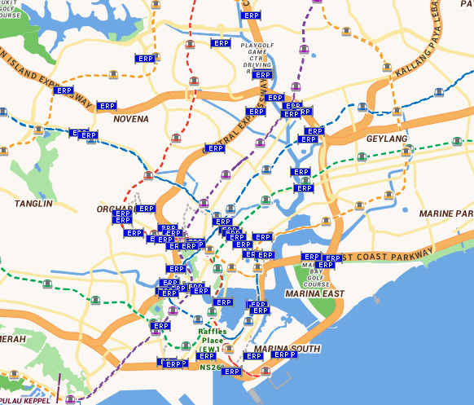
Locations of the ERP gantries
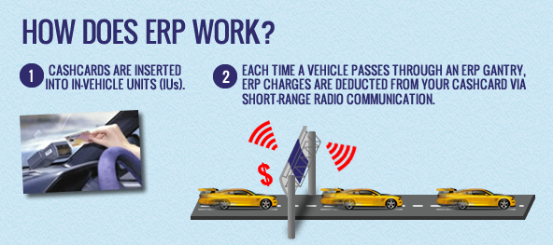
Communications between vehicles and gantries
Figure A. 1 The ERP system in Singapore.

London, UK
London suffers from the worst congestion in the UK and among the worst in Europe. The average travel speed within the central area was only around 15 km/h during the morning peak in 2002 (Transport for London, 2007). To reduce congestion by encouraging more travel by public and active transport as well as to raise funds for investing in London’s transport system, the London congestion charge was introduced in 2003 by Transport for London (TfL) (see Figure A. 2). To detect vehicle movements and allow for communications, cameras with automatic licence plate recognition technology is employed. Traffic signs at all entry points to the charging zone show where the charge applies. A limitation is that a once-a-day charge allows an unlimited number of passages through the charging zone without considering the actual distance travelled. The charge being fixed rather than varying based on time of day highlights that the system does not realise its full potential (unlike the ERP system in Singapore).
The London congestion charge has a few considerations for addressing the equity concern:
- Residents within the charging zone are entitled to a 90 per cent discount.
- Qualified low emission vehicles can receive a 100 per cent discount.
Due to a range of exemptions and discounts, the charge affects a limited number of people. Only half of cars paid the full charge in 2007, while 30-40 per cent paid no charge and around 10 per cent enjoyed the 90 per cent discount (Evans, 2008). The resident and low emission discounts are not reported as a problem. Rather, private hire vehicles like Uber and London licenced taxis are exempt from the charge creating unintended congestion and affecting the effectiveness of the system. This highlights the importance of decision making on exemptions and discounts. Currently, exemptions also apply to some other vehicle types including motorcycles, emergency vehicles, registered buses, and people with mobility impairments.
The initial setting-up costs of the London congestion charge amounted to around £162 million in 2003. The generated revenues (£249.6 million) and system operating costs (£85.7 million) in the 2016/17 financial year generated a substantial amount of revenues for TfL (Evans, 2007, Transport for London, 2017). By law, net revenues from the congestion charge are spent on further improving transport across London.
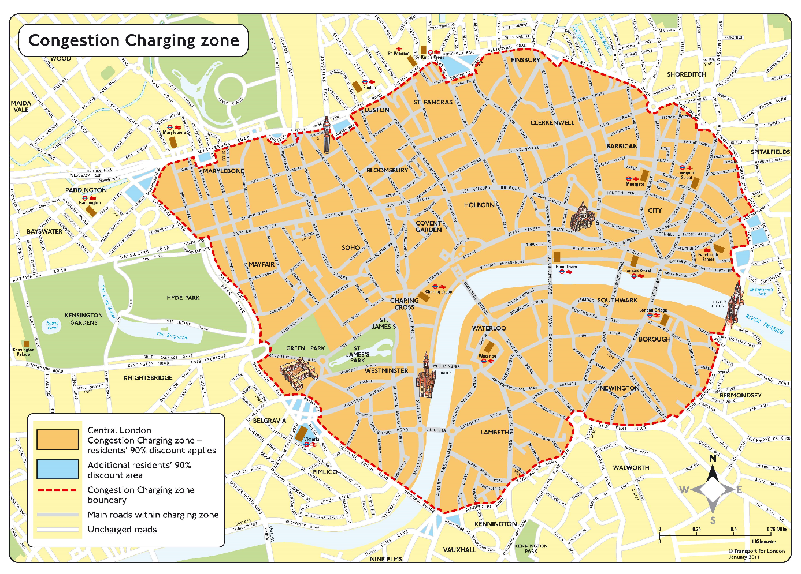
Figure A. 2 The congestion charge in London.

Stockholm, Sweden
Due to rapid population growth, increasing trip lengths, rising car ownership and a constrained number of road corridors as a result of the city’s geography, congestion in Stockholm stays at a relatively high level compared with its moderate size. Between January and July 2006, a congestion charging trial was launched to tackle the increasing level of congestion in central Stockholm, in addition to the environmental objective. The trial was initially meant to consist of a charge only, but was later complemented by a public transport investment including several new bus lines, additional capacity on commuter trains and subways, and more park-and-ride facilities. Because the public gradually became supportive of the charge during the trial as a result of various positive outcomes (see Table 4), it was reintroduced on a permanent basis in 2007 following a referendum (see Figure A. 3).
18 control points along the boundary of the cordon area employ automatic camera identification to monitor vehicle entries and exits. Compared with London’s flat charge, the time-of-day pay-per-entry charge in Stockholm is more equitable for users and more efficient for congestion reduction, because a time-dependent charge that responds to the changing travel conditions avoids overcharging or undercharging users (see our previous discussion on the London congestion charge).
Exempt traffic currently account for about 15 per cent of all traffic (Eliasson, 2014). Exemptions have varied over time such as for taxis and alternative fuel cars which are no longer exempt, and are currently granted for buses over 14 tonnes, emergency vehicles, diplomatic vehicles, foreign-registered vehicles, motorcycles, and people with mobility impairments.
The total start-up costs of Stockholm’s congestion charge were approximately 1.9 billion Swedish kronor including the operating costs for the first year. The estimated annual operating costs are about 220 million Swedish kronor. The revenues in 2013 were around 850 million Swedish kronor, generating a substantial amount of revenues for the Stockholm Government. The revenues are earmarked for road investments in an agreement between the City of Stockholm and the national government (Eliasson, 2014).
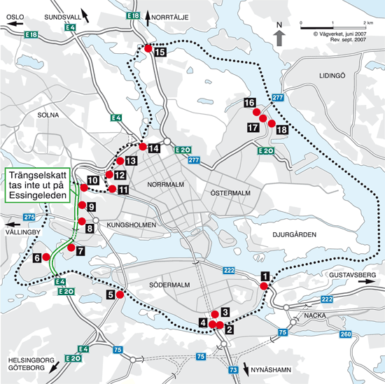
Figure A. 3 The congestion charge in Stockholm.

Milan, Italy
Although having an extensive public transport system, Milan used to be a highly auto-dependent city. In 2006-07, 75 per cent of daily trips in the Lombardy region (Milan being the capital) were made by private vehicles while only 14 per cent were by public transport. This made Milan a city with the third-highest concentration of particle matter among large European cities (Percoco, 2013). Since traffic emissions are mainly responsible for the poor air quality in Milan, a pollution charge called Ecopass was introduced in the city centre in 2008 aiming to reduce PM₁₀ concentrations. A total of 43 access points to the cordon area were set with the help of surveillance cameras. While the system was effective in reducing both emissions and congestion in the first year, its effectiveness in reducing congestion progressively decreased as new, cleaner vehicles substituted the older, more polluting ones. As a result charged vehicles accounted for only 10 per cent of all vehicles entering the cordon area in 2011 (Croci, 2016).
In 2012, Ecopass was replaced by Area C (see Figure A. 4). The main objective was to reduce road congestion. To maintain environmental quality in the city centre, “Euro 0” petrol vehicles and “Euro 0, 1, 2, 3” diesel vehicles (i.e. high emission vehicles) with a length of more than 75 metres are forbidden from entering the cordon area. Exempt traffic currently includes buses, taxis, emergency vehicles, utility vehicles, motorcycles, EVs, and people with mobility impairments. Residents within the cordon area are entitled to 40 free accesses per year after which any access will cost a discounted €2 (AU$3).
The initial set-up costs of the Ecopass amounted to about €7 million in 2008. The annual operating costs of both the Ecopass and the Area C were about €14 million. The current annual revenues were reported to reach about €30 million for improving public transport services (Croci, 2016).
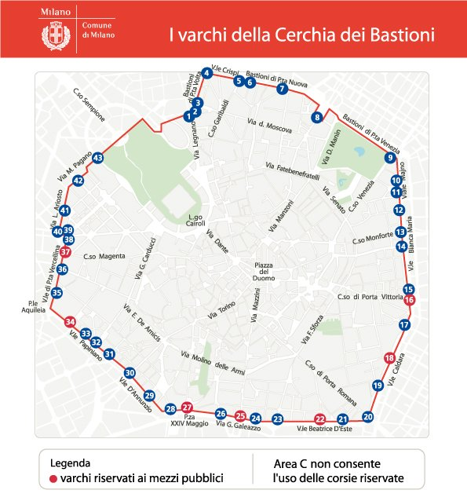
Figure A. 4 The Area C in Milan.

Oregon, USA
Oregon as a road finance pioneer was the first state in the USA to enact a fuel tax. Fuel tax-generated revenues have been declining in Oregon primarily due to increase in vehicles’ fuel efficiency. Several attempts so far have been made to increase the state fuel tax, but all failed. In July 2001, the Oregon Legislative Assembly passed authorising a Road User Fee Task Force aiming to design a new fair revenue collection strategy that could replace the fuel tax with a long-term, stable source of funding for transportation projects.
There were two trials conducted in 2007 and 2012. During the first trial, a fee of 1.2 cents per mile was adopted to replace the fuel tax. To study the feasibility of using the system to collect congestion charges, a higher 10 cents per mile for rush hour travel was also tested (see Figure A. 5). The trials were followed by the introduction of the program in 2013, which is currently under the name of OReGo as a state-wide distance-based charge. The rate is set as 1.5 cents per mile in 2017, but will increase to 1.7 in 2018 to coincide with the state’s fuel tax increase from 30 to 34 cents per gallon. The first phase of OReGo is limited to 5,000 cars and light-duty commercial vehicles. In response to the privacy concern expressed during the pilot program, different mileage reporting options/technologies are currently offered from which opt-in users to the system can choose based on their preferences.
In 2003, the Oregon Department of Transportation estimated the cost of implementation at roughly US$33 million including initial set-up and other capital costs. The annual operational costs to administer the mileage fee were estimated at approximately US$1.6 million, which only represented a small fraction of the possible revenues (Whitty, 2007). The State Government believed that the net revenues could serve as a reliable source to fund transportation projects for all Oregonians.
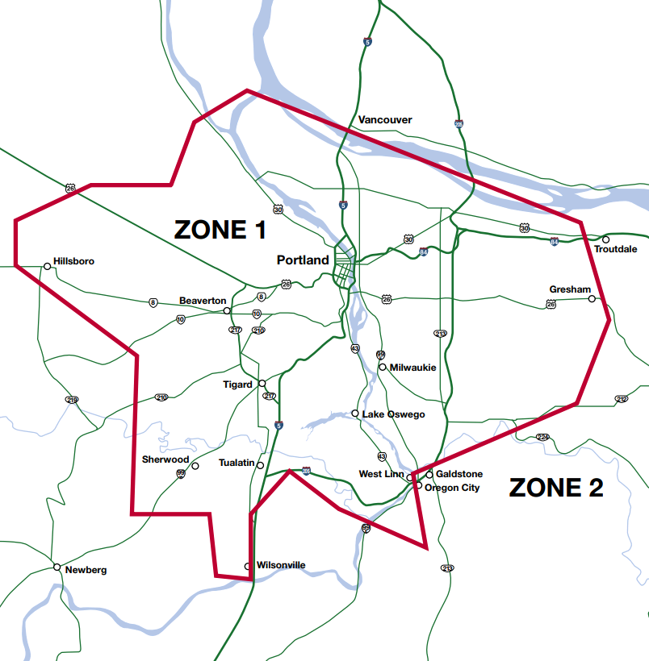
Figure A. 5 The road user charge pilot program in Oregon (Whitty, 2007).

Appendix B. Details of not adopted road user pricing

New York, USA
Despite having extensive toll roads and one of the largest public transport systems in the world, New York has retained a heavy demand for auto-dependent travel resulting in severe road congestion. Under these circumstances, a congestion charge (see Figure B. 1) as part of a long-term urban land use plan called PlaNYC (Schaller, 2010) was proposed as the first area-based pricing for a major North American city. Extensive discussion and promotion of congestion pricing was carried out among public advocacy groups. Political support was provided through Mayor Michael Bloomberg. The original plan was later expanded and released in 2007 in which the congestion price attracted the most attention. The proposal was introduced to the state legislature and evaluated by a newly established Traffic Congestion Mitigation Commission. Despite several changes to the proposal based on public opinion, the congestion price was not adopted due to strong opposition from several boroughs outside Manhattan. The strongest opposition came from highly auto-dependent parts of Queens and Brooklyn, areas that also had the poorest public transport access.
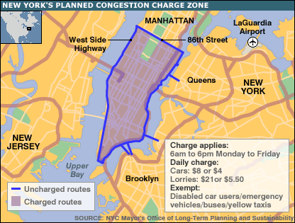
Figure B. 1 The proposed congestion charge in New York.

Hong Kong
Due to the increasing number of registered vehicles in the 1970s unaccompanied by road infrastructure expansion, congestion in Hong Kong became increasingly severe. Given that the average daily traffic composition in central Hong Kong during the morning peak was dominated by private cars and taxis, the ERP system was introduced in Hong Kong in 1983 and trialled from July 1983 to March 1985, thereby making Hong Kong the first region in the world to test the technical, economic, and administrative viability of the ERP system (Hau, 1990). The ERP system was not adopted on a permanent basis due to a variety of reasons (see Table 5).

Edinburgh, UK
Edinburgh is the capital city of Scotland attracting a large number of commuter trips from neighbouring regions due to its role as a major employment centre. In 2004, the City of Edinburgh Council launched a new transport strategy in which the most influential proposals were to reintroduce trams and to introduce road user pricing. Without a congestion price and improved public transport services, urban traffic and congestion were expected to increase to unacceptably high levels (50 per cent and 180 per cent respectively within 20 years) (Gorman et al., 2008). Proposed as a means of slowing down the traffic growth and raising revenues for public transport investment, the Edinburgh congestion charge consisted of an inner cordon and an outer cordon (see Figure B. 2). While only inbound trips were to be charged, residents living outside the outer cordon were to be exempt from the outer cordon charge (not the inner cordon charge). In 2005, a postal referendum was held on the charge which was opposed by 74 per cent of those who voted (see Table 5 for a variety of reasons).
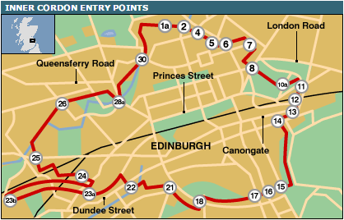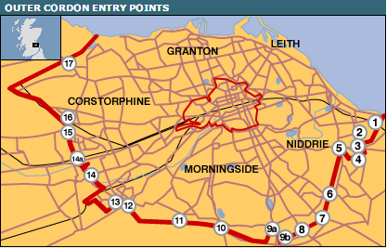
Figure B. 2 The proposed congestion charge in Edinburgh.

Greater Manchester, UK
The Greater Manchester congestion charge was part of a proposal to the Greater Manchester Transportation Innovation Fund (TIF) focusing on congestion reduction and revenue generation for improving public transport. The proposal aimed to implement the largest congestion charge in the world, covering an area of about 210 km² and consisting of two cordons: an outer ring roughly cordoning off the entire conurbation comprising the Greater Manchester urban area and an inner ring surrounding the city centre (see Figure B. 3). In 2008, a public referendum was held in Greater Manchester during which all of the 10 involved local councils opposed the charged by large majorities (Hepburn, 2014).
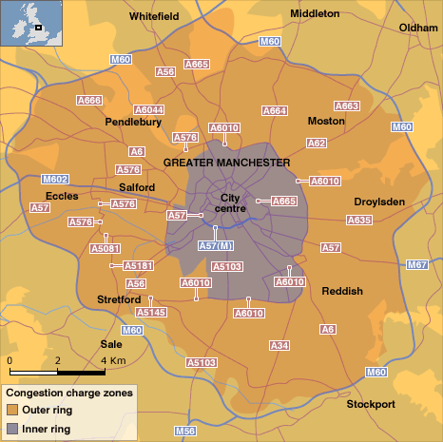
Figure B. 3 The proposed congestion charge in Greater Manchester.

References
Australian Government Productivity Commission. 2007. Road and Rail Freight Infrastructure Pricing.
Bhatt, K., Higgins, T. & Berg, J. T. 2008. Lessons learned from international experience in congestion pricing. Washington, DC: FHWA-HOP-08-047, US Department of Transportation, FHWA.
Bureau of Infrastructure, Transport and Regional Economics. 2015a. Australian Infrastructure Statistics: Yearbook 2015.
Bureau of Infrastructure, Transport and Regional Economics. 2015b. Traffic and congestion cost trends for Australian capital cities.
Christin, T., Hug, S. & Sciarini, P. 2002. Interests and information in referendum voting: An analysis of Swiss voters. European Journal of Political Research, 41, 759-776.
City of Melbourne. 2012. Transport Strategy 2012: Planning for future growth.
City of Melbourne. 2016. Future Melbourne 2026.
City of Melbourne. 2017a. Analysis of the Victorian Integrated Survey of Travel and Activity.
City of Melbourne. 2017b. Daily Population Estimates and Forecasts.
City of Melbourne. 2017c. Summary of the ABS Journey to Work Data, 2011.
Croci, E. 2016. Urban Road Pricing: A Comparative Study on the Experiences of London, Stockholm and Milan. Transportation Research Procedia, 14, 253-262.
De Borger, B. & Proost, S. 2012. A political economy model of road pricing. Journal of Urban Economics, 71, 79-92.
Department of Economic, Development, Jobs, Transport and Resources. 2016. Victorian Integrated Survey of Travel and Activity (VISTA) 2016.
Department of Infrastructure and Regional Development. 2016. The Australian Governments's Response to Infrastructure Australia's Australian Infrastructure Plan.
Department of the Environment and Energy. 2016. Australia's emissions projections 2016.
Eliasson, J. 2014. The Stockholm congestion charges: an overview. Centre for Transport Studies (CTS) Working Paper 2014: 7, KTH Royal Institute of Technology.
Evans, R. 2007. Central London congestion charging scheme: ex-post evaluation of the quantified impacts of the original scheme. Transport for London, UK.
Evans, R. 2008. Demand Elasticities for Car Trips to Central London as revealed by the Central London Congestion Charge. Transport for London, UK.
Gorman, D., Higgins, M. & Muirie, J. 2008. The Edinburgh congestion charging proposals: The devil in the detail. Public Health, 122, 1188-1190.
Gu, Z., Liu, Z., Cheng, Q. & Saberi, M. 2018. Congestion pricing practices and public acceptance: A review of evidence. Case Studies on Transport Policy.
Hau, T. D. 1990. Electronic road pricing: developments in Hong Kong 1983-1989. Journal of Transport Economics and Policy, 203-214.
Hensher, D. & Li, Z. 2013. Referendum voting in road pricing reform: a review of the evidence. Transport Policy, 25, 186-197.
Hepburn, P. 2014. Local Democracy in a Digital Age: Lessons for Local Government from the Manchester Congestion Charge Referendum. Local Government Studies, 40, 82-101.
Infrastructure Victoria. 2016a. All Things Considered: Exploring options for Victoria's 30-year infrastructure strategy.
Infrastructure Victoria. 2016b. The Road Ahead: How an efficient, fair and sustainable pricing regime can help tackle congestion.
Infrastructure Victoria. 2016c. Victoria's 30-Year Infrastructure Strategy.
Jones, P. & Hervik, A. 1992. Restraining car traffic in European cities: an emerging role for road pricing. Transportation Research Part A: Policy and Practice, 26, 133-145.
Knight, F. H. 1924. Some fallacies in the interpretation of social cost. Quarterly Journal of Economics, 582-606.
KPMG. 2016. Preliminary Demand Modelling and Economic Appraisal.
Liu, Z., Meng, Q. & Wang, S. 2013. Speed-based toll design for cordon-based congestion pricing scheme. Transportation Research Part C: Emerging Technologies, 31, 83-98.
Liu, Z., Wang, S. & Meng, Q. 2014. Optimal joint distance and time toll for cordon-based congestion pricing. Transportation Research Part B: Methodological, 69, 81-97.
May, A. D. & Milne, D. S. 2000. Effects of alternative road pricing systems on network performance. Transportation Research Part A: Policy and Practice, 34, 407-436.
Percoco, M. 2013. Is road pricing effective in abating pollution? Evidence from Milan. Transportation Research Part D: Transport and Environment, 25, 112-118.
Pigou, A. C. 1920. The Economics of Welfare, London, MacMillan.
Rye, T., Gaunt, M. & Ison, S. 2008. Edinburgh's congestion charging plans: an analysis of reasons for non-implementation. Transportation Planning and Technology, 31, 641-661.
Santos, G. 2005. Urban congestion charging: a comparison between London and Singapore. Transport Reviews, 25, 511-534.
Schaller, B. 2010. New York City’s congestion pricing experience and implications for road pricing acceptance in the United States. Transport Policy, 17, 266-273.
Sheffi, Y. 1985. Urban Transportation Network: Equilibrium Analysis with Mathematical Programming Methods, Englewood Cliffs, NJ, Prentice-Hall, Inc.
Small, K. A. & Gómez-Ibáñez, J. A. 1997. Road pricing for congestion management: the transition from theory to policy. In: BUTTON, K. J. & VERHOEF, E. T. (eds.) Road Pricing, Traffic Congestion and the Environment: Issues of Efficiency and Social Feasibility. Cheltenham: Edward Elgar.
Terrill, M., Batrouney, H., Etherington, S. & Parsonage, H. 2017. Stuck in traffic? Road congestion in Sydney and Melbourne. Grattan Institute Report No. 2017-10.
Terrill, M. & Emslie, O. 2016. Road user charging belongs on the political agenda as the best answer for congestion management. Grattan Institute.
Transport for London. 2007. Central London congestion charging impacts monitoring: Fifth annual report.
Transport for London. 2017. Annual Report and Statement of Accounts.
Transurban. 2016. Changed Conditions Ahead: The Transport Revolution and What it Means for Australians. Melbourne, Australia.
Victorian Department of Environment, Land, Water and Planning. 2016a. Plan Melbourne 2017-2050.
Victorian Department of Environment, Land, Water and Planning. 2016b. Victoria in Future 2016.
Victorian Department of Environment, Land, Water and Planning. 2017. Melbourne Planning Scheme.
Victorian Government. 2017. Victorian Infrastructure Plan.
Whitty, J. M. 2007. Oregon's Mileage Fee Concept and Road User Fee Pilot Program. Oregon Department of Transportation, USA.
Yang, H. & Huang, H. 2005. Mathematical and economic theory of road pricing, Oxford, Elsevier.

Source: http://www.budget.gov.au/2009-10/content/glossy/infrastructure/download/infrastructure_overview.pdf.
Source: VicRoads Traffic Monitor 2013-14.
Source: Public Transport Victoria 2013-16.
Off-street parking levy in inner Melbourne imposed by the State Government.
See https://www.ato.gov.au/Business/Excise-and-excise-equivalent-goods/Fuel-excise/Excise-rates-for-fuel/ for current fuel excise rates.
Source: http://www.sro.vic.gov.au/car-parks.
Source: https://www.ptv.vic.gov.au/getting-around/maps/.
See https://www.ntc.gov.au/heavy-vehicles/heavy-vehicle-charges/.
More information can be found in the City of Melbourne discussion paper on emerging transport technologies. Also refer to the seminar held in Melbourne in August 2017 by the Institute for Sensible Transport on disruptive transport innovation and road user pricing. Source: https://sensibletransport.org.au/seminar/.
More discussion about pricing options and their practical applications will be provided in Sections 3 and 4.
See http://www.myorego.org.
See http://www.myorego.org.
See the seminar held in Melbourne in August 2017 by the Institute for Sensible Transport on disruptive transport innovation and road user pricing. Source: https://sensibletransport.org.au/seminar/.
An example is the London congestion charge discussed in Appendix A.
Latest ERP rates can be found at https://www.onemotoring.com.sg/content/onemotoring/en/on_the_roads/ERP_Rates.html.
See https://www.comune.milano.it/dseserver/webcity/comunicati.nsf/weball/077F561DB4A21D98C125752F004CDE33 for charges applied to different types of vehicles.
See https://www.theguardian.com/politics/2008/dec/12/congestioncharging-transport.
See http://transportinfrastructurecouncil.gov.au/publications/heavy_vehicle_road_reform.aspx.
See https://www.racv.com.au/membership/member-benefits/royalauto/motoring/information-and-advice/help-shape-the-future-of-victorias-transport.html.
See http://www.primemovermag.com.au/news/article/freight-focus-group-supports-road-pricing-change.
For example, due to fewer and shorter vehicle trips in inner Melbourne, more lanes could be allocated for public and active transport use such as dedicated bus lanes, separated cycling corridors, and footpaths.
See the City of Melbourne discussion paper on emerging transport technologies.
If congestion increases above a threshold, the price can be set higher; if congestion decreases below the threshold, the price can be set lower.
See http://www.ifaq.gov.sg/mot/apps/fcd_faqmain.aspx#FAQ_1697.
Source: https://www.onemotoring.com.sg/content/onemotoring/en/imap.html?param=redirect.
Source: https://www.lta.gov.sg/content/ltaweb/en/roads-and-motoring/managing-traffic-and-congestion/electronic-road-pricing-erp.html.
Source: https://tfl.gov.uk/modes/driving/congestion-charge/congestion-charge-zone.
Source: http://roadpricing.blogspot.com.au/2012/09/stockholm-congestion-pricing-has-had.html.
See http://www.isis-it.net/curacao/?content=cdemilan.
More information on the European emission standards for passenger cars can be found at https://www.dieselnet.com/standards/eu/ld.php.
Source: http://urbanaccessregulations.eu/countries-mainmenu-147/italy-mainmenu-81/milan-area-c-charging-scheme.
Source: http://news.bbc.co.uk/2/hi/americas/7335806.stm.
Source: http://news.bbc.co.uk/2/hi/uk_news/scotland/4287145.stm.
Source: http://news.bbc.co.uk/2/hi/uk_news/england/manchester/7778110.stm.

