Hardware Lane Streetscape Renewal Concept Plan Design
2018

Overview
This draft concept plan provides information about a proposed streetscape renewal for Hardware Lane, Melbourne.

Design Approach
We’re upgrading Hardware Lane to ensure it continues to be a vibrant, safe and accessible Melbourne laneway into the future.
We’ll do this by:

Upgrading the current road surface with varied bluestone paving treatment.
This will create defined zones for pedestrians, diners and vehicles while retaining the existing functions of the street.

Upgrading lighting to meet Australian Standards and enhance the character of Hardware lane and its buildings.

Removing declining trees (Robinia psuedoacacia ‘Frisia’) to allow a new generation of trees to be planted with optimal growing conditions.
Selected species will be consistent with the current street character.

Replacing drainage with increased capacity to meet current and future needs.

Images

Map of Hardware Lane between Bourke and Lonsdale Streets

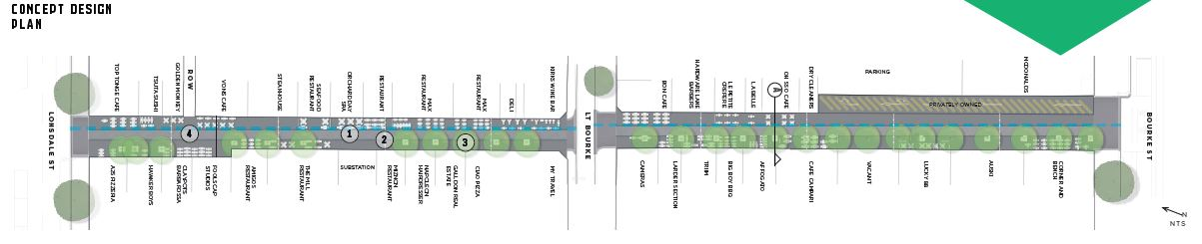

Cross section design of Hardware Lane showing proposed upgrades

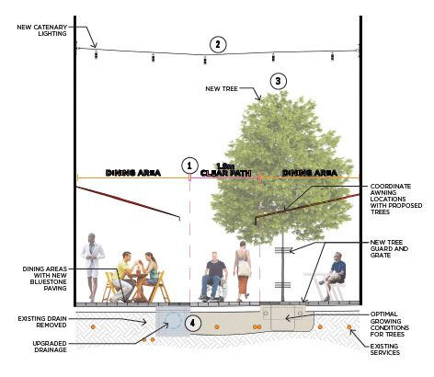

Photos of Hardware Lane
