Circular economy and Climate Change Scoping Study

What is a circular economy?
Melbourne, like cities across the world, operates within a global economic system, based on a linear “take – make – use – dispose” approach.
Rising population and concentration of economic activities increase the demands and pressures on urban infrastructure and government resources, as well as the consumption of resources. This leads to economic losses from structure waste and negative environmental impacts.
Most of the economic value in materials are lost in the linear economy, even when we recycle. This loss of material value is compounded through “structural waste”; when the things we make are under-utilised. For example, studies around the world consistently show that cars are parked a good 90% of the time, and in Europe the average office is used only 35–50% of the time, even during working hours. We can also consider the costs of congestion from ineffective urban mobility systems, and the cost of waste management and collection on municipal budgets.
Negative environmental impacts of the linear model in cities include air, water, and noise pollution, the release of toxic substances, and greenhouse gas emissions.

Principles of a circular economy
A circular economy keeps more value in products, components and materials and decouples growth from the consumption of finite resources by:
- designing out waste: designing goods to last longer and to be easily repaired, upgraded or used differently in future cycles, and actively managing negative externalities such as the release of toxic substances
- keeping materials in use: cycling products, components and materials at their highest value by sharing and reusing products, refurbishing and remanufacturing components, to preserve their useful function and the embodied energy used to make them, then returning materials to the economy through efficient recycling processes; cascading them into different, increasingly low-grade applications
- preserving and rebuilding natural capital: using less resources and opting for renewable or better-performing resources where possible; and enhancing natural capital by encouraging flows of nutrients within the system and creating the conditions for regeneration of, for example, soil.
In this alternative to a traditional linear economy, the maximum value is extracted from resources in use, then products and materials are recovered and regenerated at the end of each service life.
Value can be considered in different ways. Monetary value is a key driver to ensure that circular solutions are economically feasible, but value in terms of job creation, emissions reduction and social impact can also be considered, especially for the CoM, as it contributes to other parts of their goals and priorities. This reflects that many of the negative impacts of the linear economy are not currently reflected in pricing structures – that is, they are externalities. Local governments like the CoM bear the price of some of these impacts, through services such as environmental management, waste management, community health services and roads.
The different strategies for achieving ‘circularity’ are mapped out on the systems diagram in Figure 1.

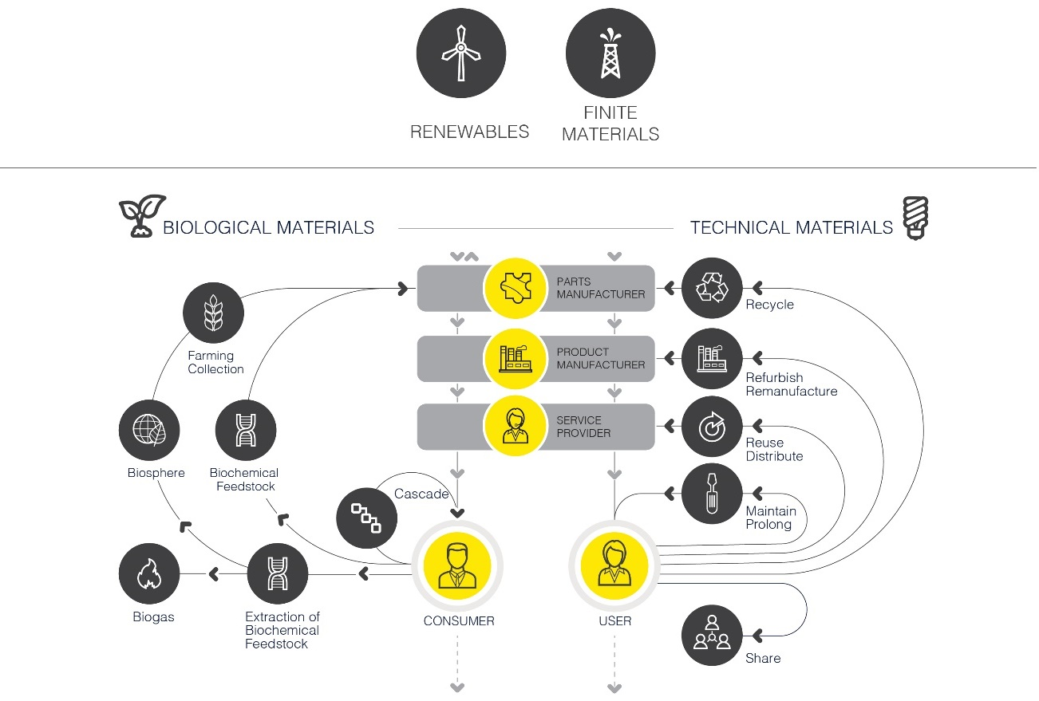
Figure 1 – Circular economy systems diagram, adapted from the Ellen MacArthur Foundation.

From materials to carbon emissions
In arguing for both resource efficiency across the life cycle of products and services, and the use of renewable resources, rather than finite, the circular economy can reduce carbon emissions through:
- improving energy use (efficiency) and increasing the part of renewables in the energy mix
- reducing the carbon emissions embedded in the materials circulating in the economy
- reducing carbon emissions related to waste management

Circular economy and cities
Much of the activity on circular economy focusses on the roles of and opportunities for business, and strategy/policy work at the national or regional level.
Cities have a crucial part to play in transitioning to a circular economy.
Cities consume 75% of natural resources globally (materials, energy, water). They produce 50% of global waste and 60-80% of greenhouse gas emissions (UNEP, 2012). Circularity in resource flows in cities can tackle the consumption of resources, such as energy, water, buildings and land.
Cities are concentrators of flows, linked to the high density of both business and consumers. The critical mass effect of this concentration is conducive to developing reverse operations at scale – goods can be brought back for repair, reuse, sharing or cascading more easily. This local looping can increase the self-sufficiency of cities; where consumption is usually much higher than the production of goods.
Land and buildings are also under-utilised in cities. In Melbourne alone over 82,000, or almost 5% of total housing stock was estimated to be vacant in 2014 (Prosper Australia Research Institute, 2016). There is huge scope to harness this ‘structural’ waste.
Cities can also be hotbeds of innovation through initiatives such as incubator spaces, maker labs or urban farming. Indeed, they can sometimes move faster than their national counterparts.
Systems integration, flexibility, intelligence, cooperative behaviour, localisation, recycling and renewable resources are the key concepts under-pinning the Circular City.
The Ellen MacArthur Foundation’s report “Cities in the Circular Economy: an initial exploration” sets the following vision for a circular city:
“A circular city embeds the principles of a circular economy across all its functions, establishing an urban system that is regenerative, accessible and abundant by design. These cities aim to eliminate the concept of waste, keep assets at their highest value at all times, and are enabled by digital technology. A circular city seeks to generate prosperity, increase liveability, and improve resilience for the city and its citizens, while aiming to decouple the creation of value from the consumption of finite resources.”

A circular city will likely include the following elements:
Built environment | Modular and flexible design using healthy materials that improve the life quality of the residents, and minimise virgin material use.  Efficient construction techniques.  Shared, flexible and modular office spaces and housing minimise “structural waste”.  Components of buildings are maintained and renewed as needed.  Buildings generate, rather than consume, power and food by facilitating closed loops of water, nutrients, materials, and energy.
Energy systems | Resilient, renewable, localised, distributed systems allow effective energy use, reducing costs with positive environmental impact.
Urban mobility system | Accessible, affordable, and effective.  Multi-modal mobility structure incorporates public transportation, with on-demand cars as a flexible last-mile solution.  Transportation is electric-powered, shared, and automated.  Remanufacturing, durability, efficiency and easy maintenance are central to vehicle design.
Urban bioeconomy | Nutrients are returned to the soil appropriately, while generating value and minimising food waste.  Nutrients are captured from the organic fraction of municipal solid waste and wastewater streams, and processed to be returned to the soil in forms such as fertiliser for urban and rural agriculture.  Urban farming enables Melbourne to supply some of its own food, reusing food waste and sewage in closed and local loops to produce vegetables, fruit, and fish. Electricity could be generated from wastewater, biofuels and biorefineries.  These offer additional revenue streams to the city, capitalising on the utilisation of material and nutrients that are already in use.
Production systems | ‘Local value loops’ mean more local production, and increased and more diverse exchanges of value in local economies.  Maker-labs (to encourage local production, repair, and distributive manufacturing), collective resource banks (to even out the demand and supply of materials) and digital applications (to broker the exchange of goods, materials, and services) feature in these local, circular production systems.

In a circular city:
- resources can be cycled between urban activities
- resources can be cycled within city regions
- cities can be designed so that land and infrastructure can be re-used/recycled over time

Who is working on this?
Most cities are approach energy and climate change from one angle, with circular economy initiatives coming out of recycling and waste management divisions. It is a challenge for cities to capture the benefits of implementing systemic, circular approaches.
The Ellen MacArthur Foundation launched a ‘circular cities network’ in 2016 with 12 members (invitation only peer referral scheme- see box). This network has not continued as the Foundation partnered with the C40 network in November 2017 to reach a larger number of cities. The list in the box gives a good indication of the cities that are actively exploring the concept.
Circle Economy also has a cities programme, using their ‘circle city scan’ methodology. The results for Amsterdam and Glasgow are publicly available.
London and Amsterdam are the only two cities with an articulated circular economy strategy. Summaries of these are provided in Appendix
Circular cities network
- Austin*
- Boulder
- Copenhagen*
- Ljubljana
- London*
- New York*
- Peterborough
- Phoenix
- Rio De Janeiro*
- Tel Aviv
- Toronto*
- Vancouver*
List accessed June 2017
www.ellenmacarthurfoundation.org/programmes/government/circular-cities-network
*also C40 members

Appendix A Typical circular city action areas
This first scoping piece of research identifies some ‘typical’ action areas under a circular economy approach for cities.
A key resource is the 2015 Ellen MacArthur report ‘Growth Within’ which analysed three of Europe’s largest basic needs, mobility, food and the built environment, to provide a vision of how the circular economy could look in each of these areas. Growth Within identified the following research areas for cities:
- Zero-waste cities
- Urban circular water system
- Urban circular material flows (urban mining/integration)
- Peri-urban nutrition for a city
- Shared mobility system in a city
- Roads to living space programme
Growth Within also identifies the following areas as possible city-related pilots:
Table 6 – Potential circular economy city pilots

Transport | Built Environment | Food
- Vehicle sharing  - Electric vehicles  - Automated vehicles  - Efficient/durable materials  - Vehicle take-back, maintenance, remanufacturing | - Industrial production and 3D printing.  - Improve energy efficiency and distributed production of renewable energy | - More resource-efficient agricultural practices using IT, big data, remote sensing, and satellite positioning data.  - Regenerative farming practices such as no-till and organic  - Closed loops of nutrients and other materials through digestion and composting  - Restoring degraded land for food production  - peri-urban and urban farming to meet the increasing demand for local, fresh, relatively unprocessed food  - Digital supply chains to reduce food waste

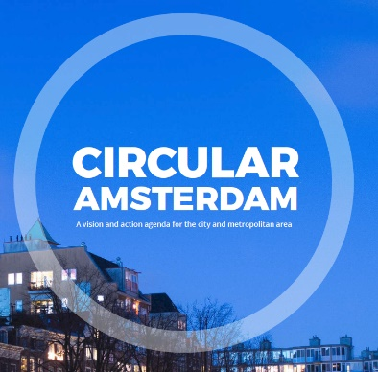

The City of Amsterdam has developed the following seven principles of the circular economy:
- All materials enter into an infinite technical or biological cycle.
- All energy comes from renewable sources.
- Resources are used to generate (financial or other) value.
- Modular and flexible design of products and production chains increase adaptability of systems.
- New business models for production, distribution and consumption enable the shift from possession of goods to (use of) services.
- Logistics systems shift to a more region oriented service with reverse-logistics capabilities.
- Human activities positively contribute to ecosystems, ecosystem services and the reconstruction of “natural capital”.
Through their ‘Circular Amsterdam’ programme, they aim to redesign twenty product or material chains. They evaluate that implementing material reuse strategies has the potential to create a value of €85 million per year within the construction sector and €150 million per year with more efficient organic residual streams. Amsterdam set up an innovation program on the circular economy; www.amsterdamsmartcity.com/circularamsterdam.
Amsterdam is issuing a Roadmap for Circular tendering for constructing sites. The Roadmap contains a thorough definition of circular construction and how you can measure the degree of circularity (quantitative and qualitative) with practical information how to design a circular tender. In late 2017 the municipality of Amsterdam will use the Roadmap for issuing building sites for houses and one non-housing site. The instrument will also be used for tenders on the field of transformation, renovation and demolition.
The ‘circular Amsterdam’ vision and action agenda details actions in the construction and organic residual chains:
Construction:
- Facilitating resource and material storage: allocating locations for the physical storage of building materials, and playing a facilitating role in drawing up the conditions that the materials must meet to qualify for storage and reuse.
- Stimulating high-value reuse: contributing to the development of procurement guidelines and building codes with specific requirements for high-value reuse, and being a launching customer for recycled and reused building materials.
- Stimulating material passports: capturing information on materials and processes used, and the possibilities for material reuse
Organic residual streams
- Virtual resource platform: develop and make publicly accessible digital (commercial) platforms for organic waste.
- Circular free zone bio-refinery: initiate circular free zones to take away certain (legislative) barriers that currently hinder innovation, such as the ban on the use of digestate on agricultural land.
- Launching customer: introduce criteria in its purchasing policy to stimulate locally produced grass, wood (as in street furniture) and food (catering).
The City of Amsterdam also has cross cutting programmes around circular business, energy and governance/collaboration.

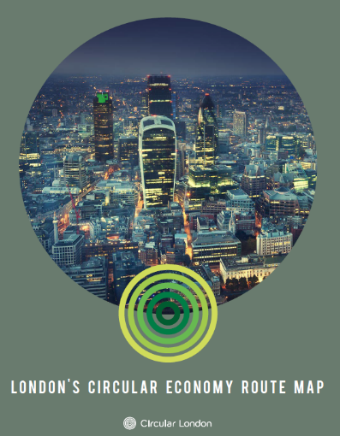

The Greater London Authority (GLA) and London Waste and Recycling Board (LWARB) have been working on a circular economy strategy for London since 2015, culminating in the publication of a circular economy routemap in June 2017.
Their Towards a circular economy (LWARB, December 2015) report set out the context and opportunities for a London circular economy route map, identifying five initial focus areas for action: built environment, food, textiles, electricals and plastics.
Employment and the circular economy – job creation through resource efficiency in London (WRAP, December 2015) describes how taking a circular economy approach has the potential to create new jobs in London. The report states that the capital could benefit from 40,000 gross jobs and 12,000 new jobs.
The Circular Economy route map (LWARB, June 2017) details cross cutting themes and actions
Cross-cutting themes:
- Communications including case studies, ambassadors
- Collaboration across supply chains, and between business-research-policy makers
- Policy, including linkages to zero carbon city ambition
- Procurement and market development: public sector procurement and leveraging private sector buying power
- Finance: supporting development and growth of circular economy SMEs through incubation/acceleration, venture capital and private equity funds.
- Business support through ‘Advance London’ business support programme and start-up accelerator programmes
- Demonstration projects and business model pilots
- Innovation through accelerators and incubators and links to education
Actions:
- Built environment: circular economy design, managing building materials, operation of buildings
- Food: preventing avoidable food waste (household & organisational), Valuing food waste and food surplus, maximising use of urban space for food growing
- Textiles: design, embedding circular economy into the textile supply chain, re-use and recycling
- Electricals: design, extending the life of products, effective collection and recycling
- Plastics

Ellen MacArthur Foundation, SUN and McKinsey Center for Business and Environment, Growth Within: a circular economy vision for a competitive Europe (2015)

