

Market Street Road Section

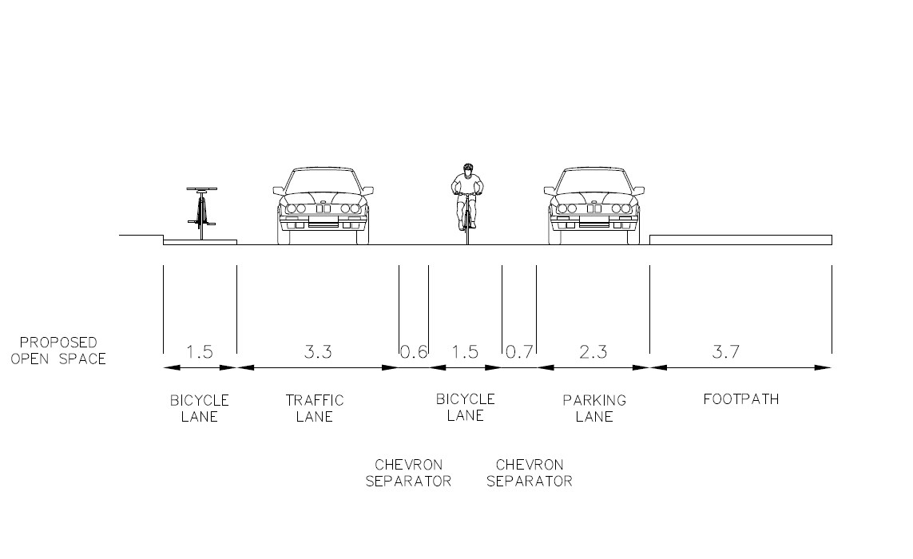

Market Street will be reduced in size to create the new park. It will accommodate single direction southbound traffic only.

It will include:

* A new path network linking Flinders Lane and Collins Street, providing clear visual and pedestrian connection.
* New mid-block pedestrian crossing
* Two new bicycle lanes separated from vehicle traffic.
* New lighting, trees and gardens.

**SOUTHBOUND TRAFFIC**

