Market Street Park Concept

We are creating the first urban park in the central city since City Square was developed in 1980. The new park, located on Market Street, will create 1900 square metres of new public open space in the central city.
The new park, designed by Oculus, features large lawn areas to accommodate park users, wide bluestone paths, new seating, space for programmed events and improved pedestrian access to public transport. The new park will also feature a wide variety of trees and water sensitive urban design to reduce stormwater runoff.
The project includes a discontinuance of more than 1300 square metres of Market Street to be developed as public open space, including new bicycle lanes and parking.
The abutting development site ‘Collins Arch’ has been designed in collaboration with Cbus Property, Woods Bagot and New York City-based SHoP Architects. It will include a collection of residences, commercial offices and a 5-star hotel, W Melbourne.
Key features of the project include the creation of a new north-south oriented public park in the western section of Market Street and will include:
- city garden and lawns
- playful terrace
- new separated north and southbound bicycle lanes
- central plaza connection from Market Street
- reconfiguration of Market Street to southbound traffic only
The project is expected to be completed in 2020. It is guided by the City of Melbourne’s Open Space Strategy and Urban Forest Strategy.
Explore the concept plan and tell us what you think of the new park: participate.melbourne.vic.gov.au/market-street
Community consultation is open from 19 September to 10 October.

Collins Street / Market Street Interface  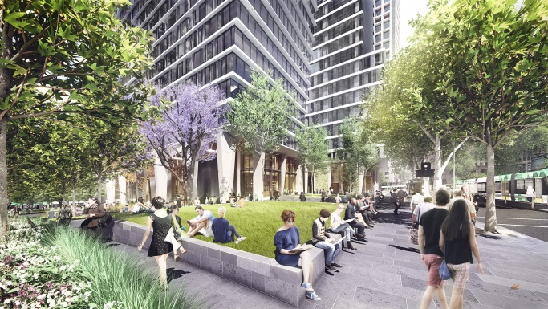 | This area will feature:  - Large open lawn space with trees, seating walls and lawn  - Improved pedestrian crossing to Collins Street tram stop  - A new City of Melbourne public toilet
Northern Lawn / Collins Street  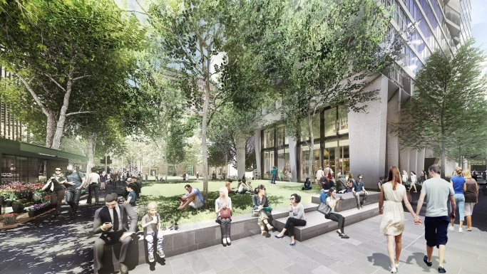 | This area will include:  - A new north-facing lawn and garden area with seating walls to provide a place to eat lunch, rest and relax  - Retention of the Collins Street London Plane trees and new tree planting
Playful Terrace  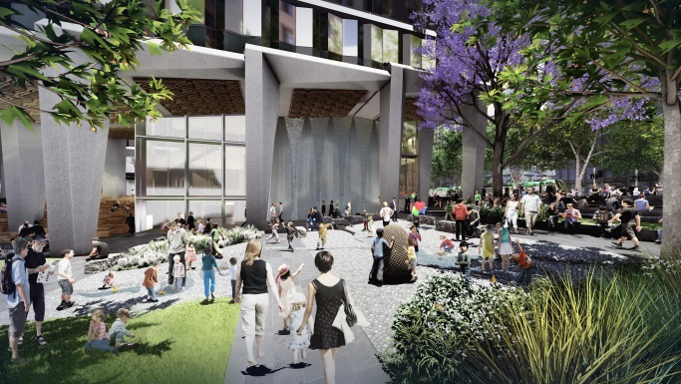 | Playful Terrace  This area features:  - Integrated water-play elements  - Path network and sensory garden spaces which encourage nature-based play  - Deciduous trees for shade in summer and access to winter sun
Central Plaza  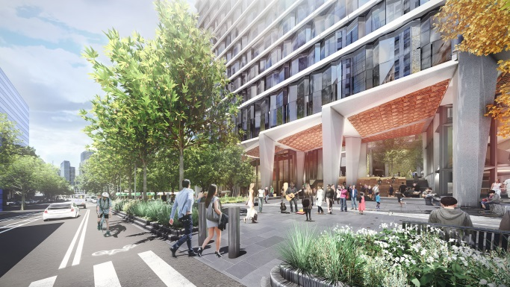 | This area features:  - Central plaza  - Market Street connection and pedestrian crossing  - Seating areas  - Opportunities for programmed events
City Garden  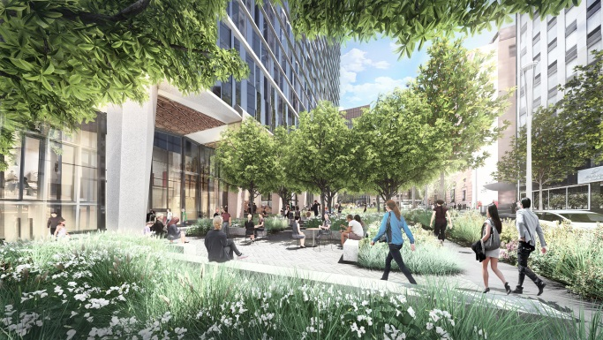 | This area features:  - Garden spaces and shade trees  - Seating walls and edges for rest  - Extensive horticulture and trees
Market Street  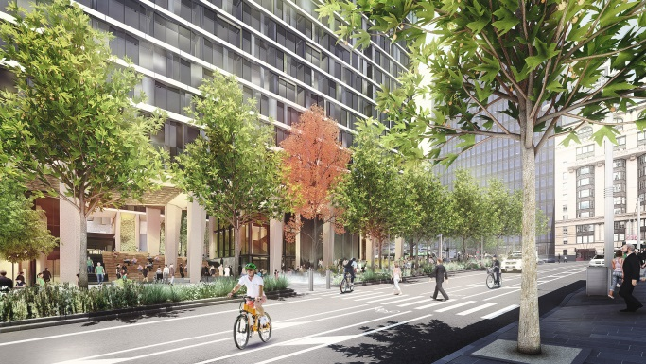 | Market Street will be reduced in size to create the new park. It will accommodate single direction southbound traffic only and:  - A new path network linking Flinders Lane and Collins Street, providing clear visual and pedestrian connection  - New mid-block pedestrian crossing  - Two new bicycle lanes separated from vehicle traffic  - New lighting, trees and gardens

