
Climate Change Mitigation Strategy to 2050
Melbourne together for 1.5°C
Draft 21 August 2018
Acknowledgement of Traditional Owners
The City of Melbourne respectfully acknowledges the Traditional Custodians of the Land.
For the Woiwurrung (Wurundjeri), Boonwurrung, Taungurong, Dja Dja Wurrung and the Wathaurung groups who form the Kulin Nation, Melbourne has always been an important meeting place for events of social, educational, sporting and cultural significance.
Today the City of Melbourne is proud to say that Melbourne is a significant gathering place for all Aboriginal and Torres Strait Islander people.
Acknowledgements
The City of Melbourne would like to acknowledge the generous funding from Bloomberg Philanthropies, the support of the C40 Climate Action Planning Pilot Program and the cities that participated in the program.
Many people contributed their time and expertise to the development of this draft strategy. Thank you to the members of the external reference group, community, government and business representatives, expert consultants, City of Melbourne councillors and staff. The City of Melbourne would also like to thank the representatives from the many local and international cities who have peer-reviewed our progress to date and who continue to collaborate on solutions.
This draft strategy is one of a suite adopted in conjunction with the Council Plan and should be read as consistent with the overall vision and outcomes of the Council Plan. Note that any specific actions or initiatives outlined in this strategy are not binding upon the City of Melbourne but will inform its planning and resourcing considerations and may endorsed as part of its Annual Plan and Budget.
Contents
Abbreviations 5
Glossary 5
Executive Summary 6
1. Introduction 12
1.1 How can we work together to reduce greenhouse gas emissions? 12
1.2 Melbourne’s emissions profile 13
1.3 Why we need a new approach 14
Zero net emissions by 2020 14
C40 Climate Action Planning Framework 15
1.4 A low carbon, circular economy 15
2. Taking bold action together 17
2.1 City of Melbourne’s role 17
2.2 Australian and Victorian climate change policy 17
2.3 Proposed emission reduction targets 19
3. Strategic priorities 22
3.1 Priority 1: 100 per cent renewable energy 23
The story so far 23
Challenges 23
Strategic opportunities 23
The environmental, social and economic benefits of taking action 24
Proposed actions 26
3.2 Priority 2: Zero emissions buildings and precincts 27
The story so far 27
Challenges 27
Strategic opportunities 28
The environmental, social and economic benefits of taking action 28
Proposed actions 30
3.3 Priority 3: Zero emissions transport 31
The story so far 31
Challenges 31
Strategic opportunities 32
The environmental, social and economic benefits of taking action 32
Proposed actions 34
3.4 Priority 4: Reducing the impact of waste 35
The story so far 35
Challenges 35
Strategic opportunities 36
The environmental, social and economic benefits of taking action 36
Proposed actions 38
4. How we will implement the strategy 39
4.1 Consider climate adaptation and mitigation in an integrated way 39
Integrating climate adaptation and mitigation actions 40
4.2 Social inclusion and community participation 40
Health benefits 40
4.3 Innovation, knowledge and transparency 41
Developing and sharing new solutions 41
4.4 Measuring, reporting and evaluating progress 42
5. List of proposed actions 43
References 45
Appendix A: Technical notes 46
Melbourne’s greenhouse gas emissions profile 46
Calculating costs and benefits 47
Appendix B: Long alternative text descriptions 48
Figure 1 and Figure 6 Emissions reductions needed under each scenario 48
Figure 2 and Figure 7 Significant emission reduction scenario 2020–2050 48

Abbreviations
Term | Definition
C40 | C40 is a network of the world’s megacities committed to addressing climate change. C40 supports cities to collaborate effectively, share knowledge and drive meaningful, measurable and sustainable action on climate change.
GBCA | Green Building Council of Australia
ICLEI | International Council for Local Environment Initiatives
IPCC | Intergovernmental Panel on Climate Change
NABERS | National Australian Built Environment Rating System
UNFCCC | United Nations Framework Convention on Climate Change
ZNE | Zero Net Emissions

Glossary
Term | Definition
Carbon offsets | Carbon offsets are tradeable units that represent abatement of greenhouse gas emissions. Offsets represent the rights to a greenhouse gas reduction, and the carbon offsets purchased are retired through a registered third party so they cannot be counted twice.
Carbon neutral | Being carbon neutral means that the net greenhouse gas emissions associated with an organisation’s or city’s, activities are equal to zero. It is achieved through a combination of measuring and reducing greenhouse gas emissions and purchasing of carbon offsets. The terms zero net emissions and carbon neutral can be used interchangeably.
Emissions | This term is used interchangeably with greenhouse gas emissions in this context unless specifically stated that it relates to air quality pollutants.
Greenhouse gas emissions | The greenhouse gas emissions from human activities that cause climate change: carbon dioxide (CO₂), methane (CH₄), nitrous oxide (N₂O), ozone (O₃), and synthetic gases, such as chlorofluorocarbons (CFCs) and hydrofluorocarbons (HFCs).
Paris Climate Agreement | The Paris Climate Agreement entered into force on 4 November 2016. The Paris Agreement is made under the United Nations Framework Convention on Climate Change (Climate Change Convention, also referred to as the UNFCCC). Australia announced its ratification of the Paris Agreement on 10 November 2016. Its stated goal is to limit the increase in the global average temperature to ‘well below 2°C’ above pre industrial levels, that we should ‘pursue efforts’ to limit the temperature increase to 1.5°C (Article 2). In addition, parties are aiming to peak global greenhouse gas emissions ‘as soon as possible’ (Article 4). According to the Intergovernmental Panel on Climate Change (IPCC), global warming of more than 2°C would have serious consequences, such as an increase in the number of extreme weather events
Science-based targets | The amount of emissions that need to be reduced to avoid the 1.5°C increase in global average temperatures as recommended by the IPCC and referred to in the Paris Climate Agreement.
Zero emissions or Zero net emissions | The net greenhouse gas emissions associated with an organisation’s or city’s activities are equal to zero.

Executive Summary
Local action, global leadership
The global role of cities in stepping up to act on climate change was recognised in the 2015 Paris Climate Agreement. Since that time, national and state governments, cities, investors, businesses and communities have begun to take action to reduce greenhouse gas emissions to help avoid a global average temperature rise of 1.5ºC.
In 2016, the City of Melbourne hosted the Future Melbourne deliberative democracy process to develop a community vision and set priorities for the city. Reducing greenhouse gas emissions from the municipality was identified as a top priority and this is reflected in our Council Plan 2017–2021. This view is shared across Victoria: 80 per cent of people are willing to act on climate change and 87 per cent think local government should be taking action.
We will deliver on our commitment to the science-based targets in the Paris Climate Agreement by working with others to reduce emissions from the municipality. We have also joined seven cities in a C40 Climate Action Planning Pilot Program: Boston, Durban, Los Angeles, London, Mexico City, New York, and Paris.
This strategy is a draft for public comment. We will consult widely with the community, to support community participation and the fair distribution of benefits.
Raising our ambition
In 2003, the City of Melbourne set an ambitious target of zero net emissions from the municipality by 2020. We were one of the first cities to set such an ambitious target and many other cities followed our lead. We are now part of a movement of cities around the world taking bold action for the benefit of our communities and for future generations.
To align with the Paris Climate Agreement, we need to set ambitious emission reduction targets for 2030, achieve net zero emissions before 2050 and align our strategy to the C40 Climate Action Plan Framework.
The Australian Government has now ratified the Paris Climate Agreement and the Victorian Government has introduced the Climate Change Act 2017. This provides a fresh opportunity for the City of Melbourne to act on the emissions that cause climate change. This draft strategy identifies the actions that we can take to leverage systemic change.
For example, we want to pilot a virtual power plant powered by renewables in the city. We will expand the ground-breaking Melbourne Renewable Energy Project (MREP) to facilitate power purchase agreements for businesses across the city. This will generate investment in new renewable energy. We will also advocate for Victorian and Australian Government action to deliver 100 per cent renewable energy to our city and to increase the ambition of Australia’s climate policy.
The City of Melbourne will partner with industry and the Victorian and Australian Governments to demonstrate zero emissions for the Fishermans Bend and Arden precincts and remove barriers to zero emissions buildings. We will advocate for effective building standards to reduce emissions.
We will invest in better walking and cycling infrastructure and advocate for Melbourne’s public transport to be powered by 100 per cent renewable energy. We will apply a circular economy approach to reduce emissions from buildings and precincts.
And we will collaborate with community organisations, businesses, cities, and government agencies to reduce climate risk to fulfil our future responsibilities under the Local Government Bill 2018.
The Victorian Climate Change Act 2017 provides a framework for local governments to make a voluntary Council Pledge to implement five-year Emission Reduction Plans for the municipality from 1 January 2021. This strategy will be supported by a rolling five-year implementation plan that will be our first Council Pledge under the Victorian Climate Change Act 2017.
We need to take bold action together
Aligning to the Paris Climate Change Agreement requires a mix of delivery mechanisms: engaging, facilitating, collaborating and partnering. We will lead the delivery of actions within our powers and advocate for policy change and action from others.
To inform the development of the Climate Change Mitigation Strategy to 2050 we analysed four scenarios:
- business as usual (BAU)
- offsetting all remaining emissions from 2020
- a significant action program to reduce emissions
- an accelerated action program.
Both the significant and accelerated action scenarios require investors, businesses and the Victorian and Australian Governments to also take action.
The chart below summarises the four scenarios. It illustrates the reduction in emissions needed as part of the international effort to stay below a 1.5ºC rise in global average temperatures.
Figure 1: Emissions reductions needed under each scenario
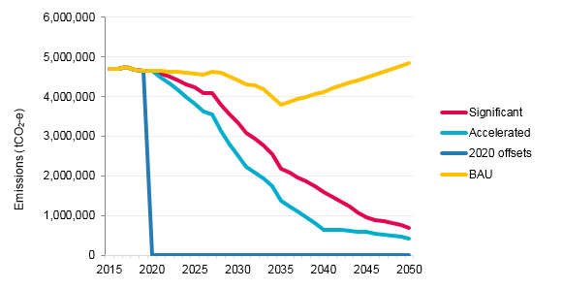
Table 1: Economic costs and benefits of each scenario compared to business as usual
Scenario | Target per person in 2030 | Net Zero Emissions | Aligned to Paris Climate Agreement | Economic Estimate
Business as usual | 22.1 tCO₂-e | never | no | Cost to the municipality economy (burden) would be $12.6 billion from increased maintenance, healthcare, business failure etc from the impacts of climate change
Purchasing offsets | 22.1 tCO₂-e | 2020 | no | Cost to the City of Melbourne of $30 million per year. increasing due to supply demand pressures. No reduction to municipality economic burden.
Significant action | 14.4 tCO₂-e | 2050 | yes | Investment of $2.3 billion to implement, however reduces the municipality economic burden by $3.1 billion
Accelerated action | 10.2 tCO₂-e | 2043 | yes | Investment of $2.9 billion to implement, however reduces the municipality economic burden (BAU) by $5.6 billion
If we do not act decisively to reduce emissions as part of the global effort, the impacts of climate change and missed economic opportunities of transitioning to a low carbon economy will cost the community $12.6 billion from 2020 to 2050 (business as usual scenario). The second scenario requires purchasing offsets to meet the target of zero net emissions. This does not address the causes of greenhouse gas emissions and provides no return on investment to the Melbourne community. For the reasons above, scenarios 1 and 2 do not appear to be in the best interests of the community.
According to preliminary estimates, we will generate substantial social, economic and environmental benefits for the community by taking decisive action to reduce emissions. The preliminary estimate of the net benefits to the community is $3.1 billion for the significant action scenario and $5.6 billion for the accelerated action scenario when compared to business as usual over the 2020–2050 period. The benefits are generated by the reduced burden of climate impact on the economy if the science-based targets in the Paris Climate Agreement are achieved.
The emission reduction targets that the significant and accelerated action scenarios could achieve in 2025, 2030 and 2050 are presented in the tables below. Both scenarios align to the science-based targets of the Paris Climate Agreement.
Table 2: Proposed targets: significant action scenario
Item | Baseline 2015 | Significant action scenario 2015 | Significant action scenario 2015 | Significant action scenario 2015
Absolute emissions | 4.7 MtCO₂-e | 4.2 MtCO₂-e | 3.4 MtCO₂-e | 0.5 MtCO₂-e
% reduction on 2015 | 4.7MtCO₂-e | 10% | 29% | 90%
Per capita emissions | 33.8 tCO₂-e | 20.2 tCO2-e | 14.4 tCO2-e | 1.3 tCO2-e
Table 3: Proposed targets: accelerated action scenario
Item | Baseline 2015 | Significant action scenario 2025 | Significant action scenario 2030 | Significant action scenario 2050
Absolute emissions | 4.7 MtCO₂-e | 3.7 MtCO₂-e | 2.4 MtCO₂-e | 0.2 MtCO₂-e
% reduction on 2015 | 4.7 MtCO₂-e | 21% | 50% | 94%
Per capita emissions | 33.8 tCO₂-e | 17.7 tCO2-e | 10.2 tCO2-e | 0.7 tCO2-e
Strategic priorities and outcomes
This draft strategy outlines four priorities the City of Melbourne will work towards:
- 100 per cent renewable energy
- zero emissions buildings and precincts
- zero emissions transport
- reducing the impact of waste.
To implement the strategy we will:
- integrate climate adaptation and mitigation
- deliver environmental, social and economic benefits to the community
- support innovation, knowledge sharing and transparency.
Our aim is to reduce the largest sources of emissions in the municipality to achieve science-based targets and align our strategy to the Paris Climate Change Agreement and C40 Climate Action Plan Framework.
The graphs on the following page show the potential contribution of actions that reduce emissions from energy supply, buildings, transport and waste in the significant and accelerated emission reduction scenarios.
Figure 2: Emissions reductions needed under each scenario
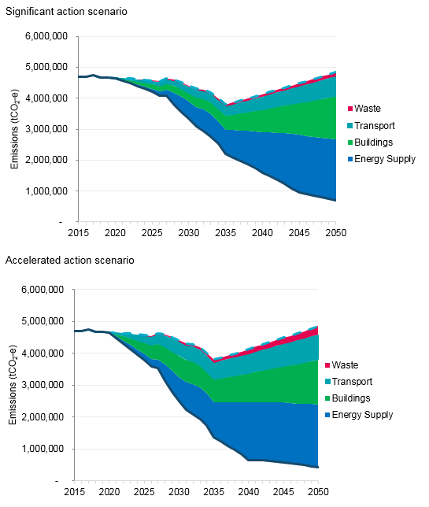
Long-term thinking, short-term action
This Climate Change Mitigation Strategy to 2050 is one in a suite of strategies delivering step-change for our community as part of our Council Plan 2017–2021. These include Climate Change Adaptation, Nature in the City, Transport, and Waste and Resource Recovery strategies.
The proposed timeframe is:
- 2020–2050 for this strategy with an interim target for 2030: aligned to the period of the Paris Climate Agreement
- 2020–2025 for the rolling implementation plan: aligned to the Council Pledge requirements of the Climate Change Act 2017.
We will measure and report our progress to the community annually and evaluate the implementation of the strategy by 2025.
Figure 3: Potential contribution of Australian and Victorian Government policies to Melbourne’s municipal emission reductions 2020–2050
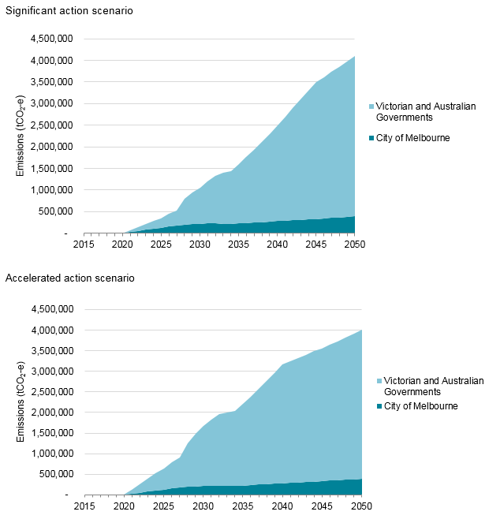
As shown above, without policy changes in state and national jurisdictions, the City of Melbourne will not be able to achieve alignment to the Paris Climate Agreement targets. These targets can only be achieved through collaborative action across all three levels of government.
This strategy identifies opportunities within City of Melbourne’s control, together with opportunities outside of City of Melbourne’s control where the role of Council is to advocate and influence. For example, the City of Melbourne does not operate public transport and does not have the power to regulate energy performance standards in buildings, energy supply or renewable energy targets for the city. The graphs show the emission reductions that can be delivered by the City of Melbourne aligned with the Victorian and Commonwealth Governments if a 2030 renewable energy target was set and/or an ambitious national climate and energy policy was endorsed.

Introduction

How can we work together to reduce greenhouse gas emissions?
Greenhouse gas emissions in the municipality of Melbourne are generated from electricity, gas, transport, and waste produced by our daily activities. They are also generated by food and agriculture, goods and services, and the resources that go into packaging, clothes and building materials.
To reduce greenhouse emissions we need collective action by customers and businesses, commuters and transport companies, tenants and building owners, investors and government regulators. The actions we take each day illustrate the challenges and opportunities to reducing greenhouse emissions across the city.
The good news is change is already underway. More and more customers are choosing sustainable products and services. Melbourne’s trams will soon be powered by renewable energy. Businesses all over the city are choosing greener buildings and 100 per cent renewable energy. At the City of Melbourne, we have reduced emissions from our operations and have been certified carbon neutral every year since 2012.
But there is a lot more to do. This draft strategy describes the actions we can take to address the causes of climate change. It might be a global problem, but the solutions are right here in our city.
The draft strategy consists of four sections:
- Introduction: what has changed since the last zero net emissions strategy and why we need a new approach.
- Taking bold action together: how we are responding.
- Strategic priorities: the actions we propose to take.
- How we will implement the strategy.
This strategy proposes actions to achieve emission reductions consistent with the science-based targets of the Paris Climate Agreement. This is the emissions we need to reduce to contribute to international efforts to avoid a 1.5ºC increase in global average temperature.
How coffee drinking might be part of the solution
Jo is studying at the University of Melbourne. Each morning she catches a train to Flinders Street Station and gets a coffee in Degraves Street before jumping on the tram up to the university. Trams in Melbourne will soon be powered by renewable solar energy.
In the café, she orders a flat white, and the barista grinds the coffee and heats the milk. The café’s electricity generates greenhouse gas emissions, and the efficiency of the café’s refrigeration, lighting and air-conditioning also makes a difference to the greenhouse gas emissions produced. The café’s supplies are delivered each morning, sometimes from many kilometres away and this generates transport emissions. At the end of the day the café workers separate organic waste and recycling and donate left over food to charity so that only a small amount of waste is sent to landfill.
If cafes and trains in Melbourne were powered by renewable energy and buildings and freight vehicles were more efficient, then the daily activity of drinking coffee would be supporting our emission reduction goals.

Melbourne’s emissions profile
Most of Melbourne’s emissions are from energy use in buildings, transport and waste. The majority of these emissions are due to energy use in commercial buildings and transport. Our programs have addressed emissions from these sources however there is still more to do. Without further action emissions will not reduce rapidly due to population growth, urban densification and the electrification of private vehicles.
In 2015, the municipality’s emissions were 4,700,672 tonnes CO2 equivalent, or 33.8 tonnes per person. Melbourne’s emissions are one of the highest in the world on a per capita basis. One reason our per capita emissions are so high is because we have a residential population of 148,000, but a large week day population of 900,000 including tourists and workers. The majority of our electricity is generated by high emitting brown coal-fired power stations, which also increases our per capita emissions.
Figure 4: Sources of municipal emissions in 2015
Emissions by source
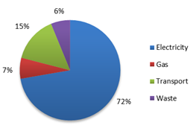
Emissions by source | Percentage
Electricity | 72%
Gas | 7%
Transport | 15%
Waste | 6%

Emissions by sector
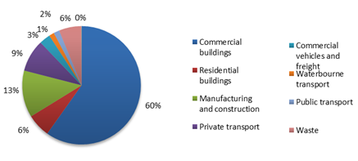
Emissions by sector | Percentage
Commercial buildings | 60%
Residential buildings | 6%
Manufacturing and construction | 13%
Private transport | 9%
Commercial vehicles and freight | 3%
Waterbourne transport | 1%
Public transport | 2%
Waste | 6%

Why we need a new approach

Zero net emissions by 2020
In 2003, the City of Melbourne set an ambitious target of zero net emissions from the municipality by 2020, prior to Australia ratifying the Kyoto Protocol. We were one of the first cities to set such an ambitious target, and many other cities followed our lead. The most recent update of the Zero Net Emissions by 2020 Strategy was completed in 2014, prior to the Paris Climate Agreement.
In 2016, the City of Melbourne hosted the Future Melbourne deliberative democracy process to develop a community vision and set the priorities for the city. Reducing greenhouse gas emissions from the municipality was identified as a top priority and this is reflected in our Council Plan 2017–2021. This view is shared across Victoria: 80 per cent of people are willing to act on climate change and 87 per cent think local government should be taking action.
Now that the Australian Government has ratified the Paris Climate Agreement and the Victorian Government has introduced the Climate Change Act 2017 there is a fresh opportunity for the City of Melbourne to pursue our long-standing commitment to action on the emissions that cause climate change. This goal is more important than ever as our city will continue to grow over the coming decades and the decisions we make today will lock in the future emissions profile of our energy, buildings, transport and waste management. The Paris Climate Agreement introduced ambitious science-based targets. Cities around the world have responded with new frameworks to measure and plan for emission reductions.
The City of Melbourne completed our Climate Change Adaptation Strategy Refresh in 2017. This complementary Climate Change Mitigation Strategy focuses on reducing greenhouse emissions. It responds to the new science-based targets and frameworks introduced since the Paris Climate Agreement was ratified in 2016.

C40 Climate Action Planning Framework
C40 is a network of the world’s megacities committed to addressing climate change. To ensure the approach to this strategy demonstrates global leadership, the City of Melbourne joined seven cities in a C40 Climate Action Planning Pilot Program: Boston, Durban, Los Angeles, London, Mexico City, New York, and Paris. This peer-review and exchange has contributed greatly to the approach we are taking.
By participating in this program, the City of Melbourne contributed to the development of the C40 Climate Action Planning Framework. Cities can use this framework to meet their commitments to the Paris Climate Agreement.
The key features of the C40 Climate Action Planning Framework are:
- Develop a pathway to deliver an emissions neutral city by 2050 at the latest and set an ambitious interim target and/or carbon budget.
- Demonstrate how the city will adapt and improve its resilience to the climate hazards that may impact the city now and in future climate change scenarios.
- Outline the social, environmental and economic benefits expected from implementing the plan, and improve the equitable distribution of these benefits to the city’s population.
- Detail the city’s governance, powers and partners who need to be engaged in order to accelerate the delivery of the city’s mitigation targets and resilience goals.
Cities need to do this by:
- Considering adaptation and mitigation in an integrated way, identifying interdependencies to maximise efficiencies and minimize investment risk.
- Setting an evidence-based, inclusive and deliverable plan for achieving transformational mitigation and adaptation, centred on the city’s powers and wider context.
- Establishing a transparent process to monitor delivery, communicate progress and update climate action planning in line with governance and reporting systems.
The City of Melbourne will be sharing the lessons learnt from participating in the pilot program with other cities in Australia and around the world. We have started with a capacity building program for local governments in metropolitan Melbourne.

A low carbon, circular economy
Melbourne is Australia’s second largest city and an important centre for finance, professional services and the knowledge economy in the Asia-Pacific region. Tourists and visitors to the city are attracted by small businesses in Melbourne’s restaurant, retail and entertainment precincts. Melbourne’s environmental sustainability is central to its reputation as an attractive place to work and do business.
Cities consume 75 per cent of natural resources globally, and many cities are now taking climate change more seriously as an investment issue as well as an operational issue. For example, the financial ratings agency Moody’s recently advised US cities to start addressing climate change or face ratings downgrades.
In 2015 Council unanimously decided not to invest in fossil fuels or fossil fuel aligned companies and to call upon our default superannuation fund to create a fossil fuel free investment option for its members. They also decided to consider fossil fuel exposure when deciding which banks to award our transactional banking contract to when services are tendered.
The Investor Group on Climate Change, representing $2 trillion assets under management, is encouraging companies to manage climate risks. More businesses and investors are positioning to take advantage of the opportunities of a low carbon economy. They are setting science-based emission reduction targets, purchasing renewable energy and divesting from fossil-fuels. Company directors are starting to consider climate change in their decision-making.
The leadership of these investors and businesses will contribute to our transition to a low carbon economy. It will help Melbourne’s economic resilience to the risks of climate change. A low carbon economy supports business activities by generating the highest value for the least emissions. Melbourne’s knowledge economy is well positioned: its strengths in professional, technical, scientific and financial services will benefit from the transition to 100 per cent renewable energy and zero emissions buildings.
The concept of a circular economy recognises that the way we currently design many products, buildings, transport systems and cities contributes to wasted resources. Many products generate a lot of waste in their manufacture or transport, are only used once or require excessive packaging. Wasted energy and material resources also go into buildings and car parks that sit vacant. Making urban systems more efficient reduces emissions from the wasted energy used to manufacture and operate inefficient products, buildings and transport.
The principles of a circular economy are to design out waste, keep products and materials in use at their highest value, and preserve and rebuild natural capital. Because of the emissions generated by the manufacture or transport of materials (called “embodied emissions”) there is a relationship between our transition to a low carbon economy, and a more efficient circular economy. For example, the emissions produced by growing, producing and transporting food, or the manufacture of clothing or building products, and the mining and industrial processing of raw materials for buildings and roads.
We need to reduce waste of all kinds and decouple emissions intensity from economic value. Through urban design and planning, cities can support an increase in energy efficient buildings and transport systems and the reduction in both structural and material waste.

Taking bold action together

City of Melbourne’s role
The City of Melbourne directly controls less than one per cent of emissions sources in the municipality through our operations. Since 2003 we have been working to reduce emissions from the municipality with influential programs such as CitySwitch and the Melbourne Renewable Energy Project.
In 2016, we introduced a 1.5°C science-based target for our operations in our Emission Reduction Plan 2016-2021. We have taken strong action to reduce emissions from our own operations and to power our buildings with 100 per cent renewable energy. All remaining emissions are offset to enable City of Melbourne to be a certified Carbon Neutral organisation.
However, there are many activities in the municipality that the City of Melbourne does not have a direct responsibility for such as energy supply and use in privately owned buildings and transport. We still include the emissions from these sources in the municipality’s greenhouse gas accounts using international standards. To address them, we need to work collaboratively with the community, other governments and businesses across the municipality.
The actions that the City of Melbourne can take will be defined by our powers in the Local Government Bill 2018. It states that:
(a) priority is to be given to achieving the best outcomes for the municipal community, including future generations;
(b) the economic, social and environmental sustainability of the municipal district, including mitigation and planning for climate change risks, is to be promoted;
The Climate Change Mitigation Strategy 2020–2050 specifically responds to these principles of good governance and also fulfils the remaining principles relating to community engagement, transparency, collaboration with other levels of government and good financial management as outlined in section 9 of the Local Government Bill 2018.

Australian and Victorian climate change policy
The City of Melbourne cannot mitigate climate risk for the economic, social and environmental sustainability of the municipality without supporting action from the Victorian and Australian Governments to reduce greenhouse gas emissions. Unlike some cities in other countries, we do not have the power to regulate building energy performance standards or operate public transport or energy utilities. The City of Melbourne has limited powers to implement urban planning controls.
The graph below illustrates the impact on emissions that different levels of government can have on Melbourne through their policies.
Figure 5: Potential contribution of Australian and Victorian Government policies to Melbourne’s emission reductions 2020–2050
Two graphs showing the potential contribution of Australian and Victorian Government policies to the municipality’s emissions reductions from 2020–2050. The two graphs show the relative contribution of actions that the City of Melbourne has jurisdiction over, compared to those that are under the jurisdiction of state or federal government. Under both the significant action scenario and accelerated action scenario, the City of Melbourne can implement actions that would reduce emissions by approximately 12% of the cumulative total by 2050. This increases to 18% under the accelerated action scenario.
As shown above, without policy changes in state and national jurisdictions, the City of Melbourne will not be able to achieve alignment to the Paris Climate Agreement targets. These targets can only be achieved through collaborative action across all three levels of government.
This strategy identifies opportunities within City of Melbourne’s control, together with opportunities outside of City of Melbourne’s control where the role of Council is to advocate and influence. For example, the City of Melbourne does not operate public transport and does not have the power to regulate energy performance standards in buildings, energy supply or renewable energy targets for the city. The graphs show the emission reductions that can be delivered by the City of Melbourne aligned with the Victorian and Commonwealth Governments if a 2030 renewable energy target was set and/or an ambitious national climate and energy policy was endorsed.
The Victorian Climate Change Act 2017 provides a framework for local governments to make a voluntary Council Pledge to implement five-year Emission Reduction Plans for the municipality from 1 January 2021. The implementation plan that will support this strategy will describe what we can do by 2025 as the basis for a Council Pledge.

Proposed emission reduction targets
Aligning to the Paris Climate Agreement needs a mix of delivery mechanisms: engaging, facilitating, collaborating and partnering with others, taking leadership in the delivery of actions within our powers and advocating for policy change and action from others.
To inform the development of the Climate Change Mitigation Strategy 2020–2050 we analysed four scenarios:
- business as usual
- offsetting all remaining emissions from 2020
- a significant action program to reduce emissions
- an accelerated action program.
In addition to the actions within the City of Melbourne’s powers, both the significant and accelerated action scenarios require investors, businesses and the Victorian and Australian Governments to also take action.
The figure below summarises the scenarios analysed. It illustrates the emissions we need to reduce as part of the international effort to stay below the 1.5ºC rise in global average temperatures.
Figure 6: Scenarios for emission reduction targets
City of Melbourne’s preferred approach is to deliver the actions needed to achieve the significant action scenario and pursue actions for the accelerated action scenario when there is the opportunity to go further. Both of these scenarios require us to take bold action within our powers, to collaborate with others and to advocate for policy change from the Victorian and Australian Governments. This will meet our commitments to the Paris Climate Agreement while acknowledging our limited powers and financial resources.
If we do not act decisively to reduce emissions as part of the global effort, the impacts of climate change and missed economic opportunities of transitioning to a low carbon economy will cost the community $12.6 billion from 2020 to 2050 (business as usual scenario). The second scenario requires purchasing offsets to meet the target of zero net emissions. This does not address the causes of greenhouse gas emissions and provides no return on investment to the Melbourne community. For the reasons above, scenarios 1 and 2 do not appear to be in the best interests of the community.
According to preliminary estimates, we will generate substantial social, economic and environmental benefits for the community by taking decisive action to reduce emissions. The preliminary estimate of the net benefits to the community is $3.1 billion for the significant action scenario and $5.6 billion for the accelerated action scenario when compared to business as usual over the 2020–2050 period. The benefits are generated by the reduced burden of climate impact on the economy if the science-based targets in the Paris Climate Agreement are achieved. Further explanation of the method used to calculate costs and benefits can be found in Appendix A.
Offsets also provide important environmental, social and economic benefits for reducing emissions in remote and regional Australia, and in many other countries. However, achieving emission reductions through purchasing offsets alone will not address the causes of greenhouse gas emissions in our city or achieve the co-benefits.
Carbon offsets are also expected to increase in cost exponentially beyond the year 2020 because many countries have signed up to the Paris Agreement, which will mean demand for offsets are likely to increase. In addition, the Kyoto agreement offset mechanisms end in 2020 and it is unclear how they will be replaced.
For the reasons above scenarios 1 and 2 do not appear to be in the best interests of the community.
The emission reduction targets that the significant and accelerated action scenarios could achieve in 2025, 2030 and 2050 are presented in the tables below. Both scenarios align to the Paris Climate Agreement.
Table 4: Proposed targets: significant action scenario
Item | Baseline 2015 | Significant action scenario 2025 | Significant action scenario 2030 | Significant action scenario 2050
Absolute emissions | 4.7 MtCO₂-e | 4.2 MtCO₂-e | 3.4 MtCO₂-e | 0.5 MtCO₂-e
% reduction on 2015 | 4.7 MtCO₂-e | 10% | 29% | 90%
Per capita emissions | 33.8 tCO₂-e | 20.2 tCO2-e | 14.4 tCO2-e | 1.3 tCO2-e
Table 5: Proposed targets: accelerated action scenario
Item | Baseline 2015 | Significant action scenario 2025 | Significant action scenario 2030 | Significant action scenario 2050
Absolute emissions | 4.7 MtCO₂-e | 3.7 MtCO₂-e | 2.4 MtCO₂-e | 0.2 MtCO₂-e
% reduction on 2015 | 4.7 MtCO₂-e | 21% | 50% | 94%
Per capita emissions | 33.8 tCO₂-e | 17.7 tCO2-e | 10.2 tCO2-e | 0.7 tCO2-e
Figure 7: Significant emission reduction scenario 2020–2050

Strategic priorities
Where should we put our effort?
In preparing this strategy we searched high and low for the best ideas and we are not finished yet. We welcome the community’s suggestions as part of the consultation process.
To ensure emissions are reduced as rapidly as possible, we need to put the most effort into reducing the largest sources of emissions that we can control or influence. We analysed opportunities for transformational actions regarding the major sources of emissions in the city: energy supply, buildings, transport and waste.
To identify new ideas we investigated:
- priorities identified in the Future Melbourne community process
- actions taken by other cities around the world
- climate impacts
- changes in technology
- demographics and urban densification trends
- business and economic trends
- policy settings of the Victorian and Australian Governments.
We debated solutions with representatives of other cities from around Australia and around the world by participating in the C40 Climate Action Planning Pilot program. In 2017, we hosted experts from 20 cities for the Carbon Neutral Cities Alliance meeting in Melbourne.
We engaged expert consultants to analyse proposed actions for their potential to reduce greenhouse emissions and their social and economic benefits. And we tested these early ideas with business, government and community representatives as part of our external reference group. We also held five community focus groups to refine the ideas further.
We will conduct further analysis on the new ideas generated by community consultation and we invite you to have your say.
Strategic priorities and outcomes
This draft strategy groups the actions into four priorities:
- 100 per cent renewable energy
- zero emissions buildings and precincts
- zero emissions transport
- reduce the impact of waste.
The outcome of these strategic priorities is intended to reduce the largest sources of emissions in the municipality to achieve science-based targets and align to the requirements of the C40 Climate Action Plan Framework.
We are proposing actions that we can implement directly as well as those we need to work with others to deliver and advocate for.
The way we implement the strategy will:
- consider climate adaptation and mitigation in an integrated way, identifying interdependencies to maximise efficiencies and minimise investment risk
- deliver environmental, social and economic benefits to the community and improve the accessibility of these benefits by the community
- take an innovative, transparent and evidence-based approach to report and evaluate progress in implementing the strategy.

Priority 1: 100 per cent renewable energy

The story so far
The Melbourne Renewable Energy Project was a game-changing initiative led by the City of Melbourne. Bringing together some of Melbourne’s leading businesses, universities, local governments and public institutions, the City of Melbourne developed an Australian first group Power Purchase Agreement. This commitment to purchase our power from a new renewable energy development enabled the construction of a 39 turbine windfarm at Crowlands, about two hours from Melbourne in regional Victoria. This project alone will increase renewable energy in the city by 3 per cent in addition to the 18 per cent currently adopted.
Local governments have demonstrated leadership for many years by bargaining with energy companies to facilitate lower cost renewable energy for the community in the form of solar panels and GreenPower. Homeowners and businesses have benefitted from policies such as feed-in tariffs, solar rebates, and renewable energy targets implemented by Victorian and Australian Governments. These programs have contributed greatly to the uptake in renewable energy and rapid reduction in the market cost.
In the past, the higher cost of renewable energy meant purchasing solar panels and GreenPower was more expensive than standard electricity. However the costs of renewable energy have now reduced significantly, while the cost of ordinary electricity and gas has increased. This particularly affects some of our more vulnerable residents.

Challenges
While a proportion of homeowners enjoy the benefits of solar power on their rooftops, access can be limited for people who are renting or living in apartments.
In previous years, we trialled programs to support the installation of solar panels on commercial buildings. It was challenging to find suitable commercial sites for installation due to overshadowing from surrounding buildings, and regulations that made connection to the electricity grid and distribution to neighbouring properties difficult.
Investment in new renewable energy is being driven by the commitments of state governments to renewable energy, including the Victorian Government commitment to 40 per cent renewable energy by 2025. Without a commitment to a further renewable energy target for 2030 or appropriate targets in the proposed National Energy Guarantee or similar policy mechanism, the investment needed in renewable energy is likely to stall.

Strategic opportunities
To achieve our emission reduction goals, the city’s buildings, precincts and transport need to be electrified and powered by 100 per cent renewable energy. This requires a transition away from gas, petrol, diesel and coal. It will generate investment opportunities in clean energy infrastructure.
The influence of the Melbourne Renewable Energy Project has greatly accelerated the uptake of renewable energy in recent years. New analysis shows that nationally, a third of the contribution to the Australian Renewable Energy Target scheme is from corporate power purchase agreements. We can accelerate the uptake of renewable energy by continuing to amplify the impact of the Melbourne Renewable Energy Project to contribute to future Victorian and Australian Government renewable energy targets.
The development of a virtual renewable energy power plant or facilitation of renewable energy purchases for residents could help share the benefits of the renewable energy transition with people who live in apartments as well as stand-alone houses.
For example the City of Melbourne could facilitate a bulk purchase of solar panels or batteries to provide them to residents at a reduced price. The Victorian Government has recently announced half price solar panels for 650,000 homeowners. We could support this program by promoting it and reducing barriers to installing solar panels, and we could extend a similar initiative to renters. Another type of virtual power plant is a larger scale installation of solar panels and storage on a public building or a vacant rooftop located inside the municipality with benefits flowing to nearby residents. Some communities have also developed community energy projects where residents or businesses purchase a share in, or purchase energy from, a large scale renewable energy development outside the municipality. The energy generated is then directly counted against resident energy use. We could also drive innovation by engaging university researchers in trialling new technology in the innovation precinct.
Community support for renewable energy in Melbourne is high despite the challenges of overshadowing from surrounding buildings. The decreasing cost of renewable energy and the increasing cost of gas and coal-fired electricity in Australia has also generated community support for renewable energy and employment opportunities for regional Victorians. There is a growing consensus from investors, energy companies, and businesses that renewable energy is needed to replace coal-fired power stations. The City of Melbourne could amplify this by advocating for ambitious renewable energy targets in Victorian and Australian Government policy.

The environmental, social and economic benefits of taking action
The many environmental, social and economic benefits of taking action include:
- increased energy security
- increased local employment
- reduced health impacts from air pollution
- reduced ecosystem impacts from air pollution
- reduced ecosystem impacts from coal mining.
Actions modelled:
- Facilitate and support corporate Power Purchase Agreements
- Facilitate residential purchasing of renewable energy products
- Advocate for a more ambitious renewable energy target
Scenario | Emissions reduction | Discounted benefits  ($ million) | Discounted costs ($ million) | Benefit cost ratio
Significant | 28.9 MtCO₂-e | 756.56 | 15.70 | 48.18
Accelerated | 34.5 MtCO₂-e | 1,513.52 | 31.79 | 47.60
The figures below show the abatement potential associated with each energy supply action under the significant and accelerated action scenarios.
Figure 8: Emission reductions potential of energy supply actions
Significant action scenario
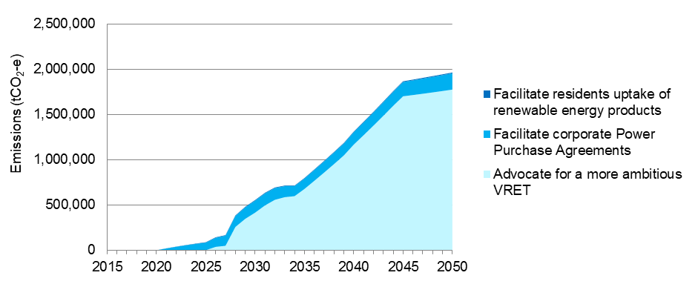
Significant modelled action | 2030  tonnes of carbon dioxide equivalent | % of reduction as at 2030 | 2050  tonnes of carbon dioxide equivalent | % of reduction as at 2050 | Cumulative total  tonnes of carbon dioxide equivalent | Cumulative %
Advocate for a more ambitious VRET | 414,617 | 75% | 1,774,787 | 90% | 24,953,013 | 86%
Facilitate corporate Power Purchase Agreements | 132,634 | 24% | 179,322 | 9% | 3,711,771 | 13%
Facilitate residents uptake of renewable energy products | 7,144 | 1% | 9,659 | 0% | 199,929 | 1%
Accelerated action scenario
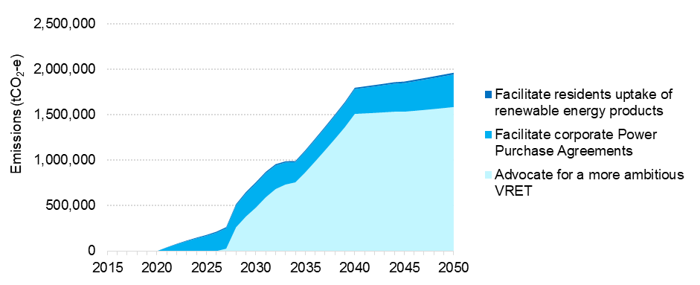
Accelerated modelled action | 2030  tonnes of carbon dioxide equivalent | % of reduction as at 2030 | 2050  tonnes of carbon dioxide equivalent | % of reduction as at 2050 | Cumulative total  tonnes of carbon dioxide equivalent | Cumulative %
Advocate for a more ambitious VRET | 478,116 | 63% | 1,585,806 | 81% | 26,438,621 | 77%
Facilitate corporate Power Purchase Agreements | 265,269 | 35% | 358,644 | 18% | 7,423,542 | 22%
Facilitate residents uptake of renewable energy products | 14,288 | 2% | 19,318 | 1% | 405,354 | 1%
In both the significant and accelerated action scenarios, the majority of the abatement potential to 2050 is associated with advocating for a more ambitious renewable energy target. In the accelerated action scenario, the higher ambition relating to facilitating corporate power purchase agreements is evident. Renewables penetration of the electricity grid reaches 100 per cent in 2040 under the accelerated action scenario and in 2045 under the significant action scenario.

Proposed actions
- Advocate for a more ambitious renewable energy target.
- Accelerate corporate Power Purchase Agreements.
- Facilitate residential purchasing of renewable energy products.
- Facilitate a virtual power plant for residents.
- Collaborate with other cities, investors, superannuation companies to accelerate divestment from fossil-fuel energy supply.
- Partner with businesses and universities to promote innovative renewable energy technology and research.
The above list is a set of indicative actions to address this strategic priority. This list is not exhaustive or final and will be subject to the City of Melbourne’s Annual Plan and Budget process.
Case study: Melbourne renewable energy project
The Melbourne Renewable Energy Project (MREP) is a world first. The City of Melbourne partnered with 13 local governments, cultural institutions, universities and corporations to collectively purchase renewable energy. This commitment to purchase power to purchase power from a renewable energy development enabled the construction of a new 39 turbine, 80 MW capacity wind farm at Crowlands, Ararat. This project alone will increase renewable energy in by 3 per cent. It also produced a guide to help other organisations pursue power purchase agreements, which is further accelerating the uptake of renewable energy as a power source.
Case study: 100 per cent renewable energy for the Australian Capital Territory
In 2016 the Australian Capital Territory (ACT) set a bold target for the territory to be powered by 100 per cent renewable electricity by 2020. It is part of the ACT Climate Strategy to achieve net zero emissions by 2045 or earlier. Electricity and transport are the major contributors to the ACT's emissions. The ACT Government is increasing public transport use to lower emissions from driving personal cars. Many government agencies also use electric vehicles and hybrids as part of their vehicle fleet. The ACT Government is currently considering whether to apply a monetary value on any emissions above their target and reinvesting these funds in emission reduction measures.

Priority 2: Zero emissions buildings and precincts

The story so far
The City of Melbourne developed Australia’s first new 6-star Green Star rated office building in 2006 called Council House 2. This building trialled new energy saving technology, sustainable materials and a green roof garden. It will be powered by 100 per cent renewable energy. Over the last decade, we have integrated the lessons learnt across our portfolio of public and community buildings including the Library at the Dock and the Queen Victoria Market precinct renewal.
In the last five years, we have achieved a 24 per cent reduction in emissions across our building portfolio. We have undertaken energy saving upgrades and retrofits in existing buildings, including a number of heritage listed buildings such as the Melbourne Town Hall.
We have also collaborated with apartment owners and tenants, and the commercial property sector to drive improved environmental performance. CitySwitch is a national program delivered in partnership with the Cities of Sydney, North Sydney, Willoughby, Adelaide, Perth and the New South Wales Office of Environment and Heritage. It achieved an emissions reduction of 667,000 tonnes of CO2 in 2017 and won an international C40 award.
The City of Melbourne and the City of Stockholm co-lead the C40 Low Carbon Districts and Climate Positive network. This international network of cities collaborates on precinct-scale solutions. In 2013, we expanded our local planning policy for sustainable office buildings to include all types of development.
We are working with Victorian Government partners to introduce net zero emissions targets for urban renewal precincts such as Fishermans Bend and Arden, and to incorporate these into planning and implementation.

Challenges
Buildings generate 79 per cent of emissions in the municipality, mainly because the majority use energy from coal-fired power in the Latrobe Valley. Gas is another source of building emissions. Until the transition is made away from gas, having a 100 per cent renewable electricity system will still result in buildings generating emissions.
Melbourne’s buildings are also not as efficient as they could be and benchmarks for measuring the performance of the city’s building portfolio are not fully developed, especially for apartments.
Long-term trends in population growth and urban densification mean that Melbourne is in the greatest property development boom since the 1850s gold rush. Apartment buildings are already the most common type of residence and they are growing at a rapid rate. The buildings developed today will still be part of our city in 2050.
Because buildings retain heat they also contribute to the urban heat island effect. This can make poorly designed buildings uninhabitable if there is a power cut during a heat wave. Heat waves are occurring more frequently due to climate change as summer temperatures become more extreme.
The social impacts of building thermal performance during heatwaves and extreme weather needs to be considered because some members of our community, the young, elderly and vulnerable are more at risk. Energy security and heatwaves also affect workers and business operations.

Strategic opportunities
By collaborating with industry, the City of Melbourne can accelerate emission reductions from buildings across the city. The Green Building Council of Australia’s Carbon Positive Roadmap aligns the future energy performance of buildings to the science-based targets of the Paris Climate Agreement. It has set an objective for new commercial buildings to achieve carbon neutrality by 2030, and existing commercial buildings to achieve carbon neutrality by 2050.
The industry-led Australian Sustainable Built Environment Council is advocating for the National Construction Code to be urgently updated so that new buildings are fit for a zero carbon future. The construction sector can improve the energy efficiency and thermal performance of buildings and integrate renewable energy into building fabric. This will reduce emissions and help the community adapt to climate change.
Shifting our focus from individual buildings to sector-wide engagement and precinct-scale development will help deliver emission reductions through long-term infrastructure, urban renewal and planning policy.
Applying the principles of the circular economy means buildings need to be designed to provide multiple functions over their life-span the emissions generated by building materials reduced and used building materials need to be upcycled.

The environmental, social and economic benefits of taking action
The benefits of taking action on buildings include:
- energy security
- increased asset values of buildings
- urban biodiversity from green roofs
- reduced health impacts from air pollution
- increased productivity
- increased thermal comfort
- increased disaster resilience
- reduced water consumption/sewage production
- reduced Urban Heat Island effect.
Built to Perform, a report by Climate Works Australia and the Australian Sustainable Built Environment Council, shows that setting stronger energy standards for new buildings in the National Construction Code could reduce energy bills by up to $27 billion. It could cut energy network costs by up to $7 billion and deliver at least 78 million tonnes of cumulative emissions savings between now and 2050.
Actions modelled:
- Advocate and facilitate to transition from gas to electricity
- Facilitate and advocate to ensure all existing residential buildings are zero net by 2050
- Facilitate and advocate to ensure all existing commercial buildings are zero net by 2050
- Take action, collaborate and advocate to ensure all new residential buildings are zero net by 2030
- Facilitate and advocate to ensure new commercial buildings are zero emissions by 2030
Scenario | Cumulative abatement potential by category | Discounted benefits  ($ million) | Discounted costs ($ million) | Benefit cost ratio
Significant | 16.3 MtCO₂-e | 4,103.93 | 2,209.44 | 1.86
Accelerated | 33.6 MtCO₂-e | 6,031.80 | 2,752.55 | 2.19
Figure 9: Zero emissions buildings and precincts
Significant action scenario
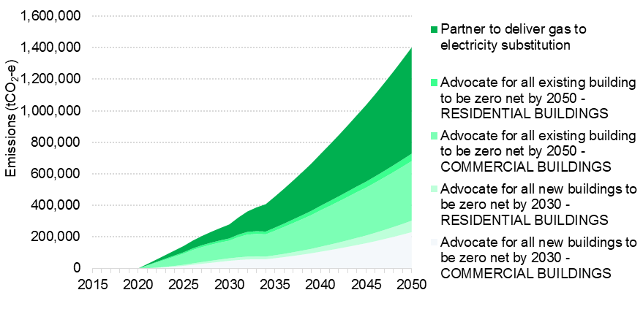
Significant modelled action | 2030  tonnes of carbon dioxide equivalent | % of reduction as at 2030 | 2050  tonnes of carbon dioxide equivalent | % of reduction as at 2050 | Cumulative total  tonnes of carbon dioxide equivalent | Cumulative %
Advocate for all new buildings to be zero net by 2030 - Commercial Buildings | 48,488 | 17% | 230,298 | 16% | 2,646,262 | 15%
Advocate for all new buildings to be zero net by 2030 - Residential Buildings | 16,024 | 6% | 72,673 | 5% | 819,111 | 5%
Advocate for all existing building to be zero net by 2050 - Commercial Buildings | 111,799 | 40% | 377,883 | 27% | 5,548,336 | 32%
Advocate for all existing building to be zero net by 2050 - Residential Buildings | 13,968 | 5% | 47,213 | 3% | 693,212 | 4%
Partner to deliver gas to electricity substitution | 88,630 | 32% | 674,299 | 48% | 7,671,783 | 44%
Accelerated action scenario
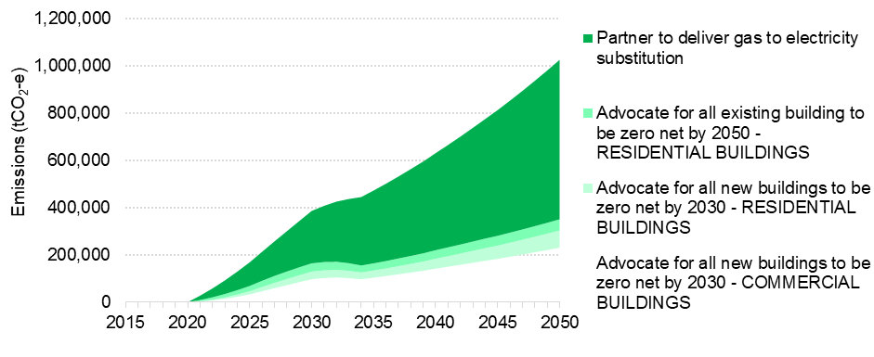
Accelerated modelled action | 2030  tonnes of carbon dioxide equivalent | % of reduction as at 2030 | 2050  tonnes of carbon dioxide equivalent | % of reduction as at 2050 | Cumulative total tonnes of carbon dioxide equivalent | Cumulative %
Advocate for all new buildings to be zero net by 2030 - Commercial Buildings | 96,977 | 15% | 230,298 | 16% | 3,462,090 | 15%
Advocate for all new buildings to be zero net by 2030 - Residential Buildings | 32,048 | 5% | 72,673 | 5% | 1,078,162 | 5%
Advocate for all existing building to be zero net by 2050 - Commercial Buildings | 279,499 | 42% | 377,883 | 27% | 7,821,761 | 34%
Advocate for all existing building to be zero net by 2050 - Residential Buildings | 34,921 | 5% | 47,213 | 3% | 977,255 | 4%
Partner to deliver gas to electricity substitution | 221,576 | 33% | 674,299 | 48% | 9,830,748 | 42%
Our long-term aim is for new and existing, commercial and residential buildings to become carbon neural by 2050 at the latest. This level of ambition supports the aspirations of the Green Building Council as represented in the accelerated action scenario.

Proposed actions
- Demonstrate innovative carbon positive design and operation of council-owned buildings and precincts.
- Partner with industry, Victorian and Australian Government agencies to reduce barriers and deliver zero emissions buildings and urban renewal precincts.
- Accelerate existing commercial buildings and tenants’ energy efficiency programs through CitySwitch and other partnerships
- Advocate for energy performance disclosure for a greater range of commercial buildings, plus residential buildings, at the point of lease and point of sale.
- Facilitate the take up of the National Built Environment Rating Scheme for apartments across the municipality.
- Renew and implement planning policies to support the development of zero emissions buildings and precincts.
- Partner with industry to advocate for higher energy performance standards in the National Construction Code, Building Act 1993 and regulations.
- Advocate and facilitate to transition from gas to electricity in buildings and precincts.
- Adopt circular economy principles to reduce the environmental impact and embodied emissions from products, materials and buildings across the city through procurement, urban design and planning.
The above list is a set of indicative actions to address this strategic priority. This list is not exhaustive or final and will be subject to the City of Melbourne’s Annual Plan and Budget process.
Case study: Greening our buildings
The Council House 2 is Australia's first 6 Star Green Star building. The office building is 10 storeys and houses around 600 employees. It includes sustainable materials, water and energy saving technology, a green roof garden and bike storage and changing facilities in the basement to promote cycling. Energy consumption per employee in Council House 2 is less than half of consumption in Council House 1, which was built in 1970. The City of Melbourne has progressively increased the number of Green Star rated buildings in our portfolio. Examples include East Melbourne Library, Art Play, and Library at the Dock, which was awarded 6 Star Green Star for its design.

Priority 3: Zero emissions transport

The story so far
Transport accounts for 15 per cent of the city’s emissions, the majority from private cars and freight that drive across the city. Public transport into the city also contributes to Melbourne’s emissions profile. The city’s trams will soon be powered by solar energy, yet trains still source their power from by coal-fired power.
Melbourne has a large week day population of 900,000 people, including workers, tourists and residents, who cycle, use public transport, and drive to the city from the surrounding suburbs.
Our city also has an extensive network of pedestrian laneways that contribute to Melbourne’s retail and café culture. Swanston and Bourke streets are partially closed to traffic and they support major retail precincts in the city. Many people enjoy walking and recreation in public parks and gardens. However, cycling levels remain static, and cycle routes across the city are patchy.
The Victorian Government has invested in major new rail infrastructure for Melbourne. The City of Melbourne is actively involved in planning the public space and infrastructure needed to support pedestrian access to the new train stations.

Challenges
Melbourne already experiences significant overcrowding at various locations due to substantial growth in the number of people walking, and limited pedestrian space. The City of Melbourne needs to widen footpaths to accommodate the number of pedestrians. Currently, at the street-level, more public space is allocated to driving and parking cars than walking and cycling, even though the number of people walking and cycling is far greater.
The biggest barrier to increasing the proportion of people riding bicycles is safety. Current routes with dedicated cycle lanes are poorly connected. Having only a few physically protected lanes contributes to an unnecessarily stressful experience for people riding bicycles in Melbourne.
As climate change becomes more severe, the city needs to prepare for the impact of increased temperatures, flood and drought on people walking, cycling and using public transport. Increasing green infrastructure can cool the city, reduce the impact of floods and provide shade and respite for people while they are travelling around the city. Particular attention can be given to intersections exposed to direct sun, which become hotspots during heatwaves. By reducing waiting times priority could be given to people walking, riding bicycles and using public transport at these intersections, reducing waiting times and exposure to the weather.
The majority of transport emissions are still from private cars and freight vehicles that drive across the city on the freeways. In the short term, the electrification of vehicles will increase emissions until there is adequate supply of renewable energy in the electricity grid. In the long term, cars, buses and commercial vehicles will need to be powered by 100 per cent renewable energy to reduce emissions in line with the Paris Climate Agreement. This will also improve air quality.

Strategic opportunities
Melbourne’s rapid population growth means investment in the Melbourne Metro project will only keep up with demand for train travel.
Substantial investment in walking, cycling and public transport, and better use of existing infrastructure, is needed to reduce transport emissions and meet Melbourne’s growth. The City of Melbourne’s Transport Strategy Refresh, being developed in parallel with this strategy, is reviewing options to allocate more public space for people walking and cycling.
Trains and trams are the original electric vehicles! The Victorian Government recently delivered solar energy to power Melbourne’s tram network, however trains are still powered by coal-fired power. In the future, these could be powered by 100 per cent renewable energy.

The environmental, social and economic benefits of taking action
The many benefits of taking action include:
- increased energy security
- reduced health impacts from air pollution
- reduced health impacts from noise
- reduced urban congestion
- reduced travel time
- increased road safety.
Actions modelled:
- Reallocate road space for walking, and cycling
- Implement higher charges for congestion and parking
- Advocate for public transport to be powered by renewable energy
- Advocate for lower intensity of motor vehicles and support transition to electric vehicles
Scenario | Year | Emissions Reduction | Discounted benefits  ($ million) | Discounted costs  ($ million) | Benefit cost ratio
Significant | 2050 | 9.7 MtCO₂-e | 129.15 | 9.78 | 13.21
Accelerated | 2050 | 14.7 MtCO₂-e | 227.96 | 16.60 | 13.73
Figure 10: Transport accelerated action scenario
Significant action scenario
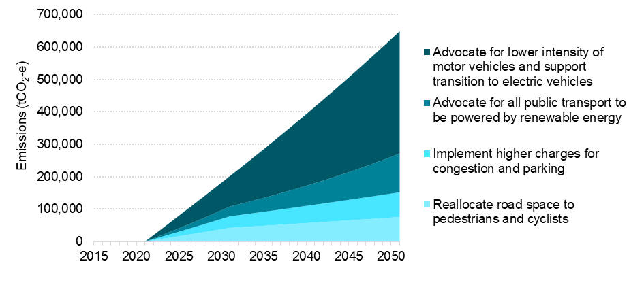
Significant modelled action | 2030  tonnes of carbon dioxide equivalent | % of reduction as at 2030 | 2050  tonnes of carbon dioxide equivalent | % of reduction as at 2050 | Cumulative total tonnes of carbon dioxide equivalent | Cumulative %
Reallocate road space to pedestrians and cyclists | 44,119 | 20% | 75,975 | 12% | 1,426,376 | 15%
Implement higher charges for congestion and parking | 37,359 | 17% | 75,975 | 12% | 1,318,750 | 14%
Advocate for all public transport to be powered by renewable energy | 33,145 | 15% | 119,567 | 18% | 1,584,389 | 16%
Advocate for lower intensity of motor vehicles and support transition to electric vehicles | 107,804 | 48% | 377,250 | 58% | 5,370,653 | 55%
Accelerated action scenario
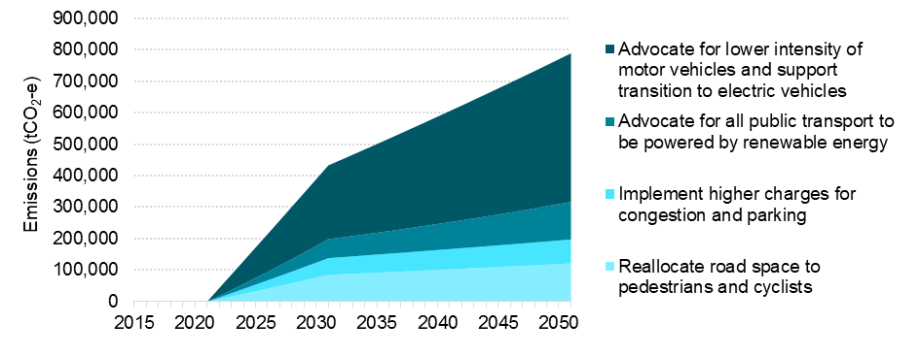
Accelerated modelled action | 2030  tonnes of carbon dioxide equivalent | % of reduction as at 2030 | 2050  tonnes of carbon dioxide equivalent | % of reduction as at 2050 | Cumulative total tonnes of carbon dioxide equivalent | Cumulative %
Reallocate road space to pedestrians and cyclists | 85,098 | 20% | 121,560 | 15% | 2,540,503 | 17%
Implement higher charges for congestion and parking | 53,186 | 12% | 75,975 | 10% | 1,587,814 | 11%
Advocate for all public transport to be powered by renewable energy | 60,257 | 14% | 119,567 | 15% | 2,077,638 | 14%
Advocate for lower intensity of motor vehicles and support transition to electric vehicles | 234,260 | 54% | 471,563 | 60% | 8,483,821 | 58%

Proposed actions
- Reallocate road space to create more space for walking, cycling and green infrastructure.
- Prioritise active and public transport through dedicated lanes, traffic light priorities, parking controls and road user pricing.
- Advocate for public transport to be powered by renewable energy.
- Advocate for the Victorian Government to build “Metro 2” train infrastructure for Melbourne.
- Advocate for lower carbon intensity of motor vehicles and support transition to electric vehicles.
The above list is a set of indicative actions to address this strategic priority. This list is not exhaustive or final and will be subject to the City of Melbourne’s Annual Plan and Budget process.
Case study: Solar powered trams
In 2017, the Victorian Government ran a tender to help build new large scale solar farms, of which 35 MW will be linked to power Melbourne's tram network. This initiative will reduce more than 80,000 tonnes of greenhouse gas emissions every year to cover 493 trams, and 24 routes across greater Melbourne.
Case study: Congestion prices in Stockholm
Since Stockholm introduced permanent congestion charges in 2007, use of cars and other vehicles has reduced significantly. As a result, carbon dioxide emissions have decreased by 10 to 15 per cent across the inner city, and by 2 to 3 per cent in the metropolitan area. Air quality has improved and there has been an estimated reduction in premature deaths of 25 to 30 annually.

Priority 4: Reducing the impact of waste

The story so far
More than 800,000 tonnes of waste (including garbage and recycling) is estimated to be generated in the municipality each year. Only 6 per cent of this waste is collected by the City of Melbourne. The total waste produced generated 6 per cent of the greenhouse emissions from our municipality in 2015. Emissions from waste are included in our greenhouse inventory even though waste treatment facilities are currently located outside our municipal boundary.
The vast majority of waste in the municipality is generated by business activities, which is collected by private operators. These waste streams have relatively high rates of recycling. The recycling rate is around 61 per cent for commercial and industrial waste, and 87 per cent for construction and demolition waste. The recycling rates are lower for the much smaller volume of waste collected from households (25 per cent) and public places (22 per cent).
The City of Melbourne is currently developing a new Waste and Resource Recovery Strategy with a goal to develop and introduce cost effective, environmentally responsible waste and resource recovery systems. The waste strategy is underpinned by the waste hierarchy and circular economy thinking. A circular economy approach designs out waste wherever possible and keeps materials in use as long as possible through repair and reuse). It then returns materials to the economy through efficient recycling processes.
The Victorian Government sets policy for metropolitan waste and resource recovery including landfill levies, and fund waste and resource recovery programs through Sustainability Victoria. In 2017 the Australian Government released a National Food Waste Strategy with a goal to halve Australia’s food waste by 2030.

Challenges
Waste generated in the municipality is expected to grow as Melbourne’s population increases over coming decades. The City of Melbourne is responsible for collection and recycling or disposal, of waste from our operations, residents and public places such as streets and parks. We do not have the responsibility for waste collection from restaurants, offices or businesses with commercial waste contracts.
State and local governments across Australia have been impacted by the changes in global recycling markets since early 2018. Councils are facing increased costs as a result of the Chinese Government’s decision to tighten standards for the import of recycled materials.

Strategic opportunities
In 2017 the Australian Government released a National Food Waste Strategy with a goal to halve the nation’s food waste by 2030. Organic waste is a priority because it generates greenhouse emissions twenty-five times more intense in their global warming potential than carbon dioxide. By promoting the health benefits of smaller portion sizes and supporting social enterprises to make use of leftover food, we can help to design out food waste and reduce emissions.
There is growing community support for reducing waste as a measure to address climate change. The Victorian Government recently committed to implement a ban on single use plastic bags, which has already been introduced in other states. The South Australian Government has had container deposit legislation to encourage the recycling of bottles and cans. The Australian Government has the power to regulate packaging standards that could significantly reduce waste.
A large proportion of materials that are sent to landfill can be reduced through better design and less packaging. Developing new products from recycled materials including building materials can also contribute to reduced emissions and a circular economy. This has the potential for economic growth in the region and building local capability for recycling rather than relying on overseas treatment of waste.

The environmental, social and economic benefits of taking action
The benefits of taking action to reduce the impact of waste include:
- improved amenity and reduced noise
- neighbourhood co-operation and participation
- improved health outcomes from better outdoor air quality
- waste education benefits
The economic analysis is based on the macroeconomic benefits of reducing greenhouse emissions from waste. It does not include the analysis of waste treatment technology.
Actions modelled:
- Divert commercial and industrial waste from landfill:
  - 70 per cent significant,
  - 75 per cent accelerated
- Divert residential waste from landfill:
  - 30 per cent significant,
  - 85 per cent accelerated
Scenario | Cumulative abatement potential by category | Discounted benefits  ($ million) | Discounted costs ($ million) | Benefit cost ratio
Significant | 4.3 MtCO₂-e | 444.33 | 36.37 | 12.22
Accelerated | 7.5 MtCO₂-e | 741.24 | 71.57 | 10.36
Case study: Diverting food waste from Degraves Street cafes
One of Melbourne’s most iconic laneways is now one of its greenest, thanks to the Degraves Street Recycling Facility. Waste audits at Degraves Street indicated that 90 per cent of waste was either recycling or food waste and could be diverted from landfill. In collaboration with local businesses, the City of Melbourne introduced a shared commercial recycling program and a food dehydrator to turn food waste into a compost-like soil conditioner. The program successfully diverted 237,600 litres of recyclable material from landfill. The organic waste was treated on site and used in the city’s parks and gardens. Businesses on Degraves street also noticeably improved their efforts to reduce waste.
Figure 11: Waste emissions reduction potential
Significant scenario
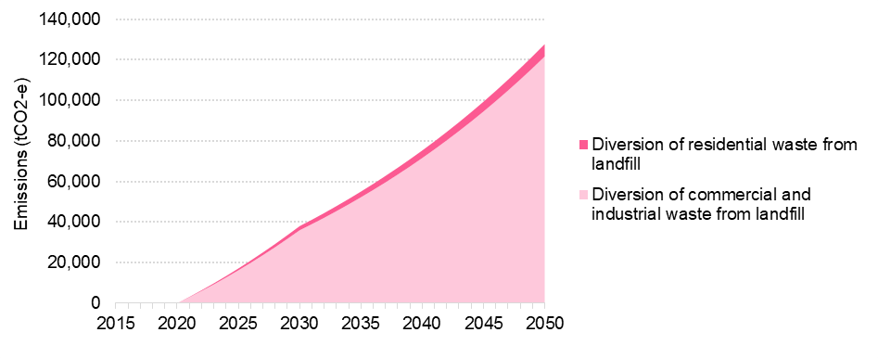
Significant modelled action | 2030 tonnes of carbon dioxide equivalent | % of reduction as at 2030 | 2050 tonnes of carbon dioxide equivalent | % of reduction as at 2050 | Cumulative total tonnes of carbon dioxide equivalent | Cumulative %
Partner to deliver ARRT for diversion of commercial and industrial waste | 39,019 | 95% | 121,647 | 95% | 1,709,285 | 95%
Partner to deliver ARRT for diversion of residential waste (ARRT) | 2,165 | 5% | 6,105 | 5% | 89,239 | 5%
Accelerated scenario
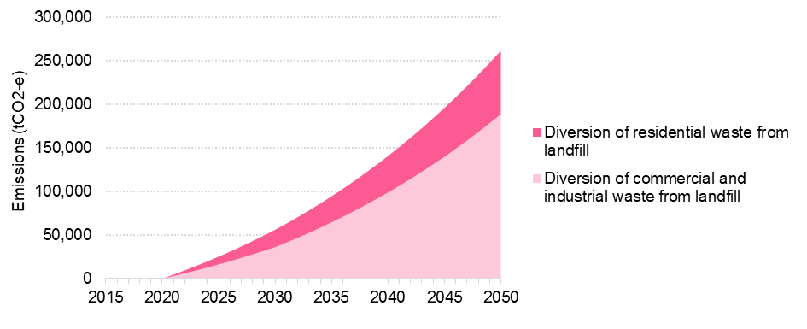
Accelerated modelled action | 2030 tonnes of carbon dioxide equivalent | % of reduction as at 2030 | 2050 tonnes of carbon dioxide equivalent | % of reduction as at 2050 | Cumulative total tonnes of carbon dioxide equivalent | Cumulative %
Partner to deliver ARRT for diversion of commercial and industrial waste | 36,018 | 64% | 188,489 | 72% | 2,327,100 | 70%
Partner to deliver ARRT for diversion of residential waste (ARRT) | 19,939 | 36% | 72,748 | 28% | 996,148 | 30%

Proposed actions
- Continue to promote and facilitate waste avoidance, recycling, recovery and diversion of waste from landfill by implementing the City of Melbourne’s Waste and Resource Recovery Strategy.
The above list is a set of indicative actions to address this strategic priority. This list is not exhaustive or final and will be subject to the City of Melbourne’s Annual Plan and Budget process.

How we will implement the strategy
Our actions to reduce emissions will be evidence-based and we will report our progress publicly. We have proposed actions that are bold and ambitious, within our powers as well as policy changes and actions needed by the Victorian and Australian Governments.
We will develop a rolling 5-year implementation plan to fulfil the requirements of a Council Pledge under the Climate Change Act 2017. It will provide interim targets and enable us to adjust our approach as Victorian and Australian Government policy settings change or if the shift to renewable energy technology occurs more quickly than expected.
In implementing the Climate Change Mitigation Strategy 2020–2050 we will:
- consider climate adaptation and mitigation in an integrated way, identifying interdependencies to maximise efficiencies and minimise investment risk
- deliver environmental, social and economic benefits to the community and improve the accessibility of these benefits by the community
- take an innovative, transparent and evidence-based approach to report and evaluate progress in implementing the strategy.

Consider climate adaptation and mitigation in an integrated way
Climate change affects human health, particularly for the young, elderly and vulnerable members of our community. It will impact future generations of Melburnians and the long term environmental, social and economic interests of the municipality.
Managing climate risk requires public institutions, investors and businesses to reduce emissions as part of their social license to operate as well as managing the impacts of climate change on people, assets and infrastructure as well as business operations. The relationship between heatwaves and power outages in buildings and public transport is a good example of how climate change adaptation and energy supply issues can interact with negative consequences for the community.
Melbourne is already experiencing the impacts of climate change. Increased drought, flooding and extreme heatwaves have been occurring more frequently and the impacts have become more severe. Experts warn that these impacts will continue to worsen in the next few decades. We updated our Climate Change Adaptation Strategy in 2017 to respond to these challenges. It identifies climate risks and sets actions and priorities to ensure we adapt well to the impacts of climate change.
The Climate Change Mitigation Strategy 2020–2050 will complement and mutually reinforce the priorities of our Climate Change Adaptation Strategy. This will enhance the opportunities for synergies and avoid any unintended trade-offs.
The Climate Change Adaptation Strategy includes five goals:
- Enhance natural environment and green spaces in our municipality.
- Shape our built form and urban renewal areas to withstand future climate change impacts.
- Strengthen the resilience of our inclusive, family friendly and culturally diverse community.
- Protect and enhance our diverse economy.
- Continue to build Melbourne’s adaptation capabilities and expertise.
It is supported by the Total Watermark Strategy, which integrates water management across the municipality in response to increased drought and flooding; and the Urban Forest Strategy, which addresses the impact of drought and the rising temperatures associated with the urban heat island effect. The Nature in the City Strategy aims to improve the health of animal and plant populations including their resilience to climate change impacts. These strategies use nature based solutions to help cool our city on hot days which, improves liveability, resilience and community health. This helps to reduce the heat load on buildings during summer, which reduces the energy needed for air conditioning and peak demand on the electricity grid.
As part of our implementation plan for our Climate Change Mitigation Strategy 2020–2050, we will consider the potential for positive or negative synergies, trade-offs and feedback loops between our climate change adaptation and emission reduction goals. This will ensure that we can increase community benefits and avoid unintended negative consequences.

Integrating climate adaptation and mitigation actions
Positive synergy: energy efficient buildings that reduce emissions and also stay cooler during heat waves without the use of air conditioning.
Trade-off: competition for roof space between green infrastructure and solar panels.
Positive feedback loop: enhance the urban forest and use green infrastructure to reduce the urban heat island effect reducing both flood risk and the impact of heat on buildings.
Negative feedback loop: irrigating green infrastructure increases demand for water and can also increase greenhouse emissions for pumping and treatment of water supply.

Social inclusion and community participation
Currently, about 140,000 residents live in the municipality, while the weekday population of city workers and visitors is 900,000 (as at 2017).The resident and daily visitor populations are expected to nearly double by 2036.
Climate change will impact everyone however some members of our community are more vulnerable to heatwaves, energy bill shock and changes to buildings and transport infrastructure. Melbourne is also a culturally diverse city, well known for its food culture, community festivals and beautiful parks and gardens. These qualities contribute to our reputation as a liveable city.
This draft Climate Change Mitigation Strategy 2020–2050 prioritises actions that support the health and wellbeing of the community including future generations.
Our aim is for a socially inclusive strategy, in keeping with the values of fairness and equity that people expressed during the Future Melbourne deliberative democracy process in 2016.
The City of Melbourne will consult widely on the ideas presented in this draft strategy, to ensure they support community participation and the fair distribution of benefits.

Health benefits
Healthy lifestyles can contribute to reducing greenhouse gas emissions through daily activities such as walking and cycling. These activities produce zero greenhouse gas emissions compared to cars and contribute to mental and physical health. Eating a healthy diet, reducing portion sizes to avoid food waste, and consuming less meat can also contribute to lower greenhouse gas emissions. Buying locally produced food, rather than food transported long distances, also reduces greenhouse gas emissions. Energy efficient homes are better at keeping warm in winter and cool in summer, saving money on energy bills and protecting people during heatwaves.
We engaged expert consultants to conduct community focus groups, research the links between climate change and health and identify social impacts of our priorities and actions. The social benefits identified included:
Energy supply
- Switching to renewable energy suppliers means less emissions of health damaging air pollutants from fossil fuels.
Buildings
- Transitioning to more energy efficient or carbon neutral buildings supports mental and physical health measures, improved living conditions and thermal comfort, greater productivity, engagement and retention.
- Transitioning to greater energy efficient or carbon neutral buildings can also offer improved access, inclusion and affordability for people from low income households.
Transport
- A combination of a reduction in air pollution from reduced vehicles on the road, shift to active transport and switch to electric vehicles presents considerable health savings.
- Health savings due to Quality Adjusted Life Years gains from reduced pollution could be up to $120 billion for the accelerated scenario.
- Increased walking is estimated to produce accumulated savings of up to $6 billion in an accelerated scenario and up to $3.5 billion in a significant scenario.
Waste
- Actions that promote community engagement and education to divert waste from landfill can contribute to neighbourhood participation, which could be worth up to $26 million by 2050.

Innovation, knowledge and transparency

Developing and sharing new solutions
Advances in building intelligence systems provide the foundation for using technology to enable a smarter city. The City of Melbourne has demonstrated new energy saving technologies including one of the first large solar arrays on the sheds of the Queen Victoria Market, and we trialled micro-turbines on the rooftop of Council House 2. The installation of smart meters in buildings across the city, and technological advances in building intelligence systems provide the foundation for using technology to enable a smarter city. We collaborated with the University of Melbourne and Royal Melbourne Institute of Technology, launching an innovation precinct to test smart city technology.
We work with governments, international and local city networks and university researchers on demonstration projects, pilot programs, and testing new solutions. We also sponsor competitions and hack-a-thon events for university students to develop the skills needed for the low carbon economy of the future.
The City of Melbourne also participates in several international and local city-networks that support knowledge sharing between cities on climate change solutions. The development of this strategy was part of an international pilot program run by C40 for cities to share solutions. We contribute to the international efforts of cities to address climate change through the International Council for Local Environment Initiatives (ICLEI), the Carbon Neutral Cities Alliance and 100 Resilient Cities. We collaborate with other Australian capital cities and metropolitan Melbourne local governments in the delivery of programs.
We could support innovation by using the city as a lab to test and refine solutions. Real-time, publicly accessible data about the city’s energy performance and emissions profile would enable people to develop new digital, transport and energy solutions.
Multiple research gaps and information barriers must be addressed before real-time city-wide data could be made available. Some basic data, including the average energy performance of apartments, is not currently available.
More research is needed to identify the best methods to avoid waste and achieve carbon positive buildings and precincts, zero emissions transport and renewable energy. By collaborating with other cities and urban researchers, we will be better able to identify gaps and commission urgent research to help us track our progress.

Measuring, reporting and evaluating progress
We will develop a comprehensive measurement and evaluation plan to accompany this strategy. It will also fulfil the requirements of the Council Pledge made under the Climate Change Act 2017, to evaluate and report on the implementation of emission reductions by 2025.
We will report our progress annually as part of our commitment to the Global Compact of Mayors and Carbon Disclosure Project, supporting the transparency priorities of the Future Melbourne 2026 Plan and the Local Government Bill 2018.
The Carbon Disclosure Project provides a holistic reporting framework for cities to report the emissions profile of the municipality, emission reduction actions, greening, and climate adaptation; in order to support the measurement, monitoring and management of environmental impacts.
Our reports will be publically accessible on the Carbon Disclosure Project Cities platform so that our performance can be tracked, evaluated, and benchmarked against other cities.

List of proposed actions
Actions and initiatives outlined in this strategy are indicative. The final strategy and set of actions will inform the City of Melbourne’s planning and resourcing considerations and will be subject to Annual Plan and Budget processes.
Priority 1: 100 per cent renewable energy
- Advocate for a more ambitious renewable energy target.
- Accelerate corporate Power Purchase Agreements.
- Facilitate residential purchasing of renewable energy products.
- Facilitate a virtual power plant for residents.
- Collaborate with other cities, investors, superannuation companies to accelerate divestment from fossil-fuel energy supply.
- Partner with businesses and universities to promote innovative renewable energy technology and research.
Priority 2: Zero emissions buildings and precincts
- Demonstrate innovative carbon positive design and operation of council-owned buildings and precincts.
- Partner with industry, Victorian and Australian Government agencies to reduce barriers and deliver zero emissions buildings and urban renewal precincts.
- Accelerate existing commercial buildings and tenants’ energy efficiency programs through CitySwitch and other partnerships
- Advocate for energy performance disclosure for a greater range of commercial buildings, plus residential buildings, at the point of lease and point of sale.
- Facilitate the take up of the National Built Environment Rating Scheme for apartments across the municipality.
- Renew and implement planning policies to support the development of zero emissions buildings and precincts.
- Partner with industry to advocate for higher energy performance standards in the National Construction Code, Building Act 1993 and regulations.
- Advocate and facilitate to transition from gas to electricity in buildings and precincts.
- Adopt circular economy principles to reduce the environmental impact and embodied emissions from products, materials and buildings across the city through procurement, urban design and planning.
Priority 3: Zero emissions transport
- Reallocate road space to create more space for walking, cycling and green infrastructure.
- Prioritise active and public transport through dedicated lanes, traffic light priorities, parking controls and road user pricing.
- Advocate for public transport to be powered by renewable energy.
- Advocate for the Victorian Government to build “Metro 2” train infrastructure for Melbourne.
- Advocate for lower carbon intensity of motor vehicles and support transition to electric vehicles.
Priority 4: Reducing the impact of waste
- Continue to promote and facilitate waste avoidance, recycling, recovery and diversion of waste from landfill by implementing the City of Melbourne’s Waste and Resource Recovery Strategy.
Additional actions to implement the strategy
- Identify and address synergies, trade-offs and feedback loops between the implementation of the Climate Change Mitigation Strategy 2020-2050, Climate Change Adaptation, Nature in the City Strategy and other relevant strategies.
- Take an innovative, evidence-based approach to prioritising actions and open data on our emissions profile for urban researchers to develop new solutions.
- Participate in city-networks to share knowledge and continue to co-lead the C40 Low Carbon Districts and Climate Positive forum to learn from innovative international projects.
- Report progress in reducing emissions annually and update the rolling 5-year implementation plan based on progress.
- Evaluate the implementation of the strategy by 2025 to meet the Council Pledge requirements under the Climate Change Act 2017.

References
Australian Sustainable Built Environment Council and Climate Works Australia. (2018). Built to Perform: An Industry Led Pathway to a Zero Carbon Ready Building Code. Retrieved from Australian Sustainable Built Environment Council and Climate Works Australia Built to Perform: An Industry Led Pathway to a Zero Carbon Ready Building Code report (PDF 2630KB)
Building Act 1993
City of Melbourne Council resolution October 2015 Retrieved from City of Melbourne Council resolution October 2015 (PDF 25KB)
Climate Change Act 2017
Commonwealth of Australia. Department of the Environment and Energy (2018). Carbon Neutral Network. Retrieved from Commonwealth of Australia: Department of the Environment and Energy website
C40 Cities Climate Leadership Group. (2018). About C40. Retrieved from C40 Cities website
Local Government Bill 2018.
Saddler, H. (2018). National Energy Emissions Audit: Electricity Update. Retrieved from National Energy Emissions Audit: Electricity Update website
Stadler, A. (2018) Corporate PPAs already deliver 34% of generation capacity required under the Renewable Energy Target. Retrieved from Energetics website
State of Victoria. Department of Treasury and Finance (2013), Economic Evaluation for Business Cases Technical guidelines. Retrieved from State of Victoria, Department of Treasury and Finance, Technical Guides website
State of Victoria. Sustainability Victoria. (2016). Victorian’s Perceptions of Climate Change. Retrieved from State of Victoria, Sustainability Victoria website
United States Environmental Protection Agency. (2016). Social Cost of Carbon. Retrieved from EPA Fact Sheet (PDF 72KB)

Appendix A: Technical notes

Melbourne’s greenhouse gas emissions profile
The City of Melbourne uses the Greenhouse Protocol for Communities (GPC) to measure and report municipal greenhouse emissions. Emissions are reported annually through the Carbon Disclosure Project (CDP) platform, which is a requirement of Global Covenant of Mayors and C40 membership. The sources of emissions that are reported using this method are illustrated in the diagram below.
Figure 12: Greenhouse protocol for community’s emissions boundary
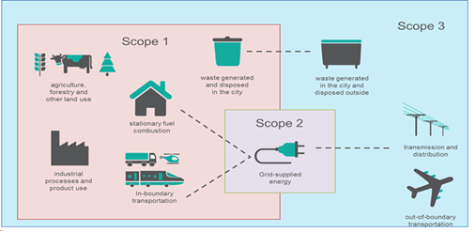
Scope 1:
- Agriculture, forestry and other land use
- Industrial processes and product use
- Waste generated and disposed in the city
(links to Scope 3 waste generated in the city and disposed outside)
- Stationary fuel combustion (links to scope 2 grid-supplied energy)
- In-boundary transportation (links to scope 2 grid-supplied energy)
Scope 2:
- Grid-supplied energy (links to scope 1, stationery fuel combustion and in-boundary transportation, and scope 3, out of boundary transportation and transmission and distribution)
Scope 3:
- Waste generated in the city and disposed outside
- Transmission and distribution
- Out-of-boundary transportation
A second method for measuring emissions is called the consumption-based approach which takes into account the upstream and downstream impacts of products and services that Melbourne consumes including imports and exports from the city. Under this method, the emissions produced by growing, producing and transporting food, or the manufacture of clothing or building products, and the mining and industrial processing of raw materials are also included.

Calculating costs and benefits
In this analysis, economic benefits are represented by the avoided social and economic damage costs of greenhouse gas emissions. These benefits are quantified using the Social Cost of Carbon (SCC) in accordance with the Victorian Department of Treasury and Finance guidelines.
The SCC was developed by the US Environment Protection Authority (EPA) to assess the cost of actions with marginal impacts on cumulative global emissions. It estimates the dollar figure of damages over the next 100 years (or more) from one extra tonne of greenhouse gas emissions.
This marginal cost is calculated using three integrated assessment models translating emissions into changes in atmospheric greenhouse concentrations, atmospheric concentrations into changes in temperature and changes in temperature into economic damages. A range of plausible socio-economic and emissions trajectories are used.
The SCC “is a comprehensive estimate of climate change damages and includes, among other things, changes in net agricultural productivity, human health, property damages from increased flood risk and changes in energy system costs, such as reduced costs for heating and increased costs for air conditioning.
The EPA’s model looks at the future impacts (out to 2300) of emitting one tCO2-e today. It quantifies the damage costs caused by global temperature increases due to an additional tonne and discounts this back to today’s value.

Appendix B: Long alternative text descriptions

Figure 1 and Figure 6 Emissions reductions needed under each scenario
This graph shows the trajectory of four emission reduction scenarios between 2015-2050, showing expected total emissions across the municipality per year.
- The business as usual scenario – this shows that total emissions are expected to remain at the current just under 5 million tonnes of carbon dioxide equivalent per year, gradually decreasing to just under 4 million tonnes of carbon dioxide equivalent per year by 2035 due to current local, state and national policy measures, and then increasing back to 5 million tonnes of carbon dioxide equivalent per year by 2050.
- The significant action scenario shows a gradual decline in emissions reaching approximately 600,000 tonnes of carbon dioxide equivalent per year by 2050- the residual emissions level.
- The accelerated action scenario shows a steeper decline in emissions reaching approximately 600,000 tonnes of carbon dioxide equivalent per year around 2043, and decreasing further to less than 500,000 tonnes of carbon dioxide equivalent per year by 2050- the residual emissions level.
- Offsetting all remaining emissions from 2020 scenario. This scenario shows emissions abruptly reducing from 2020 due to the purchase of offsets.
The City of Melbourne’s preferred approach is to deliver the actions needed to achieve the significant action scenario and pursue actions for the accelerated action scenario where there is the opportunity to go further.
This will require us to take bold action within our powers, collaborate and advocate for policy change from the Victorian and Australian Governments. Our approach aligns with the Paris Climate Agreement while acknowledging our limited powers and financial resources.

Figure 2 and Figure 7 Significant emission reduction scenario 2020–2050
These two graphs shows the emissions reductions needed from each of the key sectors of Waste, Transport, Buildings and Energy Supply by 2050, under the Significant Action Scenario and the Accelerated Action Scenario.
It shows that Energy Supply is the most significant opportunity reduce to emissions, accounting for approximately 500,0000 tonnes of carbon dioxide equivalent per year by 2030, and 2 million tonnes of carbon dioxide equivalent per year by 2050 under the Significant Action Scenario- or 50% of cumulative emissions reduction.
Under the Accelerated Action Scenario the emissions reduction from this sector increases to approximately 800,000 tonnes of carbon dioxide equivalent per year by 2030, and 1.9 million tonnes in 2050, or 45% of cumulative emissions.
Emissions from the Buildings sector are the second most significant opportunity. Reductions needed to meet the Significant Action scenario are 550,000 tonnes of carbon dioxide equivalent per year in 2030, or 26% of total emissions reduction at that date, and 1.4 million tonnes, or 34%, at 2050. This is 30% of cumulative emissions to 2050.
Under the Accelerated Action Scenario the emissions reduction from this sector increases to approximately 800,000 tonnes of carbon dioxide equivalent per year by 2030, or 40% of total emissions reduction at that dates, and 1.9 million tonnes at 2050. This is 31% of cumulative emissions to 2050.
The Transport sector accounts for 200,000 tonnes of carbon dioxide equivalent per year by 2030, equivalent to 19%, and 650,000 tonnes or 18% in 2050- this is 17% of cumulative emissions to 2050.
Under the Accelerated Action Scenario the emissions reduction from this sector increases to approximately 430,000 tonnes of carbon dioxide equivalent per year by 2030, or 23% of total emissions reduction at that date, and almost 800,000 tonnes, or 18%, at 2050. This is 19% of cumulative emissions to 2050.
Emissions reduction opportunity from the waste sector under the Significant Action scenario is 17,000 tonnes of carbon dioxide equivalent, or 5% at 2030, and 127,000 tonnes of carbon dioxide equivalent or 3% of the total in 2050. Waste is 3% of cumulative emissions.
Under the accelerated scenario waste actions account for the remaining 55,000 tonnes or 3% of emissions reduction opportunity in 2030, and 260,000 tonnes or 6% in 2050- 4% of cumulative emissions.

https://unfccc.int/process/the-paris-agreement/what-is-the-paris-agreement
https://unfccc.int/process/the-convention/history-of-the-convention
http://parlinfo.aph.gov.au/parlInfo/search/display/display.w3p;query=Id%3A%22media%2Fpressrel%2F4926485%22
http://www.ipcc.ch/
Sustainability Victoria Social Research on Climate Change 2016
The calculation for 2030 needs to follows the C40 Deadline 2020 approach with contraction and convergence of emissions by 2030. This means our target needs to be no more than 14.6 tonnes CO2 equivalent per person by 2030.
The C40 Climate Action Planning Framework supports cities in developing climate action plans. It sets out the essential components of a climate action plan that is deemed to be compatible with the objectives of the Paris Agreement.
Populations correct as at 2017. Our per capita emissions are calculated by dividing total emissions of the municipality by the number of residents. The central business district is quite energy intensive compared to residential suburbs and this affects the result. This is the standard used internationally to compare the emissions of cities.
Sustainability Victoria Social Research on Climate Change 2016
C40 Cities website
Council resolution October 2015 (PDF 25KB)
These are called “consumption-based” emissions.
City of Melbourne Emission Reduction Plan for our operations (PDF 2072KB)
Australian Government Carbon Neutral Program website
Local Government Bill 2018 Part 2 Division 1 Section 9
The Australia Institute National Energy Emissions Audit (PDF 376KB)
Energetics website
Benefits to the community compared to the business as usual scenario.
ASBEC and ClimateWorks Australia. 2018 website.
Benefits to the community compared to the business as usual scenario.
Benefits to the community compared to the business as usual scenario.
Benefits to the community compared to the business as usual scenario.
The quality-adjusted life year is a generic measure of disease burden, including both the quality and the quantity of life lived. It is used in economic evaluation to assess the value for money of medical interventions.
https://www.asbec.asn.au/wordpress/wp-content/uploads/2018/07/180703-ASBEC-CWA-Built-to-Perform-Zero-Carbon-Ready-Building-Code-web.pdf
https://www.melbourne.vic.gov.au/about-council/committees-meetings/meeting-archive/meetingagendaitemattachments/706/12791/oct15%20ccl%20agenda%20item%207.4.pdf
http://www.environment.gov.au/climate-change/government/carbon-neutral/certified-businesses
https://www.c40.org/about
http://www.tai.org.au/content/audit-july-electricity-update
https://www.energetics.com.au/insights/thought-leadership/corporate-ppas-deliver-34-of-generation-capacity-required-under-the-ret/
https://www.dtf.vic.gov.au/investment-lifecycle-and-high-value-high-risk-guidelines/technical-guides
http://www.sustainability.vic.gov.au/About-Us/Research/Victorians-perceptions-of-climate-change
https://www.epa.gov/sites/production/files/2016-12/documents/social_cost_of_carbon_fact_sheet.pdf
Department of Treasury and Finance, Economic Evaluation for Business Cases Technical guidelines, August 2013
EPA 2015, Social cost of carbon fact sheet

