Transport Strategy Refresh
Participate Melbourne Community Engagement Analysis
EY Sweeney

Introduction

Background

Context
- The City of Melbourne is refreshing its Transport Strategy (2012) to prepare for significant population growth and changes expected over the coming decades, and to establish a long-term vision for transport policy for the next ten years.
- Short discussion papers, which present evidence, best practice from other cities, options and ideas for consideration were developed to encourage community debate and to prompt discussion to inform the draft Transport Strategy.
- Each paper was released to the public and the media individually between April and July 2018 via the Participate Melbourne website. The Participate Melbourne site included a dedicated page for each topic area with materials relating to each topic and space for community feedback.
- The focus of this document is to report on the information submitted by the community via the Participate Melbourne website.

The overall aim of this report
To provide independent reporting of responses received from the community on the Transport Strategy refresh discussion papers.
- Develop coding framework to identify key themes
- Code responses to the framework
- Analyse and present the results in a written report

Community submissions
- The discussion papers contained ‘What if’ statements and prompting questions in order to commence the community conversation. Each topic page presented 4-5 prompts for feedback, requesting community members:
  - share experiences in relation to the topic (e.g. what is your experience of walking in Melbourne?)
  - share ideas about how to address the issues raised in the paper
  - share thoughts on the ‘what if’ ideas put forward in the paper
  - share thoughts on the visual scenarios presented
  - share any additional thoughts through an open text response
- At the completion of the consultation period, the City of Melbourne received the following responses to be analysed:
  - 1,024 submissions via Participate Melbourne relating to discussion paper topics
  - 252 submissions via Participate Melbourne as part of the ‘ideas forum’
  - 40 submissions received via email and mail.
- Note: the 40 additional submissions have been combined with those received via Participate Melbourne and reported as a part of the ‘additional comments’ sections, where appropriate.

Considerations
Based on the information provided in the consultancy brief, we acknowledge the following issues have been taken into consideration when designing the framework for coding and analysis:
- Transport lens… In order to provide meaningful input for the Draft Transport Strategy, it is critical that all analysis and interpretation is conducted through a transport lens. Themes that do not have a direct link to transport have been filtered.
- Data integrity … The commentary provided by the community via the Participate Melbourne website was not restricted. That is, there were no constraints or sampling approach applied. This means that specific targeted input from lobby groups or other interest parties cannot be distinguished from any other responses. This report is simply categorising and reporting on the data provided rather than necessarily an accurate representation of the views of the entire community.

How to read this report

Coding of responses
Given the expansive nature of many of the comments provided by the community, reporting has endeavoured to capture as much context as possible in the coding process. As such, many comments have been allocated to multiple codes, as they are multi-faceted in their content. Consequently, the percentages presented in charts will add to more than 100%.Codes should not be combined by readers of this report by adding the percentages reported on the page.

‘Other’ codes
Reporting has aimed to capture as much of the richness provided in community comments as possible. However, given the volume of feedback provided and the wide-ranging nature of responses, for practical purposes comments with few or no other directly equivalent comments have been grouped into a catch-all category ‘Other’.

For the purposes of reporting, codes receiving only a limited number of responses have also been combined into ‘Other’. To view these additional codes, please refer to the appendix.

Key themes
In order to quantify the most common sentiments contained within the comments, key themes have been highlighted, where appropriate. Indicators have been included on pages to show the reader which codes have been combined to create key theme figures.
The key theme groupings contained within this report have been calculated using statistical software that takes into account the multiple coding of comments.

Post code data

Distribution of responses
- Responses collected via Participate Melbourne came from a wide range of postcodes throughout Victoria; including regional areas, such as Ballarat.
- The suburbs which recorded the greatest number of responses are typically those surrounding the CBD: especially the Northern and Western inner suburbs.

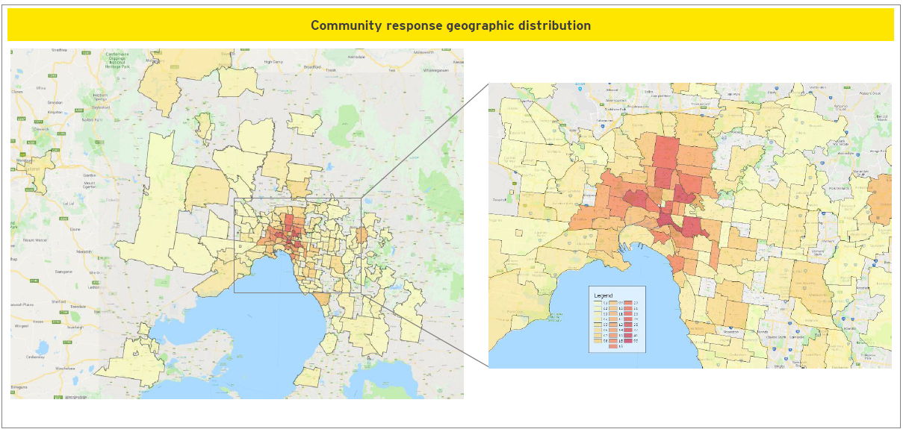

Executive Summary

Ideas forum
Analyses of comments in the ideas forum shows improvements to cycling infrastructure as the most positively perceived topic of public discussion, with 40 comments and a combined 426 net ‘up-votes’ (471 ‘up-votes’ minus 45 ‘down-votes’). Improvements to public transport and pedestrian infrastructure also proved to be popular themes of discussion, receiving 293 and 261 net ‘up-votes’, respectively.
Motor cycle parking appears to divide opinions, receiving a large number of comments and achieving 100 net ‘up-votes’, despite receiving the most ‘down-votes’ of any topic analysed.

Walking (74% support discussion paper suggestions)
When asked to describe their experiences of walking in Melbourne, around one in two contributors (54%) highlight that overcrowding on footpaths is detrimental to their enjoyment of the inner city. Comments provided suggest that the effects of overcrowding are exacerbated by poor pedestrian etiquette (21%) and the length / frequency of crossing signals at intersections (20%). To address these issues, almost three in four (74%) contributors support proposals for car-free zones and pedestrian priority. CBD-wide slow zones for vehicles was a more divisive proposal –with one in fourteen (7%) contributors feeling it would have little benefit for pedestrians and worsen congestion for drivers.

3. City Space (87% support discussion paper suggestions)
The Hoddle Grid is seen to be struggling to cope with population growth, with seven in ten comments (68%) describing it as overcrowded. A quarter of contributors suggest that overcrowding contributes to impatience and confusion amongst drivers, leading to risky behaviour. To address these issues, the majority (59%) of responses suggest initiatives to reduce the interaction between cars and pedestrians: either through superblocks (31%), a car-free CBD (23%), or reduced parking (18%).

4. Public Transport Network (63% support discussion paper suggestions)
Public transport services are found to be overcrowded by two in five commenters (38%). Frequent delays are also mentioned by 25% of contributors. Dedicated lanes for trams and buses is seen as a way to improve public transport by a quarter of commenters. There is also a desire for more services to be added to existing public transport routes (20%).
Long term public transport proposals, such as Melbourne Metro 2 & 3, are viewed as desirable by two in three (63%) responses.

5. Emerging Technology
Compared to other topics, the responses to emerging technology was limited. Despite all topics receiving coverage in traditional and social media, only 18 individuals submitted responses with regards to emerging technology.

6. Cycling (90% support discussion paper suggestions)
Of the eight topics tested, cycling received the greatest number of responses, with 366 community members responding. Three in five (61%) comments describe cycling in the inner city as being dangerous due to forced interactions with vehicles and pedestrians. Responses commonly mention the risk of car-dooring (16%) and collisions with pedestrians entering cycling lanes (17%). To alleviate these risks, two in three (66%) suggest increasing the separation between cyclists and other modes of transport through the expansion of dedicated cycling lanes (56%) and protected intersections (20%). It is also felt amongst one in eight (13%) respondents that greater education is needed to ensure all road users are aware of the appropriate road rules and accordant behaviours.

7. Car Parking (67% support discussion paper suggestions)
Half (53%) of responses to car-parking issues recommend the de-prioritisation of cars and / or improvement of other transport modes as a long-term solution. Proposed changes to parking in Melbourne were received warmly by two in three contributors (67%).

8. Motor Vehicles (60% support discussion paper suggestions)
Two in five (41%) comments contain anecdotes of cars in the Hoddle Grid engaging in reckless or illegal behaviours. These behaviours are seen to compromise the safety of pedestrians, cyclists and other motorists. Comments from motorists support these observations and express frustration with traffic congestion experienced while driving in the CBD (23%).

To address these issues, over half (55%) of comments relate to improving alternative modes of transport to reduce the reliance on private vehicles. Most commonly, the modes cited are: cycling (33%), walking (31%) and public transport (23%). There is some limited support for encouragement of motor-cycle usage (3%). This emphasis on alternative transport modes is also shown in the overwhelming (80%) support shown for Scenario 2, which emphasises dedicated bike lanes, greenspace, and motorcycle parking.

9. Transport Pricing (44% support discussion paper suggestions)
When prompted to think about the costs of different modes of transport, the view of two in five (41%) contributors is that public transport needs to be improved before congestion pricing is applied. Even if they support the concept of congestion pricing in theory, two in five (41%) comments express scepticism about the ability of any government body to practically implement such a solution.

Detailed findings

Ideas forum- sample
Between April and July 2018, City of Melbourne undertook community consultation on a number of topics that are being considered in the development of a new Transport Strategy for Melbourne.

The Participate Melbourne site also allowed members of the community to post comments that were publically viewable on the site. These comments were open for other community members to ‘up-vote’ or ‘down-vote’.

This section summarises the top 10 most ‘up-voted’ topics of comments provided. Other topics and their respective votes are viewable in the appendix.

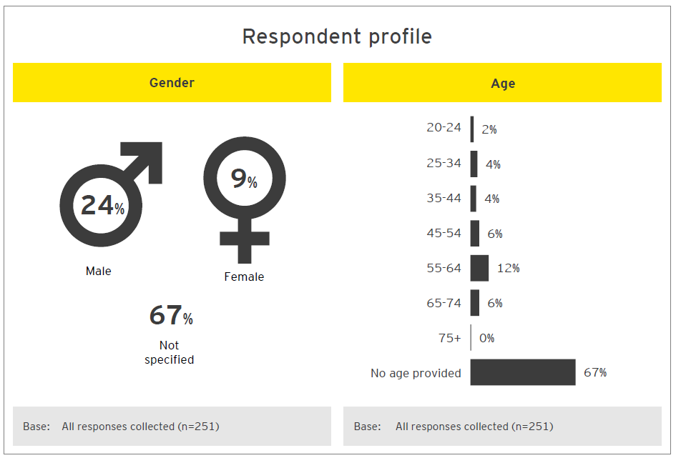

Ideas forum
- Comments pertaining to the improvement of cycling infrastructure received the greatest number of net ‘up votes’ (‘up votes’ minus ‘down votes’).

- Motor cycle parking proved to be a divisive topic receiving the fifth most ‘up votes’ and the most ‘down votes’ outright.

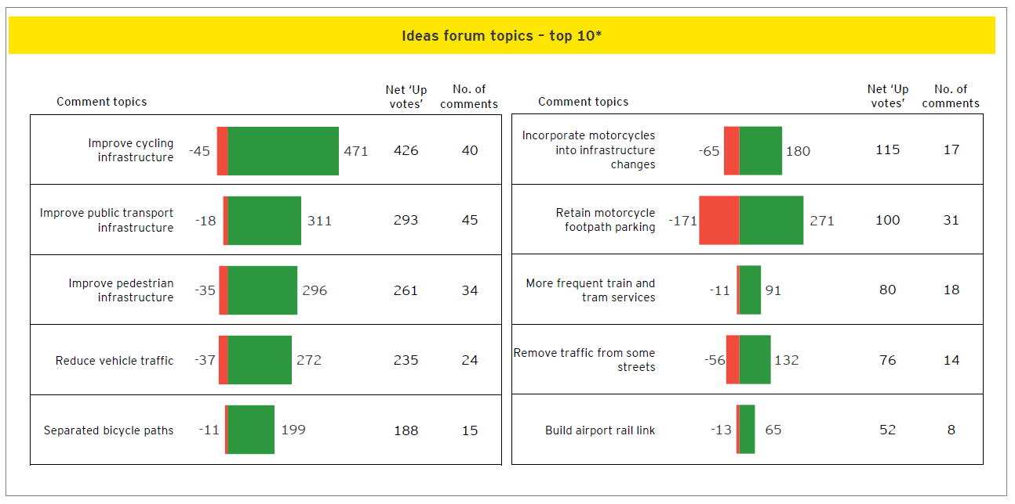

Discussion papers

Walking

Introduction and sample
Between April and July 2018, City of Melbourne undertook community consultation with regards to a number of topics that are being considered in the development of a new Transport Strategy for Melbourne. Eight topics were presented to the public, via the Participate Melbourne website. This section summarises feedback to the Walking topic. For more information about the discussion paper in question, please refer to the Participate Melbourne website: https://participate.melbourne.vic.gov.au/transportstrategy/walking

Extract of discussion paper tested
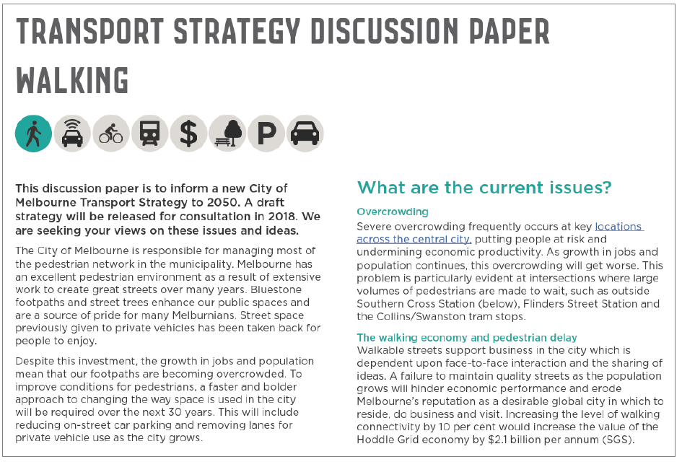

Walking: respondent profile
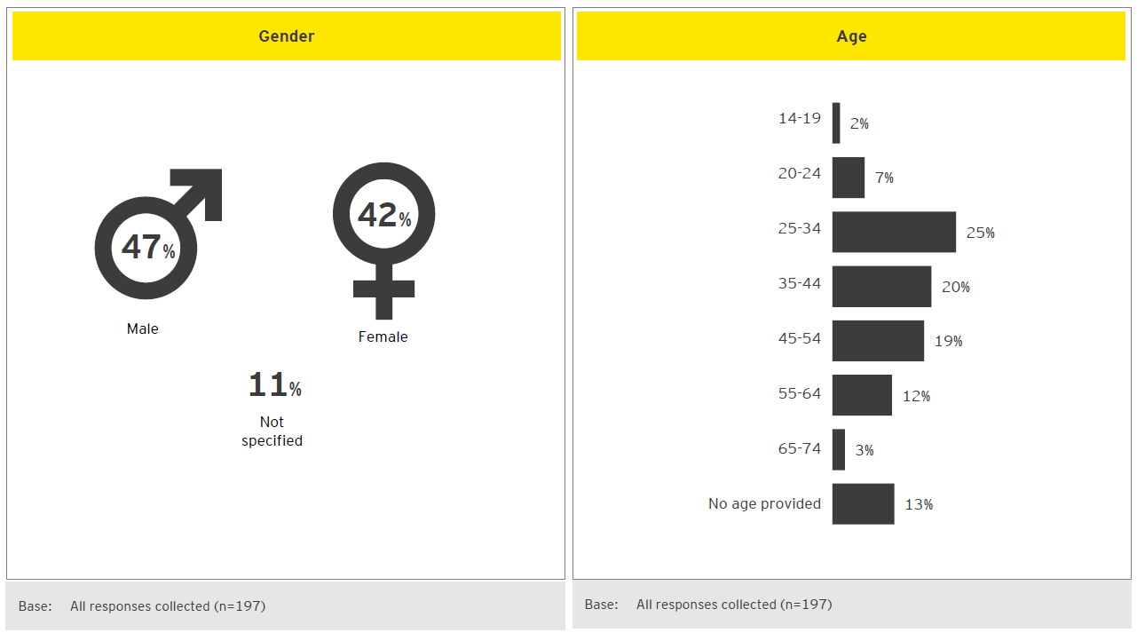

Walking: experiences walking in CBD
- Overcrowded footpaths reduce walking enjoyment… Respondents had several suggestions to reduce the congestion on footpaths. Firstly, many suggest physically widening the footpaths –although it is not always apparent that commenters consider this would come at the expense of other modes of transport (i.e. would involve reducing parking or narrowing streets for vehicles).
- In part due to reduced space…. Alternatively a number of responses pertained to reclaiming existing footpath space by restricting the ability of cafes and restaurants from expanding their seating on to the footpaths. Street performers and lengthy queues that impede pedestrian traffic were also mentioned as activities that could be regulated and reduced.
- Intersections are seen to be congested and unsafe for pedestrians…. As a by-product of the traffic congestion for the CBD, busy intersections often result in vehicles becoming stranded and ignoring traffic signals (such as pedestrian crossing lights) in attempts to clear the intersection.
- Pedestrians can be prone to poor etiquette, especially when using mobile phones… Inattentive pedestrians are a frequent source of frustration to many. They are seen to impede other travellers by walking slowly or meandering erratically.
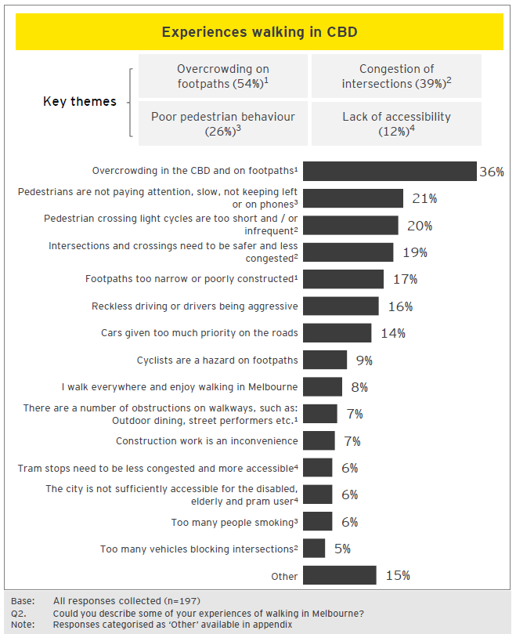

Experiences with walking
Overcrowding

“Footpaths are often crowded. They are increasingly overshadowed and wind effected by new poorly designed tall buildings, especially in the Northern CBD.”

“Melbourne footpaths are commonly too small for the number of people using them. All the footpaths on the ‘Little' streets are barely wide enough for 2 people to walk past each other and are clearly not wide enough for people with accessibility requirements. Little Bourke St (China town) is a prime example, it's a very busy restaurant area where the vast majority of people are walking, but 90% of the space is allocated to the few cars/taxis driving through.”

“Overcrowding, safety concerns at night, other walkway users blocking paths i.e. standing in groups to have a discussion, buskers taking up too much of the path space, people not knowing to stand to the left on stairs/escalators.”

Pedestrian congestion at intersections
“Wait times at crossings is much too long, especially at peak periods. There can be hundreds of people waiting to cross (while about 20 people go by in private vehicles). This encourages people to cross against the lights and is more dangerous for all road users.”

“I find it to be very crowded at major intersections in the CBD and often get stuck behind dawdling people who I can't navigate around easily as there is not enough room to pass.”

“Cars jumping the traffic lights and blocking pedestrians at intersections -this is the biggest problem right now. Also food delivery e-bikes riding on pavements at incredible speeds. Motorbike sales shops in Elizabeth Street using pavement space to display their stock.”

Walking: suggestions to address issues
- The issues highlighted on Participate Melbourne were:
- Overcrowding
- The walking economy and pedestrian delay
- Safety, security, and hostile vehicles
- Restricted mobility
- Comments indicate that there is a desire for wider footpaths to alleviate the strain from overcrowding… More than a quarter of comments contained a suggestion to expand the physical area dedicated to foot traffic in the CBD. It is felt that narrow footpaths, especially in the ‘Little’ streets (Little Collins for example), are unable to cope with the volume of foot traffic using them.
- Reducing the number of cars in the CBD is seen as a way to facilitate this goal… It is felt that, in order to free up the space required to expand pedestrian areas, the number of cars in the CBD could be reduced: either through car free zones or limitations in the availability of parking.
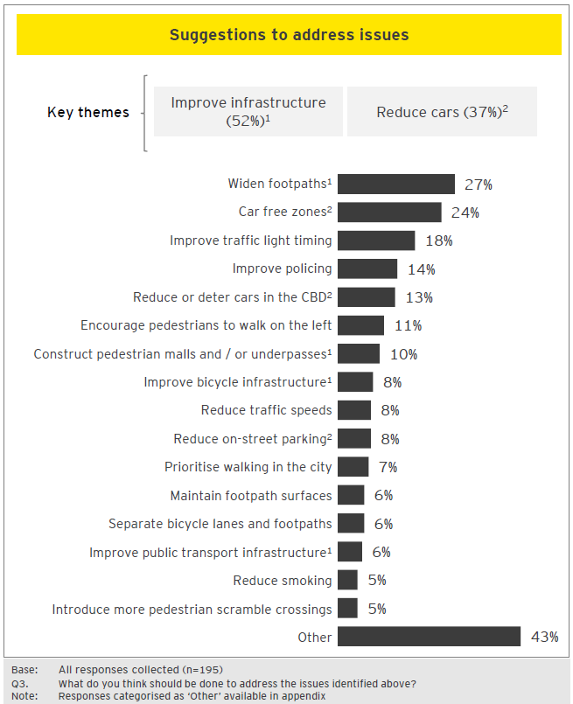

Suggested actions
Infrastructure
“Wider footpaths, priority to pedestrians at traffic lights, lower speed limits for cars and fewer cars in the city.”
“Widen footpaths where possible. Pedestrianisehuge areas of the CBD and inner suburbs. So many roads are unnecessary and could be pedestrianised without impacting traffic. Especially small streets near busy pedestrian areas.”
“The footpaths should be widened, there are far more pedestrians than motorists yet much of the street space is given to a handful of cars. It's not about reducing the number of cars in the city, simply about managing space appropriately based on volume of users. Countdown timers at pedestrian crossings should be introduced as well as increasing crossing times.”
Reduction of cars

“Reduce the amount of cars in the city by reducing parking options in the CBD and providing more parking options at train stations. Work with Vic Police to increase safety of pedestrians at intersections from red light runners. Possibility of overpasses at busy intersections. Pedestrianisesmaller streets apart from loading vehicles.”

“More car free zone, more clever way to divide cyclist and pedestrians traffic. Wider foot path and clever street design to let people walk and rest. Better ways to improve street safety.”

“Melbourne should go forward with the congestion pricing to alleviate cars from the CDB. It also should review parking rates and implemented a software based (JIT?) pricing. Melbourne should also protect more the bike lanes from the street and try to pedestrianisemore streets.”

Walking: reactions to discussion paper
- The Participate Melbourne site presented four ‘what if’ ideas for which reaction was sought. What if…
- We implemented car-free zones at pedestrian gathering places to protect pedestrians from vehicles and grow the local retail economy.
- We implemented a CBD-wide slow zone for vehicles. 30km/hr max speed limit in the Hoddle Grid and Docklands, with lower limits and car-free areas around pedestrian hotspots.
- We implemented a pedestrian priority CBD where delays at traffic light for pedestrians were minimised across the municipality.
- We used innovative design of streets and public places to make people safer from vehicles.
- There was strong support for the ideas proposed… Over half of the comments expressed support for the ‘what if’ ideas tested as a whole. Amongst submissions that specifically indicate support for one or more ideas, car-free zones is the most frequently mentioned.
- The vehicle slow zone triggered some concerns amongst the responses… Many commenters are uneasy about the vehicle slow zone, as they feel it will exasperate issues by increasing vehicle congestion.
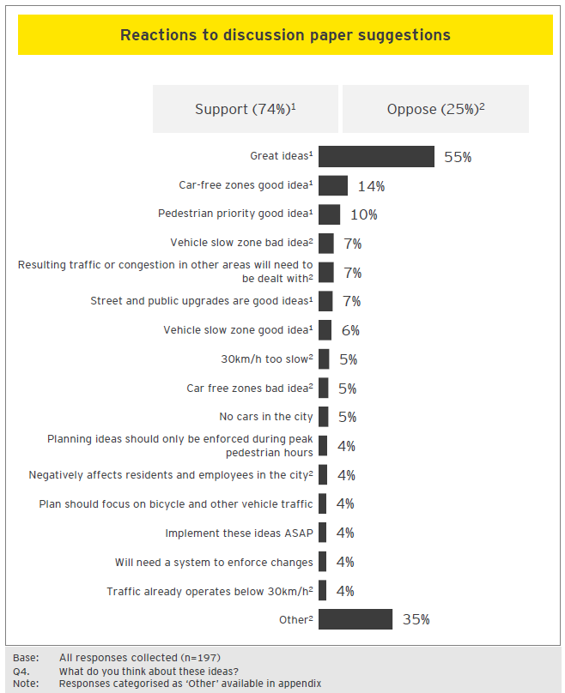

Reactions to discussion paper
Support
“All good. I'm a driver but rarely drive in the CBD as I can walk in from Richmond. Pedestrians should always be the priority. We are the lowest impact, most vulnerable group.”
“All great ideas best one is car free zones.”
“All great ideas. The more car-free areas the better, keep cars to major thoroughfares and encourage trams/walking through the remainder.”
“All sound very good. I think it is important that we also still incorporate bike lanes in such areas too. This would encourage more people to commute into and around to the CBD by bike. This should be designed to keep trams, bikes and pedestrians separate and safe.”
“Excellent ideas. Pedestrianized areas are also able to become a hub for showcasing local artists.”
Concerns
“A CBD wide slow zone would be a total nightmare. Driving and parking in CBD is already a hassle. It is not just about pedestrians. We have to think about businesses and employees who need to get from point A to B quickly. We need to think about families with kids who drive into the city. A slow zone would make a lot of people.’slife difficult. A slow zone would result in overcrowded trams. It would slow down the whole system. Keep the cars moving. Other ideas are good.”
“Not good won’t work because we don't have the infrastructure to redirect the flow of traffic, which in turn will cause another problem for another area of the city and in turn cause a domino effect.”
“Lowering the number of vehicles in the city won't improve anything for pedestrians and would only hurt CBD retailers and city workers. This would be a step backwards. For the most part, pedestrians are already safe from cars.”

Walking: additional comments
- Proposed initiatives generated a strong reaction from the responses… Commenters demonstrate a high degree of desire to have involvement in the future developments of the city. It is recognised, by many, that decisions about the future will inherently require trade-off decisions and to some degree it is not possible to ensure all individual preferences are met.
- Additional comments touched on a wide variety of topics… Many contributors reiterate their support or concerns to the ‘what if’ ideas. Some suggest additional ideas to improve liveability in Melbourne, these include: promotion of cycling, improvement of public transport, and an increased commitment to greenery and green spaces.
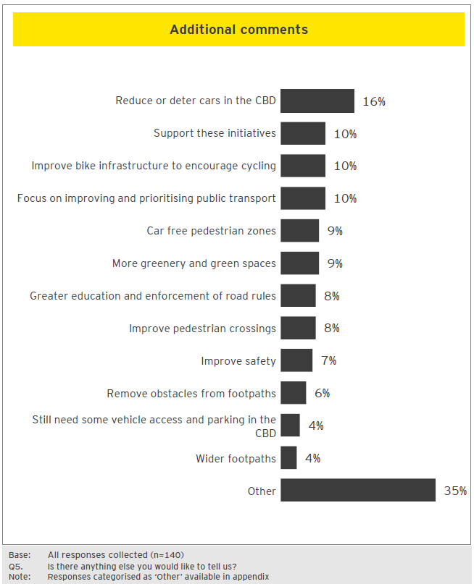

Additional comments
Support
“Data and evidence need to drive decisions and changes or defend the status quo. I feel we have been hostage to a small but vocal minority (in terms of movements in the CBD) that has made others unsafe and challenged the ongoing liveability for our great city. Please have the courage and employ the skills to make the above happen.”
“Fossil fuelled vehicles are a major air pollution factor in cities, we can make a meaningful difference to our and others’ health by driving less frequently. It's time to reclaim space that drivers have abused, and turn it into dedicated space for more vulnerable street users. Good on you City of Melbourne!”
“I support the City of Melbourne advocating for pro-pedestrian, street improvements across the greater city. I would like to see VicRoads acknowledge that pedestrians use streets too and that improved pedestrian environments be part of their responsibility.”
Concerns

“My greatest concern as a resident is that there is already inadequate management of the streets. Focus is on transients through the city rather than having an understanding that residents need to use their cars from time to time for legitimate purposes. If I wanted to buy something at Big W or JB Hi Fi in the city that could not be carried on transport, and do not want to pay a $100 delivery fee, I already have parking and loading issues that are not being addressed. My mother in law, who is an aged care resident, has medium needs and when we pick her up from the suburbs and bring her in for a visit I do not wish to be delayed even further because of speed and pedestrian lights. A broader cohabitated view needs to be made, rather than just removing cars or making it harder for residents to get around.”

“Stop making the CBD so impossible for cars. Unless you can pull 4 billion out your back pocket to build all the required East/West and North/South interlinking tunnels to keep traffic away ... then stop screwing us! Find solutions that work for both. All you seem to care about are the peds.”

City Space

What was tested
Between April and July 2018, City of Melbourne undertook community consultation with regards to the development of a new Transport Strategy for Melbourne. Eight topics were presented to the public, via the Participate Melbourne website. This section summarises feedback to the City Space topic. For more information about the discussion paper in question, please refer to the Participate Melbourne website: https://participate.melbourne.vic.gov.au/transportstrategy/cityspace

Extract of discussion paper tested
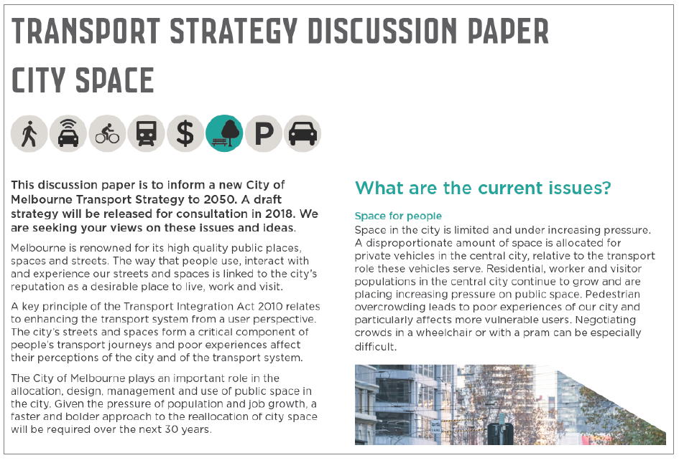

City Space: respondent profile
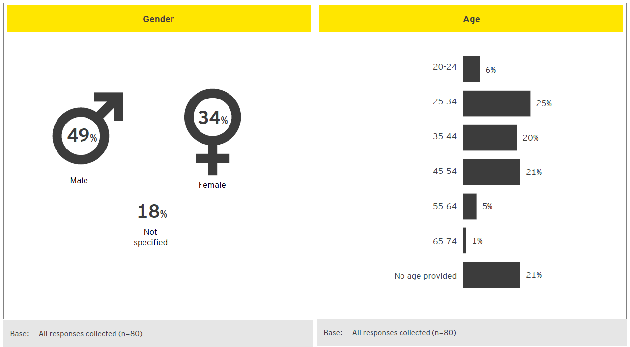

City space: public experiences
- Contributors, when asked for experiences of city streets in Melbourne, provided a range of issues and concerns. However, beyond overcrowding of footpaths, no other single experiences were mentioned by more than one in six respondents.
- City is seen to be struggling to cope with the strain of population growth… Contributors overwhelmingly described a sense of overcrowding: on footpaths and public transport.
- Safety is a pressing concern… Traffic congestion is seen to be contributing to impatience, confusion and recklessness amongst drivers. It is perceived that this is leading to an increased propensity for risk taking and compromising the safety of cyclists, pedestrians and other motorists.
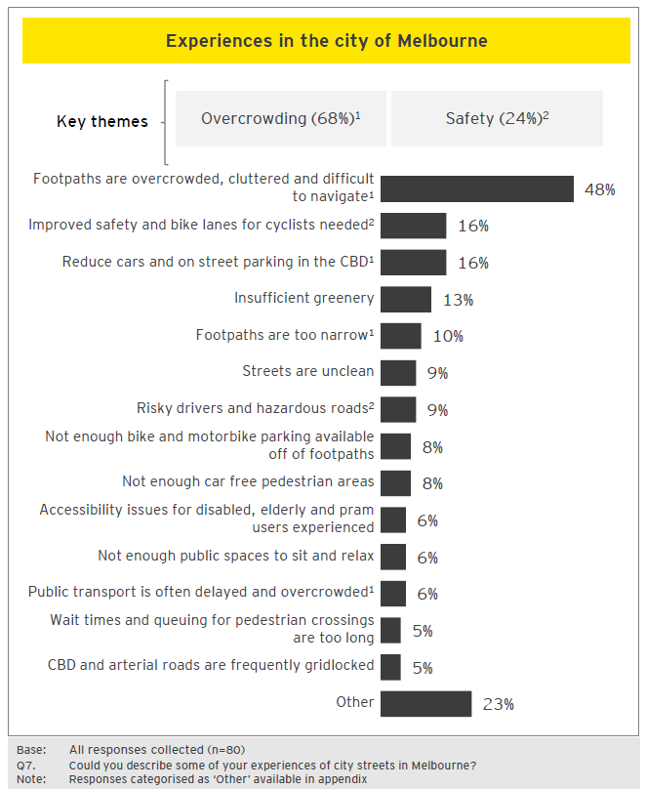

What are the current experiences
“I think Melbourne is a very walkable city, I love the accessibility of everything and being able to walk (and take the tram) so easily. My main problem that I run into is overcrowding on the sidewalks. If you want to move quickly, it can be a real challenge at times. There are bottlenecks at corners waiting for lights. We need longer times to cross streets so the waiting isn't as long. I think more pedestrian only laneways would be ideal (like Bourke Street Mall). I also think this would make the CBD more vibrant and enticing. Perhaps even having cafes or tables in the middle of a wide open pedestrian area. I think it would attract a lot of people and create a nice environment.”
“As a cyclist, drivers tail gate because there isn't a cycle lane and to keep clear of car doors, it is necessary to share the same lane that drivers are on. Speed limit is 40kmph, faster than I can cycle, so cars get impatient as the traffic lights are designed for movement at 40kmph. Consequently cars anxious to pass to make the green light.”

City space: suggestions to address issues
- The issues highlighted on Participate Melbourne were:
      - Space for people
      - Competing demands for street space
      - Prioritising the allocation of city space
- The community provided a range of suggestions for addressing the above city space issues. Of note is that the top 3 proposed solutions all relate to reducing the importance and space given to cars.
- Vehicle traffic is seen as detrimental to the liveability of the city… respondents has been outspoken in voicing suggestions relating to the reduction of cars in the CBD.
- Superblocks and reduced parking are amongst the suggested actions… To address the vehicle congestion in the CBD –contributors recommend physically excluding cars from areas of the CBD and / or reclaiming space dedicated to on-street parking. The space that these initiatives would free-up should be used for widening footpaths and expanding green areas.
- Other suggestions relate to shifting focus to more space efficient modes… Cycling is seen as a viable alternative to cars for many commuters –however it is felt that until bike lanes and bike parking are more common, throughout the city, cycling will remain underutilised.
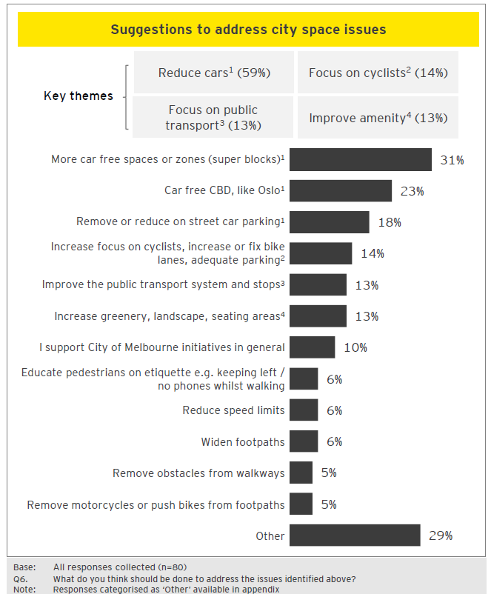

Examples of suggested actions in comments
Car free CBD
“I believe that cars currently occupy a vastly disproportionate amount of space within the CBD and we should work to eliminate cars as much as possible. I think removing cars from streets and providing priority for walking, public transport and bicycles will vastly aid in resolving the issues identified above. I think Oslo has the right idea and we should be aiming to reduce as much personal car use in the city as possible.”
Focus on cyclists
“Remove cars from congested areas. Clearly marked cycling lanes to encourage bikes to stay in then and pedestrians to stay out of them. Adequate bike parking so that they aren't forced to park along poles etc. which is in the way of pedestrians.”
Focus on public transport
“I would like to see a removal of cars in the city (except for deliveries). I would like to see more buses to deliver people to the city (along with trains and trams), the bus route in Brisbane is amazing please have a look at their model.”
Improve city amenities
“Closing streets to through traffic is a great idea, as this will make pedestrians the priority and will create significant areas of new public space which can be dedicated to things like gardens, outdoor dining areas, street markets / festivals. Melbourne needs far more green space in the central Hoddle Grid.”

City space: reactions to discussion paper
- The Participate Melbourne site presented three ‘what if’ ideas for which reaction was sought. What if…
- We removed clutter from footpaths to improve disability access and public safety.
- We removed on-street parking spaces and built wider footpaths for pedestrians and provided more space for outdoor dining, street life and more trees.
- We applied the Barcelona ‘Superblocks’ model to sections of the Hoddle Grid, with 10 km/h shared spaces for walking cycling, deliveries and residential access on Flinders Lane and Little Collins Street.
- Strong general support for proposed ideas… Four in ten expressed support for all the ideas. Improving pedestrian experience by removing obstacles, either footpath clutter or car parking, were commonly cited solutions.
- Concerns about equity for disabled or older citizens requiring vehicles… Some respondents voice concerns that limiting space for private vehicles in the CBD would impede older citizens or those with accessibility requirements.
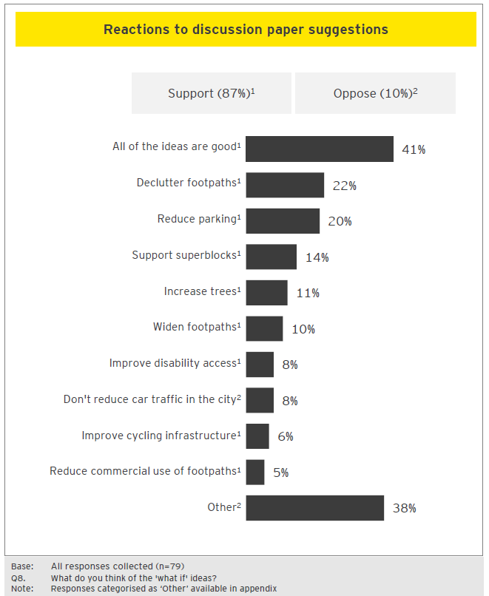

Reactions to discussion paper
Support
“Those ideas are great and need to be put in place ASAP. Cars do not need to access every single street. Superblocks is an inexpensive and easy solution to increase car-free space to continue to make Melbourne the greatest city in the world. We need to be proactive, not only followers.”
“I think these are all wonderful ideas. Especially more trees and removing on-street parking -this would really change the feel and experience of using these areas as a pedestrian.”
“All excellent ideas so long as trams still have a clear way through. Barriers or another tram safety measure should be considered with wider footpaths.”
Concerns
“I think the Barcelona idea is a terrible one! The roads are for all users not just bike riders or pedestrians!
Also by removing parking spaces drivers will be stuck paying to park in private garages. Why should drivers be impacted in such a way!”
“I'd find reduced parking would impact detrimentally on my life. I am increasing my physical abilities at the moment and require options. I'm about to have a friend drive me into the city as part of recuperating from a major operation. Limiting access and parking would make the adventure difficult.”

City space: additional comments
- Many commenters reaffirm their support of initiatives to reduce cars in the Hoddle Grid… While additional comments span a range of topics, support for proposed ideas to reduce the number of private vehicles in Melbourne is the most common theme, observed in one in six responses.
- More green space is desired amongst members of the public… Commenters express a desire for steps to be taken to promote the development of green space to add to the city’s overall appeal. Suggestions include: increasing the number of trees and implementing vertical gardens as a space efficient solution.
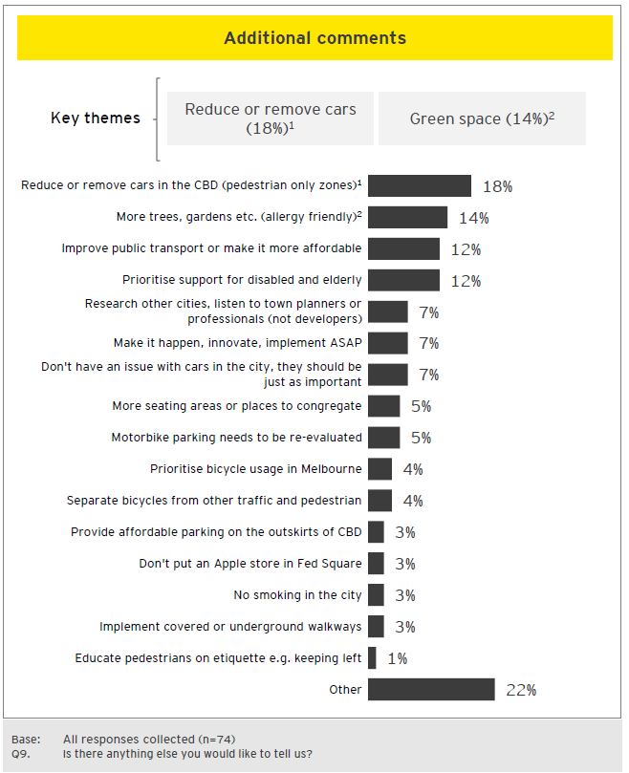

Additional comments
Rethinking pedestrian movement
“Please take cars off our CBD streets, make more room for pedestrians & cyclists, and allow this beautiful city to flourish. In parts of the CBD our street life is a joy, famous globally, and makes living in the CBD a wonderful lifestyle. In other parts, where vehicles take precedence, they are mean, noisy, dangerous & unfriendly streets. I commute by bicycle daily up Collins. It’s become dangerous & unpleasant. PLEASE make Melbourne the vibrant, glorious, international city that it can so easily be. Start with super blocks but please don’t stop there.”
“Some great ideas! I love the idea of the Barcelona super blocks. Giving back space to pedestrians, dining and open space including cycling makes complete sense. Provide people with a safe area to walk / cycle and dine. You’d need to provide large through sections where a super block or ‘super lanes’ crisscross the city so riders can choose to use those safer ways to get around and walkers can utilise the greener spaces and linking up with other major bike paths too. Great ideas, keep them coming.”
Green space
“Just to add that the trees are an incredibly important part of this space and I'd love to see more innovative ways of increasing vegetation in the CBD -vertical gardens etc.”
“There should be more fruit and seed bearing native plants to attract and sustain native birds.”
“I'd like to see a green space walkway between Southern Cross and Flinders Street, like the highline in New York. More public space with seating, places to congregate and be social.”

Public transport network

What was tested
Between April and July 2018, City of Melbourne undertook community consultation with regards to the development of a new Transport Strategy for Melbourne. Eight topics were presented to the public, via the Participate Melbourne website. This section summarises feedback to the Public Transport Network topic. For more information about the discussion paper in question, please refer to the Participate Melbourne website: https://participate.melbourne.vic.gov.au/transportstrategy/public-transport-network
Extract of discussion paper tested 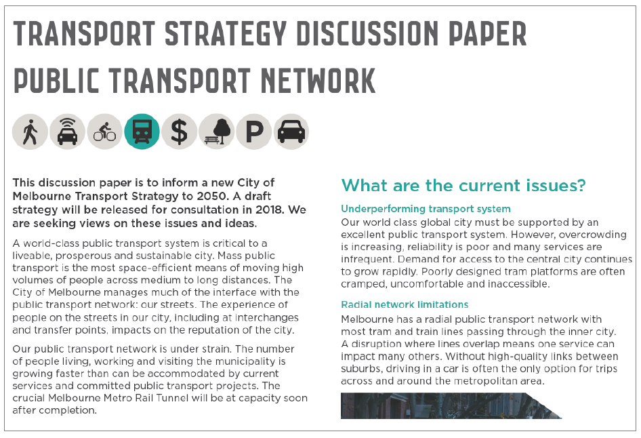

Public Transport Network respondent profile
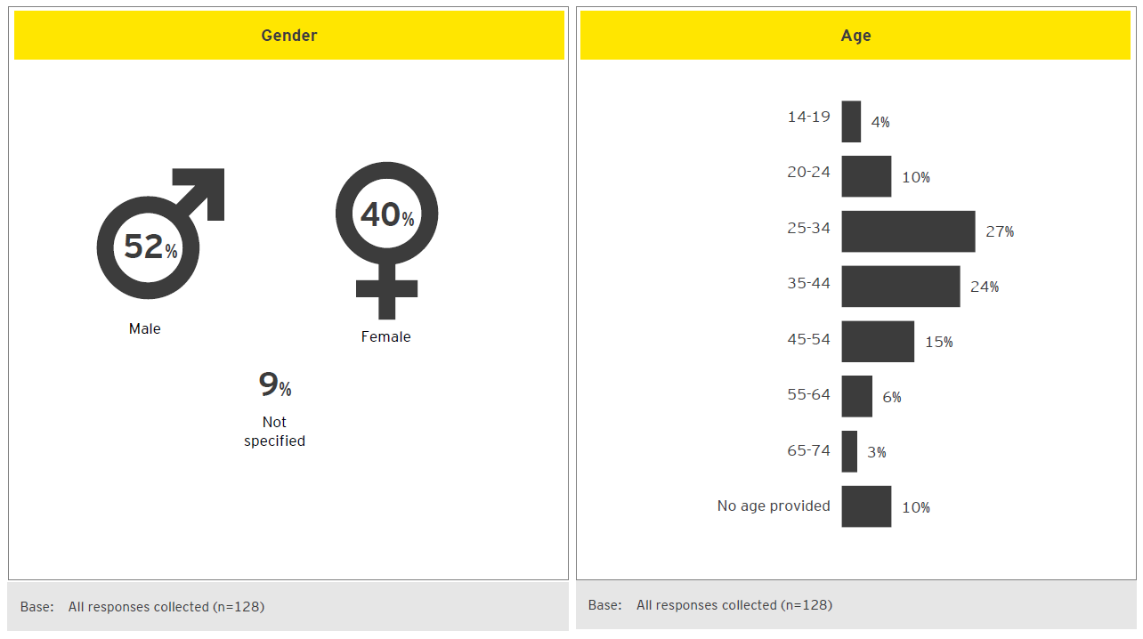

Public Transport Network: experiences with public transport
- Overcrowding on public transport viewed as an impediment to Melbourne’s growth trajectory… Participants note that services are becoming increasingly overcrowded during peak travel times. This is felt to be a threat to the prospects of Melbourne supporting the predicted future population growth in a sustainable manner.
- Delays are seen to contribute to overcrowding and to dissuade PT usage… It is felt that delays make public transport an unpredictable transport mode. This was especially evident in those who described using PT in outer suburban areas where there are fewer options and less infrastructure. This is seen to contribute to a sense of reluctance when considering public transport options.
- Upgrades to PT vehicles is desired… Experiences with ageing vehicles have led some travellers to express a desire for upgrades to be made to the fleet. This particularly noted by contributors with accessibility requirements.
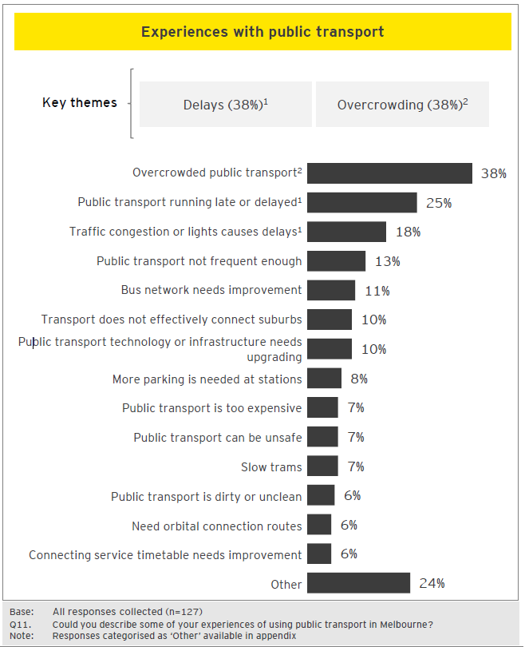

What are the current experiences
Overcrowding
“Terrible! Everyday I'm questioning why I'm paying full fare while being sandwiched between bodies in trams that are straining with the ever-increasing passenger load. There are many old trams still in operation which are not maintained properly (no AC when used in summer, doors that constantly fail, odd sounds, PA system that is either too loud or barely audible) or driven properly (jerky moves, sudden stops). Constant joke about Melbourne not having a rail service to the airport at this age (and it will likely be many more years away).”

“Overcrowded trains present a safety risk to passengers. Some services at Flagstaff and Footscray are so full people cannot get on trains.”
“Long waits at Richmond changing from Frankston line for loop services in the morning. Severe overcrowding on Pakenham and Dandenong line services right through very long peak times. Very overcrowded tram services between Melbourne Central and Melbourne University.”
Running late or delayed service
“Instead of taking me 30-40 minutes to get home, sometimes due to poor organisation of replacement bus services on the Cranbourne/Pakenham line, it's taken me approximately 2 hours. It shouldn't take the same amount of time to get to a city suburb as it does to go to Bendigo to visit my family. One day I had to do both in 24 hours, meaning that I travelled over 8 hours in one day. Then apart from rude/unhelpful staff, the connecting train was 20 minutes late, and I felt unsafe being alone that late at night walking home from the station when I finally arrived.”
Lack of accessibility
“Life-long tram and Metro train user. In later years, have been handicapped by mobility issues and have become acutely aware of the tram network's failure to work towards DDA compliance. If I have to go into the city, I now drive to the most convenient tram super stop or rail station to avail myself of stepless access, as I live on the 57 route which even now still uses solely Z-class trams!”

Public Transport Network: suggestions to address issues
- The issues highlighted on Participate Melbourne were:
  - Underperforming transport system
  - Trams and buses stuck in traffic
  - Tram stop design improvements
- Frequently, responses included a desire to increase number and frequency of services… This is seen to be a key solution to alleviating two of the major negative experiences associated with public transport: overcrowding and delays. It is felt this could be achieved by deploying more vehicles on the network. Furthermore, a number of comments suggest that investigating public transport in other countries and / or upgrading technology in vehicles could lead to improvements.
- Dedicated lanes seen to reduce the likelihood of delay and improve consistency of service… Comments observe that public transport can be hindered by its interactions with other forms of transport. To alleviate this, 25% of comments suggest creating dedicated lanes or creating separate routes.
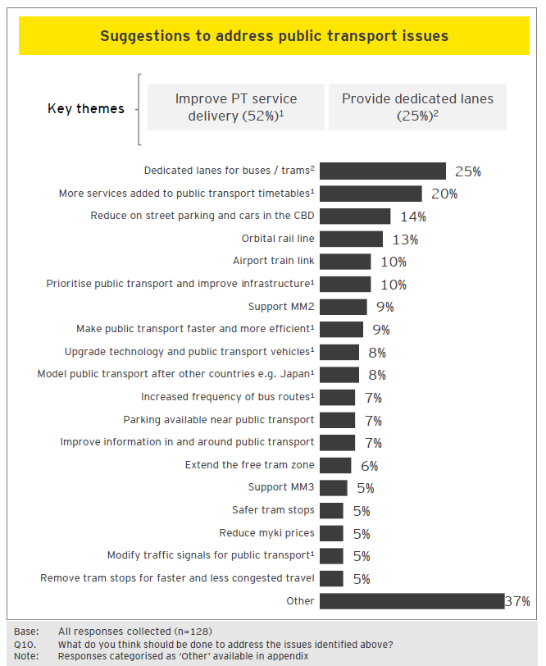

Infrastructure investment
“Increase PT services and make it comfortable, efficient and easy. Improve toilets and provide more parking at stations, especially outer suburban stations. This will encourage more people to travel on PT and less cars on the roads, especially in inner suburbs and CBD, therefore less traffic congestion and pollution. Extend train lines out further. Resurrect and repair old stations and tracks that were put out of use by some government with no vision.”
“Need to tunnel, add more train services and higher speed rail is a must! Need new technology to allow trains to run closer together and more often. Need to increase transit speed of trains to get people around faster and run more services.”

Dedicated lanes for buses and trams
“Bus and trams stopped at traffic lights is frustrating as it does not reflect the amount of people travelling on these modes of transport. They need to be given priority over cars at traffic lights. If you look at Queensland they have a really great way for buses, special dedicated places where there is large bus terminals with times for next bus and the buses are much more frequent.”
“Trams need dedicated road areas so they don't get stuck in traffic. Increasing bus-only lanes would also be ideal. This prioritises public transit, making everything more efficient and rewarding people for using public transit and keeping cars off the road (and reducing pollution).”

Public Transport Network: reactions to discussion paper
- The Participate Melbourne site showcased four ‘what if’ ideas for which reaction was sought. What if…
- Melbourne Metro 2 was completed by 2030, connecting the western suburbs into the central city and unlocking the potential of Fishermans Bend.
- Melbourne Metro 3 was completed by 2035, providing a second airport rail link and north-west connectivity through the central city to North Richmond and beyond.
- Trams were ‘supercharged’ with more tram-only right of way and cars removed from tram tracks across the network to improve travel times and reliability.
- New and existing road rules to protect the priority of efficient transport modes were enforced.
- There is broad support for investing in improvements to the public transport network… Half of comments were positive to all ideas proposed. This demonstrates a significant appetite for public transport investment amongst contributors. Of the specific ‘what if’ ideas, dedicated tram / bus lanes are the most commonly supported.
- Some concerns about dedicated tram / bus lanes were expressed… Although outnumbered by positive comments, there were a number of individuals who expressed a dislike of the dedicated lanes. Amongst these comments, it is felt that dedicated lanes will serve to increase congestion on roads and make car travel more difficult than it currently is.
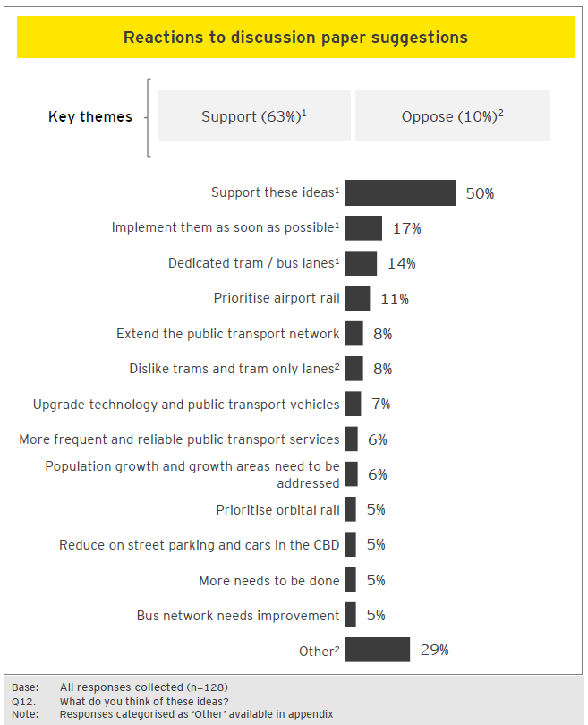

Reactions to discussion paper
Desired speed of implementation
“Good, but let's deliver them sooner yeah? It's another decade or two before we see some of these major changes, yet we are already buckling with the current demand. How bad will things get to until we see the improvements? Less talking and (spending millions of dollars) planning, and more actions please.”
“Good, but we need this now and not in 17 years. In 17 years the requirements will be even greater.”
“Great! Public transport should always have priority over cars! I just wish it was done sooner.”
“Great! Let's get them done sooner and keep the new ones coming.”
Airport link
“I think these ideas are good but would like to see the airport link completed much sooner.”
“Metro 3 is way more important than Metro 1 or Metro 2. Even Perth is going to have an airport train service before Melbourne!”
Improve public transport infrastructure
“I agree we need to fast track Metro 2 and 3 and alongside these projects we seriously need to consider how we are going to eventually shift the entire network onto high capacity trains, signalling and eventually driverless trains.”
“I would also like to see more efficient transport modes introduced as soon as possible. Such as 'bike traffic light priority' (such as the Canning St/Elgin Street intersection lights) and 'supercharged' tram lanes coming into play.”

Public Transport Network: additional comments
- Improvements to the frequency of service and passenger experience are desired… Many commenters express a sense of frustration and disillusionment with the quality of public transport services. It is felt that there are significant opportunities for improvement. Furthermore, comments state that these improvements are necessary to facilitate Melbourne’s growth trajectory.
- Some respondents want public transport to be considered in a holistic manner by city planners… Contributors are wary of public transport assets being considered in isolation and express a desire for them to be considered as a part of an overall transport strategy.
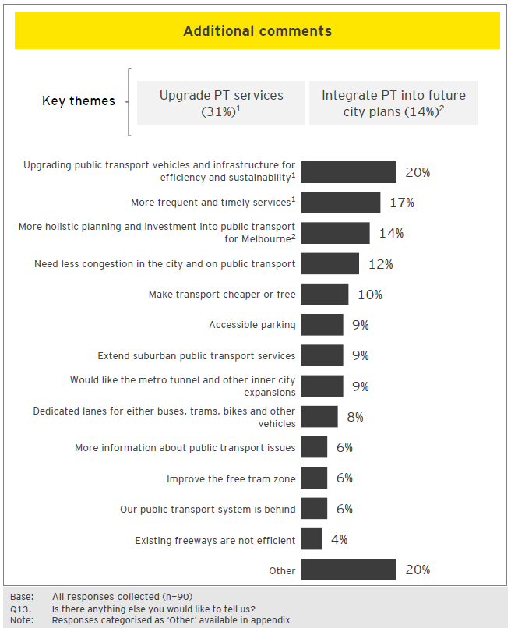

Additional comments
Infrastructure
“Public transport needs a massive overhaul throughout the whole state and needs to be viewed holistically, along with vehicle and pedestrian flow, not just development. Land corridors need to be set aside now, not when it's too late. It's not just about moving around the city but getting in and out, or being able to avoid that if not required. Get suburban transport off regional lines. Make travel times better. Make the system more reliable. Don't develop new population areas without the infrastructure to support people movement already in place.”
Planning
“Transport infrastructure needs to be planned by a body outside of politics, otherwise the marginal electorates get all the improvements. Plans need to holistic, progressive and integrated, not headlines.”
“Melbourne desperately needs to improve its public transport system. I've seen a decline in quality of service over the last 10 years, which at times, has encouraged me to drive. People are going to take the most comfortable, convenient option possible. It is therefore crucial that work is done ASAP to improve the system. Otherwise, we risk turning into a car-dominated city where journey times are greatly increased.”

Emerging technology

What was tested
Between April and July 2018, City of Melbourne undertook community consultation with regards to the development of a new Transport Strategy for Melbourne. Eight topics were presented to the public, via the Participate Melbourne website. This section summarises feedback to the Emerging Technology topic. For more information about the discussion paper in question, please refer to the Participate Melbourne website: https://participate.melbourne.vic.gov.au/transportstrategy/emerging-technology
Extract of discussion paper tested
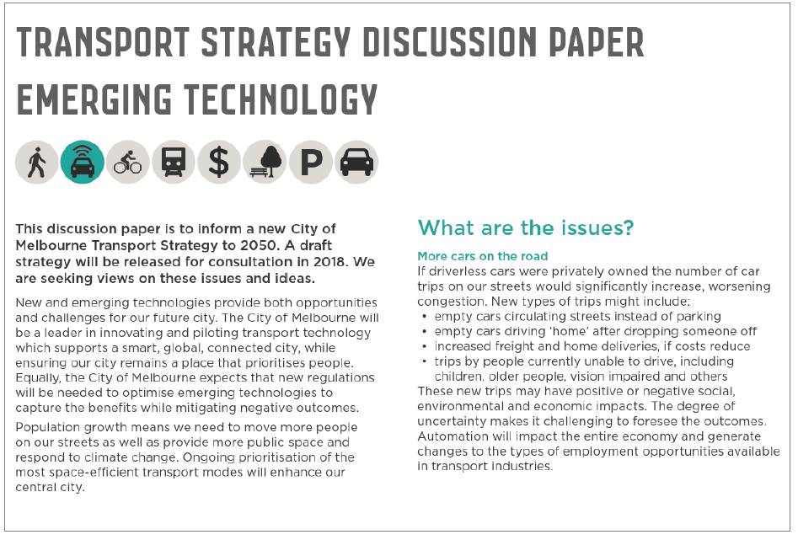

Emerging technology: respondent profile
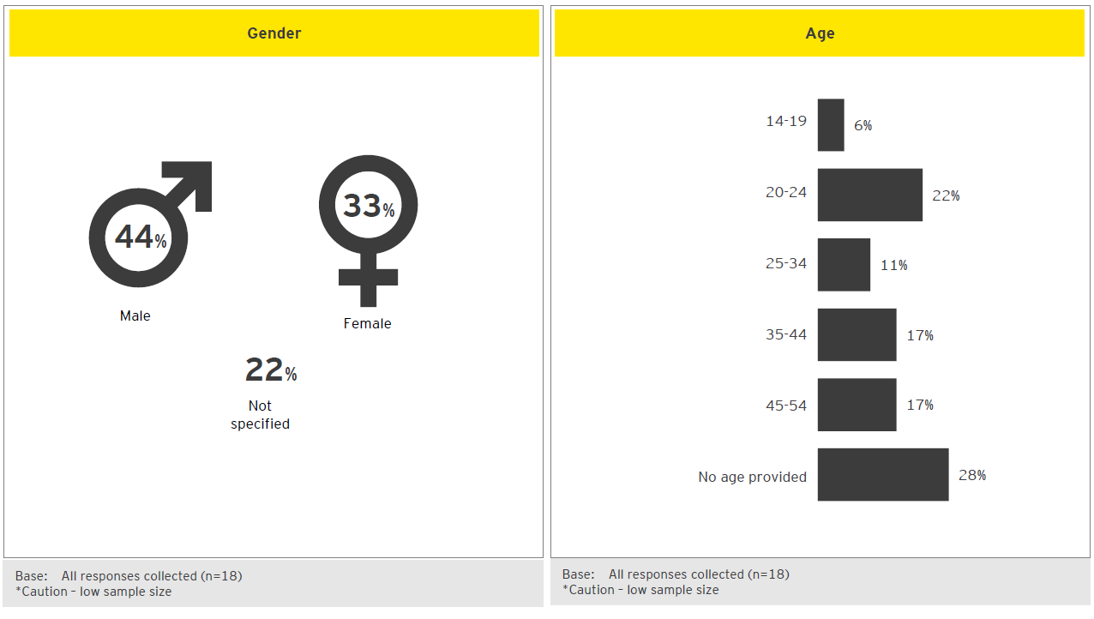
- Emerging technology: suggestions to address issues
- The issues highlighted on Participate Melbourne were:
- More cars on the road
- Shared mobility
- Mobility as a Service
- Data security
- New freight systems and vehicles
- Smart sensors for better decisions
- Please note: small sample sizes due to low input from community. This precludes robust conclusions being drawn from Emerging Technology community inputs.
- Emerging technology receives less engagement than other topics… All discussion papers were supported with coverage in the mainstream media and on social media, however, Emerging Technology received dramatically less engagement than other papers. This may be an indication that, despite the speculation of futurists, many members of the community are not yet looking ahead to the impact of not-yet-realised technologies on Melbourne. Instead commenters appear to be more engaged with regards to facets of city life that they currently experience on a day-to-day basis.
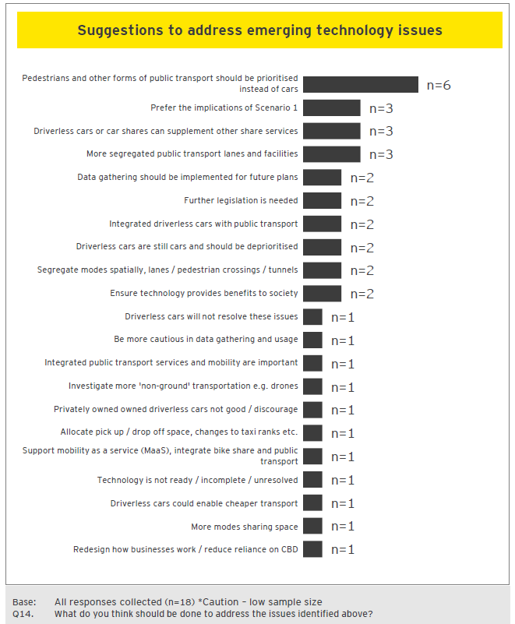

Emerging technology: reactions to discussion paper
- The Participate Melbourne site presented five ‘what if’ ideas for which reaction was sought. What if…
- Empty driverless cars paid a fee to use the road, preventing increased congestion.
- Driverless cars were regulated to move out of the way for buses and trams.
- Smart sensors halved time that buses and trams spent waiting for cars at traffic lights.
- Deliveries were made by robots on the ground and in the air, reducing congestion.
- For a monthly fee, people could access public transport, ride hailing, bike and car share via an app.
- Please note: small sample sizes due to low input from community. This precludes robust conclusions being drawn from Emerging Technology community inputs.
Some contributors urge caution with regards to changing public transport pricing and the use of drone technology… These individuals suggest that upgrading the existing myki ticketing system and / or making it more affordable would have a greater benefit to the community than a monthly fee; and it is felt drones may be impeded by aerial obstacles (i.e. power lines).
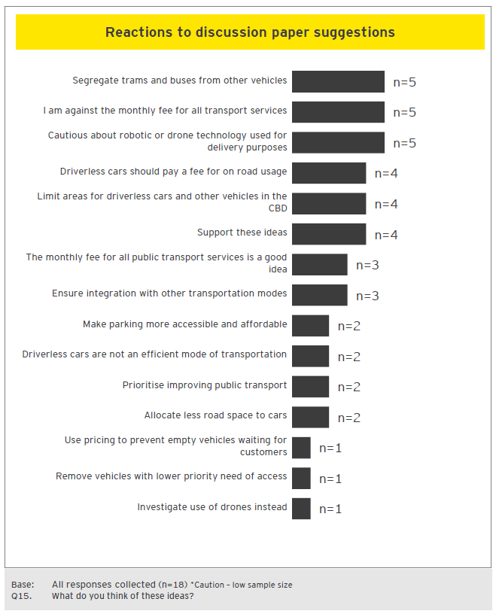

Emerging technology: reactions to scenarios presented in discussion paper
- Please note: small sample sizes due to low input from community. This precludes robust conclusions being drawn from Emerging Technology community inputs.
- Car sharing and autonomous vehicle technology are seen as desirable by some contributors… Six comments highlighted the potential benefits of these technologies. It is felt that this technology would be especially useful in instances where a desired destination is not easily accessible by public transport.
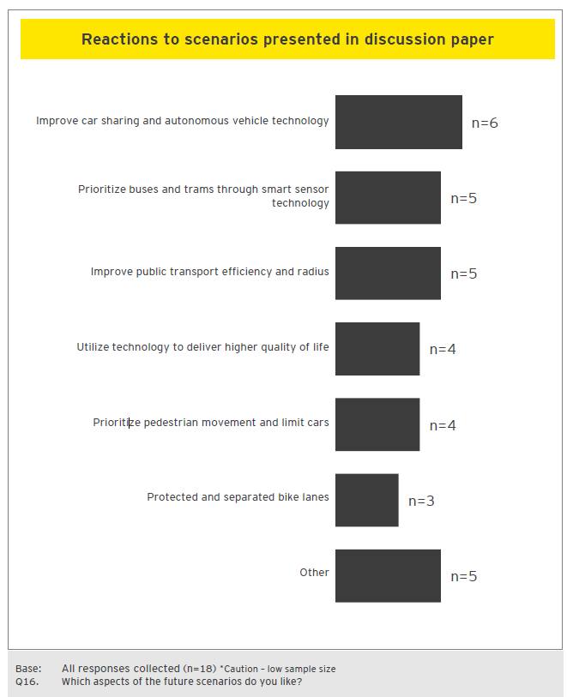

Emerging technology: additional comments
- Please note: small sample sizes due to low input from community. This precludes robust conclusions being drawn from Emerging Technology community inputs.
- More affordable and accessible public transport is desired… Four comments expressed the sentiment that emerging technologies should be used to help improve the accessibility and affordability of public transport services.

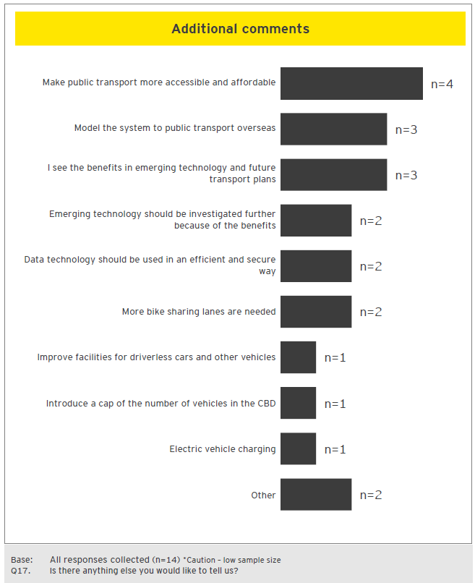

Cycling

What was tested
Between April and July 2018, City of Melbourne undertook community consultation with regards the development of a new Transport Strategy for Melbourne. Eight topics were presented to the public, via the Participate Melbourne website. This section summarises feedback to the Cycling topic. For more information about the discussion paper in question, please refer to the Participate Melbourne website: https://participate.melbourne.vic.gov.au/transportstrategy/cycling

Extract of discussion paper tested
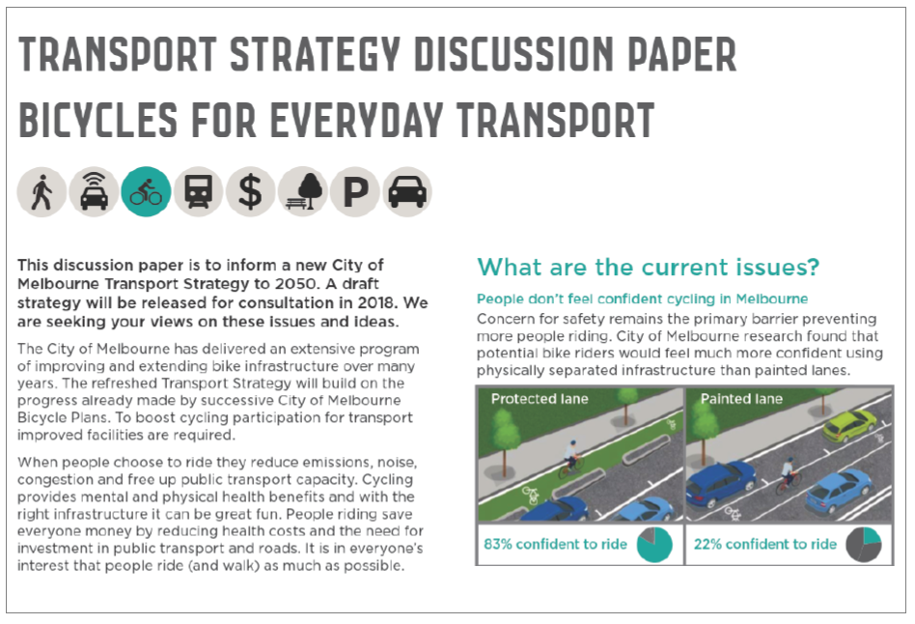

Cycling: respondent profile
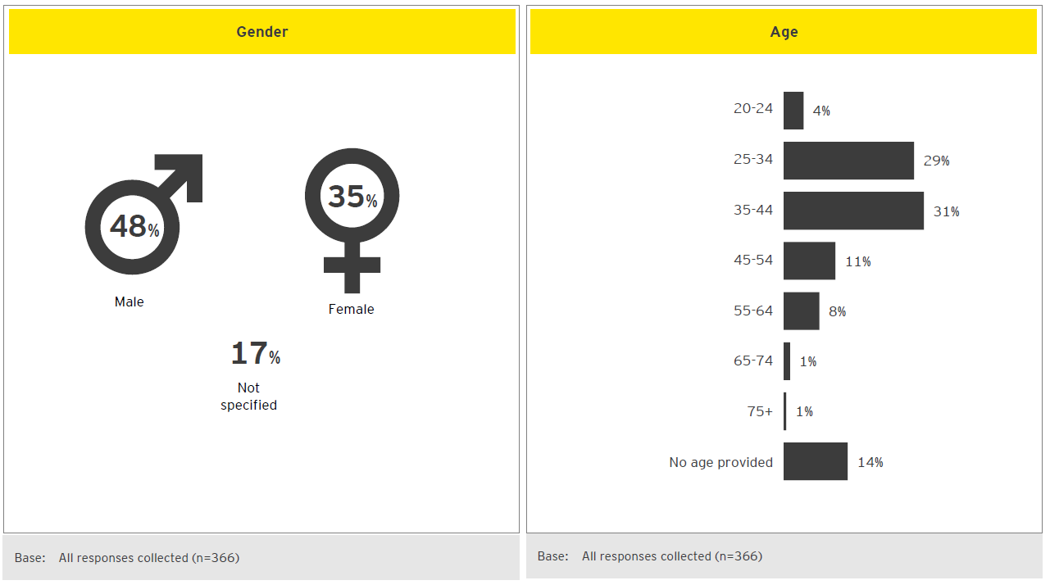

Cycling: experiences riding in Melbourne

- Cycling in Melbourne is seen to be fraught with hazards… Contributors view cycling as intimidating due to the perceived risks of collision or car dooring. Certain streets are mentioned by name as particularly unfriendly to cyclists and avoided; Collins Street is one often cited example.
- Inattentive pedestrians and motorists… Responses frequently mention absent-minded motorists undermining the safety of cyclists. Shared lanes and motorists merging without performing head-checks appears to be a significant pain point for cyclists.
- Street parking and car dooring seen to be inextricably linked… Car dooring is perceived to be a persistent threat to cyclists. On-street parking naturally is seen to increase the likelihood of car dooring and is viewed negatively by cyclists.
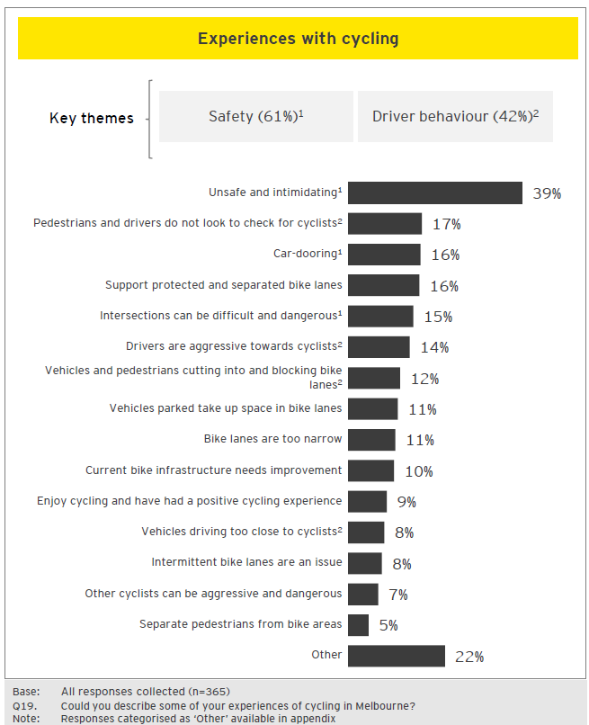

What are the current experiences
Interactions with motorists
“A complete lack of regard for 'open' cycle lanes by parking motorists. Generally space for pedestrians and for motorists are considered 'dedicated', this same logic doesn't follow for cyclists who are clearly unwelcome in shared zones. I hear a lot of talk about cyclist breaking the law but I see motorists blocking bike/pedestrian ways at least twice a day, each way on my commute. Intersections are a disgrace. In the place where most conflicts occur cyclists are required to mix with traffic. This must be very discouraging for those who feel that cycling in the city is too dangerous.”

Feelings of riding being unsafe

“Basically none as I had a bike but too scared to ride it. Seeing some of the motorists and their unpredictable driving put me off as well as stories from other cyclists including getting doored meant I never rode. It would just be too stressful.”

“Constantly on alert for motor vehicles and hazards. The existing infrastructure is either poorly implemented (LaTrobeSt lanes that come and go, weave in and out and have too many driveway crossings), time restricted (Exhibition Street half-way, peak only bike lanes), inadequate (Collins Street is a joke and should never have encouraged people ride down there with 'fake' bike lanes), inconsistent (variation at hook turn intersections as to whether a person on a bike passes to the left or right of a driver waiting to complete a hook turn) or just plain non-existent (every intersection where the bicycle infrastructure fades out and leaves the person on a bike very vulnerable).”

Cycling: suggestions to address issues

The issues highlighted on Participate Melbourne were:
- People don’t feel confident cycling in Melbourne
- Providing for local bicycle trips
- Conflict and behaviour
- Road rules
- Other barriers which prevent more people riding bikes
Respondents express desire for for cyclists to be separated from other transport modes… The threat of having an accident is seen to be greatly reduced in areas where there are dedicated bike lines, separating cyclists from motorists. Over half of the responses gathered mention a greater desire for dedicated bike lanes.
Education and awareness amongst other road-users is seen as an easy win… While many responses pertained to infrastructure investment, in the shorter-term a number of comments suggest that issues could be alleviated through greater education, for cyclists and non-cyclists alike.
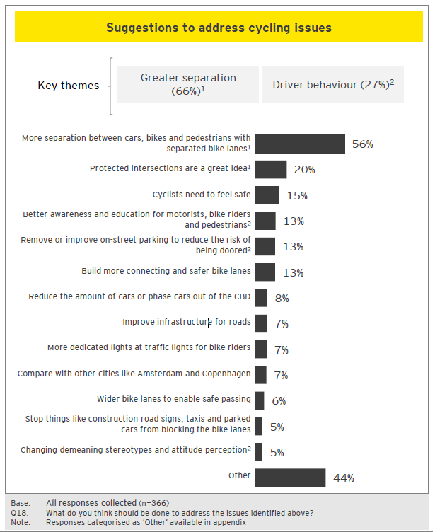

Suggested actions
Separation
“They've already been stated I know, but the two main things would be increasing protected bike lanes and installing bike lights at intersections. I always struggle with whether or not to go on the left of cars turning left -I know I'm not supposed to but often it seems like the best option (e.g. they are stopped for pedestrians, and I don't feel safe swerving out onto the road to go around because of other cars and cyclists). Having a green light for cyclists before cars reduces this problem significantly.”

“Introduce physically separated bike paths aggressively across the city and major bike routes to it. But also introduce measures to reduce car traffic within the city. Even with separated lanes safety can only be maximized so far when there is so much car traffic in the city, particularly turning cars.”

“The protected lane proposed idea is awesome, I reckon can help to feel safe, increasing the number of people that decide to leave the car and choose to ride.”
Investment and education
“More education, more advertising on good cycle behaviour done by the government, authorities and Bicycle Network to encourage common sense, rules awareness and general courtesy to other users on the road and other bikes. Make cycling the norm just like walking to work, and public transport.”
“All above discussion is sensible. Increase investment, separated bike lanes, better parking. Advertising campaign to promote cycling and to help educate car drivers. Most don't understand what a car door zone is and why a cyclist might be using the extreme right of a cycle lane. Clearer rules and expectations for cyclists and drivers.”

Cycling: reactions to discussion paper
- The Participate Melbourne site showcased four ‘what if’ ideas for which reaction was sought. What if…
- Everyone who wanted to ride a bike felt safe to do so at any time of day and for any type of trip.
- Protected bike lanes radiated out in each direction from the city, removing some traffic lanes to move more people.
- Bike lanes continued to and through intersections.
- We trialled fully separated bike lanes along Flinders Street linking the MCG to Docklands.
- Strong support for cycling initiatives… Seven in ten responses express a positive reaction to all four ideas. This is the strongest support for any of the eight discussion papers. Furthermore, a number of comments voice the desire for these proposals to be extended beyond the CBD and implemented in surrounding suburbs.
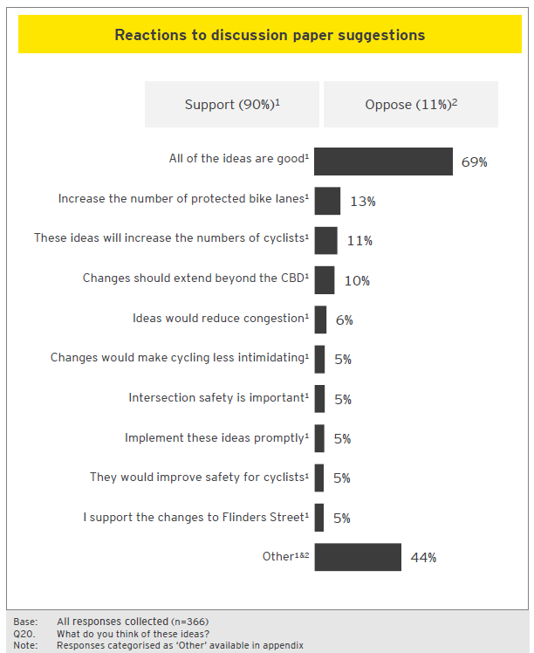

Support for initiatives was strong
Support initiatives
“Absolutely support more protected bike lanes. Think it is really key that bikes lane link up as well as if they don’t link up to existing bike paths/routes then there will still be dangerous areas. Support the idea of some streets becoming dedicated cycling routes.”

“Agree with all of these ideas! Focussing on what new users need to feel safe is the key, not what current riders want. New protected routes through the CBD are desperately needed.”
All of the above sounds great!
“Separated bike lanes everywhere as in the pictures above would be fantastic with barriers between the bike lane and car lanes like Swanston St would be awesome. I now no longer live in the City of Melbourne but further out and would like to see this rolled out into other councils where it’s even more dangerous to ride as the traffic is travelling faster and there are fewer cyclists.”
Desire greater education in addition
“All of the ideas above are great, but must be combined with education campaigns explaining road rules for all and emphasising that cyclists have equal rights to share the road with cars, including using a car lane when necessary. Cycling infrastructure shouldn't be a battle with two sides, it should be something that benefits everyone by reducing car traffic and improving the liveability of the city.”
“All above discussion is sensible. Increase investment, separated bike lanes, better parking. Advertising campaign to promote cycling and to help educate car drivers. Most don't understand what a car door zone is and why a cyclist might be using the extreme right of a cycle lane. Clearer rules and expectations for cyclists and drivers.”

Cycling: additional comments

- Change for cyclists is seen as imperative… Three in five responses affirm that change for cyclists is important. Cycling is seen to be an increasingly viable alternative to private vehicles and a transport mode that can scale alongside population growth. But these benefits are only expected to be realised if cycling is given due consideration in city planning initiatives.
- Beyond infrastructure, attitudes are seen to be in need of change… Many comments express frustration at a perceived lack of understanding or duty of care for cyclists on behalf of other road users. While infrastructure development is important to alleviate the risk of altercations –there is a perception that in-roads can be made through behavioural change as well.
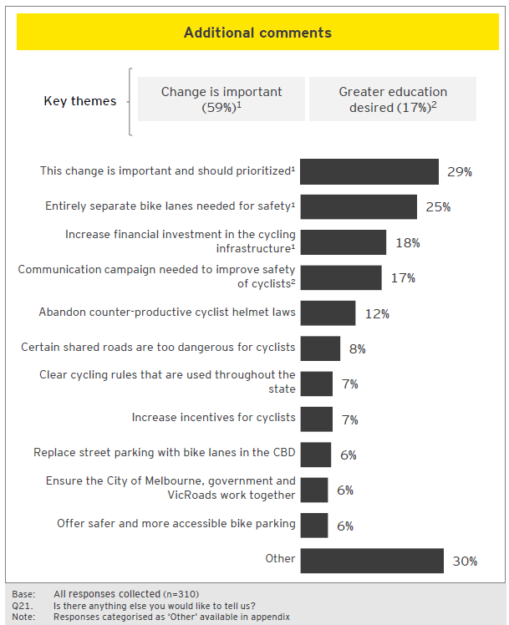

Additional comments
Support for cycling
“I'd like to reiterate how important cycling is to a healthy community. It improves physical and mental health of individuals, reduces congestion and pollution, provides the means for a greater, more impactful connection with the place you live in, and as a result greatly improves society and the way we connect and interact with each other.”
“Keep up the good work. Reducing vehicle use, by providing efficient safe alternatives, such as public transport, pedestrianisationand safe bike infrastructure will make Melbourne a nicer city to be in.”
“Socially, economically and environmentally cycling is by far the best form of transport. Best of all it's fun. I'm really happy to see you considering how we can make improvements to increase the number of cyclists in Melbourne.”
Need for community change
“Please consider using some money in advertising to educate drivers on how to respectfully share the roads.”
“Yeah, put a gender lens on this! There are really low levels of female participation in cycling, and we need to think about why. Ideally we would see a bigger demographic cycle, including families, older people and women. Having spaces for slower bikes / bikes people can use in their work outfits, or with children is big: please hear the voices of women cycling and families!”
Concerns
“Cyclists need to be banned from the footpath and on the Yarra Promenade. They are a risk to public safety and the City Council is liable for any accidents arising from their use. The City Council has not consulted other road users in its strategy plans. Missing from the review is the needs of other road users such as Motorcyclist, Scooter riders. Delivery vans, Couriers and the disabled.”

Car parking

What was tested
Between April and July 2018, City of Melbourne undertook community consultation with regards to the development of a new Transport Strategy for Melbourne. Eight topics were presented to the public, via the Participate Melbourne website. This section summarises feedback to the Car Parking topic. For more information about the discussion paper in question, please refer to the Participate Melbourne website: https://participate.melbourne.vic.gov.au/transportstrategy/car-parking
Extract of discussion paper tested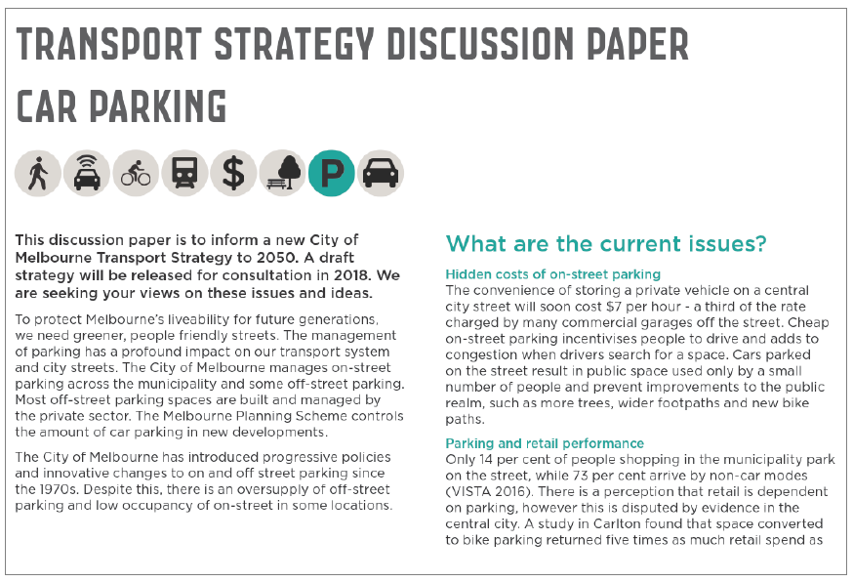

Car parking: respondent profile
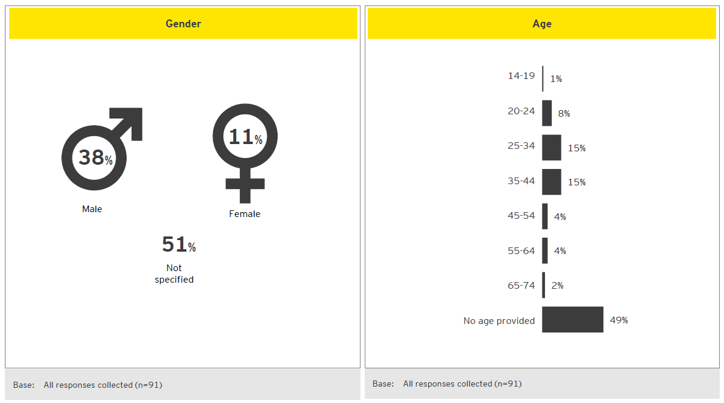

Car parking: suggestions to address issues
- The issues highlighted on Participate Melbourne were:
- Hidden costs of on-street parking
- Parking and retail performance
- Oversupply of off-street parking
- New technologies, decline in parking revenue
- Access for all people
- Street parking is perceived as an inefficient allocation of space… When faced with the key issues relating to city parking, respondents often suggest that problems could be addressed by deprioritising private vehicles in the city; removing cars and consequently parked cars altogether. It is suggested that this space could be reappropriated for use as: dedicated bike lanes, widened footpaths, or creating additional green space.
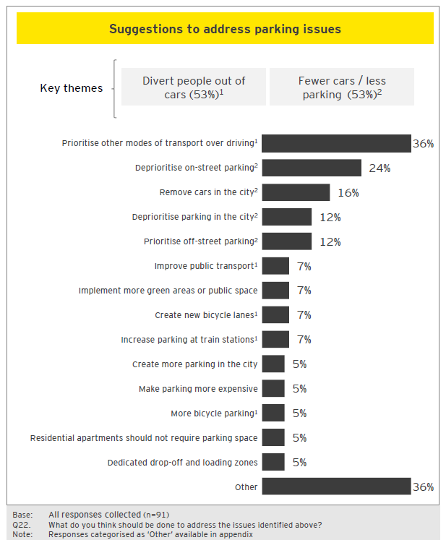

Suggested actions
Divert people out of cars
“The City of Melbourne should aim to maximise the appeal of Melbourne for use of (in order) walking, bikes, public transport. There is simply not enough space to do anything other than reduce car dependency and parking. The city must be for people, not for cars.”
“I think it is critical that the City of Melbourne prioritise active transport and public transport over private vehicles. Private vehicles should always have some access and some parking to the city for transporting people with disabilities, deliveries or transporting large purchases. However, most trips are best provided by low carbon, low pollution, safer, healthier options such as walking, cycling, train, tram or bus. Active and public transport also has a smaller impact on the city landscape. Cars create more noise and emission pollution, while taking up copious amounts of space when travelling, seeking parking or being parked.”
“Create bus lanes, give buses priority over cars. This would encourage more to take public transport.”
Fewer cars / less parking

“I am loving the idea to get rid of car parks in the city -some of the car parks could be used for bike parking and then ban bike parking on sidewalks which will free up more space for pedestrians.”
“Remove all on-street car parking -it is incredible that there are still on-street parking spaces only metres from Flinders St and Southern Cross stations, the two busiest and well-connected railway stations in the state. On-street car parking is the most egregious waste of space on our streets imaginable. People should not think of it as their right to dump their private property on city streets.”
Maintain city parking
“The issue address above is totally one sided and only looks at facts which support the intended argument. Cars and private used vehicles are (and still will be for many decades) a fundamental form of transport into the city from those who do not live in the CBD... Cities are designed around vehicle access and parking for a reason, not around how many people can fit on a footpath or how many push bikes can be written. This is a fairy tale idea to take cars out of the picture.”

Car parking: reactions to scenarios presented in discussion paper
Scenario 2 receives greater support than Scenario 1… This highlights the desire for CBD space to be utilised in a manner which promotes green space and lively retail / hospitality trade. Off-street parking is seen as a somewhat drab use of city space and on-street parking is perceived as standing as a barrier to other modes of transport.
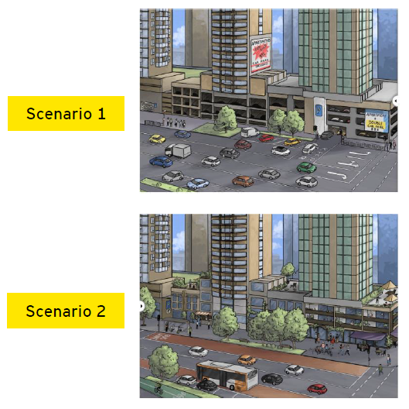

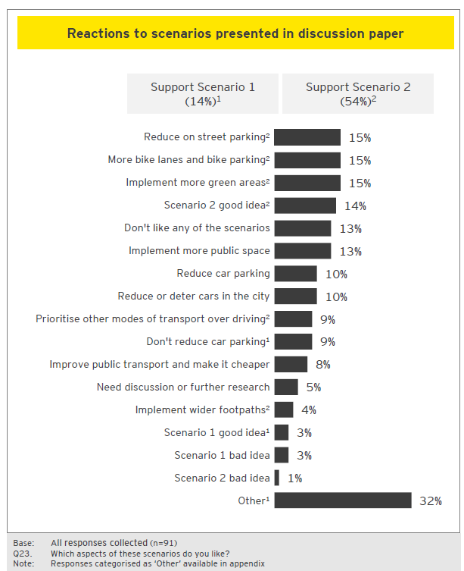

Reactions to scenarios
Support for Scenario 2
“Scenario two! Clearly there are already too many vehicles in the CBD/Southbank and it follows logically that there must be too much parking since there is fairly limited through-traffic. Thus, while off-street (and so far as possible, below-ground) parking should be much preferred to on-street parking, the supply should not be expanded. Rather, use of existing parking spaces could be made more efficient.”
“I like Scenario 2 as it has less car parking more public transport & pedestrian access.”
“I am totally in favour of Scenario 2 – since prioritising sustainable and active transport throughout the municipality will lead to vastly better outcomes for all residents, workers and visitors. A lot of my generation (early 20s) understands how ridiculous it is to drive into the CBD, and I hope that as we age this belief is further enshrined.”
“I really like Scenario Two as the way ahead. I like that the streets are taken over by the people (who represent the 'life' in the street), with priority on the road space for buses and bikes. Cars should not dominate, and parking just encourages the use of cars, for which there is no space.”
Support for Scenario 1
“I prefer 1 as it gives more car access and car lanes.”

Car parking: reactions to discussion paper
- The Participate Melbourne site showcased five ‘what if’ ideas for which reaction was sought. What if…
- Large numbers of on-street parking spaces across Melbourne were converted to open space, trees, bike lanes and footpaths.
- New residential buildings near public transport were provided with car share instead of car storage, supporting sustainable travel.
- The price of on-street space was adjusted according to demand to ensure some spaces are always available on each block.
- All parking structures were publicly accessible to use parking more efficiently and enable widespread sharing of vehicle and car parks.
- People without cars could buy cheaper apartments because all car parks were sold separately.
- Parking can be a divisive topic… There is strong support for ideas proposed in the discussion paper; shown by 43% of responses supporting the implementation of all ideas. However, a sizeable proportion (22%) reject the proposed changes. Often their comments express a feeling that significant parking reductions will be ineffective in addressing Melbourne’s congestion issues. These individuals feel that private vehicle usage will remain an important mode of transport in Melbourne’s future.
- Removing on-street parking the most popular idea tested… Contributors responded most positively to the prospect of removing on-street parking. More than half (55%) of comments either mentioned removing on-street parking specifically or supported all ideas (including removal of on-street parking).
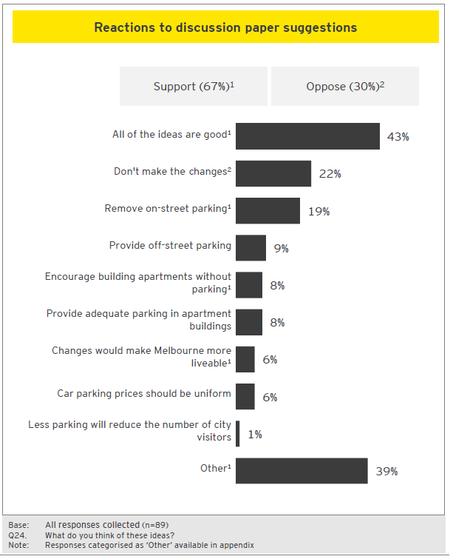

Reactions to discussion paper
Support
“Excellent ideas. Why do we still give priority to the motor car? Private cars usually carry one passenger so it makes no sense.”
“l agree with all 5 suggestions. Implementing those would transform Melbourne and absolutely make it more liveable.”
“I am mostly supportive of these ideas – I fully support the conversion of large numbers of on-street parking to other uses and like the idea of share parking.”
“They sound great, I'd prefer a focus on expanding access to public transit and expanding the free zone for tram use rather than encouraging car shares, which doesn't aim to change the mindset of car-centric Melburnians.”
Concerns
“These ideas are ridiculous. Melbourne is 90th on the list of cities by population. People will always need cars. Their friends and family live in the suburbs, so how are they supposed to get there? What about sporting grounds, the city people need to get to them by car. The foot paths are wide enough for the pedestrians. Making roads narrower is a dumb idea.”
“Currently I drive into the city on weekends because I'm shopping at the market, I'll often bring my kids. Public transport for myself and the kids is much more expensive than parking. This should not be the case. By the same token if the price was to increase significantly I'm less likely to go to the market as a regular shopping trip and it would become a less frequent excursion.”
“They’re mostly terrible. Vehicle sharing hasn’t taken off in this country because people are still attached to a car as a status symbol and something of entitlement. Work on safety in the city before minimising transport options.”

Car parking: additional comments
- De-prioritisation of cars is seen to be necessary for Melbourne to grow… Though responses vary in their enthusiasm for the prospect, a common thread across many comments is a desire to see modes of transport other than private vehicles emphasised in the upcoming Transport Strategy.
- This is seen as beneficial for pedestrians… Transitioning away from the use of cars is seen to be an important step towards ensuring that the city is safe and easy to traverse while on foot.
- Predicted to empower cyclists… Commenters expect the benefits of fewer cars are also going to be realised for cyclists.
- However there are lingering concerns about equity and accessibility…A number of comments express a view that emphasising walking and cycling could make the CBD exclusionary for older people or those with accessibility needs. Furthermore, concerns were raised about the prospect of equity for those paying car registration fees being excluded from driving on roads.
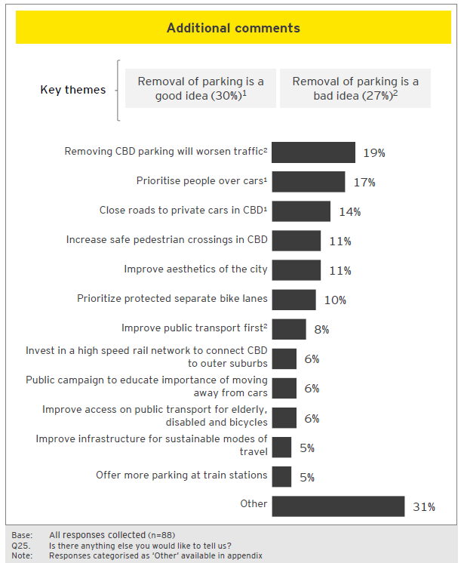

Additional comments
Change is desired
“I appreciate the radical thinking the council is trying. Melbourne is a fantastic city and we need to find ways to keep it that way while the population is exploding.There are a number of different ways that bike lanes have been implemented in Melbourne, a unified approach needs to be found, there are pro's and con's to many but the different rules are confusing for everyone.”
“Melbourne has always been a place of innovation, change and a sense of community. We have the opportunity to show leadership and blueprint a sustainable formula for Australian cities rather that retaining an outdated 1960's Detroit formula based on selfish private car ownership. This community loves bikes, lets take it all the way.”
“Socially, economically and environmentally cycling is by far the best form of transport. Best of all it's fun. I'm really happy to see you considering how we can make improvements to increase the number of cyclists in Melbourne.”
Limit changes to parking
“I find it not only amusing but incredulous that drivers continue to be charged for registration that includes insurance and taxes for roads, but our ability to use roads is being eroded. I'm all for it if the corresponding taxes are reduced.
The roads are increasingly being changed to cater for cyclists who are not paying anything toward the cost as motorists do.”
“Also I wonder if Melbourne city is going to be available to only young people able to ride bikes. How many 60, 70 & 80 year olds are able to cycle into town? Remember too, these are the people that have been paying for these roads for a lifetime.”
“Stop trying to interfere with our existing rights and choices. Keep theoretical academia out of this. Melbourne traffic, accessibility, bicyclists and pedestrians enjoy the right balance generally. Leave it alone. Go to Florence and sort them out instead.”

Motor vehicles

What was tested
Between April and July 2018, City of Melbourne undertook a community consultation with regards to the development of a new Transport Strategy for Melbourne. Eight topics were presented to the public, via the Participate Melbourne website. This section summarises feedback to the Motor Vehicles topic. For more information about the discussion paper in question, please refer to the Participate Melbourne website: https://participate.melbourne.vic.gov.au/transportstrategy/motor-vehicles
Extract of discussion paper tested
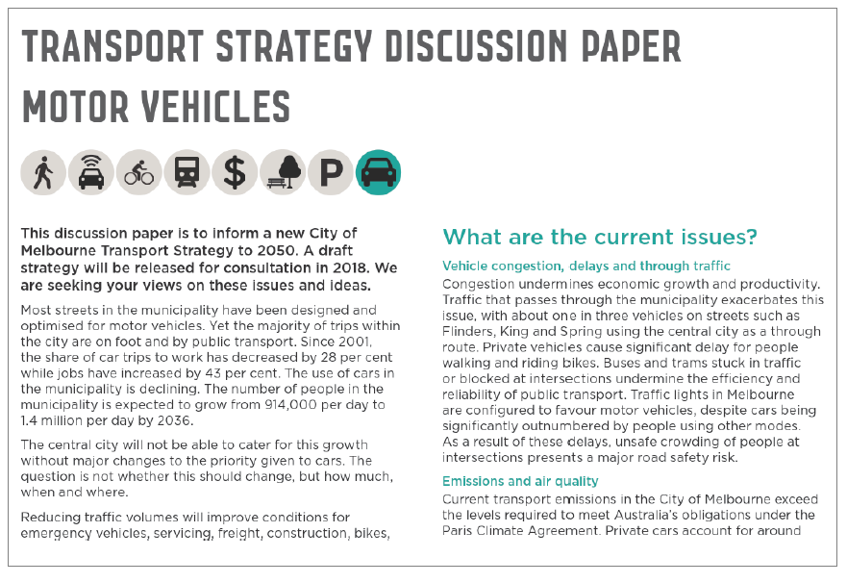

Motor vehicles: respondent profile
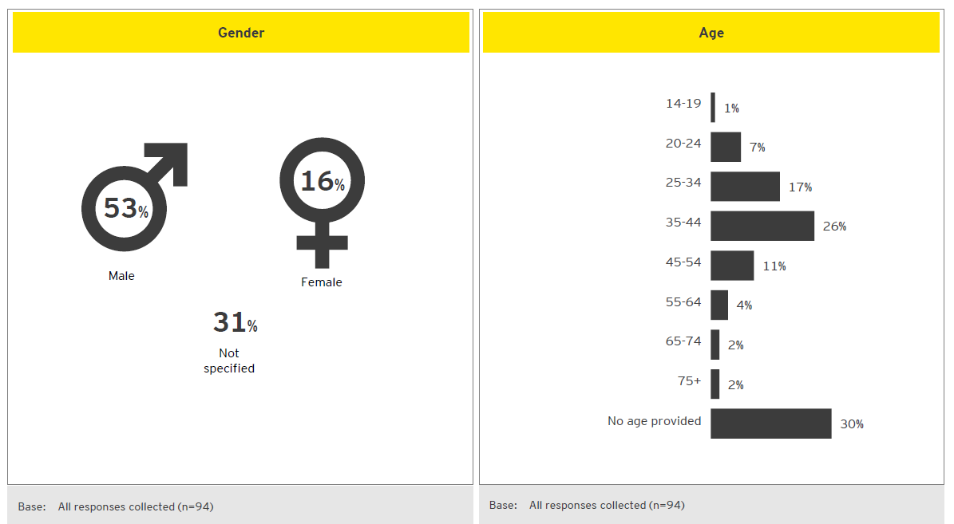

Motor vehicles: experiences with motor vehicles in CBD
- Many experiences cite risky drivers… There is a perception that many drivers in the CBD engaging in reckless and illegal behaviour: such as blocking intersections, travelling through red lights and performing illegal U-turns. Taxis are specifically mentioned as exhibiting these behaviours by a number of contributors.
- This is seen to create an unsafe environment for pedestrians and cyclists… Contributors, in their comments, often express feelings of vulnerability while cycling or walking in the inner city, due to forced interactions with cars. This is partly seen to be a result of motorists’ poor behaviour. However, it is also felt to be a consequence of city planning which has paid to little attention to the needs of non-motorists.
- Drivers express frustration at the traffic and congestion in the Hoddle Grid… Many commenters feel that driving in the city is slow, stressful, and frustrating. They cite a number of contributing factors: too many vehicles, disruptions to traffic due to construction, and lack of compliance with road rules. Often comments explain that these experiences have led them to avoid driving in the inner city. However, others feel driving is an essential mode of transport for them. Motorcyclists convey positive experiences driving in the inner city, but represent a small proportion of overall comments.
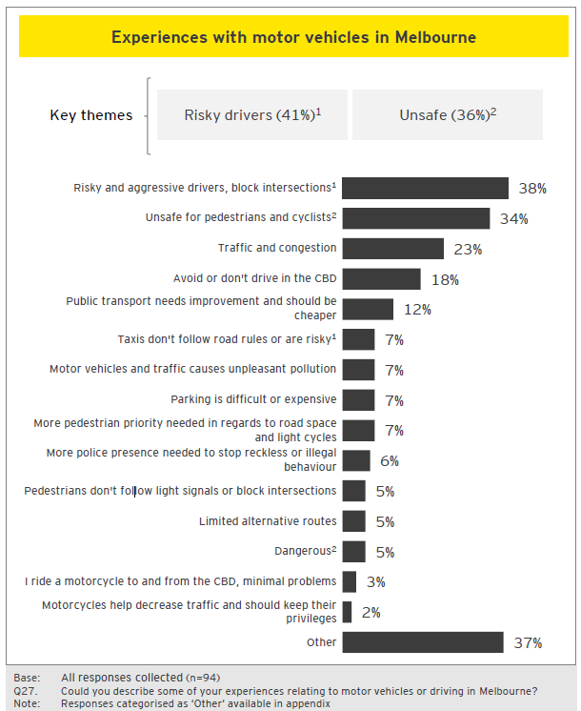

What are the current experiences
Dangerous motorists
“Drivers regularly block intersections so that when the lights change drivers heading in the other direction cannot pass through the intersection. Double parking regularly blocks lanes and causes traffic jams. Trams also regularly block Latrobe Street next to Melbourne Central when stopping on Elizabeth Street. Also motorbikes and mopeds drive in bicycle lanes around the CBD.”
“Cars do not obey the road rules, I see motorist run a red light AT LEAST ONCE A DAY, usually more. It is really dangerous to be a pedestrian in this city, where car traffic is prioritised over people lives. It is safer for me to jaywalk in Melbourne, because I can better predict what the traffic will be doing. Traffic lights have become redundant.
“Because Melbourne City Council have so badly managed cycling traffic, the few cyclists still around are forced to break the rules. A lot of money has been wasted messing up the traffic in Melbourne.”
“Motorised bikes are clogging up the already crowded footpaths.”
“I cycle and walk everywhere and find that Melbourne drivers are selfish. Dangerous behaviour including running red lights. running stop signs, talking on the phone, speeding etcs rife and police are no where to be seen. We need a cultural campaign to change behaviour led from the top and serious penalties.”
Driving in the city
“Riding a motorcycle through Melbourne is relatively safe and could be safer if promoted as a preferred form of transport, the bonuses are, footpath parking, free parking, lane filtering. Lane filtering is legal now and safe. Once again these points needs to be promoted. Driving a car through Melbourne has become rather arduous and frustrating, between huge unnecessary tram stops, less parking availability, road and building works everyway you go. There just seems to be no communication between any one government department. Everything is just happening all at one time with no thought to traffic.”

Motor vehicles: suggestions to address issues
- The issues highlighted on Participate Melbourne were:
- Vehicle congestion, delays and through traffic
- Emissions and air quality
- Inequality
- Safety and security
- Contributors express a desire to reduce vehicle access in the CBD… It is felt that as long as cars are given access to the city the issues cited in the discussion paper will only continue to worsen.
- Instead commenters call for emphasis to be placed on alternative transport modes… Strong support can be seen in the comments for the development of cycling and pedestrian friendly infrastructure (as seen overleaf).
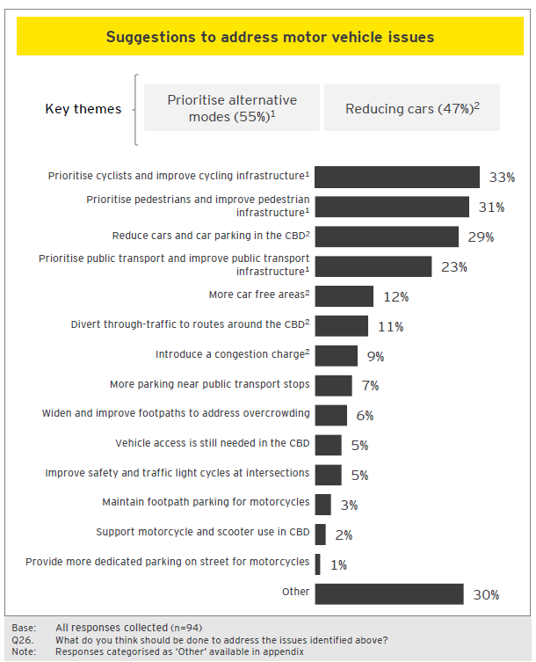

Suggested actions
Reduce cars in CBD
“Definitely time to prioritise people above cars in the CBD grid to start with, and hopefully expanding out from there. Completely agree that maximum one car lane in each direction on Hoddle St grid should be adequate, leaving space for other uses. Many of the laneways may be able to be closed to private vehicles completely.”
“The number of cars should be reduced. Having to live in the city, the air quality is very poor during peak hours. Especially around King Street and Spencer Street. Reducing car lanes, and on street parking, as well as close a few streets for car access as they use the street as a short cut.”
Promote infrastructure and cycling
“I would like to see a car free CBD, but maybe introducing a ‘congestion charge’ for the time being might ease the problem. Currently there seems to be little to no enforcement of basic road rules in and around the CBD. People will without hesitation run red lights, ignore ‘no right turn.’ or .’no U-turn.’ signs, and worst of all enter and block intersections, blocking and delaying trams and emergency services. Maybe giving parking inspectors extra powers / a new role to photograph and fine intersection blockers, tram delayers etc. might dissuade people, as I’m sure the police have a lot to be doing.”
“1. Make cycling accessible. The City of Melbourne has completely ruined cycling lanes, making them so much worse than they used to be -confusing to motorists, cyclists and pedestrians. It is a mess and is discouraging cycling. 2. Enforce motor traffic violations 3. Put up ‘KEEP LEFT’ signs for pedestrians. People are walking down narrow streets at peak hour all over the place.”

Motor vehicles: reactions to scenarios presented in discussion paper
- Scenario 2 is vastly preferred to Scenario 1 by commenters… Although 25% of comments mentioned Scenario 2 by name, a greater proportion expressed the sentiment that: a vision of Melbourne’s future that prioritises cycling, public transport and green space is highly desirable.
- The perceived benefits of Scenario 2 are seen to extend to multiple stakeholder groups… These cited benefits include: freeing up space in the CBD, making the city safer for inhabitants and reducing pollution / congestion.
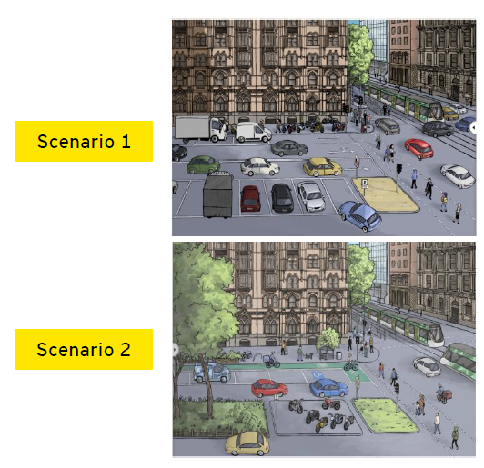
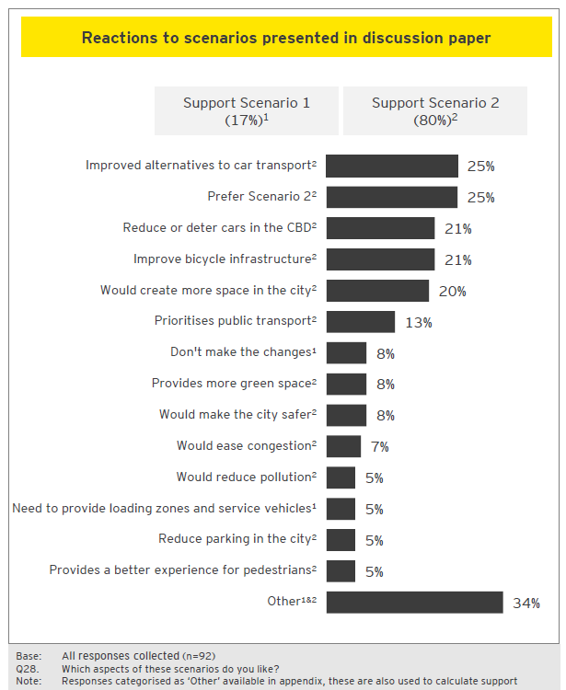

Scenario reactions
Support for Scenario 2
“Scenario 2 is a great step in the right direction. Trams / trains & busses should have right of way like emergency vehicles it would make for faster services and better efficiency in peak traffic times for public transport.”
“Scenario two where movement of people is prioritised makes so much sense. Melbourne is set to experience a huge increase in population, as we accommodate more and more people we need to create opportunities for people to safely and sustainably take alternate modes of transport.”
“Scenario 2 is the ideal scenario as it provides the best social and environmental outcomes.
“People have a greater sense of place, community and safety being surrounded by other people. As mentioned, space can be repurposed for community uses and beautification. You just have to look at examples of pedestrianisation in Europe to see the social benefits and sense of place it creates. Environmentally, it's a no brainer that reduction in vehicles (no matter how efficient and clean they become in the future) that walking and cycling are the only truly sustainable forms of movement.”
“Scenario two is the better option, but it still has too many cars. Turn more streets into linear parks with bicycling veloways instead of traffic lanes (service vehicles are permitted at certain times). Trees everywhere!”

Motor vehicles: reactions to discussion paper

- The Participate Melbourne site showcased four ‘what if’ ideas for which reaction was sought. What if…
- Cars which do not have a destination in the central city, but are just travelling through, were removed from the Hoddle Grid, releasing space for other uses.
- All major streets in the Hoddle Grid were reduced to a single lane each way, maintaining property access and improving mobility for efficient modes.
- New developments provided a number of electric car share vehicle charging facilities upon completion.
- Traffic signal cycle times were minimised across the central city to increase the efficient movement of people –on foot, bikes and public transport.
- Initiatives receive broad support, but single lane suggestion is seen as somewhat divisive… The general consensus form participants leant towards support. Participants in the majority are looking to implement ideas / strategies in order to reduce the volume of cars in the city. However, concerns were raised that single lane roads would only serve to increase congestion.
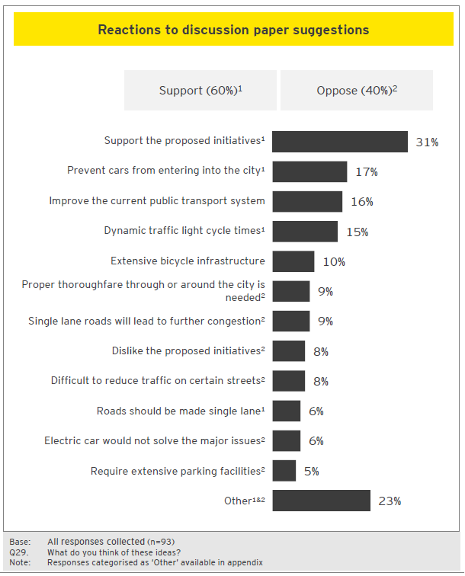

Reactions to discussion paper
Support
“All great ideas, however the CBD is rapidly growing beyond the CBD where pedestrian conditions are a lot worse. Southbank, Parkville and soon FishermansBend are often awful places to walk with very long delays at traffic lights for pedestrians, faster traffic speeds, and more traffic. These surrounding areas where the city is growing need to be remembered!”
“All ideas would be greatly welcomed and appreciated by my family!”
“All good ideas, they should all be implemented. I'm not convinced there is an alternate for the traffic on King Street however.”
“I think all of these ideas are amazing and should be implemented immediately.”
Concerns
“Absolute rubbish. You take our rates and we pay for our cars to be used on the roads. Bike riders pay nothing. You expect 70-80 year olds to walk and carry groceries and other purchases?”
“As mentioned above I think that these ideas are completely unreasonable and extremely elitist and will result in a CBD that it totally isolated and irrelevant.”

Motor vehicles: additional comments
- Motor vehicles are still viewed as important… There is some apparent concern around the impact of making driving in the CBD more difficult. The outcome of fewer cars in the CBD appears to be unclear for some and therefore, greater caution is desired.
- Public transport the main alternative… For many respondents an improved pubic transport system is felt to be the key solution to motor vehicle related issues in the city.
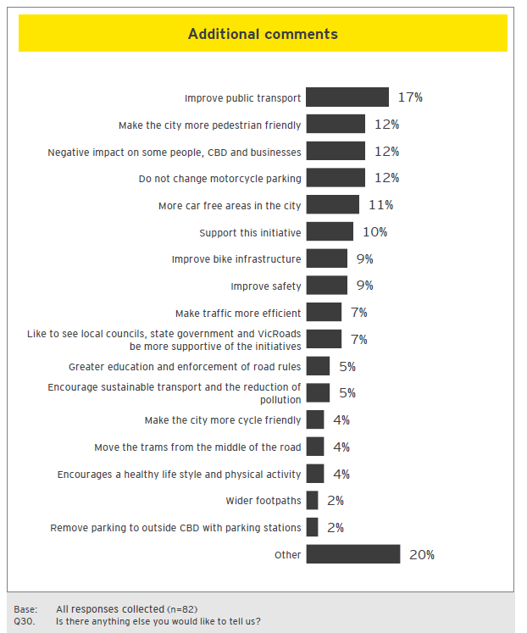

Additional comments
Motor vehicles still important
“The press this morning reported that you were considering the council setting a car free zone in the lower central block. This is the most ludicrous suggestion and has the potential to totally ruin the city. Pedestrian safety is your rationale. Pedestrians need to take responsibility for their actions. They need to get off their devices and be aware of where they are. Constantly changing conditions for cars is not the solution. If you think that this car free zone is a good idea then you should all quit council now! If you cannot see the issues with closing Queen St and Flinders Lane to through traffic then you don't understand the city. My beloved city is already losing its liveability with all the lane conversions to bike lanes that don't allow peak traffic flows to clear. Stop wasting public money on poorly thought out plans. We can all cycle and it doesn't work for everyone. We need through traffic routes through the Hoddle Grid. Where would the cars go if there were superblocks.”
Improve public transport
“Public transport is too expensive for short-distance commuters. For instance, if I want to travel from Elgin / Lygon Street to Queen Victoria Market and back, I have to tap on twice, which means over $8 spent. I'd rather drive instead and park there for an hour for free. If you want to encourage people to use public transport, why not make it cheaper (like by half?) or expand the free tram zone area. Expanding it to Parkville /Uni Melbourne would be a massive help because so many people who live there frequently travel to the city.”
“I think that Melbourne is not suited to riding bicycles, the weather is not suited, we have trams which complicate things and we need to focus on allowing traffic to flow as it is impossible to complete many tasks by banning or reducing the number of cars in the city through lane closures. The best method is to encourage and fix other methods of transportation. Right now the trains are full, trams are full and the metro rail project will run at capacity once opened.”

Transport pricing

What was tested
Between April and July 2018, City of Melbourne undertook a community consultation with regards the development of a new Transport Strategy for Melbourne. Eight topics were presented to the public, via the Participate Melbourne website. This section summarises feedback to the Transport Pricing topic. For more information about the discussion paper in question, please refer to the Participate Melbourne website: https://participate.melbourne.vic.gov.au/transportstrategy/transport-pricing
Extract of discussion paper tested
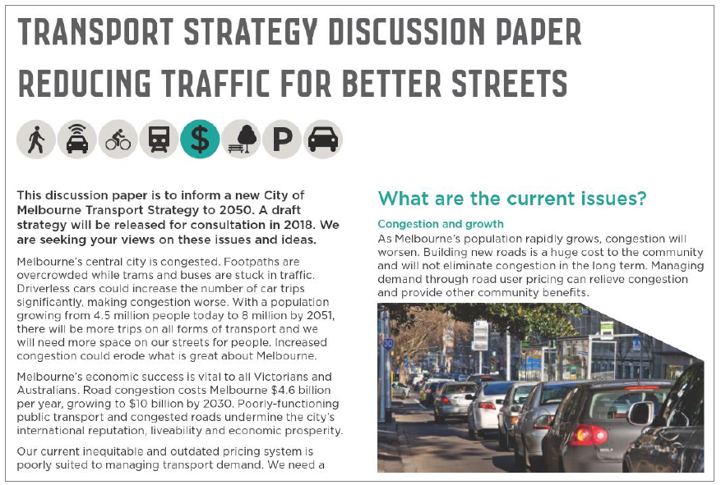

Transport pricing: respondent profile
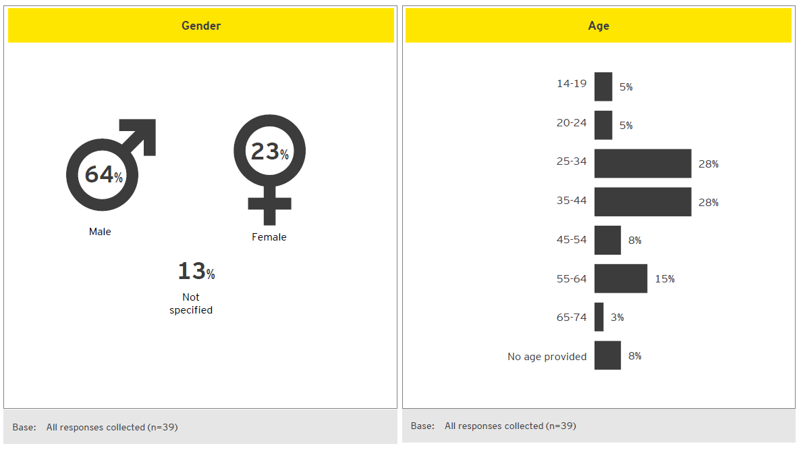

Transport pricing: suggestions to address issues
- The issues highlighted on Participate Melbourne were:
- Congestion and growth
- Driverless cars
- Declining fuel excise revenue
- Inequity in fuel excise costs
- Alternative modes of transport seen as long term solution… Many contributors chose to adopt a long-term view of issues –in particular, promoting the development of alternative means of transport, public transport and cycling in particular. These responses indicate a desire for other transport options to be improved before changes to transport pricing are made.
- Congestion tax receives cautious support… One in five comments cited congestion tax as being a viable solution to address the CBD’s transport issues, but there is a shared sense amongst a number of commenters that further research would be required before implementation.
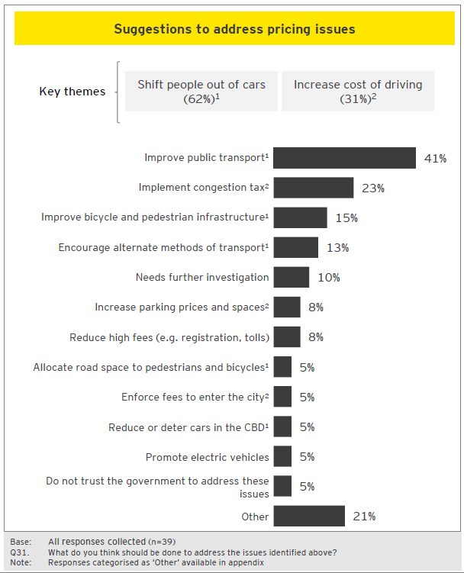

Suggested actions
Shift people out of cars
“I'm in favour of this proposal and strategy. A per km charge system is a good proposal for addressing congestion but it does seem complicated and possibly open for hacking and cheat. A congestion zone might be easier to implement. It's crucial that any additional revenue from this be transparently be allocated to public transport, walking, and cycling infrastructure.”
“Your suggestions are excellent; I hope you have the political strength to bring them to reality. We must transition away from private cars being an acceptable way to transport individuals along the same routes served by public transport. (Exemptions for people who really need a car / van; delivery drivers, tradies, etc; more subsidy for elderly to travel without driving themselves which can be a danger to others, e.g. extend taxi 50% subsidy to closer to a train fare).”
Improve public transport
“It's cheaper and more pleasant for people to drive to work. When you can park in the city for the same as 1 persons return on the train, or less than 2 people, it makes economic sense to drive. The state of the public transport -crowded and unreliable, also makes the journey by your own car better. People should be deterred from this with increased costs of commuting with your own car.”
“1. Improve public transport. 2. Improve parking spaces and security at all train stations 3. Reliability, quicker, express, frequency so no timetable is needed. 4. Make bicycling a real option by providing real infrastructure for cyclists.
When public transport is better than driving it will naturally be used. Japan is a good example and there is no pay per mile where I have seen good public transport.”
Transport pricing: reactions to discussion paper
- The Participate Melbourne site showcased four ‘what if’ ideas for which reaction was sought. What if…
- You could opt-out of fuel excise and car registration fees and choose to pay less and drive less.
- The roads were less congested at the times you needed to travel most.
- A road pricing scheme reduced through-traffic in sensitive areas like neighbourhoods, shopping strips, on public transport routes and in the central city.
- Empty robo-taxis were discouraged by charging higher prices for empty vehicles to use the road.
- Scepticism narrowly outweighs support for proposed initiatives… It is felt by a number of commenters that transport pricing will not have a positive effect on the long-term challenges faced by the city. Rather, it is felt that there would be significant barriers restricting the ability of initiatives to be implemented effectively.
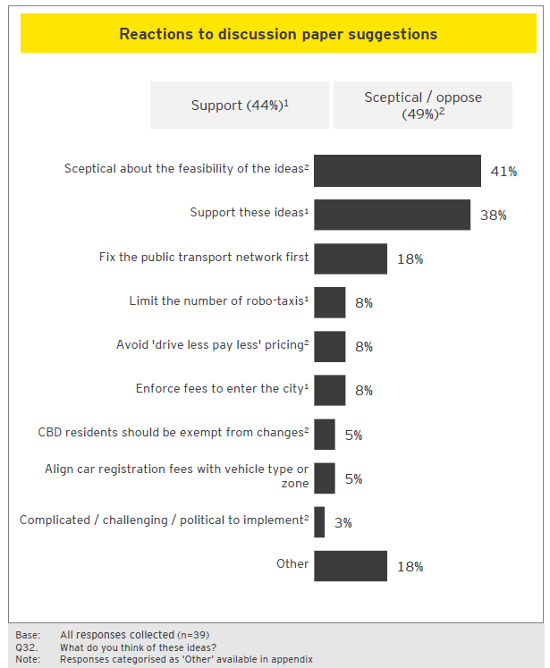

Reactions to discussion paper
Scepticism about ideas (slide 1 of 2)
“These are not good ideas as user pay model for road usage will always be divisive. Imagine applying the same idea to Medicare. There is already a fee structure in place that charges more for people driving more by way of fuel excise (see my comments above on Q1 on electric cars). There are other (better) ways of decreasing congestion by way of making public transport better. One look at our train network map will show that we don't have a suitable inner / middle /outer 'ring' transport network connecting all the train lines that currently head straight into CBD.”
“Excellent ideas and would definitely vote for it. One thing that concerns me is how to do it effectively and efficiently, i.e. not overcharging when we choose to drive. I would 100% opt for a fair pay-as-you-drive system.”
“I'd absolutely love the ideas above. Some of the ideas seems complicated to implement. For example, how would you distinguish through traffic in areas like shopping strips with traffic going through the shops? I'm sold on the idea. But you'd have to convince a lot of other people. Getting this message across to the folks of Melbourne would be next to impossible. Decades of car centric policies have enshrined an entitlement because they pay rego.”
“I do not believe this will work. People still need to get to work and, I know in the UK, the fuel excise reduction will not be reflected in a price drop at the pumps, I suspect rego will not reduce, therefore this will just boost costs to road users.”
Scepticism about ideas (slide 2 of 2)
“I think these are weird things for Council to advocate for beyond its boundaries when Council has so many levers to make central Melbourne a more liveable and efficient place through allocation of road space. The sorts of pricing mechanisms discussed can be, at best, regressive, and at worst, totally inconsistent given the mixed bag of toll road pricing around the joint. Melbourne would be an easier place to get around if we:
“Better regulated motorcycle parking (i.e. get them off footpaths).”
“Increase pedestrianisation(Elizabeth St and Little Bourke an obvious start).”
“Get rid of extraneous street furniture.”
“Create continuous and protected bike lines by reclaiming on-street parking.”
“These are not good ideas as user pay model for road usage will always be divisive. Imagine applying the same idea to Medicare. There is already a fee structure in place that charges more for people driving more by way of fuel excise (see my comments above on Q1 on electric cars). There are other better ways of decreasing congestion by way of making public transport better. One look at our train network map will show that we don't have a suitable inner / middle /outer 'ring' transport network connecting all the train lines that currently head straight into CBD.”
“Agree with point one would help but does not change the public transport chaos. Point 2 would be great. But if everyone thought the roads were going to be less congested they would only become more congested for drivers would be thinking this and use it more. No road pricing. Governments cannot be trusted with this form of revenue raising –think of what you will be doing to business.”

Transport pricing: additional comments
- Responses to this optional question are distributed across a number of topics… Areas of interest typically related to relieving congestion in the inner city –either through improved public transport or initiatives to reduce the number cars in the CBD. Additionally, some contributors took this opportunity to reiterate their support or opposition to congestion pricing.
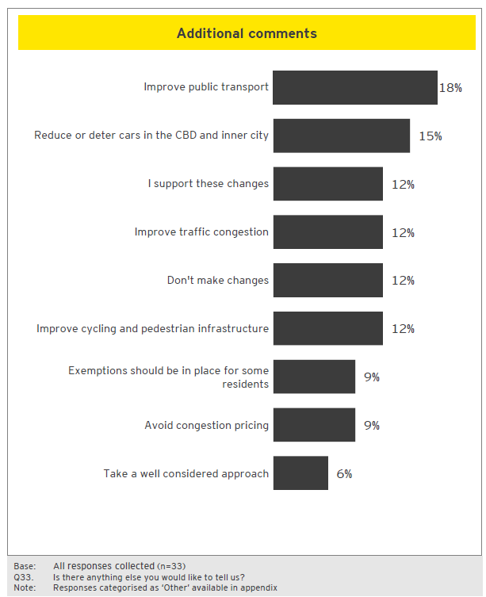

Additional comments
Support for transport pricing changes
“I'm pleasantly surprised at this forward-looking approach from a council!”
“Stop mucking around with surveys and get things happening now that are future proofed.”
Concerns raised
“Consideration should be given to the lowest socio-economic sectors and providing an exemption and / or subsidy on the congestion tax. Consider a park and ride bus system as an interim solution to getting people out of cars.”
“Extra caution has to be taken to ensure that people who live further away are not disadvantaged due to distance. Outer city folks who are already less affluent socially and financially could he impacted by this negatively, worsening inequality if we don't get this right. Public transport gets worse the further you go out, and so does cycling and walking infrastructure. Driving is almost a necessity. This is an uphill battle to convince people.”

Appendix

Note on appendix

‘Other’ codes
As described in the introduction to this report, some codes receiving only a limited number of responses have been combined into ‘Other’. This section shows the results for these limited response codes. When interpreting these results, the reader should refer to the sample size which is described in the footnote of each slide. For example, in the instance of the results for Q2 (shown opposite), 3% of the total 197 responses mention the need to address homelessness. Therefore, it can be inferred that the homelessness was mentioned by six individual contributors.
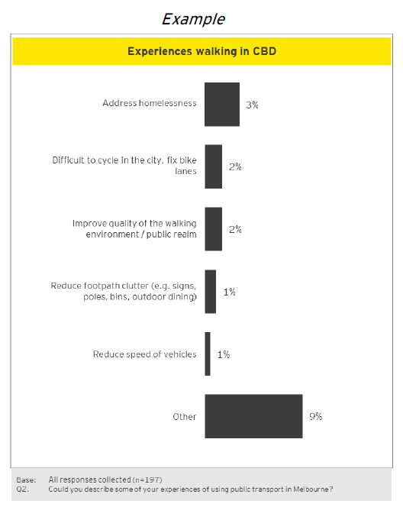

Ideas forum

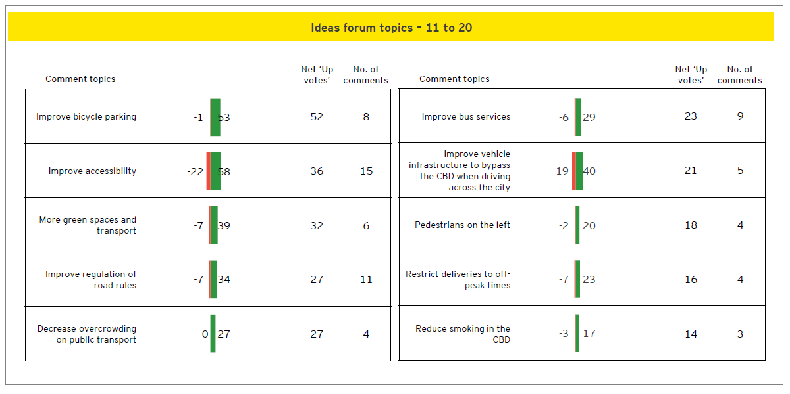
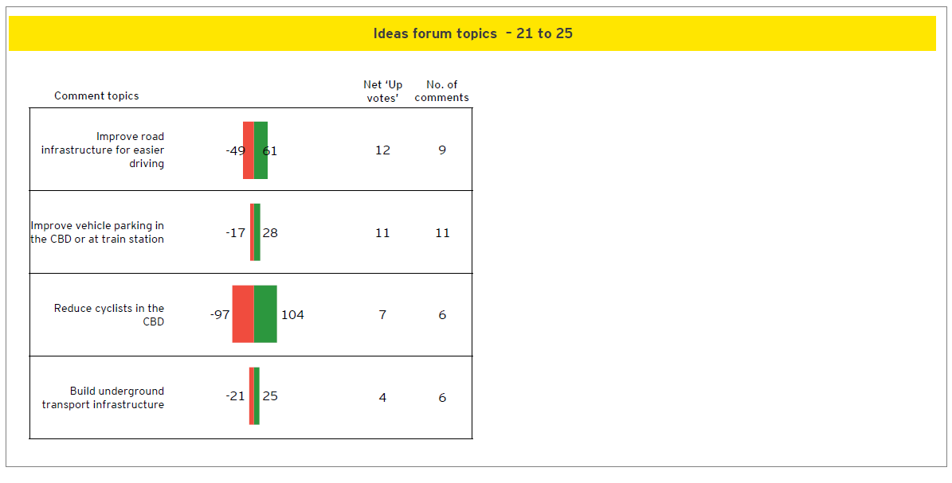

Walking –Other comments
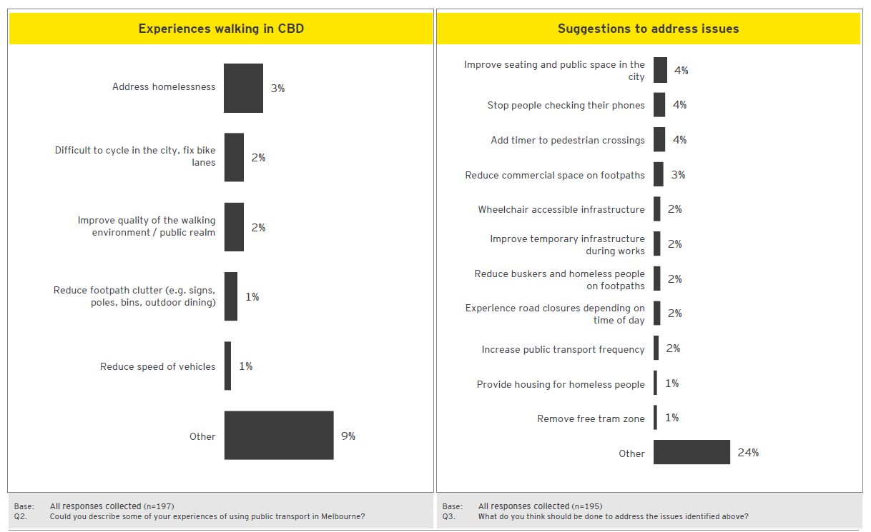
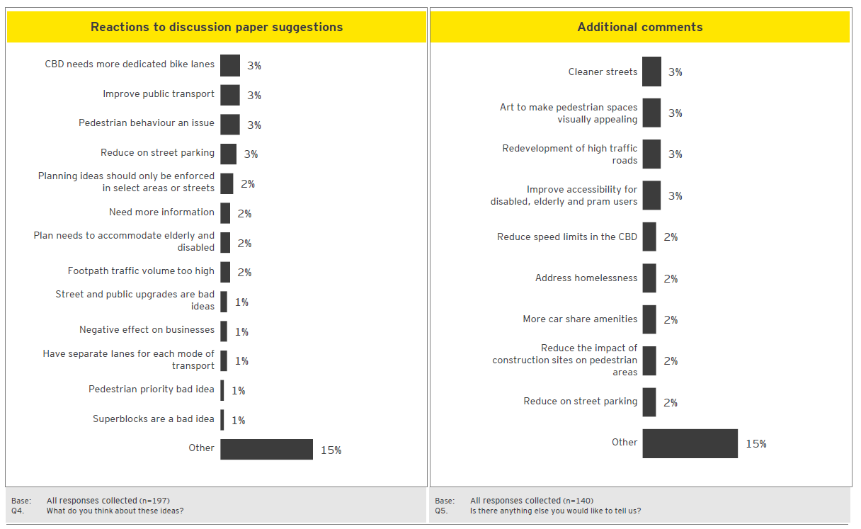

City Space –Other comments
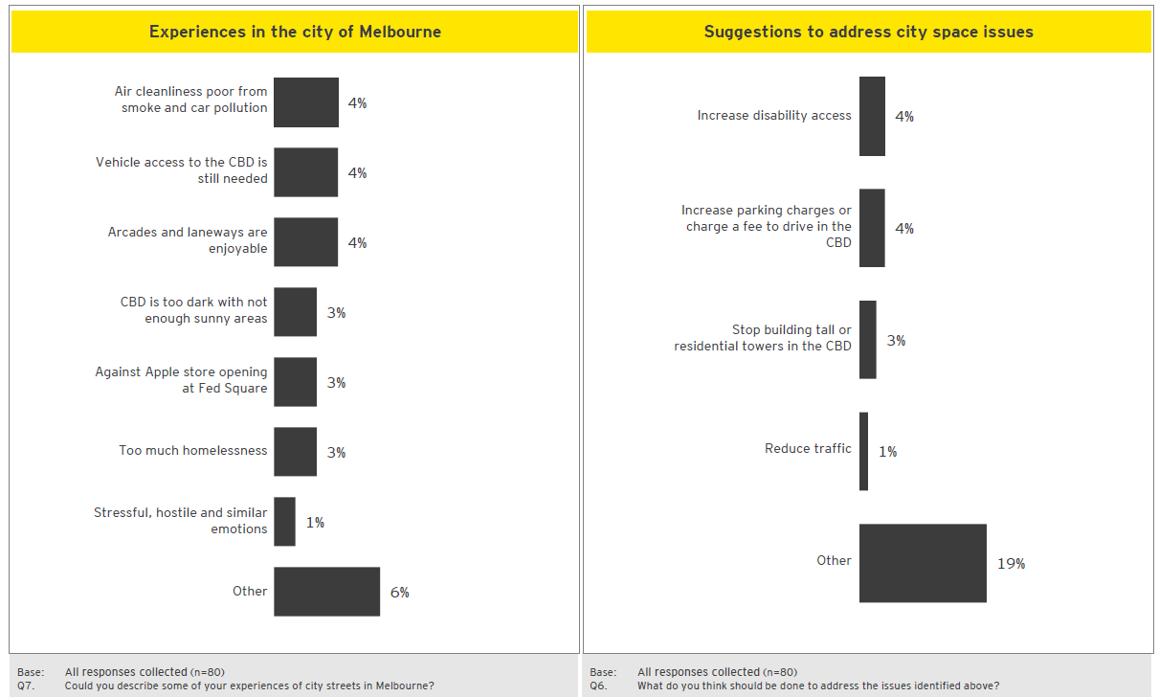
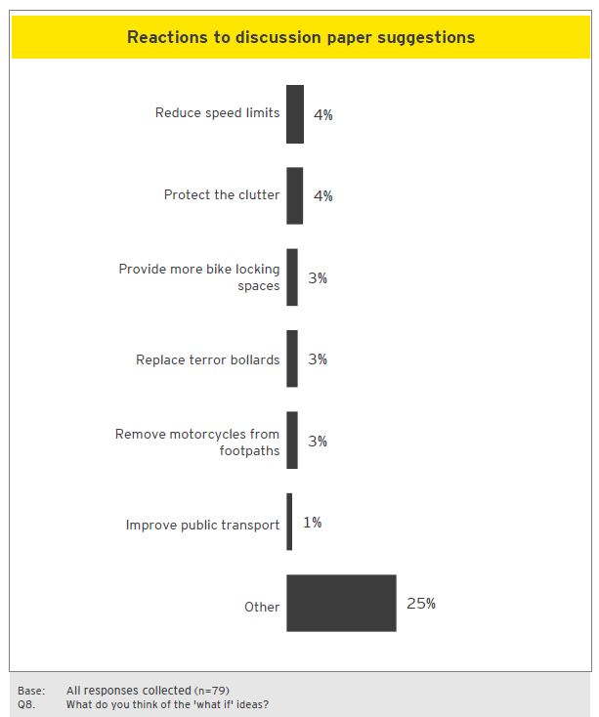

Public Transport Network–Other comments
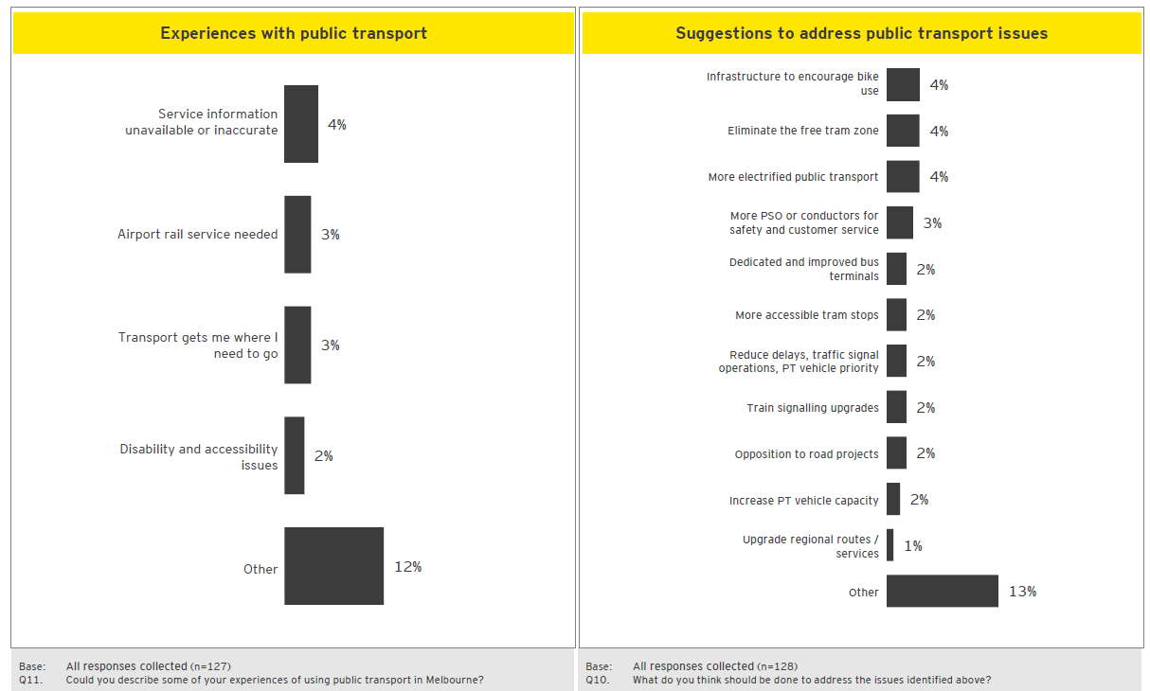
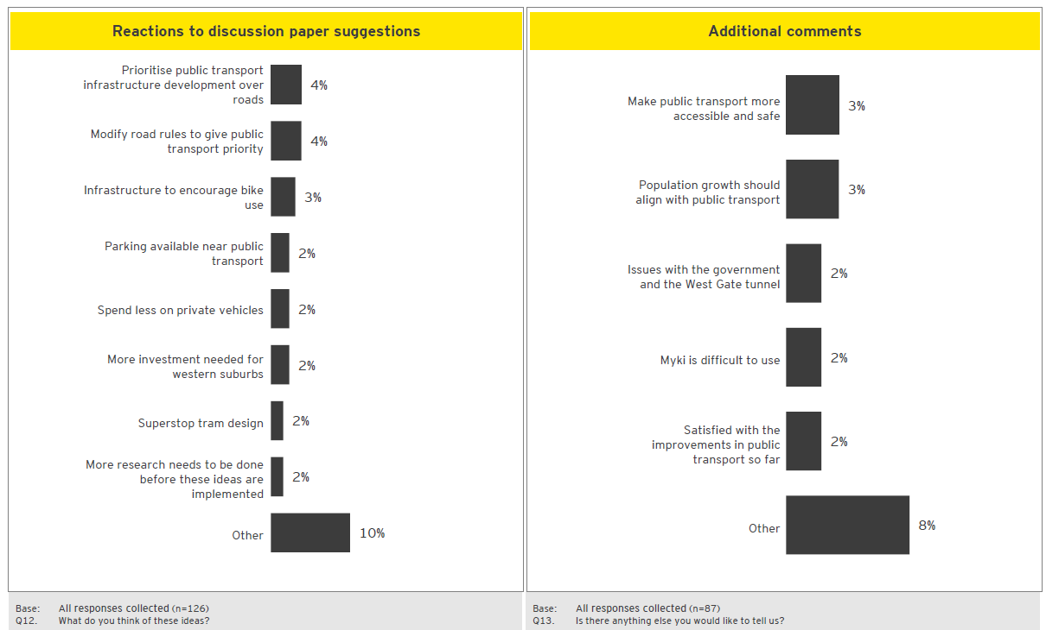

Cycling –Other comments
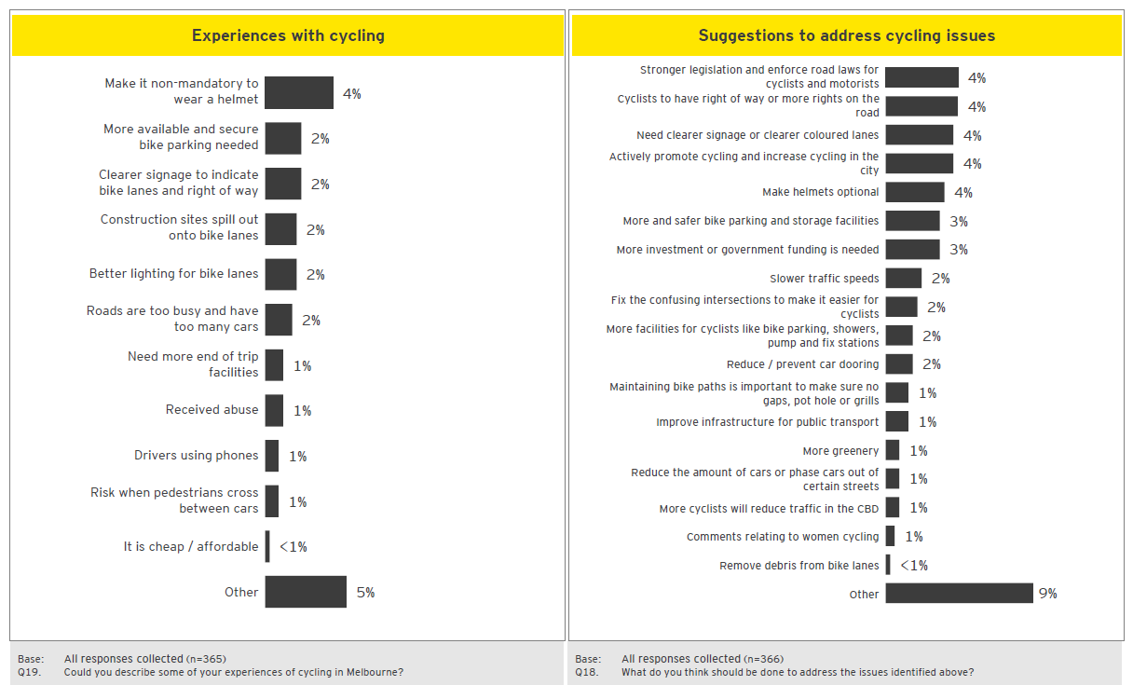
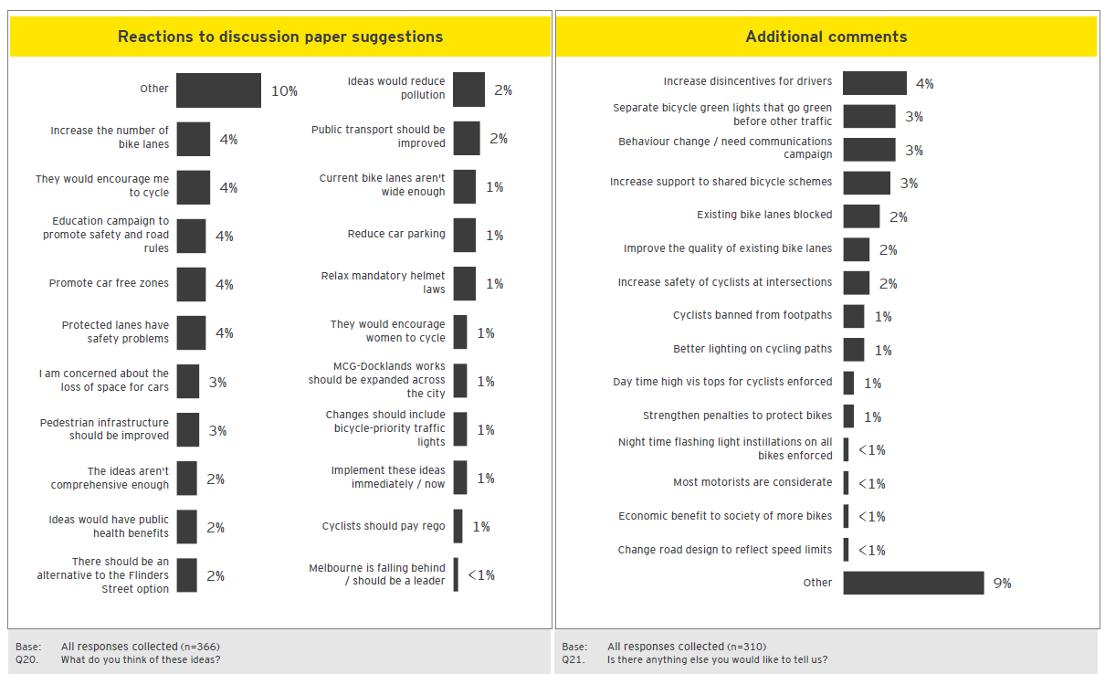

Car Parking –Other comments

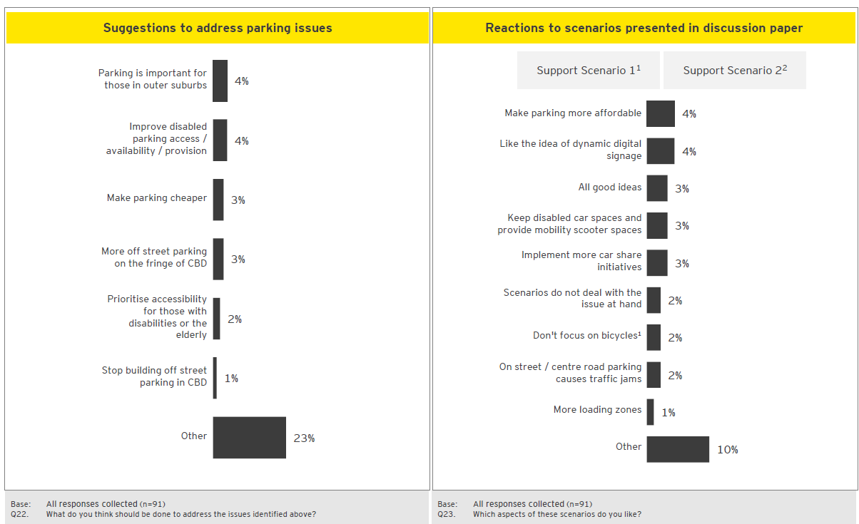
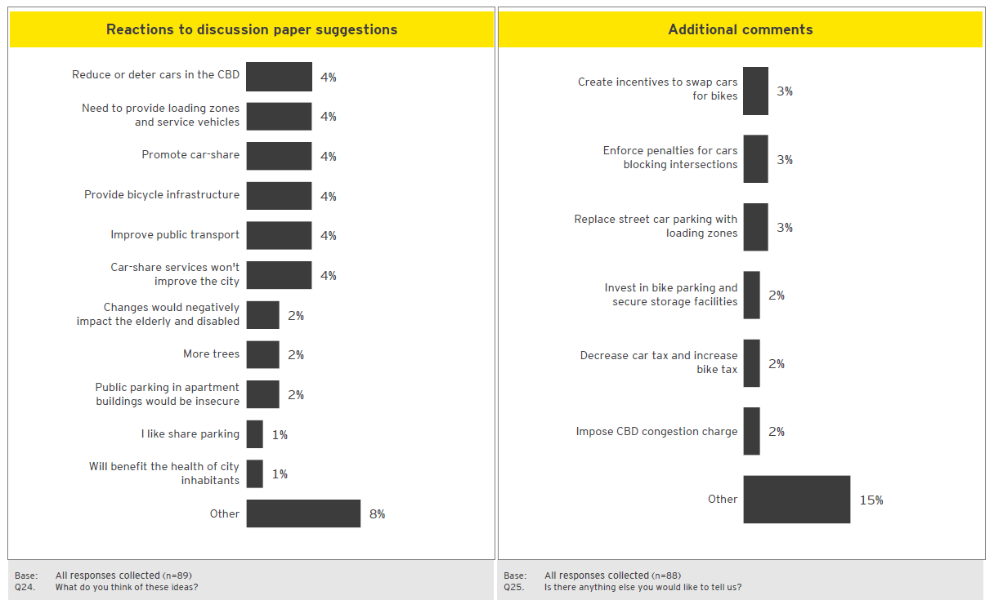

Motor vehicles –Other comments
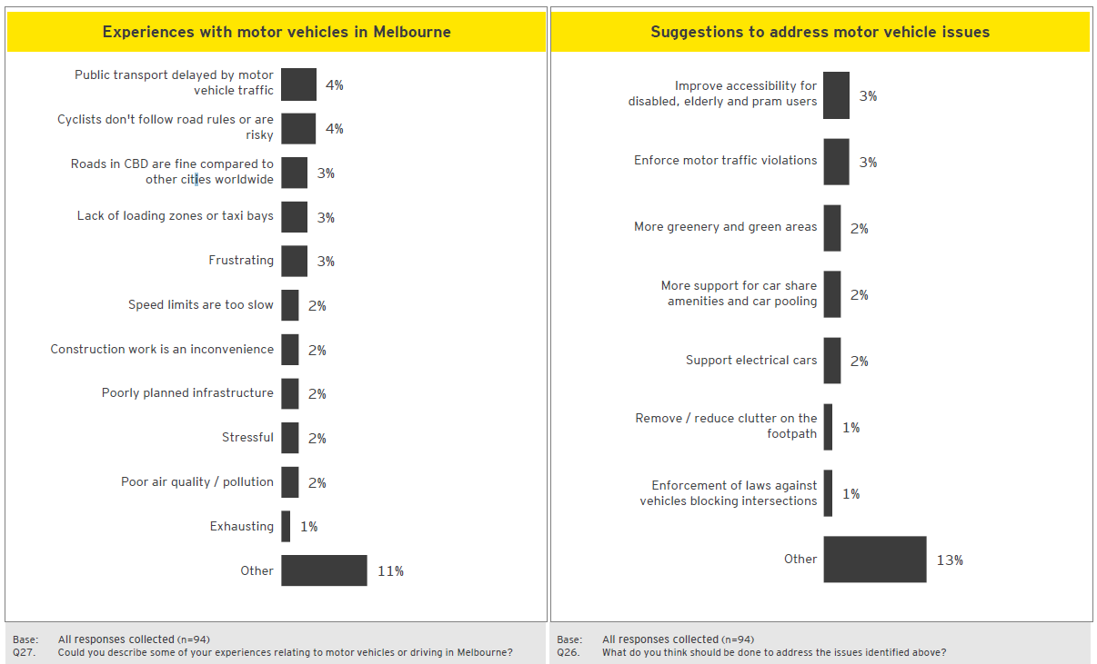
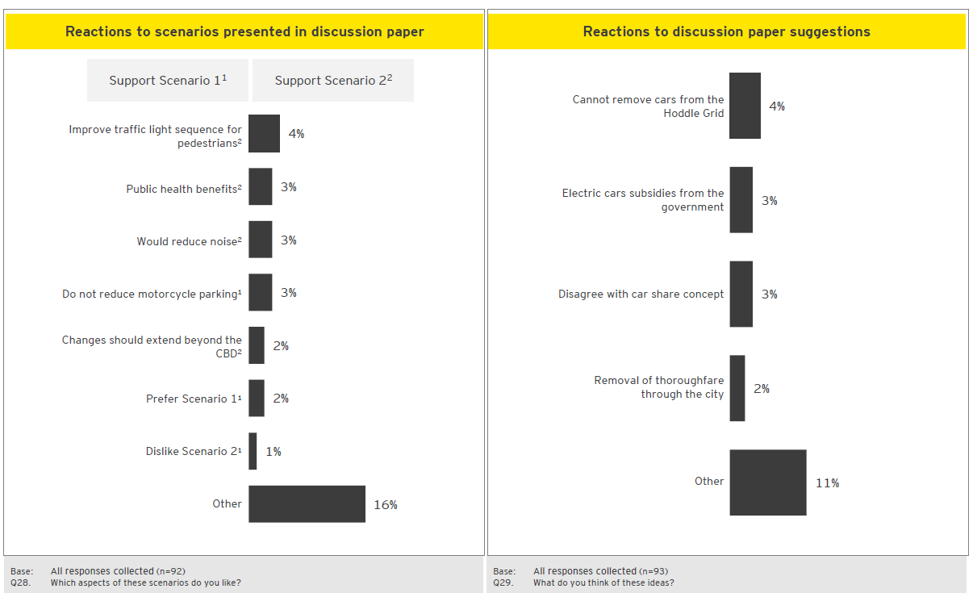

Transport Pricing –Other comments
