MARKET STREET PARK

COMMUNITY ENGAGEMENT SUMMARY

December 2018

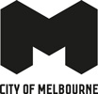

CONTENTS

Introduction p.3

PART A: ENGAGEMENT OVERVIEW
Project Context p.5

Engagement Snapshot p.6
Media Snapshot p.7

Engagement Outcomes p.8
Community Feedback Summary p.9

PART B: RECOMMENDATIONS

City Garden p.12

Playful Terrace p.13
Central Plaza p.14

Northern Lawn / Collins Street p.15
Collins Street / Market Street Interface p.16

2

INTRODUCTION
This document has been compiled following the conclusion of community engagement for the Market Street Park (September 2018). Over the engagement period, 49 participants submitted recommendations and comments on the proposed public space through the City’s online engagement platform Participate Melbourne.

The City of Melbourne in partnership with Cbus Property are creating the first urban park in the central city since City Square was developed in the 1980s. The new park, located on Market Street, will create 1900m2 of new public open space in the central city.

The purpose of this engagement was to present to the community a draft concept plan for a proposed new public space along Market Street. The proposal would see the first public green space created in the CBD since City Square was developed in the 1980’s.

The proposed scope of works includes:

- Terracing of a new 1900m2 park from Collins Street to Flinders Lane
- Construction of new footpaths on the eastern side of the park, blue stone paving across central sections of park
- Planting of large new lawn areas to the north of the park
- New public lighting, raised garden beds and blue stone seating areas
- Landscaping
- Improved north south connection between Collins Street and Flinders Lane

Significantly, through both the Nature in the City, Urban Forest and Open Space strategies, the City of Melbourne is committed to conserving biodiversity and creating sustainable and diverse urban ecologies and green spaces. As Melbourne’s population continues to grow, providing green space in the city is important to support diverse, resilient and healthy ecosystems that can adapt to differing needs and uses, while providing people with the opportunity to connect with nature.

The park’s features include large lawn areas to accommodate a high number of uses, wide paths for ease of pedestrian movement through the space, new seating, space for programmed events as well as improved pedestrian access to public transport along Collins Street. The project will also transform over 1300m2 of Market Street into
public open space, including new bicycle lanes and parking adjoining the park.

Recent initiatives including the Elizabeth Street Pop-Up Park (December 2017 to March 2018) have demonstrated that green spaces within the CBD play an important role for people as well as for businesses. Learning from this experience, the Market Street Park aims to provide a similar
amenity to local residents, workers and visitors as the Elizabeth Street Pop-Up Park.

This report on the engagement process and outcomes has been commissioned by The City of Melbourne and completed by The Space Agency
- an independent consultancy specialising in stakeholder engagement and placemaking.

The Space Agency was engaged, as an impartial, external consultant, to review and analyse community feedback in order to identify key themes and recommendations. Every effort has been made by the authors of this document to represent accurately participant feedback and insights.

For recommendations or questions, Please contact: citydesignstudio@melbourne.vic.gov.au
3

PART A: ENGAGEMENT OVERVIEW
4

PROJECT CONTEXT
In order to create the new park, Market Street will be reduced in size and accommodate single direction southbound traffic only. Also included will be:
- A new path network linking Flinders Lane and Collins Street, providing a clear visual and pedestrian connection
- A new mid-block pedestrian crossing
- Two new bicycle lanes
- New lighting, trees and garden beds

In addition to this, the Market Street park will include:
- City garden and lawns
- Playful terrace (with integrated water play elements)
- New north and southbound bicycle lanes
- Central plaza connection from Market Street
- Reconfiguration of Market Street to southbound traffic only

Under consultation from the City of Melbourne the Market Street park has been designed by OCULUS landscape architects.

The site is located in close proximity to the Immigration Museum Plaza and former Port Authority buildings, reflecting the nearby presence of the Yarra, former commercial wharfs and turning basin.

In the mid-20th century, the National Mutual Plaza was built on the site; a large plaza was constructed on the northern side of the site along Collins Street with significant solar access. It was used extensively as open space due to its aspect and
was popular with office workers, particularly during lunchtime. It was one of the few public spaces within the CBD grid.

The Collins Arch development includes a collection of residences, set above Collins Street, premium commercial offices and a 5-star hotel. The approval for this development requires 474m2 of space within the title boundary of the development site be constructed as public open space and vested
to Council on completion of the development. The development site has been designed to integrate with the future park (so as not to present blank, inactive boundary walls or similar.
5

ENGAGEMENT SNAPSHOT

PARTICIPATION OUTCOMES:
2,232
Draft Concept Plan
Page Views
103
Draft Concept Plan
Recommendations
1,520
Unique Visitors to Participate
Melbourne
49
Participate Melbourne Submissions

INFORM ENGAGE
Engagement Outcomes

Participate Melbourne is the digital hub for all City of Melbourne engagements. Over the duration
of the engagement, the platform attracted 1,520 unique visitors.
A total of 49 participants commented on the interactive concept plan on Participate
Melbourne. Together, participants put forward 103 recommendations.

HOW WAS IT PROMOTED?

- CoM social media released a Broadsheet article titled ‘Collins Street Is Getting a Huge New Public Park’, on the 14th September.
- CoM Participate Melbourne launched ‘A new park for Market Street’, on the 19th September.
- CoM social media platforms including facebook, linkedin and twitter promoted the park on the 19th September.
- CoM news (internal communications) posted ‘Want more green space?’, on the 19th September.
WHAT HAPPENED?

- The City of Melbourne ran a three-week community engagement campaign from the 19th of September to the 10th of October.
- During this period, the draft concept plan was presented to the public via an interactive plan on Participate Melbourne.

WHAT’S NEXT?
- Community feedback will be reviewed and integrated into an updated concept plan.
- The finalised concept plan will be displayed for community view (Phase 2) via Participate Melbourne in January 2019.
6

MEDIA SNAPSHOT

The engagement was supported by a media campaign including posts on the City of Melbourne social media channels - including: Facebook, Twitter and LinkedIn and multiple Broadsheet stories. A selection of these are featured below.

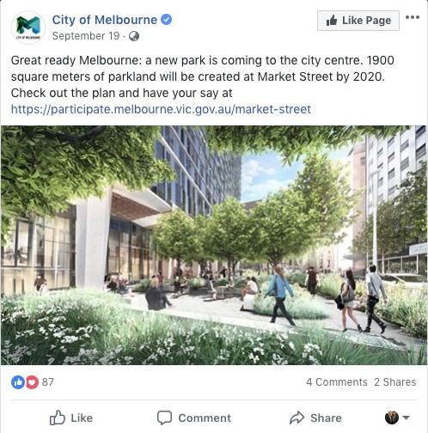
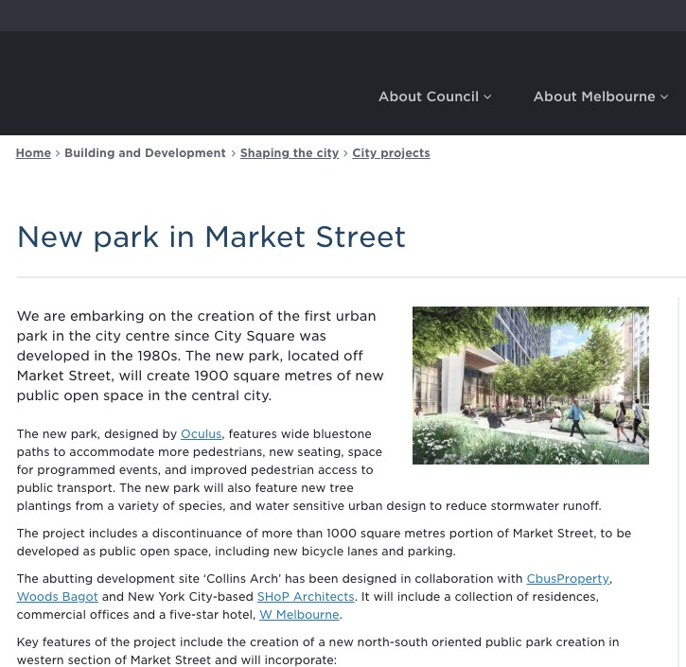
CoM Facebook post CoM Website article

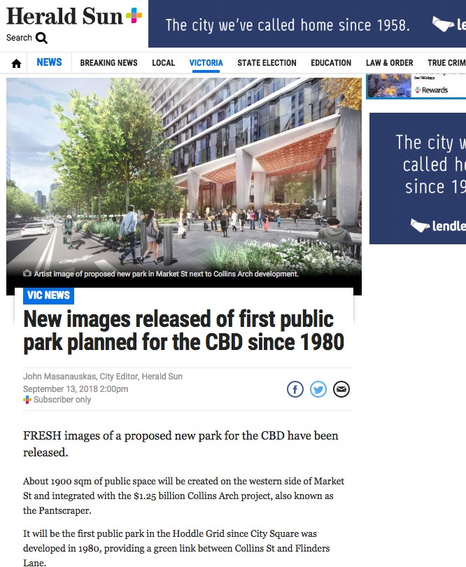
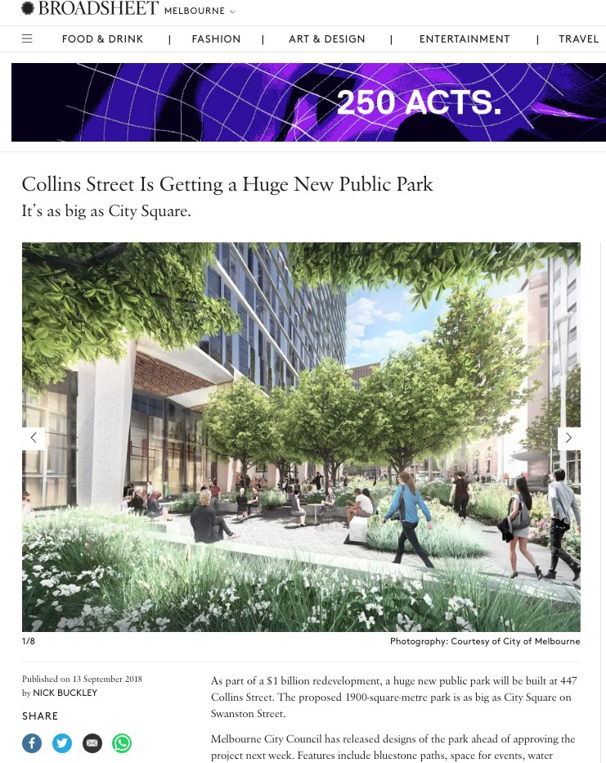
Herald Sun news article Broadsheet news article
7

ENGAGEMENT OUTCOMES

RECOMMENDATIONS
The community engagement collected responses from 49 participants that have been independently reviewed by an external consultant. Respondents were asked if they had any comments about the Market Street park concept plan. These responses and recommendations have been categorised into five key themes and major sub-themes within each:
Action Area | N | %
Open Space and Greenery | 32 | 31%
Native planting | 10 | 10%
Shrubbery / understorey planting | 6 | 6%
Public Amenity | 32 | 31%
Seating | 8 | 8%
Water feature | 6 | 6%
Safety and vehicle movement | 19 | 18%
Remove parking | 8 | 8%
Separate bike lane | 8 | 8%
Other recommendations | 11 | 11%
Sustainability | 9 | 9%
Total | 103 | 100%

Open space and greenery
  - Native planting
  - Shrubbery / understorey planting

Public amenity
  - Seating
  - Water feature

Safety and Vehicle Movement
  - Remove parking
  - Separate bike parking

Sustainability
Other recommendations
8

COMMUNITY FEEDBACK SUMMARY

Participant comments have been individually reviewed and organised into the following five themes.

N. | % | Recommendations / Comments
Open space and greenery
32 | 31% | 32 comments related to the theme of open space and greenery. Of this number, ten recommended planting native species within the proposed park. A further six comments recommended introducing shrubbery or similar mid-level planting to create more layers in the proposed landscape design. Comments and recommendations included:  - Less formal planting including grasslands, native forest, or even a rain garden.  - Possible issues with lawn, including drainage and irrigation, access to sufficient sunlight for growth; as well as contingencies for these issues.  - Expectations of a high quantity of greenery / trees.  - Suggestions to minimise the use of paving and concrete in order to keep the space green and natural.  - Considerations on how to improve the urban ecology and attract local flora / pollinators.  - Suggestions to include a diversity of plant species including evergreens for greenery in winter
Public amenity
32 | 31% | With 30 comments collected, the theme of public amenity covered a range of topics. Recommendations centered around the experience for people using the park and how it could be a more functional space for users. Eight participants recommended greater focus on seating choices within the concept plan, and six recommended adding a water feature. Recommendations and comments included:  - Additional public seating, including different formats: for reclining and tiered seating on northern side.  - Adding an element of water, such as a fountain or mist sprayer. This was partly for aesthetic purposes, as well as to make the space cooler in summer.  - Retention / relocation of the public toilets.  - Making the park a smoke-free area.  - An acoustic element that reduced city noise  - Including games (giant chess, outdoor table tennis)  - Space for a Christmas tree
Safety and vehicle movement
19 | 18% | Comments and recommendations from 19 participants related to safety and vehicle movement around the park. Many recommendations suggested further reduction or removal of parking on Market street. A similar number suggested fully-separate bike lanes. Six participants recommended that Market Street should be closed to vehicles completely,  allowing for a larger park than what is proposed. Recommendations and comments included:  - Improved safety / separation of road and bike lanes.  - Closure of the street to traffic and removal of car parking.  - Including deterrents to skateboarding.  - Safety bollards - designing them to incorporate planter boxes and/or collected water storage.
9

N. | % | Recommendations / Comments
Other
11 | 11% | Participants provided a range of recommendations and comments that were more general in nature. A majority of these comments were statements of general support or opposition to the project without specific feedback
Sustainability
9 | 9% | Nine participants commented on the inclusion of water sensitive urban design, rain water capture and other sustainable design elements that could be included in the park such as solar lighting and water tanks integrated underground or within safety barriers.

10

PART B: RECOMMENDATIONS

11

CITY GARDEN
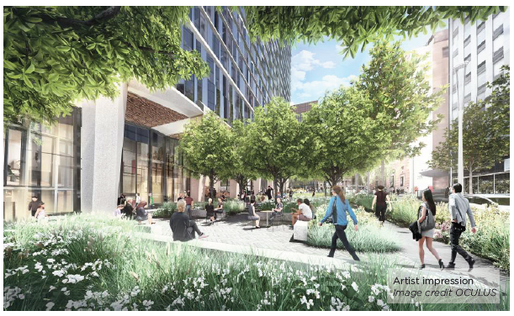

CONCEPT PLAN PROPOSAL:

- Garden spaces and shade trees
- Seating walls and edges for rest
- Extensive horticulture and trees

WHAT PARTICIPANTS SAID:
“ ... well thought-out plan for a greenery space in the centre of Melbourne CBD as it allows public
enjoyment for all seasons and in all weather conditions throughout of the year.”

12 participants made comments and recommendations relating to the City Garden.

Ten comments were around the inclusion of natural and indigenous planting, with specific emphasis on Victorian natives. Six of the suggestions that related to the City Garden were to provide more layered planting and screening from the road.

One participant commented on programing the space with a gelato stand and flexible furniture, creating a ‘mini Bryant Park’ (New York) for Melbourne.

Another commented on the park’s opportunity to implement a more progressive landscape design, showcasing an exemplar for environmental standards within the City of Melbourne.

Two comments within this section expressed the participants’ support for the draft concept plans and the overall park layout
12
and design, noting that it is very comprehensive and has been well thought out

PLAYFUL TERRACE

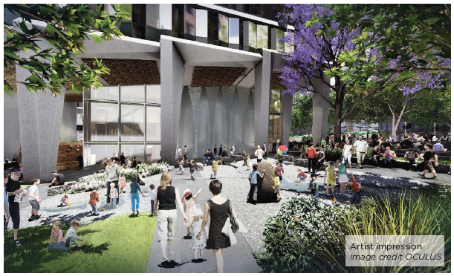

CONCEPT PLAN PROPOSAL:

- Deciduous trees for shade in summer and access to winter sun
- Path network and sensory garden spaces which encourage nature-based play
- Integrated water play elements

WHAT PARTICIPANTS SAID:
" ...more logs, more tree hollows, more rocks, more shrubs, more
small wetlands, less artificial lighting at night.
If you can even get at least some of that into the park it will improve it for users and wildlife alike..”

Seven participants made comments and recommendations relating to the Playful Terrace.

One participant commented on the park’s potential to bring something unseen to the CBD, stating that the park should be a ‘landmark for all Melbournians’.

Other recommendations included that the park should incorporate a feature element, with one participant recommending a community section that brings people together.

Participants questioned the lack of inclusion of public art, feature trees, feature lighting and water elements, one participant encouraged the addition of a ‘fun activity area’ such as ping-pong tables or a basketball net.
13

CENTRAL PLAZA

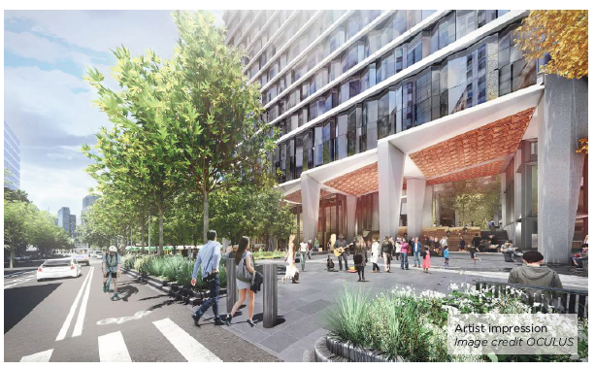

CONCEPT PLAN PROPOSAL:
- Central plaza
- Seating areas
- Future café
- Opportunities for programmed events
- Market Street connection and pedestrian crossing

WHAT PARTICIPANTS SAID:
“ ... I really like this concept, make sure there is a lot of seating so people can enjoy the space.”

Eight participants made comments and recommendations relating to the Central Plaza, of which three related to the plaza appearing to be more of an extension of the Collins Arch building foyer, and less of a public park and plaza. A recommendation was made for placement of additional tiered seating with a northern aspect to gain better natural light.

Eight participants commented on the need for some tables and chairs / picnic benches so that people can eat their lunch within the Central Plaza, and not be restricted to the Northern Lawns area of the park. One participant also recommended some conversation areas for outdoor meetings and socialising.

Participants also commented on the flexibility of the space, and the provisions for short term initiatives to be set up within the park such as an outdoor barista to or a gelato van in summer
14

NORTHERN LAWN / COLLINS STREET

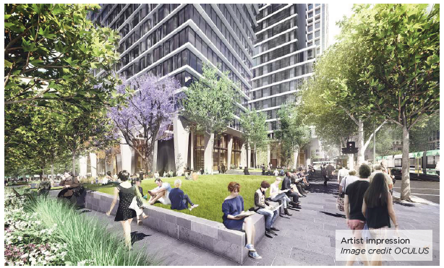

CONCEPT PLAN PROPOSAL:
- A new north-facing lawn and garden area with seating walls to provide a place to eat lunch, rest and relax
- Retention of the Collins Street London Plane trees and new tree planting

WHAT PARTICIPANTS SAID:

“ ...more park/tiered seating space on northern face where most natural like will be.”

Nine participants made comments and recommendations relating to the Northern Lawn / Collins Street. This element of the park received a higher number of positive responses and a lower number of recommendations.

One participant commented that the rendered image suggest the Northern Lawn will be filled with people sitting, eating and utilising the grass, whereas they felt that once completed, this are would be more of ‘looking grass’ where people would not actually interact and use it.

Another participant raised concerns around not being able to sit and utilise the Northern Lawn due to dogs defecating and urinating on it.

Comments also included the lack of large trees within this area of the park, noting that in summer northern sun that will flood the Collins Street end of the park and it is likely to make the grass difficult to grow (unless well irrigated), making this an uncomfortable space to sit an eat lunch in the heat with no shade.
15

COLLINS ST / MARKET ST INTERFACE

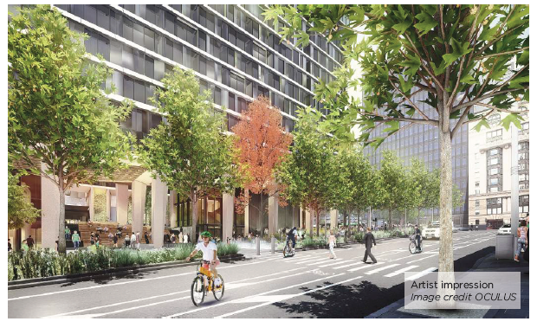

CONCEPT PLAN PROPOSAL:

- Large open lawn space with trees and seating walls.
- Improved pedestrian crossing to Collins Street tram stop
- A new City of Melbourne public toilet

WHAT PARTICIPANTS SAID:
“This park is a fantastic chance to turn Market Street into a pedestrian and cycling boulevard, and a lack of physical separation will prevent people from cycling down it.”

Eleven participants made comments and recommendations relating to the Collins St / Market St Interface, with nine relating to the car parking along Market Street. These participants all mentioned that removing the car parking and using this space to extend the park would be a preferred outcome.

Often paired with a recommendation to remove car parking, nine participants commented on the benefit of a physically separated bike lane and how this would encourage more users to ride bikes by increasing safety for riders. One participant mentioned that the lack of physical separation between the bike lane and vehicle lane will prevent people from cycling down it.

Three participants commented on the placement of the public toilet, acknowledging that it is required. One participant mentioned that its placement on Collins Street attracts people leaving Ms. Collins nightclub five nights a week, attracting anti-social behaviour and loitering
16

This engagement summary has been commissioned by The City of Melbourne and completed by The Space Agency - an independent consultancy specialising in stakeholder engagement and placemaking.

The Space Agency was engaged, as an impartial, external consultant, to review and analyse community feedback in order to identify key themes and recommendations. Every effort has been made by the authors of this document to accurately represent participant feedback and insights.

For recommendations or questions, Please contact: citydesignstudio@melbourne.vic.gov.au
17

