A New Park for Market Street

Final Concept Plan
We are creating the first urban park in the central city since City Square was developed in 1980. Located on Market Street, the new park is bound by Collins Street, Flinders Lane and the new ‘Collins Arch’ development. This exciting project will create 1900 square metres of new public open space in the central city.
Community consultation on the draft concept plan took place from September to October 2018. In total, 49 participants submitted feedback and recommendations. This document provides a summary of those comments and outlines the final design of the new open space.
The new park, designed by Oculus, will feature large lawn areas to accommodate park users, wide bluestone paths, new seating, space for programmed events and improved pedestrian access to public transport. It will also feature a wide variety of trees and water sensitive urban design to reduce stormwater runoff.
The project includes the discontinuance of more than 1300 square metres of roadway in Market Street, to be developed as public open space, including new bicycle lanes and parking.
The abutting development site ‘Collins Arch’ has been designed in collaboration with Cbus Property, Woods Bagot and New York City-based SHoP Architects. It will include a collection of residences, commercial offices and a 5-star hotel, W Melbourne.
Construction of the new park is expected to be completed in 2020.
The project is guided by the City of Melbourne’s Open Space Strategy and Urban Forest Strategy.

Market Street Open Space

Final Concept Plan

The new public park in Market Street will include the following key features:
- City garden and lawns
- Playful terrace
- Central plaza connection from Market Street
- Reconfiguration of Market Street to southbound traffic only
- New separated north and southbound bicycle lanes

These areas are described in greater detail on the following pages.

Aerial view of the final concept plan
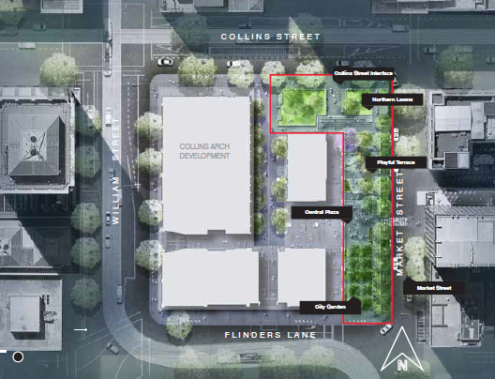

Market Street Open Space

Northern Lawn
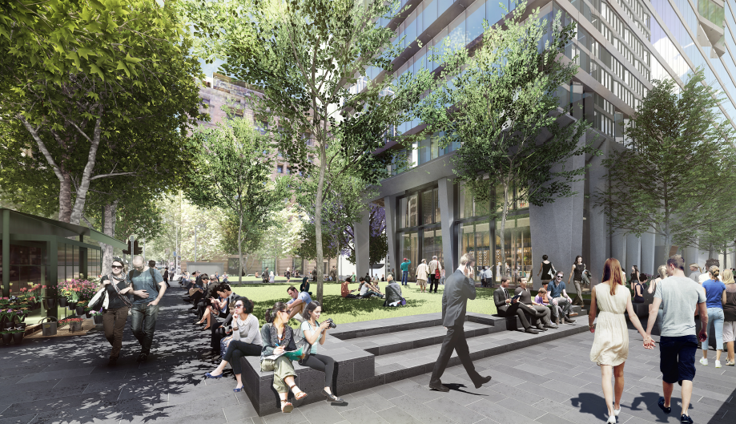

This area will include:
- A new north-facing lawn and garden area with seating walls to provide a place to eat lunch, rest and relax
- Retention of the Collins Street Plane trees and new tree planting.
- Florist to be retained.

Why are we doing this?
During the community engagement process, the lawn area received largely positive feedback, however it was noted that the area lacked large trees for shade in summer and the lawn would need to be maintained to ensure it was usable all year round.
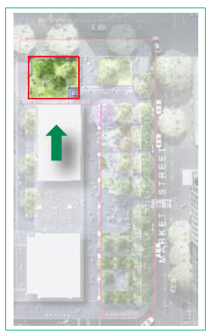
Northern Lawn areas on Collins Street

Market Street Open Space

Collins Street/Market Street Interface
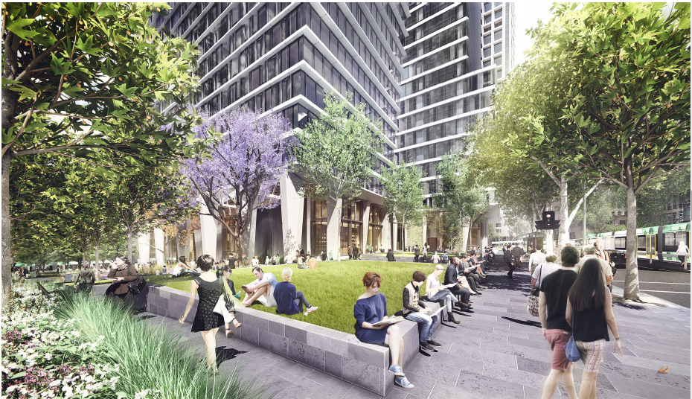

This area will feature:
- Large open space terraced lawns and planting, trees and seating walls.
- Improved pedestrian crossing to Collins Street tram stop.
- A new City of Melbourne public toilet.

Why are we doing this?
During the community engagement process you emphasised the importance of improved pedestrian access, places to sit, greening and a new public toilet.
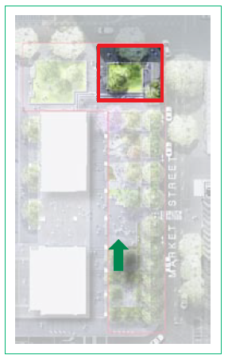
Interface between Collins Street and Market Street

Market Street Open Space

Playful Terrace
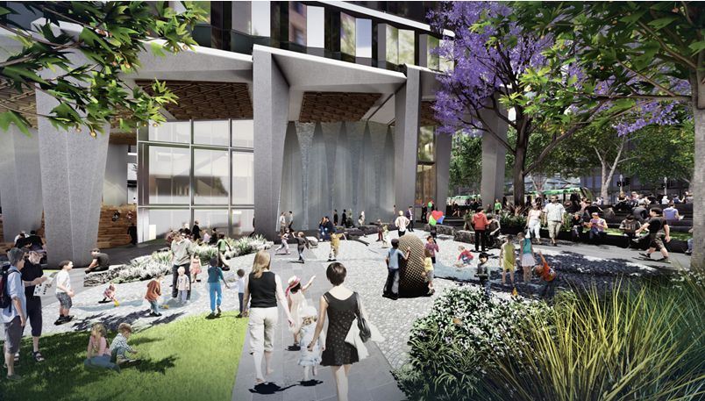

This area features:
- Integrated water-play elements evoking a dry creek bed with integrated lighting elements.
- Path network and sensory garden spaces including feature specimen trees to encourage nature-based play
- Deciduous trees for shade in summer and access to winter sun

Why are we doing this?
In the community engagement process you emphasised the importance of:

- Feature element
- Potential to be a landmark
- Public Art
- Feature lighting
- Feature trees
- Water element
- ‘Fun activity area’
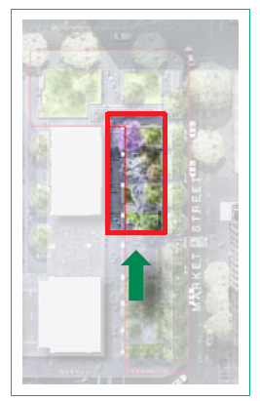
Area for playful terrace on Market Street edge

Market Street Open Space

Central Plaza
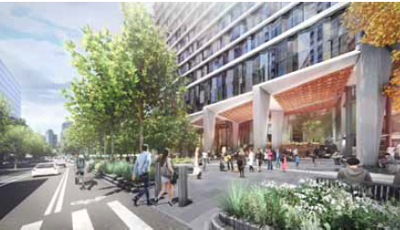

This area features:
- Central plaza
- Market Street connection and pedestrian crossing
- Seating areas with flexible furniture
- Opportunities for programmed events
- Future potential café

Why are we doing this?
During the community engagement process, you emphasised the need for the space to be flexible in seating opportunities with:
- A plaza like extension of Collins Arch
- Tiered seating
- Tables and chairs
- Flexibility of space
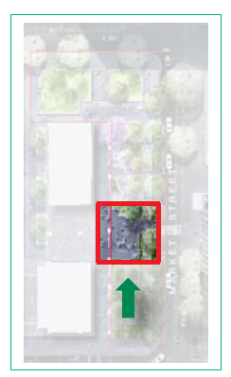
Location of central plaza on Market Street edge

Market Street Open Space

City Garden
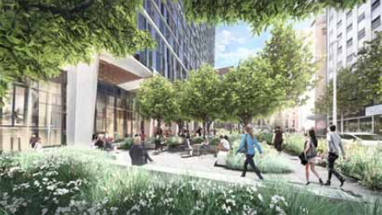

This area features:
- Garden spaces and shade trees
- Seated walls and edges for rest
- Extensive horticulture and trees for visual interest and increased biodiversity.

Why are we doing this?
During the community engagement process, you emphasised the importance of natural and indigenous planting design in providing visual interest, protection and screening from adjacent roadways and flexible furniture.
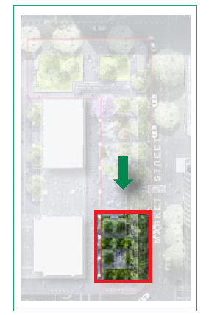
City Garden location on the corner of Market Street and Flinders Lane

Market Street Open Space

Market Street
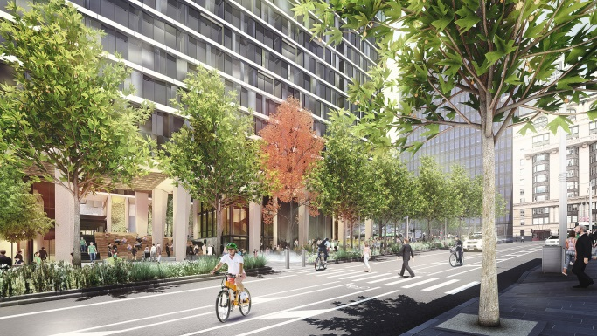

This area features:
- New mid-block pedestrian crossing to Improve pedestrian crossing to the eastern side of Market Street.
- A new path network linking Flinders Lane and Collins Street, providing clear visual and pedestrian connection.
- Market Street road carriageway will be reduced in size to create the new park. It will accommodate single direction southbound traffic only.
- Two new bicycle lanes physically separated from vehicle traffic.
- New lighting, trees and gardens

Why are we doing this?
During the community engagement process, you supported:
- Car parking removal
- Extension of park
- Separated bicycle lane
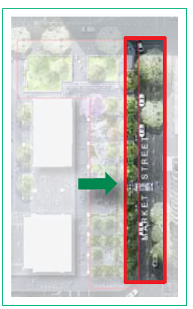
Full extent of Market Street between Collins Street and Flinders Lane

https://www.melbourne.vic.gov.au/community/parks-open-spaces/page
https://www.melbourne.vic.gov.au/community/parks-open-spaces/urban-forest/pages/urban-forest-strategy.aspx

