Seafarers Rest Park Stage 1

Engagement summary and analysis
November – December 2018

14 March 2019

Prepared by Global Research Ltd

For City of Melbourne

Contents
Executive summary 2
About the process 2
Key findings 2
Project overview 4
Introduction 4
Background 4
Objectives 4
Stage 1 engagement: full results 5
Quantitative analysis overview 5
Respondent characteristics 5
Summary of connection, use, frequency of use 7
Summary of written comments 10

Report prepared by
Global Research
150 Office Rd
Merivale
Christchurch 8014
New Zealand
P +64 3 355 4562
M +64 27 2433 083
E. patrick.oneill@globalresearch.nz
www.globalresearch.nz

Executive summary

About the process
The City of Melbourne is working in partnership with the Victorian Government, developer Riverlee, and landscape architects Oculus to create a new park at Seafarers Rest in Docklands, to:
- Increase pedestrian and bicycle access
- Retain existing trees where possible
- Protect neighbouring heritage sites
To complete stage one, the City of Melbourne undertook a community engagement and consultative process between 19 November and 14 December 2018. They wanted to gain an understanding of the local community’s interest and ideas for a new park at Seafarers Rest (SR) in Docklands.
Feedback was received via an eight-question online survey, which 89 participants completed. Additionally, 2 emails and 1 written letter were received from the public.
The aims of this consultation were to:
- Determine the value of Seafarers Rest to communities.
- Determine what connections respondents have with the area.
- Determine how community members use and would like to use the space.
- Determine which design features the community would like to see at the redeveloped SRP.
- The consultation also aimed to understand the diversity and representativeness of respondents in relation to gender, living situation and age.

Key findings
Overall, people wanted Seafarers Rest Park (SRP) to have a high amenity value, welcome users with space for rest, relaxation, recreation and reflection, while at the same time accommodating foot and cycle commuters and minimise inter-activity conflict.
There was general consensus that the area would benefit from redevelopment
- Respondents thought SR currently has little utility value.
- SR is considered to currently have minimal aesthetic value.
Natural spaces and aspects are important to people
- Respondents want trees, plants and greenery in addition to open spaces for amenity value and for practical use such as shade and shelter.
- Natural surfaces, such as grass, are desired.
Local history must be represented in the redeveloped SRP
- The connection with the Mission is important to people, as well as highlighting its maritime history.
People anticipate SRP facilitating multiple activities and functions
- Most respondents recommended features that facilitate active or passive recreation.
- It was anticipated the area will remain a thoroughfare for many.
- Designing features to minimise conflict between park-users, cycle and foot commuters were suggested.
- Built features such as play equipment, exercise equipment, seating and art were supported. As were practical aspects such as water fountains, rubbish bins and lighting.
Some conflicting uses and outcomes for the area were identified
- The provision of public toilets is contentious, with equal numbers of respondents supporting or opposing public toilets in the development.
- Park users want to minimise modal conflict within the park.
- Respondents want the park to feel safe and welcoming for everyone and were concerned about potential negative social behaviour

Respondents’ connection and use of Seafarers Rest
- Most respondents either lived or worked in the area. Others used the wharf or were visitors.
- Respondents mainly used the area as a thoroughfare.
- Around one third of respondents used the area for leisure and as a place to exercise.
- Current Seafarers Rest area use was evenly spread over the week and weekend with morning, afternoon and evening use reported.
Respondents’ characteristics
- Older age-groups were over-represented in responses when compared to Docklands’ usual population.
  - over half of respondents were 35-54 years of age. Whilst Docklands residents in this age group make up only one quarter of the population.
- The 14-24 age bracket was under-represented
  - only 2% of respondents were 14-24 years of age. But this age-group makes up 18% of the Docklands population.
- Nearly three quarters of respondents were couples and families with children.
- Couples without children (36%) were the most common household type to respond; although, this was still significantly fewer than the Docklands population (63%).

Project overview

Introduction
The City of Melbourne is working in partnership with the Victorian Government, developer Riverlee, and landscape architects Oculus to create a new park at Seafarers Rest in Docklands. This is one of eight new parks the City of Melbourne will create by 2020.
Seafarers Rest is an existing public open space earmarked for renewal in the City of Melbourne’s Open Space Strategy. It has also been identified as a key area in the Docklands Public Realm Plan.
The park is located on the north bank of the Yarra River between The Mission to Seafarers heritage building and the Seafarers Bridge. It aims to:
- Increase pedestrian and bicycle access.
- Retain existing trees where possible.
- Protect neighboring heritage sites.
A larger project to build a new 17-level mixed use development and restore the neighboring wharf shed and crane, is also underway near the park.

Background
A communications and engagement plan was developed for the project. It outlines a three staged approach to consult and inform the community including residents, businesses, workers and visitors to the area. The three staged strategic approach includes:
Stage 1 – Engage stakeholders and future park users and ensure feedback is incorporated into the project brief where possible.
Stage 2 - Inform stakeholders and future park users to the proposed design and request feedback.
Stage 3 - Keep stakeholders and future park users informed with regular updates at key stages of the project, including design development and construction.
As part of Stage 1, the City of Melbourne undertook a community engagement and consultative process between 19 November and 14 December 2018, to gain an understanding of the local community’s interest and ideas for a new park at Seafarers Rest in Docklands.
Feedback was received and collected via a public online survey. Eight questions were asked and demographic and contact details were collected. Eighty-nine people completed the survey. Additionally, 2 emails and 1 written letter were received via a public project inbox.
This report presents a synthesis of all the information that was received.

Objectives
The aims of this consultation were to:
- Determine the value of Seafarers Rest to communities.
- Determine what connections respondents have with the area.
- Determine how community members use and would like to use the space.
- Determine which design features the community would like to see at the redeveloped SRP.
The consultation also aimed to understand the diversity and representativeness of respondents in relation to gender, living situation and age. This report presents a synthesis of the information received and is structured to answer these four objectives.

Stage 1 engagement: full results

Quantitative analysis overview
Frequency analysis was completed on the demographic and connection to SR questions and is presented as charts below.
The results for respondents’ age groups and household, were compared with Docklands population data, sourced from Australian 2016 Census data (retrieved from:
http://quickstats.censusdata.abs.gov.au/census_services/getproduct/census/2016/quickstat/SSC20760).
Note the sample size was relatively small. It consisted of 89 survey respondents and was not randomly selected. These two factors mean the results are not representative of the whole Dockland’s population, but are reflective of the opinions of those who participated in the engagement process. When results are compared with Australian Census data, percentages have been used. Given the small sample size, however, total numbers are used to present results for the remaining questions.

Respondent characteristics
Summary of respondents to the Seafarers Rest engagement:
- Older age-groups were over-represented in responses – over half of the respondents were 35-54 years of age. While Docklands residents in this age group make up only one quarter of the population.
- The 14-24 age bracket was under-represented, with 2% of respondents being from this group, but this age-group forms almost a fifth of the Docklands population.
- Couples and families with children made up nearly three quarters of respondents.
- Couples with no children (36%) were the most common household type to respond, this was significantly fewer than the Docklands population (63%).

Respondent age groups
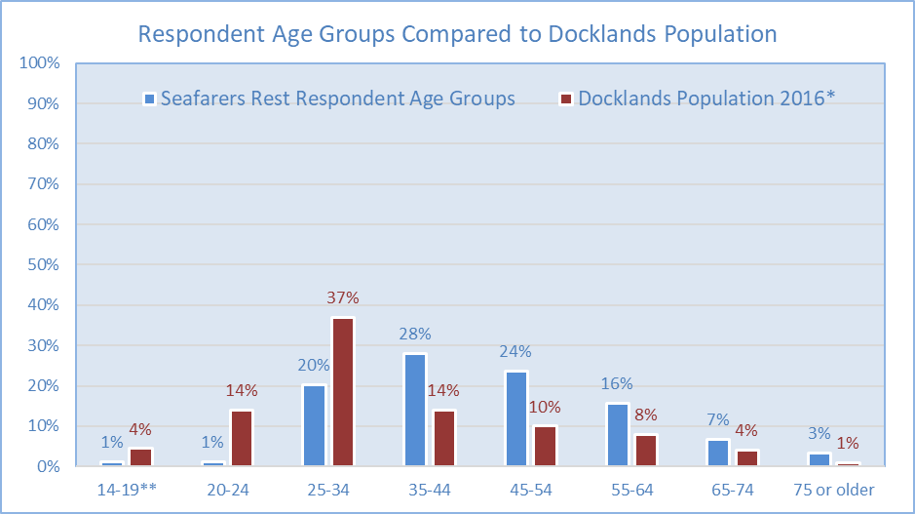
* Docklands Population Data has been sourced from Australian Bureau of Statistics, Australia Census 2016.
** Note the survey age category was 14-19 years of age, and the Census data is for 15-19 years of age. The difference between this age-group would be greater if the same age categories were used.

Age group summary analysis
- Over half of respondents (n.46) were aged between 35 and 54 years of age
- Two percent of respondents (n.2) were aged 24 years or younger.
- A higher percentage of respondents (41% more) were older than 34 years of age compared with the Docklands population.
- Fewer respondents (18% fewer) were younger than 35 years of age compared with the Docklands population.

Respondent household types
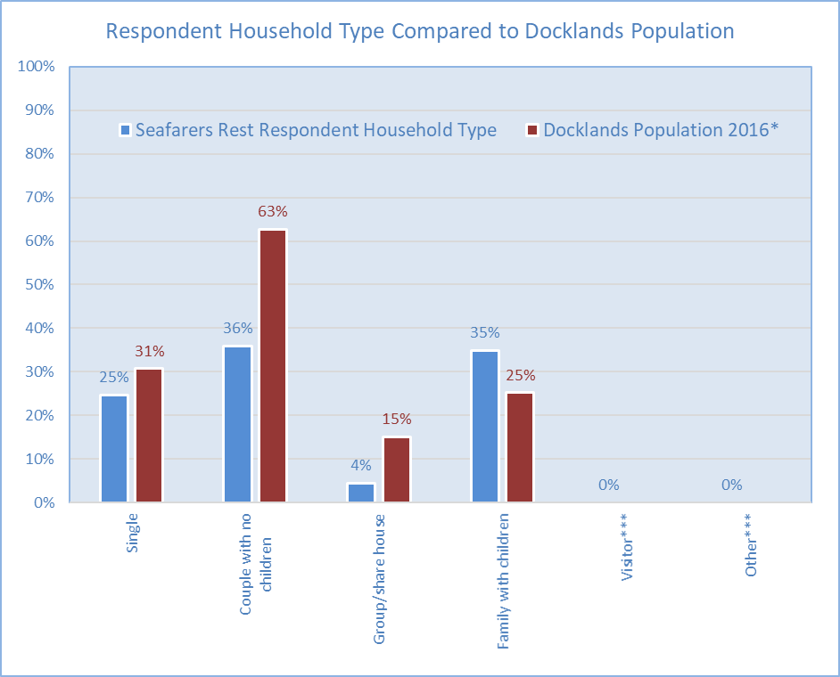
* Docklands Population Data has been sourced from Australian Bureau of Statistics, Australia Census 216
*** Note, Census data is not available for the Visitor or Other categories.

Household type summary analysis
- 36% of respondents (n.32) lived as a couple with no children, which was a significantly smaller percentage than the 63% who make up the Docklands population.
- 35% of respondents (n.31) stated they were part of a family with children, which was slightly more than the 25% who make up the Docklands population.
- 25% of respondents (n.22) were single, which was slightly fewer than the 31% who make up the Docklands population.
- 4% of respondents (n.4) lived in a group/share household which was fewer than the 15% who make up the Docklands population.

Summary of connection, use, frequency of use
Summary of respondents’ connection and use of Seafarers Rest:
- The majority of respondents either lived or worked in the area. Others used the wharf or were visitors.
- Respondents’ use of the area was mainly as a thoroughfare.
- Around one third of respondents used the area for leisure and as a place to exercise.
- Use of the area was relatively evenly spread over the week and weekend with morning, afternoon and evening use reported.

Respondents main connection with Seafarers Rest
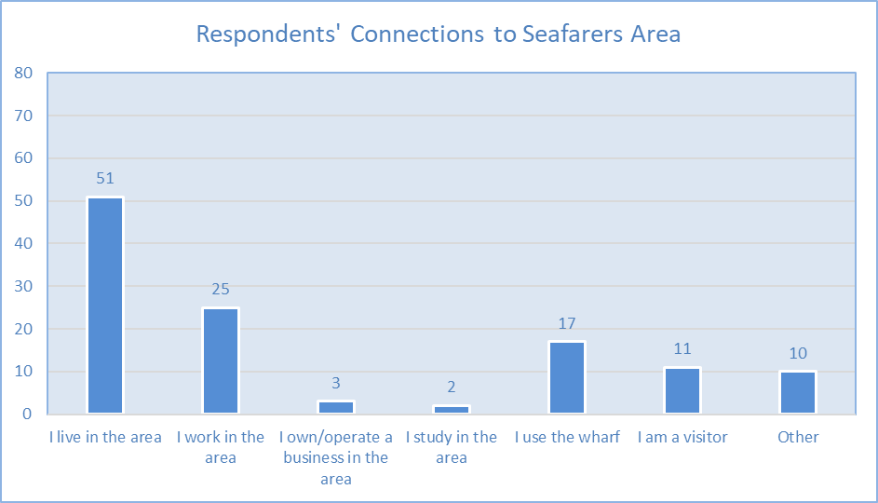
Note because the response rate was relatively low (n.89), the remaining charts are presented as total numbers, not percentages.

Respondents’ main connection to area summary:
- Over half of the respondents (n.51) live in the area
- Just over one quarter work in the area (n.25)
- Around one fifth use the wharf (n.17)

How did/do people currently use Seafarers Rest
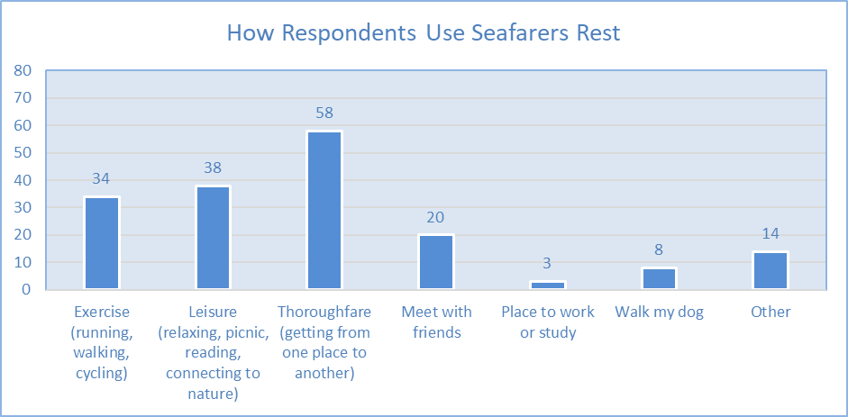

How people currently use Seafarers Rest summary:
- The most common use of the area is as a thoroughfare (n.58)
- Leisure or relaxing was the second most common use (n.38)
- Nearly half of the respondents (exercise or dog walking) identified physical activity as a use (n.42)
- Around one fifth of respondents use Seafarers Rest to meet with friends (n.20).

When the park is usually used
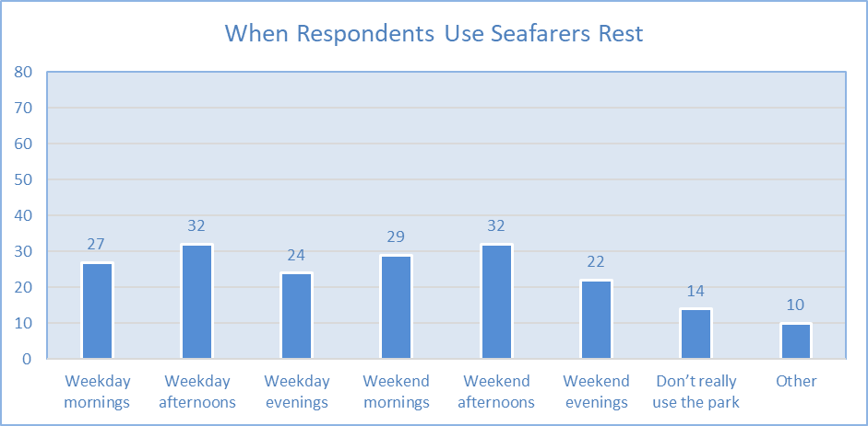

When the park is usually used summary:
- Use of the area by respondents is spread consistently throughout the week and time of day.

Frequency of park use
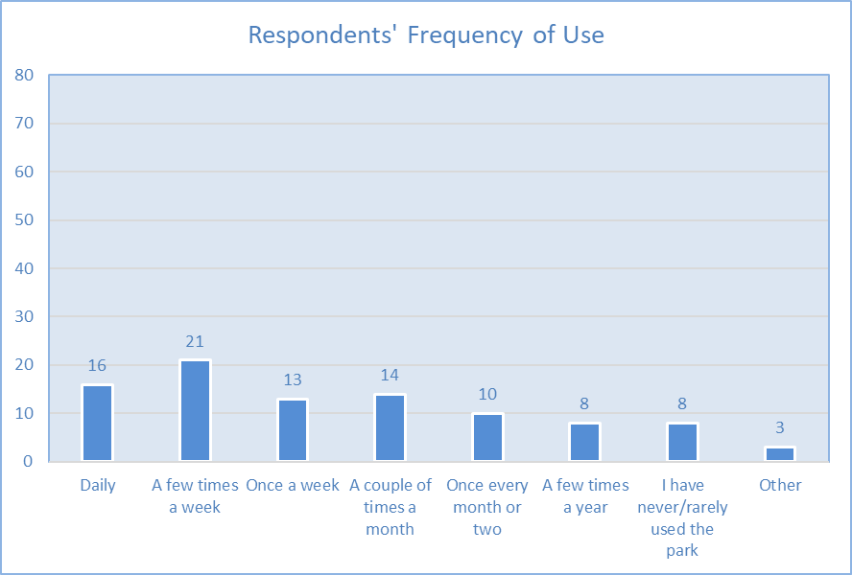

Frequency of park use summary:
- Over half of respondents (n.50) use the area at least once a week.
- Almost one fifth rarely or hardly ever use the area (n.16).

Summary of written comments

Overall synthesis of all written comments:
- Overall, people wanted SRP to be a place with high amenity value, be welcoming for users, and provide space for rest, relaxation, recreation and reflection.
- At present, the space is described as providing little to attract people.
- People wanted the park design to include trees, plants and natural surfaces, for amenity value and for more practical uses such as shade and shelter.
- Respondents suggested, directly and implicitly based on how they want to use the park, that design features should cater to a diverse range of activities.
  - While most respondents recommended design features that can be used for active or passive recreation purposes, it was anticipated that the area will remain a thoroughfare for many.
  - Design features to minimise conflict between park-users, cycle and foot commuters were suggested.
- Built features such as play equipment, exercise equipment, seating and art were supported, as were practical aspects such as water fountains, rubbish bins and lighting.

Written comments analysis and reporting overview

Analysis approach
The following discussion presents results from a qualitative analysis of the following four free-text questions, which captured ideas and opinions from participants in the engagement process.
- Does Seafarers Rest have a special feature, aspect or character that is important to you?
- What would you like to see at the new park?
- Is there anything else you would like to see at the park?
- Is there anything else you would like to tell us about Seafarers Rest?
Responses were combined during analysis to present findings summarised under three themes:
- Suggestions/recommendations for design of Seafarers Rest.
- Awareness and interest in the use of Seafarers Rest
- How respondents would like to use Seafarers Rest
The summaries that follow present the key points made relevant to each of the three main engagement themes.
Appendix 1 to this document provides further in-depth analysis of the written comments received.

How analysis was completed
To complete the analysis, Global Research analysts read each comment received from the community and organised them into themes and topics based on the points made. Most comments contained multiple points, relevant to multiple topics, resulting in many comments being coded multiple times. The analysis was assisted by NVivo qualitative analysis software.
Analysts developed a coding schedule based on the desired objectives for the project, as listed by CoM and the content of comments. The objectives were:
- Awareness and interest in the use of SRP;
- How respondents would like to use SRP;
  - As indicated in the proposal, anticipated use was inferred from the types of features respondents stated they would like the park to contain. These were found in responses to questions six and seven, and were about what respondents would like to see in the park.
- Suggestions and/or recommendations for design of SRP; and,
- Any feedback received that corresponds to issues noted above and/or potentially new issues.
New topics were created and comments coded to these as they arose, ensuring all comments and the points made were included in the analysis.

Theme 1: Suggestions/recommendations for design of Seafarers Rest

Summary of design suggestions/recommendations:
- Design feature suggestions made up a large proportion of respondents’ comments. Specific design features were requested across multiple categories. In order of most requested, these include:
  - Shaded areas
  - Art features
  - Access to drinking water
  - Lighting
  - BBQ areas
  - Dog-friendly areas
- Public toilets were a contentious topic, with arguments both for and against their provision in SRP.
- When asked about the design of a new SRP, greenery (in the form of trees, plants and grass) was the most frequently suggested feature.
  - People wanted trees and planting to provide areas with amenity value.
  - There was strong support for green and open spaces to be included in the design.
- Respondents were clear in their desire for any SRP designs to reflect the history of the area. Most often, this was in relation to the maritime connection.
  - The Mission was noted several times. Respondents wanted to see the building better connected to the park, and maritime aspects reflected in design.
- Play and exercise equipment were commonly suggested, the provision of which would encourage a range of age groups to use the area.
- Respondents wanted seating included in the park design, to provide places to stop, rest and relax.

Theme 2: Awareness and interest in the use of Seafarers Rest

Summary of awareness/interest in Seafarers Rest use:
- Respondents’ awareness of the area was centred around its connection with water. Both the river, and the maritime connection, such as the Mission, were key points of interest for respondents.
- People valued the proximity to the river, and the historic maritime significance. For many respondents though, the area is of little significance and is mainly used as a thoroughfare.
- SR as an open space was an attraction for respondents, however, awareness and use of the area is currently limited by its poor amenity value.

Theme 3: How respondents would like to use Seafarers Rest

Summary of how respondents would use Seafarers Rest:
- Respondents anticipated using the park in ways which necessitate it having greened areas, open areas and sheltered areas.
- Although the area is anticipated to remain in use as a thoroughfare (as evidenced by the cycling comments), respondents stressed that the park ought to provide for multiple uses, i.e., places for socialising and passive recreation, have ample seating, and useable spaces (such as for exercise).

