A review of the regulatory framework related to live music venues in City of Melbourne

APRIL 2014

Acknowledgements
Melbourne City Council appointed the Music Advisory Committee (chaired by Councillor Rohan Leppert) to review the 2010 City of Melbourne Music Strategy with a view to expanding its scope and provide ongoing advice on the City of Melbourne’s relationship with musicians, live music venues and music public programming. During its proceedings the Committee appointed a sub-committee of Ashley Admiraal (Music Victoria) , Lucy Ribush (The Toff in Town/Cookie/Boney), Andrea Baker (Monash University), Adrian Basso and a number of City of Melbourne Officers to investigate in detail the regulatory framework related to live music venues and report back to the Committee. This report is substantially based on the work of the sub-committee.
Table of Contents
Executive summary 4
The purpose of this review 4
City of Melbourne Music Strategy 2010 and the Melbourne Planning Scheme 4
2013/14 Council Plan Priority Action 2.6 4
The Music Strategy Review and Advisory Committee and Formation of Working Group 4
Profile of live music venues in the City of Melbourne 4
Live Music Venues and Noise Complaints 4
Conclusions and Recommendations 4
Regulatory Framework 4
Overview 4
Environmental Protection Authority (EPA) Regulations 4
Victorian/Australian Building Code 4
Liquor Licensing 4
Food Act 13
The ‘Agent of Change Principle’ 4
Melbourne Planning Scheme 4
Ministerial Announcements and State Policy Reform 4
Conclusions and Recommendations 4
Planning Permit process 4
Assessing Planning Permits for Live Music Venues 4
Standard Planning Permit Conditions 4
Permits issued by the Planning Minister 4
Conclusions and Recommendations 4
Live Music Venues Case Studies 4
Case Study 1 – Cherry Bar 4
Case Study 2 – The Mercat 4
Case Study 3 – Savoy Tavern 4
Case Study 4 – Wah Wah Lounge 4
Conclusions and Recommendations 4
Overall Conclusions and Recommendations 4
References 4
Appendix A - Music Venues in the City of Melbourne 4
Appendix B - Music and Noise Attenuation related provisions in the Melbourne Planning Scheme 4

Executive summary
Purpose of this Review
This review has been done as a first phase of implementing Council’s Annual Plan 2013-2014 year one Action 2.6 ‘Develop a planning policy to encourage the development and operation of live music venues’. The Review assessed the current local and State policy framework relating to live music venues and how it is working in practice to establish if and how these policies may need to be changed to ensure they are meeting the City of Melbourne’s objectives in its Music Strategy 2010.
Profile of Live Music Venues in the City of Melbourne
In 2012 Metropolitan Melbourne had more than 460 venues that regularly (minimum of two nights per week) host live music performances. Of these, 149 were small venues (pubs/clubs/bars) and 18 were concert/theatre venues in the Melbourne Hoddle Grid Area.
Noise complaints in the City of Melbourne are generally increasing and music venues are the fifth most commonly received complaint about noise. However there may be different reasons for increases in complaints for particular types of cause of complaint. Complaints of noise from entertainment venues have increased but this could be being driven by the increase in the number of entertainment venues. Also the data doesn’t indicate a clear correlation with the rising central city residential populations. Furthermore live music venues are a minority subset of entertainment venues and they have only attracted a small number of complaints about noise.
Regulatory Framework
A number of Melbourne Planning Scheme provisions acknowledge the cultural value of music to Melbourne. The Planning Scheme supports and protects existing and proposed entertainment venues by requiring the design of new residential developments to take into account the potential impacts on residential amenity from established and future neighbouring uses, including noise, by requiring acoustically insulating the dwellings. The Capital City Zone decision guidelines use the agent-of-change principle to, as appropriate, request noise insulation of new dwellings. The review of the City of Melbourne’s issuing of permits to develop over recent years showed that these provisions have been successful in managing the balance of developing uses, particularly in the central city
In the State Planning Policy Framework, and therefore also within Local Planning Policy Framework, music (including live music) is deemed to be included within the “Entertainment Venues” land use category. Therefore it is not a separately defined land use in the Melbourne Planning scheme local policies including the MSS and Clause 22.22 (Licensed Premises local policy). The review found that this was satisfactory and that there is no need for a distinct land use definition of live music as the land use definitions are primarily concerned with amenity impacts of different land uses and live music venues have the same profile of potential amenity impacts as would any entertainment venue.
The Department of Transport Planning and Local Infrastructure (DTPLI) have advised the City of Melbourne that they are reviewing the State Planning Provisions related to live music venues. The City of Melbourne will await the release of these reviewed state planning provision changes before determining whether or not further local planning scheme amendments are relevant.
The Environment Protection Authority (EPA) regulates noise emissions from live music venues through State Environment Protection Policy (Control of Music Noise from Public Premises) SEPP N2. The provisions of this legislation also have a significant impact on the operations of live music venues. The EPA has advised City of Melbourne that a review of a number of its environment protection policies including SEPP N-2 would occur in mid-2014 and take approximately one year to complete. The City of Melbourne will seek to participate in this review from a number of perspectives including those relating to these issues of noise and live music.
Planning Permit process
There is currently no requirement under the Melbourne Planning Scheme to apply standard noise conditions on permits for new residential developments in the Capital City zone, rather this is a decision guideline in the CCZ. Whilst not required by the planning scheme, standard noise permit conditions are applied at the City of Melbourne, as appropriate.
As no permit is required for residential uses in the Capital City Zone, there is no requirement for nearby properties to be notified of applications for residential developments.
So that particular noise sources are considered in the early stages of development, certain CCZ provisions could potentially be modified. However, this change and any other change must be informed by the review of the State Planning Provisions. Following the DTPLI and EPA reviews, the need for consequent amendments the planning scheme to require noise attenuation will be evaluated.
Live Music Venues Case Studies
Most complaints about noise from music venues appear to come from the older residential developments and are in relation to older venues. The older planning permits for residential developments (prior to 2000) rarely included conditions relating to noise attenuation.
New music venues (for example the Savoy Hotel) are required to meet the requirements of the Licensed Premises Policy (Clause 22.22) so therefore have a greater degree of acoustic attenuation than the older venues. That there are fewer complaints in relation to new venues is an indication that Clause 22.22 and associated acoustic attenuation requirements are effective.
Conclusion
This review of the regulatory framework related to live music in Melbourne has revealed that the existing Melbourne Planning Scheme includes a number of provisions which acknowledge the value of music to Melbourne. Also included are provisions which guide residential developments to attenuate when there are existing noise sources. The main opportunity for planning policy changes effecting live music venues are at the State level and specifically SEPP N-2 and the State Planning Policy Planning Provisions. Both of these regulations are currently being reviewed and City of Melbourne is engaged in both of these review processes. Depending on the outcome of these reviews, amendments to the Melbourne Planning Scheme should be considered.
the purpose of this review
City of Melbourne Music Strategy 2010 and the Melbourne Planning Scheme
The vision of the City of Melbourne’s Music Strategy is Melbourne: a city that enjoys a rich and diverse music culture, creating and attracting passionate musicians and audiences, and fuelling a vibrant, entrepreneurial music industry. The Strategy has five goals.
- Melbourne fully embraces its international reputation for music
- Melbourne has a vibrant and supported music industry, providing a welcome economic contribution, employment for Melbourne people, and opportunities for performers
- Melbourne has an active music scene for the benefit of performers and audiences – residents and visitors
- Music is part of the experience of living in Melbourne.
- The City of Melbourne understands the role and contribution of music.
Goals 3 and 4 acknowledge how music plays a role in the life of the city and how it needs to be considered by the City of Melbourne in its planning for the use and development of land in the city. Goal 3 identifies that the City of Melbourne needs to ensure that any existing or new venue must address the potential noise and amenity impacts that may arise from their operation. Goal 4 identifies that the City of Melbourne needs to be fully conscious of the noise and nuisance issues around late night activities, including live music, and that policy will be developed to mitigate the effect on residents.
2013/14 Council Plan Priority Action 2.6
Goal 4 has an action “to develop policies to benefit the music scene and residents”. Council has sought to implement this action in its Annual Plan 2013-2014 Action 2.6 which is to ‘Develop a planning policy to encourage the development and operation of live music venues’. The City of Melbourne’s Strategic Planning Branch is responsible for this action.
This review has framed the following questions to determine the planning policy and other related regulations that would encourage or discourage the development and operation of live music venues:
- What are the current provisions in the Melbourne Planning Scheme related to Live Music and Live Music Venues?
- What are the current provisions in the Melbourne Planning scheme related to noise attenuation?
- What are the key issues affecting the development and operation of live music venues?
- How much disturbance does music from live music venues actually cause and how significant is it compared to other noise sources (including nightclubs, bars, restaurants etc)?
- What is the nature of noise complaints from Live Music Venues? Is it from live music, amplified music, patron noise? Which live music venues receive the most and least noise complaints (maps, statistics)?
- Where are the noise complaints about live music venues coming from? Are they coming from new residential developments, old residential developments, apartments, flats etc?
- What are the general acoustic attenuation laws, controls and standards?
The Music Strategy Review and Advisory Committee and Formation of Working Group
The Music Strategy 2010 is being reviewed in 2013. The Music Strategy Advisory Committee (MAC) was established to assist with this review. At its second meeting in December 2013, the Music Strategy Advisory Committee (MAC) focussed on live music venues in Melbourne and the issues they experience and, in relation to Council’s 2014/15 action, how the Melbourne Planning Scheme encourages or discourages them.
At this meeting it was agreed that that further investigation into these issues was needed to clarify how the planning scheme currently protects and encourages live music venues and whether changes can or should be made to planning provisions. A sub-committee of MAC was formed to do the investigation. This working group met twice early in 2014 and discussions in these meetings contributed to this review.

Profile of live music venues in the City of Melbourne
In November, 2011 Music Victoria released the ‘Melbourne Music City Guide’ which maps live music venues in Melbourne, suburbs and regional Victoria. In October 2012, Music Victoria (in partnership with the City of Melbourne, NMIT and over 100 student volunteers) carried out the Victorian Live Music Census 2012 (the ‘Census’). The Census defined a live music venue as ‘a venue presenting live music performances on a minimum 2 nights per week’. Examples of venue types include can be a Hotel, Bar, Nightclub, Music Club, Cafe or Theatre. Figure 1. below is a map of all the live music venues in the City of Melbourne as listed in the Census (See Appendix A for the List of venues in the City of Melbourne).
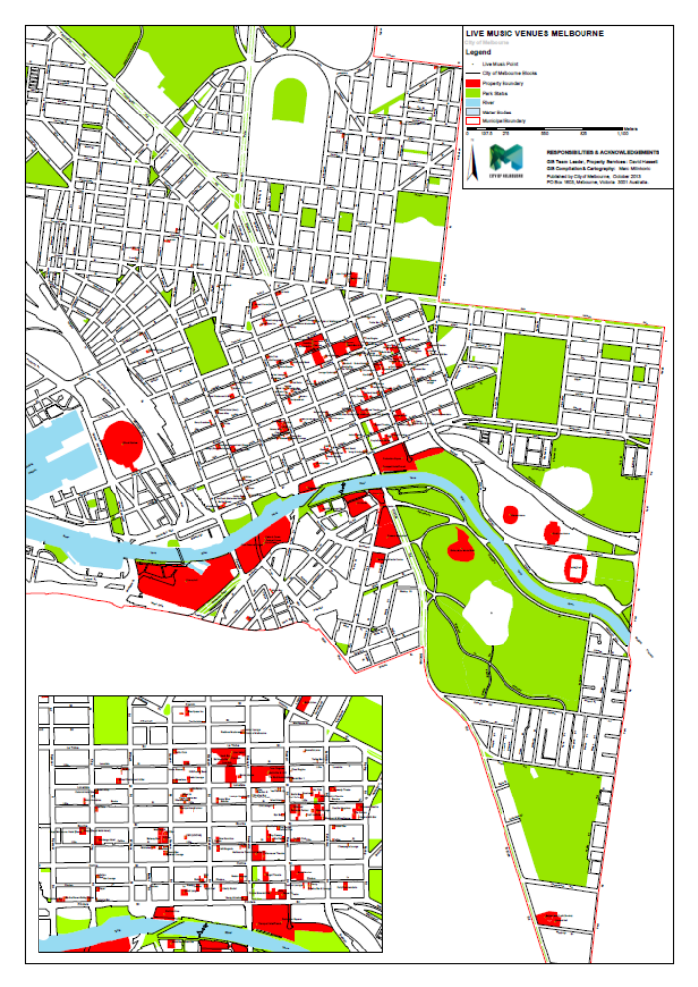
Figure 1 Map of live music venues in the City of Melbourne as listed in the Victorian Live Music Census 2012 (See Appendix A for full list of venues)
The Census found that there are a higher proportion of nightclubs and bars in the Hoddle Grid area, while hotels are more often found in suburban precincts and outer suburbs.
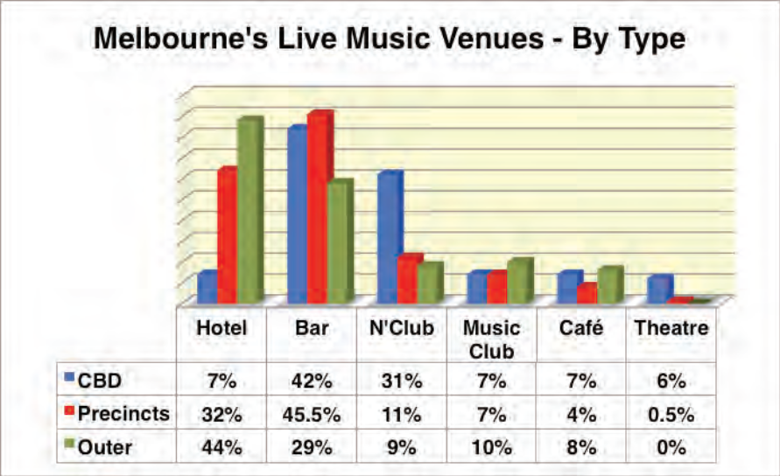
Figure 2 Types of live music venues in the City of Melbourne (Source – ‘Victorian Live Music Census, 2012’)
The Census also found that greater Melbourne has more than 460 venues that regularly (minimum of two nights per week) provide live music performances Of these, 149 were small venues (pubs/clubs/bars) and 18 concert/theatre venues in the Melbourne Central Business District. Figure 2 shows the proportions of Venues by type in the CBD, suburban precincts and outer suburbs of Melbourne .
The Census also found that of the suburban precincts, Fitzroy, St Kilda and Prahran had the highest numbers of live music venues and that the highest number of annual live gigs in Melbourne venues in 2012 were in the suburban precincts with 34,300, followed by the Hoddle Grid area with 19,100 and the outer suburbs with 9000. This is summarised in Figure 3.
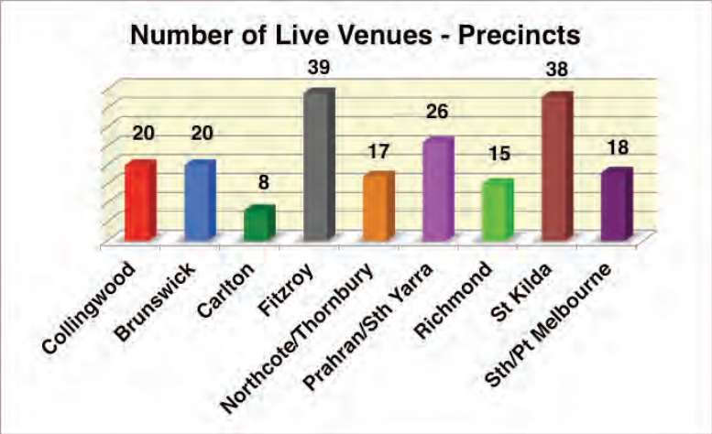
Figure 1 Number of live music venues in suburban precincts the city of Melbourne (Source – Victorian Live Music Census 2012)
The Census represents the most recent data on live music venues in Melbourne. However, as there is lack of clarity and agreement about what defines live music and what constitutes a live music venue, the City of Melbourne Music Strategy should define “live music venue” and then investigate another census conducted by a research agency.

Live Music Venues and Noise Complaints
Much of the discussion at the MAC and working group meetings focussed on live music venues and the issues they experience. A variety of issues were discussed, however the key issue was the impact of noise from venues on residents and residents’ complaints about noise from live music venues.
Looking to the future there was a concern about the potential conflict between new residential developments and existing entertainment venues and the prospect that increasing numbers of people living closer to existing live music venues would lead to increased complaints about noise from those venues and increased pressure for those venues to invest in noise mitigation infrastructure for their venues.
The available data does not show a clear correlation between noise complaints and increasing residential population. Table 1 below shows the numbers of complaints about noise of all types that the City of Melbourne has received under the over the past 5 years.
Out of the 12 types of causes of noise complaints the top five over that period have been illegal busking (1, 657) followed by building workers (1,117), then construction noise (1,101), followed by air-conditioners and other machinery (770), with complaints about noise from entertainment venues (620) being the fifth most common.
Table 1 Noise complaints in the City of Melbourne (source City of Melbourne data, at 7January 2014)
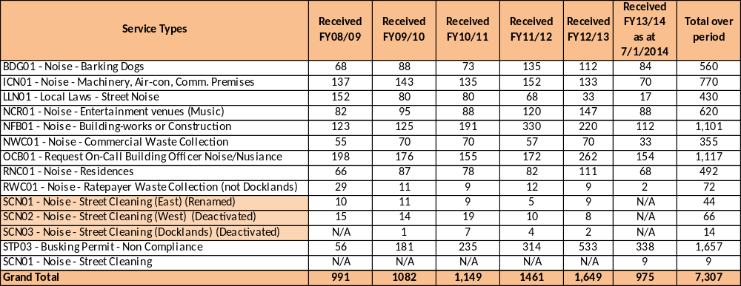
Overall across the 12 types of causes of noise complaints, complaints about noise in the City of Melbourne have almost doubled since 2008/09. Five of these categories including entertainment Venues show a marked increase over that period. However there could be multiple causes for the increases in each of the types. It is not clear that increasing residential densities are correlated with increasing complaints about noise in general or complaints about Entertainment Venues noise in particular.
Also, live music venues are only a subset of entertainment venues. An analysis of noise complaints in the City of Melbourne for 2013/14 financial year (as at 6 Dec 2013) about entertainment venues shows that most of the complaints were about nightclubs 22, followed by bars/cafes 10, hotels 6, outdoor major events 5, warehouse parties 3, karaoke bars 2, function centres 2, restaurants 1 and jazz bar 1. In total 88 complaints were made about these venues in 2013/14 (as at 7 January 2014).
Only 12 of these 42 entertainment venues were listed in the Victorian Live Music Census 2012. They are the Horse Bazaar, Wah Wah Lounge, Vatican Lounge Bar, Misty Bar, Hamer Hall, CQ Nightclub, Baroq House, The Night Owl, Section 8, Fusion, Royal Melbourne Hotel, and the Deck Bar. Twelve complaints were made about these live music venues in 2013/14.
Furthermore it is a difficult ascertaining whether complaints are about live or recorded music. This is because complainants are not always able to identify where noise is coming from and what type of noise it is.
Conclusions and Recommendations
- The Victorian Census of Live Music 2012 found that greater Melbourne has more than 460 venues that regularly (minimum of two nights per week) provide live music performances. Of these, 149 were small venues (pubs/clubs/bars) and 18 concert/theatre venues in the Melbourne Central Business District.
- Whilst noise complaints in the City of Melbourne are increasing in general and entertainment venues are in the top five cause of complaint there may be different reasons for increases in complaints for particular types of cause of complaint. Complaints of noise from entertainment venues have increased but the correlation with rising residential populations is not clear. Live music venues appear to be a minority subset of entertainment venues and have only attracted a small number of complaints.

Regulatory Framework
Overview
The framework regulating live music venues is a combination of three acts: (1) The Planning and Environment Act 1997, the purpose of which is to establish a framework for planning the use, development and protection of land in Victoria; (2) The Environment Protection Act 1970, the philosophy of which is to prevent pollution and environmental damage by setting environmental quality objectives and establishing programs to meet them and; (3) the Liquor Control Reform Act 1993 which is the primary piece of legislation regulating the supply and consumption of liquor in Victoria. The first is administered primarily by the Minister for Planning and is managed by the Department of Transport, Planning and Local Infrastructure (DTPLI); the second is administered by the Environmental Protection Authority (EPA) and the third is administered by the Victorian Commission for Gambling and Liquor Regulation (VCGLR).
Figure 4 below is from Music Victoria’s 2012 paper, ‘Music Industry Position Paper – The Case for Regulatory Reform, and shows the relationships between these three pieces of legislation.

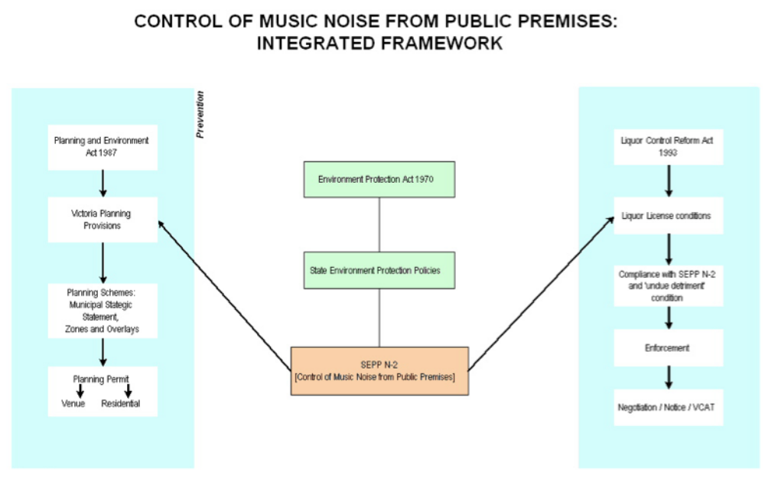
Figure 2 Legislative Framework related to Music Venues (from ‘Music Industry Position Paper – The case for regulatory reform, July 2012’)

Figure 4 shows the regulatory framework related to live music venues. This framework is comprised of overlapping and interdependent systems of controls, so that a change to one will impact on the others. The City of Melbourne has the authority to only effect change to the Local Policy Section of the Melbourne Planning Scheme (circled in red in Figure 4).
Environmental Protection Authority (EPA) Regulations
The EPA State Environment Protection Policy No N-2 (Control of Music Noise from Public Premises), referred to as SEPP N-2 is pivotal to all other regulations and decisions about noise from music venues and residential amenity.
SEPP N-2 has the status of subordinate legislation under the Environment Protection Act 1970 and establishes the objective standard for sound levels and music noise regulation. It is included (at clause 13.04-1 ‘Noise abatement’) in the State Planning Policy Framework of all planning schemes and so must be considered by all responsible authorities in all planning applications. SEPP N-2 ‘aims to protect residents from music noise that may affect their amenity (quiet enjoyment of their homes or sleep disturbance), while recognising the demand for a wide range of musical entertainment.’
SEPP N-2 controls music noise emissions from entertainment venues. Music and other activities in a night-club or bar are covered by SEPP N-2. Patron voice noise within the premises that is associated with music is also covered by SEPP N-2, but the policy does not apply to noise associated with the arrival and departure of patrons as these activities are external to the premises, or patron conversations (on and off the premises).
Where the level of music noise emissions exceeds limits set by SEPP N-2, it is the responsibility of the operator of the venue generating the music noise to take steps to reduce emissions.
In most cases, a venue’s compliance with noise limits set under SEPP N-2 for outside a conventional residential dwelling with openable windows will provide a satisfactory noise environment inside. Compliance will result in noise levels being audible outside and just audible to inaudible inside with windows open and in most cases, inaudible with windows closed.
SEPP N-2 noise requirements are often included in a venue's liquor licence or planning permit conditions.
Some issues that have been identified with SEPP N-2 include:
- SEPP N-2 places the emphasis for limiting noise impacts on the noise creator, and does not differentiate between an existing use and a new development, so therefore the primary emphasis is on live music venues to control their noise emissions within SEPP N-2 limits.
- Under SEPP N-2, music sound from public premises is treated as ‘pollution’ and subject to the ‘polluter pays’ principle, so therefore the venue operator is classified as an ‘emitter of pollution’
- SEPP N-2 has not kept pace with technological change in that it does not adequately address noise that is produced by computers (as is the case with most contemporary electronic music.
The EPA has advised City of Melbourne that a review of SEPP N-2 would begin in February 2014 and take approximately 18 months to complete. The City of Melbourne will engage with the EPA on the SEPP N-2 review to ensure that City’s issues are adequately addressed.

Victorian/Australian Building Code
The Code has yet to introduce noise performance criteria. The Australian Building Code Board acknowledges problems associated with new developments not meeting minimum noise standards expected for amenity, safety and sustainability objectives efficiently.
For the live music industry there is an issue with the building code in relation to the Classification of buildings and structures whereby if more than 10 per cent of the floor area of a venue is used for entertainment, the class of the building changes because of its use. So in the case of music venues, they can change from a Class 6 building (retail, bar, hotel, restaurant) to a Class 9b building (place of assembly, nightclub). The costs associated with Class 9B compliance with fire protection requirements are significantly greater than Class 6 requirements.
Liquor Licensing
The Victorian Commission for Gambling and Liquor Regulation (VCGLR) is responsible for regulating the liquor and gambling industries and administering Victoria’s gambling and liquor laws. Any person or organisation that intends to supply liquor in Victoria must apply for a liquor licence. The type of licence required will depend on the type of applicant and how they wish to supply the liquor.
An agreement regarding live music was reached in 1998 between the State Government of Victoria, the Director of Liquor Licensing and the Live Music Industry where all parties agreed that live music makes a significant cultural and economic contribution to Victoria. This contribution has been reflected through a legislative change to the objectives of the Liquor Control Reform Act 1998 Act, at s 4(1)(c), which is to, “contribute to the responsible development of the liquor, licensed hospitality and live music industries”.
Food Act
The Food Act 1984 requires that all food businesses within a municipality must be registered with that municipality. Food includes any substance or thing that is sold for human consumption, and includes beverages. Authorised Officers of the municipality must inspect the premises and be satisfied that the business meets the requirements of the Food Act prior to granting an annual registration. This is to ensure that all food sold is safe for human consumption and that the food meets the requirements of the Food Standards Code.
The ‘Agent of Change Principle’
The Agent of Change Principle is defined on DTPLI’s online Live Music Plactice Guide as follows:
The agent of change principle determines responsibility for noise management. That is, where changed conditions are introduced into an environment, (for example through a new use, or changed operating conditions), the reasonable expectations of the existing land users should be respected. This applies to both venue operators and residents.
- For an existing resident, this means the continued protection of amenity in the event of a change to an existing venue’s operation or the development of a new venue. In these circumstances, the burden of any remedial measures, such as noise attenuation or modified operating practices, falls upon the venue operator – the agent of change.
- For an existing venue operator, this means that where a venue is currently compliant with relevant noise attenuation standards and its operation does not change, new residential or other noise sensitive development should not lead to new compliance costs for the venue operator. The onus of any remedial measures in this instance, falls upon the new resident, owner or developer – the agent of change.

Melbourne Planning Scheme
There are a number of policies and provisions in the Melbourne Planning Scheme which relate to live music (see Appendix B for full copies of these provisions). The supports and encourages entertainment and arts uses in the Capital City and Docklands Zones and entertainment and cultural attractions consistent with amenity principles in Commercial and Mixed Use Zones, subject to a planning permit and to meeting the Environment Protection Authority (EPA) requirements.
There are a number of provisions that aim to manage noise from venues, and the agent of change principle is included to manage the impact of new uses. This is discussed below.
The Municipal Strategic Statement
Melbourne’s Municipal Strategic Statement (the MSS) recognises the value of music to Melbourne and at Clause 21.02-4 states that ‘Melbourne is a national and international leader in creative endeavours such as music, performing and visual arts…the City has expanded rapidly as an entertainment and cultural centre with over 1,100 cafes and restaurants in the central business district area alone and a multitude of entertainment, cultural and dining venues in its inner suburbs…”.
The City is also recognised in the MSS (Clause 21.02) as ‘a national and international tourist destination and the State’s entertainment and celebration capital’ and that ‘numerous large sports and entertainment venues, convention facilities and cultural facilities draw visitors to the city’.
The MSS incorporates the agent-of-change principle. Clause 21.07 – Housing recognises the importance of managing residential growth ‘…to ensure a good quality of life and amenity for existing and future residents’ and to ‘…consider the amenity impacts of established and potential uses, including noise and light spill, and take protective steps to minimise these impacts..’
Objective 2 of Clause 21.07 includes strategies to protect new dwellings from current off-site amenity impacts. These Strategies are:
- ‘Strategy 2.1 In the Capital City, Docklands and Commercial Zones, ensure residential developments are designed to mitigate the amenity impacts from surrounding established and future uses, including insulation from noise.’
- ‘Strategy 2.2 Encourage consideration of acoustic attenuation measures in dwellings that adjoin or are located close to the Capital City Zone, Docklands Zone, or Commercial Zones, or are in the Mixed Use Zone.’
- ‘Strategy 2.3 Encourage all residential developments adjacent to industry, rail corridors and major roads to provide acoustic insulation in dwellings.
- ‘Strategy 2.4 Ensure new residential development close to existing Industrial Zones acknowledges and manages off-site effects caused by these industrial areas.’
Land Use Definitions
Under the Victorian Planning System, there is no definition for live music or live music venues. Live Music and all other kinds of live performance fall under the general umbrella term of ‘entertainment’ and could occur in a range of land uses defined in the planning scheme such as Place of Assembly, Tavern, Hotel, Restaurant or Function centre. The definitions in the planning scheme of each of these uses are as follows (most live music venues are bars, hotels and nightclubs according to the Census):
- Nightclub – A building used to provide entertainment and dancing. It may include the provision of food and drink for consumption on the premises. It does not include the sale of packaged liquor, or gaming.
- Place of Assembly – Land where people congregate for religious or cultural activities, entertainment, or meetings.
- Restricted place of assembly – Land used by members of a club or group, or by members’ guests, for religious or cultural activities, entertainment, or meetings. It may include food and drink for consumption on the premises, and gaming.
- Tavern – Land used to sell liquor for consumption on the premises. It may include accommodation, food for consumption on the premises, entertainment, dancing, amusement machines, and gambling.
- Hotel – Land used to sell liquor for consumption on and off the premises. It may include accommodation, food for consumption on the premises, entertainment, dancing, amusement machines, and gambling.
- Restaurant – Land used to prepare and sell food and drink, for consumption on the premises. It may include: a) entertainment and dancing; and b) the supply of liquor other than in association with the serving of meals, provided that tables and chairs are set out for at least 75% of patrons present on the premises at any one time. It does not include the sale of packaged liquor.
- Function Centre – Land used, by arrangement, to cater for private functions, and in which food and drink may be served. It may include entertainment and dancing.
There definition of a “live music venue” is also not clear cut. Most venues that offer live music also play recorded music as background between live music performances. The allocation of time given to live music and recorded music on any given night can vary in a venue over the week and the year. Also some genres, such as DJ music use recorded music in their live performances. Furthermore In instances when a venue may the subject of a noise complaint whether or not the music noise is live or recorded is immaterial.
As demonstrated above, pursuant to the provisions of the Melbourne Planning Scheme there is no reference to live music venues as such and the defined uses of nightclubs, taverns, and hotel can all potentially be live music venues. The lack of clarity and agreement over the definition of a live music venue means that the planning scheme does not distinguish between types of music venue is to be encouraged and protected under the planning scheme. ). However there is no need for a distinct land use definition of live music as the land use definitions are primarily concerned with amenity impacts of different land uses in so far as a live music venue is an entertainment venue, it is deemed to result in generally the same amenity impacts as would any entertainment venue.
It is considered that the definition for live music venues should be defined in the Music Strategy. This would assist with any actions related to live music including a possible future live music venue census.

Local Policies
Clause 22.22 of the Melbourne Planning Scheme is the ‘Policy for Licensed Premises that Require a Planning Permit’. This policy sits within the Local Planning Policy Framework of the Melbourne Planning Scheme and applies where a planning permit requirement is triggered under Clause 52.27 ‘Licensed Premises’, (which sits in the State Planning Policy Framework) or where a permit for a tavern, hotel or nightclub in the Capital City Zone and Docklands Zone, is required..
The basis of this Policy is as follows:
‘The City of Melbourne has approximately 1600 licensed premises across the municipality that provide opportunities for social interaction in the municipality and a vital night-time economy providing music, food and entertainment.
The Municipal Strategic Statement acknowledges that licensed premises contribute to the vibrancy and economic strength of the municipality. The Municipal Strategic Statement (at Clause 21.08-1) also acknowledges that some parts of the municipality (especially the Central City) are encouraged to develop as a “24 hour” precinct where a range of activities, including licensed premises are supported.
Well managed licensed premises contribute positively to the activity, appearance, character, and image of the area. Small licensed premises are particularly important to the vitality of the Central City as a 24 hour city.
The purpose of this policy is to provide guidance for new licensed premises and where existing licensed premises change their operation.’
and the objectives are:
‘▪ To identify appropriate locations and trading hours for licensed premises.
▪ To manage the operation of licensed premises to minimise adverse impacts on the amenity of the area and maintain the positive character, image and function of the city.
▪ To ensure that the cumulative impacts of licensed premises are assessed where venues are clustered in the one location.’
The Policy includes comprehensive provisions related to noise attenuation and management of licensed premises and also references SEPP N-2. Since being included in the Melbourne Planning Scheme in 2010, this policy has been applied effectively and has required new premises (for example the new Savoy Hotel – see details under ‘Case Studies’ section below) to provide thorough details and measures regarding noise emissions and the amenity of surrounding areas.
As live music venues invariably are licensed premises (as they involve the consumption and purchase of liquor), this licensed premises policy applies to them. However, as the State Land Use Planning definitions do not have a separate definition for live music venues, live music venues are not noted in Clause 22.22.

Zones
The current planning zone under which most live music venues fall in the City of Melbourne is the Capital City Zone, (followed by the Commercial, Mixed Use and Docklands Zones). These zones encourage and support a range of uses. Generally live music venues (which most frequently fall under the categories of taverns, nightclubs or hotels because they are generally licensed) are subject to a planning permit. .
The “agent of change principle” is included in the Capital City Zone (Clause 37.04) Decision guideline:
- Habitable rooms of new dwellings adjacent to high levels of external noise should be designed to limit internal noise levels to a maximum of 45 dB in accordance with the relevant Australian Standards for acoustic control.

Overlays
There are two noise attenuation design and development overlay (DDOs) areas in the Melbourne Scheme.
DDO12 applies to the area around Etihad Stadium and its particular design objectives are:
- To ensure that new or refurbished developments for new residential and other noise sensitive uses constructed in the vicinity of the Docklands Major Sports and Recreation Facility include appropriate acoustic measures to attenuate noise levels, in particular music noise, audible within the building, and
- To ensure that land use and development in the vicinity of the Docklands Major Sports and Recreation Facility is compatible with the operation of a Major Sports and Recreation Facility.

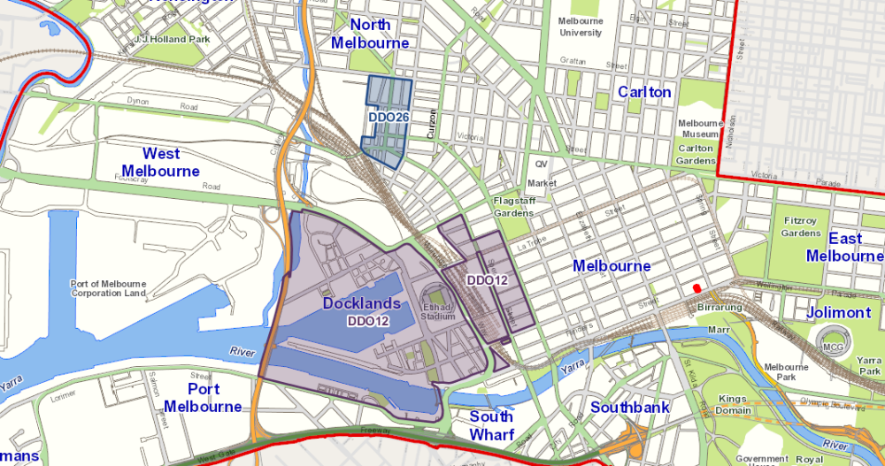
The requirements under DDO12 are:
Any new or refurbished development or any conversion of part or all of an existing
building that will accommodate new residential or other noise-sensitive uses must:

- Be designed and constructed to include noise attenuation measures. These measures must achieve a maximum noise level of 45 dB in habitable rooms with windows closed when music is emitted from the Major Sports and Recreation Facility in the Melbourne Docklands Area.
- Be fitted with ducted air conditioning if the new or refurbished development is within 400 metres of the centre point of the Docklands Major Sports and Recreation Facility.
- Have external glazing and doors and the air conditioning or ventilation system in all new residential and other noise-sensitive use and development designed by a recognised acoustic consultant.

For the purpose of this requirement, noise-sensitive uses are those that have an element of residential accommodation and are nested under the definition of accommodation in the planning scheme.

The objectives of DDO26, however, are to ensure that new residential or sensitive uses are attenuated from noise from the North Melbourne Industrial Area. The DDO26 requires a greater extent of acoustic attenuation (than DDO12) specifying maximum noise levels of 35dB in new dwellings.

Ministerial Announcements and State Policy Reform
Over the course of this project, a number of announcements have been made by State Ministers regarding changes to ‘reduce red tape’ for live music venues, which relate to reform of some of the regulations discussed above. On 21 November 2013 the Minister for Liquor and Gaming Regulation, announced new guidelines for live music venues, the ‘Best Practice Guidelines for Live Music Venues’ (the guidelines) and planned legislative changes that will mean ‘less red tape for licensees hosting under age and mixed-age gigs.
On 8 January 2014, the State government announced 36 red tape reforms to ‘boost productivity and reduce costs for Victorian businesses’. The changes to the Liquor Licensing laws under Section 20 of the Liquor Control Reform Act 1998 (the Act) mean that licensees can now apply to the Victorian Commission for Gambling and Liquor Regulation (VCGLR) for temporary approval of unaccompanied underage persons on licensed premises. Also, the liquor licensing laws change will remove the obligation of local Councils to supply a “permit not required” letter for a liquor license variation that does not involve planning issues. This will remove this administrative task currently required by City of Melbourne development planning. The guidelinesprovide advice on the regulatory requirements and industry best practice for running a live music venue. It is recommended that City of Melbourne direct potential new live music venue operators to these guidelines and that this should be an action within the Music Strategy.
Another of the reforms announced was to the Building Code of Australia Building Classification 9(b) (as discussed in ‘Building Code’ section above). The Premier state that “this reform will simplify and reduce planning approval for change of land use for small venues seeking to host live music”. The City of Melbourne should also engage with the state government on this policy reform.
On the same day, Planning Minister announced that the state government will be attempting to implement a principle of agent of change into Victoria’s planning system.
DTPLI have advised that some changes in the State Planning Policy provisions are expected to be released in mid 2014. Any potential changes to local planning policy provisions will be impacted by changes to state policy, so the working group agreed that the most suitable course of action is to await the release of state planning provision changes before pursuing local planning scheme amendments.
Conclusions and Recommendations
- The Planning Scheme supports and protects existing and proposed entertainment venues by requiring new residential developments to take into account the amenity impacts of established and future neighbouring uses, including noise, by acoustically insulating the dwellings. The Capital City Zone decision guidelines use the agent-of-change principle to, as appropriate, request noise insulation of new dwellings.
- Pursuant to the provisions of the Melbourne Planning Scheme there is no reference to live music venues as such and the defined uses of nightclubs, taverns, and hotel can all potentially be live music venues. It is considered that the term “live music venues” should be defined in the Music Strategy. This would assist with any actions related to live music including a possible future live music venue census. The City of Melbourne to await the release of state planning provision changes before pursuing local planning scheme amendments as relevant.
- The EPA has advised City of Melbourne that a review of SEPP N-2 would begin in mid 2014 and take approximately a year to complete. It is important that the City of Melbourne continue to work closely with the EPA on the SEPP N-2 review to ensure that issues relevant to the City of Melbourne are adequately addressed and the policy is effectively updated
- There is the potential for provisions in the CCZ and the MSS to be strengthened. However this must be informed by the EPA’s SEPP N-2 review.
- The City of Melbourne should engage with the State government on the Building Code of Australia Building Classification 9(b) policy reform, and any other relevant changes to the Building Code.
- City of Melbourne direct potential new live music venue operators to the ‘Best Practice Guidelines for Live Music Venues’, endorsed by the Minister for Liquor and Gaming Regulation and that this should be an action within the Music Strategy.

Planning Permit process
Assessing Planning Permits for Live Music Venues
Over the past few years that have been a few applications for new taverns that are able to function as live music venues (for example the new Savoy Hotel on Spencer Street). However, due to the land use definitions (discussed above), the term ‘live music’ venue is not considered uniquely and separately to the entertainment use term, so therefore it is difficult to quantify how many live music venues have started up. Restaurants, hotels and cafes are all permitted to host live music and entertainment, without having to notify Council so Council does not always become aware of new live music venue operations. Regardless, it is apparent that applications for live music venues on licensed premises that comply with the licensed premises policy (Clause 22.22 of the Melbourne Planning Scheme as discussed previous) are rarely refused.
Standard Planning Permit Conditions
Any planning permit issued for a new music venue will generally contain conditions which relate to the need for sound proofing, noise limitation and noise management plans. The conditions on planning permits aim to manage noise from the premises, and manage crowds entering and leaving the premises.
With regard to new dwellings the standard condition that is applied when there is an identified noise source such as a live music venue near the dwelling is:
“Prior to the commencement of the development, an acoustic report prepared by a qualified acoustic consultant must be submitted to and be to the satisfaction of the Responsible Authority. The report must provide for noise attenuation measures to achieve a maximum noise level of 45dB(A)Leq in unfurnished and uncarpeted habitable rooms with all windows and doors closed, unless there is no suitable air conditioning and/or mechanical ventilation, in which case the maximum noise level of 45dB(A)Leq in unfurnished and uncarpeted habitable rooms must be achieved with all the windows half open and the doors closed. The report must be based on average external noise levels measured as part of a noise level assessment. The recommendations in the approved acoustic report must be implemented, at no cost to the Responsible Authority, prior to the occupation of the dwelling(s).”
Sometimes in conjunction with this condition:
“Prior to the occupation of the dwelling(s), acoustic testing must be conducted by a qualified acoustic consultant. The test must verify that the maximum noise level specified in condition (specify) above is achieved, to the satisfaction of the Responsible Authority. A report containing the results of the testing must be submitted to the Responsible Authority prior to the occupation of the dwelling(s).”
These standard conditions have been found to be effective and defended at the Victorian Civil and Administrative Tribunal (VCAT).For example, in 2004 Council issued a Notice of Decision for the development and use of the land at 21 Liverpool Street, Melbourne as a tavern (‘Double Happiness’ BarTP04/466). In this case, VCAT supported Council’s decision and one of the reasons for the support was the noise attenuation condition that was part of the permit for a residential development on the other side of the lane at 16 Liverpool Street and also because the apartments were designed so that noise sensitive rooms (bedrooms) were not adjacent to the laneway.
Permits issued by the Planning Minister
The Minister for Planning is the responsible authority for development that is in excess of 25,000 square metres.
An example of such a development is the residential tower at 110-120 Kavanagh Street, Southbank. The planning permit for this development (TPM-2007-22) was approved by the Planning Minister with a noise attenuation condition is as follows:
17. Prior to the commencement of the development, a report from a qualified acoustic engineer, must be submitted to the satisfaction of the responsible authority certifying that the development shall be designed and treated with noise attenuation measures that achieves a maximum noise level of 45dB(A).
It is to be noted that the Minister, being the responsible authority for such developments, is responsible for enforcing these conditions of permit. City of Melbourne enforcement officers do not have the authority to enforce conditions on Ministerial Permits.
Conclusions and Recommendations
- Whilst not required by the planning scheme, standard noise permit conditions are applied, as appropriate.
- There is currently no requirement under the Melbourne Planning Scheme to apply standard noise conditions on permits for new residential developments in the Capital City zone, rather this is a decision guideline in the CCZ. With reference the DTPLI and Environment Protection Authority reviews, the option of an amendment the planning scheme to require noise attenuation maybe explored.

live Music Venues Case Studies
In order to better understand how the planning system works in relation to live music venues in Melbourne, case studies of four key live music venues Cherry Bar, The Mercat, The Savoy Hotel and Wah Wah Lounge, were undertaken. A map showing the location of these four venues is below:
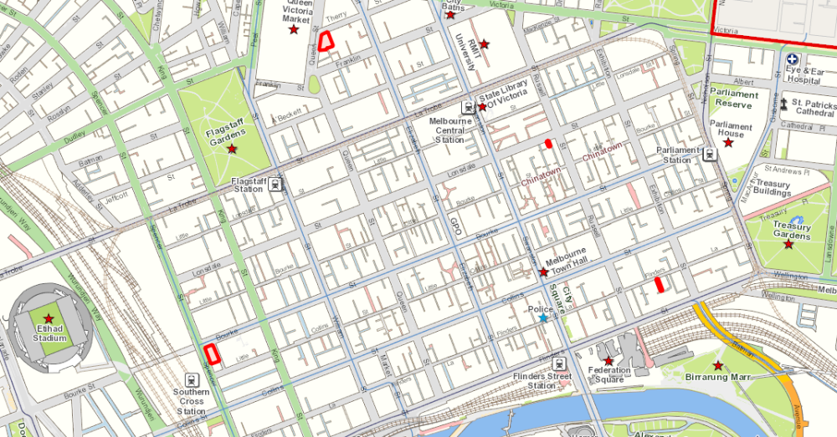
The Mercat, 143-151 Therry Street
The Savoy Hotel, 134-154 Spencer
Wah Wah Lounge, 185 Lonsdale Street
Cherry Bar, 103 Flinders Lane
The main factors investigated in the case studies included:
- Approvals and advertising for each venue
- Music/Noise Planning Assessments
- Planning Permit and Liquor License Conditions
- Residential Developments in proximity.
Council officers collected this information by retrieving and exploring planning files, compiling and analysing Council data and having discussions with various teams within Council. The Table 2 below summarises the results of the results of the case studies:

Table 2 : Summary of the findings of four live music venue case studies in Melbourne.
Factor | Cherry Bar | The Mercat | The Savoy | Wah Wah
How is the premises defined in the planning permit (and under current planning scheme land use definitions)? | Bar (Tavern) | Hotel with existing use rights (Hotel) | Hotel (Hotel) | Bar/café (Tavern)
What is the maximum patronage of the venue? | 200 | 1081 | 508 | 260
When was the permit(s) issued? | 1999 & 2001 | No planning permit has been issued this venue. It has existing use rights. | 2013 | 1998
Who issued the approval? | City of Melbourne, under delegation | N/A | City of Melbourne, under delegation | City of Melbourne, under delegation
Was the application advertised? | Yes, both. | N/A | Yes | Yes
Where advertised, was noise a cause for concern for the objectors? | Yes, both | N/A
Where approved under delegation, did the officer report address noise? | Yes, both | N/A
Does the approval require the venue/premises to incorporate its own noise attenuation measures? | Yes | Yes, via liquor license conditions
Does the permit contain the standard SEPP N-2 Conditions? | Yes, both | Yes, via liquor license conditions
Does the permit contain condition(s) related to patron management? | Yes | Yes, via liquor license conditions
Is the premises located within a noise attenuation Design and Development Overlay? (DDO15 or DDO12)? | No | No | Yes | No
What type of licence has been issued for the premises by VCGLR? | Late Night (On-Premises) | Late Night General Licence | General Licence | Late Night (On-premises)
Does the liquor licence specify amenity/noise conditions not specified on the planning permit? | Yes – an amenity related condition | N/A | Yes | Yes
How many properties containing residential uses are located in nearby properties? | 6 | 6 | 7 | 5
How many noise complaints have been recorded for these residential properties in relation to the music venue? | 2 (in relation to Cherry Rock festival only) | 2 | 0 (not open) | 2
How many of the residential developments were issued under the delegation of the City of Melbourne | 3 | 6 | 2 | 3

Case Study 1 – Cherry Bar
Cherry Bar - Cherry Bar is located on AC/DC Lane, and is described on its website as a late night street rock n roll bar. Cherry Rock Festival – Cherry Rock is a ‘street rock n roll festival’ held annually outdoors in ACDC Lane and has been held 8 times since 2007. Prior to the event being held, Events Melbourne notify surrounding residents of the event by distributing Event Notification Letters to all properties in the precinct bordered by Flinders Street, Russell Street, Exhibition Street and Flinders Lane.
Cherry Bar has operated since 1999. Its approvals are spread over two permits: TP- 1998-1057 (issued on 19 June 1999) and TP-2000-1111 (issued on 13 March 2001). Combined, these allow the venue to trade until 3 am from Mon-Thurs and until 5am Sat-Sun. The approvals impose noise and security restrictions and other amenity related requirements on the premises. The venue’s website says it has live music always finishing by 11:30pm followed by DJs until closing.
Council records show that no complaints have been received in relation to the normal operation of the venue. However, City of Melbourne has received two recorded complaints about Cherry Rock Festival since 2007. In 2012 one resident complained that there was loud music being played from the temporary stage from 6pm the day before the event. In 2013 an employee of a company overlooking the venue complained about the level of noise and choice of music.
Cherry Rock needs a Permit Event from Melbourne Events for use of Council Land, Occupancy Permit for Place of Public Entertainment and Health Permits. The Permits include conditions on noise and require that the event must operate within the maximum 72dB noise limit at all times ceasing at 9:30pm and that a production manager/sound engineer be on site to monitor compliance with these sound levels.
Residential developments in proximity
Cherry Bar is surrounded by a number of residential developments as shown in the map below (residential buildings highlighted in red):
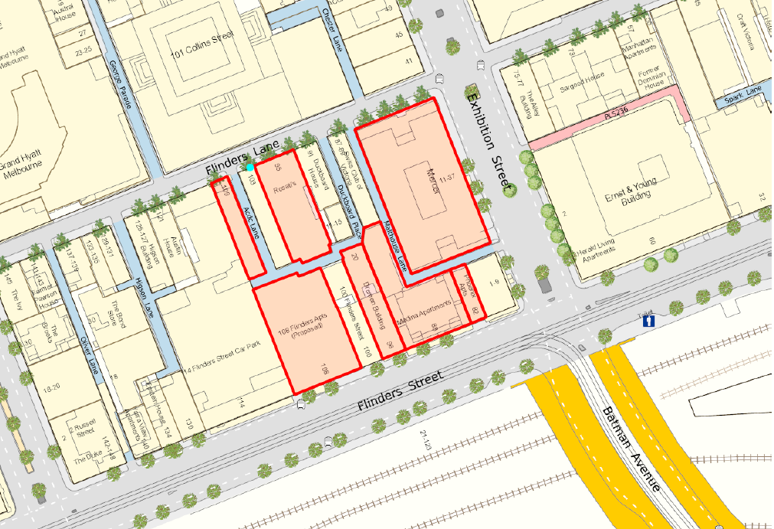
Cherry Bar Location
108 Flinders Apartments

The 108 Flinders Apartments development is located at the south end of ACDC Lane and was approved under delegation (TP-2010-330/A). It allows for construction of a 13 residential storey building. The application was not advertised as it was exempt from notice and review, pursuant to Schedule 1 of the Capital City Zone.
The assessing officer’s report addressed the issue of internal amenity and noise attenuation and imposed on the permit a standard condition - 10. Prior to the commencement of the development, plans/details showing treatment to the habitable rooms windows/openings to limit internal noise to a maximum of 45dB(A) in accordance with relevant Australian Standards must be submitted to the satisfaction of the Responsible Authority.
A report by Marshall Day Acoustics was submitted and endorsed as complying with the requirements of this condition. The report detailed compliance with the relevant Australian Standard which has requirements in excess of the 45dB(A).
The intention of the acoustic condition included on permit TP-2010-330 was for applicants to provide details on how they will acoustically treat habitable room windows. The applicant provided this detail by way of an Acoustic report. This condition has since been reviewed and the requirements strengthened. The current standard condition states:
Prior to the commencement of the development, an acoustic report prepared by a qualified acoustic consultant must be submitted to and be to the satisfaction of the Responsible Authority. The report must provide for noise attenuation measures to achieve a maximum noise level of 45dB(A)Leq in unfurnished and uncarpeted habitable rooms with all windows and doors closed, unless there is no suitable air conditioning and/or mechanical ventilation, in which case the maximum noise level of 45dB(A)Leq in unfurnished and uncarpeted habitable rooms must be achieved with all the windows half open and the doors closed. The report must be based on average external noise levels measured as part of a noise level assessment. The recommendations in the approved acoustic report must be implemented, at no cost to the Responsible Authority, prior to the occupation of the dwelling(s).
Rosati’s, 95-101 Flinders Lane is located next door to Cherry Bar. A planning permit was recently approved for this site for the construction of an 11 storey building for a residential hotel. This application was exempt from advertising under the provisions of the CCZ. No discussion of noise attenuation is contained within the delegated report on file and no conditions relating to noise were placed on the permit.
Phoenix Apartments are located to the south of Cherry Bar at 82 Flinders Street. A planning permit for a mixed use development, with the upper levels comprised of residential uses, was approved at the direction of VCAT in 2010. The same noise condition that was included on the 108 Flinders Street permit, was included on the 82 Flinders Street Permit.
The Medina Apartments are located at 84-94 Flinders Street. The permit approved by VCAT in 1998 was for the construction of a 19 storey building and conversion and extension of an existing four storey building for residential accommodation. The Permit does not contain any conditions relating to noise attenuation.
The Mercer Hotel is located at 11 – 37 Exhibition Street. Council issued this permit in 1995 for the erection of a nine level building to be used as a residential hotel. There is no discussion regarding noise attenuation in the delegated report and the permit issued does not contain any noise related conditions.
Case Study 2 – The Mercat
The Mercat is currently operating as a hotel/nightclub and has existing use rights as its use has been operating continuously for at least 15 years. It therefore does not have, or require, a planning permit for its use. Complaints about loud, amplified music have been received from two properties; the Stargate Apartments at 114 Franklin Street and the Franklin Apartments at 126 Franklin Street. The below map shows the location of these properties in relation to the Mercat site:

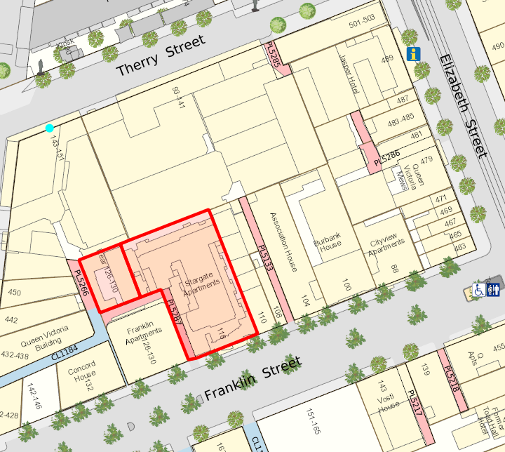
The Mercat
Franklin Apartments
Stargate Apartments
The Mercat has a Late Night General Licence and can have a total of 1081 patrons within the premises at any one time. The Liquor Licence includes the following conditions related to noise and amenity:
The licensee shall not cause or permit undue detriment to the amenity of the area to arise out of or in connection with the use of the premises to which the licence relates during or immediately after the trading hours authorised under this licence.
The licensee shall ensure that the level of noise emitted from the licensed premises shall not exceed the permissible noise levels for entertainment noise as specified in the State Environment Protection Policy (Control of Music Noise from Public Premises) No.N-2.
When live or recorded amplified music other than background music is provided:
The licensee shall install and maintain a surveillance recording system able to clearly identify individuals, which shows time and date and provides continuous images of all entrances and exits, bars and entertainment/dance floor areas. The surveillance recording system must operate from 30 minutes before the start of the entertainment being provided, until 30 minutes after closure. A copy of the recorded images must be available upon request for immediate viewing or removal by the Victoria Police, or a person authorised in writing by the Director of Liquor Licensing, or otherwise retained for at least one month. The position of the cameras will be to the satisfaction of the Licensing Inspector.
Signs, as described below, are to be displayed in all areas subject to camera surveillance. Such signs shall read:
"For the safety and security of patrons and staff this area is under electronic surveillance".
Crowd controllers, licensed under the Private Security Act, are to be employed at a ratio of 2 crowd controllers for the first 100 patrons and 1 crowd controller for each additional 100 patrons or part thereof. One crowd controller is to be present outside the premises to monitor patrons arriving at and departing from the premises. Crowd controllers are to be present from 30 minutes before the start of the entertainment being provided, until 30 minutes after closure.
Compliance with Liquor License conditions is enforced by the Compliance Division of the VCGLR.
Stargate Apartments are located to the south of The Mercat at 114-122 Franklin Street, Melbourne. The Permit was issued in 1999 for an 11 storey building comprising 186 apartments and the permit does not contain any conditions relating to noise attenuation.
The Franklin Apartments are located at 126 – 130 Franklin Street Melbourne. The permit was issued in 1991 and was for a three storey residential and commercial apartment building. No conditions relating to noise attenuation are included on file.

Case Study 3 – Savoy Tavern
The Savoy Tavern is regarded as one of Melbourne’s oldest pubs dating back to 1866. It has been closed since 1995 and recently reopened in March, 2014 after a permit was issued for a hotel in November last year. An acoustic report was submitted with the application. This assessed the impact of the venue on the surrounding residential properties. The design of the venue incorporated the absorptive treatment, sold flooring and sound lock entrances to limit noise pollution to the surrounding area.
The land is affected by the Noise Attenuation Overlay DDO12 (which applies to land around Etihad Stadium). Under the DDO12, a greater degree of noise attenuation is required for new residential developments. Enforcement officers have reported that very few noise complaints in general come from residential towers in these areas affected by the DDO12.
The map below shows the location of the Savoy Tavern and the nearby residential developments.
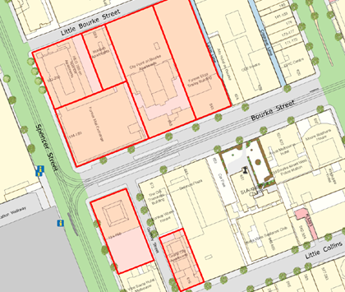
Savoy Tavern
Savoy Hotel
City Point Apartments
Grand City Apartments
There are extensive and detailed acoustic attenuation and music related requirements included on the permit as follows:
Prior to commencement of the use, the numerous recommendations contained within the Acoustic Report prepared by Marshall Day Acoustics, dated 24 May 2013 and subsequent correspondence dated 14 and 30 August 2013, including the fitting of a noise limiting device, must be implemented at no cost to the City of Melbourne and be to the satisfaction of the Responsible Authority.
The use must not detrimentally affect the amenity of the area or the amenity of persons living in proximity of the site by reason of the emission of noise. The Responsible Authority, with just cause, may at any time request lodgement of an acoustic report, prepared by a suitably qualified acoustic consultant. The report must be to the satisfaction of the Responsible Authority and identify all potential noise sources and sound attenuation work required to address any noise issues and to comply with State Environment Protection Policy, (Control of Noise from Commerce, Industry and Trade), No. N-1, and State Environment Protection Policy (Control of Music Noise from Public Premises) No. N-2. The recommendations of the report must be implemented by the applicant to the satisfaction of the Responsible Authority.
The noise generated by the premises must at all times comply with the requirements of the State Environment Protection Policy, (Control of Noise from Commerce, Industry and Trade) No. N-1, and State Environment Protection Policy (Control of Music Noise from Public Premises) No. N-2, to the satisfaction of the Responsible Authority.
No external sound amplification equipment or loud speakers are to be used for the purpose of announcement, broadcast, playing of music or similar purpose, to the satisfaction of the Responsible Authority.
Prior to the commencement of the use, a clearly legible sign must be placed directly outside the entrance to the premises, providing a telephone number effective for contacting the designated manager at all hours during which the premises is operating. The design, lighting and maintenance of the sign must be to the satisfaction of the Responsible Authority.
Any external operable wall/glazing system/doors shown on the endorsed plans must be closed at 11.00pm, except for access and egress to the satisfaction of the Responsible Authority.
Live or recorded amplified music or entertainment (other than background music or entertainment played at background music levels) is to be restricted to pre-booked functions in the Lounge Bar and must cease by midnight when the premises are open to the satisfaction of the Responsible Authority.
Background music only is permitted in the Public Bar.
Condition 3 required submission and endorsement of a venue management plan containing details about airlock entrances and associated arrangements when music (other than background music) is playing at the site.
The liquor license contains the following condition regarding noise:
The licensee shall ensure that the level of noise emitted from the licensed premises shall not exceed the permissible noise levels for entertainment noise as specified in the State Environment Protection Policy (Control of Music Noise from Public Premises) No.N-2.

Case Study 4 – Wah Wah Lounge
Wah Wah lounge is a bar/nightclub located at 185-187 Lonsdale Street, Melbourne. The planning permit for this use was issued by City of Melbourne under delegation in 1998. In 2002 this permit was then amended to enable the premises to trade as a 24 hour venue.
The Permit allows for a maximum patronage of 260 and includes the following conditions related to noise:
3. The hours of operation shall be 24 hours, except on Anzac day and Good Friday.
4. Windows to the first and second floor of the premises abutting Waratah Place shall be fixed at all times and the windows facing Lansdale Street are to be fixed from 10.00pm until closing, Monday to Sunday.

5. The maximum noise level emitted from the premises shall not exceed levels specified in the State Government Protection Policy (Control of Noise from Commercial, Industrial or Trade Premises within the Melbourne Metropolitan Area), No. N 1.

6. The Maximum Noise level emitted from the premises shall not exceed levels specified in the State Environmental Protection Policy (Control of Music Noise from Public Premises) No. 2

7. The use hereby permitted shall not cause injury to or prejudicially affect the amenity of the locality by reason of the emission of noise.

8. Any noise emitted from the site from the subject premises shall:

• At all times comply with limits, standards or rules prescribed thereto or imposed by, inor under State Environment Policy made pursuant to the Environment Protection Act 1970.
• At no time be such as to cause any nuisance to occupants of any adjacent or other buildings in proximity to the subject premises.

The map below shows the location of Wah Wah Lounge and surrounding residential developments:
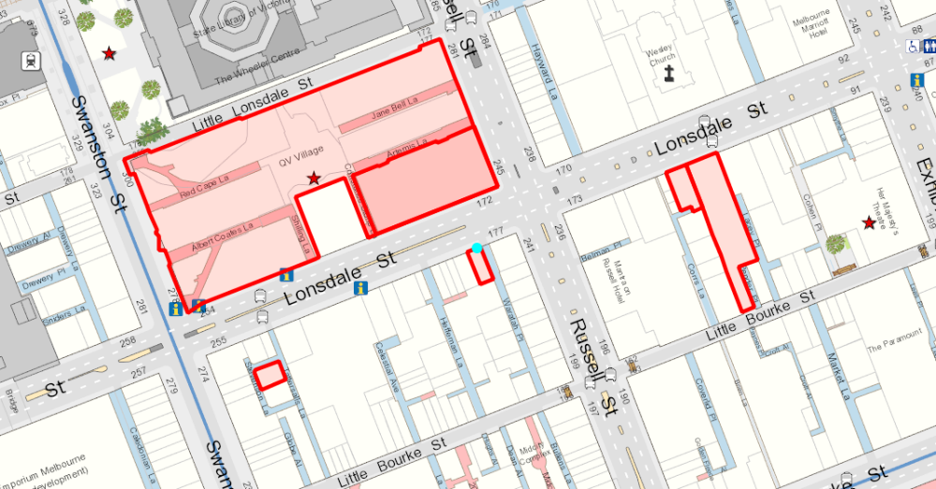
Wah Wah Lounge
131-137 Lonsdale Street (Hotel Grand Chancellor/ Lonsdale heights apartments)
Permit was issued under delegation in 1999 for Alterations and additions to the rear of the existing building for residential accommodation. Condition 2 on the Permit states:
Prior to the commencement of works hereby permitted, a plan showing treatment to the habitable room windows to limit internal noise levels to a maximum of 45 dB in accordance with the Australian Standards shall be provided to the Responsible Authority to its satisfaction.
The application was not advertised and the assessment addressed noise as a factor for consideration and specified that the imposition of the condition outlined above would address noise issues.
139-143 Lonsdale Street
Planning Permit was issued under delegation in 2001 to demolish existing building and develop a 15 storey building for accommodation (89 apartments, associated retail, office and restaurant at ground floor level, car spaces and plant room) and associated uses.

The application was exempt from notice under the CCZ. However, notice was given pursuant to the Heritage Overlay. Meaning that the assessing officer could only consider matters related to heritage, not amenity.

The following properties were notified and notices were erected on site: 145 Lonsdale Street, 28 Corrs Lane, 131 Lonsdale Street, .111 Lonsdale Street Five objections were received. One objection mentioned noise and this was related to the impact it would have on the operation of a Japanese restaurant. Noise was not addressed elsewhere in the report.

The Permit contains the following standard condition related to noise:
The development hereby approved shall be designed and treated with noise attenuation measures so as to ensure that the maximum level of noise from external sources does not exceed 45dB (A) within habitable rooms with windows closed in accordance with relevant Australian Standards for acoustic control, to the satisfaction of the Responsible Authority.
27-29 Tattersalls Lane
This property is currently occupied by Section 8 but has received approval under delegation for a tower. The permit has been extended until September 2014.
The delegated report does not discuss noise attenuation/ impacts of surrounding properties and the application was not advertised (as the site is within the CCZ).
The following standard noise condition was imposed on the permit:
Prior to the commencement of the development, plans/details showing treatment to the habitable room windows/openings to limit internal noise to a maximum of 45 dB (A) in accordance with relevant Australian Standards must be submitted to the satisfaction of the Responsible Authority.
BHP Billiton Centre 180 Lonsdale Street / QV Village 278-300 Swanston Street
A planning permit was issued at the direction of the Planning Minister in 2001 for retail premises, office & residential accommodation and associated car parking. The permit does not appear to contain any conditions relating to noise attenuation and it is unclear whether advertising took place as the development was dealt with by the Minister for Planning.
Conclusions and Recommendations
- Most complaints about noise from music venues appear to come from the older residential developments and are in relation to older venues. For example, the Mercat Hotel is an old building with an old permit and surrounded by older apartment buildings.
- The older planning permits for residential developments (prior to 2000) rarely included conditions relating to noise attenuation.
- New music venues (for example the Savoy Hotel) are required to meet the requirements of the Licensed Premises Policy (Clause 22.22) so therefore have a greater degree of acoustic attenuation than the older venues. That there are fewer complaints in relation to new venues is an indication that Clause 22.22 and associated acoustic attenuation requirements and effective.
- As no permit is required for residential uses in the Capital City Zone, there is no requirement for nearby properties to be notified of applications for residential developments.
- So that particular noise sources are considered in the early stages of development, it is considered that the CCZ provisions could potentially be modified. For example, under the Application Requirements Section of the existing CCZ Schedule 1, noise sources (such as live music and entertainment venues) could potentially be included in the list of considerations in the urban context report. However, this change and any other change must be informed by the review of the State Planning Provisions.

overall Conclusions and Recommendations

This review of the regulatory framework related to live music in Melbourne has revealed that the existing Melbourne Planning Scheme includes a number of provisions which acknowledge the value of music to Melbourne. Also included are provisions which guide residential developments to attenuate when there are existing noise sources. The main opportunity for planning policy changes effecting live music venues are at the State level and specifically SEPP N-2 and the State Planning Policy Planning Provisions. Both of these regulations are currently being reviewed and City of Melbourne is engaged in both of these review processes. Depending on the outcome of these reviews, amendments to the Melbourne Planning Scheme should be considered.

.

References
City of Melbourne, Annual Plan and Budget 2013 – 2014
City of Melbourne, Music Strategy 2010
Department of Transport Planning and Local Infrastructure Victoria, Planning and Environment Act, 1987
Environment Protection Authority Victoria, Environment and Protection Act, 1970
Music Victoria,2012 ‘Music Industry Position Paper – The Case for Regulatory Reform’.
Music Victoria, 2012, ‘Victorian Live Music Census 2012’
Music Victoria, 2011 ‘Melbourne Music City Guide’
Victorian Commission for Gambling and Liquor Regulation, The Liquor Control Reform Act, 1998

Appendix A - Music Venues in the City of Melbourne
This list of live music venues is compiled from The Victorian Live Music Census 2012)

MELBOURNE CDB - Pubs, Clubs, Bars (129)
• 1000 Pound Bend 361 Lt Lonsdale St Melbourne 3000
• All Nations Bar 2 Spencer Street Melbourne 3000
• Amber Lounge 388 Lonsdale Street Melbourne 3000
• Balcony Bar 422 Little Collins Street Melbourne 3000
• Bambu Bar & Lounge 10 Flinders Lane Melbourne 3000
• Bang! (Royal Melb Hotel) 621-629 Bourke Street Melbourne 3000
• Baraki Bar 168 Lonsdale Street Melbourne 3000
• Baroq House 9 Drewry Lane Melbourne 3000
• Basemint 95 Queen Street Melbourne 3000
• Bass Lounge 91-103 Little Bourke Street Melbourne 3000
• Belgian Beer Café (Eureka) 557 St Kilda Road Melbourne 3004
• Bennetts Lane 25 Bennetts Lane Melbourne 3000
• Berlin Bar 16 Corrs Lane Melbourne 3000
• Bertha Brown 562 Flinders Street Melbourne 3000
• Billboard 170 Russell Street Melbourne 3000
• Bond Lounge 24 Bond Street Melbourne 3000
• Brown Alley cnr King & Lonsdale Streets Melbourne 3000
• Bunker Lounge 407 Swanston Street Melbourne 3000
• Café Segovia 33 Block Place Melbourne 3000
• Canary Club 6 Melbourne Place Melbourne 3000
• Carlton Club 193 Bourke Street Melbourne 3000
• CBD (3-D/DV8) 12 McKillop Street Melbourne 3000
• Celtic Club 316 Queen Street Melbourne 3000
• Chaise Lounge 105 Queen Street Melbourne 3000
• Champagne Lounge 39-41 Little Collins Street Melbourne 3000
• Charlies Bar 71 Hardaware Lane Melbourne 3000
• Cherry AC/DC Lane Melbourne 3000
• Chez Regine 270 Russell Street Melbourne 3000
• Chi Lounge 195 Lt Bourke Streert Melbourne 3000
• Cho Gao Level 3, Melbourne Central Melbourne 3000
• Clique 26 King Street Melbourne 3000
• Club Retro 383 Lonsdale Street Melbourne 3000
• Colonial Hotel (Next) 585 Lonsdale Street Melbourne 3000
• CQ Bar 113 Queen Street Melbourne 3000
• Croft Institute 21-25 Croft Alley Melbourne 3000
• Decca Bar 95 Queen Street Melbourne 3000
• Deep 11 456 Queen Street Melbourne 3000
• Déjà vu 525 Lonsdale Street Melbourne 3000
• Ding Dong Lounge 18 Market Lane Melbourne 3000
• Double Happiness 21 Liverpool Street Melbourne 3000
• E55 55 Elizabeth Street Melbourne 3000
• Ed Hardy Bar Level 3, Melbourne Central Melbourne 3000
• Element Lounge 85 Queen Street Melbourne 3000
• Elephant & Wheelbarrow 94 Bourke Street Melbourne 3000
• Eurotrash 18 Corrs Lane Melbourne 3000
• Exchange Hotel 120 King Street Melbourne 3000
• Exford Hotel 199 Russell Street Melbourne 3000
• Fad Gallery 14 Corrs Lane Melbourne 3000
• Famous Spiegeltent 25 St Kilda Road Melbourne 3000
• Fashion Lounge 121 Flinders Lane Melbourne 3000
• Fortyfive downstairs 45 Flinders Lane Melbourne 3000
• Galley Room Lvl 1, 510 Flinders Street Melbourne 3000
• Geddes Lounge Geddes Lane Melbourne 3000
• Gertrudes Brown Couch 30 Gertrude Place Melbourne 3000
• Gin Palace 10 Russell Street Melbourne 3000
• Hairy Canary 212 Little Collins Street Melbourne 3000
• Hi-Fi Bar 125 Swanston Street Melbourne 3000
• Horse Bazaar 397 Little Lonsdale St Melbourne 3000
• Hush Bar Lvl 3 Melbourne Central Melbourne 3000
• Inflation 60 King Street Melbourne 3000
• Insignia Bar 502 Flinders Street Melbourne 3000
• Irish Times 427 Little Collins St Melbourne 3000
• Key Club 117 Lonsdale Street Melbourne 3000
• Khokolat Bar 43 Hardware Lane Melbourne 3000
• Korova Milk Bar 12 Bourke Street Melbourne 3000
• La Dida 577 Little Bourke Street Melbourne 3000
• Liberty Social 279 Flinders Lane Melbourne 3000
• Lion Hotel Level 3, Melbourne Central Melbourne 3000
• Little Penninsula 308 Little Lonsdale Street Melbourne 3000
• Lounge Upstairs 243 Swanston Street Melbourne 3000
• Madisons 461 Bourke Street Melbourne 3000
• Marrakech 25 Bank Place Melbourne 3000
• Match Bar & Grill 249 Little Lonsdale Street Melbourne 3000
• Max Bar 54-58 Hardware Lane Melbourne 3000
• Melbourne Central Lion 211 A La Trobe St, Level 3 Melbourne 3000
• Mercat Cross (Hotel) 456 Queen Street Melbourne 3000
• Metropolitan Hotel 263 William Street Melbourne 3000
• Misty 3-5 Hosier Lane Melbourne 3000
• Murmur 1/17 Warburton Lane Melbourne 3000
• Nectar Lounge 228 Flinders Lane Melbourne 3000
• New Guernica 318-322 Lt Collins Street Melbourne 3000
• Night Owl 33 Elizabeth Street Melbourne 3000
• Order Of Melbourne 401 Swanston Street Melbourne 3000
• Paris Cat 6 Goldie Place Melbourne 3004
• Penny Blue 2 Driver Lane Melbourne 3000
• Platform One 371 Flinders Street Melbourne 3000
• Pony 68 Little Collins Street Melbourne 3000
• Portland Hotel 115-127 Russel Street Melbourne 3000
• Pugg Mahones 106 Hardware Lane Melbourne 3000
• Purple Emerald Bar 191 Flinders Lane Melbourne 3000
• Randy Dragon 313 Flinders Lane Melbourne 3000
• Red Violin 231 Bourke Street Melbourne 3000
• Redlove Musicroom 401 Swanston Street Melbourne 3000
• Regent Theatre 191 Collins Street Melbourne 3000
• Robot 12 Bligh Place Melbourne 3000
• Rooftop Bar Lvl 7, 252 Swanston Street Melbourne 3000
• Roxanne Parlour 2 Coverlid Place Melbourne 3000
• Royal Melbourne Hotel (Bang) 629 Bourke Street Melbourne 3000
• Section 8 Bar 27 Tattersalls Lane Melbourne 3000
• Shamiana 420 Lonsdale Street Melbourne 3000
• Sorry Grandma 590 Little Bourke Street Melbourne 3000
• Spice Market 504 Elizabeth Street Melbourne 3000
• Stork Hotel 504 Elizabeth Street Melbourne 3000
• Syn Bar 163 Russell Street Melbourne 3000
• The Apartment 401 Little Bourke Street Melbourne 3000
• The Carlton 193 Bourke Street Melbourne 3000
• The Deck (Waterside Hotel) 508 Flinders Street Melbourne 3000
• The Match Bar 249 Little Lonsdale Street Melbourne 3000
• The Palace 20-30 Bourke Street Melbourne 3000
• The Red Hummingbird 246 Russell Street Melbourne 3000
• The Toff In Town 252 Swanston Street Melbourne 3000
• The Workshop 413 Elizabeth Street Melbourne 3000
• Three Degrees QV Square, Swanston Street Melbourne 3000
• Tony Starr's Kitten Club 267 Little Collins Street Melbourne 3000
• Transport Hotel/Transit Cnr Swanston & Flinders Streets Melbourne 3000
• Troika Bar 106 Little Lonsdale Street Melbourne 3000
• Turf Bar 131 Queen Street Melbourne 3000
• Tuscan Bar 79 Bourke Street Melbourne 3000
• Two Floors Up 159 Lonsdale Street Melbourne 3000
• U Bar 2 Spencer Street Melbourne 3000
• Vatican Bar 272 City Road Melbourne 3000
• Velvet Underground 167 Franklin Street Melbourne 3000
• Vialleto 75 Hardware Lane Melbourne 3000
• Wah Wah Lounge 185 Lonsdale Street, Melbourne Melbourne 3000
• West Space Inc 15-19 Anthony Street Melbourne 3000
• Wheat Restaurant & Bar 534 Lonsdale Street Melbourne 3000
• Word 14 Goldie Place Melbourne 3000
• Wow 243 Lonsdale Street Melbourne 3000
• Young & Jackson Cnr Swanston & Flinders Streets Melbourne 3000
MELBOURNE CBD & Inner - Large Venues (17)
• Etihad Stadium 740 Bourke Street Docklands 3008
• AAMI Park Olympic Boulevard Melbourne 3000
• Arts Centre - Fairfax Studio St Kilda Road Melbourne 3000
• Athenaeum Theatre 188 Collins Street Melbourne 3000
• Comedy Theatre 240 Exhibiyion Street Melbourne 3000
• Federation Square Cnr Flinders & Swanston Sts Melbourne 3000
• Forum Theatre Cnr Flinders & Russell Sts Melbourne 3000
• Hamer Hall St Kilda Road Melbourne 3000
• Her Majesty's Theatre 219 Exhibition Street Melbourne 3000
• Hisense Arena Batman Avenue Melbourne 3000
• Melbourne Town Hall (Main) 90 Swanston Street Melbourne 3000
• Ormond Hall 557 St Kilda Road Melbourne 3004
• Plenary Hall 1 Convenmtion Place Melbourne 3000
• Princess Theatre 163 Spring Street Melbourne 3000
• Regent Theatre 161 Collins Street Melbourne 3000
• Rod Laver Arena Batman Avenue Melbourne 3000
• Sidney Myer Music Bowl 21 Linlithgow Avenue Melbourne 3000
• Southbank (8)
• Club Odeon at Crown 8 Whiteman Street Southbank 3006
• Co. at Crown 8 level 3 Whiteman Street Southbank 3006
• Eve 334 City Road Southbank 3006
• Fusion at Crown 8 Whiteman Street Southbank 3006
• Melbourne Recital Centre 31Sturt Street Southbank 3006
• Palms at Crown 8 Whiteman Street Southbank 3006
• PJ Obrien 3 Southgate Avenue Southbank 3006
• World Restaurant Bar 4/2 Riverside Quay Southbank 3006
• Carlton (8)
• Bella Union Cnr Victoria & Lygon Streets Carlton 3053
• Clare Castle Hotel 421 Rathdowne Street Carlton 3053
• Clyde Hotel 385 Cardigan Street Carlton 3053
• Dan O'Connell Hotel 225 Canning Street Carlton 3053
• Draculas 100 Victoria Street Carlton 3053
• John Curtin Hotel 29 Lygon Street Carlton 3053
• Pugg Mahones 175 Elgin Street Carlton 3053
• Sippers 164 Rathdowne Street Carlton 3053
• North Melbourne and West Melbourne (6)
• Leveson 46 Leveson Street North Melbourne 3051
• Prose Bar 7 Errol Street North Melbourne 3051
• Town Hall Hotel 33 Errol Street North Melbourne 3051
• Victoria Hotel 380 Victoria Street North Melbourne 3051
• Drunken Poet 65 Peel Street West Melbourne 3003
• Spensers Live 419 Spencer Street West Melbourne 3003

Appendix B - Music and Noise Attenuation related provisions in the Melbourne Planning Scheme

13.04-1 Noise abatement

Objective
To assist the control of noise effects on sensitive land uses.

Strategy
Ensure that development is not prejudiced and community amenity is not reduced by noise
emissions, using a range of building design, urban design and land use separation
techniques as appropriate to the land use functions and character of the area.

Policy guidelines
Planning must consider as relevant:
▪ State Environment Protection Policy (Control of Music Noise from Public Premises)
No. N-2.
▪ State Environment Protection Policy (Control of Noise from Commerce, Industry and
Trade) No. N-1 (in metropolitan Melbourne).
▪ Interim Guidelines for Control of Noise from Industry in Country Victoria
(Environment Protection Authority, 1989).
▪ A Guide to the Reduction of Traffic Noise ( VicRoads 2003).
17 ECONOMIC DEVELOPMENT
Planning is to provide for a strong and innovative economy, where all sectors of the
economy are critical to economic prosperity.
Planning is to contribute to the economic well-being of communities and the State as a
whole by supporting and fostering economic growth and development by providing land,
facilitating decisions, and resolving land use conflicts, so that each district may build on its
strengths and achieve its economic potential.
17.01 Commercial

17.01-1 Business
Objective
To encourage development which meet the communities’ needs for retail, entertainment,
office and other commercial services and provides net community benefit in relation to
accessibility, efficient infrastructure use and the aggregation and sustainability of
commercial facilities.

Strategies
Locate commercial facilities in existing or planned activity centres.
Provide new convenience shopping facilities to provide for the needs of the local
population in new residential areas and within, or immediately adjacent to, existing
commercial centres.
Provide small scale shopping opportunities that meet the needs of local residents and
workers in convenient locations.
Provide outlets of trade-related goods or services directly serving or ancillary to industry
and which have adequate on-site car parking.
Locate cinema based entertainment facilities within or on the periphery of existing or
planned activity centres. Such facilities should not require a permit for use within activity
centres and are not encouraged on freestanding sites.
A five year time limit for commencement should be attached to the planning approval for
all shopping centres or expansions of over 1,000 square metres in floorspace.

21.02-4 Creative City
Melbourne is a national and international leader in creative endeavours such as music,
performing and visual arts; film, television and radio; writing, publishing and print media;
design and architecture; software and electronic gaming, web and multimedia
development; and advertising and marketing.

Along the Sturt Street spine there is a cluster of many of Australia’s premier cultural
institutions extending from Federation Square to the Arts Centre to the Malthouse Theatre.
The North Melbourne Arts precinct is the other main arts cluster. The municipality’s rich
cultural life contributes to the City’s liveability, capacity for innovation, competitiveness
and reputation as a creative city. The City has also expanded rapidly as an entertainment
and cultural centre with over 1,100 cafés and restaurants in the central business district area
alone and a multitude of entertainment, cultural and dining venues in its inner suburbs.
(CLUE 2010 Small Area Report: Melbourne (CBD)

Other City cultural assets include the Shrine of Remembrance and Royal Botanic Gardens,
the Royal Exhibition Building and the surrounding Carlton Gardens, the Melbourne
General Cemetery, the Melbourne Zoological Gardens and Sidney Myer Music Bowl.
21.07 HOUSING
The City of Melbourne supports the growth of the municipality’s residential population,
which is forecast to reach 177,000 people by 2030 (ID Consulting 2011, Population
Forecasts). Most of this increased population is planned to be accommodated in the City’s
areas of urban renewal, planned urban renewal and the Hoddle Grid.

Outside these areas increased population growth will be modest and in some established
areas such as South Yarra, parts of Parkville, North Melbourne, Kensington, Carlton, East
Melbourne and Jolimont, there will be minimal change.

Residential growth must be managed to ensure a good quality of life and amenity for
existing and future residents. High standards of on-site amenity should be provided in all
residential developments including good access to sunlight and daylight and privacy
Residential development also needs to consider the amenity impacts of established and
potential uses, including noise and light spill, and take protective steps to minimise these
impacts.

Social diversity is an important factor in the social health of the city. A diverse population
needs a diversity of housing sizes and types. There is also a need to increase the proportion
of lower cost accommodation, social housing and housing for people of all abilities.

21.07 – 1 Residential development

Objective 1 To provide for new housing while preserving the valued characteristics of
the existing neighbourhoods.
Strategy 1.1 In areas outside the Central City and Urban Renewal Areas, increase housing
quantity and density consistent with the existing character of the area.
Strategy 1.2 Encourage the most significant housing and population growth in the Central
City and Urban Renewal areas.
Strategy 1.3 Ensure that new residential development achieves high standards of amenity
including access to sunlight and daylight and protection from overlooking.
Strategy 1.4 In areas of Proposed Urban Renewal, encourage housing that is consistent
with an approved structure plan, or where it can be demonstrated it will not
adversely impact on ongoing industry or port uses.
Strategy 1.5 Discourage housing where it will undermine the viability of port uses.

Objective 2 To ensure new dwellings are located and designed to protect residents
from current and future off-site amenity impacts.
Strategy 2.1 In the Capital City, Docklands and Commercial Zones, ensure residential
developments are designed to mitigate the amenity impacts from surrounding
established and future uses, including insulation from noise.
Strategy 2.2 Encourage consideration of acoustic attenuation measures in dwellings that
adjoin or are located close to the Capital City Zone, Docklands Zone, or
Commercial Zones, or are in the Mixed Use Zone.
Strategy 2.3 Encourage all residential developments adjacent to industry, rail corridors and
major roads to provide acoustic insulation in dwellings.
Strategy 2.4 Ensure new residential development close to existing Industrial Zones
acknowledges and manages off-site effects caused by these industrial areas.

Objective 3 To ensure the amenity of existing residential uses is protected.
Strategy 3.1 Ensure that the reasonable expectations of amenity for existing residential uses
are maintained

21.10-6 Cultural/Arts and Entertainment Facilities

Objective 1 To provide a diverse range of leisure, arts, cultural and entertainment
facilities.

Strategy 1.1 Discourage the concentration of sexually explicit adult entertainment,
amusement parlours and gaming venues in the Central City.
Strategy 1.2 Support quality public institutions, including art galleries, libraries and
museums, throughout the municipality, where consistent with the local
amenity.
Strategy 1.3 Support entertainment, music and cultural attractions in Commercial and
Mixed Use Zones, where consistent with the local amenity.

Objective 2 Enhance the City as Victoria’s pre-eminent cultural and entertainment
location.

Strategy 2.1 Support and encourage the growth of a vibrant cultural environment in the
Hoddle Grid, Southbank and Docklands, by supporting entertainment uses,
music and the arts.
Strategy 2.2 Support the City’s major sports facilities and parks in recognition of their
national significance.
Strategy 2.3 Promote the Docklands waterfront as a tourism and leisure destination of State
significance.
21.12 HODDLE GRID

Housing
▪ Support permanent and short term residential development in the Hoddle Grid that
accommodates a diverse population.

Economic development
▪ Encourage the development of a range of complementary precincts within the Hoddle
Grid that offer a diverse range of specialist retail, cultural and entertainment
opportunities.
▪ Encourage the retention and enhancement of specialised shopping and entertainment
precincts within the Hoddle Grid, particularly, Hardware Lane, Chinatown, Collins
Street and Little Collins Street.
▪ Support entertainment, bars, eating and other evening uses throughout the Hoddle
Grid.
▪ Support the Retail Core as a compact, high-density retail precinct and facilitate easy
pedestrian access.
▪ Support the consolidation of education clusters on the northern and western edges of
the Hoddle Grid and in Flinders Street.
▪ Ensure the Northbank of the Yarra River has increased open space opportunities.
▪ Support the Queen Victoria Market as a retail and tourist facility, and as a heritage
asset of State significance.
▪ Ensure the form and use of development around the Queen Victoria Market does not
detract from its amenity nor compromise its 24 hour function.

21.15 – 3 Sports and Entertainment Area
The Sports and Entertainment Area includes some of Melbourne’s major sporting and
entertainment venues as well as some of the largest areas of parkland in the vicinity of
the Central City, along the Yarra River corridor. It provides recreational, cultural and
entertainment opportunities including Birrarung Marr, the Shrine of Remembrance,
Government House, Sidney Myer Music Bowl and the National Herbarium within the
Domain and Royal Botanic Gardens.
This area’s development will continue to provide Melbourne with world class
recreational, entertainment and leisure facilities. Its future development could incorporate
the urban renewal of the Jolimont rail corridor.
Economic development
▪ Ensure that commercial uses in the Royal Botanic Gardens and Domain Parklands do
not detract from their landscape qualities and amenity.
Built Environment and Heritage
▪ Investigate the potential future development of the Jolimont railyards corridor.
▪ Protect the Shrine of Remembrance vista.
▪ Maintain the beauty, cultural values and functionality of the Royal Botanic Gardens
and Domain Parklands and the institutions within them.
▪ Support the maintenance of the natural state of Yarra Park by retaining and enhancing
its native vegetation.
Transport
▪ Ensure existing access and links to transport facilities in the area are maintained and
strengthened.
▪ Develop pedestrian links between the water side entertainment and recreational
attractions.
▪ Develop pedestrian links between Birrarung Marr across the Yarra River to
Alexandra Gardens.
▪ Develop pedestrian links from the Sports and Entertainment Precinct to areas to the
north and east, especially Richmond Station and other public transport nodes.
▪ Support the extension of Spring Street to Brunton Avenue and the development of the
triangle of land between this new link, Wellington Parade and west of Jolimont Road.
▪ Minimise the impact of car parking on Yarra Park by reducing vehicle access and car
parking as new opportunities arise.
Infrastructure
▪ Support the functioning and growth of sports and entertainment facilities
commensurate with their key state and national role.

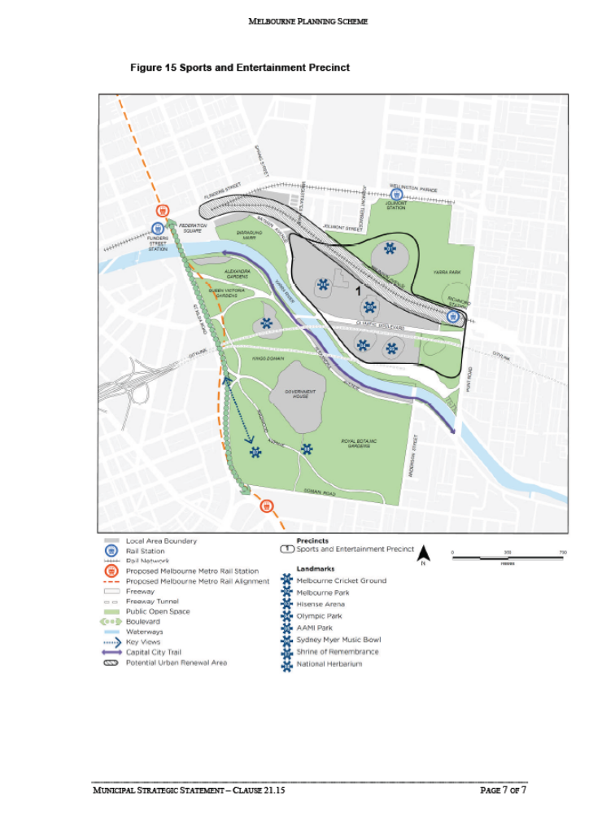

22.14 DISCRETIONARY USES IN THE RESIDENTIAL 1 ZONE
This policy applies to all applications to use land for Section 2 (discretionary) uses in the
Residential 1 Zone.
Policy Basis
The established residential areas in the City of Melbourne are a significant capital city
asset. They provide high quality and attractive residential environments at the doorstep of
the Central City. The MSS recognises the importance of these areas for the liveability and
economic performance of the city. Clause 21.04 of the MSS sets out objectives and
strategies for land uses applicable to this Clause.

The primary purpose of the Residential 1 Zone is to provide for residential development at
a range of densities. The zone provides for a range of educational, recreational, religious
and a limited range of other uses to serve local needs.

The proximity of the residential areas of the City of Melbourne to the Central City makes
these areas attractive for uses that are not focussed on local needs and may not be
compatible with residential amenity. To protect these areas, it is important to restrict the
encroachment of incompatible non-residential uses.

It is also important to acknowledge that there are existing non-residential uses in residential
areas which make important contributions to local neighbourhoods. In these instances, the
responsibility for management of impacts should fall upon the ‘agent of change’.
Objectives
• To retain existing residential uses.
• To facilitate non-residential uses in residential areas only where they are compatible
with the residential character and amenity and serve the needs of the local community.
• To discourage new non-residential uses that have a negative impact on residential
amenity or would be more appropriately located within Mixed Use or Business Zones.
Policy
It is policy to:
• Discourage new non-residential uses in the Residential 1 zone unless there is a net
benefit to local residents and the local community.
• Ensure the intensity of non-residential uses are appropriate to a residential context.
• Minimise the effects of non-residential uses on residential amenity (by controlling
numbers of operators, practitioners, staff levels, hours of operation, traffic and parking
movements, light, noise and air emissions).
• Encourage non-residential uses to locate:
− In buildings that were purpose-built for predominantly non-residential purposes.
− On corner sites that have direct access to a road in a Road Zone.
− On sites that are located adjacent to the boundary of a non-residential zone.
• Ensure that responsibility for management of operational impacts such as traffic,
parking, odour, lightspill, signage and noise falls upon the agent of change to
minimise impacts on the neighbourhood.
It is policy that proposals are assessed against the following criteria:
• Non-residential uses should have a clear and workable management plan for their
operation.
• Non-residential uses should not result in significant changes to traffic conditions in
local streets or significantly increase demand for on-street car parking.
• The times of loading or unloading of deliveries should not adversely affect the
amenity or traffic function of the area.
• Noise associated with deliveries should not cause disturbance to nearby residents.
• Non-residential uses should not subject neighbouring residential properties to
unreasonable levels of noise or vibration (associated with the operation of the use, the
hours of operation, music and entertainment, air conditioning and other plant
equipment).
• Provision should be made on site for appropriate waste storage and collection
facilities, including provision for specialised wastes. Waste facilities should be
screened from neighbouring properties, streets and laneways.
• Rubbish and waste collection, particularly the collection of bottles and other
recyclable materials, should not disturb residential amenity.
• Signage and its illumination must not detrimentally impact the residential amenity of
the area.
• Non-residential uses should prevent light spillage onto residential properties.
• Residential properties should not be subjected to dust, or offensive air emissions.
• Residents should not be disturbed by the operation of the activity during the night.
• Non-residential uses should not cause electrical interference to neighbouring
properties.

Application Requirements
An application should be accompanied by the following information, as appropriate:
• A site layout plan showing the existing and proposed location of all buildings, vehicle
access, car parking, loading and unloading and waste storage and collection areas on
the site, and relationship to public areas outside the boundaries of the site such as
footpaths and open space.
• The internal layout of the premises, including the location of doors and windows, and
the total floor area to be occupied by the proposed use.
• The external layout of the premises, including location and details of plant equipment,
external lighting, signage, waste storage and landscaping.
• A neighbourhood context plan showing the proximity of the premises from residential
properties with details of all doors, habitable room windows and open space areas of
all adjacent residential properties.
• A descriptive statement of the existing and proposed use including, where relevant:
- Hours of operation for all parts of the premises.
- Scale of the use, including numbers of operators, practitioners, staff, seats,
patrons.
- Demonstration that the proposal will address a local demand and result in a net
benefit to local residents and the local community.
- The type of any liquor licence to be sought.
- The number of car parking spaces to be provided, proposed site access
arrangements and a statement justifying any reduction or the waiving of car
parking requirements.
- Details of any air and noise emissions and vibration from the premises generated
by the proposed use and appropriate attenuation measures.
- General rubbish, specialised wastes, bottle and other recyclable material storage
and removal arrangements including hours of pick up.
- The management of and arrangements for deliveries to and from and loading and
unloading at the premises, including the times that this will occur.

22.20 CBD LANES
22.22 This policy applies to all existing and proposed laneways and all land with a boundary to a
laneway in the Central Business District bounded by Flinders Street, Spring Street, Victoria
Street, Peel Street, LaTrobe Street and Spencer Street, excluding the RMIT University.
Policy Basis
The Central City laneway network is a valued and vital part of the city’s urban form and
provides an insight into the city’s built form evolution.
Lanes provide some of the most important and unique public spaces within the Central
City. Lanes provide an environment for social interaction and activity such as live music
performances, outdoor dining, play and art appreciation, and can make a significant
contribution to the enjoyment, identity and vitality of Melbourne……

22.22 POLICY FOR LICENSED PREMISES THAT REQUIRE A PLANNING PERMIT

This policy applies to the consideration of all planning permit applications and
amendments to permits that involve the sale and consumption of liquor in the
municipality. The policy applies where a permit is triggered under Clause 52.27 of the
Melbourne Planning Scheme or where a permit for a tavern, hotel or nightclub in the
Capital City Zone and Docklands Zone is required.

22.22-1 Policy basis
The City of Melbourne has approximately 1600 licensed premises across the
municipality that provide opportunities for social interaction in the municipality and a
vital night-time economy providing music, food and entertainment.

The Municipal Strategic Statement acknowledges that licensed premises contribute to the
vibrancy and economic strength of the municipality. The Municipal Strategic Statement
(at Clause 21.08-1) also acknowledges that some parts of the municipality (especially the
Central City) are encouraged to develop as a “24 hour” precinct where a range of
activities, including licensed premises are supported.

Well managed licensed premises contribute positively to the activity, appearance,
character, and image of the area. Small licensed premises are particularly important to
the vitality of the Central City as a 24 hour city.

The purpose of this policy is to provide guidance for new licensed premises and where
existing licensed premises change their operation.

22.22-2 Objectives
▪ To identify appropriate locations and trading hours for licensed premises.
▪ To manage the operation of licensed premises to minimise adverse impacts on the
amenity of the area and maintain the positive character, image and function of the
city.
▪ To ensure that the cumulative impacts of licensed premises are assessed where
venues are clustered in the one location.

22.22-3 Policy

It is policy that:

Noise
▪ The licensed premises should be operated to ensure that noise emissions from the
premises:
▪ will not have an unreasonable impact on the amenity of the surrounding area;
▪ comply with the standards as specified in the State Environmental Protection
Policies; and
▪ are regulated and monitored, making use of noise limiters where appropriate.
▪ Where noise attenuation measures are required, ie. Limiters, these should be installed
by a suitably qualified person to prevent the attenuation measures being easily
tampered with or altered.
▪ Noise impacts associated with waste management and bottle crushing should be
minimised by incorporating measures such as:
▪ On site storage of waste;
▪ The use of on-site bottle crushers within noise proof enclosures; and
▪ Limiting waste collection before 7am and after 9pm or earlier when licensed
premises is closed
Patron numbers
The maximum number of patrons permitted in a licensed premise should be limited to
manage any unreasonable impact on the amenity of the surrounding uses and area and the
maximum occupancy capacity of the premises, as determined by the Building Act 1993.
Hours of Operation
Applications to extend operating hours beyond the hours otherwise specified for indoor
and outdoor areas within this policy will only be supported where the further extension of
hours will not unreasonably impact on the amenity of the surrounding area.
Capital City Zone and Docklands Zone
▪ Taverns, hotels and nightclubs which accommodate less than 100 patrons and which
have appropriate noise attenuation will be encouraged throughout the Capital City
Zone and Docklands Zone.
▪ Hours of operation of taverns, hotels and nightclubs in the Capital City Zone and
Docklands Zone should be limited to 1am
▪ Outdoor areas, including smoking areas, rooftops and open courtyards, should not be
occupied past 1am and in noise sensitive areas alcohol should not be consumed in
those areas after 11pm.
Residential 1 and 2 Zones
▪ New licensed premises are discouraged from locating in the Residential 1 Zone.
▪ Operating hours beyond normal business hours (9am – 6pm) for licensed premises in
the Residential 1 Zone beyond will be discouraged.
Mixed Use Zone
▪ New licensed premises are discouraged in the Mixed Use Zone where the
predominant surrounding land use is residential.
▪ Hours of operation of licensed premises in the Mixed Use Zone should be limited to
11pm.
Business Zones
▪ Hours of operation of licensed premises in the Business Zones should be limited to:
▪ 11pm if the licensed premise is within 30 metres of a residential zone;
▪ 1am elsewhere.
▪ Outdoor areas, including smoking areas, rooftops and open courtyards, should not be
occupied past 1am and in noise sensitive areas alcohol should not be consumed in
those areas after 11pm.

22.22-4 Application Requirements
An application for the establishment of a new licensed premise or the extension of
existing licensed premises should be accompanied by the following information, as
appropriate:
Plans
▪ Location plan showing the proximity of the premises to other licensed premises.
▪ Location Plan showing the location of properties used for sensitive uses in direct line
of sight and within 100m of the site. Details of doors, windows and open space areas
should be shown.
▪ Site plan showing all areas likely to be used by patrons including areas outside the
boundaries of the site i.e. public spaces or footpaths.
▪ Site plan showing car parking layout (if parking is to be provided).
▪ Plan showing the existing and proposed internal layout of the premises.
▪ Plan showing the locations of all doors and windows within the premises.
▪ Plan showing the total numbers of patrons to be accommodated on the premises and
the allocation of these patrons to identified areas.

Written Submission
▪ Licensed premises operating after 11pm are required to demonstrate how amenity
impacts would be addressed, including the potential for cumulative impacts where
there are existing late night venues in the locality.
▪ Applications for a tavern, hotel and/or nightclub should provide a Management Plan,
which should include the following:
▪ Hours of operation for all parts of the premises.
▪ Details of the provision of music.
▪ Security arrangements including hours of operation and management to minimise
queues outside the venue.
▪ Entry and exit locations.
▪ Pass-out arrangements.
▪ Training of staff in the management of patron behaviour.
▪ A complaint management process.
▪ Management of any outdoor areas to minimise impacts on the amenity of nearby
properties.
▪ Management of patrons who are smoking.
▪ Lighting within the boundaries of the site.
▪ Security lighting outside the premises.
▪ General rubbish storage and removal arrangements, including hours of pick up.
▪ Bottle storage and removal arrangements, including hours of pick up.
▪ Noise attenuation measures including the use of noise limiters.

22.22-5 Decision Guidelines
Before deciding on an application, the responsible authority must consider, as
appropriate:
All applications
▪ Zoning and use of the land.
▪ Site characteristics.
▪ Nature and use of surrounding land including;
▪ Proximity of the site to sensitive uses.
▪ Proximity of the site to other licensed premises including details of the nature of
licensed premises, their hours of operation and maximum patron numbers.
▪ The location of doorways, windows and other noise sources on the premises with
respect to nearby residential properties.
▪ Location of outdoor areas to be used in association with the licensed premises,
including outdoor smoking areas, beer gardens and terraces.
▪ Specific nature of the proposed use including details of activities and entertainment to
be provided.
▪ Proposed hours of operation.
▪ The number of patrons likely to be on the premises at any time.
▪ Potential effect of the use on the amenity of the surrounding area including the ability
to comply with relevant noise standards and whether noise attenuation measures are
required.
▪ Whether bottles and waste are able to be stored within the premises until 7.00am and
the adequacy of removal arrangements.
▪ Availability of sufficient car parking.
▪ Proximity of or access to public transport and taxis.
▪ The cumulative impact of any existing and the proposed liquor license, the hours of
operation and number of patrons, on the amenity of the area.
Extensions to existing licensed premises
▪ For applications to extend the licensed area and/or trading hours of existing licensed
premises, regard shall also be given to the following:
▪ The views of relevant authorities.
▪ Relevant information including complaints and problems with the premises,
breach of planning or liquor license permit conditions.
▪ The conditions of the existing liquor license or planning permit controlling noise,
security, patron numbers and hours of operation.

SCHEDULE 12 TO THE DESIGN AND DEVELOPMENT OVERLAY
Shown on the planning scheme map as DDO12
NOISE ATTENUATION AREA
1.0 Design objectives
􀂃 To ensure that new or refurbished developments for new residential and other noise
sensitive uses constructed in the vicinity of the Docklands Major Sports and Recreation
Facility include appropriate acoustic measures to attenuate noise levels, in particular
music noise, audible within the building.
􀂃 To ensure that land use and development in the vicinity of the Docklands Major Sports
and Recreation Facility is compatible with the operation of a Major Sports and
Recreation Facility.
2.0 Requirements
Any new or refurbished development or any conversion of part or all of an existing
building that will accommodate new residential or other noise-sensitive uses must:
􀂃 Be designed and constructed to include noise attenuation measures. These measures
must achieve a maximum noise level of 45 dB in habitable rooms with windows closed
when music is emitted from the Major Sports and Recreation Facility in the Melbourne
Docklands Area.
􀂃 Be fitted with ducted air conditioning if the new or refurbished development is within
400 metres of the centre point of the Docklands Major Sports and Recreation Facility.
􀂃 Have external glazing and doors and the air conditioning or ventilation system in all
new residential and other noise-sensitive use and development designed by a recognised
acoustic consultant.
For the purpose of this requirement, noise-sensitive uses are those that have an element of
residential accommodation and are nested under the definition of accommodation in the
planning scheme.
3.0 Exemption from notice and appeal
An application to construct a building or construct or carry out works is exempt from the
notice requirements of Section 52(1)(a), (b) and (d), the decision requirements of Section
64(1), (2) and (3) and the review rights of Section 82(1) of the Act.
4.0 No permit required
A permit is not required for buildings and works other than buildings and works associated
with new, refurbished or converted developments for noise sensitive uses.
5.0 Subdivision
A permit is not required to subdivide land.
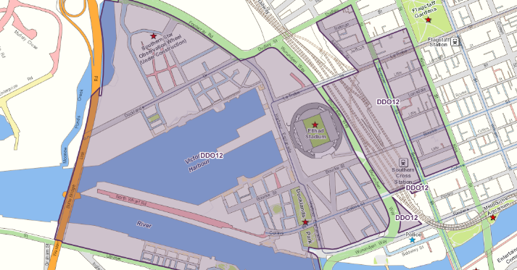

VC26 26 AUG 2004 Makes changes to the SPPF to implement recommendations of the
Live Music Task Force;

52.27 LICENSED PREMISES

Purpose
To ensure that licensed premises are situated in appropriate locations.
To ensure that the impact of the licensed premises on the amenity of the surrounding area
is considered.

Scope
These provisions apply to premises licensed, or to be licensed, under the Liquor Control
Reform Act 1998.

Permit required
A permit is required to use land to sell or consume liquor if any of the following apply:
▪ A licence is required under the Liquor Control Reform Act 1998.
▪ A different licence or category of licence is required from that which is in force.
▪ The hours of trading allowed under a licence are to be extended.
▪ The number of patrons allowed under a licence is to be increased.
▪ The area that liquor is allowed to be consumed or supplied under a licence is to be
increased.
This does not apply:
▪ To a limited licence.
▪ To a licence to manufacture liquor.
▪ If the schedule to this clause specifies that a permit is not required to use land to sell
or consume liquor under a particular type of licence.
▪ To a variation that reduces the hours of trading allowed under a licence.
▪ To a variation that reduces the number of patrons allowed under a licence.
▪ To a variation that reduces the area within which liquor is allowed to be consumed or
supplied under a licence.
▪ To a variation of licence at the initiative of the Victorian Commission for Gambling
and Liquor Regulation, pursuant to Section 58 of the Liquor Control Reform Act
1998.
▪ To a variation of licence for a variation prescribed in Part 6, Regulation 31 of the
Liquor Control Reform Regulations 2009.
▪ If a different licence or category of licence is required solely as a result of changes to
licence categories.
▪ To a licence to sell only packaged liquor for consumption elsewhere issued before 8
April 2011.
The schedule to this clause may specify that a permit may not be granted to use land to
sell or consume liquor under a particular type of licence.

Referral of applications
An application must be referred and notice of the application must be given in
accordance with Clause 66 of this scheme.

Decision guidelines
Before deciding on an application, in addition to the decision guidelines in Clause 65, the
responsible authority must consider, as appropriate:
▪ The State Planning Policy Framework and the Local Planning Policy Framework,
including the Municipal Strategic Statement and local planning policies.
▪ The impact of the sale or consumption of liquor permitted by the liquor licence on the
amenity of the surrounding area.
▪ The impact of the hours of operation on the amenity of the surrounding area.
▪ The impact of the number of patrons on the amenity of the surrounding area.
▪ The cumulative impact of any existing licensed premises and the proposed licensed
premises on the amenity of the surrounding area.
SCHEDULE 1 TO THE capital city ZONE
01/11/2012
C195
Shown on the planning scheme map as CCZ1
OUTSIDE THE RETAIL CORE
Purpose
To provide for a range of financial, legal, administrative, cultural, recreational, tourist, entertainment and other uses that complement the capital city function of the locality.
1.0 Table of uses
01/11/2012
C195

Section 1 - Permit not required
Use | Condition
Accommodation (other than Corrective institution)
Any use permitted under the Reference Areas Act 1978, the National Parks Act 1975, the Fisheries Act 1995, the Wildlife Act 1975 or the Forest Act 1958.
Apiculture | Must meet the requirements of the Apiary Code of Practice, May 1997.
Education centre
Home occupation
Informal outdoor recreation
Mineral exploration
Mining | Must meet the requirements of Clause 52.08-2.
Minor sport and recreation facility | Must occur on the Yarra River or on land abutting the Yarra River which is managed by Melbourne Parks and Waterways or Parks Victoria.  Must be licensed by Parks Victoria.
Minor utility installation
Office
Place of assembly (other than Amusement parlour and Nightclub)
Pleasure boat facility | Must occur on the Yarra River or on land abutting the Yarra River which is managed by Melbourne Parks and Waterways or Parks Victoria.  Must be licensed by Parks Victoria.
Railway
Railway station
Retail premises (other than Adult sex bookshop, Department store, Hotel, Supermarket, and Tavern)
Road
Search for stone | Must not be costeaning or bulk sampling.
Tramway
Any other use not in Section 3 | A use conducted by or on behalf of Melbourne Parks and Waterways or Parks Victoria under the Water Industry Act 1994, the Water Act 1989, the Marine Act, the Port of Melbourne Authority Act 1958, the Parks Victoria Act 1998 or the Crown Land (Reserves) Act 1978.
Section 2 - Permit required
USE | CONDITION
Adult sex bookshop
Amusement parlour
Car park | Must meet the requirements of Clause 52.06.  Must not be an open lot car park.
Corrective institution
Department store
Hotel
Industry | Must not be a purpose listed in the table to Clause 52.10 (other than Materials Recycling)
Leisure and recreation (other than Informal outdoor recreation)
Mineral, stone, or soil extraction (other than Extractive industry, Mineral exploration, Mining, and Search for stone)
Nightclub
Supermarket
Tavern
Utility installation (other than Minor utility installation)
Warehouse (other than Freezing and cool storage, and Liquid fuel depot)
Any other use not in Section 1 or 3
Section 3 - Prohibited
USE
Cold store
Extractive industry
Freezing and cool storage
Liquid fuel depot
2.0 Subdivision
17/05/2006
C116
Exemption from notice and review
An application to subdivide land is exempt from the notice requirements of Section 52(1)(a), (b) and (d), the decision requirements of Section 64(1), (2) and (3) and the review rights of Section 82(1) of the Act.
3.0 Buildings and works
01/11/2012
C195

Prohibitions
The construction of footbridges, pedestrian ways, vehicle bridges and links across the above ground level of Bourke Street, Collins Street, Swanston Street and Elizabeth Street, Melbourne is prohibited.
The construction of buildings and works which would cast a shadow across the south bank of the Yarra River between 11.00 am and 2.00 pm on 22 June is prohibited, except for unenclosed structures associated with the construction of gangways, mooring poles and pontoons which are constructed by or on behalf of Melbourne Parks and Waterways or Parks Victoria under the Water Industry Act 1994, the Water Act 1989, the Marine Act 1988, the Port of Melbourne Authority Act 1958, the Parks Victoria Act 1998, or the Crown Land (Reserves) Act 1978.
Permit Requirement
A permit is required:
To construct a building or construct or carry out works.
To construct a building or construct or carry out works which will cast a shadow across the north bank of the Yarra River between 11.00 am and 2.00 pm on 22 June. A permit may only be granted if the responsible authority considers the overshadowing will not prejudice the amenity of the Yarra River corridor.
To construct a building or construct or carry out works which would cast a shadow across any part of Federation Square, City Square, Queensbridge Square and the State Library Forecourt between 11.00 am and 2.00 pm on 22 June. A permit may only be granted if the responsible authority considers the overshadowing will not prejudice the amenity of the squares.
To construct a building or construct or carry out works which would cast a shadow between 11.00 am and 2.00 pm on 22 March and 22 September over public space, public parks and gardens, public squares, major pedestrian routes including streets and lanes, and privately owned plazas open to the public. A permit may only be granted if the responsible authority considers the overshadowing will not prejudice the amenity of those areas.
To construct a building which does not extend to the road boundary of the site.
To construct any part of a building within 10 metres of a road frontage which is inconsistent with the dominant road frontage parapet height.
To construct any part of a building exceeding a height of 40 metres within 10 metres of a road frontage.
To construct a building providing fewer than one bicycle parking space per 500 metres of gross floor area in the case of a new building without on site car parking.
To construct a building providing fewer than one bicycle parking space for every 100 car parking spaces in the case of a new building with on-site car parking.
This does not include:
Buildings or works carried out by or on behalf of Melbourne Parks and Waterways or Parks Victoria under the Water Industry Act 1994, the Water Act 1989, the Marine Act, the Port of Melbourne Authority Act 1958, the Parks Victoria Act 1998 or the Crown Land (Reserves) Act 1978.
Buildings or works for Railway purposes.
Alterations to a building authorised under the Heritage Act, provided the works do not alter the existing building envelope or floor area.
Footpath vehicle crossovers provided they are constructed to the satisfaction of the responsible authority.
Bus and tram shelters required for public purposes by or for the Crown or a public authority in accordance with plans and siting to the satisfaction of the responsible authority.
Decorations, gardens and planting required for public purposes by or for the Crown, a public authority or the City of Melbourne.
Street furniture.
A work of art, statue, fountain or similar civic works required for public purposes by or for the Crown, a public authority or the City of Melbourne.
Buildings or works or uses on public land for which a current permit exists under a City of Melbourne local law.
The erection of information booths and kiosks required for public purposes by or for the Crown, a public authority or the City of Melbourne.
Traffic control works required by or for the Crown, a public authority or the City of Melbourne.
The construction, or modification, of a waste pipe, flue, vent, duct, exhaust fan, air conditioning plant, lift motor room, skylight, security camera, street heater or similar minor works provided they are to the satisfaction of the responsible authority.
A flagpole.
A modification to the shop front window or entranceway of a building to the satisfaction of the responsible authority having regard to the architectural character of the building.
An addition or modification to a verandah, awning, sunblind or canopy of a building to the satisfaction of the responsible authority.
The painting, plastering and external finishing of a building or works to the satisfaction of the responsible authority.
Changes to glazing of existing windows to not more than 15% reflectivity.
External works to provide disabled access that complies with all legislative requirements to the satisfaction of the responsible authority.
Application Requirements
An application for permit must be accompanied by a written urban context report documenting the key planning influences on the development and how it relates to its surroundings. The urban context report must identify the development opportunities and constraints, and document the effect of the development, as appropriate, in terms of:
State Planning Policy Framework and the Local Planning Policy Framework, zone and overlay objectives.
Built form and character of adjacent and nearby buildings.
Heritage character of adjacent and nearby heritage places.
Microclimate, including sunlight, daylight and wind effects on streets and other public spaces.
Energy efficiency and waste management.
Ground floor street frontages, including visual impacts and pedestrian safety.
Public infrastructure, including reticulated services, traffic and car parking impact.
Vistas.
An application to construct a building or to construct or carry out works must include, as appropriate, upgrading of adjacent footpaths or laneways to the satisfaction of the responsible authority.
An application for a permit to construct or carry out works for development of a building listed in the Heritage Overlay must be accompanied by a conservation analysis and management plan in accordance with the principles of the Australian ICOMOS Charter for the Conservation of Places of Cultural Significance 1992 (The Burra Charter) to the satisfaction of the responsible authority.
Exemption from notice and review
An application to construct a building or construct or carry out works for a use in Section 1 of Clause 37.04-1 is exempt from the notice requirements of Section 52(1)(a), (b) and (d), the decision requirements of Section 64(1), (2) and (3) and the review rights of Section 82(1) of the Act.
Decision guidelines
Before deciding on a permit application under this schedule the responsible authority must consider, as appropriate:
The State Planning Policy Framework and the Local Planning Policy Framework, including the Municipal Strategic Statement and local planning policies.
The comments and requirements of relevant authorities.
The size and shape of the parcel of land to which the application relates, the siting of the proposed development and the area to be occupied by the development in relation to the size and shape of the land, adjoining land and adjoining development.
The movement of pedestrians and cyclists, and vehicles providing for supplies, waste removal, emergency services and public transport.
The provision of car parking, loading of vehicles and access to parking spaces and loading bays.
The adequacy of entrance to and egress from the site.
The streetscape, the scale and height of the neighbouring buildings and the proposed development, the proximity to heritage places, the design of verandahs, access from street frontages, the protection of active frontages to pedestrian areas, the treatment of the front and backs of buildings and their appurtenances, illumination of buildings or their immediate spaces and the landscaping of land adjoining a road.
The existing and future use and amenity of the land and the locality.
The location, area, dimensions and suitability of use of land proposed for public use.
The provision of landscaping.
The effect of the proposed works on solar access to existing open spaces and public places.
The potential for increased ground-level wind speeds and the effect on pedestrian comfort and the amenity of public places.
The responsibility for the maintenance of buildings, landscaping and paved areas.
The impact on the amenity of any existing dwellings on adjacent sites.
Where new buildings incorporate dwellings, that the design respects and anticipates the development potential of adjacent sites, to ensure that the future development of the adjacent site does not cause a significant loss of amenity to the subject site.
Habitable rooms of new dwellings adjacent to high levels of external noise should be designed to limit internal noise levels to a maximum of 45 dB in accordance with relevant Australian Standards for acoustic control.
The design of buildings to provide for solar access, energy efficiency and waste management.
The impact on amenity of existing or proposed sensitive land uses susceptible to the off-site effects of industry.
Decision Guidelines – Bicycle Parking
Before deciding on an application involving bicycle parking facilities, the responsible authority must consider, as appropriate:
The design and location, accessibility and security (ie. suitable lighting, locking devices) of the facilities.
The City of Melbourne Bike Plan 1997.
Local Planning Policy Framework.
4.0 Demolition or Removal of Buildings
17/05/2006
C116
A permit and prior approval for the redevelopment of the site are required to demolish or remove a building or works.
This does not include:
Demolition or removal of temporary structures.
Demolition ordered or undertaken by the responsible authority in accordance with the relevant legislation and/or local law.
Before deciding on an application to demolish or remove a building, the responsible authority may require an agreement pursuant to Section 173 of the Planning and Environment Act 1987 between the landowner and the responsible authority requiring, as appropriate:
Temporary works on the vacant site should it remain vacant for 6 months after completion of the demolition.
Temporary works on the vacant site where demolition or construction activity has ceased for 6 months, or an aggregate of 6 months, after commencement of the construction.
Temporary works must be constructed to the satisfaction of the responsible authority. Temporary works may include:
The construction of temporary buildings for short-term retail or commercial use. Such structures shall include the provision of an active street frontage.
Landscaping of the site for the purpose of public recreation and open space.
Exemption from notice and review
An application to demolish or remove a building or works is exempt from the notice requirements of Section 52(1)(a), (b) and (d), the decision requirements of Section 64(1), (2) and (3) and the review rights of Section 82(1) of the Act.
5.0 Advertising signs
02/06/2011
C167

A permit is required to erect an advertising sign, except for:
Advertising signs exempted by Clause 52.05.4.
An under-verandah business sign if:
It does not exceed 2.5 metres measured horizontally, 0.5 metres vertically and 0.3 metres between the faces of the sign;
It is located between 2.7 metres and 3.5 metres above ground level and perpendicular to the building facade; and
It does not contain any animation or intermittent lighting.
A ground floor business sign cantilevered from a building if:
It does not exceed 0.84 metres measured horizontally, 0.61 metres vertically and 0.3 metres between the faces of the sign;
It is located between 2.7 metres and 3.5 metres above ground level and perpendicular to the building facade; and
It does not contain any animation or intermittent lighting.
A window display.
A non-illuminated sign on a verandah fascia, provided no part of the sign protrudes above or below the fascia.
Renewal or replacement of an existing internally illuminated business identification sign.
Exemption from notice and review
An application to erect or construct or carry out works for an advertising sign, is exempt from the notice requirements of Section 52(1)(a), (b) and (d), the decision requirements of Section 64(1), (2) and (3) and the review rights of Section 82(1) of the Act.
6.0 Referral of applications
08/09/2011
C183

An application that includes the creation or alteration of access to the arterial road – Wurundjeri Way must be referred in accordance with Section 55 of the Act to the referral authority specified in the schedule to Clause 66.04.

