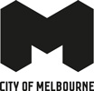
Draft City River Strategy
Future Aspirations for Melbourne’s Inner City River
April 2019
A city planning for growth

Melbourne will be a leader in planning for growth and technological advancement. We will guide and influence the future development of the city for the benefit of all city users and in a way that values and celebrates its historical and cultural identity.

Acknowledgement of Traditional Owners
The City of Melbourne respectfully acknowledges the Traditional Owners of the land, the Boon Wurrung and Woiwurrung (Wurundjeri) people of the Kulin Nation and pays respect to their Elders, past and present.

Contents
Introduction 5
The Strategy 6
Why this Strategy is needed 6
What we want to achieve 6
Approach 8
Strategic context 9
The Vision 13
Key priorities 15
Strategic directions 16
Background 18
Changing role of the Yarra River 18
Governance arrangement 20
International context 21
Culture: Heritage and narrative 23
Background 23
Key challenges 23
Strategic directions 25
Ecology: Habitat and water 28
Background 28
Key challenges 29
Strategic directions 30
Place: Activity and character 37
Background 37
Key challenges 38
Strategic directions 39
Movement: Journey and connection 46
Background 46
Key challenges 47
Strategic directions 48
Strategic directions in summary 54
Next steps 58

Issue for Future Melbourne Committee - APRIL 2019 - DRAFT FOR DISCUSSION
Cover Image: Birrarung aerial view looking east. Photo Credit: City of Melbourne
Disclaimer
This report is provided for information and it does not purport to be complete. While care has been taken to ensure the content in the report is accurate, we cannot guarantee is without flaw of any kind. There may be errors and omissions or it may not be wholly appropriate for your particular purposes. In addition, the publication is a snapshot in time based on historic information which is liable to change. The City of Melbourne accepts no responsibility and disclaims all liability for any error, loss or other consequence which may arise from you relying on any information contained in this report.
To find out how you can participate in the decision-making process for City of Melbourne’s current and future initiatives, visit melbourne.vic.gov.au/participate

Introduction
The Yarra River, Birrarung, is one of the defining features of Melbourne, providing both a recreational area and destination for many of the activities that contribute to the life of the City. As Melbourne continues to experience significant growth and change, it is increasingly important to preserve and celebrate our city’s greatest natural asset. This strategy will guide Council’s future planning for enhancing the river. It outlines strategic directions and opportunities for how to improve the way we use our river and edges.
The Birrarung corridor has strong cultural, economic and social significance to Melbourne. Over recent decades, the inner-city reaches of the river have evolved from a working industrial waterfront to a vibrant recreational area. However the substantial potential of this asset to the city remains to be fully realised. Areas from Punt Road to Princes Bridge have long recognised the recreational benefits of the Birrarung, however to the west, surrounding uses have little relationship with the waterways and there is limited expression of cultural heritage.
As a river city, we need to focus on the city’s relationship with the river and the unique opportunity the waterfront provides adjacent to a highly dense, urban environment. We need to reveal the layers of history particularly the Aboriginal significance of the river, and be discerning about what future opportunities will be supported to highlight the best of the city river to residents and visitors alike.
The purpose of this Draft Report is to present findings from the work completed to date, and outline a series of future strategic directions to support decision making for the continued evolution of the City River. The information introduced here will be the basis for ongoing research, discussion and engagement to identify further issues and opportunities as this project evolves. It is intended that responses we receive on this Draft will inform finalisation of the Strategy.
From herein in this strategy, the Yarra River is called by its traditional name Birrarung meaning ‘river of mists’ in the Boon Wurrung and Woiwurrung languages.

The Strategy

Why this Strategy is needed
The City of Melbourne is Australia’s fastest growing city, with the daily population in the municipality currently expected to increase from 911,000 to 1.4 million by 2036. As Melbourne continues to grow, we are presented with even more opportunities to broaden the way we use our river and its edges. Increasing worker, residential and visitor populations will put additional demands on the public space, recreation and movement uses of the river. Sustaining and improving people’s experience of the Birrarung has never been so important.
There is currently a vast collection of projects, plans and strategies that are pertaining to the inner city reaches of the Birrarung, completed by various levels of government and private developments. This highlights the need for the City of Melbourne to clearly define its approach to the central city waterways and waterfront usage.
The particular focus of this strategy is on a ‘place based’ urban waterways study that provides a multi-layered understanding of the complex urban waterways environment - considers the landscape and water, urban character and open space, movement and uses and quality of place. The document introduces opportunities to maximise pedestrian connectivity, enhance amenity, create accessible and integrated civic spaces and foster an understanding of Aboriginal heritage and culture. Ultimately, the goal is to significantly raise the quality of the Birrarung environs in this central city stretch to be the centrepiece of Melbourne’s economy, culture and liveability.

What we want to achieve
The purpose of this work is to establish an overall framework to guide the long term future of the City River Precinct. This framework will define City of Melbourne’s vision for the inner-city reaches of the Birrarung and be used as an advocacy tool to guide the City of Melbourne in preserving and evolving the Birrarung’s character and liveability and offer a planned response to ad hoc proposals and future development.
What this Strategy is
- A propositional discussion.
- A strategic guide for Council decision making.
- A basis for future capital works planning.
- An outline summary of opportunities that could be implemented in the short, mid or long term.
What this Strategy isn’t
- A Statutory Plan.
- A strategy for improving overall governance.
- A plan that covers detailed matters dealt with by other Council strategies, such as waterway quality and advice on fishing and berthing facilities.

Image 01. A ‘place based’ urban waterways strategy
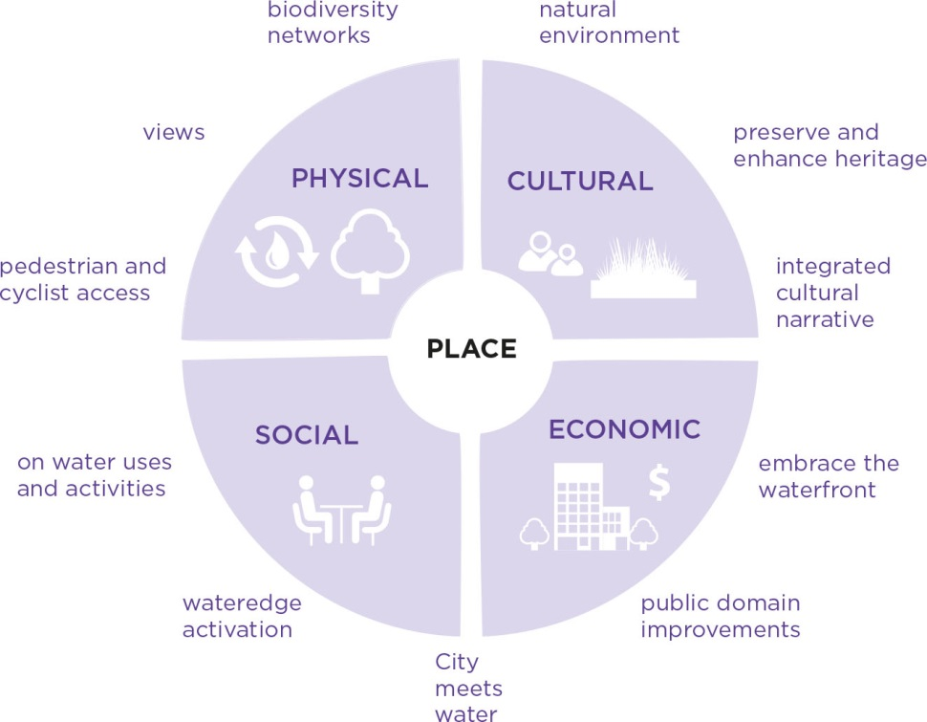

Approach
The City River Strategy proposes a design approach for the inner city reach of the Birrarung. It is organised around four key themes within which key strategic directions are outlined to provide guidance on how the river and its edges should be planned for and managed.
The four themes are:
- Culture: Heritage and narrative.
Cultural values, stories, spiritual, genealogical, historical.
- Ecology: Habitat and water
Holistic urban waterways environment: landscape, ecology and water.
- Movement: Journey and connection
Network of connections to and along the waterfront.
- Place: Activity and Character
Identity, quality, activation and economy of the urban environment.

The development of this Draft Strategy was based on the following approach:
- A review of relevant plans, strategies and policies that influence the planning and design of the waterways across the City of Melbourne municipality.
- Site visits involving observing user behaviour and the influence of the physical environment on their behaviour.
- Reference to the City of Melbourne’s pedestrian counting data at key locations across the corridor and reference to previous speed and volume surveys undertaken through recent studies.
- Pre-contact historical research of vegetation and landscape conditions.
- Multi-layered analysis of: biodiversity and urban forest; topography and flooding; place and urban design; access and movement; and activation and uses.
- A review of international best practice in urban waterfront developments.
- Key internal and external stakeholder engagement, including commencing discussions with the Traditional Owner groups.

Strategic context
The relationship of this project to previous plans and key projects currently underway is briefly outlined below.
Melbourne Water – Yarra Strategic Plan
Melbourne Water is developing a 10 year Yarra Strategic Plan which is to include a 50 year community-led vision, performance objectives around waterway health, landscape and parklands amenity and cultural and heritage values and a decision making framework. The City of Melbourne is represented on the Yarra Collaboration Committee, which advises Melbourne Water on the development of the Yarra Strategic Plan.
This report will inform and guide Council’s input and, as the Yarra Strategic Plan covers a broader scope (entire 200km of the Birrarung), it will be complementary in terms of offering more place specific discussion. Melbourne Water is working towards a public Draft by mid -2019 and a final, endorsed plan in 2020.
Lower Yarra River Management Advisory Committee
The Lower Yarra River Management Advisory Committee is also working on improvements to the Lower Yarra River governing arrangements and has developed a series of recommendations as a forward strategy regarding the allocation of commercial berths.
City of Melbourne Strategies
City of Melbourne has numerous Strategies and Plans to grow and enhance the city’s open spaces and public realm that have been considered and relate to this report. These include the Open Space Strategy 2012, Transport Strategy 2014 – 2030, Total Watermark – City as a Catchment 2014, Urban Forest Strategy 2012–2032 and Bicycle Plan. There are also other waterways related initiatives being developed in parallel, covering Moonee Ponds Creek, Arden Macaulay and Fishermans Bend respectively.
City of Melbourne Capital Works
The City of Melbourne is currently working on a number of projects to improve the public realm of the north and south bank of the Birrarung. These include:
- Southbank Boulevard upgrade
- Seafarers Rest Park
- Domain Parklands Masterplan
- Birrarung Marr Master Plan
- Market Street Park

Image 02. Yarra Strategic Plan area and City River Strategy scope.
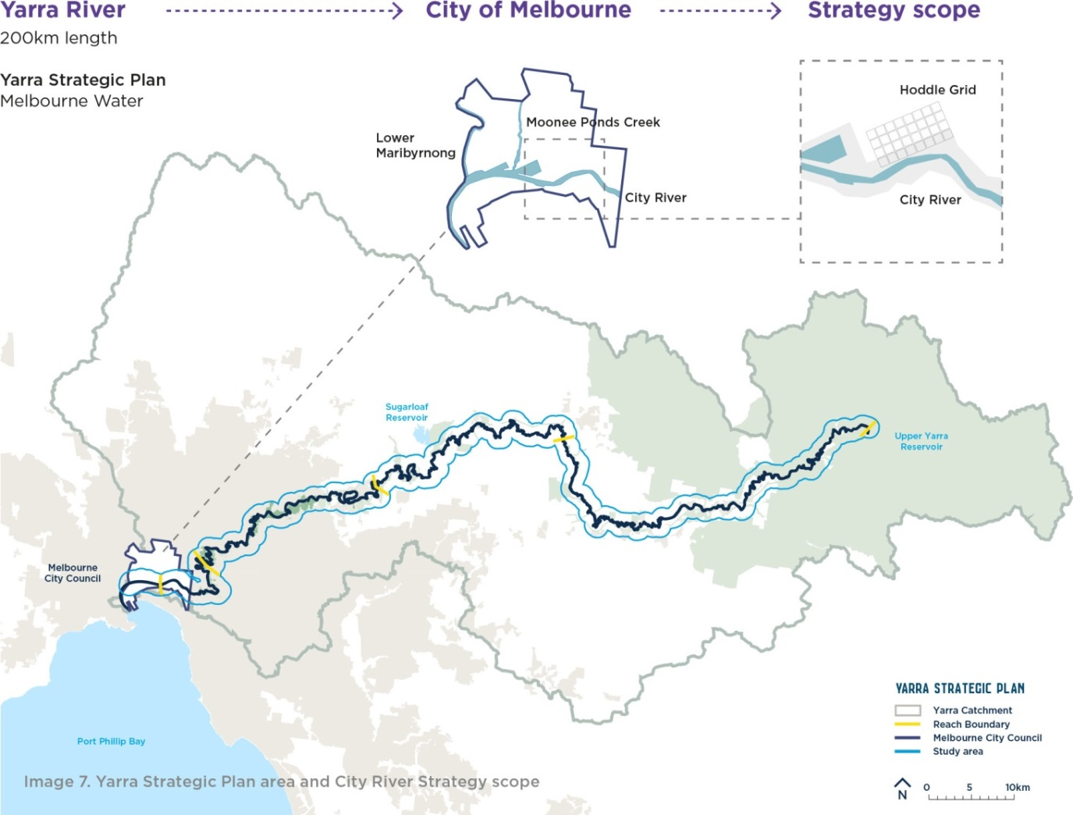

Study area and conditions today
The focus of the Strategy is the inner city reaches of the Birrarung, covering 11kms of diverse river edges and urban settings (5.7km on the north bank and 5.6km on the south bank), as indicated in the map below.
Image 03. Plan of the study area with key open spaces and bridges and images illustrating some of the key challenges:
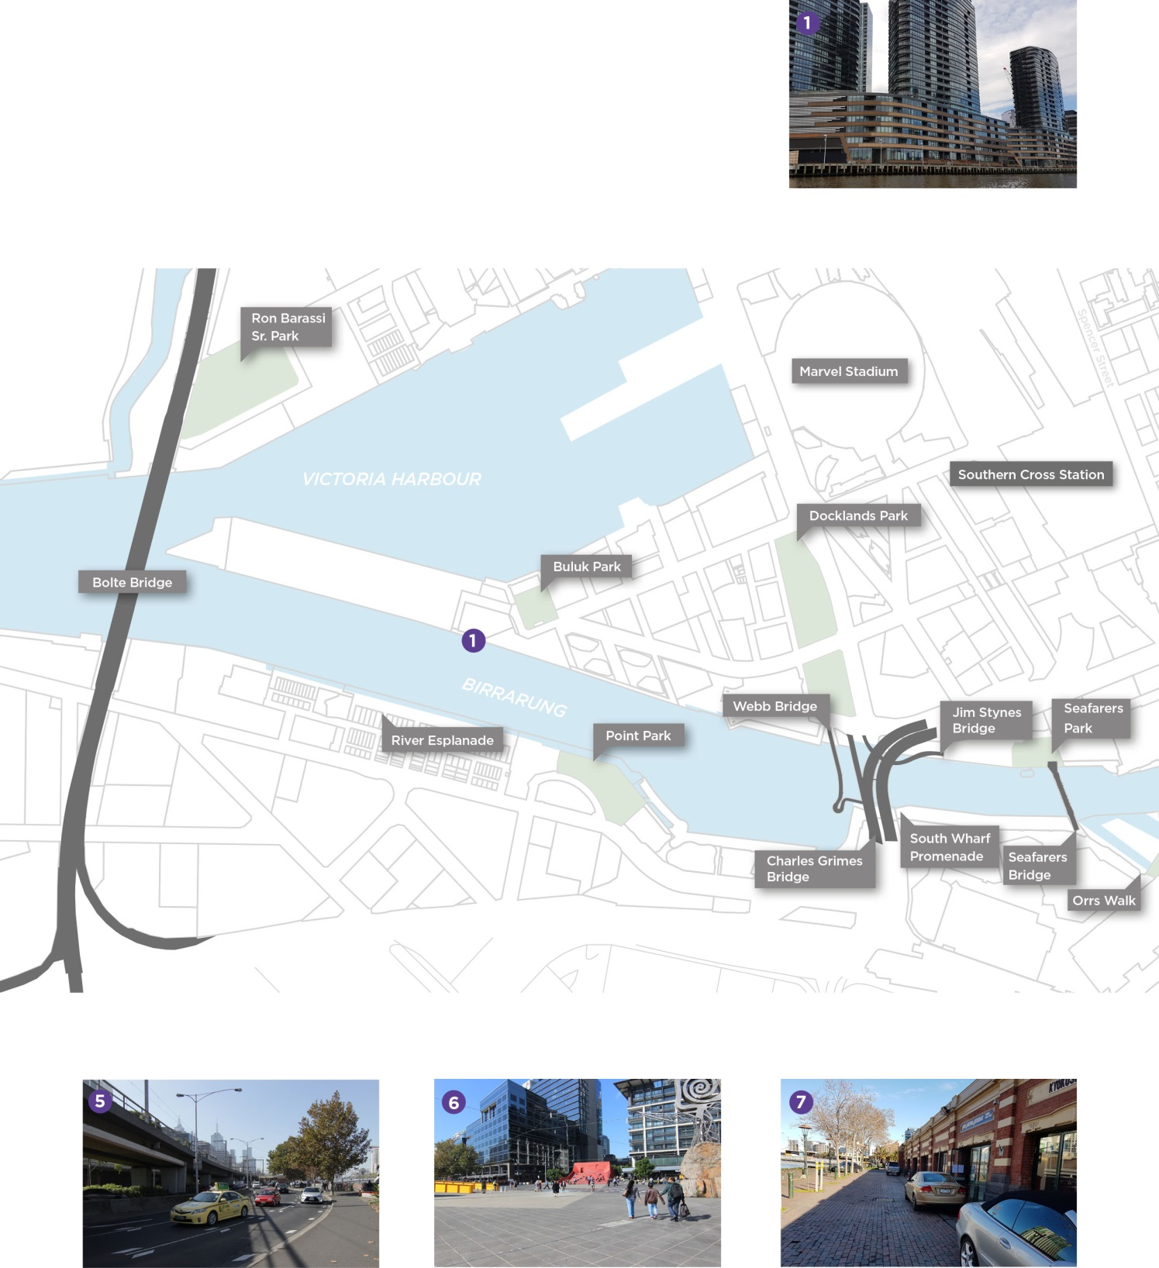
.
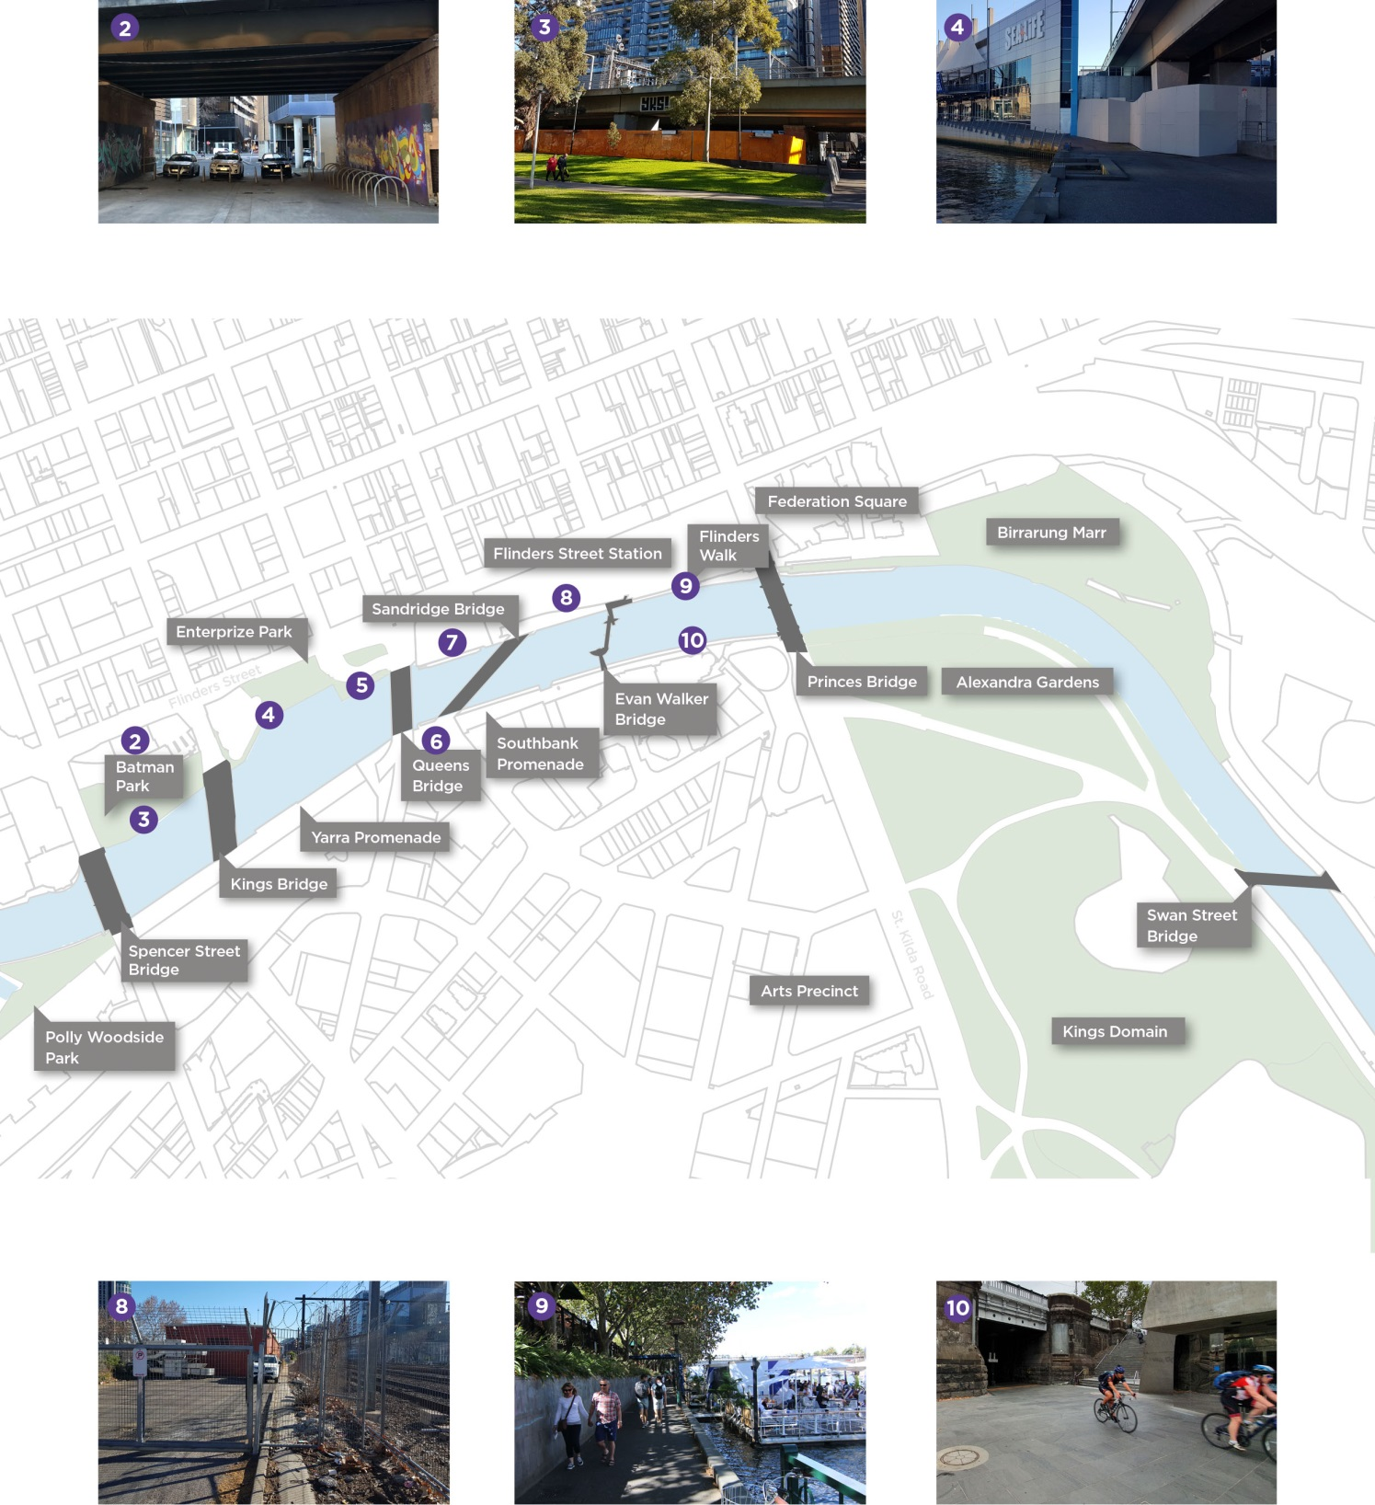

The Vision
The whole of river 50 year community vision, developed by Melbourne Water as part of the Yarra Strategic Plan, is that “Our Yarra River, Birrarung, is recognised around the world as an iconic example of a nurturing relationship between a river and its community...” The City of Melbourne supports this direction and take this as our cue for future aspirations for the City River.
In parallel with development of this Draft Strategy, Melbourne Water has been leading delivery of the Yarra Strategic Plan. Melbourne Water’s first step in devising The Plan involved inviting the broader community to contribute to the development of the Yarra River 50 Year Community Vision. Capturing the entire 200km expanse of the river, the Vision is that “Our Yarra River, Birrarung, is recognised around the world as an iconic example of a nurturing relationship between a river and its community.” The City of Melbourne supports this direction and looks to apply these values of a positive, prosperous and healthy connection with our waterways to focus on the unique characteristics of our municipal area of the Birrarung.
Over recent decades, the inner-city reaches of the river have evolved markedly, however the substantial potential of this asset remains to be fully realised. The complex land ownership and governance arrangements along the central city waterfront challenge decision making and the delivery of change. Numerous areas of the riverfront, especially along the western Northbank, are also characterised by a lack of cultural expression, limited ecological habitat and day to day activation, privatisation of public places and poor pedestrian connectivity.
Yarra River 50-year Community vision
“Our Yarra River, Birrarung, is recognised around the world as an iconic example of a nurturing relationship between a river and its community...”
Melbourne Water.
Draft City River Strategy vision
“A world class urban riverfront which celebrates Aboriginal culture, environmental quality and resilience.”
The City of Melbourne.
The Birrarung is critical to Melbourne’s identity, appeal to tourists and liveability. As a river city, we need to focus on the city’s relationship with the river, revealing the layers of history, particularly the Aboriginal significance. Our emerging vision for the City River is a world class urban riverfront which celebrates Aboriginal culture, environmental quality and resilience.
This will be accomplished by:
- Offering a waterfront that fosters an understanding of Aboriginal heritage and culture.
- Distinguishing the river as a slower paced environment with safe, connected walking routes to and along the waterfront.
- Providing universal accessibility along safe, well maintained pathways for all people to enjoy.
- Encouraging activation that offers broader community inclusion and supports a public waterfront.
- Establishing a new, resilient waterway condition that responds to flood events.
- Introducing further greening, including trees and riparian vegetation in the river corridor.

Image 04. Artist’s impression of a possible future river conditioning (Illustrative for discussion purposes only).
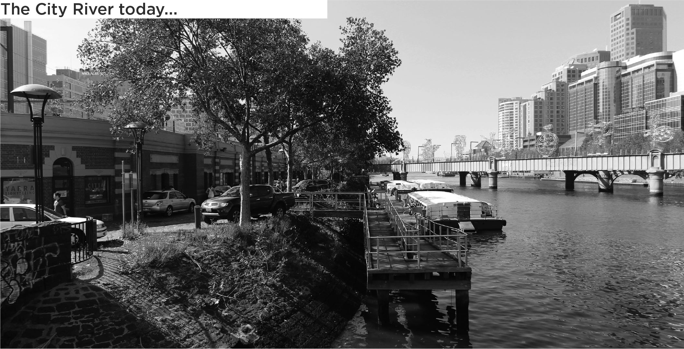
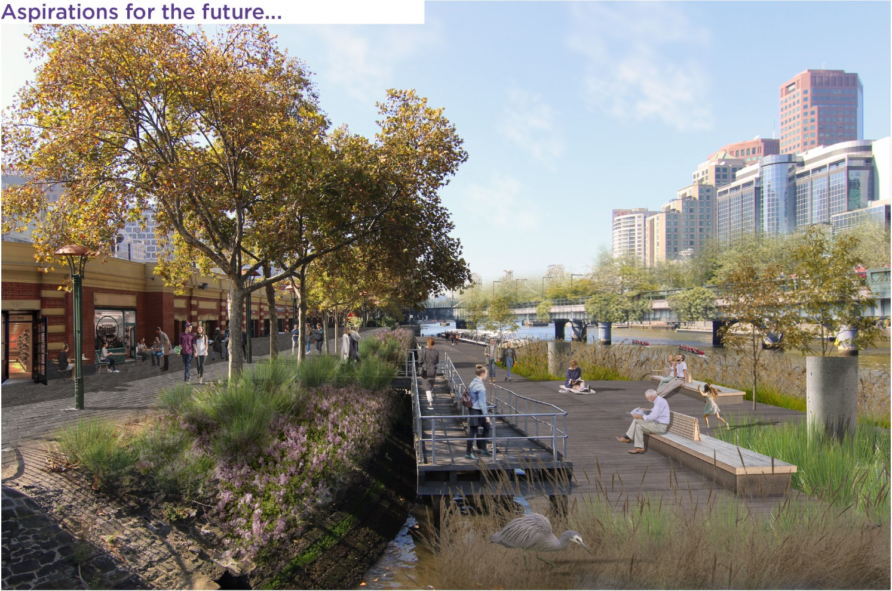

Key priorities
The Birrarung will be an inspiring public waterfront that celebrates the rich Aboriginal history of Melbourne, offers a green sanctuary and is a loved place in the hearts of Melbournians.
1. Embrace Aboriginal culture and heritage
Indigenous stories of the past, present and future have a powerful and important influence on the identity of our city. These stories should have a tangible presence in the public domain. There is great potential to celebrate and reflect on the indigenous heritage, and inspire how the future conditioning of the City River can be a canvas for Aboriginal values, cultural trails, paths and landscapes that celebrate the earliest memories of the place and enrich it with meaning.
A major role in identifying the cultural narrative lies with the Traditional Owner groups in order to build a strong story of the Aboriginal connection to the Birrarung and its banks.
2. Prioritise Northbank | Greenline
The Northbank is a distinguishing feature of the City River and major focus for business, tourism and leisure. Significant improvements are proposed for the public realm to accommodate the increasing numbers of pedestrians that move through this space and to strengthen Melbourne’s identity as a River City.
Increasing pressures from commercial uses, including on-river floating facilities, require an investment that clearly identifies and guarantees public realm civic quality and free movement along Flinders Walk and Banana Alley. The Green Line project, currently being developed by CoM, is a catalyst initiative that will provide inspiration for this public space improvement.
3. Restore the natural landscape
The Birrarung plays a critical environmental health role in the city. This strategy proposes to maximise the environmental contribution of the river, healthy water conditions and urban cooling through riparian greening and building on Urban Forest principles.
The river has the potential to be the major biodiversity connector in the Melbourne municipality. Birrarung will be connecting up the main biodiversity hotspots in the city and become an important link for animals and other living creatures, forming unique urban ecosystems. These ecosystems are crucial for maintaining health and wellbeing by filtrating air and water and providing shade and places for recreation.

Strategic directions
The following section summarises a set of strategic directions to guide appropriate actions and future development of the of the City River corridor.

Theme 1 CULTURE: Heritage and Narrative
- C1 Collaborative
Establish a protocol for on-going collaboration with Traditional Owner groups to help tell the story of the Aboriginal connection to the Birrarung.
- C2 Visible
Increase the public visibility of Aboriginal intangible heritage and the history of the Birrarung through interpretation and information.
- C3 Maritime
Recognise the historical and contemporary importance of the maritime uses of Birrarung.

Theme 2 ECOLOGY: Habitat and water
- E1 Riparian greening
Re-introduce a riparian zone to improve water habitat, biodiversity and create a healthy river ecosystem.
- E2 Ecologically connected
Optimise the urban vegetation along the river banks prioritising an Indigeneous palette to improve local biodiversity and ecological networks.
- E3 Resilient
Address flood risk and improve water quality.

Theme 3 PLACE: Activity and character
- P1 Inviting
Prioritise Northbank renewal to create an inviting backdrop to the City.
- P2 Multi-functional
Celebrate character areas and encourage new economies: a range of civic, educational, cultural, hospitality and water dependant uses.
- P3 Public
Sustain the civic focus by encouraging activation that offers broader inclusion and supports a public waterfront.
- P4 Legible
Rationalise clutter and on-water infrastructure to ensure unobstructed vistas and views.

Theme 4 MOVEMENT: Journey and connection
- M1 Slow
Distinguish the river as a slower paced environment by creating safe, alternative north and south cycle routes.
- M2 Integrated
Transform the condition of key ‘barriers’ to address the gaps to the north-west and integrate access with the City.
- M3 Accessible
Raise the quality and universal accessibility of riverfront pathways.
- M4 Diverse water activity
Encourage more water related activity and greater diversity of vessels, particularly more non-motorised crafts.

Background

Changing role of the Yarra River
The Birrarung has played a pivotal role in the Aboriginal history and the modern development of Melbourne. As a defining feature of the central area, a natural imprint and formation, the Birrarung set the location and orientation of Melbourne as an early European settlement and the city’s progress and development has always been intertwined with the river.
40,000 years of Indigenous history - An intimate connection to nature and place
For at least forty thousand years prior to European settlement, the Birrarung was part of the ancient Aboriginal country of the Woi wurrung and Boon wurrung clans of the Kulin people, who spoke in five different languages. The Wathaurung, the Bunurong, and the Woiworung people lived near the Port Phillip Bay area. The Woiworung comprised a number of clans including the Wurundjeri, whose territory was located close to the area drained by the Birrarung and its tributaries.
In the initial years of early settlement the Aboriginal clans still camped at their traditional locations on either side of the Birrarung. Fresh waterfalls were the traditional meeting place for the clans living on opposite banks. This was the place where freshwater met saltwater and the people would meet half way to negotiate trade, perform marriages and exchange information. The area around the Birrarung was abundant in bird life and the waters plentiful in fish. The tributaries running into the Birrarung were rich in flora and fauna, providing places for hunting and areas of shelter. Aboriginal people placed great reliance upon the procurement of plant foods from their clan estates. The Birrarung was the lifeblood of the community, a rich and flourishing ecosystem providing a bountiful food source and an important location for spiritual and recreational purposes.
Early settlement - Laying the foundations of a city
The existence and discovery of the Birrarung, and its fresh water, was crucial to the founding and subsequent development of Melbourne. The imposition of urbanisation on this landscape, already rich with function and meaning, was rapid and changed forever the relationship between Aboriginal people and their country. In 1835, John Batman and John Pascoe Fawkner, two sons of British convicts transported to Australia, initiated a process that would result in the creation of Melbourne. In May of that year, John Batman as the expedition leader, signed the infamous treaty with the Kulin people, allowing British settlement on their land around Port Phillip Bay. Within a year, the seeds of a new colony and its new capital were sown. Governor Bourke accompanied by the surveyor Robert Hoddle traced out on horseback the streets of the new township of Melbourne in 1837 to a design that would become known as the Hoddle Grid, aligned with the natural curve of the Birrarung.
Industry defines the riverfront
The river was a focus for the fledgling colony, providing water, fertile land for farming and access. However, over the subsequent decades its role and value changed dramatically as Melbourne rapidly urbanised. The river was a ready-made sewer and it gave early industries the water necessary in their processes. There was a steady deterioration in water quality during the 19th century, with the river effectively serving as the city’s gutter for factory muck and sewage. This period relegated the status of the riverfront and prescribed how the river environs came to be treated for some time.
Role of the river today
In more recent years, the Birrarung has begun its transformation and the river now serves as a key focus for the City of Melbourne. The revitalisation of the river banks commenced in the 1970s and 80s with numerous key developments along the river including the Victorian Arts Centre and Southbank replacing industrial uses. The development of Southbank Promenade followed in the 1990s, dramatically improving the riverfront experience for an eager public. Around 2000, the river became a focus of major government projects including Melbourne Exhibition and Convention Centre and Birrarung Marr park development which further enhanced the river environs. Today the Birrarung is highly used for recreation and entertainment purposes and is the host to key annual events such as the Moomba festival, White Night and New Year’s Eve celebrations. Southbank Promenade is one of the city’s top three visitor destinations. The Birrarung is an important part of Melbourne’s culture and the identity of the city. The City of Melbourne is committed to further enhance these values.
Image 05. Melbourne in 1838, view with Birrarung in the foreground (State Library of Victoria)
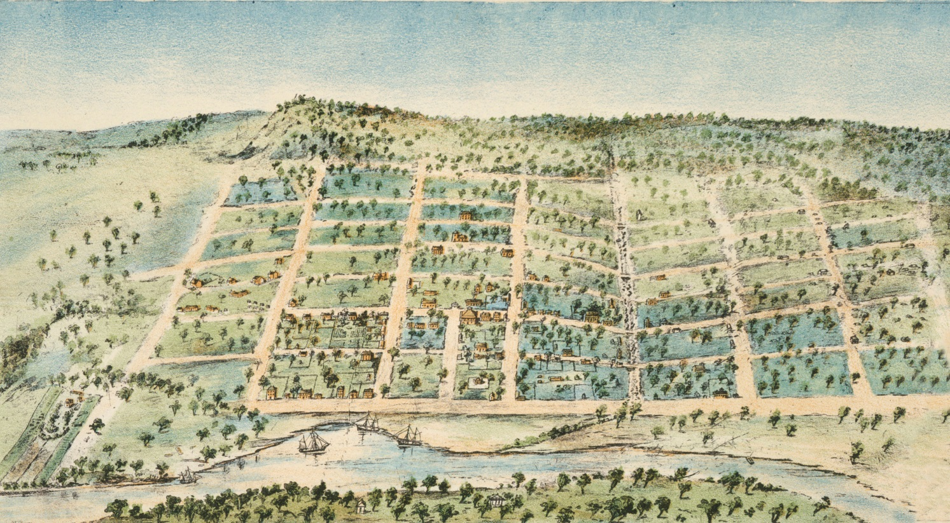
Image 06. Flinders Street ca. 1912, with the old Fish Market in the background (State Library of Victoria)
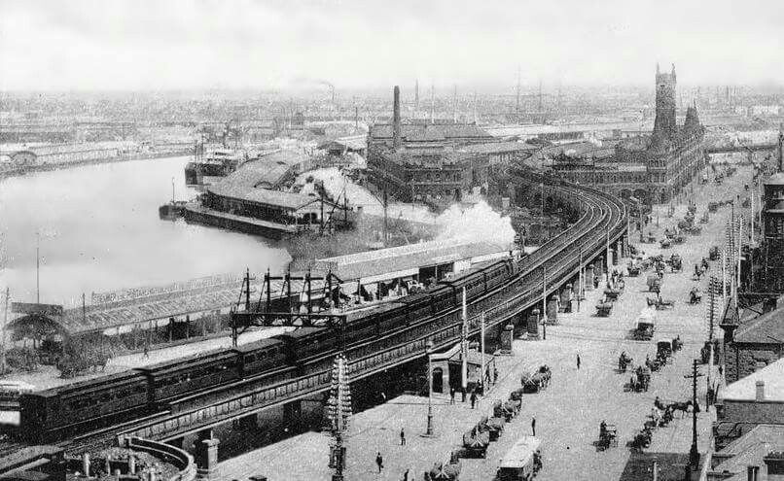
Image 07. Land ownership/management plan (Map devised through a desktop investigation of land ownership, undertaken using a combination of available GIS mapping and VicMaps).
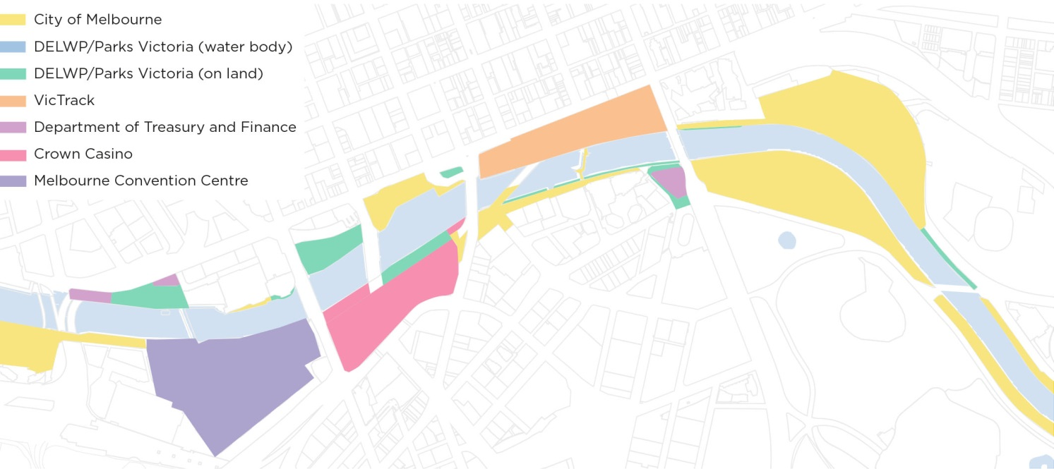

Governance arrangement
The governance arrangement of the Birrarung is highly complex and fragmented. There is a diversity of land owners and management for the river, dispersed across state government agencies, local councils and statutory authorities. These represent a range of interests, functions, purposes and (partially) operate under different legislation. This creates delivery challenges with works requiring coordination and possibly legal agreements with numerous parties, and as projects are typically developed by separate entities, may not achieve an integrated approach. The diversity of land owners and managers also creates challenges for the provision of a legible corridor.
While this City River Strategy does not address the issue of overall governance, we raise it briefly as a major impediment to achieving change within the waterfront environment. The Yarra Strategic Plan will hopefully be the delivery mechanism for an improved governance arrangement. An improved riverfront needs a unique approach and broad cross-government and community commitment.
Image 08. Waterways governance: Parks Victoria is the water manager of the Lower Birrarung including piers and jetties, and the land manager along the river, except for Docklands, while Melbourne Water manages the physical water of the Birrarung waterway.
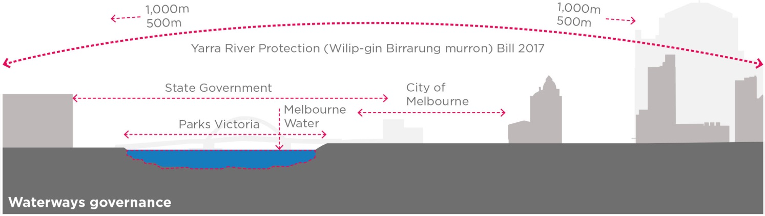

International context
Cities around the world are embracing their riverside locations as a cultural, ecological and recreational asset. Consequently, many urban waterways are now being transformed, restored and developed. The following examples are highlighted as successful city river renewal projects internationally. They are all high profile, transformative interventions that have been championed by local authorities and political actors, often over an extended period of time and typically requiring substantial budget.
The Brisbane River Southbank project was triggered by the World Expo, held in 1988. The City of Brisbane organised a Design Competition in 1989 and the development of the project was overseen by the Southbank Corporation (State and local Government + Private groups). The site was constrained by flooding, land contamination and established uses in the precinct. Southbank ‘Brisbane’s Backyard’ is now an iconic riverfront destination for local, interstate and international visitors. The project has reconnected the Southbank suburbs to the Brisbane River and achieved social change, better pedestrian access, connectivity and improved ecological outcomes.
The Chicago River was part of a polluted water system and the riverfront was not being used or contributing actively to city life. The City of Chicago developed a long term vision: ‘Great Rivers Chicago’. This was the framework that prompted the development of the Riverwalk Project developed by the City of Chicago Department of Transportation together with State Government. The project includes 2km riverfront divided into six different ‘coves’. Fragmented landownership resulted in a three phase delivery process and intensive engagement through the ‘Friends of the Chicago River’ Program.
The Berges du Rhone project in Lyon (completed 2007) was initiated by the Lyon City Planning Agency in 2002 to improve activation of the riverfront and transform the river into a vibrant urban environment. The new open space was created by removing many parking spaces on the quays along both left and right banks. The project includes public baths, pontoons, fishing platforms and a skate park.
Another internationally celebrated example is the Cheonggyecheon river in Seoul, South Korea. It is a Seoul Metropolitan Government project that included reconstruction and daylighting of an 11 km long stream on a grand urban scale. Following significant government effort, including demolishing an elevated freeway, it was restored and today is an oasis in a concrete jungle, a boost to local biodiversity and economic development.
The City of Paris has developed the ‘Promenade des Berges de la Seine’ project, which opened in 2013. The promenade, created on the former highway that ran along the left bank, includes five floating gardens, planted atop barges, exhibition areas, performance and classroom spaces, playgrounds, sports facilities and cafes. Everything in the park can be dismantled and moved within 24 hours if the water of the river rises too high.

Image 09. Maps of Melbourne Birrarung, Brisbane River, Chicago River, Lyon Rhone River, Seoul Cheonggyecheon Stream, Paris Seine River.
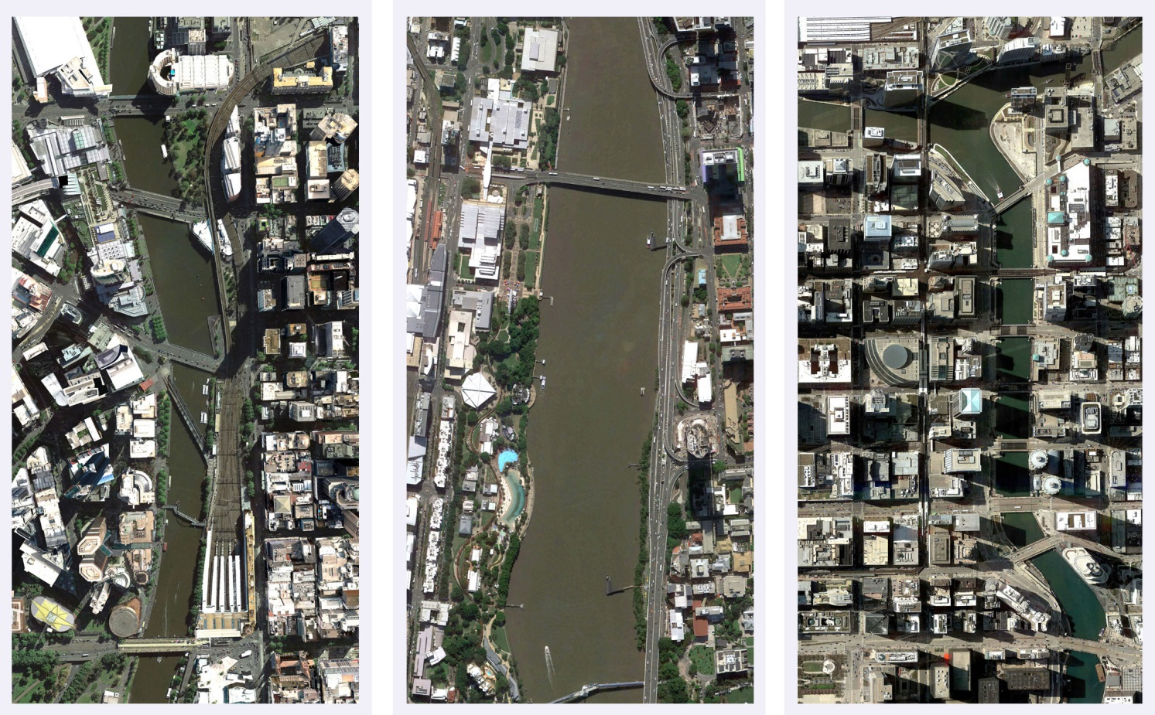
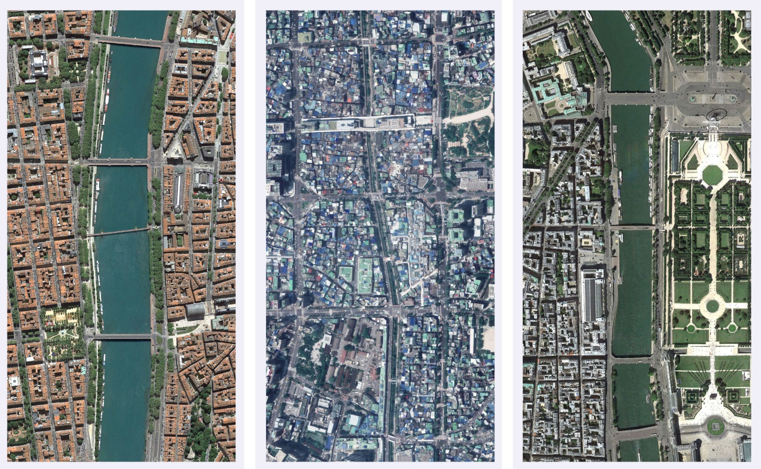

Culture: Heritage and narrative
The Birrarung is a significant place of shared Aboriginal and non-Aboriginal history and cultural values, however this narrative is largely absent from the river experience today. We look to better acknowledge and reflect the sites, stories and memories to offer a place of reflection, education and enrichment.

Background
There are many cultural values and spatial characters within the City River urban landscape. The area has evolved over time, people have settled, places have been established, and the Birrarung has been a constant presence throughout that history. The river is a place of shared Aboriginal and non-Aboriginal history and cultural heritage values.
Before European settlement the Birrarung was a rich and fertile landscape. The river followed a different course, with extensive wetlands along much of the lower parts of the area. It provided food supplies and was an important meeting place.
The Birrarung landscape is a place of great spiritual importance for Aboriginal People. The Aboriginal cultural narrative for the City River provides an opportunity to reconnect to heritage, landscape and ecology in the urban context.
The Birrarung played a central role in the communities of Aboriginal groups who lived in harmony with their environment. This is reflected in the creation stories that provide insight into the importance of water and the river in the delta landscape of the lower reaches of the Birrarung.
The Birrarung is also tightly connected to the story of the European colonisation and to the choice for the location of Melbourne City itself. The old Falls in the Birrarung was the location where fresh water could be obtained by the settlers and ship access from Port Phillip Bay was possible up to this point.

Key challenges
Key heritage and narrative challenges are defined below:
- Many stories from Melbourne’s history are intertwined with the Birrarung, making the river a very rich and layered source of cultural narrative from both pre and post contact eras.
- The Aboriginal cultural heritage is an underrepresented layer in the contemporary city river landscape of Birrarung and is lacking visibility in the City.
- Significant elements of the pre contact river landscape have been largely removed, like the Falls, the wetlands and Batmans Hill. These elements are important parts of the history of Melbourne but are currently not celebrated or referenced.
- The Aboriginal Cultural Narrative connected to Birrarung is often embedded in intangible records such as stories and practices like song, dance and ritual.
- Melbourne City was planned and surveyed by European colonists. It was established in close proximity to the Birrarung. The river gave settlers access from Port Phillip Bay and also access to fresh drinking water from the river upstream of the Falls. As a result there was a strong functional connection between City and River.
- Through the development of industry along the Birrarung and port activities that were shifting westward, the City gradually turned its back on the river and the intrinsic connection with the Birrarung was lost over time.
- Many of the European cultural heritage physical aspects related to Birrarung are engineering works that assisted in, and improved shipping access to Melbourne. These works have altered the natural landscape that the City was built on, including the original course of the Birrarung.

Image 10. Heritage aspects City River.
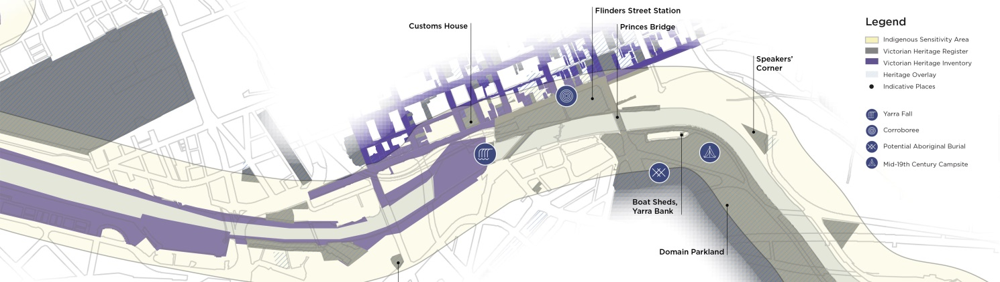

Strategic directions
The following section summarises a set of key strategic directions to guide appropriate actions to improve recognition of the collective history of the unique riverfront environment.
CULTURE - STRATEGIC DIRECTION 1:
Collaborative
Establish a protocol for on-going collaboration with Traditional Owner groups to help tell the story of the Aboriginal connection to the Birrarung.
The Birrarung is of cultural and historic interest to the people of Victoria as evidenced by various separate listings on the Victorian Heritage Register, National Heritage List and Victorian Aboriginal Heritage Register. In addition to the official histories, monuments and structures there is also the stories and memories of people over generations, which influences what people value today. This is also a place of living culture, not just one reflecting the past. The Birrarung is significant to Aboriginal People. It is a place of shared Aboriginal and non- Aboriginal history and cultural heritage values.
C1A: Establish a protocol for on-going collaboration with the Traditional Owner groups to establish an Aboriginal cultural narrative of the Birrarung and the river banks.
There are three distinct Aboriginal communities associated with the City River reach of the Birrarung. At the same time, the Birrarung is important for all the Aboriginal Nations in Victoria. There are also specific groups with stated connection to the City River.
Before European settlement the Birrarung was a rich and fertile landscape. The Birrarung followed a different course, with extensive wetlands along much of the lower parts of the area. It provided food supplies and was an important meeting place.
This strategy acknowledges the Aboriginal history of the Birrarung, while also creating a platform to celebrate Aboriginal culture in Melbourne in the 21st century. People want to know the story of the river.
The Aboriginal Cultural Narrative is to highlight tangible and intangible aspects of history and culture while highlighting opportunities to incorporate these in the public realm or spatially in an integrated, contemporary way.
C1B: Commission further research of historical data from primary sources and the Birrarung’s landscape and natural values, with a focus on the botanical aspects of indigenous vegetation.
Cataloguing vegetation that would have historically been present in the pre contact landscape and of importance for Aboriginal people’s livelihood is an important task. The Aboriginal names of plants give insight in the use of the plants, the landscapes they were in, the management of the landscape and the seasons associated with plant growth, flowering and fruiting.
The pre contact landscape of the Birrarung was a sustainably managed landscape by Aboriginal groups. The landscape was considered part of the tribe or the family and was being referred to and cared for accordingly. Such knowledge of landscape management is an important part of the Aboriginal Cultural Narrative, as it highlights the unique Aboriginal approach to living in and with nature.

CULTURE - STRATEGIC DIRECTION 2:
Visible
Increase the public visibility of Aboriginal intangible heritage and the history of the Birrarung through interpretation and information.
For the Traditional Owners, water bodies such as rivers were and are inextricably connected to life’s meaning and have powerful cultural associations. Many Aboriginal groups told stories about special places, and believed that beings from the Dreaming occupied particular water sites. These beliefs are sometimes recorded in tangible artworks but are more often embedded in intangible records such as stories and practices such as dance, song, stories and ritual.
The Falls (Yarro Yarro) were a key factor in the founding of the City of Melbourne. They were a point of crossing in the Birrarung and the location where fresh water was accessible for settlers. The cultural significance of the Falls is of great importance for the Traditional Owners and also for the history of Melbourne post-contact. The Falls were located in the vicinity of the Queen Street Bridge. They were largely removed in 1883 in response to significant floods in the preceding years. A remnant of the Falls still remains between the Queens Bridge and Sandridge Bridge landings at Southbank Promenade. These rocks can be viewed at low tide.
C2A: Increase the public visibility of the Aboriginal history of the Birrarung through information and interpretation.
Public visibility of Aboriginal history and narrative needs to be increased because of the historic significance and unique local qualities of the river. The way to improve visibility will be through information, but opportunities must also be sought to integrate interpretation and give more inclusive meaning to specific places along the Birrarung. Aboriginal values will be more holistically expressed by means of physical projects, integrated in capital works initiatives.
C2B: Recognise the historical and Aboriginal cultural importance of the Yarro Yarro Falls.
The strategic direction for the Yarro Yarro falls aims at exploring the opportunities to reference the history and cultural importance of the Falls in the public domain of the City River. A number of options could be explored including reinstating the Falls, partial reinstatement or artistic or cultural interpretation.
Full physical reinstatement of the Falls was investigated as part of this study to broadly understand the implications for the hydrology of the river, including flooding. A number of scenarios were modelled (including 100yr rain event, king tide and climate change sea level rise impacts) concluding that reinstating the Yarro Yarro Falls in the original location is likely to have a significant impact upon flood levels within the CBD.
Based on this outcome, investigating the feasibility of alternative approaches is recommended including partial reinstatement of the Falls or interpretation through urban design treatments, landscape architecture or art.

CULTURE - STRATEGIC DIRECTION 3:
Maritime
Recognise the historical and contemporary importance of the maritime uses of Birrarung.
There are many cultural values and characters associated with the Birrarung. It is a river of shared Aboriginal and non-Aboriginal history and cultural heritage values.
In the early settler days ships could reach Melbourne sailing up from Port Phillip Bay to dock or anchor at what is now Enterprize Park, just below the Falls. The Falls were blown apart by dynamite in 1883 and the river was widened, particularly upstream. The interface between Birrarung and the early City became the focus of activity but over time this intrinsic relationship between the river, the landscape and the settlement was degraded by industrial uses and polluting development on the river’s edge.
The river’s role changed quickly from being the focus of life and source of food, to an industrial corridor serving the City. The City turned its back on the river. The ecological values and biodiversity of the river were seriously degraded.
As the recreational values of the river started to be appreciated, the river interfaces were transformed and the typical Melbourne street landscape of bluestone and plane trees was continued to some of the river’s edges. Hard treatments were used for the river edges to reduce the risk of flooding and support berthing for boats and other activities.
Today, the Port of Melbourne has shifted to the west and ships on the City River are mostly for recreational use and transport.
C3A: Recognise the historical and cultural importance of the maritime history of the Birrarung
The many aspects of the post contact history of the Birrarung are reflected in some of the key milestones of development of Melbourne: the discovery of fresh water by the first colonists, the survey of the Hoddle Grid, the first Princes Bridge built in 1844, expansion during the Gold rush, the shift to industrial uses, the abattoirs on the river banks, the engineering work transforming the Birrarung, the Coode Plan and channelisation of the river, realisation of Victoria Dock to name a few.
There are opportunities to reference these key aspects of Melbourne history, integrated in built form, in the public domain, in art, signage and in urban landscapes. The Melbourne maritime history is a significant aspect of the Birrarung sense of place. It gives shape to the iconic qualities of the City River. Seafarers Rest Park is an example of a current opportunity for renewal and inclusion of maritime heritage and contemporary uses in a key location along North Wharf.

Ecology: Habitat and water
Referencing the richness of the pre-contact landscape and enhancing the ecological values, the River immerses people in nature. The City River, Birrarung, is restored as a healthy water landscape experience.

Background
The City of Melbourne is increasingly facing significant challenges: climate change, flooding, urban heating and population growth. These will place pressure on the urban fabric, services and people of the city. We need to respond to these challenges by proactively building healthy resilient landscapes for future generations. The Birrarung plays a critical environmental role in this context.
The Birrarung also has the potential to be the major biodiversity connector in the Melbourne municipality. It could connect up the main biodiversity hotspots in the city and become a key link for animals and other living creatures, forming unique urban ecosystems. These ecosystems are also crucial for maintaining health and wellbeing by filtrating air and water and providing shade and places for recreation.
The delta landscape of the Melbourne region is defined by the convergence of rivers and creeks including the Birrarung, the Maribyrnong River, Moonee Ponds Creek, Stony Creek and other smaller streams. Historic maps indicate that the Melbourne area previously featured an intimate delta landscape surrounded by woodland (Refer Image 11).
More than half of the current municipality of the City of Melbourne was (and is) positioned either on low lying land or dunes, wetlands/swamps or waterbodies. The current inner city growth areas like Arden, Macaulay, E-Gate and Fishermans Bend are all located in these low lying areas and have to resolve flooding issues to enable their development.
Image 11. Melbourne’s pre-European landscape types and present day suburbs.
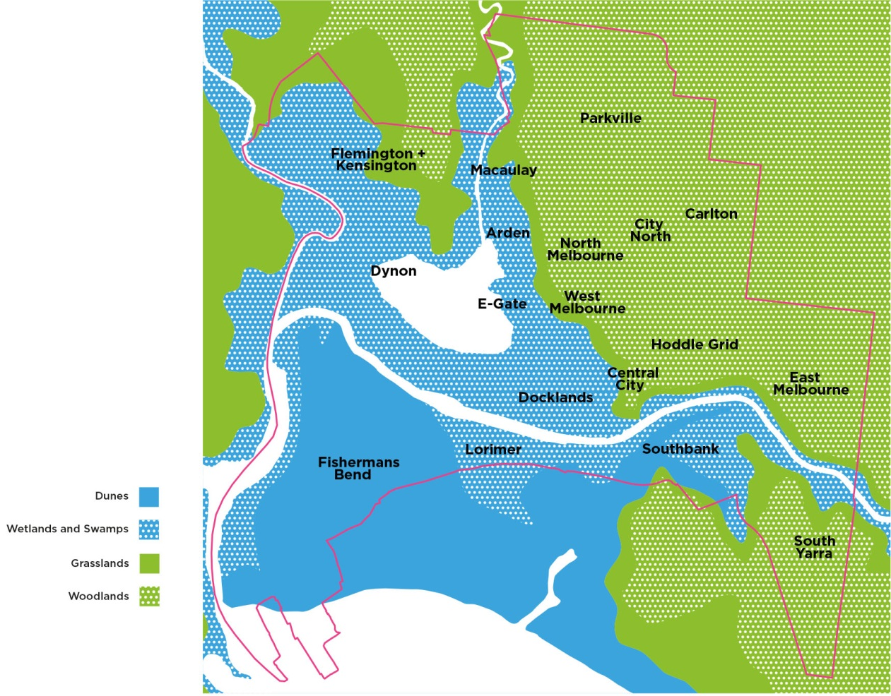
Image 12. 1/100 year climate change flooding levels in the City River area. Data: Melbourne Water
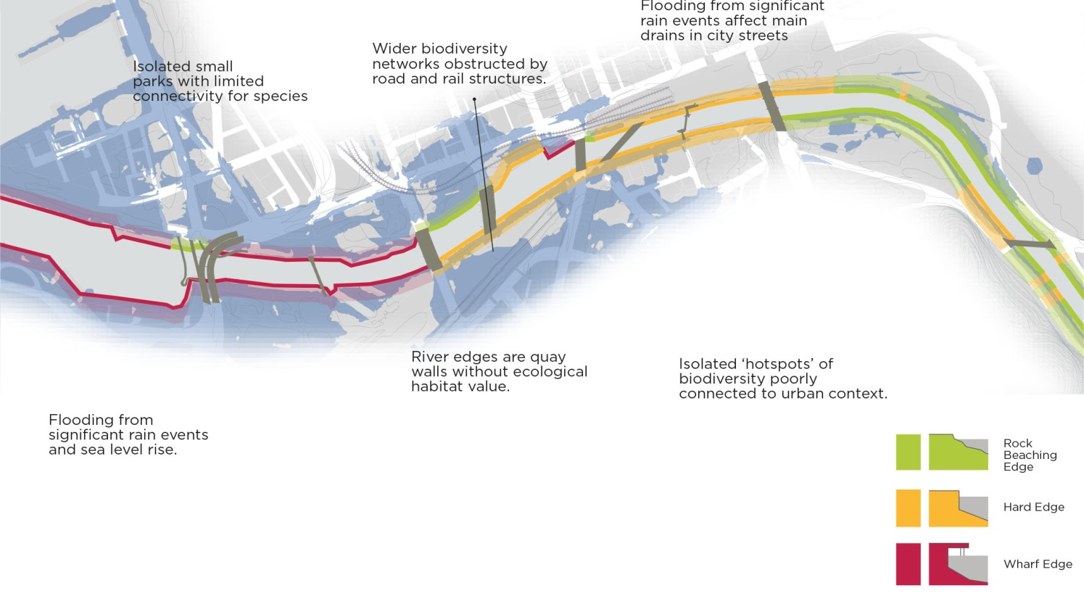

Key challenges
Key habitat and water challenges are defined below:
- The ecological values and biodiversity of the original landscape in the wider delta region have been removed.
- Biodiversity values are now limited to ‘hotspots’ (Royal Park, Domain, Westgate Park). These are areas including a variety of indigenous planting and a range of tree canopy, mid storey and understorey vegetation, attracting wildlife from different animal groups.
- There is little or no functional connectivity for species between these ‘hotspots’ through a lack of habitat or structural barriers to movement.
- There is little or no riparian habitat available for fauna in the City River precinct. River edges are made up of hard materials and surfaces reducing the ability of riparian land to act as a corridor for wildlife.
- The opportunities for improvement of the Urban Forest are limited in the City River precinct because of constrained conditions like rail cover decking, rail infrastructure, wide arterial roads and bridges along the river corridor.
- There is limited opportunity to be close to the water and be immersed in an experience of ‘urban calm’ away from the bustling city.
- There are limited water access points for recreational access (for wading, canoe or kayak).
- There is risk of flooding through significant rain events with water levels in the City River rising and main storm water drains being affected at Elizabeth Street, King Street, Spencer Street and Clarendon Street.
- Flooding levels will be further exacerbated through expected sea level rise in the coming decades. This will particularly affect the western part of the City.

Strategic directions
The following section summarises a set of key strategic directions to guide appropriate actions to improve the habitat and water conditioning of the City River corridor.
ECOLOGY - STRATEGIC DIRECTION 1:
Riparian greening
Re-introduce a riparian zone to improve water habitat, biodiversity and create a healthy river ecosystem.
Pre-settlement, the riparian zone along the Birrarung provided wildlife habitat and movement corridors, enabling aquatic and riparian organisms to move along the river systems. The vegetation slowed the flow of water, which reduced soil erosion and flood damage. Historic maps convey a river landscape that was porous, rich in swamps, inlets, wetlands and lagoons. The riparian landscape was extensive.
Today, the City River is mostly channelised through stone or concrete application on the river banks. Most of the wetlands have been removed and the smaller streams have been culverted. The landscape edging the river has been dramatically altered. The riparian ecosystem and habitat values have been diminished.
Alterations to the river edges were undertaken to support urbanisation and to gain more control over the fluctuating levels and velocity of the river water and storm water runoff. The river is a dynamic body of water that would previously have flooded the wider area on a regular basis when the landscape comprised of ephemeral wetlands. Currently the City River is a contained stream that is engineered to remain inside the bounds of the hard river edges and quay walls.
E1A: Introduce riparian vegetation to shallow sections of the river.
Riparian vegetation has a prominent role in supporting a diversity of species and improving water quality. A primary strategic direction for the City River is to transform the hard edges of the river banks with vegetation with the aim to reintroduce and improve the ecological riparian condition in the City. The City River includes many shallow sections that could be transformed to incorporate riparian vegetation. A navigable width of 50 meters is required for boats on the river. This width is actively dredged by Parks Victoria while other more shallow sections are allowed to silt up.
The interface of the river edge with the adjoining parks of Birrarung Marr and Alexander Gardens provides an ideal location to extend the ecological benefits of the parks into the water. Batman Park and Enterprize Park also offer potential to incorporate more riparian vegetation on their river edges. There is also potential to incorporate boardwalk access through the wetland edges to provide a different river edge experience and connection to nature. Impact on active water uses, such as rowing, boating and berthing would need to be considered in the planning of riparian edges. Intensive people use can also interfere with fragile riparian environments and management of this should be considered. Hydrological and river dynamics must also be considered and may require designed elements to slow the river and protect the plants. Trials and pilot planting programs may be required to test species selection and technical solutions along varied sections of the river.
An overall riparian vegetation target is suggested to be set for the reach between Swan Street Bridge and Spencer Street Bridge of 25% of the length of the river banks being transformed by 2030. This will allow for trials to be carried out and to establish an overall strategy for riparian greening.
E1B: Create floating habitat in the urbanised river sections.
Some areas of the river including Southbank and Docklands have an urbanised edge and limited opportunity to incorporate riparian planting within the edge. In these locations there are still options to improve biodiversity within the river environs through floating pontoons or barges with vegetation at the water’s edge or floating gardens. This approach has been used successfully internationally to improve the natural character and local identity of river landscapes, while aiding biodiversity and connectivity for flora and fauna.
Image 13. Illustration of a floating garden at Flinders Walk.
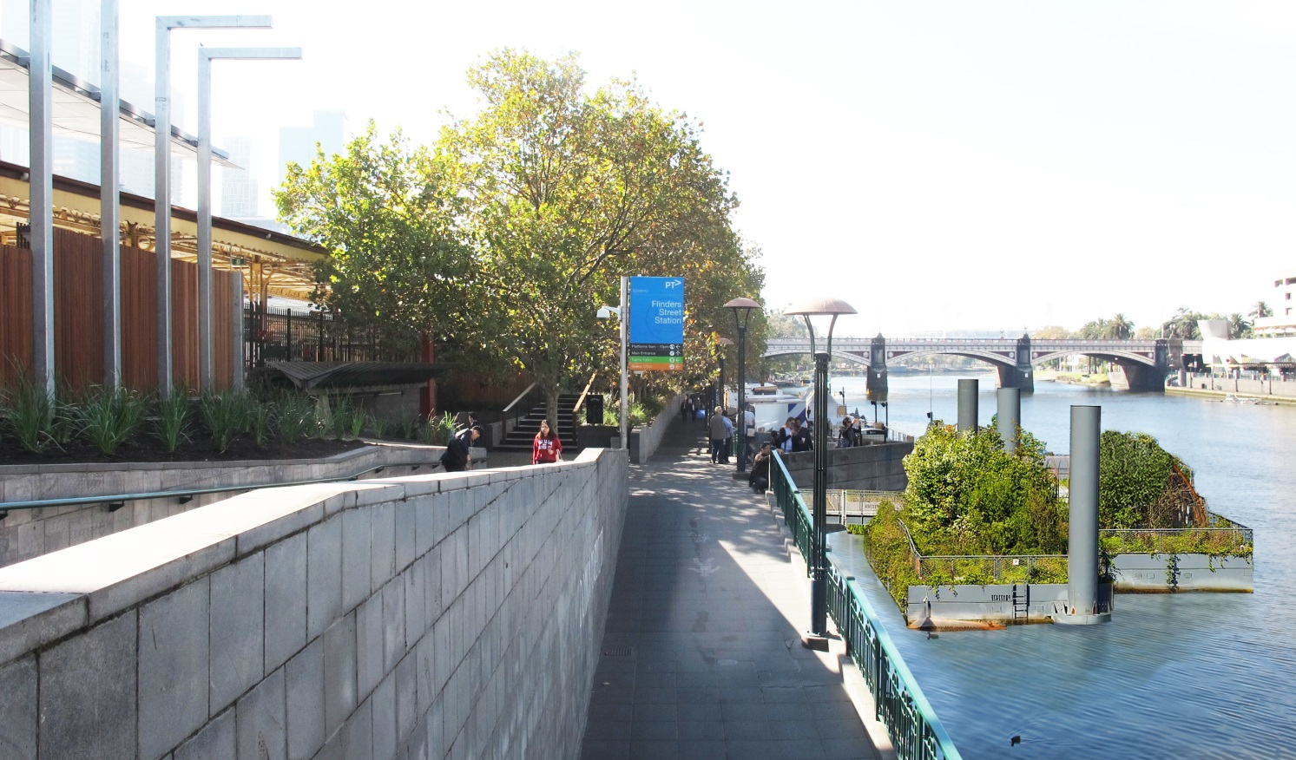
Image 14. Riparian zones indicative locations (Illustrative for discussion purposes only)
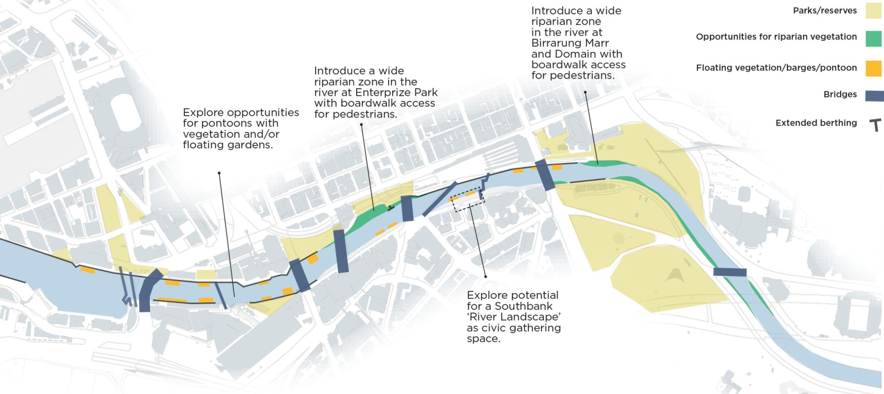

Image 15. Current river edge with rock beaching (basalt).
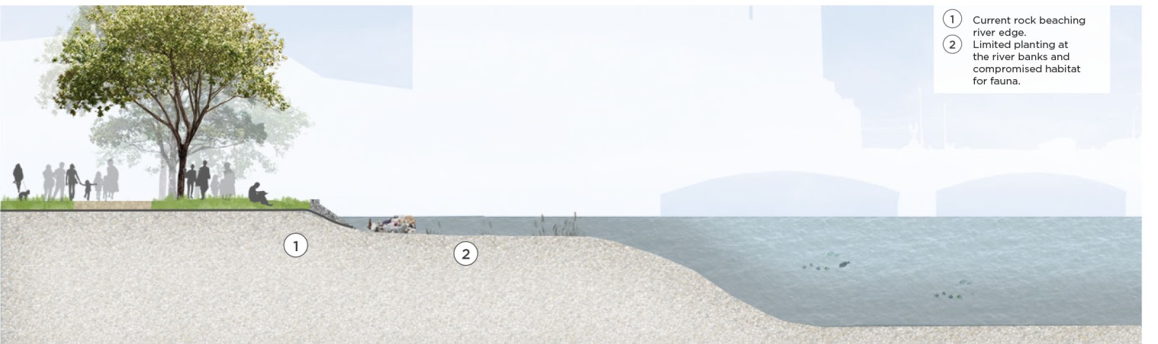
Image 16. Proposed river edge with extended riparian zone and replanting with indigenous species (Illustrative for discussion purposes only)
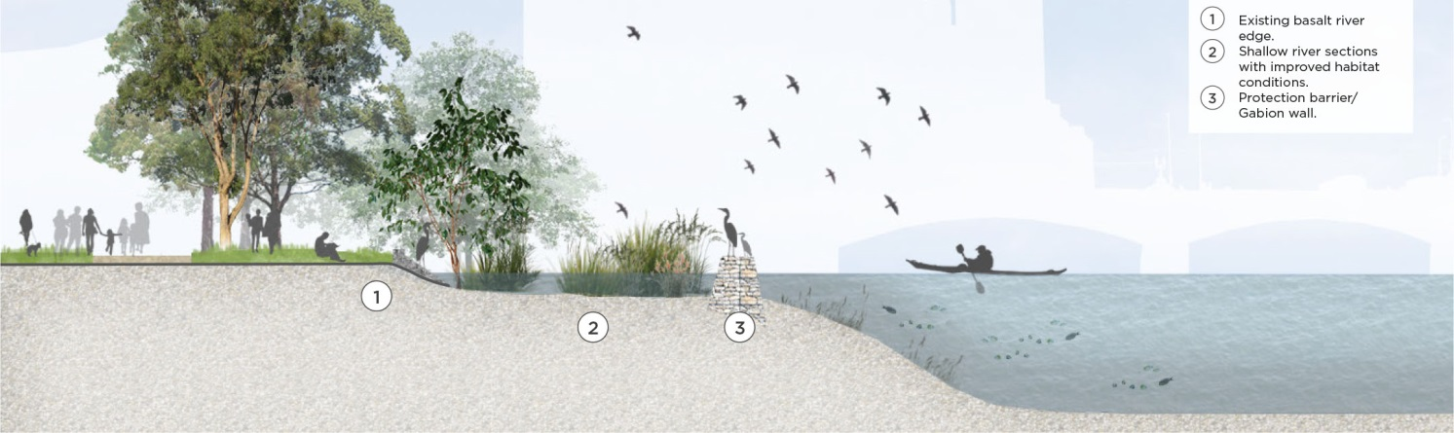

ECOLOGY - STRATEGIC DIRECTION 2:
Ecologically connected
Optimise urban vegetation along the river banks prioritising an Indigeneous palette to improve local biodiversity and ecological networks.
The 1750 Ecological Vegetation Class mapping (Victoria State Government) of the Melbourne area conveys a rich variety in vegetation types along the river with reed swamps, brackish wetlands, swamp scrub and mangroves. This highlights the character and the reach of water in the delta landscape. This pre-contact landscape incorporated a rich floristic biodiversity but only sporadic remnants remain today. The landscape character of the original vegetation has completely disappeared and mostly replaced with exotic vegetation, consisting of lawn and introduced trees.
Larger open spaces and reserves like Westgate Park in Fisherman’s Bend and the Royal Botanic Gardens have re-established biodiversity hotspots in the contemporary urban context of Melbourne. Waterways act as a connector for wildlife and the spread of vegetation through a connected habitat framework for water and land based species particularly birds, reptiles and frogs. Physical barriers need to be identified in order to improve connectivity and reduce habitat fragmentation. The benefits of a more connected habitat framework with restored and improved biodiversity values for the City are wide ranging. This is articulated in the City of Melbourne Nature in the City Strategy 2017 with ‘The city as an ecosystem’ philosophy. The beneficial ecosystem services and a ‘Nature for People’ that will result from better habitat connectivity and permeation will allow for people to be in close proximity to natural systems in their direct environment. The benefits of contact with nature include improved health and wellbeing.
The Urban Forest Strategy and Precinct Plans for both the Central City and Southbank precincts indicate that many trees in the river corridor have a limited ‘useful life expectancy’. This strategy proposes that many European tree types in the city should be replaced by other species, including indigenous ones. Especially many of the elms and plane trees are suggested to be partly replaced over the coming 10 years. This will improve tree diversity, tree health and decrease vulnerability to diseases and pests.
E2A: Prioritise a diverse landscape palette with a native focus on the river banks
There is an opportunity in the City River precinct to improve the urban forest diversity and health and reintroduce indigenous tree species and other indigenous vegetation. The river precinct will regain some of its original characteristic vegetation, including riparian plant communities, where possible. This will change the character of the river precinct dramatically and will involve a conscious departure from the European style landscaping that has dominated the parks in proximity to the river. It will also provide a clear river landscape identity and strong distinction from the city street landscape character. The use of indigenous species will provide a greater link to place and the Aboriginal history, establishing a characteristic City River experience in the heart of Melbourne.
In selecting species, the specific soil conditions, local climatic constraints and future climate change effects must also be considered to ensure a resilient approach. An informal planting approach could also assist in creating a new landscape identity that contrasts with the formality of the city streets.
E2B: Encourage a wildlife corridor along the river that connects city users with nature
Introducing new trees and vegetation along the river, including mid height plants and ground cover, will re-establish a movement corridor for urban wildlife and increase the areas for fauna habitat. It will encourage people to engage with the natural environment in the City and be immersed in a riverine experience. Interpretive signage and other forms of education about the river landscape should be provided to encourage interest and engagement.

E2C: Create saltmarsh habitat conditions in order to attract a selection of wetland birds
Create riparian habitat conditions that will attract wading birds like White-faced heron, Nankeen night heron, Great egret and Royal spoonbill. These species are now increasingly found in urban environments (like Royal Gardens and Carlton Gardens) and are likely to use the City River if appropriate habitat conditions are being reinstated. A target should be set for the establishment of saltmarsh and riparian conditions to enable birdlife to forage and a place for roosting. Creating the right conditions for wetland birds will increase the likelihood of other fauna establishing itself in the river corridor and in general aid in the connectivity for species.
Image 17. Improve biodiversity connections (Illustrative for discussion purposes only)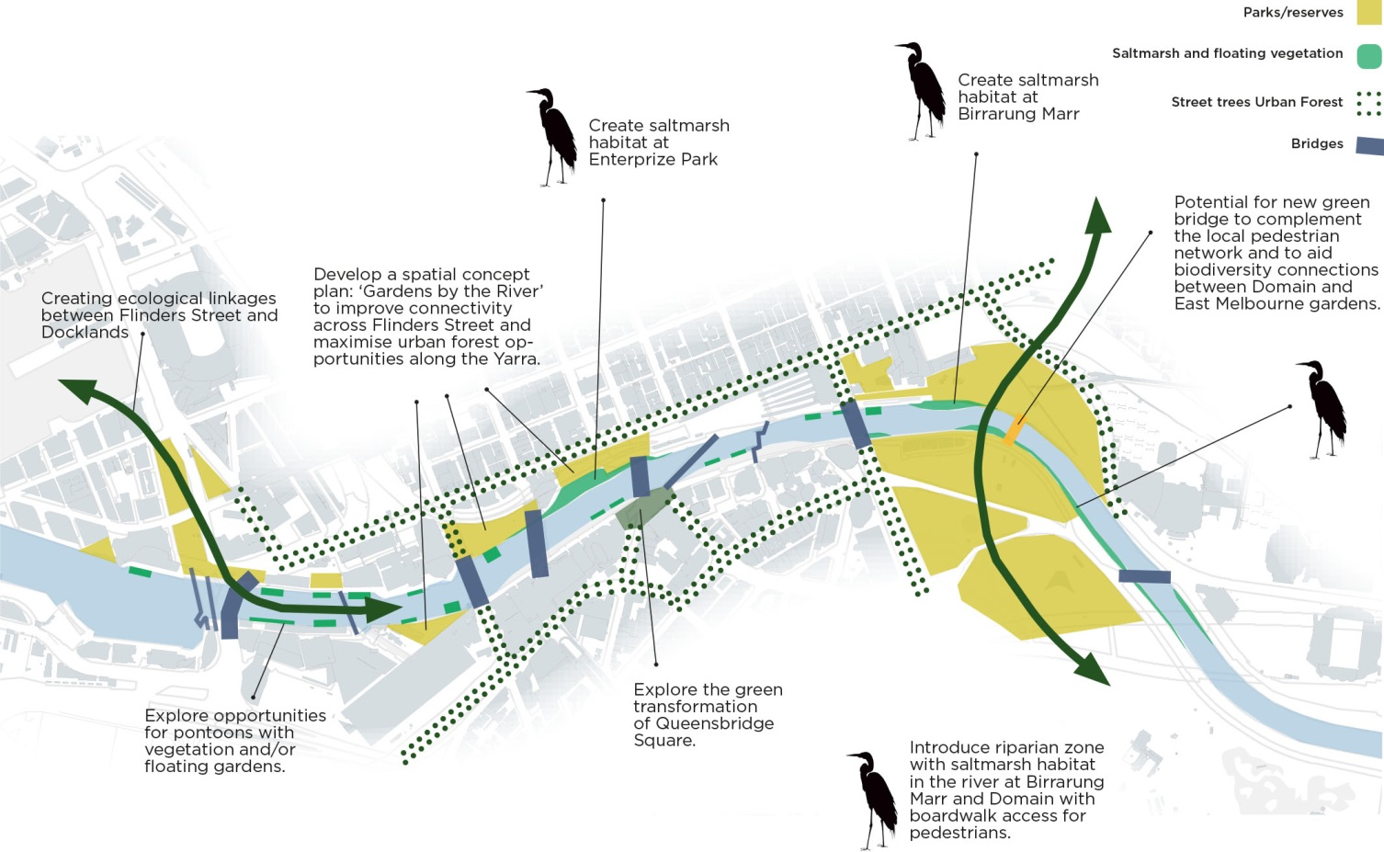

ECOLOGY - STRATEGIC DIRECTION 3:
Resilient
Address flood risk and improve water quality.
The flood mapping for heavy rain events and sea level rise impacts in the urban area of Melbourne highlights the vulnerability to flooding in the City, especially west of Princes Bridge. Both Southbank and Northbank will be affected by flooding from significant rain events. This includes the bottom of King and Spencer Streets on the Northbank, a stretch of Flinders Street and generally Southbank, Lorimer and Docklands.
Historically, the river was part of a dynamic landscape where flooding was a regular event during which the floodplain would have increased the size of the river temporarily. In the urban context, the river is now being deprived of much of the floodplain and water is being channelled through the City at in order to clear the urban space from storm water as quickly as possible. In that context, flooding events are simply seen as a drainage infrastructure issue and managed through a pit and pipe system.
The riparian condition of the waterways has been degraded and minimal amounts of vegetation remain or have been partly replanted more recently. This has significantly reduced the ability of riparian land to act as a natural bio filter, to stabilise the river banks and to dampen flood peaks.
E3A: Investigate the reinstatement of the Falls to provide fresh water closer to the central city.
Currently options are being reviewed by City of Melbourne to improve access to fresh water for park irrigation. Constructing a pipeline for fresh water from the Fairfield area to the city is one of the (costly) options. There are a number of benefits to bringing fresh water further downstream including being able to irrigate urban parkland directly from the river.
Exploring the impact of reintroducing the Falls on ecology and biodiversity, given changes from brackish to freshwater conditions would need to be undertaken to measure the impact and value of this approach.
Although modelling has shown that reinstating the Falls in the original location at Queens Bridge would have flooding impacts, there may be less impact in other locations. Other potential locations for a Falls structure (further upstream) and other technical solutions may be tested in the future.
E3B: Investigate potential water retention measures in public spaces on the river edge.
An approach that some cities take to address flooding and water quality is to think of the city as a sponge. In this approach, in order to minimise the effects of flooding, stormwater is captured, retained, filtered and slowed down as much as possible. The ‘Sponge City’ concept promotes the idea of a managed floodplain in an urban context.
This strategic direction is to explore opportunities to physically combine stormwater management measures with public realm spaces at the river edge. Water retention measures could be designed to retain volumes in a peak rain event and slow down runoff significantly. In storm events, open spaces could be utilised to partly accommodate excess rain water volumes. This would temporarily allow water to be retained in the public realm, which incorporates water storage within urban public space in a functional and aesthetically interesting way.
This concept will allow the City River precinct to be an attractive and inviting area that isn’t constrained by its relationship to water, but instead is enhanced by it. It will generate opportunities to shape environmental quality and local identity in different sections of the river.
E3C: Include water sensitive urban design (WSUD) and other initiatives in the river precinct to improve water quality.
The City of Melbourne Total Watermark Strategy (update 2014) and Integrated Water Management Plan (2014) highlight water for liveability and the environment. A water quality target for stormwater is set for 2030 as a 30% reduction in Total Nitrogen contributed to the waterways from the municipality of Melbourne’s catchment (baseline year 2000). To enhance the health and biodiversity of our waterways, we need to reduce stormwater pollutants and improve water quality.
All development in proximity to the river’s edge should incorporate features to retain and slow water and improve the water quality. This can be achieved through a range of measures including retention tanks, constructed wetlands and raingardens, increased tree cover and permeable pavements. Permeable pavements, for example increase porosity of hard surfaces and create more opportunities for infiltration of water. Place based guidance for innovative responses to water can provide design inspiration adding to the sense of place rather than being regarded purely as an engineering issue.
Image 18. Water retention locations (Illustrative for discussion purposes only)
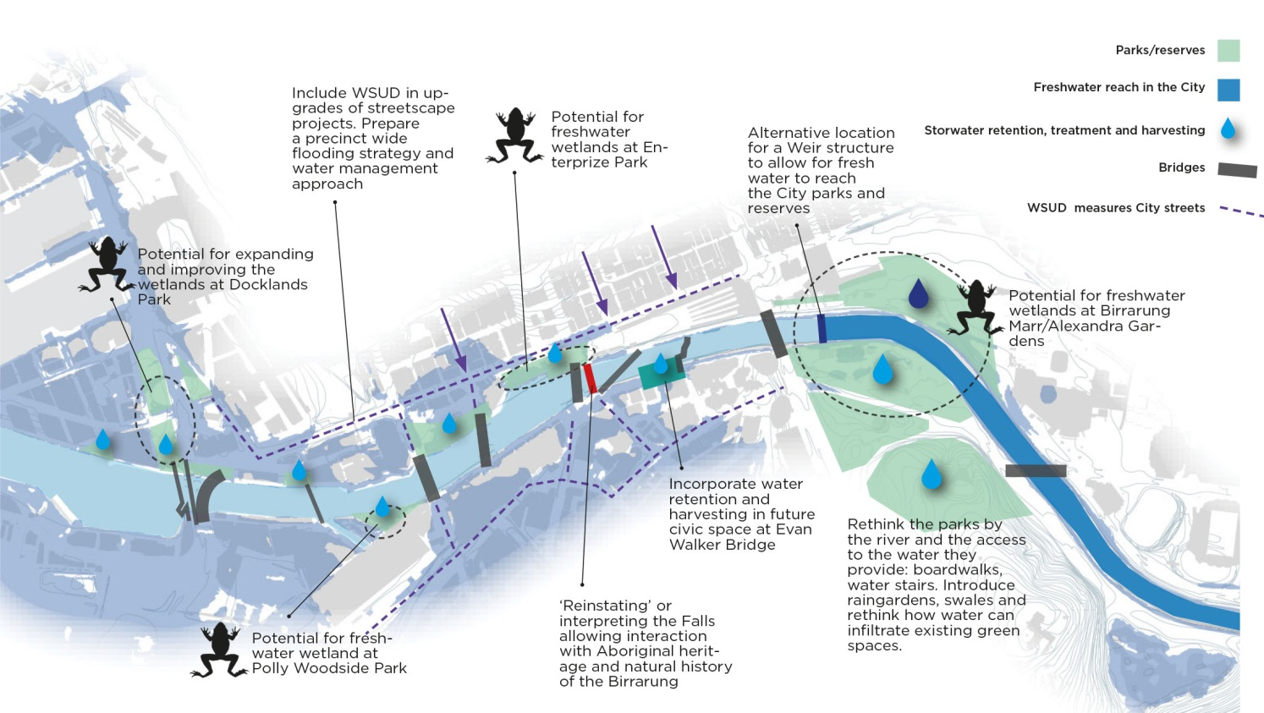

Place: Activity and character
Melbourne’s river is a defining feature of the city’s identity, consistently presented in promotional imagery. However historically, the City has not fully embraced its waterways, despite the cultural significance and proximity. The river and its banks should be an attractive complement to the central area, offering a diversity of uses and new economies that are welcoming to all.

Background
The character of the City River has evolved over time through the layering of decisions and incremental changes. There remains some historical elements embedded within this urban fabric despite the conditions being modified significantly over 200 years. The river was extensively widened during the gold rush era to create the expansive watercourse, of 120 metres in width, known today. Historically the river west of the old falls near Queens Bridge, was where boats would dock, while to the east soft, landscape edges with access to fresh water were a feature. These conditions of parkland edges to the east and docks to the west are still evident today, though the central city waterfront has transformed to be home to a range of major recreational, cultural and hospitality destinations.

The City River is identifiable by its distinctive features of the parks, bridges, vaults, railway viaduct structures, sweeping city views and numerous historical sites. It is important to respond and celebrate these features alongside other undiscovered features of significance. It is vital for our economy that the City River continues to emerge as a vibrant, creative destination, unique to Melbourne. A riverfront with a distinctive character that promotes its past and present will build a genuine and memorable city identity.

The character of Docklands and the area west of Spencer Street is continuing to undergo rapid transformation with numerous significant developments introducing further commercial and residential uses, as well as additional public spaces and river front promenades. Complementing this, Batman Park features passive recreational activities and informal uses with direct river views. The rail viaduct is a defining characteristic of this area, however the studios along Rebecca’s walk and at-grade parking underneath the rail structures, detract from the amenity and activity potential of the park. The general presentation of the park is also in need of improvement to encourage increased usage as a safe neighbourhood space for the surrounding community.

Enterprize Park was the site of the first European settlements and also historically known as the Turning Basin, as this was the furthest point that ships could navigate up the Yarra River. The Aquarium and Immigration Museum are the main public attractors to this area, yet these have limited relationship with the waterside setting, due to access and orientation issues. This is also an area with high potential for improvement due to its significance. The central Northbank zone comprises the Flinders Street Rail Station, refurbished Sandridge Bridge and Banana Alley vaults. There is an inconsistent quality of riverfront experience across this stretch compared to the active promenade of Southbank.

Image 19. The different character areas of our City River.
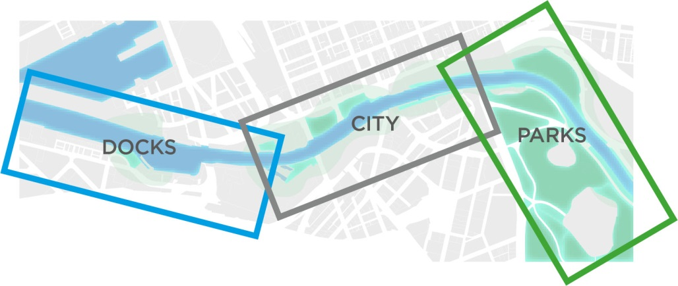

Key challenges
Key activity and character challenges are defined below:
- Northbank stands out as a broad area of poor definition and inconsistent quality that weakens a strong, attractive identity for the City.
- Limited day to day activation of the central waterfront.
- Some privatisation of public areas and potential risk of over commercialisation of waterways and adjoining parklands.
- Riverfront features range of treatments, furniture, signage types, contributing to a lack of consistency and clarity.
- The diversity of landowners impacts the character and conditioning of waterfront areas.

Strategic directions
The following key strategic directions guide appropriate actions for improving the activation and diversity of experience for a range of City River users.
PLACE - STRATEGIC DIRECTION 1:
Inviting
Prioritise Northbank renewal to create an inviting destination immediate to the City.
Northbank is located on the doorstep of the City, yet has been long perceived as the unattractive counterpart to the southern bank. Southbank Promenade and Crown Casino feature sunny, active highly pedestrianised and populated public spaces. These contrast markedly with areas along Northbank, where public spaces and pathways are generally of a lower quality, removed from active frontages and more prone to safety and security issues.
In recent decades, Melbourne has certainly sought to re-embrace the Yarra River and the completion of Birrarung Marr and Federation Square, has raised the profile of the northern bank of the River. More recently, the 2013 Flinders Street Station competition also generated ideas to improve the riverfront area, including Banana Alley. However, the central city expanse of Northbank, particularly from Spencer Street to St Kilda Road, covering Banana Alley, Enterprize Park and Batman Park continues to remain a key portion of the City River lacking an inviting and direct relationship with the water, along with longstanding safety and security concerns.
The poor and inconsistent quality of the public realm in these areas, lack of active frontages and connectivity issues create a highly underwhelming experience, which is out of step with this coveted location so close to the central city. Notable issues include the physical environment of Banana Alley, the isolated and unsafe experience at Enterprize Park, numerous riverfront spaces interfaced by at-grade car parking and the studios along Rebecca’s Walk in Batman Park, formerly the fish market location, are largely vacant and left vandalised.
P1A: Create an attractive backdrop to the Central City through major upgrade works to Northbank.
Northbank provides a critical, linear pathway and, as a featured backdrop to the city, plays a prominent role in contributing to Melbourne’s identity. As further development occurs and the central city population increases, there is growing demand to lift the northern side of the river to better standards of safety, security and amenity. There are modest improvements currently planned for Enterprize and Batman Parks and works to key station entrances also being undertaken by the State Government as part of the Flinders Street Station upgrade. However, we recommend making Northbank a priority of major investment, enabling much needed public realm improvements of this highly visible asset to the central city. Interventions could include widening the Flinders walk pathway so that they are broad, well-lit and have visible destinations; and major design modifications to Enterprize Park and Banana Alley. A concerted focus on this particular area of the City River would reinforce the central, urban waterfront as an inviting, attractive asset of Melbourne.
P1B: Activate deserted zones through a program of events and activities.
Along Northbank, public spaces and pathways are removed from active frontages and more prone to be unsafe and deserted. For instance Les Erdi Plaza features a high fenced edge with views to a line of car parking. Alternately this surplus railway land could be used to enhance adjoining urban spaces. The spaces under the railway viaduct also hold great potential to be transformed into a vibrant place through temporary and permanent uses, artwork and events. A relevant precedent is Im Viaduct in Zurich where new life has been injected into the arches of the railway viaduct in the form of a new ~550 metre long urban meeting place.

Image 20. Artist’s impression of possible improvements to Enterprize Park (existing photograph above in black and white).
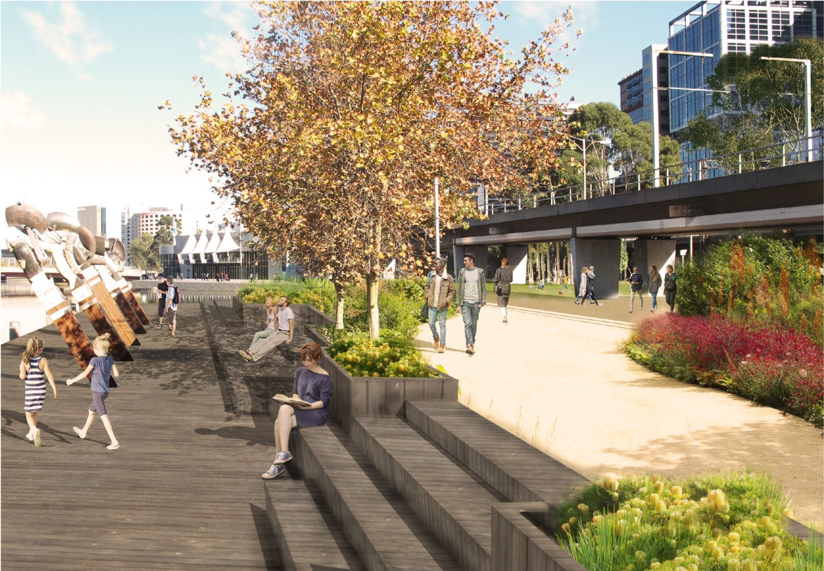

PLACE - STRATEGIC DIRECTION 2:
Multi-functional
Celebrate character areas and encourage new economies: a range of civic, educational, cultural, hospitality and water dependant uses.
Successful urban environments are defined by well used, high quality, plentiful and diverse spaces and activities. Places and spaces along the central city river have a distinct identity and offer a mix of sensory experiences, ranging from the openness of the eastern parklands to the more intimate setting along Flinders Walk, where cafes and bars echo the character of the city’s laneways. Downstream of Queens Bridge is dominated by larger-scale uses including the Melbourne Exhibition and Convention Centres, large businesses and residential complexes that transition into the Docklands precinct.
P2A: Encourage a range of civic, educational, cultural, hospitality and water dependant uses.
Looking to the future, the City River should offer an even greater diversity of uses that offer extended occupation and are appealing to broad sections of the community including locals, visitors, old and young. Currently the inner-city river reaches are largely populated by drinking and eating venues and so there lies the potential for new economies that offer broader areas of interest, inclusion and make the most of the river location, such as creative and water dependant industries. Enterprise Park has much potential as an education opportunity, whereby the history and role of the river could be enhanced and better understood. There is also a need for a children’s outdoor play area in the western portion of the river, offering a water and nature learning opportunity.
P2B: Build on diverse character districts to create a series of unique experiences.
As opposed to a homogenous corridor, the City River should build on the series of unique districts that feature their own character, spatial definition and function to increase activation and utilisation of the Yarra River and its edges. Currently there are at least 12 different areas with their own distinctiveness and character that punctuate the journey along the river, offering many layers of experience. These areas could be programmed, branded and marketed as distinct areas in order to attract patronage to support the functions therein and could be broadly grouped into five main urban settings or districts, suggestions are as follows:
Riverside Park
For fitness and connection to nature.
Princes Bridge to Birrarung Marr, including the following areas:
- Birrarung Marr
- Alexandra Gardens (Rowing Precinct)
Characterised by openness with the expansive landscape area of Birrarung Marr and the Domain parklands.
City River alleys and arcades
For intimate cafes and hidden bars.
Northbank: Queensbridge to Princes vaults, including the following areas:
- Princes Vaults
- Flinders Walk
- Banana Alley
This area is immediate to the central city area, a major transport interchange point and the retail core. It is characterised by a more intimate, urban character, featuring key heritage landmarks. The direct link between the city, Northbank and Southbank generates significant pedestrian activity that offers great potential for additional social activity and hospitality uses in this area.
Southbank Promenade
For feasting and festivities.
Southbank: Queensbridge to Princes Bridge, including the following areas:
- Southbank
- Crown Casino
This area features a notable concentration of arts, cultural, creative and hospitality venues. It is characterised by key landmarks of the Arts Centre, Southgate complex and Crown Casino.
Neighbourhood market / recreation
For play and reflection
Queens Bridge to Spencer Street, including the following areas:
- Batman Park
- Enterprize Park
This area is characterised by its urban, open space areas, directly connected to the river’s edge and includes Batman Park, the Aquarium, the Turning basin and Enterprize Wharf and Park. It holds great potential as an excellent neighbourhood recreation, education and event area. The arcade spaces could potentially be activated with seasonal produce markets, recalling the original fish market use, or passively with public art. Activities should support the high residential population of over 10,000 households immediate to this zone.
Urban docks
For maritime, docks experience
Docklands to Spencer Street, including the following areas:
- Exhibition Centre
- Convention Centre
- Northbank West
This precinct is characterised by its hard urban edges, contained landscape features and substantial wharf structures and boardwalks. Major public and private sector projects include the Melbourne Convention & Exhibition Centre, Seafarers Bridge, South Wharf and DFO.

PLACE - STRATEGIC DIRECTION 3:
Public
Sustain the civic focus of the river by encouraging activation that offers broader inclusion and supports a public waterfront.
The City River is a venue for many of the activities that contribute to the life of the City. However, some events or uses are privatising portions of the riverfront. We promote the importance of the Birrarung being first and foremost a public place for people and recommend generous public access and pathways along the banks. This is currently compromised in some locations along the river with pedestrian passage constrained by adjoining private spaces. Numerous private developments along the city riverfront are also guilty of turning their back to the waterway. The Northbank is particularly vulnerable to the incidence of this given the southern aspect.
We advocate for a balanced approach between activation and commercialisation along the banks. We recommend the river’s legibility as a public place be elevated, so that it can be enjoyed without expense. We place a significant economic value on the river as an entity in its own right, so advocate for a strong curatorial and creative approach to be adopted for commercial opportunities, ensuring every intervention responds to the inherent qualities of the river, and is of the highest quality and design to deliver memorable and delightful experiences to tourists and citizens.
P3A: Ensure unrestricted public waterfront access
The city riverfront must uphold the civic focus by ensuring generous public access along the water’s edge. This could be achieved by administrating a continuous, clear width for pedestrian access along the water’s edge, for instance a minimum width of 2.5 to 3m (refer image 21).
Application of permanent structures over riverbank spaces that impede visual and physical permeability should also be dissuaded. This pertains particularly to key landmark or heritage structures such as the Federation Wharf and Banana Alley historic vaults. Any structures on the riverbank or on water should be materially lightweight, of a single storey height only (no higher than 3m) and feature a slim, horizontal profile that still allows for clear appreciation of landmark areas of the riverfront.
P3B: Encourage waterfront buildings to address the water.
The relationship of surrounding developments immediate to the water environs has a significant impact on the use of these spaces and the behaviour of users within them. On water and water edge activities, events and uses should be orientated and designed for public use. The Aquarium extension is an inward oriented development that takes little advantage of the prime location adjacent to the water’s edge. Future waterfront developments should be required to feature active frontages that welcome the public and embrace the waterfront. All landscapes in waterfront developments should also be publicly accessible.
P3C: Promote activities that support a public waterfront
While the commercial function and economy generated by the river is important, these should not compromise the public benefit of the river asset. A balanced approach which distributes commercial operations, allowing room for other activities to diversify the riverfront experience is encouraged.
In February, the Victorian Government released the Yarra River Action Plan, which includes the establishment of an advisory council made up of local stakeholders, to be named the Birrarung Council after the Wurundjeri name for the Yarra, to assist with striking this delicate balance between business development and environmental concerns.
A programme for ‘civic’ activation that focused on both day to day local activities to complement larger, regional events could be established. There is much scope to particularly increase activation of Queensbridge Square on the Southbank and the areas beneath the rail viaduct on Northbank. The City of Melbourne’s ‘Love your laneways’ project focused on improving streetscape safety and amenity in the Hoddle Grid and considered a number of issues such as waste management and public lighting, alongside artistic and cultural uses. Perhaps there could be a ‘Love your River’ project undertaken following similar motivations.
Image 21. Recommended minimum standards for unfettered public access at all times.
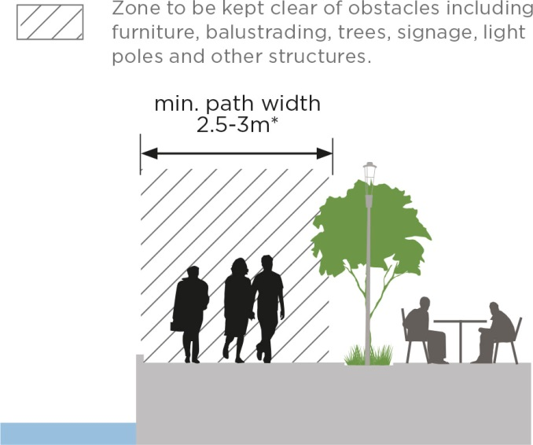

PLACE - STRATEGIC DIRECTION 4:
Legible
Rationalise clutter and on-water infrastructure to ensure unobstructed vistas and views.
The role of rivers in a city context could be likened to urban parks in terms of providing essential elements of fresh and clean air, trees and green space, openness and relief from the intensity of central city life. Waterfront clutter and on-water infrastructure should not detract from the elemental qualities of this unique, natural setting, nor undermine the peaceful amenity of the area. It is important that we preserve our riverfront, acknowledging its significance and are accordingly discerning about what structures and objects are placed within the confines of this natural asset.
There is a myriad of signage and ad hoc placement of outdoor seating, bins and light poles, adversely impacting pedestrian flow, which collectively weaken the legibility and overall attraction of the waterfront asset. Floating, on-water infrastructure such as bars, boats under repair, pontoons and expansive berthing areas also compete with uses on the banks and most importantly obstruct clear views of the waterfront. There are also numerous at-grade parking areas immediate to waterfront areas, particularly along the Northbank.
P4A: Rationalise clutter to ensure unobstructed appreciation to identified views and landmarks.
The placement of objects (signage, bins, light poles) or structures (floating bars) should be well integrated with the environs, have a clear, beneficial purpose and key views, as identified in Image #, must be protected. This concerns selectively rationalising electrical service cabinets and bins, consolidating light poles and introducing better placement of street furniture to de-clutter the riverfront.
In addition, the location of floating bars and other on-water infrastructure should be effectively dispersed so as not to dominate an area or obstruct public access to the water’s edge for long distances. Encouraging a reduction to the numerous instances of visible, at-grade car parking from this key people zone is also critical. There, however, still lies a place for on-water infrastructure within the City River, as is the case of art installations or water related forms which are specifically designed and located to enhance the riverside experience, both on a temporary and permanent basis.
P4B: Develop a technical guide for waterfront treatments to establish a consistent palette.
To improve the legibility of the corridor, co-ordinate treatments and evoke an authentic, local character, the development of a specialised technical guide for the riverfront is recommended. This would offer clear direction on a base palette of preferred materials, landscaping and details that recognise the unique location, scale and detailing required when building on or near the water and are visually cohesive and recessive. For application along the waterfront and extending to a block either side, this could include treatments which accord with each character area and may involve adoption of current City of Melbourne Design and Engineering standards, where contextually appropriate.
P4C: Provide additional bridges only where cross river connectivity is critical
Cross-river links play a key role in stitching together destinations, integrating with local neighbourhoods and for an appreciation of panoramic river views. There are currently nine cross-river links within the central city area. The location of bridges and their alignment to minimise expanse and maximise the environmental and visual experience of users is key to the riverfront experience. Height is a further consideration, noting the Spencer Street Bridge (2.05m in height) heavily constrains vessel movement during high tide.
Currently, there is potentially a need for one to two additional bike and pedestrian crossings over the City River area to support enhanced connectivity and use. The proposal for a bridge across to Fisherman’s Bend on the Collins Street axis will offer critical connectivity between the City, Docklands and this new community. The design and location however must be sensitively resolved to respect the local context and environment.

Image 22. A draft suggestion of key City River views that should remain unobstructed.
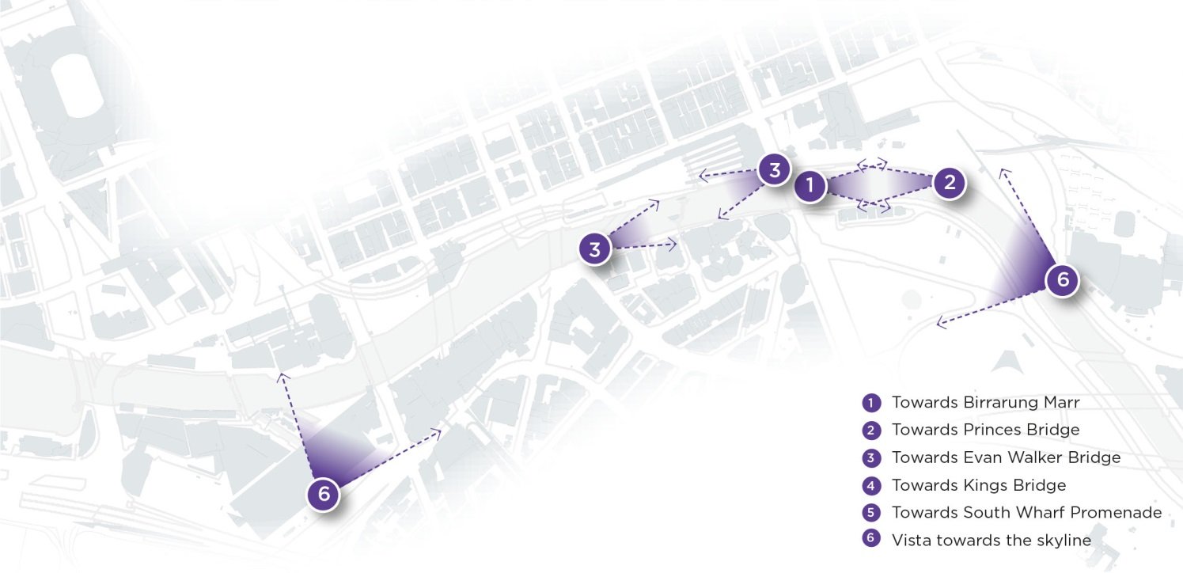

Movement: Journey and connection
Rather than just a corridor to swiftly move through, the river becomes an important destination and place to enjoy the journey away from the intensity and rush of the urban centre. Through improved access to and along the waterfront, the river will provide the natural complement to the fast pace of the City and Southbank.

Background
The City River offers a unique setting and being lineal in nature is a key drawcard for many users wishing to both connect with other destinations and enjoy the river environs. Consequently, the waterfront currently accommodates significant volumes of both pedestrians and cyclists. These two broad categories of users, have very different needs and expectations. Pedestrians using the river include those walking for leisure, transport, running, jogging and walking dogs. Cyclists cover people riding bicycles for recreation and commuting, in groups or individually. The intensity and movement patterns vary greatly across and within these groups. As such, conflict between users sometimes occurs and consequently the overall experience of the waterfront is negatively impacted.
The fundamental issue is that the riverfront is currently pressured to accommodate both ‘place’ and high speed, commuter functions within a constrained environment. Some spaces currently have greater focus on movement (e.g. Southbank East and Northbank East) whilst others are primarily destinations (e.g. Southbank Promenade and Batman Park). The primary or priority purpose of these areas is unclear, and sometimes the place and movement functions appear to conflict, as is the case of Southbank Promenade where the destinational value is diminished by its role as one of Melbourne’s busiest bicycle commuter routes. This issue has been a concern of Southbank residents and retailers for many years, and some minor solutions have been incorporated in an attempt to slow cyclists but have not yet successfully resolved this issue.
Despite the number of assets within the river environs, there also exist challenges relating to surrounding rail and road infrastructure that hinder easy access to and enjoyable movement along the river. The section from Northbank West to Banana Alley features a particularly poor level of connectivity due to numerous, major traffic barriers that avert creation of a continuous link. The physical conditioning of pathways, extent of universal accessibility and the lack of a coherent wayfinding and signage is a further compounding issue. A particularly challenged setting for easy movement is the physical environment of Banana Alley that features steep level changes, uneven paving, a range of signage and on-grade car parking.
In terms of on-water movement, there is unrealised potential for non-motorised crafts along the river with only one landing site. There lies much opportunity to include better facilities for non-motorised watercrafts such as kayaks and canoes with additional public launch and mooring sites. There are also numerous private, exclusive berths with extended overnight berthing arrangements that could perhaps be consolidated and better located to maximise public benefit in this central city location.
Volumes of people
Recent counters indicate significant pedestrian volumes at four key City River locations:
- Northbank (Flinders Station exit) 4,550
- Southbank 4,282
- Princes Bridge (near Flinders St) 3,417
- Sandridge Bridge 1,841
(Reference: City of Melbourne’s pedestrian counting data recorded September 2018, afternoon peak ~5pm)

Key challenges
Key access and movement challenges are defined below:
- Many cyclists travel at speed, despite speed limits signage, yellow strips, with numerous sites where modal conflict occurs, particularly along Southbank Promenade and Crown Casino.
- Lack of awareness and compliance of shared paths and spaces and lack of clarity of who has priority.
- Poor level of pedestrian connectivity due to major traffic barriers along the section from Northbank West to Banana Alley.
- Numerous pathways with a gradient steeper than 1:14 averting access for all.
- Numerous instances of visible, at-grade car parking immediate to the riverfront compromising amenity and character.
- Constrained access to the riverfront from the Central City, especially to Northbank west.
- Narrow paths where often widening would risk loss of trees or lighting and insufficient sightlines for both cyclists and walkers.
- Poor physical pathway conditions and lack of a coherent wayfinding and signage approach.
- Numerous private berths and extended overnight berthing arrangements.
- Unsafe lighting and poor levels of illumination along waterfront pathways.

Strategic directions
The following key strategic directions guide appropriate actions for improving safe, continuous movement and access for all City River users.

MOVEMENT - STRATEGIC DIRECTION 1:
Slow
Distinguish the river as a slower paced environment by creating safe, alternative north and south bicycle routes.
The riverfront is an important recreational asset of natural beauty, a place to wander, rest and observe. It is important that these values are protected by adopting an enduring approach to remedying movement issues along the riverfront. The main cause of modal conflict long the riverfront is the mixing of commuting and recreational users. There is a strong differentiation between the needs and behaviour of walkers and commuting cyclists with the principal issue being one of speed. Shared paths are designed to support slow speeds, whereas commuter cycling is focused on high speeds.
The spatial constraints of our city riverfront further exacerbate this issue. The Northbank is well serviced by public transport, however, the location of Flinders Street and surrounding road infrastructure to the west, has created a particularly narrow river corridor for movement and access. Current pathways, which are as narrow as 2m along Flinders Walk, are too restrictive for the passage of multiple modes. Furthermore the corridor width doesn’t allow for separate cycle pathways, away from key pedestrian areas.
As a key destination that primarily functions as a ‘place’ rather than a movement corridor, we recommend promoting travelling along the river and its edges at a slower pace, enabling time to appreciate the key views and diverse spaces. This would be consistent with the 5 knot zone (fast walking speed) defined for the waterways.
While it is recognised that the current conditions are not ideal for commuter cyclists, it is important to acknowledge that the Yarra River corridor has long been seen as a commuter cycling route in strategic documents, and significant improvements have been made to riverfront cycle paths leading to the city. The fact that the bicycle network does not currently provide a suitable alternative commuter cycle route at present is also critical. However, investigating opportunities within the wider bicycle network, including new commuting connections with the river corridor could offer a solution.
M1A: Reduce modal conflicts through development of a safe, alternative Northbank bicycle route.
We propose interrogation into a safe, comfortable, and connected alternative bicycle route on the northern, central city side of the river to provide a viable, preferable alternative to the river promenade for fast cyclists. The alternate route must perform well against three key objectives of: connectivity (easy access to other routes); speediness (offers a quick journey with minimal delays); and safety (separation between vehicles and pedestrians).
A potential future route for cyclists, particularly commuter cyclists, could be Flinders Street via Batman Avenue. This would address the poor level of connectivity along the section from Northbank West through to Banana Alley. Flinders Street holds great potential to be an optimal alternate route because it is not a local route; there is a current lack of east-west connections in the southern portion CBD; it features a flatter, topographical alignment; and Flinders Street holds the opportunity for complete separation from vehicles, alongside better connectivity with key cycling routes in the south-west such as Harbour Esplanade. While entailing significant changes to the existing streetscape, including the potential removal of mature trees and redesign of tram stops, Flinders Street holds the potential for a long term solution of the issue, rather than ongoing management of conflict between modes.
Image 23. Potential locations for alternative north and south bicycle routes (Illustrative for discussion purposes only).
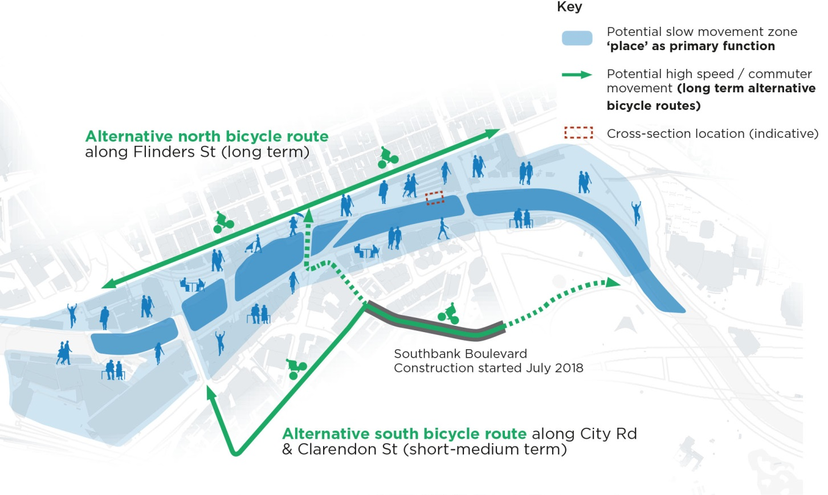
M1B: Continue delivery of the alternative Southbank bicycle route.
The investigation into an alternative Southbank Promenade route diverting from along the waterfront to alternately follow Alexandra Avenue, City Road to Clarendon Street has been proposed by numerous policy documents. These include the Southbank Structure Plan 2010 and the Bicycle Plan 2016-2020 which introduces the action of a long term preferred alternative bike route, noting the current development of Southbank Boulevard as an interim route, with City Road a more appropriate long term solution. Major upgrade works to Southbank Boulevard are currently underway however, to complete the route requires delivery of the Alexandra Avenue, City Road, Linlithgow Avenue and Clarendon Street segments. The redevelopment of City Road is also a key recommendation of the Southbank Structure Plan 2010, including the provision of separated bicycle lanes running the length of City Road and Clarendon Street that should be delivered.

MOVEMENT - STRATEGIC DIRECTION 2:
Integrated
Transform the condition of key ‘barriers’ to address the gaps to the north-west and integrate access with the City.
Easy and direct access from the central city to the river and continuous movement along the waterfront is impeded by the condition of key surrounding routes. The positioning of major road connections, substantial developments, and car parks has compromised access along and to the waterfront area.
The Docklands area has long been perceived as separate, rather than an extension to the central city and the connectivity issues impose further isolation. Northbank west (Docklands to Spencer St) is bound by arterial roads and the public environment is essentially a vehicular corridor carrying high volumes of traffic between Docklands and the West Gate Freeway. Wurundjeri Way is a major hindrance to access between Docklands and the Yarra River with the complex road arrangement and speed of traffic detracting from the amenity of the area. Pedestrian crossings are also far apart and the alignments provide extended crossing distances. Siddeley Street is currently not a safe alternative due to the vehicular traffic and bluestone paving making this a hazardous option.
Batman and Enterprize Park are particularly disconnected with notable gaps to continuous east west movement along the waterfront. Bound on all sides by the major barriers of two major arterial roads and two overhead rail viaducts, this physical and visual disconnection from the city discourages park use. A quality walking environment is impeded by “dog-leg” crossings and multiple crossing stages. Lack of wayfinding and the poor quality public realm further compound the accessibility issue.
M2A: Better integrate pathways along and leading to the waterfront by creating direct crossing arrangements and amenity improvements.
Flinders Street, Williams Street, King Street, Spencer Street, Wurundjeri Way and the railway corridor currently act as visual and physical barriers to integrated access. Converting, where possible, the conditions of these mini motorways into more pedestrian friendly environments that feature improved visual and physical qualities would vastly improve access to and along the waterfront. This aligns with City of Melbourne’s current work being completed to transform Southbank Boulevard and Dodds Street into a pedestrian friendly place and improve connectivity between the Domain Parklands and Yarra River.
Some minor interventions, offering immediate resolution, could be made at Queensbridge Street, Kings Way, Spencer Street and Russell Street such as planting trees, widening kerbs and realigning paths to create more direct crossings. More long-term, major transformations could include changing the free flow arrangement at Queen’s Bridge and Williams Street to remove the multiple western lanes leading to Williams Street, enabling extension of the Park and creating a better connectivity to and along the waterfront. Investigation into the possibility of lowering Wurundjeri Way to create a safer, higher amenity and more direct pedestrian link across to Docklands is also worth encouraging. A key factor to consider is that Wurundjeri Way is an important heavy vehicle route and popular alternative to the CityLink Tunnel and Bolte Bridge. Also any proposed changes would need to be assessed and approved by VicRoads.

Image 24. Improve conditions of these key barriers to improve access to the waterfront.
- Flinders Street
Review traffic function to increase pedestrian and bicycle opportunities

- William Street
Review road layout to eliminate diversion to William Street.
Rationalise pedestrian crossings.

- Kings Street
Plant trees, and improve pedestrian crossing convenience.

- Spencer Street
Plant trees, and improve convenience of pedestrian crossings.

- Wurundjeri Way
Improve pedestrian experience round WTC, Mission to Seafarers, Flinders St, Siddeley Sreet.

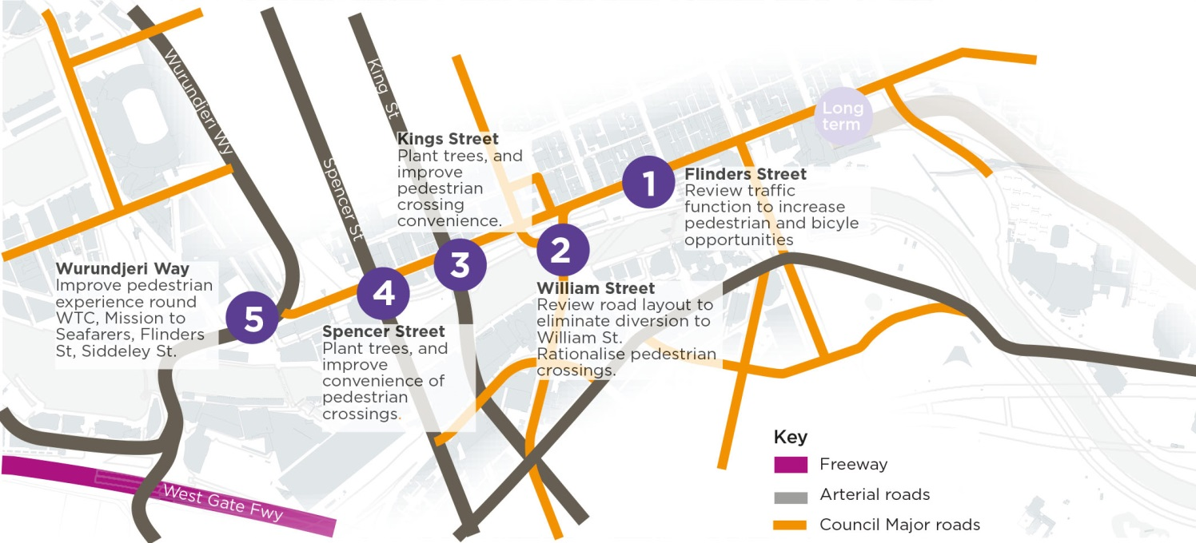

MOVEMENT - STRATEGIC DIRECTION 3:
Accessible
Raise the quality and universal accessibility of riverfront pathways.
The maintenance, conditioning and safety of pathways vary considerably along the City River corridor. The materials and detailed design of the pedestrian environment in some areas is of a high quality, however the linking areas adjoining these spaces is generally poor. There are also some materials not fit for purpose. For instance the precast pavers are not sufficient for events loading and others offer limited environmental benefit.
Numerous pathways and bridges along the river feature challenging level changes, both limiting access for all and creating safety hazards. Examples include disappearing edges, excessive crossfalls which do not meet accessibility standards and vertical access issues. Access between the western footpath of St Kilda Road and the river’s edge is currently limited to a series of staircases. Once along Flinders Walk there are also several areas within the steep gradient category, that are steeper than 1:14. The journey down to Banana Alley from the eastern approach involves a particularly steep grade on an uneven surface.
M3A: Deliver universal accessibility at key waterfront access points
Universal accessibility to and along the water’s edge, including access for people with physical limitations, needs to be provided. All walkways must meet accessibility standards. A series of access improvements, including universally accessible ramps, walkways and elevators needed in numerous areas to ensure easy access for everyone, and to improve the function and commercial viability of the riverfront. Key waterfront access points that should be prioritised for better accessibility include addressing the steep transition from Banana Alley to Les Erdi Plaza and access from the north-western side of Princes Bridge down to Flinders Walk.
M3B: Develop a wayfinding and signage strategy to ensure easy waterfront navigation
Wayfinding is the way we navigate our environment using sensory cues, spatial arrangements, built form, landmarks and where necessary, signage. Currently a wide spectrum of behavioural and directional type signs are provided across the river corridor with considerable variation in the style of the behavioural signage. In specific locations existing signage creates confusion rather than providing clarity for behavioural expectation.
The Yarra River corridor has the potential to feature a coherent and legible wayfinding and signage approach. Development of a strategy would address the distinctiveness and personality of the different spaces. Better pedestrian connections and signage to the river will help all to enjoy the river more. A wayfinding and signage strategy could potentially cover and co-ordinate three signage types: Destination signs; Directional and orientation signs; and Behavioural signs.
M3C: Ensure pathway widths, physical conditioning and maintenance safely caters for everyone.
After decades of wear and tear there are numerous pathways along the riverfront due for renewal. Existing tree location, bins, bollards, light poles, stairs, bridge landings often reduce useable circulation space and visibility in key areas and the worn condition negatively impacts the riverfront experience. Intense pedestrian flows in peak periods and the impact buskers have on movement of all users of the corridor, particularly along Southbank Promenade and Crown Casino, which generate crowds and impede the flow of users are particular areas where pathways capacity is critical.
A detailed audit of existing conditioning and capacity issues is recommended and then staged renewal of all paving, lighting and street furniture with material selection and furniture placement coordinated by a technical guide for waterfront treatment (refer discussion in PLACE Strategic Direction 5: P5B)

MOVEMENT - STRATEGIC DIRECTION 4:
Diverse water activity
Encourage more water related activity and greater diversity of vessels, particularly more non-motorised crafts.
Activities provided by the water environment should supplement the city centre so that the waterfront becomes a valuable extension of the city. The physical water provides an excellent opportunity for introducing more recreational and water related activities to enrich the experiences of an active waterfront.
There are currently 17 berths within the central city area, including eight private, exclusive berths. There is only one landing site for non-motorised watercrafts located on the eastern Southbank and one fishing platform, which is located even further east along the Southbank. These existing activities provide water activation but need to be carefully managed and balanced against other uses of the river.
The commercial berthing arrangements have a strong visual presence around Banana Alley, particularly with extended overnight berthing arrangements. It appears that the capacity for these commercial vessels is frequently underutilised and they are often just sitting dormant in prime city waterfront sites.
M4A: Seek diversification of vessels, operators and encourage more non-motorised water transport.
It is recommended that water-related activities, which generate life over longer periods are encouraged. The introduction of more programs and activities to the water is a further necessity. Activities could include boat rentals, fishing station and opportunities to experience the water. The Yarra is currently host to an established rowing community and is world renowned as a rowing circuit. This reputation is one that we wish to support and build upon. There also lies much opportunity to include better facilities for other non-motorised watercrafts such as kayaks and canoes with additional public launch and mooring sites, particularly from the Northbank so people would have immediate access to the central city.
M4B: Consolidate central city berths and reduce exclusive berths in the longer term.
The overnighting of vessels, or long term berthing of vessels which are decommissioned or under repair, should ideally take place at less prominent and valuable locations other than the central city, such as down the river at Yarra’s Edge, as tides permit. The provision of a shared infrastructure ‘maritime precinct’ for vessel fuelling, maintenance or longer term repair outside of public areas would encourage this outcome.
Consolidating existing exclusive central city berths and changing these, where appropriate, to quick stop berths is a further suggestion for consideration. The Lower Yarra River Management Advisory Committee has been tasked with working on improvements to governing arrangements and management of the Lower Yarra River and strategic direction on the allocation of the commercial berths.

Strategic directions in summary
CULTURE - Heritage and Narrative
Collaborative
Establish a protocol for on-going collaboration with Traditional Owner groups to help tell the story of the Aboriginal connection to the Birrarung..
Strategy | Description
C1A | Establish a protocol for on-going collaboration with the Traditional Owner groups to establish an Aboriginal cultural narrative of the Birrarung and the river banks.
C1B | Commission further research of historical data from primary sources and the Birrarung’s landscape and natural values, with a focus on the botanical  aspects of indigenous vegetation

Visible
Increase the public visibility of Aboriginal intangible heritage and the history of the Birrarung through interpretation and information.
Strategy | Description
C2A | Increase the public visibility of the Aboriginal history of the Birrarung through information and interpretation.
C2B | Recognise the historical and Aboriginal cultural importance of the Yarro Yarro Falls.

Maritime
Recognise the historical and contemporary importance of the maritime uses of the Birrarung.
Strategy | Description
C3A | Recognise the historical and cultural importance of the maritime history of the Birrarung.

ECOLOGY - Habitat and Water
Riparian greening
Re-introduce a riparian zone to improve water habitat, biodiversity and create a healthy river ecosystem.
Strategy | Description
E1A | Introduce riparian vegetation to sections of the river.
E1B | Create floating habitat in the urbanised river sections.

Ecologically connected
Optimise the urban vegetation along the river banks prioritising an Indigeneous palette
to improve local biodiversity and ecological networks.
Strategy | Description
E2A | Prioritise a diverse landscape palette with an Indigenous focus on the river banks.
E2B | Encourage a wildlife corridor along the river that connects city users with nature.
E2C | Create saltmarsh habitat conditions for a selection of key species.

Resilient
Address flood risk and improve water quality
Strategy | Description
E3A | Investigate the reinstatement of the Falls to provide fresh water closer to the central city.
E3B | Investigate potential water retention measures in public spaces on the river edge.
E3C | Include WSUD and other initiatives in the river precinct to improve water quality.

PLACE - Activity and Character
Inviting
Prioritise Northbank renewal to create an inviting destination immediate to the City.
Strategy | Description
P1A | Create an attractive backdrop to the Central City through major upgrade works to Northbank.
P1B | Activate deserted zones through a program of events and activities.

Multi-functional
Celebrate character areas and encourage new economies: a range of civic, educational, cultural, hospitality and water dependant uses.
Strategy | Description
P2A | Encourage a range of civic, educational, cultural, hospitality and water dependant uses.
P2B | Build on diverse character districts to create a series of unique experiences.

Public
Sustain the civic focus of the river by encouraging activation that offers broader inclusion and supports a public waterfront.
Strategy | Description
P3A | Ensure generous public waterfront access along the banks of the river.
P3B | Encourage waterfront buildings to address the water.
P3C | Promote activities that support a public waterfront.

Legible
Rationalise clutter and on-water infrastructure to ensure unobstructed vistas and views.
Strategy | Description
P4A | Rationalise clutter to ensure unobstructed appreciation to identified views and landmarks.
P4B | Develop a technical guide for waterfront treatments to establish a consistent palette.
P4C | Provide additional bridges only where cross river connectivity is critical.

MOVEMENT - Journey and Connection
Slow
Distinguish the river as a slower pace environment by creating safe, alternative north and south bicycle routes.
Strategy | Description
M1A | Reduce modal conflicts through development of a safe, alternative Northbank bicycle route.
M2B | Continue delivery of the alternative Southbank bicycle route.

Integrated
Transform the condition of key barriers to address the gaps to the north-west and integrate access with the City.
Strategy | Description
M2A | Better integrate pathways along and leading to the waterfront by creating direct crossing arrangements and amenity improvements.

Accessible
Raise the quality and universal accessibility of riverfront pathways.
Strategy | Description
M3A | Deliver universal accessibility at key waterfront access points
M3B | Develop a wayfinding and signage strategy to ensure easy waterfront navigation.
M3C | Ensure pathway widths, physical conditioning and maintenance safely caters for everyone.

Diverse water activity
Encourage more water related activity and greater diversity of vessels, particularly more non-motorised crafts
Strategy | Description
M4A | Seek diversification of vessels, operators and encourage more non-motorised water transport use.
M4B | Consolidate central city berths and reduce exclusive berths in the longer term.

Next steps
The successful delivery of a renewed central city waterfront, an expression of the values covered within this Strategy, will require coordination and funding across a number of different stakeholders. The first step in creating a platform for cooperation will be gaining support for the Strategic Directions proposed in this Draft Strategy. Bringing the ideas of all external stakeholders together will work towards gaining the necessary encouragement for ongoing research, discussion and engagement to identify further issues and opportunities as this project evolves.

