Elizabeth Street Strategic Opportunities Plan
Summary Report 2018

Contents
Introduction 3
Elizabeth Street today 6
The future vision 9
Achieving the vision 11
Streetscape opportunities 15
Preparing for change 21

Introduction
Elizabeth Street is one of Melbourne’s most significant city streets. It is an entrance to the central retail area, a primary pedestrian thoroughfare, a key transport route and hosts a number of landmarks. This Plan provides a robust framework for streetscape improvements to enhance both the experience and economic viability of the street.
The City of Melbourne is one of Australia’s fastest growing cities, with the daily population in the municipality currently expected to increase from 911,000 today to 1.4 million by 2036. In parallel, there has been significant retail growth since 1985. Located in the retail core, the design and functionality of Elizabeth Street is critical to ensuring that Melbourne’s retail and business centre continues to thrive.
This Strategic Opportunities Plan is focused on restoring Elizabeth Street’s integral position as a central city retail street. It outlines a future plan for streetscape improvements that will enhance both the civic experience and economic viability of the street by improving amenity, safety and accessibility.
To establish this Plan we have engaged with key stakeholders, including residents and businesses who address Elizabeth Street. Traffic modelling has confirmed the robustness of the Plan and a summer pop-up space at Elizabeth Street South, between Flinders Street and Flinders Lane, piloted some of the key ideas.
This Plan provides a strategic framework for streetscape improvements. Detailed streetscape designs and further engagement will be undertaken during subsequent delivery phases.

Area of focus
The Plan focuses on the area of Elizabeth Street between Little Collins and La Trobe Streets. Implementation of streetscape improvement works to the southern end have been endorsed by Council in May 2017 and so we are now focusing on the northern end.
Image 1: Elizabeth Street is a significant civic and transport spine in the Central City.
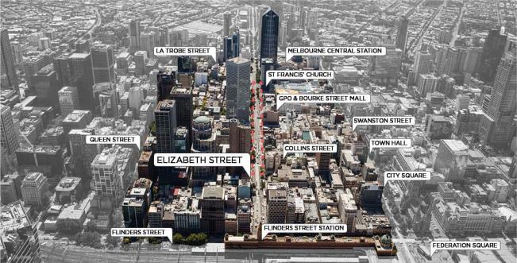

Elizabeth Street: historical significance
Elizabeth Street has played an important role in the history and evolution of the city. Over the past two centuries, the site of Elizabeth Street has gone through a marked transformation from a natural creek, at the low point of the central city, to a bustling city street in the retail core. Today it offers important transport connections to the north and hosts a number of landmarks and significant heritage buildings, including Flinders Street Station and the GPO.
A natural creek line
Melbourne was settled on the land of the Kulin Nations, which continues to be a deeply significant place to it’s Traditional Owners. Prior to British settlement, there was a natural water course named William’s Creek that flowed into the Yarra. This is now known as Elizabeth Street.
Central axis to the ‘Grid’
At the time of early settlement, Governor Bourke, accompanied by the surveyor Robert Hoddle, traced out the streets of the new township of Melbourne to a design known as the Hoddle Grid. Elizabeth Street was located along the central axis of the grid, right in the middle of the eastern and western parts of the township.
Street of landmarks
As further European settlement continued, the central location of Elizabeth Street ensured a social and civic prominence with many historically important buildings and landmarks adorning its edges, many of these remain today. and include the GPO and St Francis Catholic church, one of Melbourne’s oldest surviving buildings.
Key transport route
Into the twentieth century, Elizabeth Street became an important strategic transport connection, like Swanston Street. Today, Elizabeth Street continues to have an important multi-modal function allowing people to connect from Flinders Street and Melbourne Central stations to other areas by tram and on foot.
A retail destination
Elizabeth Street has long been an important commercial district. In the middle of the nineteenth century, it featured a variety and volume of hotels and shops with a notoriety akin to London’s Oxford Street. Today it continues to be at the heart of the ever increasing central city, retail core.

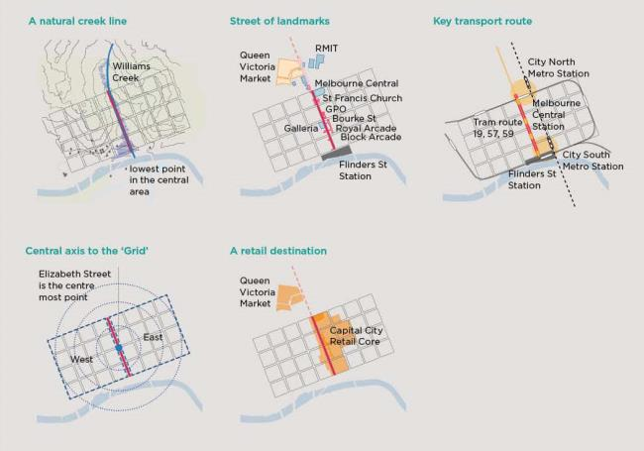

Elizabeth Street today
Elizabeth Street is an intensely active street environment, accommodating an array of activities and transport modes. However, it is currently characterised by poor amenity and constrained walking space, despite significant pedestrian volumes and public space needs in the area.

The Challenges
Congested access to trams and stations
The tram stops and transit interchanges at Flinders Street and Melbourne Central are some of the most congested parts in the city. New accessible tram stops were installed in 2013, however ever increasing user numbers have led to overcrowding, safety issues and also impact network efficiency.
Limited pedestrian space
The City of Melbourne’s daily population has vastly increased over the past two decades, and many of the city’s streets are unable to meet pedestrian demand. Pedestrian flow is key to the functioning of the city and vital to the economy. Current footpaths along Elizabeth Street are not wide enough for the number of pedestrians, resulting in overcrowding and poor pedestrian safety and circulation.
Lack of street trees and places to sit
There is currently a lack of spaces to pause or casually sit and take in the surrounds along Elizabeth Street. There are also entire city blocks, along its length that are absent of any street trees or other landscape. This has created a largely sealed, impervious setting, offering little environmental value or visual amenity to the city.
Image 2: Central City precinct of Elizabeth Street is Melbourne’s retail and commercial heart.
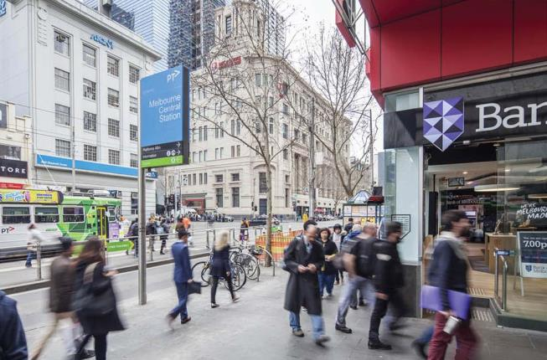

Cluttered street environment
Tourism and retail are vital components of the City of Melbourne’s economy. Welcoming streets attract people and economic activity to the city. Currently, Elizabeth Street is not as attractive as it could be, nor is it easy to navigate due to an abundance of physical elements and clutter in the street. The footpaths are muddled by signage, tram and light poles, services infrastructure and low quality street furniture.
Social and safety issues
There is a perceived safety issue along the southern portion of Elizabeth Street, near Flinders Street, particularly at night. There have also been numerous collisions along Elizabeth Street, with over 95 incidents recorded over a five year period, and around 45% of crashes involving either a cyclist or a pedestrian.
Dominance of vehicle roadway
Elizabeth Street is primarily configured as a vehicle thoroughfare, with almost half the street space being allocated to traffic and parking. Walking has been identified as the way the vast majority of people travel along Elizabeth Street, yet pedestrians have the least amount of space.
Flooding risk and substantial infrastructure
A large proportion of Elizabeth Street is at risk of flooding during heavy rain events. During Elizabeth Street’s construction, the original creek was piped underground taking the form of substantial stormwater drains. The drains constrain where street trees and vegetation can be located along the street.
Obstructed landmarks and vistas
As a key entrance to the central city’s retail area, Elizabeth Street is underwhelming. Important views to landmark buildings and vistas along this major street are obscured by narrow, crowded footpaths and street elements.
Image 3: Record rainfall turns Elizabeth Street into a river. Source: Herald Sun Image Library (1972).
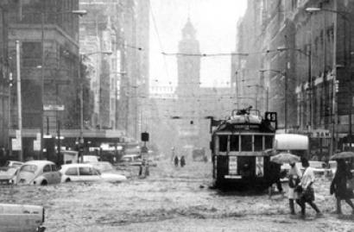

Transport findings
Traffic analysis indicates walking and tram users are the primary transport modes and these modes are growing, while vehicle numbers are declining. Key findings are summarised below:
On average
90% of people on Elizabeth Street walk or catch a tram
PM peak: pedestrian volumes
A plan diagram which indicates the following volumes at these locations on Elizabeth Street:
- 4,393 pedestrians between La Trobe and Little Lonsdale Streets.
- 6,010 pedestrians between Bourke and Little Collins Streets.
- 9,357 pedestrians between Flinders La and Flinders Street.
AM/PM peak: travel mode share
A pie chart indicating that the travel mode share during AM/PM peak hours of Elizabeth Street is as follows:
- 3% People on bicycles
- 6% Vehicles
- 49% Tram users
- 41% Pedestrians

2015 vs 2018 comparisons
Diagram comparing the results of movement surveys undertaken in 2015 and 2018:
Pedestrians
In 2015, in the PM weekday peak there were 1,700 pedestrians, whereas in 2018 there was an increase to 4,393 pedestrians.
The results were for the block between Little Lonsdale to La Trobe St, undertaken during the weekday and indicate total pedestrian volumes covering both sides.
Vehicles
In 2015, in the PM weekday peak there were 730 vehicles, whereas in 2018 there was a decrease to 527 vehicles.
The results were for the Elizabeth /La Trobe Street intersection, undertaken during the weekday and cover both sides of the street, southern section of the intersection.
All diagrams are based on the findings in the Traffic Analysis Elizabeth Street Report, Movendo, 2018.

The future vision
To celebrate and enhance Elizabeth Street as the core retail precinct in the central city by creating a greener, safer, people friendly street.
Place and movement function
Elizabeth Street will be a great city street, successfully meeting the many needs of the community, delivering economic, social and public health benefits. This strategic aspiration aims to achieve a balance in the movement and place function of the street and so is framed around three key themes:
People
Support social, creative, recreational and economic activity
Transport
Create an efficient and safe public realm for walking, cycling and public transport.
Environment
Introduce more nature and foster healthy urban environments.
Image 4. Provide high quality public spaces and amenities such as new street furniture and lighting.
Image 5. Complement the existing cycling network in the Central City with dedicated bicycle lanes for local connectivity.
Image 6. Increase tree canopy cover where possible whilst integrating Water-Sensitive Urban Design measures.
Image 7. Ensure safe and efficient inter-modal connectivity and access to public transport.
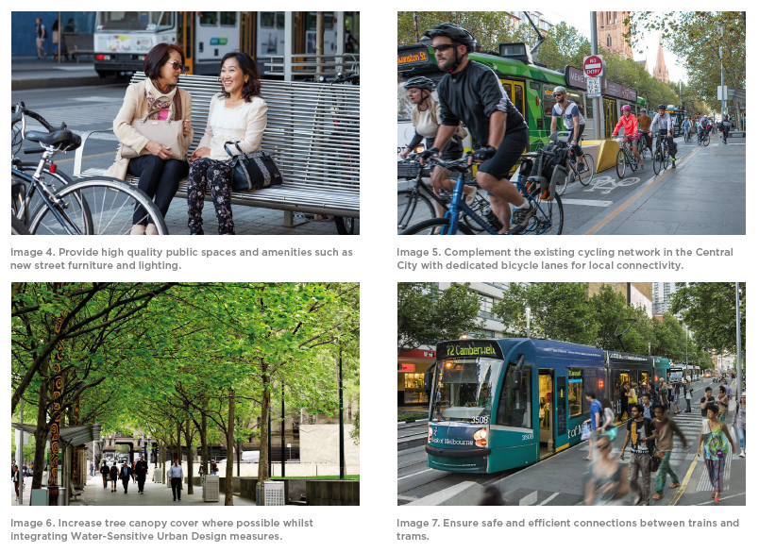

Streetscape objectives
These streetscape objectives draw inspiration from the historical significance of Elizabeth Street and respond to the various site challenges and future needs of our rapidly changing city. Distilled into a set of five objectives, their intent is to guide future planning and design.
People
01 Character
Create a unique, welcoming gateway to the retail core.
Elizabeth Street has a strong history, a distinct local character and a diverse mix of land uses and activities. This objective recognises the rich geographical and cultural heritage of the street over time and supports the diversity of people who use Elizabeth Street today and in the future.
02 Amenity
Improve and expand public amenity through a high quality streetscape.
A high quality public realm will in the long term contribute to the social and economic vitality of the greater municipality. This objective aims to improve pedestrian safety and amenity through a well-designed streetscape that provides upgraded paving, street furniture, planting and lighting.
Transport
03 Safety
Prioritise pedestrians and sustainable modes.
Much of the potential success of Elizabeth Street will depend on a shift in the way the street is currently utilised. This objective addresses the ease of movement along Elizabeth Street and the adequate apportionment of space to sustainable and efficient transport modes, such as walking, cycling and trams.
04 Accessibility
Optimise tram efficiency and inter-modal connectivity.
As a key transport route, featuring increasing user numbers, Elizabeth Street must improve the safety and accessibility of tram stops, provide network efficiencies, clear tram loading, maintain or enhance levels of service and facilitate better inter-modal connectivity between trams and train stations to support business operation and growth.
Environment
05 Environmental benefit
Increase environmental resilience.
This objective highlights the City of Melbourne’s commitment to incorporating as much landscape infrastructure as possible throughout the municipality: to provide shade through increased tree canopy cover; increase biodiversity; and to implement a range of initiatives to minimise flooding risk during heavy rainfall events.

Achieving the vision
To achieve the vision, streetscape improvements are proposed including increased street tree canopy, feature planting, new places to gather and dedicated cycle lanes to improve the overall amenity and character of the streetscape.

Key actions
To simply portray how we can achieve an improved streetscape we suggest six strategic actions:
- De-clutter and rationalize infrastructure.
  - Remove obsolete cabinets, bins.
  - Offer views to key buildings.
- Enable pedestrian priority by limiting traffic in portions.
  - Maintain local access and servicing.
  - Support place activation.
- Extend and upgrade footpaths.
  - New plazas, paving, lighting, street furniture.
  - Creative elements to celebrate the former creek.
- Increase trees and planting.
  - Provide more street trees and feature planting.
  - Integrate flood mitigation measures.
- Provide bicycle lanes for local connectivity.
- Improve public transport access and efficiency.
  - Improve pedestrian safety and tram stop access
  - In the longer term, consolidate tram stops. where possible.

Streetscape opportunities
Streetscape improvements that will enhance the safety, amenity and accessibility of Elizabeth Street include increased street tree canopy, feature planting, new places to gather and dedicated cycle lanes to improve the overall amenity and character of the streetscape.
This Plan proposes to reconfigure the street for pedestrian and public transport priority, suggesting the following changes across two typical street conditions:
Tram stop blocks
In the blocks where there are tram stops, remove all vehicular traffic and extend footpaths on both sides to enable safe and efficient access to tram stops.
Image 8. Existing conditions on a typical tram stop block.
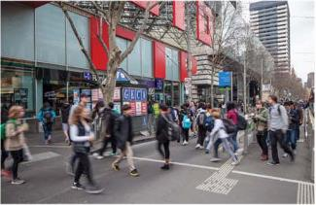
City blocks
In remaining blocks, extend footpaths out to the tram tracks on the eastern side, removing all south lane vehicular traffic, to extend the pedestrianised areas along the edge of the retail core.
Image 9. Existing conditions on a typical city block
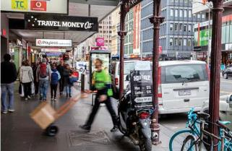

Key benefits
The opportunities outlined in this Plan would deliver the following key benefits:
Character
- An enhanced streetscape appearance with less services/signage clutter, additional trees, new bluestone paving, street furniture and well integrated public art.
Amenity
- Additional places to sit and appreciate landmarks and an increased capacity for street activation
- Widened footpaths that expand pedestrian areas of the retail core, accommodate substantially increased pedestrian volumes and allow for clearer views of key buildings.
Safety
- Increased space around tram stop to significantly improve passenger safety, provide conditions under which it will be easier and safer to board and alight trams and more direct intermodal connectivity.
- Safe and well-illuminated zones through new street lighting and considered placement of street furniture and outdoor café seating.
Accessibility
- Dedicated bicycle lanes that support local cyclist connectivity and attract more people to ride bikes.
- Continuity of the on-street disabled/loading parking supply and emergency service vehicle access.
Environmental Benefits
- Further planting to increase water infiltration and species variety in key locations to improve resilience of the urban ecosystem.
- Mitigation of overflow impacts upstream through the Elizabeth Street Integrated Water Management Plan to minimise flooding risk during heavy rainfall events.
Economic benefits
- Improved reputation and image of the area.
- Increased footfall, longer stays and more retail expenditure.
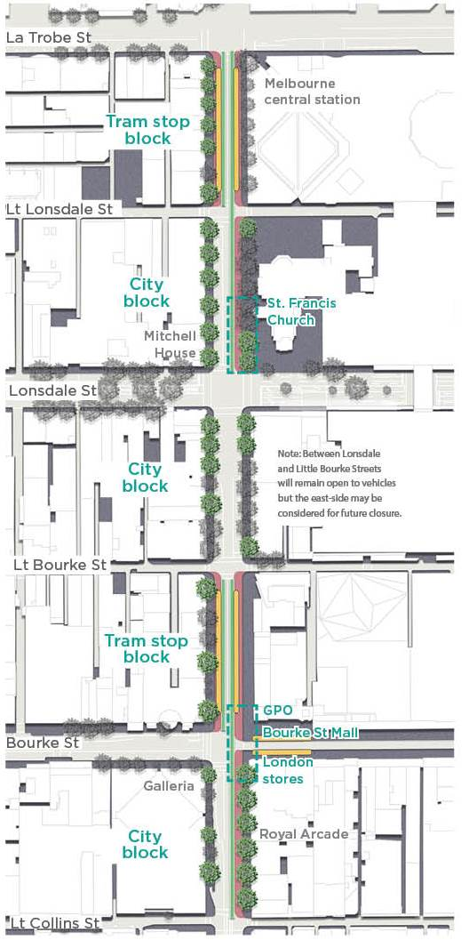
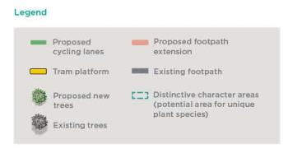

Streetscape opportunities

Elizabeth Street tram stop blocks
Tram stop blocks along Elizabeth Street will be enhanced by removing all vehicle lanes and extending footpaths on both sides to create additional space for safer transport interchanges.
Located between:
- La Trobe and Little Lonsdale Streets; and
- Little Bourke and Bourke Streets

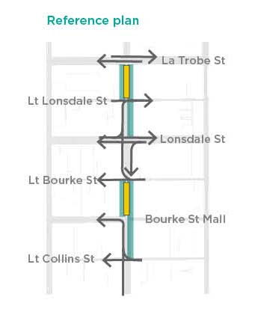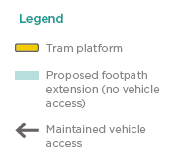
Existing streetscape cross-section
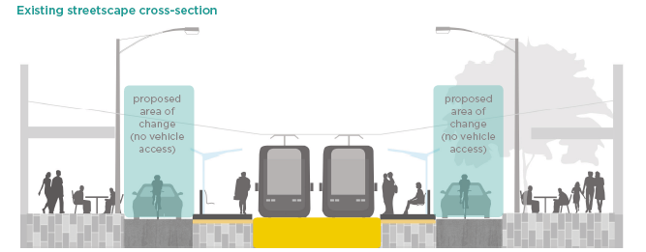
Proposed streetscape cross-section
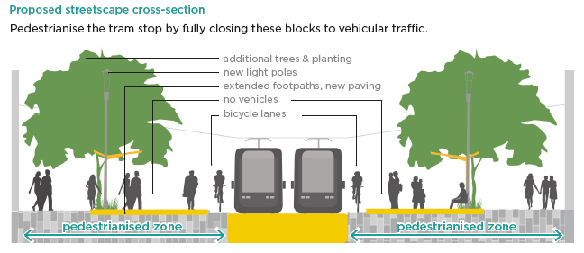
Note: These sections are indicative only, for the purposes of discussion. The final profile of the street will be determined following further engagement and full agreement with the State on overland flow modelling of capacities and best approach to bicycle lane design and streetscape accessibility.

Elizabeth Street city blocks
The remaining city blocks along Elizabeth Street have the potential to become great spaces for people that effectively expand the activity of the retail core. Pedestrianising the eastern side of the street by extending footpaths out to the tram tracks, removing all south lane vehicular traffic, will increase connectivity and provide opportunities for street trading and social interaction.
Located between:
- Little Lonsdale and Lonsdale Streets; and
- Bourke and Little Collins Streets
Note: Between Lonsdale and Little Bourke Streets will remain open to vehicles but the east-side may be considered for distant future closure
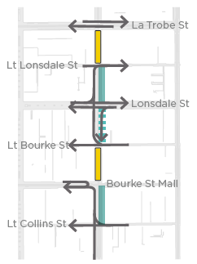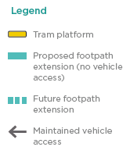
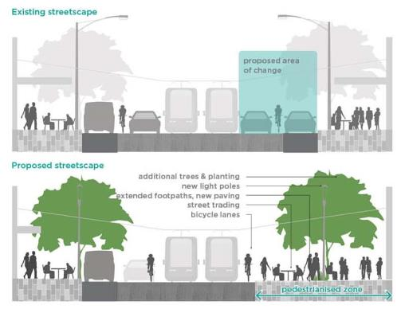
Streetscape opportunities

Tram stop blocks
In the tram stop blocks, there is an opportunity to improve how people access trams to make it much easier and safer for the thousands of people who use this space daily.
Existing streetscape
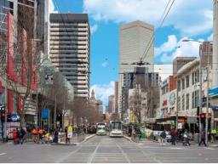
Possible future streetscape
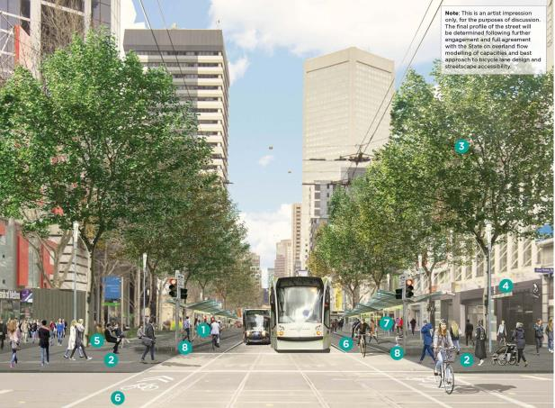
Image 10. Artist’s impression of possible improvements to an Elizabeth Street tram stop block (La Trobe Street to Little Lonsdale Street).

The artist’s impression on the above page illustrates some of the streetscape improvements that we want to investigate further.
- Expand the pedestrian space to meet the tram stops by closing the eastern and western side of Elizabeth Street to traffic.
- Introduce new bluestone paving to both the eastern and western footpaths.
- Plant street trees where possible.
- Reduce the extent of shop canopies to enable tree planting (private owner’s discretion).
- Install new street furniture and lighting.
- Provide dedicated bicycle lanes for local access.
- Limit street trading in these highly populated zones (similar to Swanston Street).
- Provide for integrated security measures.
Note: This is an artist impression only, for the purposes of discussion. The final profile of the street will be determined following further engagement and full agreement with the State on overland flow modelling of capacities, best approach to design of the bicycle lane, accessibility for pedestrians and public transport users and integration with the streetscape.

Streetscape opportunities

City blocks
In the city blocks, there is the opportunity to extend the footpath on the eastern side with additional space for ‘street life’ - places to sit, enjoy outdoor dining and cultural activities.
Existing streetscape
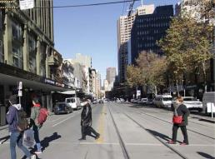
Possible future streetscape
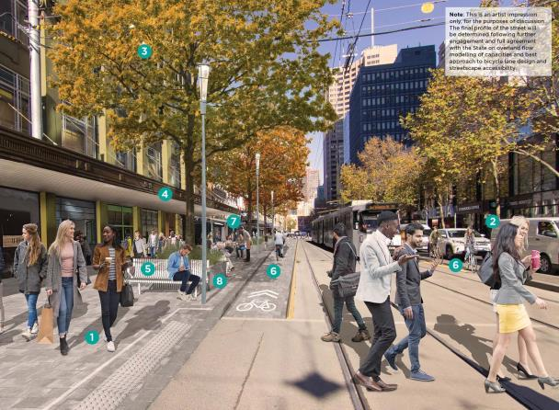
Image 11: Artist’s impression of possible improvements to an Elizabeth Street city block (Bourke Street to Little Collins Street).

The artist’s impression, on the previous page, illustrates some of the streetscape improvements that we want to investigate further.
- Expand the pedestrian space on the eastern side with new bluestone paving.
- Retain one northbound vehicular lane to allow local access and servicing.
- Plant street trees where possible.
- Reduce the extent of shop canopies to enable tree planting (private owner’s discretion).
- Install new street furniture and lighting.
- Provide dedicated bicycle lanes for local access.
- Encourage street activation.
- Provide for integrated security measures.
Note: This is an artist impression only, for the purposes of discussion. The final profile of the street will be determined following further engagement and full agreement with the State on overland flow modelling of capacities, best approach to design of the bicycle lane, accessibility for pedestrians and public transport users and integration with the streetscape.

Preparing for change
Traffic impact assessment
Detailed traffic modelling using an advanced software package known as Sidra Intersection (SIDRA) has been undertaken to test both “single-intersection” as well as “network-wide” impact analysis of capacity, level of service and other traffic performance parameters associated with simultaneous closures occurring at the following locations between La Trobe Street and Little Collins Street.
Full closure of Elizabeth Street in the blocks between:
- La Trobe and Little Lonsdale Streets; and
- Little Bourke and Bourke Streets
East-side closure of Elizabeth Street in the blocks between:
- Little Lonsdale and Lonsdale Streets;
- Bourke and Little Collins Streets: and
- Lonsdale and Little Bourke Streets *Future closure
The results revealed that the proposed closures and redistribution of traffic will have an insignificant impact on the surrounding road network.
Loading and disabled access
Whilst this plan for streetscape improvements does propose restricted areas for vehicle access, a large extent of the western side of Elizabeth Street is proposed to remain open. Vehicles will still be able to move between two city blocks maintaining local access, business servicing and delivery requirements. The current supply of on-street disabled and loading parking spaces could also be retained in alternate locations on Elizabeth Street, ensuring accessibility and continuity of business servicing.
Image 12. Elizabeth Street pop-up park over 2017/18 summer.
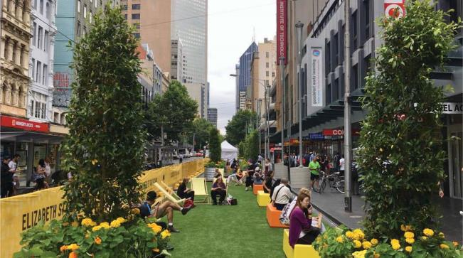

Implementation
Streetscape improvement works along Elizabeth Street are expected to be delivered through multiple phases of implementation, commencing with the southern end (Flinders Street to Flinders Lane) followed by phased delivery of the portion between Little Collins Street and La Trobe Street.
Timing and delivery of these streetscape improvement works will, however, require further testing, detailed design and engagement which will form part of next steps in delivering the opportunities outlined in this Plan. Future construction will be subject to funding and appropriate timing in relation to other major projects and works occurring around the city.
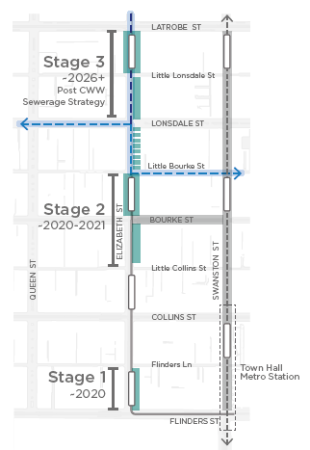
Image 13. Indicative Staging Plan

To sign up for future updates, visit participate.melbourne. vic.gov.au/elizabethstreet or call 9658 9658.

How to contact us
Online
Melbourne.vic.gov.au
In person
Melbourne Town Hall – Administration Building
120 Swanston Street, Melbourne
7.30am to 5 pm, Monday to Friday
(Public Holidays excluded)
Fax
03 9654 4854
In writing
City of Melbourne
GPO Box 1603
Melbourne VIC 3001
Australia

http://www.melbourne.vic.gov.au

