21.08 Economic Development
05/10/2018
GC81
Retail
Retailing is an important component of Melbourne’s Capital City function. The Hoddle Grid will remain the State’s pre-eminent retail centre and retailing in its Retail Core needs to be maintained and enhanced as a world class shopping district while respecting the character and heritage of this areas existing buildings and lanes.
There is a need to support the provision of local shops to serve the residential and working communities in local centres. A proliferation of eating and entertainment uses should not undermine the character and range of services offered in these local centres.
Business
The Central City is the prime location for commerce in metropolitan Melbourne, and along with the St Kilda Road commercial area, is of state significance. Areas zoned Mixed Use and Commercial around the Central City have traditionally provided locations for business activities, which support Capital City functions. These areas are under increased pressure for housing, and it is important to ensure their ongoing functioning and viability as business areas, which serve both local community needs and Capital City business activity.
Industry
Manufacturing uses in the inner City areas will continue to relocate to more competitive industrial locations in outer metropolitan Melbourne. The City of Melbourne, however offers unique locational and access advantages, particularly for advanced manufacturing industries. These industries and associated research have consolidated in the municipality. They are cleaner and more compatible with dense inner urban settings and need to be, protected and supported.
Industries can affect the amenity and environment of nearby sensitive land uses such as residential. Carefully manage this tension between the traffic, noise and other impacts of industrial operations and the amenity of surrounding residential areas.
Knowledge
Innovation in business is central to Melbourne’s economic vitality and its role as a globally competitive Capital City. The municipality is a dense centre of world standard services and research activity particularly in the financial, engineering, biotechnology and design sectors.
The University of Melbourne and RMIT University, the city campuses of four other universities and a number of TAFE institutes are able to link locally with industry, business, hospitals and research institutes in the Parkville, Alfred Hospital St Vincent’s Hospital precincts.
This dense co-location of business, education, and medical and, research centres will be supported to strengthen the City’s competitive and innovative capacity.
Figure 3 Economic Development Map
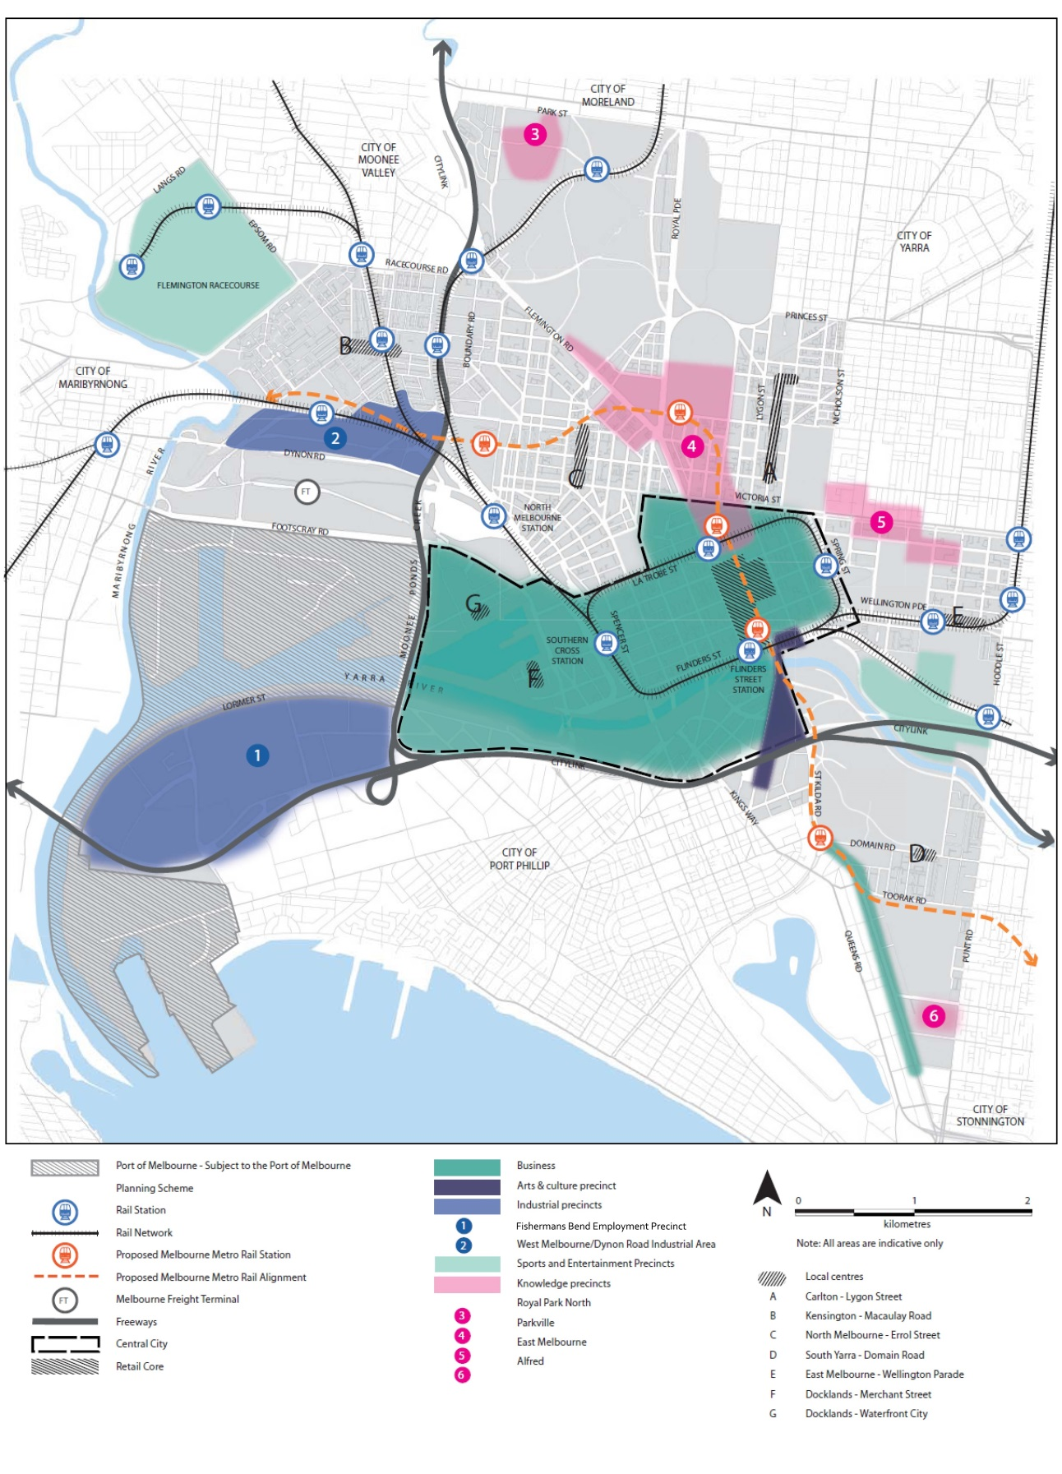
21.08 – 1 Retail
Objective 1 To support the Central City and local retail uses.
12/09/2013
C162

Strategy 1.1 Maintain and enhance the Retail Core as a world class retail offer, by supporting land uses and a built form which sustains this.
Strategy 1.2 Enhance the viability, diversity and vitality of shops and services in local retail centres providing convenience retailing serving the local community.
Strategy 1.3 Balance the regional tourism and local roles of the Lygon Street centre.
Strategy 1.4 Ensure that a proliferation of eating and entertainment establishments in local centres does not undermine the viability of their convenience retailing.
Strategy 1.5 Encourage the provision of convenience retailing and services including supermarkets in the Central City and Urban Renewal Areas for the local workers and residents.
21.08 – 2 Business
Proposed Amendment C323
Objective 1 To reinforce the City’s role as Victoria’s principal centre for commerce.
Strategy 1.1 Support the Central City as metropolitan Melbourne’s principal centre for commerce, professional, business and financial services, and encourage new and innovative business that takes advantage of the Capital City location.
Strategy 1.2 Support the development of Docklands and Southbank as a vibrant business and retail areas along with the Hoddle Grid.
Strategy 1.3 Support the consolidation of St Kilda Road as a vibrant office and high density residential district.
Strategy 1.4 Support improved links between City businesses, tertiary educational institutions, research and development organisations and training institutions.
Strategy 1.5 Support Melbourne as an Australian and the Asia Pacific gateway for health services, financial and business services, education and biotechnology.
Strategy 1.6 Support the development of enterprise incubators and facilities for innovative business sectors.
Strategy 1.7 Support the provision of facilities and services for the changing and diverse needs of residents, visitors and workers.
Strategy 1.8 Recognise the contribution of arts, cultural and creative industries to the economic health, vitality and competitive strength of Melbourne.
Strategy 1.9 Ensure noise and disturbance from late night commerce related activity does not compromise the reasonable needs of residents and other users of the City.
Objective 2 To encourage employment opportunities for local residents.
Strategy 2.1 Encourage a diversity of small to medium enterprises in the Capital City, Docklands, Commercial and Mixed Use Zones.
Strategy 2.2 Support the development of home based businesses, consistent with maintaining amenity in Residential and Mixed Use Zones.
Strategy 2.3 To ensure the nature and intensity of office and commercial activity is appropriate to its location.
Strategy 2.4 Encourage a mix of commercial and business support and services close to the Central City in identified parts of South Carlton, East Melbourne, Jolimont and North and West Melbourne.
Strategy 2.5 Ensure that all new office and business uses manage off site impacts such as noise, traffic generation and parking consistent with the local amenity.
Strategy 2.6 In Residential and Mixed Use Zones support business uses that provide services to the local community only where consistent with local amenity.
21.08 – 3 Industry
05/10/2018
GC81
Objective 1 To improve the long term viability and security of the City’s industries.
Strategy 1.1 Support the development of Fishermans Bend Employment Precinct as a National Employment and Innovation Cluster and as the City’s primary industrial area and the preferred location for clean, advanced manufacturing, research and development, and ancillary services.
Strategy 1.2 Ensure the development of commercial and retail uses in the Fishermans Bend Employment Precinct supports the vision as Australia’s leading design, engineering and advanced manufacturing precinct.
Strategy 1.3 Facilitate the on going role of industry in the West Melbourne Industrial Precinct.
Strategy 1.4 Support the ongoing 24 hour function of the Port of Melbourne and associated industries as Australia’s leading container port.
Strategy 1.5 Support the ongoing function of freight uses in the West Melbourne Industrial Precinct and the development of the Melbourne Freight Terminal to better integrating Port operations and Fishermans Bend Employment Precinct with the rail network.
Strategy 1.6 Support the ongoing operation of concrete batching plants located between Boundary and Rodgers Street and the West Gate Freeway in the transition of the Lorimer precinct from an industrial precinct to a high density mixed used precinct, recognising their significance and the role they plan in urban renewal.
Objective 2 To encourage industries to adopt the highest standards of environmental management practice.
Strategy 2.1 Encourage industries to adopt Environmental Management Plans and ensure new industrial uses incorporate measures to minimise noise and environmental impacts.
Strategy 2.2 Ensure that the appearance and operation of transport, manufacturing and wholesale and distribution industries minimise their adverse impacts on the surrounding road network and on the amenity and condition of the public realm.
21.08 – 4 Maritime precincts
12/09/2013
C162
Objective 1 To promote water transport for recreational and commuter use as part of a larger integrated transport system and consistent with maintaining safe and efficient Port operation.
Strategy 1.1 Maintain opportunities for potential future transport access to the rivers.
Strategy 1.2 Ensure the capacity for necessary shore based infrastructure such as adequate mooring facilities and passenger and service access.
Strategy 1.3 Minimise the extent of marina encroachment into navigable waterways especially in the Docklands.
21.08 – 5 Knowledge precincts
12/09/2013
C162
Objective 1 To support education, medical and research activities.
Strategy 1.1 Support the operation, development and clustering of education research centres and associated uses whilst protecting the amenity of Residential and Mixed Use zoned areas.
Strategy 1.2 Support the increased integration of the tertiary education facilities into the public realm of the City through better access connections and the design of new development.
Strategy 1.3 Encourage research and development uses in appropriate zones throughout the City.
Strategy 1.4 Discourage the encroachment of non-residential uses associated with research, education and medical institutions into adjoining Residential Zones and parkland.
Strategy 1.6 Manage the off-site impacts of education and research facilities such as car parking and traffic to protect the character and amenity, (including visual amenity) of adjoining areas.

