SCHEDULE 10 TO THE DEVELOPMENT PLAN OVERLAY
--/--/20--
C173

Shown on the planning scheme map as DPO10.
CARLTON CONNECT SITE
Site description
The site is described as 114-152 Grattan Street, Carlton and comprises land bounded by Swanston Street to the west, Grattan Street to the South, Cardigan Street to the east and The Royal Dental Hospital of Melbourne building to the north.
- Requirement before a permit is granted
--/--/20--
C173

A permit may be granted to use or subdivide land, construct or demolish a building or construct or carry out works before a development plan has been prepared to the satisfaction of the responsible authority.
Before granting a permit the responsible authority must be satisfied that the permit will not prejudice the future use and development of the land in an integrated manner and will contribute to the vision for the site.
The land may be developed in stages.
- Conditions and requirements for permits
--/--/20--
C--

Except for a permit granted before a Development Plan has been approved in accordance with Clause 1.0 of this Schedule, a permit must contain conditions that give effect to the provisions and requirements of the approved Development Plan.
A permit must also contain the following permit conditions:
- A construction management plan, which is to be prepared in accordance with the City of Melbourne - Construction Management Plan Guidelines and is to consider the following:
    - construction vehicles may not access the site from Swanston Street.
    - traffic management and in particular the need to maintain unimpeded access to Melbourne University tram terminus and adjacent sites and to maintain the provision of safe bicycle and motor vehicle access along Swanston Street.
    - public safety, amenity and site security.
    - operating hours, noise and vibration controls.
    - air and dust management.
    - stormwater and sediment control.
    - waste and materials reuse.

- Requirements for a Development Plan
--/--/20--
C173

A development plan should generally be in accordance with the Indicative Framework Plan as shown in Figure 1 to the satisfaction of the responsible authority.
The development plan must be consistent with the following vision for the site:

An exemplary mixed use and environmentally sustainable precinct, including a number of individual yet visually integrated buildings ranging generally from 25 metres to 59 metres in height, which activate and enhance the frontages along Swanston, Grattan and Cardigan Streets and provide pedestrian links through the site.
The development plan must include the following:
- An urban context and existing conditions analysis describing the surrounding and on-site land uses, built form, buildings, noise sources, access points, adjoining roads, and public transport.
- A summary of the site’s key land use and development opportunities and constraints.
- Urban design principles, which are in line with the objectives and strategies listed at section 4.0 of this schedule, and which contribute to a leading sustainability hub that demonstrates a high quality architectural response, implements innovative environmentally efficient design features, provides opportunity for best practice environmental management and provides a high level of internal amenity and pedestrian permeability.
- Indicative Built Form Concept Plans which show:
  - Building locations and the mix of land uses;
  - Building envelopes including preferred heights and setbacks;
  - Plans or diagrams of the existing buildings or portions of buildings which are proposed to be retained or demolished (if any);
  - Vehicle access, car parking, pedestrian access, disabled access and movement;
  - On-site communal open spaces and the public realm;
  - Landscape concepts;
  - Overshadowing diagrams; and
  - Staging/sequence of development.

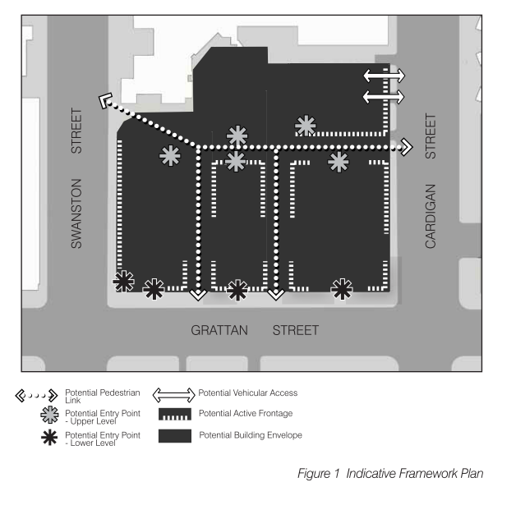

The development plan must be accompanied by the following reports to the satisfaction of the responsible authority:
- An Environmentally Sustainable Development report prepared by a suitably qualified consultant identifying the environmental features to be included in the development, in order to be a leading sustainability hub.
- A Wind Assessment Report prepared by a suitably qualified consultant demonstrating that the development has the preliminary design potential to avoid and minimise unreasonable wind impacts, including actions and requirements to ensure the detailed design will do so without reliance on vegetation. In order to manage wind, the full extent of the building envelope shown in this schedule may not be able to be achieved.
- A Traffic Management Plan prepared by a suitably qualified consultant which includes but is not limited to;
    - Estimated traffic generation (based on the indicative built form and land use mix) and the impact on the existing road network.
    - Preferred location for vehicle egress and ingress.
    - A strategy to encourage walking, cycling and public transport use, including a green travel plan.
- Objectives and strategies for new development
--/--/20--
C177
The Development Plan should demonstrate how the future use and development of land will generally achieve the following objectives and strategies:

LAND USES
The Development Plan should provide:
- An integrated mixed-use development of the site that relates to environmental sustainability research, design and education, to create a leading sustainability hub. Such a mix of uses includes but is not limited to research and development, office, education, exhibition and/or function centre, and multi-dwelling housing.
- Commercial, retail and community uses along key pedestrian corridors.
- Uses and development that do not compromise established activities on adjoining and nearby sites.
- Safe, well designed and managed affordable accommodation.
- The “casing” of the first five levels of buildings with active uses so that a visual relationship between occupants of upper floors and pedestrians is able to be established and better surveillance of the street is achieved.
URBAN DESIGN AND PUBLIC/PRIVATE REALM
The development of the site should:
- Achieve high quality design and exemplary development, including an engaging building interface both above and at street level and high quality landscape treatment.
- Enhance the role of Swanston Street as a civic spine and a major pedestrian and public transport route.
- Create a high level of amenity for occupants of the site.
- Provide design that responds suitably to existing interfaces.
- Provide a range and variety of high quality communal and private outdoor spaces.
- Integrate indoor and outdoor development.
- Create a built form character that complements existing development and the City North precinct to the south west, and steps down at the interface to the lower scale surrounding established neighbourhoods
- Create streetscapes defined by a generally consistent plane of building facades that collectively enclose the sides of the streetscapes whilst allowing good levels of daylight and sunlight to penetrate to the streets and to lower storeys of buildings.
- Contribute to a streetscape which integrates the site with its surrounding context, helping to create a precinct which is safe, appealing and convenient for users at all times of the day and night.
- Incorporate open and enclosed spaces to bring the community together and provide social cohesion.
- Provide for new ways of using and designing open space.
- The development of the site should be generally consistent with the building envelope (preferred maximum building heights and preferred minimum setbacks) specified in Figure 2.

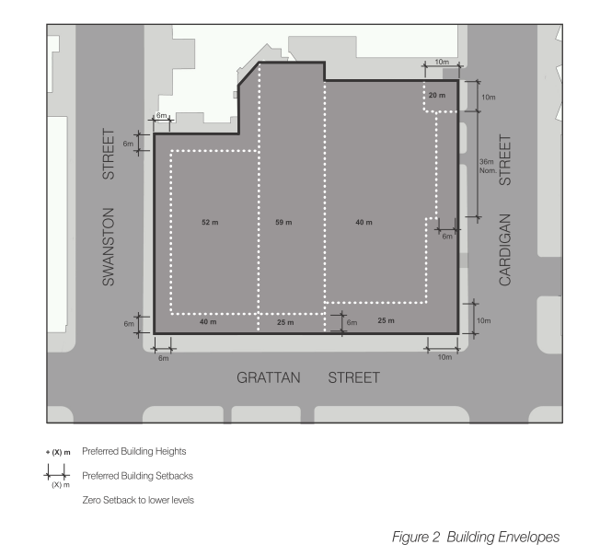
PEDESTRIAN PERMEABILITY, TRAFFIC MANAGEMENT AND BICYCLE & CAR PARKING
The development should make provision for:
- An appropriate level of motorcycle and bicycle parking and related facilities provided on site.
- Any vehicular access and parking provided on site, minimises impacts on communal spaces and on bicycle and pedestrian movement.
- Management of traffic impacts associated with the new development to the satisfaction of the responsible authority.
- Safe access for pedestrians and bicycle users at all times of the day and night.
- Convenient access for disabled persons to, from and within the site.
- Enhanced pedestrian permeability of the site and the provision of convenient and direct pedestrian movements east-west between Swanston and Cardigan Streets as well as north-south links.
- No construction vehicle access from Swanston Street.
- A ground floor splay to reduce pedestrian congestion at the Swanston Street and Grattan Street intersection.
- Vehicle access preferably at the northern end of the site off Cardigan Street and limited to left-in left-out movements.
ENVIRONMENTALLY SUSTAINABLE DESIGN
Development on the site should:
- Minimise the production of greenhouse gas emissions and maximise energy efficiency.
- Minimise mains potable water use and encourage the use of alternative water sources.
- Minimise waste going to landfill, maximise the reuse and recycling of materials and provide optimal waste collection efficiency.
- Make optimum use of available technology to contribute to future flexibility in the use of the site including its potential future reconfiguration.
- Contribute demonstration projects, advancing knowledge and establishing new benchmarks in sustainable development.
- Include an assessment of opportunities for district-scale sustainable infrastructure.
- Address all six categories of the Green Star Communities pilot tool.

COMMUNAL SPACES AND COMMUNITY FACILITIES
Development on the site should:
- Enhance the public realm and linkages between public spaces where possible.
- Create places for people to meet, sit and socialise.
- Provide community facilities that complement the existing services and facilities provided in the neighbourhood.

