SCHEDULE 8 TO CLAUSE 43.02 DESIGN AND DEVELOPMENT OVERLAY
--/--/20--
Proposed C278

Shown on the planning scheme map as DDO8
Sunlight access to public parks
1.0 Design objectives
--/--/20--
Proposed C278

To ensure the amenity of parks is protected throughout the year by maximising winter sunlight access.
To protect sunlight access to parks to support the health and wellbeing of all park users and the ecological health of the park.
To ensure new development responds with appropriate building heights and setbacks to protect sunlight access to parks.
2.0 Buildings and works
Definitions
--/--/20--
ProposedC278

For the purpose of this schedule:
- Park means the land identified as Park Type 1, 2 or 3 on Maps 1 to 10
- Land abutting a park means land with a common boundary to a park or land separated from the park by a public street or laneway.
- Existing shadow means any shadow cast by existing buildings and works
- Allowable shadow means the shadow that would be cast on the park, between 10am and 3pm, June 21, by a street wall of a building on land abutting a park, built to the lower of any street wall height requirement or building height requirement specified in this planning scheme as shown in Figure 1 below.

Figure 1
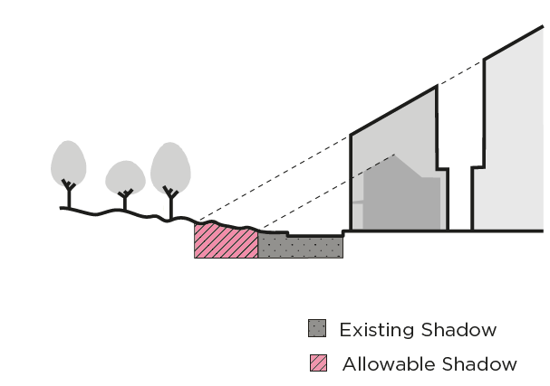
Buildings and works for which no permit is required
--/--/20--
Proposed
C278

A permit is not required for:
- Buildings and works where the overall building height is 9 metres or less.
- Buildings and works to an existing building(s) which do not alter the height or setback of any part of an existing building.
- Buildings and works which would cast a shadow across the Yarra River Corridor between 11am and 2pm on 22 June caused by unenclosed structures associated with the construction of gangways, mooring poles and pontoons which are constructed by or on behalf of Melbourne Parks and Waterways or Parks Victoria under the Water Industry Act 1994, the Water Act 1989, the Marine (Drug, Alcohol and Pollution Control) Act 1988, the Parks Victoria Act 1998, or the Crown Land (Reserves) Act 1978.
Permit requirements
--/--/20--
Proposed
C278
A permit cannot be granted for buildings and works that do not comply with the requirements set out in Table 1. In the event that buildings and works cast shadow over two or more parks in different categories, the requirement for each respective park must be met.

Table 1
Park type on Maps 1-10 | Hours and date
1 | Buildings and works must not cast additional shadow onto the park between 10am and 3pm, on June 21 beyond the existing shadow.
2 | Buildings and works must not cast additional shadow onto the park between 10am and 3pm on June 21 beyond the existing shadow or allowable shadow (whichever is the greater).
3 | Buildings and works must not cast additional shadow onto the park between 10am and 2pm, June 21 beyond the existing shadow.
3.0 Subdivision
--/--/20--
Proposed
C278

A permit is not required to subdivide land.
4.0 Signs
--/--/20--
ProposedC278

A sign must meet the requirements of this Schedule.
5.0 Application requirements
--/--/20--
Proposed
C278

The following application requirements apply to an application for a permit under Clause 43.02, in addition to those specified elsewhere in the scheme and must accompany an application, as appropriate, to the satisfaction of the responsible authority:
- A 3D model of the proposed buildings and works in a format in accordance with the City of Melbourne 3D Digital Modelling Advisory Note. The 3D model must show:
  - The existing shadow cast on the park during the defined period by existing buildings and works.
  - If applicable, the extent of allowable shadow cast onto a park during the defined period resulting from future built form compliant with nominated requirements in the planning scheme.
  - The extent of shadow to be cast by the proposed buildings and works.
  - Compliance with the requirements in Table 1 to this schedule.

6.0 Decision guidelines
--/--/20--
Proposed
C278

None specified.

Maps 1-10 to Schedule 8
