Draft City River Strategy
Analysis of Community Engagement Results
Summary Report 28 August 2019
Prepared by Global Research Ltd for City of Melbourne

Developing a City River Strategy to Guide Future Aspirations for Melbourne's Inner-City River
The Yarra River, traditionally known as the Birrarung, is one of the defining features of Melbourne. It's a recreational area and a destination for many activities that contribute to the life of the city.
As Melbourne continues to grow and change, sustaining and improving people’s experience of the Birrarung is an important priority.
The City of Melbourne is developing a strategy to guide Council’s future planning of the inner-city section of the river. It will outline opportunities to improve the way we use our river and its edges.
“The goal is to significantly raise the quality of the Birrarung environs in the central city stretch to be the centrepiece of Melbourne’s economy, culture and liveability”
There are many projects, plans, and strategies relating to the inner-city area of the Birrarung, that are currently being completed by various levels of government and private developers. This highlights a need to clearly define our preferences regarding the central city waterways and waterfront usage.
Between 17 April and 7 July 2019, a public consultation process was undertaken to communicate City of Melbourne’s emerging vision for the City River. It gauged levels of support for fourteen proposed Strategic Directions, within the themes of Culture, Ecology, Movement, and Place.
It included online and face-to-face engagement activities, pop-ups along the river, an online survey, stakeholder meetings, posters in community facilities, social media posts and an ideas forum.
This document presents a summary of the community engagement feedback received from community members and other key stakeholders. Independent analysis and a detailed Community Engagement Report has been prepared by Global Research.
A Draft Strategy Overview, and the full Community Engagement Report can be accessed via https://participate.melbourne.vic.gov.au/city-river-strategy.

Purpose of Engagement
The purpose of the engagement was to gain feedback on the City of Melbourne’s future aspirations for Melbourne's inner-city Yarra River.
The engagement aims were threefold:
- To communicate City of Melbourne’s draft vision for the river.
- To encourage the community to provide feedback on the draft City River Strategy.
- To test the proposed strategic directions with key stakeholders and the community, so the final strategy will have community support.

The Study Area
The focus of the Strategy is the inner-city reaches of the Birrarung, covering 11kms of diverse river edges and urban settings (5.7km on the north bank and 5.6km on the south bank).
Many people currently use the river and its surrounds within our city as a place to exercise, commute, relax and socialise. Improvements to the areas outlined in the strategy are envisaged to create areas that are destinations, spaces which people can both actively and passively enjoy.

The Strategy
The City River Strategy proposes a design approach for the inner-city reach of the Birrarung. It is organised around four key themes, within which key strategic directions are outlined to provide guidance on how the river and its edges should be planned for and managed.
The four themes are:
Culture: Heritage and narrative. Cultural values, stories, spiritual, genealogical, historical.
Ecology: Habitat and water. Holistic urban waterways environment: landscape, ecology and water.
Movement: Journey and connection. Network of connections to and along the waterfront.
Place: Activity and character. Identity, quality, activation and economy of the urban environment.
The development of the draft Strategy was based on the following approach:
- A review of relevant plans, strategies and policies that influence the planning and design of the waterways across the City of Melbourne municipality.
- Site visits involving the observation of user behaviour and the influence of the physical environment on their behaviour.
- Reference to the City of Melbourne’s pedestrian counting-data at key locations across the corridor, and reference to previous speed and volume surveys undertaken through recent studies.
- Pre-contact historical research of vegetation and landscape conditions.
- Multi-layered analysis of: biodiversity and urban forest; topography and flooding; place and urban design; access and movement; and, activation and uses.
- A review of international best practice in urban waterfront developments.
- Key internal and external stakeholder engagement, including commencing discussions with the Traditional Owner groups.

How We Engaged with the Community

ENGAGEMENT REACH
ACCOUNTS REACHED (TWITTER, LINKEDIN AND FACEBOOK) | 42,683
VISITORS TO THE CITY RIVER PAGE | 5,000+
CLICKS ON PARTICIPATE MELBOURNE LINK TO VIEW THE PROJECT PAGE | 321

HOW RESPONSES WERE COLLECTED
IDEAS FORUM NOTICEBOARD FOR COMMENTS, ATTRACTING 1169 REACTIONS | 128
FACE-TO-FACE POP-UP SESSION RESPONSES | 100+
ONLINE SURVEYS | 79
STAKEHOLDER SUBMISSIONS | 13

Who Completed the Survey
In total 79 survey respondents:

AGE OF SURVEY RESPONDENTS
1 | 5 | 23 | 19 | 13 | 10 | 8
UNDER 18  YEARS OF AGE | 18-24  YEARS OF AGE | 25-34  YEARS OF AGE | 35-44  YEARS OF AGE | 45-54  YEARS OF AGE | 55-64  YEARS OF AGE | OVER 65  YEARS OF AGE

MAIN REASON SURVEY RESPONDENTS VISITED THE BIRRARUNG
52 | 33 | 36 | 19 | 18
RECREATION | TRANSPORT | EXERCISE | ENTERTAINMENT | OTHER REASONS

WHERE SURVEY RESPONDENTS LIVE
39 | 39 | 1
CITY OF MELBOURNE | GREATER MELBOURNE | INTERSTATE

HOW OFTEN SURVEY RESPONDENTS VISITED THE BIRRARUNG
28 | 24 | 23 | 4
DAILY | WEEKLY | MONTHLY | QUARTERLY

The Majority of Respondents Supported the Strategy
The strategic directions outlined in the draft City River Strategy were broadly supported by the majority of respondents.
Culture | Ecology | Place | Movement
At least 87% of respondents ‘strongly agreed’ or ‘agreed’ with the directions. | At least 97% of respondents ‘strongly agreed’ or ‘agreed’ with the directions. | At least 90% of respondents ‘strongly agreed’ or ‘agreed’ with the directions. | At least 85% of respondents ‘strongly agreed’ or ‘agreed’ with the directions.

Summary of Opinions on Strategy Directions

Culture - Heritage and Narrative
Collaborative (C1): Ongoing collaboration with Traditional Owners to tell the Aboriginal story. | 69% Strongly Agree | 22% Agree | 9% Disagree
Visible (C2): Increase visibility of Aboriginal intangible heritage and history. | 69% Strongly Agree | 24% Agree | 8% Disagree
Maritime (C3): Recognise maritime, historical and contemporary importance. | 41% Strongly Agree | 46% Agree | 13% Disagree

You said:
“Maintaining Aboriginal history alive, especially in such an essential location as the Birrarung, is crucial to actually being able to re-tell the story of the river.”

We heard:
- Traditional Owners must be acknowledged via a visible presence in any changes to the river or its banks.
- First Peoples’ input is valued, equating it with returning to more environmentally sound principles.
- Historical connections to the river should be recognised and a strong narrative should be present and accessible to river visitors.
- We should celebrate post-contact maritime history alongside Aboriginal history, as well as the histories of trade, immigration, and recreation as valuable aspects of the river’s story.

Ecology - Habitat and Water
Ecology – E1 Riparian greening: Re-introduce riparian zone, improving water habitat, biodiversity and a healthy river ecosystem. | 87% Strongly Agree | 10% Agree | 3% Disagree
Ecology – E2 Connected: Optimise urban river bank vegetation, prioritising Indigenous, improving biodiversity and ecological networks. | 87% Strongly Agree | 10% Agree | 3% Disagree
Ecology – E3 Resilient: Address flood risk and improve water quality. | 84% Strongly Agree | 16% Agree | 0% Disagree

You said:
“The ecology of the river is crucial to promote and restore urban ecology within the city, for both local fauna and for the benefit of humans.”

We heard:
- It’s important that we have a healthy and useable river; ideally one we can swim in one day.
- A healthy river is one that is ecologically robust, biologically diverse, and in many cases planted with native vegetation – resembling as closely as possible pre-European settlement states.
- A whole-of-river-system approach, with appropriate planting is necessary, as opposed to piecemeal river modifications.
- We need to be environmentally responsible. This will have positive outcomes and benefits to communities.

Place - Activity and Character
Place – P1 Inviting: Prioritise Northbank renewal to create an inviting backdrop to the City. | 57% Strongly Agree | 41% Agree | 2% Disagree
Place – P2 Multi-functional: Celebrate character areas and encourage new economies: a range of civic, educational, cultural, hospitality and water-dependant uses. | 69% Strongly Agree | 26% Agree | 5% Disagree
Place – P3 Public: Sustain the civic focus by encouraging activation that offers broader inclusion and supports a public waterfront. | 54% Strongly Agree | 36% Agree | 10% Disagree
Place – P4 Legible: Rationalise clutter and on-water infrastructure to ensure unobstructed vistas and views. | 60% Strongly Agree | 37% Agree | 4% Disagree

You said:
“The river is important to Melbourne and anything to enhance it – and the public’s use of the river and waterfront – are to be encouraged.”

We heard:
- It would be good if the river developments included a new public swimming pool.
- The river should be the setting for a wide range of uses and activities, but especially for active and passive recreation.
- Water pollution, litter, graffiti and other issues need to be addressed as they detract from the river’s natural amenity value.
- The river ought to be an attractive and inviting destination for visitors.

Movement - Journey and Connection
Movement Theme – M1 Slow: Distinguish the river by creating safe, alternative north and south bicycle routes. | 62% Strongly Agree | 27% Agree | 11% Disagree
Movement Theme – M2 Integrated: Transform the condition of key ‘barriers’ to address the gaps to the north-west and integrate access. | 62% Strongly Agree | 37% Agree | 1% Disagree
Movement – M3 Accessible: Raise the quality and universal accessibility of riverfront pathways | 64% Strongly Agree | 33% Agree | 3% Disagree
Movement – M4 Water transport: Encourage more water-related activity and greater diversity of vessels, particularly more non-motorised crafts. | 52% Strongly Agree | 33% Agree | 14% Disagree

You said:
“I have seen a lot of pressure on the area, it has many tourists so would benefit from alternative routes for fast cyclists.”

We heard:
- Walking and cycling should be encouraged; however, the current state of shared paths is problematic for pedestrians (who feel unsafe) and commuter cyclists (who want to travel faster), as well as for tourists.
- Perhaps there could be alternative routes for fast cyclists, which might be separated from other transport modes.
- It’s important that all the city river reach areas are accessible, with ease of movement in and between them. More coherent and cohesive design would create logical routes and simpler wayfinding.
- It would be good to see more watercraft available and used, particularly non-motorised vessels and public transport.

Ideas Forum Comments

You said:
“A river Pool! Public bathing, lap swimming, kids recreation. It’s what the Yarra should be about.” (+33 positive reactions)

We heard:
- The topic of a pool at the Yarra was the most ‘liked’, receiving 28 comments, and attracting a total of 450 ‘likes’. Respondents showed clear support for the inclusion of a public dedicated swimming area at the Yarra.
- Relatedly, a swimmable and/or clean river was called for by Ideas Forum respondents. Swimmability was frequently raised in relation to its health and vitality as a water body, with comments urging that the river be cleaned up, healthy, or clean enough to swim or fish in.
- Community spaces, including recreation and play spaces were called for by 22 people (and agreed with by 68 ‘likes’). Suggestions included community gardens, boat launching places, outdoor gyms, public spaces, events spaces, parks and water-based events/sports.
- Riparian planting and plants to provide habitat for animals and birds were supported by 12 people (and by 61 ‘likes’). A focus on landscape, and landscaping interventions, were sought, as well as general agreement that nature was favourable compared with hard surfaces/edges.
- There was agreement from several people that certain areas were currently uninviting, and that improvements could and should be made.

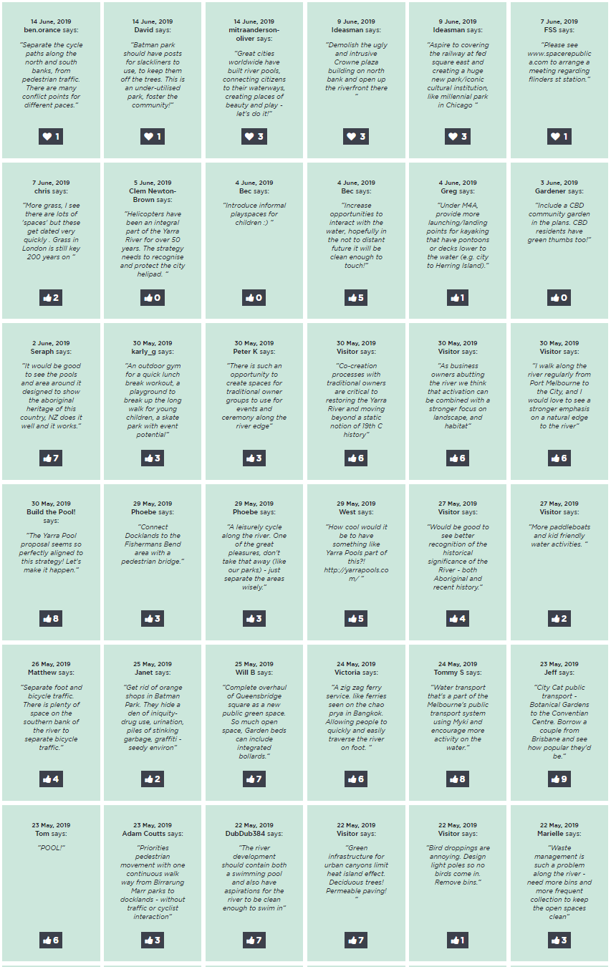

How your Feedback will be Used
We have received community and stakeholder support for the draft City River Strategy.
Your feedback is helping us revise our draft City River Strategy. The next step is to present the strategy to the Future Melbourne Committee. The Strategy will be finalised early 2020.
The vision and priorities articulated in the Plan will provide Council with a formal position from which to advocate to the State government, and to better facilitate collaboration across the full length of the City River corridor.
Your feedback is also being shared with and considered by Melbourne Water, who is tasked with undertaking the Yarra Strategic Plan. The insights gained through our consultation activities will provide them with an understanding of key ideas and opportunities for river improvement that have the greatest community support.
Thank you to everyone who has shown interest in the City River Strategy and contributed to our consultation process. Your positivity and constructive ideas are helping Melbourne make the most of the incredible city asset that is the Birrarung.

This report has been prepared by:
Global Research
150 Office Rd
Merivale
Christchurch 8014
New Zealand
+64 3 355 4562
www.globalresearch.nz

