Draft Transport Strategy 2030

Summary of feedback analysis and responses

# Introduction

The Draft Transport Strategy 2030 (the strategy) was endorsed by Future Melbourne Committee for consultation on 7 May 2019. This strategy was developed following extensive community consultation through 2018, which included the development of background reports, the release of eight discussion papers and a significant public conversation and stakeholder involvement. Results of the first phase of consultation are available at [participate.melbourne.vic.gov.au/transportstrategy](https://s3.ap-southeast-2.amazonaws.com/hdp.au.prod.app.com-participate.files/2815/5235/3448/COM_SERVICE_PROD-11901322-v6A-REPORT_-_Transport_Strategy_refresh_-_EY_Sweeney_Participate_Melbourne_Community_Analysis.PDF)

A feedback process on the Draft Transport Strategy occurred from 8 May 2019 to 19 June 2019. This engagement focussed on the detail in the strategy via both online and face-to-face activities.

This report provides a summary of engagement activities, feedback received and key updates made to the strategy in response. A full list of comments received and officers’ responses will be posted on Participate Melbourne following the endorsement of the final Transport Strategy 2030.

The 2019 engagement program was the second time that the transport strategy was the subject of significant community consultation. The first was in April 2018 when the public was invited to respond to a series of eight discussion papers about important transport issues. The results of the 2018 engagement were reported to Council on 11 December 2018 ([link](https://www.melbourne.vic.gov.au/about-council/committees-meetings/meeting-archive/pages/council-meeting-11-december-2018.aspx)). Engagement on the Transport Strategy generated the largest response to a City of Melbourne consultation process.

# Summary of engagement

## Who we heard from

* Community members
* Victorian Government departments and agencies
* Transport industry groups
* Resident groups
* Local Government Authorities
* Members of Parliament
* Professional bodies
* Major landholders
* Local businesses
* Transport related businesses
* Start-ups

## How the community spoke with us

* Hundreds of face-to-face conversations
* Formal information sessions with Q&A
* 16,000 social media reactions, engagements, likes
* 6,950 website visits
* 382 survey responses
* 45 formal submissions

## What we heard

* 1288 individual comments on more than 90 topics
* 89.5 per cent of survey respondents indicated ‘support’ or ‘strong support’ for the strategy

# Engagement activities

## Participate Melbourne engagement portal

Participate Melbourne was used as a one-stop-shop for the community to learn about the strategy and provide feedback. All background materials including the summary of the first phase of consultation, research reports, discussion papers and the strategy were posted on Participate.

The community was invited to provide feedback on the draft via several channels. A survey stepped the participants through the strategy initiative-by-initiative, with feedback given via a series of ratings and an open text field. An option for uploading a submission was also available for those wanting to provide more extensive feedback.

## Social Media

Social media was employed as a key tool to attract visitors to the Participate Melbourne webpage, while simultaneously raising the profile of the project.

Social media reach included:

* six videos
* Facebook posts, Instagram stories
* 500,000 “impressions” (passive interactions where the viewer is aware of the content)
* 109,000 video views
* 16,000 reactions, engagements, likes
* 3,750 clicks through to webpage

## Information Sessions

Two information sessions were held, giving the community an opportunity to meet council officers face-to-face, participate in detailed discussions, hear from project leadership, and ask questions at a formal Q&A panel. Seventy members of the community attended the events, held on a weekday evening and a weekend morning.

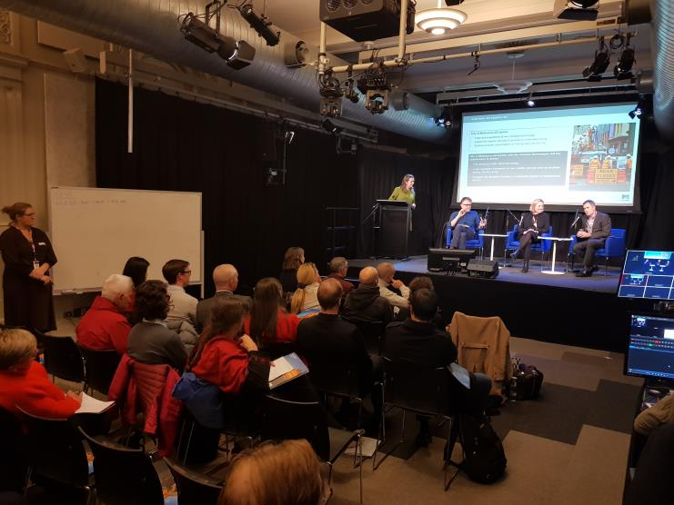Transport experts involved in the development of background papers also attended to help answer specific questions fielded by community members. Questions posed during the Q&A and comments written on post-it notes were captured and included as feedback.

## Community Pop-Ups

In order to reach members of the community who may not otherwise engage with the strategy, a series of pop-ups were held across the municipality. Members of the community passing these pop-ups were encouraged to ask questions about the strategy and transport in general. Council officers distributed postcards with links to more information about the strategy and encouraged passers-by to provide feedback.

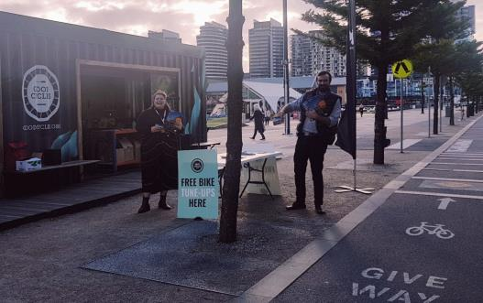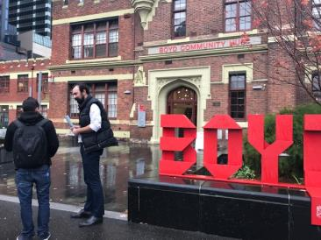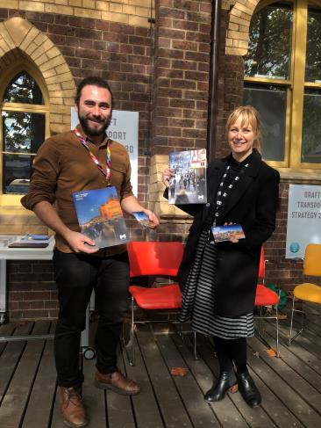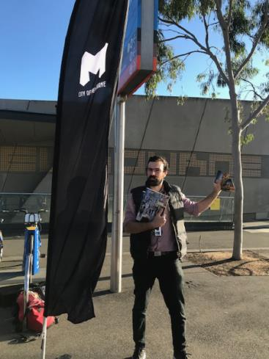

These pop-ups generated significant traffic to the Participate Melbourne website. Passers-by were also welcome to use IPads available to complete the feedback surveys at the location.

More than one thousand community members visited pop-ups, were given postcards, completed surveys on-the-spot, or participated in in-depth conversations about the strategy.

## Interactive Virtual Reality Bike Experience

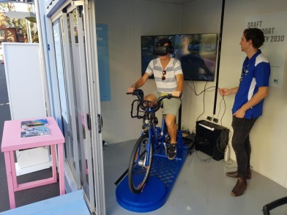An interactive virtual reality bicycle experience was developed in partnership with RMIT and RACV and deployed at the Melbourne Knowledge Week “Prototype Street”. This interactive exhibit allowed members of the community to cycle along a virtual street with several different safety treatments, to understand the differences between protected and unprotected environments.

More than 400 community members visited the exhibit, and more than 100 engaged with council officers in detailed discussions about transport in Melbourne. An IPad was available for community members to complete surveys on the strategy onsite, while others chose to take post cards or summary documents to read at their leisure.

## Postcard Drop

Postcards were produced to inform the community that the engagement on the draft strategy was occurring. These were distributed in cafes, libraries, community centres, sports centres, at universities and in other locations across the City of Melbourne. Over fifty locations were selected to help maximise the coverage and encourage feedback on the draft from a diversity of community members.

# Feedback

Feedback included comments on over 90 different topics. The Transport Strategy team analysed every comment from every survey response and submission to understand community sentiment, and further develop the strategy to reflect the aspirations, concerns, and needs of the community.

## About our analysis

Each comment was reviewed, and categorised using a series of criteria:

* *Topic*
  + Comments were categorised based on the topic they focus on. Examples include “Through-Traffic”, “Disability Access” and “Speed Limits”
* *Level of support*
  + Comments were categorised based on their alignment with the strategy.
  + Comments considered to be in alignment with initiatives outlined in the strategy were categorised as “Comment in support of initiatives, policies and actions in the Draft Strategy”.
  + Comments considered to be in conflict with initiatives, policies and actions outlined in the strategy were categorised as “Comment opposed to initiatives, policies and actions in to the Draft Strategy”.
  + Comments that were neither in alignment nor in conflict with the strategy were considered to be “Neutral”. These were often general comments, comments beyond the scope of the project, or comments noting facts.
* *Action*
  + An assessment was undertaken for each comment, to determine the best way forward.
  + Comments which influenced a change in the strategy were categorised as “include”.
  + Other comments, categorised as “refer”, were referred on to other departments, agencies or organisations.
  + Comments which did not influence any change in the strategy were categorised as “no change”
  + Some comments were categorised as “respond”, indicating a direct response from the Transport Strategy team is required.

Details from the top ten topics are provided on the following pages.

## Topic 1: General comments

One hundred and twenty three comments were classified as “General Comment”. These comments were mostly broad in nature, and often related to the strategy as a whole. Forty-five per cent of these comments were in alignment with the strategy, while a further forty-six per cent were categorised as “neutral”.

*Comments frequently mentioned:*

* Strong support for the general directions, themes and outcomes
* Support for the vision
* Support for use of data and evidence
* Requests for acceleration of implementation
* Calls for the prioritisation of outcomes detailed in the strategy
* The need for improved clarity on funding and resourcing
* Requests for improved collaboration with other LGAs
* Calls for additional consideration of municipal areas outside of Hoddle Grid
* Further consideration of safety in public spaces relating to transport e.g. lighting
* Confusion generated by the use of particular language.

*Key changes to the strategy:*

* Content edited to clarify benefits and actions for areas outside the central city
* Implementation plan developed for the strategy
* Language around several key terms was clarified. ie.‘productive kerb space’ was noted to be very frequently misunderstood and a source of confusion
* Lighting added as an initiative to improve safety for walking and cycling.

## Topic 2: Public Transport

Public Transport was the most commonly discussed specific theme, with 152 comments. Fifty-eight per cent of the comments were in alignment with the strategy, while a further thirty-eight per cent were categorised as “neutral”.

*Comments frequently mentioned:*

* A desire for improvements to station precincts
* Calls for improvements to tram priority and separation
* Strong support for improved frequency and reliability
* Accelerating rollout of accessible stops integrated with streets
* Calls for improved on-road priority for buses including trials of signal priority
* A desire for improved integration of bikes and public transport
* Consideration of tour buses and coach services.

*Key changes to the strategy:*

* Emphasis added to elevate the importance of reducing delays to buses and trams to improve reliability.
* Emphasis added to policies to assist with the prioritisation of buses.
* Clarity added surrounding aspirations for universal accessible design
* New content added to focus on ways to integrate bicycles with public transport
* Numerous technical updates and additions were made based on feedback from subject matter experts.

## Topic 3: Bicycles

Bicycles were discussed frequently, with 137 comments identified. Eighty-one per cent of the comments were in alignment with the strategy, while a further sixteen per cent were categorised as “neutral”. These included comments about network, design, infrastructure and safety.

*Comments frequently mentioned:*

* Strong support for protected bike lanes to be continued up to intersections
* Strong support for completion of missing links in network
* 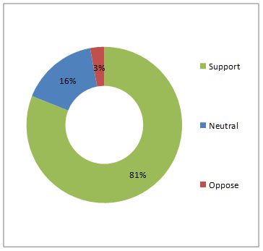Support for behaviour change and education programs
* Additional provision and improved standards for end-of trip facilities
* More consideration of lighting
* A desire for CoM to work with neighbouring councils
* Calls for better integration of bicycles and public transport
* Requests for “Little Streets” to facilitate bicycle movement
* Concern that space reallocation proposed in the strategy is insufficient for supporting mode shift aspirations.

*Key changes to the strategy:*

* Lighting added as an initiative to improve safety for cycling and walking
* New content included to focus on ways to integrate bicycles with public transport
* Added the need to investigate opportunities for green wave signal phasing to support bicycle use.
* The need for new commercial and multi-unit buildings to provide end of trip facilities was elevated.

## Topic 4: Walking

Walking was a frequently discussed theme, with seventy-six comments. Seventy nine per cent of the comments were in alignment with the strategy, while a further twelve per cent were categorised as “neutral”. Nine per cent of comments about walking were in conflict with the initiatives, policies and actions described in the strategy.

*Comments frequently mentioned:*

* Concerns that overcrowding is a frequent and problematic experience for many visitors and residents
* Strong support for the removal of footpath obstructions
* Support for wider footpaths, raised pedestrian crossings, and kerb removal
* Support for reduced delays and crossing distances
* Requests for additional raised crossings
* A desire for pedestrians to keep to the left when walking
* Requests that behaviour change programs and initiatives are employed to increase pedestrian awareness of surroundings
* Support for countdown timers and improved lighting for pedestrians
* Concerns surrounding mixing of pedestrians and bicycles

*Key changes to the strategy:*

* Text added and edited to ensure additional focus on universal accessibility
* Clarity provided on policy positions on shared zones, shared spaces and shared user paths to reduce confusion
* Additional reference to pilots and trials added to fast-track implementation which delivers improved walking environments
* Content updated to ensure clarity surrounding the relationship between walking, footpath crowding, and obstructions

## Topic 5: Motorcycles

A significant number of comments mentioned motorcycles. Out of a total of sixty-three comments, fifty-seven per cent were in conflict with the initiatives, policies and actions described in the strategy. On the other hand, twenty-five per cent were in alignment with the strategy, and a further eighteen per cent were categorised as “neutral”.

*Comments frequently mentioned:*

* Requests for a reduction of footpath obstructions caused by motorcycles
* Support for additional allocated motorcycle parking
* A desire for improved motorcycle safety in the city
* The protection of motorcycle parking rights allowing motorcycles to park on any footpath
* The benefits of motorcycles as a convenient mode of transport to central city locations.

*Key changes to the strategy:*

* Content added to clarify ambitions surrounding on-street motorcycle provision, indicating their priority over short stay car parking
* Strategy updated to reflect the fact that on-street motorcycle provision will not be capped
* Text altered to clarify that footpath obstruction reduction measures include all non-fixed objects.

## Topic 6: Emissions and Air Quality

A total of 58 comments mentioned emissions and air quality, with frequent concerns regarding local pollution and impacts on climate change. Eighty-one per cent of comments were in alignment with the strategy, while sixteen per cent were in conflict with the strategy.

*Comments frequently mentioned:*

* Strong support for electric buses
* Support for alternative renewable fuels including hydrogen and rechargeable batteries
* Support for off-street EV charging
* Concern over air quality in the city
* A desire for transport emissions targets to be more ambitious
* Comments that Australia is lagging in terms of in the adoption of electric vehicles
* Calls for prioritisation of commercial vehicles, buses, and diesel trains to transition to low emissions technology
* A desire for on-street electric charging for cars to be supported in the central city.

*Key changes to the strategy:*

* Strategy updated to recognise City of Melbourne’s position on the climate emergency
* Additional background information included to provide clarity surrounding embodied energy and emissions trends.

## Topic 7: Traffic Management

Forty-four comments were classified under “traffic management”. These comments included those relating to signals, lanes, and changes to roads and traffic flow. Sixty-six per cent of these comments were in alignment with the strategy. A further twenty-three per cent were categorised as “neutral”.

*Comments frequently mentioned:*

* Strong support for prioritisation of pedestrians and bikes at intersections
* Strong support for measures to reduce through-traffic
* Concerns that current delays for pedestrians in the city are unacceptable
* Concerns that a reduction in central city through-traffic will lead to increased congestion elsewhere
* Calls for the introduction of additional scramble crossings.

*Key changes to the strategy:*

* References added to clarify support in the Strategy for continued traffic calming on local streets outside the central city
* Details added about investigating the use of scramble crossings at locations where pedestrian crowding and delay can be reduced.

## Topic 8: Transport Pricing

A number of comments mentioned transport pricing. Out of a total of 37 comments, an overwhelming majority (92 per cent) were in alignment with the initiatives, policies and actions described in the strategy.

*Comments frequently mentioned:*

* Strong support for holistic reform to road pricing
* Support of congestion reduction through demand management and pricing
* Calls for the removal of the free tram zone
* A desire to ensure equity through exceptions or concessions for people who have to drive
* Calls for the expansion of the free tram zone
* A desire for congestion charges to be part of broader reform including improved alternatives.

*Key changes to the strategy:*

* Text updated to make clear that the Strategy supports public transport demand management including the need for off-peak travel incentives to be considered.

## Topic 9: Car Parking

A total of 32 comments mentioned car parking. Seventy-five per cent of comments were in alignment with the strategy, with a further 22 per cent classified as neutral.

*Comments frequently mentioned:*

* A desire for improved management of kerb-space demand
* Support for dynamic pricing to ensure on-street parking availability at all times
* Calls for additional consideration of bus bays
* Strong support for more aggressive reduction in car parking to reduce oversupply
* Calls for allocation of taxi bays to be reduced.

*Key changes to the strategy:*

* Plans for reviewing off-street parking policies clarified, to support mode shift and facilitate affordable, adaptable development which contributes to the streetscape
* Details added to ensure pick up and drop off zones to facilitating flexible uses such as private hire vehicles such as rideshare, taxi and charter buses are safe and well designed
* Clarity added to ensure kerb space management and adjacent land uses are suitably matched.

## Topic 10: Accessibility

Twenty-seven comments were classified under “accessibility”. Fifty-four per cent of these comments were in alignment with the Strategy, while a further twenty-seven per cent were categorised as “neutral”. Nineteen per cent were in conflict with the initiatives.

*Comments frequently mentioned:*

* Strong support for an accelerated rollout of accessible tram stops
* Calls for greater consideration for the needs of people with a disability required throughout the strategy
* Desires for drop off/pick up zones for people with a disability.

*Key changes to the strategy:*

* New initiative created, specifically referencing designing streets for everyone
* Significant review and update of the strategy to consider accessibility, particularly under initiatives 1, 3, 4, 5 and 8
* New content added to ensure vehicle access for people with disabilities is prioritised
* Text altered to emphasise support for accessible public transport.