North West Parkville Precinct Analysis
Contents
Attachment 1
- Purpose
- Subject area and surrounds
- Current ownership/management of properties
- Planning and Building approvals
- Legislative obligations
- Forecast of job, occupancy and visitation figures
- Planning policy
- Existing planning controls
- Current strategic work
- Key findings
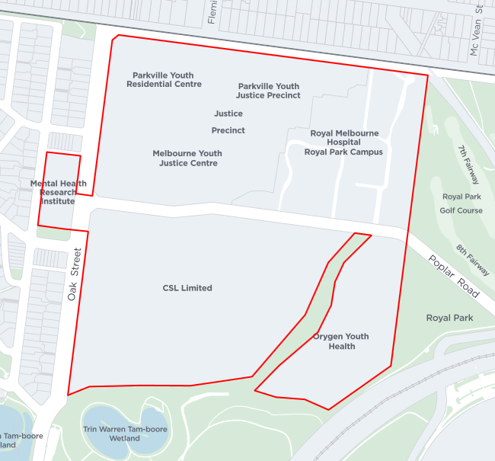
Subject Area: (A) CSL Limited (B) Parkville Youth Justice Precinct (C) Royal Melbourne Hospital (D) Orygen Youth Health (E) Mental Health Research Institute.
B
C
A
E
D

- Purpose
The purpose of this report is to provide:
- The current ownership/management entity details of land in the Precinct
- Details of any significant development approvals/proposals in the Precinct
- Details of significant or legislated obligation that binds land to a particular use either now or into the future; and
- An overview of existing planning provisions and current strategic work that affect the Precinct
- Subject area and surrounds
The subject area is bounded by Oak Street to the west, Park Street to the north and Royal Park to the east and south. Poplar Road runs through the centre of the precinct (see Figure 1).
Key sites
Key sites (including approximate site area) within the subject area are:
- CSL Limited (113,800 square metres)
- Parkville Youth Justice Precinct (94,590 square metres)
- Royal Melbourne Hospital Royal Park Campus (55,035 square metres)
- Orygen Youth Health (38,070 square metres)
- Dementia Australia (7483 square metres)
The consolidated site area of the above mentioned properties is approximately 308,978 square metres.
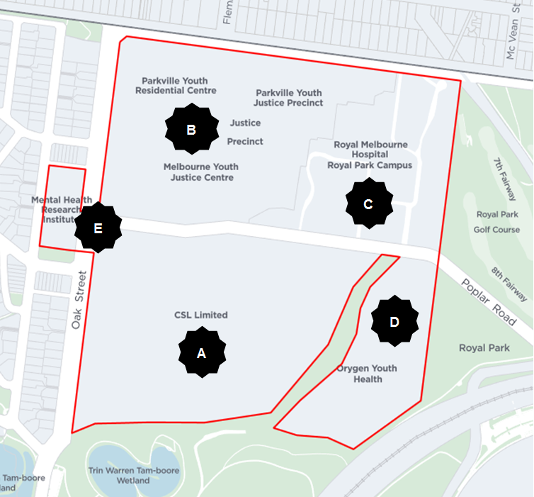 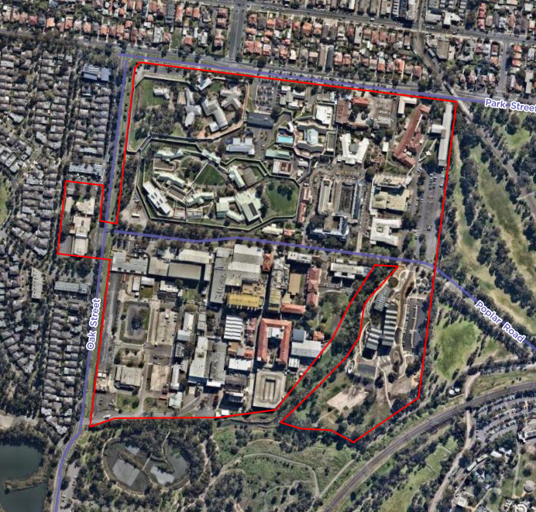
Figure 1: Subject area in cadastral view (left) and aerial (right) with the subject area shown in red outline

- CSL Limited (45 Poplar Road, Parkville)
CSL Limited currently own 45 Poplar Road, Parkville. On 3 September 2019, the Future Melbourne Committee (FMC) resolved to advise the Department of Environment, Land, Water and Planning (DELWP) that the Melbourne City Council supports the Ministerial Planning Permit application (TPM-2019-6) for the use and development of the land at 645-681 Elizabeth Street, Melbourne as a Research and Development Centre. The identified tenant for the Research and Development Centre is CSL Limited. The Minister for Planning approved the planning permit on 15 September 2019.
The Jennerian Building which forms part of the complex of buildings on the site was constructed in 1904-05 (fronting Poplar Road) and is included on the Victorian Heritage Register (Ref No H1794) (see Figure 6).
(B) Parkville Youth Justice Precinct (900 Park Street, Parkville)
The Department of Health and Human Services (the Department) engaged an independent consultant to report on a series of incidents which occurred at the Melbourne Youth Justice Centre in November 2016 and on any specific or safety issues arising from the construction and design of the Justice Precinct.
Following this review, the department commissioned the Youth Justice Review and Strategy (2017) to deliver the Victorian State Government’s commitment to reform youth justice services. The review strongly advocated for the retention of the Parkville site as an operating justice precinct, given its central location, proximity to specialist services, proximity to the CBD and access to public transportation.
Following these findings, the Victorian State Government announced in September 2019 the Parkville Youth Justice Precinct will continue its operation and that it has invested over $1.2 billion for youth justice across Victoria including for infrastructure upgrades and the construction of new units in Parkville.
(C) Royal Melbourne Hospital Royal Park Campus (34-54 Poplar Road, Parkville)
The Royal Melbourne Hospital Royal Park Campus offers extensive innovative, high quality aged care and rehabilitation services. The North West Hospital which forms part of the hospital complex (formerly Mount Royal Hospital) (fronting Poplar Road) is included on the Victorian Heritage Register (Ref No H1725) (see Figure 6).
(D) Orygen Youth Health (35 Poplar Road, Parkville)
The Victorian Government has invested approximately $60 million for redevelopment of the Orygen building.The new facility houses clinical, research, policy, education and training services which focus on improving mental health outcomes for young Victorians. Up to 5,000 young people each year will benefit from this new centre. Alongside clinical services, Orygen is also a centre of research for health professionals in search of better treatment options for young people living with mental illness, and a training and education hub for workers in the mental health sector.
(E) Dementia Australia (155 Oak Street, Parkville)
The Mental Health Research Institute and the Florey Neuroscience Institutes were amalgamated in 2012. The site is now identified as Dementia Australia which provides psychiatric services for depression, bipolar disorder and schizophrenia and neurodegenerative illnesses.
Surrounding area
The Precinct is surrounded by several significant sites (see Figure 2) including:
- Royal Park and Trin Warren Tam-boore Wetland
- Royal Park Train Station
- Melbourne Zoo
- Parkville Gardens (formerly the Athletes’ Village for the 2006 Commonwealth Games)
- State Netball Hockey Centre
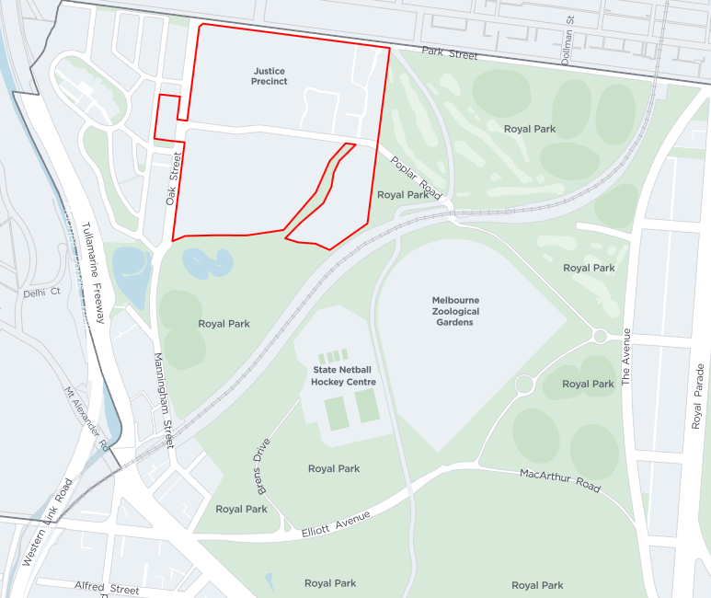 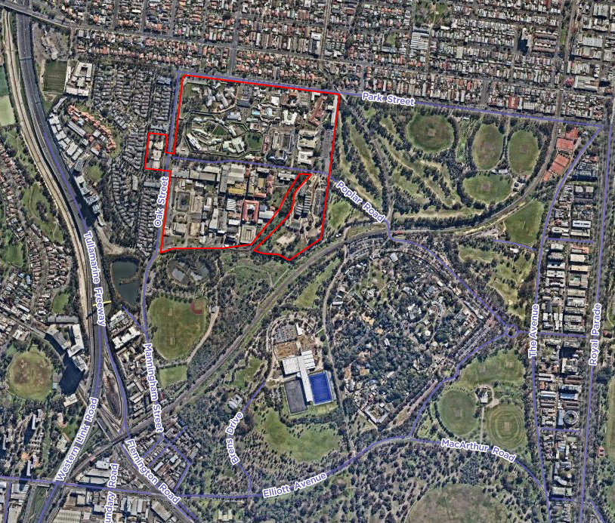
Figure 2: Subject area in context of surrounding area cadastral view (left) and aerial (right) with the subject area shown in red outline
The local road network
The local road network in the Precinct is well developed with significant capacity and an extensive supply of publically accessible car parking. However, if land use in the precinct was to change in the future, this would place additional pressure on the local road network and the available transport options would require further analysis.
The City of Melbourne publically released the Royal Park Transport Discussion Paper by Philip Boyle and Associates in September 2019 as an input into the review of the Royal Park Master Plan. The paper recommended the removal of Poplar Road west of Royal Park Station in order to recover land for the expansion of the park. If implemented this recommendation would significantly alter the operation of the road network in the precinct.
The paper also found that the current use of the car parking in Royal Park is extremely inefficient with the supply of parking surveyed to be never more than half full and at all times more than 1,500 empty bays available.
Officers are currently working with Orygen Youth Health to construct a new shared path connection between the site and the Capital City Trail.
Convenience of access to the public transport network
Access to the public transport network from the precinct is currently average, limited by the frequency of bus and train services and the restricted proximity to more frequent tram services. Current services in proximity to the precinct include:

Train
Upfield line (nearest station is Royal Park 300 metres east of the precinct, or Flemington Bridge 980 metres southwest, 20 minute frequency)
Tram
58 tram (West Coburg – Toorak, Stop 28 on Park Street is at the north west corner of the precinct, 8-10min frequency)
19 tram (North Coburg - Flinders Street Station & City, Stop 17 Levers Street 1km east, 5-10 minute frequency)
59 tram (Airport West - Flinders Street Station & City, Stop 22 Flemington Road 700 metres south, 5-10 minute frequency)
Bus
505 bus (Moonee Ponds - Melbourne University via Parkville Gardens, runs through the precinct along Poplar Road stopping at Royal Melbourne Hospital Royal Park Campus (C), 60 minute frequency)
504 bus (Moonee Ponds - Clifton Hill via East Brunswick, runs along Brunswick Road stopping 115m north of the precinct, 30 minute frequency)
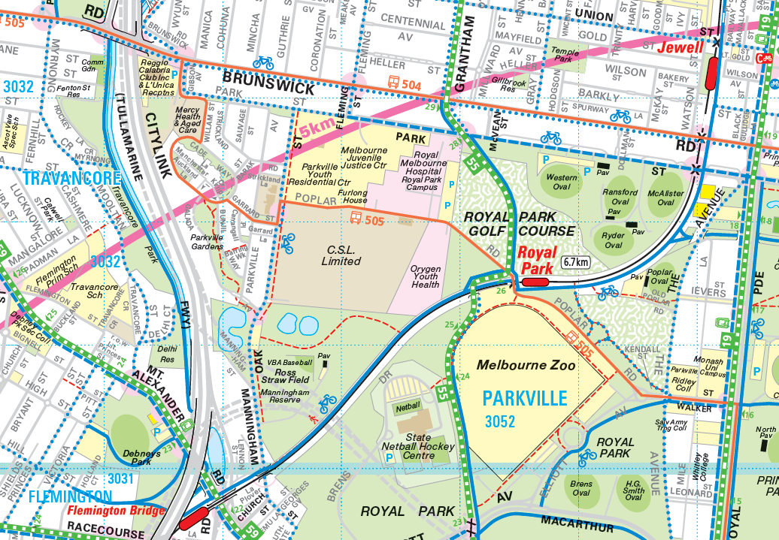
Figure 3: Current public transport network (2014)
City of Melbourne commissioned the RMIT Centre for Urban Research to undertake public transport accessibility modelling for Melbourne. This modelling, called the Spatial Network for Multi Modal Urban Transit System (SNAMUTS), considers the accessibility of places by public transport from the perspective of an everyday public transport user. The modelling considers public transport accessibility for current and future scenarios at a Census of Land and Employment (CLUE) block level across the municipality.
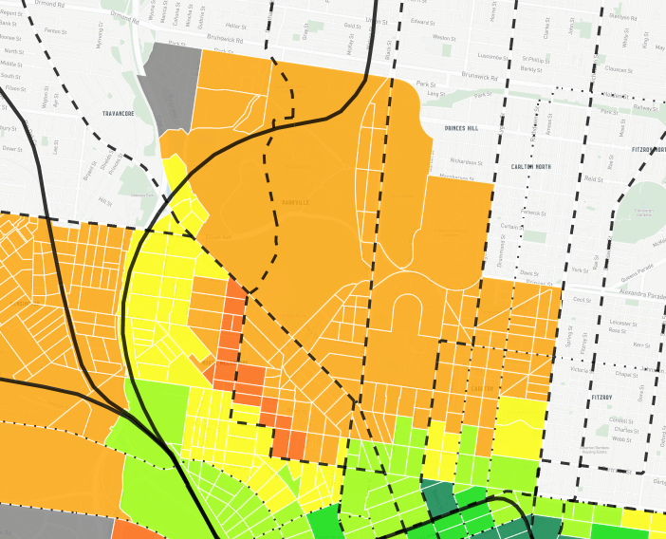
Figure 4: 2016 public transport network accessibility
This modelling shows that the Precinct currently has ‘average’ public transport accessibility. However, the proximity to Royal Park Station provides excellent connectivity to the central city and if frequency was improved this would support a highly convenient public transport service.
- Current ownership and management of properties
The current ownership and management entities for each property in the Precinct are provided in Table 1.
Table 1 – Current ownership/management of properties
Address | Owner | Management Entity
45 Poplar Road, Parkville | CSL Limited | N/A
35 Poplar Road, Parkville | Victorian State Government  (Orygen Youth Health) | Melbourne Health
155 Oak Street, Parkville | Victorian State Government  (Dementia Australia) | Dementia Australia Limited
900 Park Street, Parkville | Victorian State Government  (Parkville Youth Justice Precinct) | Department of Health and Human Services
34-54 Poplar Road, Parkville | Victorian State Government  (Royal Melbourne Hospital Royal Park Campus) | Melbourne Health

- Planning and building approvals
There are no significant applications proposed to date. The approved permits that may be of interest are:
35 Poplar Road, Parkville (Orygen Youth Health)
Demolition of office buildings (BP-2017-1511)
Construction of a new office building (BP-2017-1511/1),
Demolition of buildings and construction of a carpark (BP-2017-1511/2)
34-54 Poplar Road, Parkville (CSL Limited)
Construction of a multi-storey open deck car park (BP-2009-1728)
Construction of a new building (TP-2015-1110)
- Legislative obligations

Other than the planning scheme, there are no covenants or legislative obligations that bind land to a particular use either now or into the future.
The Crown Land (Reserves) Act 1978 (the Act) governs the reservation of Crown Land. Crown land can be either temporarily or permanently reserved for a public purpose by an Act of Parliament. Table 2 provides details for the reservation of land.
Table 2 – Reservation of Crown Land
Address | Existing Land Use | Temporary land reserved for a public purpose
45 Poplar Road, Parkville | CSL Limited | Freehold Land (not reserved for public purpose)
35 Poplar Road, Parkville | Orygen Youth Health | Crown land reserved for public purposes (mental health purposes)
155 Oak Street, Parkville | Mental Health Research Institute | Crown land reserved for public purposes (mental health purposes)
900 Park Street, Parkville | Parkville Youth Justice Precinct | Crown land reserved for public purposes (children’s welfare purposes)
34-54 Poplar Road, Parkville | Royal Melbourne Hospital | Crown land reserved for public purpose (hospital purposes)

The Governor in Council can revoke an entire temporary reserve or excise any part of it. In order for this to be undertaken, an Order in Council must be published in the Victorian Government Gazette.
The only difference between a temporary and permanent reserve is that a permanent reserve needs a new Act of Parliament to revoke or excise a part of the land. While the intention of the Victorian Government may be to retain the reservation of land for public purposes, there is no guarantee.
- Forecast of job, occupancy and visitation figures

The 2019 population in the suburb of Parkville is 8,930, and is forecast to grow to 11,153 by 2041. Forecast job, occupancy and visitation numbers are not known for the Precinct area. An economic and capacity analysis of the Precinct will be undertaken as part of a future structure plan refresh for the MID: City North Strategic Plan.

- Planning Policy
Plan Melbourne 2017-2050

Plan Melbourne sets out a strategy for supporting jobs and growth across Melbourne. Seven National Employment and Innovation Clusters (NEIC) have been identified across one of which is Parkville (see Figure 5). The cluster has education, research, health, professional and technical industries as well as significant parkland. Specifically, Plan Melbourne states that the NEIC’s are places of State significance that will be the focus for investment and growth:
‘These areas are to be developed as places with a concentration of linked businesses and institutions providing a major contribution to the Victorian economy, with excellent transport links and potential to accommodate significant future growth in jobs and in some instances housing’ (p.14).

For the Parkville NEIC, Plan Melbourne states:
- The cluster is an established, internationally renowned research centre on the doorstep of the CBD. It is centrally located, has access to a wide catchment of workers across metropolitan Melbourne and employs 40,100 people (p.28)
- Parkville is an anchor point for health and medical research (p. 34)
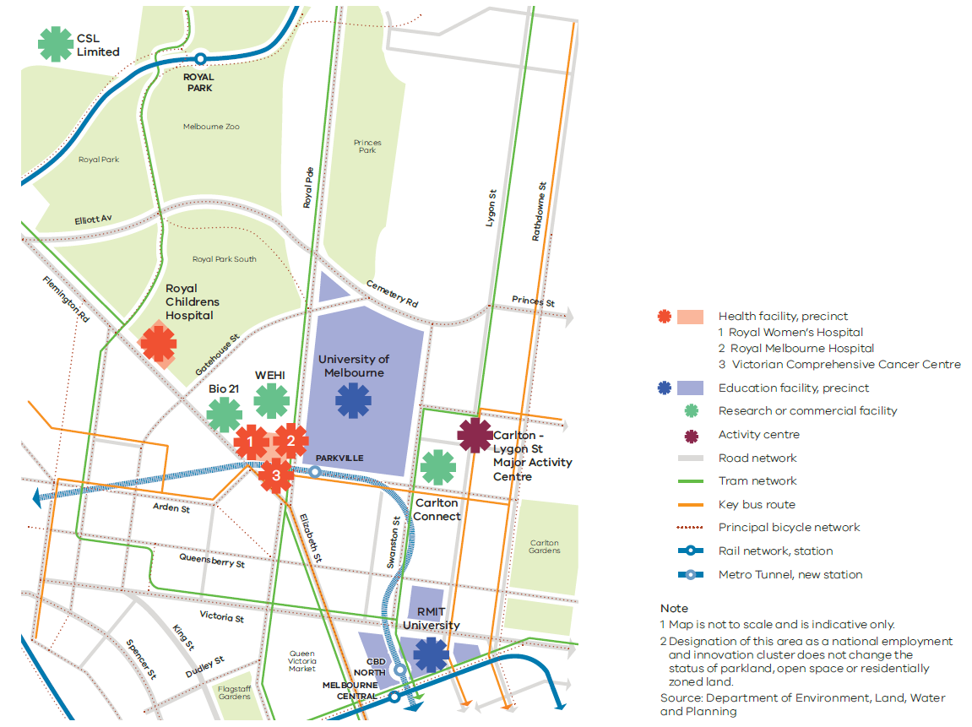
Figure 5: Location of Parkville NEIC (Extracted from Plan Melbourne)
Melbourne Planning Scheme
The following provisions in the Melbourne Planning Scheme provide guidance on the orderly planning of the Precinct.
Clause 17.03-1S (Industrial land supply)
The relevant strategies are:
- Protect and carefully plan existing industrial areas to, where possible, facilitate further industrial development.
- Avoid approving non-industrial land uses that will prejudice the availability of land in identified industrial areas for future industrial use.
Clause 19.02-1S (Health facilities)
The relevant strategies are:
- Plan public and private developments together, where possible, including some degree of flexibility in use.
- Locate hospitals and other large health facilities in designated health precincts and areas highly accessible to public and private transport.
- Provide adequate car parking for staff and visitors of health facilities

Clause 21.08 (Economic Development)
This local planning policy provides guidance for economic development in the City of Melbourne. The relevant strategies are:
- Strategy 1.1 - Support the operation, development and clustering of education research centres and associated uses whilst protecting the amenity of Residential and Mixed Use zoned areas.
- Strategy 1.3 - Encourage research and development uses in appropriate zones throughout the City.
- Strategy 1.4 - Discourage the encroachment of non-residential uses associated with research, education and medical institutions into adjoining Residential Zones and parkland.
- Strategy 1.6 - Manage the off-site impacts of education and research facilities such as car parking and traffic to protect the character and amenity, (including visual amenity) of adjoining areas.
Clause 21.16-4 (Parkville)
This local planning policy provides guidance for Parkville. The relevant objectives are:
- Ensure the scale of development respects the heritage and parkland values of the area and does not dominate or visually intrude upon parkland, streetscapes or lane-scapes.
- Ensure that new development in North Parkville maintains the existing built form character of buildings in a landscaped setting with generous setbacks from the street and between buildings. At the same time, promote quality building design and a consistent building scale.
- Ensure that development around the perimeter of the Royal Park does not significantly intrude into close range views from Royal Park.
- Support industrial research and development at the Commonwealth Serum Laboratory Limited site to the north of Royal Park, consistent with the local amenity at the interface of residential and mixed use zones.
- Discourage the encroachment of institutional uses into parkland and residential areas.
- Existing planning controls
The Parkville Youth Justice Precinct, Mental Health Research Institute and Orygen Youth Health are zoned Public Use Zone (Schedule 3), the Royal Melbourne Hospital (Royal Park Campus) is zoned Public Use Zone (Schedule 7) and CSL Limited is zoned Industrial 1 Zone (see Figure 6).Table 3 specifies the planning controls that apply to each site in the Precinct.
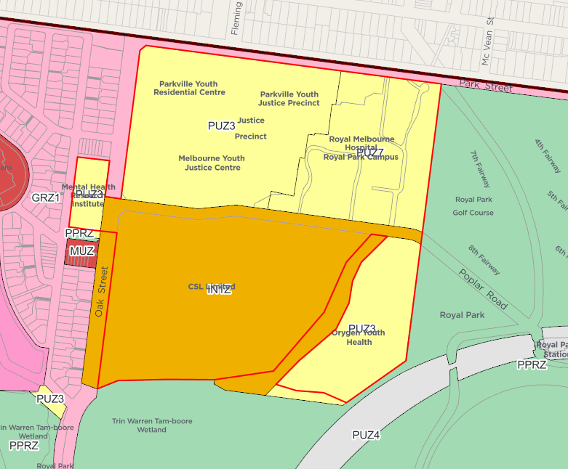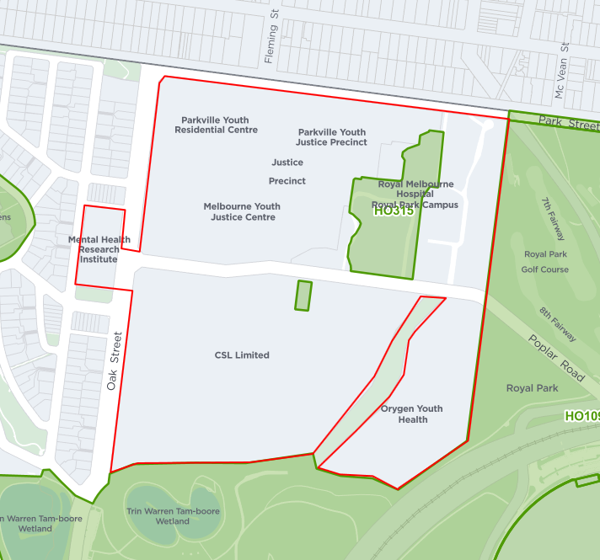
Figure 6: Zoning map (left) and Heritage Overlay map (right)
Table 3 – Planning controls in the Precinct
Address | Existing Land Use | Zone/Overlays
45 Poplar Road, Parkville | CSL Limited (Research and Development Centre) | IN1Z, HO897
35 Poplar Road, Parkville | Orygen Youth Health | PUZ3, SBO
155 Oak Street, Parkville | Dementia Australia | PUZ3, No overlays
900 Park Street, Parkville | Parkville Youth Justice Precinct | PUZ3, PUZ7, No overlays
34-54 Poplar Road, Parkville | Royal Melbourne Hospital Royal Park Campus | PUZ3, PUZ7, HO315, SBO

Zoning anomalies
52-68 Flemington Road, Parkville (Royal Park/ Trin Warren Tam-boore Wetland)
Part of the wetlands located between CSL Limited and Orygen Youth Health, and adjoining parkland to the south appears to be incorrectly zoned IN1Z and PUZ3. This will error will be reviewed as part of a future fix up planning scheme amendment.
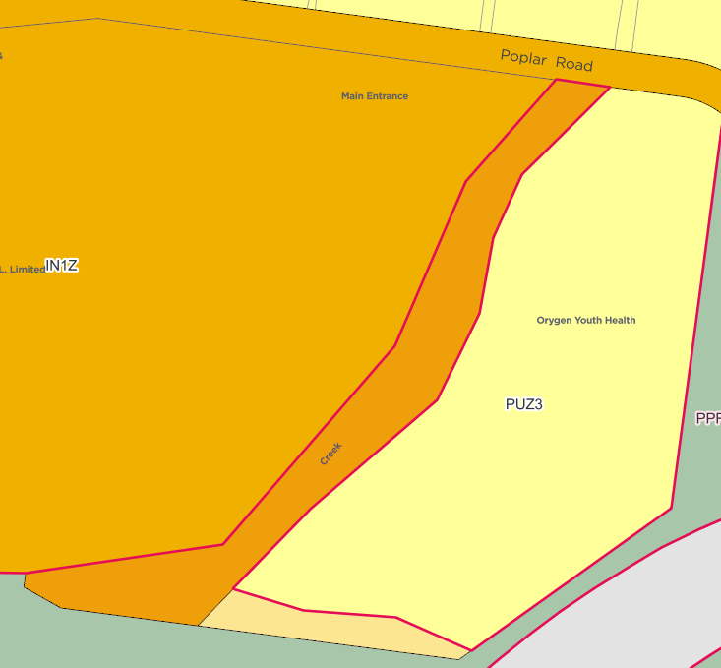
Figure 7: 52-68 Flemington Road, Parkville (Royal Park) outlined in red.
Details of the Planning Provisions
Clause 33.01 (Industrial 1 Zone)
Under Clause 33.01-1 (Table of Uses), manufacturing industry uses don’t require a permit and accommodation is prohibited. A permit is required to construct a building or construct of carry out works.
Clause 36.01 (Public Use Zone)
Under Clause 36.01-1 (Table of Uses), a permit is not required for the use or to construct a building or carry out works, if the use or development is carried out by or on behalf of the public land manager. For example, the Orygen Youth Health redevelopment did not require a planning permit for the use and construction of a building (mental health facility) as it was carried out on or behalf of the public land manager (Melbourne Health).
Note: A building permit is still required.
Clause 43.01 (Heritage Overlay)
A permit is required to demolish or remove a building and construct a building or construct or carry out works.
Clause 44.05 (Special Building Overlay)
This overlay identifies properties that are subject to drainage flooding. A permit is required to construct a building or construct or carry out works.
- Current strategic work
Melbourne Biomedical Precinct
The Melbourne Biomedical Precinct comprises over 40 hospitals, medical research institutes, biotechnology organisations and universities largely collocated to the north of the CBD (see Figure 8).
The Victorian Planning Authority (VPA) in partnership with the Melbourne Biomedical Precinct Office and the City of Melbourne is preparing a land-use framework plan that will support the ongoing growth of high-skill and high-value jobs in the Parkville NEIC.
The vision for the Melbourne Biomedical Precinct is to become ‘a renowned world top 10 biomedical precinct and a driver of healthcare advances, economic growth and jobs for Victoria’.
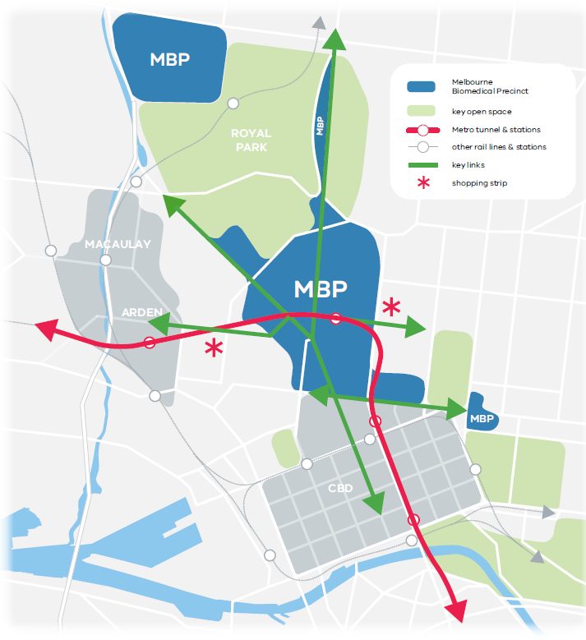
Figure 8: Location of Melbourne Biomedical Precinct
Amendment C278 (Sunlight Access to Parks)
The amendment proposes to introduce new planning controls into the Melbourne Planning Scheme to protect winter sunlight access to public parks. The proposed Schedule 8 to Clause 43.02 (Design and Development Overlay) categorises Royal Park and Garrard Street Reserve as ‘Park Type 1’ which requires that buildings and works must not cast additional shadow onto the park between 10am and 3pm, on June 21 beyond the existing shadow (see Figure 9).
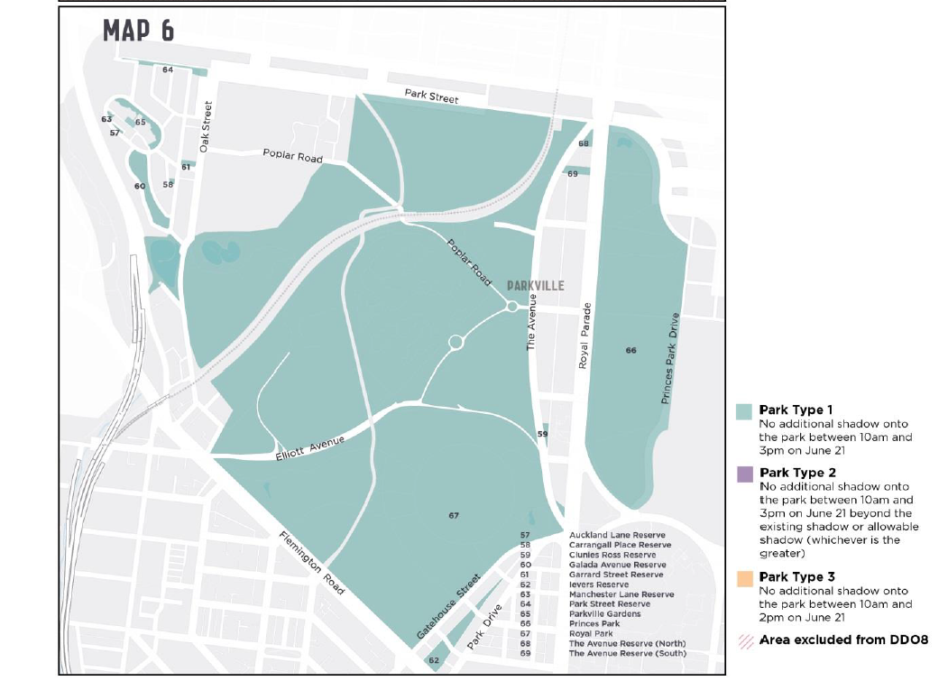
Figure 9: Map of parks affected by Amendment C278 in Parkville
While the Public Use Zone exempts the need for a planning permit the Design and Development Overlay states that a permit cannot be granted for buildings and works that do not meet the above requirement.
Royal Park Masterplan
The City of Melbourne is likely to update the Royal Park Master Plan in 2021-22.
The Melbourne Innovation District (MID)
The MID partnership was formed in 2017 by the City of Melbourne, RMIT University, and the University of Melbourne, to support urban innovation in Melbourne. The MID City North Opportunities Plan was recently endorsed by Council and has been developed to ensure the area’s significant health and research functions can be managed into the future. The MID area is comprised of significant health and education institutions including the University of Melbourne, RMIT, Royal Children’s Hospital, Royal Women’s Hospital, Walter and Eliza Hall Institute of Medical Research and Victorian Comprehensive Cancer Centre (VCCC), which each contribute to research on a global scale.
- Key Findings
- Current ownership/management of properties
The Victorian Government is the owner of all properties in the Precinct with the exception of CSL Limited. The Victorian Government has committed to continue the operation of the Parkville Youth Justice Precinct. While the intention of the Victorian Government may be to retain the reservation of land for public purposes, there is no guarantee the future use will be permanent as Crown Land reservations can be revoked by the Governor in Council (Government of the day) or by Parliament.
With regard to CSL Limited other than its existing zoning there is limited guidance in the planning scheme about the future use and redevelopment of the site.

- Legislative obligations

There are no covenants or legislative obligations that bind land to a particular use into the future.

- Conclusion
The large allotment sizes in the Precinct present an opportunity for consolidation or subdivision of land which may result in future redevelopment or change in use. In the absence of a masterplan or broader strategic vision for the Precinct, there is no certainty that the land will remain reserved for public purposes.
Plan Melbourne recognises the Parkville NEIC to be of state significance; however it does not specify a specific vision for the Precinct.
The Melbourne Planning Scheme identifies the importance of the existing education, health, research and development assets within the Parkville NEIC. While there is policy guidance in Clause 21.16 (Local Areas), specific built form and land use controls for the Precinct are not contained in the planning scheme.
There is an opportunity through the update of the City North Structure Plan to review the planning controls for the Precinct. This will need to be done in consultation with landowners and major stakeholders.

