Macaulay Refresh Discussion Paper
CONSULTATION ANALYSIS

FULL REPORT

2 March 2020

Prepared by Global Research Ltd

For
CONTENTS
FIGURES 2
REFRESHING THE MACAULAY STRUCTURE PLAN 3
ENGAGEMENT APPROACH 3
REACH 4
ANALYSIS METHODS 7
FINDINGS 8
HOW TO READ THIS REPORT 8
On the Macaulay Vision 9
On activities and land use (theme 1) 13
a) Zoning 13
b) Affordable housing 16
On urban structure and built form (theme 2) 20
On transport and access (theme 3) 23
On the public realm (theme 4) 30
On community infrastructure (theme 5) 33
On flooding (theme 6) 36
On the consultation process 39
CONCLUSIONS 42
HOW YOUR FEEDBACK WILL BE USED 43

FIGURES
Figure 1. Engagement summary: promotion, reach & feedback 5
Figure 2. Connection to Macaulay (where stated) 5
Figure 3. Age of survey respondents 6
Figure 4. Gender of survey respondents 6
Figure 5. Support for Vision 9
Figure 6. Importance of mixed development 13
Figure 7. Importance of affordable housing 16
Figure 8. Importance of certainty in development 20
Figure 9. Importance of height and shape variation 21
Figure 10. Importance of walking route improvement 23
Figure 11. Importance of bike path improvement 24
Figure 12. Importance of improving public transport 25
Figure 13. Importance of on-street parking reduction 26
Figure 14. Importance of off-street parking reduction 27
Figure 15. Activities outdoor public spaces should be used for 30
Figure 16. Activities and services indoor facilities should cater for 33
Figure 17. Importance of allocating space to manage flooding 36

REFRESHING THE MACAULAY STRUCTURE PLAN
The City of Melbourne published a discussion paper in November 2019 to share current information about the Macaulay urban renewal precinct, as well as invite a public conversation about how best to plan for the future of the neighbourhood.
Outcomes for Macaulay: A Discussion Paper to inform a Refreshed Structure Plan suggested a consolidated vision statement for the area, as well as a series of proposals under six themes:
Theme 1. Activities and land use (zoning & affordable housing)
Theme 2. Urban structure and built form
Theme 3. Transport and access
Theme 4: Public realm
Theme 5. Community infrastructure
Theme 6. Flooding
Consultation was undertaken 13 November to 19 December 2019 in and around Kensington and North Melbourne. Quantitative and qualitative feedback was collected through a range of engagement activities.
Global Research was contracted by the City of Melbourne to independently analyse this feedback and synthesise the results, so that it may inform the development of a Draft Structure Plan.
This Community Engagement Report presents the findings of our analysis. It provides the City of Melbourne, the community and other interested stakeholders with a comprehensive assessment of the rating results, along with a summary of the collated comments.
Both the Macaulay Discussion Paper and this Report can be accessed at participate.melbourne.vic.gov.au/macaulay-refresh.

ENGAGEMENT APPROACH
The City of Melbourne sought to share the Discussion Paper widely, and speak with residents, workers, neighbourhood associations, Aboriginal Custodians, landowners, property and planning groups, state agencies, local and state government.
People were informed and encouraged to participate in the conversation through targeted social media promotion, emails to local organisations and state agencies, letters posted to large landowners, e-newsletters and public information sessions at community settings. An i-Pad station was also installed at North Melbourne Library.
In-person engagement activities included:
- Pop-up information session at Kensington Market, Sunday 17 November
- Pop-up information session as part of Our Neighbourhood Speaks at Kensington Neighbourhood Centre, Saturday 23 November
- Information session at North Melbourne Library, Tuesday 26 September
- Community workshop at Jean McKendry Centre, Saturday 30 November
- Landowner information session for the larger land holdings at the Centre for U, Thursday 5 December
- CALD youth workshop at Jean McKendry Centre, Thursday 19 December.
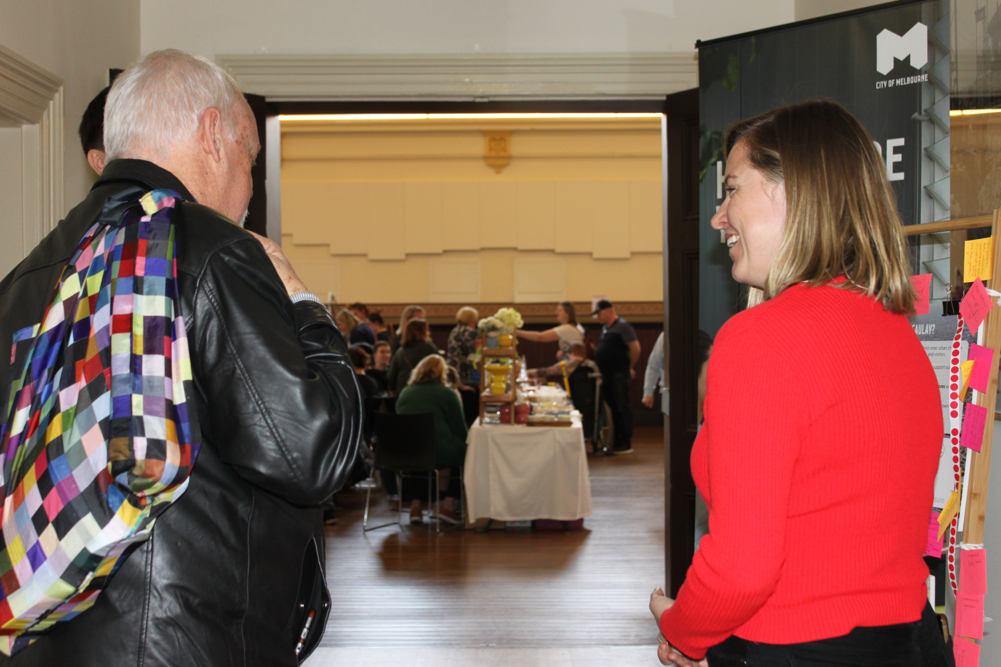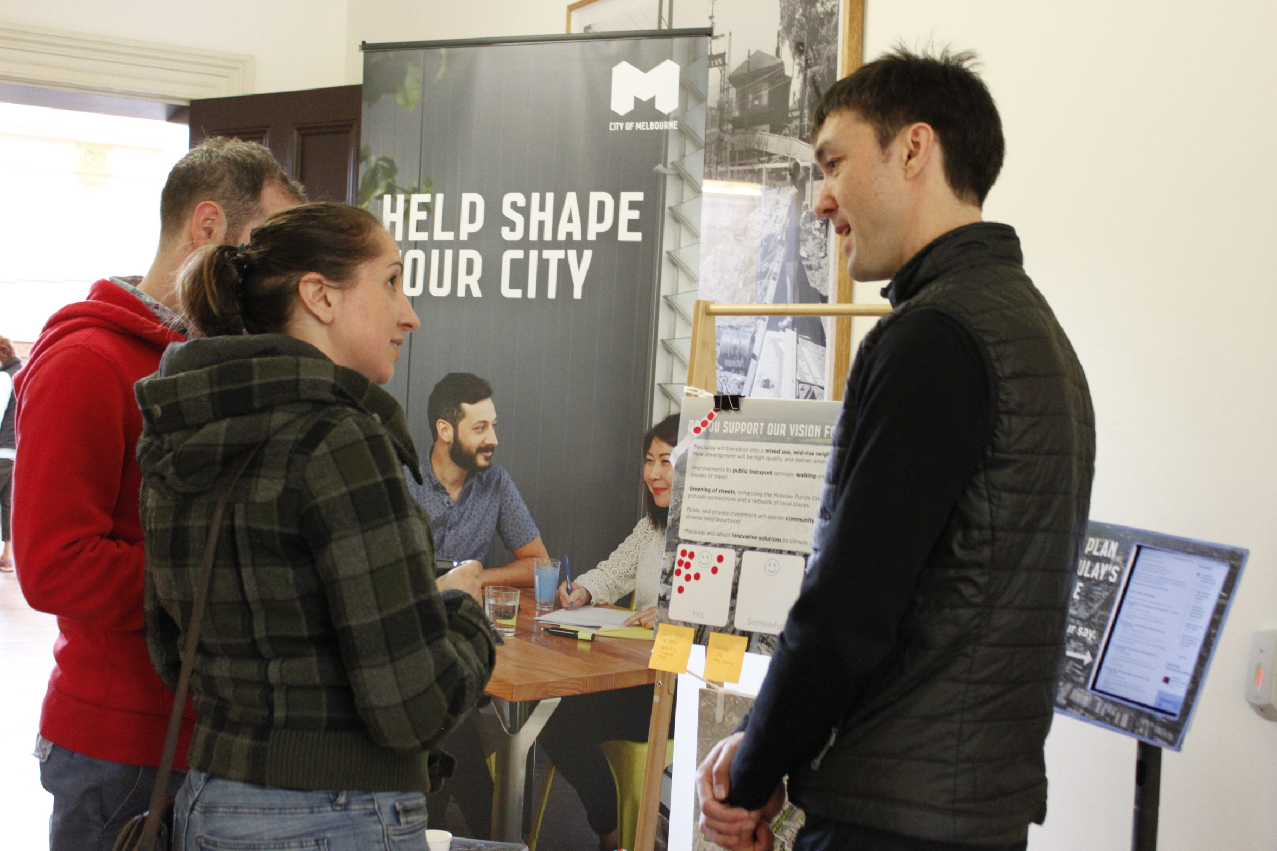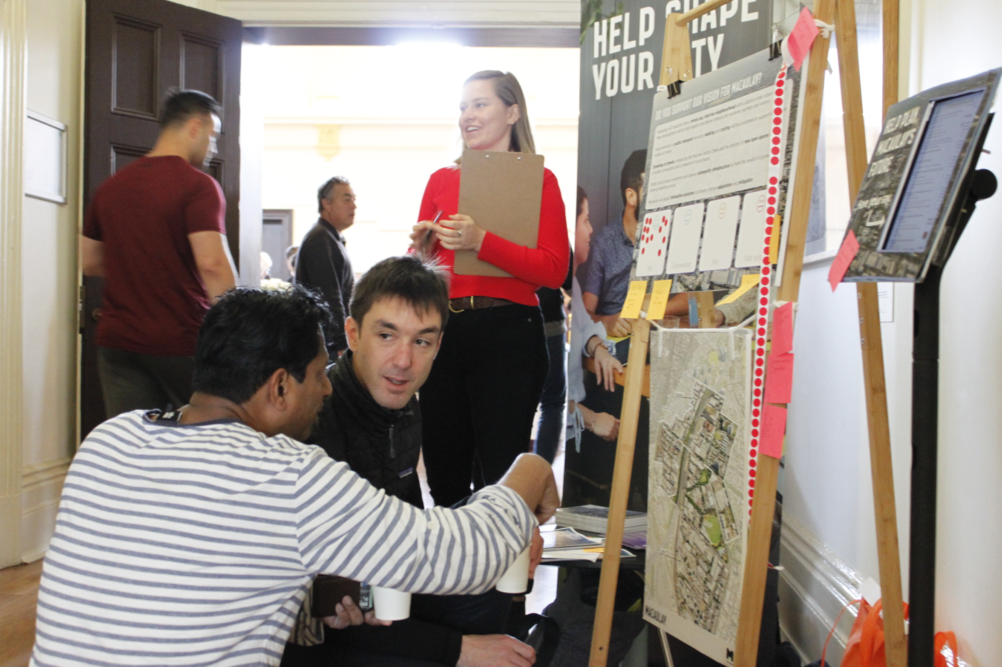
At the information pop-up sessions post-cards were handed out, and people were asked to rate their satisfaction with the proposed vision statement using stickers on a question board. Comments about what people wanted to see in the area in the future and what they valued about it now were recorded by staff on ‘post-it’ notes.
An online survey was hosted on the Participate Melbourne website, asking questions related to each of the six Discussion Paper themes. Community workshops brought small groups together to discuss collective responses to their priority themes. Long form written submissions, which were not necessarily structured according to themes, were also accepted.

REACH
Staff recorded a tally of each engagement channel and individual they made contact with in-person or online. Not all of these people chose to actively contribute to the conversation.
In total, six local events were hosted, six digital platforms were utilised, over one hundred thousand people were reached, and 269 ideas recorded.
Of the thirty-one people that participated in the online survey, 23 provided information about their age, 27 about their gender and 31 about their connection to Macaulay, using a multiple choice ‘tick-box’. While this demographic data should not be considered statistically representative of the broader participant cohort, it does give an indication of the respondent profile that contributed via the web platform. In some face-to-face activities staff recorded participants’ connection to Macaulay, however this was not done for every participant due to the nature of the session or the time that respondents had available to speak with staff.

Engagement summary: promotion, reach & feedback
ENGAGEMENT PROMOTION | 8  SOCIAL MEDIA POSTS | 197  EMAILS SENT | 400  POSTCARDS SHARED
ENGAGEMENT REACH | 103,963  SOCIAL MEDIA VIEWS | 2,509  WEBSITE VISITORS | 168  FACE-TO-FACE CONTACTS
FEEDBACK | 31  ONLINE SURVEYS | 7  WRITTEN SUBMISSIONS | 128  IN-PERSON COMMENTS
Figure 1. Engagement summary: promotion, reach & feedback

Figure 2. Connection to Macaulay (where stated)

Summary of ‘connections’ results:
The majority (75%) of respondents’ connection to Macaulay was as a resident, this was particularly true for those attending a face-to-face event.
A further third (10) of online respondents stated they were landowners, and 8 worked in the area. ‘Other’ respondents identified as either a regular visitor to the area, property developer, or as residents of a neighbouring suburb.

Figure 3. Age of survey respondents

Summary of age results:
Of the 31 respondents who completed an online survey, a quarter (26%) did not disclose their age. Of those that did, nearly half (48%) were young adults between the age 25 and 34 years.

Figure 4. Gender of survey respondents

Summary of gender results:
A slightly higher propotion of the 31 online survey respondents (48%) idenitified as female, with four respondents preferring not to state their gender.

ANALYSIS METHODS
Every narrative comment and multiple-choice rating recorded as part of the consultation activities has been read by analysts and grouped into common topics. These are presented under each theme as outlined in the Discussion Paper.
The quantitative analysis shows the results from specific questions with pre-defined answers to understand the level of support of each respondent, for example:
- Do you support the consolidated vision for Macaulay? Yes | Somewhat | No | Not sure
- How important is it that planning controls provide certainty in the amount of development for each site? Very important | Somewhat important | Not very important | Not at all important | Not sure
The qualitative analysis captures why the respondent felt the way they did. The participant comments were collected in two ways:
- Directly typed from what a participant wrote on the day
- Recorded by City of Melbourne officer during conversation with the participant.
Combined comments from the variety of consultation activities have been synthesised with the aid of social research software and discussed.
To give a clear and consistent indication of the amount of comments received on each topic, the following key has been used to describe the relative number of comments on each topic:
Key for comment numbers
2−7 comments | A small number
8−14 comments | Several
15−24 comments | A moderate number
25−50 comments | A considerable number
Participant quotes from the Participate Melbourne survey are included verbatim; spelling and grammar mistakes in survey quotes are not corrected. Quotes from all sources are highlighted within the text.
Unless otherwise specified, charts present data from the online survey; all charts are followed by a short description. Note that due to a relatively small survey sample size, there are limitations so far as making generalisations from the data. The findings do however offer insight into the sentiments, priorities and values of a fair cross-section of the Macaulay community.

FINDINGS

HOW TO READ THIS REPORT
Each of the following chapters of this report have been dedicated to the vision or a single theme:
- On the Macaulay vision
- Theme 1. Activities and land use
- Theme 2. Urban structure and built form
- Theme 3. Transport and access
- Theme 4. Public realm
- Theme 5. Community infrastructure
- Theme 6. Flooding.
These chapters include analysis of quantitative data represented in charts and summary findings, followed by analysis of qualitative data. Comments have been grouped into relevant topics and are discussed in the order of most to least frequently mentioned. This section includes verbatim comments from both online and face-to-face respondents. A ‘what was heard’ section follows the results of quantitative and qualitative data. This provides a summary of what our analysis has revealed to be the key messages from the engagement activities. The report ends with some concluding points and information on how this report will be used to inform future work.

On the Macaulay Vision
A consolidated vision for Macaulay
Macaulay will transition into a mixed use, midrise neighbourhood with a distinct inner urban character. New development will be high quality and deliver amenity for residents, workers and visitors. Improvements to public transport services, walking and cycling will be prioritised to support sustainable modes of travel. Greening of streets, enhancing the Moonee Ponds Creek and the delivery of new open spaces will provide connections and a network of local places. Public and private investment will deliver community infrastructure to meet the needs of a growing and diverse neighbourhood. Macaulay will adopt innovative solutions to climate change adaptation and mitigation.
~ Macaulay Structure Plan Refresh (Discussion Paper)

What was said:

Figure 5. Support for Vision

Summary of results:
When participants were asked to rate their level of support for the consolidated vision statement above, the vast majority (95%) were in either full or partial support. Full support was recorded more commonly at face-to-face events (93%), where this was the rating from just over half the online survey respondents (55%). Four percent of respondents from the survey and no respondents from face-to-face events stated they did not support the consolidated vision.

Support the consolidated vision 31 comments
The consolidated vision was supported by the majority of respondents. Those who supported the vision cited a number of reasons in their comments and frequently included a proviso, such as that buildings shouldn’t be too high, or that green space should be prioritised.
‘Liveability’ was the most commonly mentioned aspect of the consolidated vision that respondents commented on. People commented that the suggested improvements to cycle space and public transport, pedestrian crossings, and a general shift towards being more ‘people focused’ were commended.
A similar number of comments were made about green or open spaces, expressing the desire for priority in this area. One respondent commented:
We are starved of open space in our area of Kensington (east of the MP Creek). It is 7 years on from the Open Space Strategy and yet the Vision only says a new park in this area is "for further investigation". Get on with it! Schools are also critical, and I think the Vision should include a masterplan to revitalise 'the village' shopping strip. ~ online survey
Similarly, another respondent noted this, along with their general support for the vision:
Its all good. However community amenities and open green space must not be compromised for medium density development. ~ online survey
An additional proviso from respondents was that buildings must not be too high. The general sentiment amongst these comments was that mid-rise buildings were acceptable, but that height restrictions should be enforced in order to ensure that high-rise buildings would not be built in the area. The following two comments reflect this idea:
It is wasteful to have large areas near the city devoted to industrial when people want to have residential opportunities close to the city. Nevertheless it is important not to have masses of 8 storey apartment blocks and 'canyons', like the proposed development of Macaulay Road, Rankins to Stubbs. ~ online survey
But apartment buildings shouldn't encroach too much on the traditional single-fronted houses. ~ online survey
A small number reported overall support for the plan, but had comments about specific aspects that they wanted improved, these included: criticism of the Moonee Ponds Creek/freeway area, which was deemed unsightly for passers-by; criticism of the lack of vehicular policy to manage traffic from additional development; fears that pre-existing users of the area are not offered concessions regarding current investment; and, the call for new apartments when existing buildings could be prioritised. It is unclear whether this last comment was referring to retaining the physical fabrics of the buildings, or updating the uses of existing buildings to make the most of what is already in the area.
A small number of respondents supported high density living for its efficient use of space, particularly given the proximity of the area to the CBD. Similarly, the housing options available were viewed favourably by one respondent. Another respondent showed their support through the following comment:
the vision for Macaulay, in particular the emphasis on sustainable, high quality development that delivers for the community. ~ online survey

Do not support the consolidated vision 3 comments
A small number of respondents did not support the vision. Reasons for this were varied and include one comment lamenting the absence of a previously planned park on Fink Street, and that there is not a strategy for Area 4 (the commercial 2 zoned area south of Macaulay Road). Another of the comments included several points such as objections to high density living, a lack of proposed schools and issues with public transport, such as the following:
Public transport does not cope with current population.
Metro tunnel will have only indirect effect on public transport situation. Metro tunnel will not even have a station in South Kensington! ~ online survey
Lastly, one respondent objected to the vision on the basis that there has been extensive debate around the planning process, and that this is a “waste of time and money”.

Not sure 1 comment
One respondent who was not sure about whether or not they supported the vision stated that they would like to see more emphasis on affordable and public housing, noting that this was the “perfect opportunity”.

Concerns with the current vision 15 comments
Several participants commented about concerns they had in relation to the planning for Macaulay, though did not rate their level of support for its Vision. These ranged from comments that described a need to prioritise that proposed parks get enough sun and are accessible; that climate change be further elevated; and that a local job quota be introduced in the precinct planning.
One comment related directly to the 2019 Discussion Paper, stating that it should be more succinct. Other concerns raised by respondents included:
Concern about soil contamination, high levels of metal and toxins in ground from industrial use. Discussion paper does not seem to speak to this. ~ face-to -face
Concern about opposition from developers to what’s outlined and opposition to making community infrastructure contributions. ~ face-to -face
Does Arden Macaulay structure plan engagement go out the window? The last steps in structure plan approval took a long time – I don’t believe your timeline is achievable. ~ face-to -face
There should be coordinated consultation for Arden and Macaulay. Need to understand how it all fits together. ~ face-to -face
As stated above, the new Macaulay Vision has lost much of the ‘good things’ and ideals of the original Arden-Macaulay Structure Plan. Another example of dumbing down the Vision is that Macaulay should be an ‘eco-city’ district, not just concerned with climate change. Thus suggested rewording:
Macaulay will be an eco-city precinct and will adopt innovative integrated solutions to climate change and mitigation ~ written submission

What was heard
- The vast majority of respondents support the current consolidated vision for the Macaulay precinct
- Height restrictions on new developments should be enforced to maintain a mid-rise character
- Green, open spaces, as well as sky views and natural light should be prioritised
- The outcome must result in a nice place to live that is sensitive to the needs of those using the Macaulay area.

On activities and land use (theme 1)

a) Zoning

What was said:

Figure 6. Importance of mixed development

Summary of results:
When online survey respondents were asked to rate the level of importance to them of a neighbourhood that has a mix of homes and local employment opportunities, almost half (14) suggested it was ‘very important’, while a slightly smaller proportion (13) suggested it is ‘somewhat important’. Together, these positive responses comprise 87% of the 31 responses on this topic.

Very important or somewhat important 28 comments
The majority of respondents felt that it was at least somewhat important to have a mix of homes and local employment opportunities in a neighbourhood. Generally, respondents viewed having local employment opportunities as a positive thing for residents.
A small number of respondents approached this question from a sustainability perspective, noting the benefits of reducing travel and commuting. One such comment reads:
Reduce emissions by reducing travelling time. Also more convenient for residents in terms of a better life/work balance. ~ online survey
Some respondents felt that having a mix of homes and employment opportunities would enhance a neighbourhood’s community feel, social connectedness and encourage more social inclusion. This can be achieved by having local businesses that serve or benefit locals, and generally by having more diverse neighbourhoods. Below are some of the comments offered by respondents:
Areas & communities that have more diversity - in scale, use, types of employment, etc. - are inherently more flexible, adaptable and thus more sustainable and possibly more resilient. Diverse employment types would benefit the community. ~ online survey
The more a community can shop and work locally the less stress on the various travel modes. Staying local means more people walking, more community connectiveness and more social inclusion. ~ online survey
A small number of other respondents noted the importance of having enough cafes/shops/supermarkets in the area to support the predicted increase in residential population. One respondent stated:
As with Arden, there should be greater emphasis on mixed-use development to both alleviate population pressure and provide job opportunities for local people. Encouraging more small businesses in the area would see a return to the semi-industrial landscape of past eras — but preferably without the negative aspects of noxious odours and pollution. ~ written submission
Others, who felt that it was important to have a mix of homes and local employment opportunities in the area but also had some concerns around this shared their thoughts:
It depends what kind of spaces are created and how this affects the feel of residential streets… what makes Kensington nice is that it still feels quite residential. ~ online survey
Diversity is important but I'm more concerned by the amenity impacts of new developments on existing residents in low-rise areas, and on the character of Kensington more generally. ~ online survey
How can it be truly mixed use? Mostly just seeing residential developments. What are the other tools and mechanisms Council can use to help realise genuine mixed use? Doesn’t seem like very much. ~ face-to-face

Not very important or not at all important 2 comments
Those who felt that it was not important to have a mix of homes and local employment opportunities felt his way for the following reasons:
Most people who live here will probably work in the City , Hospitals or University. There are plenty of local employment opportunities within a 2km radios. Encourage some cafe's, bars, some shared offices, etc but that's probably all that is required. ~ online survey
I support the development of small businesses in the community, however the noise from certain types of businesses can be extreme…Businesses in the area should not overly impact nearby residents. ~ online survey
One email submission discussed concerns about how zoning may impact property developers, asking for further clarification from Council:
We note also that the Discussion Paper presents the option of changes to the existing zoning of the area to support the development of additional employment floor space. Whilst we recognise the need for additional employment generation land uses in the precinct, we note that commercial uses typically require larger floor plates than residential, which may have adverse built form outcomes when combined with FAR controls.
We request that Council provide further information regarding the preferred mechanism to deliver increased commercial floor space, and take into consideration the potential impact on development in locations where demand for retail and commercial uses isn't currently apparent. ~ written submission

What was heard
- It is important for the area to have a mix of residential and local employment opportunities
- Forming and maintaining community connections is crucial and can be facilitated by living and working in the neighbourhood
- Retaining a residential feel and reducing the carbon footprint associated with commuting should be considered
- It is important to acknowledge, promote and accept community diversity.
- While we should try and minimise the industrial ‘feel’, there should be sufficient commercial activity in the area, so locals don’t have to go elsewhere.

b) Affordable housing

What was said:

Figure 7. Importance of affordable housing

Summary of results:
When online survey respondents were asked to rate how important it is that new residential development contributes to increasing the amount of affordable housing, over a third of respondents (39%) felt that it was ‘very important’. Overall, 68% percent of survey respondents felt it was at least ‘somewhat important’ that new residential development is affordable. Under one third of respondents felt that this was either not very important or not important at all.

Somewhat important or very important 27 comments
Most respondents felt that it was at least somewhat important that new residential developments contributed to increasing the amount of affordable housing. Comments on this topic generally expressed support for increasing the amount of affordable housing in the area, some stating that the City of Melbourne should aim higher than the 6% currently proposed. One respondent suggested that the proportion of floorspace allocated to affordable housing should be no less than 10%, while another suggested it should be between 10 and 15%.
A small number of respondents discussed a desire for more of a mix of residents in the area, including those of lower socio-economic status. Below are some examples of comments on this topic:
The area is close to employment centres with great connectivity. Affordable housing in this area will give more vulnerable groups opportunities for upward social mobility. ~ online survey
Too many people cannot afford to rent a property, let alone purchase, leading to homelessness. Public housing waiting lists are going up, not down. Affordable housing, including public housing, is an urgent need. ~ online survey
Comments about the benefits of affordable housing were made by a small number of respondents, who suggested that increasing affordable housing will have positive effects for residents, including providing more opportunities to feel part of a community. One respondent commented:
Affordable housing has not grown as the need has grown. If anything, it seems like the supply has shrunk relative to demand in the past few decades. Affordable housing is a real way to address the growing homelessness pandemic in the city. In the long run, its inclusion in mixed communities strengthens them & makes them more diverse & resilient. ~ online survey

Not very important or not at all important 8 comments
Several respondents felt that it was not important to ensure that new residential developments increased the amount of affordable housing in the Macaulay precinct. The reasons given as to why respondents felt this way varied. A small number of respondents cited concerns around social issues that affordable housing may attract, though they did not specify what kinds of issues these might be.
A small number of other respondents felt there was already enough affordable housing nearby, and that the focus should be on spreading affordable housing throughout Melbourne, rather than concentrating on one area. One respondent felt that rent in Melbourne (CBD Southbank and Docklands) was already cheap enough, and that the new development should not compromise on quality for the sake of providing more affordable housing. Similarly, another respondent offered this comment:
There is ample affordable housing and subsidised housing nearby within North Melbourne, Kensington, Flemington and Carlton already. Perhaps it needs be better managed? I believe high rise tower apartments are actually quite large? Is subdividing apartments an option to consider? ~ online survey

Other comments made about affordable housing 19 comments
Several respondents expressed concerns about how making provisions for affordable housing in the area might affect current residents and landowners. In general, these respondents wished for more information, specifically about how this affordable housing would be rented, the percentage of affordable housing expected by Council, the security of public housing, and whether current residents would be moved on during the ‘urban/housing renewal’ process. Other comments made included:
There are 3 communities - affluent apartments, public housing and rental properties. ~ face-to-face
Arden estates are seen as a barrier, the community is not welcome. ~ face-to-face
That Council provide additional information around the delivery of affordable housing in the Macaulay Precinct, and consider the retention of opportunities for increased building height or floor area uplift. ~ written submission
(support for) Hard boundaries between public and private (affordable housing). ~ face-to-face
Want to see structural system not just regulatory. For instance, a proportion of development in hands of housing associations. ~ face-to-face
We commend Council for their ongoing efforts to and recognise the need for increased supply of affordable housing. That noted, additional clarity is required around the delivery of affordable housing in the Macaulay Precinct.
Specifically, this should include detailed consideration of the impacts of mandatory affordable housing contributions on the viability of development for existing landowners in conjunction with changes to built form controls. ~ written submission
Affordable housing sizes v family sizes - 2 bedroom apartments are not large enough. ~ face-to-face
What are you looking at for affordable housing? What percentage? With the outcome of Fishermans Bend do you think you will explore something similar? Social housing? ~ face-to-face

What was heard
- There must be opportunities for lower-income people to live in the area
- It is important that there be a minimum proportion of housing dedicated for low-income use
- Housing stock must remain high-quality. It is not OK to encourage cheap housing with a short lifespan.

On urban structure and built form (theme 2)

What was said:

Figure 8. Importance of certainty in development

Summary of results:
When respondents were asked how important it is to provide certainty in the amount of development on each site, three quarters of respondents (23) deemed these ‘very important’. Overall, 97% of respondents viewed these planning controls as at least ‘somewhat important’.

Figure 9. Importance of height and shape variation

Summary of results:
When respondents were asked how important it is to allow variation in the height and shape of new buildings, almost half (48%) of respondents deemed these ‘very important’. In total, 87% of respondents felt that planning controls allowing height and shape variation were at least ‘somewhat important’, with only 12% showing that they felt it was ‘not very important’ or ‘not important at all’.

Comments made about urban structure and built form 15 comments
Retaining a mid to low-rise character in the Macaulay area was important to several respondents, who expressed concerns about the height of buildings allowed to be built in the area. Comments outlined a concern that the charm and character of the area would be lost if new developments are too high. Some examples included:
Don't spoil our idyllic charming neighbourhood; it's a little treasure here, don't go high rise. ~ face-to-face
You can't create the street life without connects on the street, got to connect with people on the same level - high rise creates different types of environments that don't mix. European cities like Madrid have it right, 5-6 storeys. ~ face-to-face
Kensington is a historically mixed residential and industrial area consisting largely of single and double storey buildings. The proposed height and mass controls for the Macaulay Structure Plan Refresh are excessive and out of context; they will dramatically change the village character of Kensington and, in some instances, destroy its heritage character. ~ written submission
These respondents generally asked for height controls or limits to be strictly and consistently enforced to maintain a mid-rise development, as the following comments suggest:
Height controls should be mandatory, not discretionary, to give all parties certainty and prevent the overdevelopment that has blighted some nearby areas (e.g. Shiel Street and Canning Street, North Melbourne). ~ written submission
The same respondent went on to say:
Re-use of existing buildings and materials, especially red brick, should be a high priority for reasons of aesthetics, sustainability and economics. Image 8 on page 26 of the Outcomes for Macaulay discussion paper is the best example in the document, from an architectural and design viewpoint. Here, the height of the new building reflects its neighbours rather than 'trumping' it with extra, incongruous storeys. ~ written submission
Many properties have difficult interfaces – how will they achieve the FAR – how are you testing with context? ~ face-to-face
Provision of open space and through block links – how does council see this broken up? How will planning applications be assessed? ~ face-to-face
There is extensive contamination and flooding in the area, this limits the amount of underground car parking available – restriction in yield if you don’t go up – Is this considered in your modelling? ~ face-to-face

What was heard
- We do not support unfettered high-rise development
- It is important that height restrictions are in place to ensure human-scale living is retained
- We value the aesthetics of our neighborhood.

On transport and access (theme 3)

What was said: walking routes

Figure 10. Importance of walking route improvement

Summary of results:
When respondents were asked about the importance of improving walking routes in the Macaulay Precinct, the majority (94%) of survey respondents were in favour, with majority believing it to be ‘very important’.

Comments about improved walkways 3 comments
Two respondents commented in support of improving walking routes within the Macaulay precinct. One respondent stated:
Streets prioritised for people; better walkability, separated bike lanes, no or reduced on-street parking, more trees & gardens. ~ face-to-face

What was heard
- We all agree, to at least some degree, that walking routes should be improved
- Walking route improvement will assist people’s ability to move around within the area.

What was said: bike paths

Figure 11. Importance of bike path improvement

Summary of results:
When respondents were asked about the importance of improving bike paths around Macaulay, the majority of respondents (88%) viewed this as important. Fewer than 15% of survey respondents assessed bike path improvement as ‘not at all’ or ‘not very important’.

Comments about improved bike paths 4 comments
Respondents who supported improved bike paths suggested creating separate lanes for bikes and improving the safety of bike paths. One comment simply stated:
Got to improve the safety of cycling paths. ~ face-to-face

What was heard
- It is important that bike paths are improved
- Cyclists should be able to use this mode safely, and separate bike paths are the best way to achieve this.

What was said: public transport

Figure 12. Importance of improving public transport

Summary of results:
When asked about the importance of improving public transport, all online survey respondents stated that it was important to improve public transport, 81% stating that it was ‘very important’.

Comments about improving public transport 7 comments
The small number of respondents who made comments about improvements they wish to see in public transport in and around the Macaulay precinct had a number of suggestions.
These suggestions included: increasing the frequency and quality of buses, trams and trains; having a “single metro service into the city”; allocating more resources to public transport; ensuring that trains keep up with population growth; improving Macaulay Station; and introducing new bus services. One respondent submitted this detailed comment:
The plans to make Macaulay more bike- and pedestrian-friendly and less car-dependent are excellent. A new tramline through Arden and Macaulay sounds great, but it needs to serve a wider area than that, beyond Boundary Road, for which no details are provided. There is still no direct route to Fitzroy, for example, apart from the 402 bus, which terminates in Victoria Parade. New bus services are also needed, including one that connects Macaulay with the future North Melbourne station and the current one (to be renamed West Melbourne). ~ written submission

What was heard
- Public transport is, or should be, an integral part of any city
- It is important that public transport is regular, reliable and user-friendly
- Public transport should be prioritised for Macaulay.

What was said: car parking

Figure 13. Importance of on-street parking reduction

Summary of results:
When respondents were asked about the importance of reducing on-streetcar parking, opinions were divided. While over half of survey respondents thought it important to reduce levels of on-street parking, almost half were either unsure, or did not think it important.

Figure 14. Importance of off-street parking reduction

Summary of results:
Similarly, when respondents were asked about the importance of reducing off-street car parking, opinions were again divided. Around a third (32%) felt that it was ‘somewhat important’, with a slightly smaller percentage (26%) stating that it was ‘not at all important’.

Comments about reduced car parking 5 comments
The small number of comments in favour of reducing car parking were also generally supportive of reducing the number of cars in the Macaulay precinct as well. One respondent had this to say:
We support the Macaulay Discussion Paper 20l9's continued emphasis on active and sustainable modes of transport. Council is further commended for considering innovative and future-proofing options for reducing off-street car parking, such as maximum car parking rates, precinct-based parking and the unbundling of parking from dwellings. ~ written submission
One respondent who opposed reducing the number of car parks explicitly suggested that there should be more parking available as it is currently too limited. Another respondent noted the following:
Lived experience is that limiting on street parking is not resulting in less cars. ~ face-to-face

Other comments made about transport and access 17 comments
Respondents had a number of other concerns about transport and access within the Macaulay precinct. These concerns included: how to mitigate issues of traffic congestion currently being experienced in the area, with two respondents calling for action to discourage ‘rat running’; the need for a strategic traffic plans for the Arden, Macaulay and Kensington areas; and the need to manage increased traffic as the population grows. Below are some of the comments made:
Desperately need strategic traffic planning in Kensington. It is a gridlock affected by rat-runners and will worsen with Arden and Macaulay population increases. ~ face-to-face
Can we cut the block near Young Husband in half to discourage the rat run? ~ face-to-face
The residents of Kensington live in a state of traffic gridlock during the AM and PM peaks, and regularly during special events such as the Spring Racing Carnival and the show. The significant population expansion, both residential and commercial, envisaged by the refreshed plan will doubtless see a significant increase in traffic generation, throughput and congestion.
The suggestion in the discussion paper that this is attributable to “a few pinch points” is an understatement of staggering proportions.
(We) would like to see, as part of this refreshed Structure Plan, a detailed traffic planning exercise for the Arden, Macaulay and Kensington areas. This should address both the congestion issues identified above along with the enhanced walking, cycling and public transport opportunities identified in the discussion document. ~ written submission
Additionally, one respondent felt that the Macaulay Discussion Paper 2019 lacks clarity on certain aspects, including the full route of the proposed new tram service between Arden and Macaulay, while another felt that the suggestion that congestion can be attributed to “a few pinch points” as stated in the Discussion Paper, is an understatement. This respondent instead insisted that a detailed traffic management plan be created to address the wider issue of traffic congestion. A small number of comments were made suggesting that the two level-crossings on Macaulay Road contribute directly to traffic problems.
Other comments were made concerning different aspects of transport and accessibility, including the following:
Macaulay Road Bridge needs an upgrade. ~ face-to-face
Council should protect the amenity of residential areas by introducing restrictions for cars to turn from arterial roads to local streets. ~ face-to-face
Concern is expressed about unbundling car parking. Surely this would allow developers to separately sell or lease car parking in a development to commuter drivers? ~ written submission

What was heard
- Car parking is a contentious topic. We want the freedom to own and park a car, but we also recognise that too many cars in the area will be problematic
- It is important that plans take into account the increases in traffic that will likely occur
- Congestion is an issue, and one that will require a system-wide solution
- Measures should be taken to reduce the frequency of ‘rat-running’.

On the public realm (theme 4)

What was said:

Figure 15. Activities outdoor public spaces should be used for

Summary of results:
When respondents were asked to select the top three activities, they would like outdoor public spaces to cater for, ’sustainability’ (27), ‘social’ (25) and ‘health & wellbeing’ (18) were the most popular. An ‘other’ suggestion was for off-leash activity spaces for dogs.

Open, green space 26 comments
Respondents reported wanting to see open space, green space and planted areas within their precinct. The sentiment conveyed was that people want a local area they enjoy moving about in, and one in which there are welcoming and calming spaces. One respondent used the term “informal” to describe these outdoor spaces, showing that they need not be dedicated to particular uses.
Calls for sufficient green or open space were in some cases supported by the idea that a growing population will require this in the near future. The following examples are typical of comments in support of green, open, or planted spaces.
Seeking green walkway/spine through the precinct. ~ face-to-face
More green space; street closures, on private property, little neighbourhood parks, softening the environment, climate change. ~ face-to-face
Comments from the face-to-face events were typically short, while submissions were more descriptive. Several themes ran through the submissions on this topic, the most significant of which was around the lack of progress on incorporating more green space within the precinct thus far. There was criticism from one submitter about the lack of green space allocated in the Kensington part of Macaulay precinct. They stated:
Where will the children play, where will people engage in recreational activities, where will the community veggie gardens be located? Kensington residents have for years asked for these amenities. A population increase will also require new schools and kinders. We do not want a repeat of Docklands, which has had to retrofit community facilities and open spaces. ~ written submission
The sentiment was clear that green/open spaces are deemed an essential aspect of any renewal plans.
A small number of respondents shared some concerns they had with the current proposal around open spaces. These comments included:
Is there an overlay of biodiversity in open space? Concerned about this and this should be a priority. ~ face-to-face
How will adequate and quality open space be realised - we have been advocating for this for years, what more can we do to make this happen? Both within this engagement process and outside of it through other advocacy activities? ~ face-to-face
Discussion paper does not give perspective of population forecasts with open space allocations, i.e., what is the allocation of compulsory open space based on projected population growth? ~ face-to-face

Space and support for sport and exercise 9 comments
Several respondents were in favour of the allocation of space for being active. While one respondent simply stated, “we want room for a 'home game'”, others highlighted the benefits of sport in terms of bringing people together, and its health benefits, as the following comment demonstrates.
Sport improves wellbeing, allows us to meet people from the broader community, teaches how to interact with others. ~ face-to-face
While a small number supported dedicated facilities, one respondent was in favour of multi-purpose facilities to ensure that sufficient park space remains for other users.

Services 2 comments
A small number of comments addressed health and wellbeing services, both stated these should be prioritised. One of these is shown below.
Health and well-being activities/services are key. ~ face-to-face

Other comments 5 comments
Two of the remaining comments asked whether or not VicTrack land could be acquired (presumably to utilise for the public). Another comment included a query about the “design and designation of proposed links”, specifically how the minimum widths of the laneways and local streets will interface.
One person wanted to see more family events, such as:
block parties, street parties. ~ face-to-face
Lastly, one respondent made comments pertaining to the wording of the 2019 Macaulay Discussion Paper, offering some specific wording suggestions relating to green space:
Greening of streets … delivery of new open spaces will provide connections and a network of local places.
‘Connectivity’ is a better word than ‘connections’. Connectivity infers social, physical and environmental linkages, which is what we want, not just physical connections. ~ written submission

What was heard
- It is important that there are open, green spaces for the community to use
- These spaces must be welcoming and easy to access, e.g. sheltered from the effects of wind, rain and sun
- If the area is to be a mix of residential and commercial, it must include more public spaces that cater to the residential population.

On community infrastructure (theme 5)

What was said:

Figure 16. Activities and services indoor facilities should cater for

Summary of results:
When respondents were asked to select the top three community activities or support services they would like indoor community facilities to cater for, answers were varied. Survey respondents most commonly prioritised arts & culture (23%), as well as programs for children (23%). Sport and recreation was also popular (19%), with health & wellbeing programs gaining a similar amount of support (17%).

Community centres, spaces or libraries 22 comments
Respondents agreed that there ought to be space for community members to use at low or fair cost, and that these spaces should be accessible by an easy-to-use booking system. Interestingly, this aspect was the least prioritised by those completing the online survey.
Respondents agreed that spaces should be suitable for a range of groups and activities, sometimes of a contradictory nature. These included: large, small, formal, informal, quiet spaces, places to be able to be loud, places to socialise, and places to be active in. The following quotes are indicative.
Meeting rooms and spaces for hire is a priority. ~ face-to-face
Community facilities; somewhere to keep fit, connect with people, invigorate. ~ face-to-face
A small number of respondents noted libraries in their comments, in most cases these simply included ‘library’ or ‘libraries’ in comments. One respondent stated that it would be:
great to expand & redevelop local public library as community centre for this renewal precinct. ~ face-to-face

Sporting facilities 9 comments
Several respondents noted sporting facilities when discussing the consolidated vision. Sporting facilities were raised in several contexts, most typically this was a simple call for sports facilities as the following comment shows. In addition, indoor courts, space and “somewhere to keep fit” were requested. The following comment is an example of a general comment:
Need multipurpose sport facilities for multi-use. ~ face-to-face
A small number of respondents felt that sport activities disproportionally take up park space, and that dedicated facilities should be provided. One respondent stated that sport/exercise facilities could be more welcoming to women if they had screens on windows to protect them from outside viewers.

Sustainability issues 4 comments
A small number of respondents stated that waste and energy management needed to be considered in any precinct upgrades. One person urged that environmental credentials be ‘pushed’.
When specified, waste management referred to dedicated spaces for recycling.
[We] would be keen to see a specific theme on this topic that addresses issues such as waste and recycling infrastructure. ~ written submission

Other comments 8 comments
A small number of remaining infrastructure comments had specific issues with certain aspects of the vision. These included comments from people who wanted to see infrastructure matched with projected requirements (see comment below), landowners being the subject of a focussed consultation, and the Bruce Street development reoriented to deliver more community benefits.
How much infrastructure required should fit with modelling and projections resulting from FARs. ~ face-to-face
One respondent made the following suggestion around how to achieve community infrastructure that meets the needs of the people of Macaulay:
Public and private investment will deliver community infrastructure to meet the needs of a growing and diverse neighbourhood.
Again, simplification has left a bland generic statement. Surely it would benefit from additional words such as:
Public and private investment will deliver community infrastructure that provides strong social and civic fabric to meet the needs of a growing and diverse population. ~ written submission
Remaining comments were about toilets (especially more toilets near the station were requested), and one in which the respondent called for aspirational development, they went on to state that:
there are no opportunities to set the bar higher once implemented. ~ face-to-face
Although the charted results from the online survey suggested that people wanted arts and children’s facilities prioritised, the comments from face-to-face events were far more aligned with the view that community spaces, whether these are sporting facilities, libraries, or an urban hub with cafes, restaurants and shops are most important.

What was heard
- Access to multi-purpose community spaces should be easy and cheap
- Space should be made available for sport/fitness, community, social and creative endeavors
- Easy to book, cheap spaces will encourage community cohesion.

On flooding (theme 6)

What was said:

Figure 17. Importance of allocating space to manage flooding

Summary of results:
When asked about the importance of allocating space in streets and parks to help manage flooding, over half (58%) of online survey respondents stated that it was ‘very important’. In total, 90% of respondents felt that it was at least ‘somewhat important’.

Very or somewhat important 19 comments
Several respondents discussed the importance of space being allocated in streets and parks to manage flooding. Comments were general in nature, simply expressing the sentiment that it is important to adequately plan for flooding management for a number of reasons. These reasons included: to prevent unnecessary property loss, to save on cost (if flooding should occur), and to alleviate other social, environmental and economic impacts of flooding.
A small number of comments discussed flooding in relation to climate change, noting the increased importance of flood management due to the increased likelihood of flooding occurring in the future. One respondent commented:
The area is already susceptible to flooding, as evidenced by the existing levees. The combination of a growing population density & climate change will only exacerbate into the future. ~ online survey
A small number of comments referred specifically to Moonee Ponds Creek, noting a need for action to be taken to mitigate the flood risk and water management in this area. Below are some examples:
Currently stormwater runoff sullies MP Creek, for which efforts are planned to clean up and beautify it. Rain water collection would also be a smart way to source the water needed to keep parks green. ~ online survey
The Discussion Paper makes much of a redeveloped Moonee Ponds Creek, as it did in the 2012 Plan. The new flood mitigation management is welcome and long overdue. However, even if the narrow strip of land on both sides of the creek is revitalised as a recreational space, should families be encouraged to use an area subject to flooding? Should children be allowed to play next to an unpredictable stretch of water? ~ written submission
Furthermore, general comments in favour of improved water management in the area were made by a small number of people, including the suggestion to collaborate with Melbourne Water.

Not very important or not important at all 2 comments
Those who did not feel that it was important to allocate space in streets and parks to manage flooding made the following comments:
Having owned land on Alfred Street I do not believe there is a need for such measures and again I do not believe the burden of providing this should not be surreptitiously imposed on the landowners/developers. ~ online survey
If this is a concern make changes to moonee ponds creek to prevent this. ~ online survey

Other comments 2 comments
Other respondents raised concerns or queries around the issue of flooding in the Macaulay area. One respondent suggested that modelling of building heights should consider that there is extensive contamination and flooding in the area, as this limits the amount of underground car parking available and therefore restricts yield (if you can’t go up). Another comment raised questions about the effectiveness of swales on this site.

What was heard
- The area is under threat from flooding, particularly as future populations grow, and as climate change intensifies the impacts of weather events
- It is important to address flood mitigation in plans
- Property should be protected from the effects of flooding.

On the consultation process
Both the Participate Melbourne online survey and community workshops provided an opportunity for respondents to share their concerns and questions around the Macaulay precinct project. Some of these comments did not fit into the six themes above and were addressed more directly to the City of Melbourne.
Comments that related to the engagement process directly are included below:
The process has let the community down in the past ~ face-to-face
Would like CoM to report back to residents groups to check in on what we heard prior to the draft Structure Plan ~ face-to-face
Does Arden Macaulay structure plan engagement go out the window? the last steps in structure plan approval took a long time – I don’t believe your timeline is achievable ~ face-to-face
In future sessions, could there be representation from State Gov and Dept of Housing to state their position and hear ours? ~ face-to-face
Concerns this is not a ‘true’ consultation, as there is just a short period of time to comment rather than having a longer two-way conversation and ability to work together and genuinely have input into the process. Would prefer different engagement model with a consultative committee or reference group, comprised of community members be set-up to help shape and have input into this project over longer period. CoM seems to handed down their preferred plan for comments with very little for the community to influence. ~ face-to-face
What trust can the community have in the Council’s proposed change in planning controls when it presents misleading examples? Figure 4 (page 27) shows a development site with a plot ratio of 4:1. With 100% site coverage, this allows a maximum height of 4 storeys.
But with 60% site coverage, buildings are not ‘5-9 storeys’ as stated but depicted higher at 6-11 storeys! Eyeballing the diagram would indicate a plot ratio greater than 4:1. ~ written submission
But with 60% site coverage, buildings are not ‘5-9 storeys’ as stated but depicted higher at 6-11 storeys! Eyeballing the diagram would indicate a plot ratio greater than 4:1. ~ face-to-face

Questions raised specifically for City of Melbourne
Finally, some respondents had questions directly for the City of Melbourne, relating to various aspects of the Macaulay precinct plan. These included:
Why has a maximum height of 12 storeys now become the ‘norm’? Maximum heights should be the preferred maximum of 9 storeys. ~ face-to-face
Will AmC190’s eight DDO areas be amended to achieve ‘improvement of built form outcomes’? ~ face-to-face
What will determine front, side, rear setbacks in the plot ratio schema? ~ face-to-face
Where are mandatory, site coverage limits? Where are mandatory pervious surface requirements? How will contaminated sites be addressed if the plot ratio planning method allows open space on a site? ~ face-to-face
How will the issue of respecting existing character and built form at interface areas be covered by the plot ratio mechanism? Where are examples? ~ face-to-face
Under the AMSP, development with no front setback was encouraged. AmC190 encouraged street walls of 3-6 storeys with no front setbacks. Will the change to plot ratio controls encourage front setbacks as shown in the examples of Figure 2 (page 24)? Or is this a misleading diagram? ~ face-to-face
How will the key matters in the Minister’s letter (Appendix III, page 4) be properly addressed by the new planning controls? ~ face-to-face
Is the City of Melbourne intending to use this work to inform the Macaulay Structure Plan? ~ face-to-face
The Discussion Paper states a residential population of 10,000. What is the current population of Macaulay? ~ face-to-face
Based on our involvement in the Arden Project Control Group (PCG), VSBA understand that there may be a gas pipeline along the PROV site. Do you know anything about this (particularly whether this is a high pressure gas pipeline)? ~ face-to-face

CONCLUSIONS
Based on the feedback received from the community, it can be generalised that there are three key features for City of Melbourne to consider when drafting the Macaulay Structure Plan Refresh. Ensuring that the precinct is a place that is prepared for the future, a good place to live, and a place for community.
A place prepared for the future
  - Making provisions to ensure that our housing, transport systems and employment opportunities can support a growing population
  - Looking ahead to a changing climate, focusing on flood management, increased green spaces, and improving the precinct’s pedestrian, cycling and public transport networks.
A nice place to live
  - Making sure that the Macaulay precinct is a nice place to live, work, play and relax
  - Ensuring that employment opportunities, housing, and transport options allow for a good quality of life.
A place for the community
  - A desire for community spaces where all can be welcome and inclusive, including green spaces, sports facilities and community buildings
  - Having accessible community spaces will facilitate and encourage social connection within the community.

HOW YOUR FEEDBACK WILL BE USED
The ideas and reflections gathered through this discussion phase and analysed within this report will help the City of Melbourne to refresh the structure plan for Macaulay and identify further work required.
This full report, and a summary will be published online and provided to Council.
In early-mid 2020, a draft Macaulay Structure Plan Refresh will be shared with the community and other stakeholders. The draft plan will provide greater detail and direction for the future of the neighbourhood.
At this time, further feedback will be welcomed.
It's anticipated that in the later part of 2020 the structure plan document will be finalised and recommended to the Future Melbourne Committee for formal endorsement.

This report has been prepared by:
Global Research
150 Office Rd
Merivale
Christchurch 8014
New Zealand
+64 3 355 4562
www.globalresearch.nz

