STATEMENT OF SIGNIFICANCE
Heritage Place: Flinders Lane East Precinct | PS ref no: HO1286  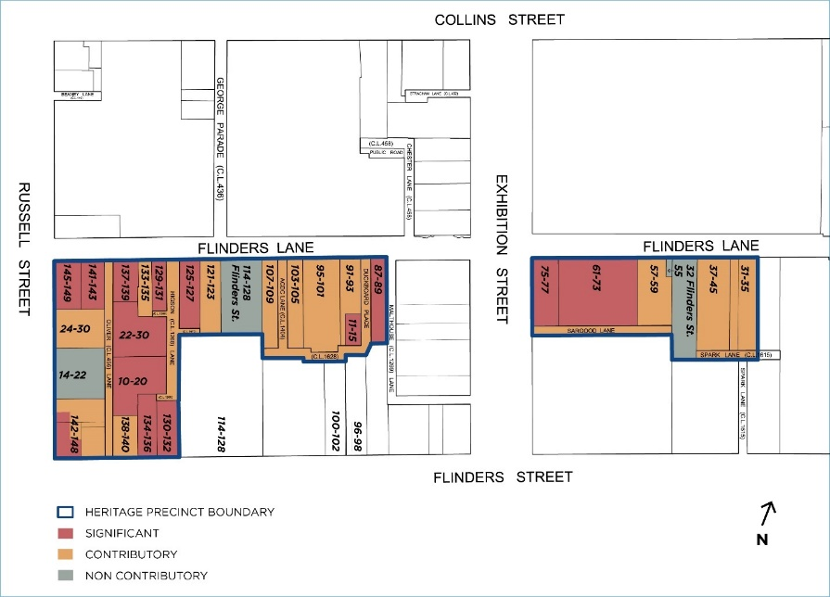
What is significant?
The Flinders Lane East Precinct comprising 31-149 Flinders Lane, 11-15 Duckboard Place, 130-148 Flinders Street, 10-30 Oliver Lane, ACDC Lane, Duckboard Place, Higson Lane, Oliver Lane, Sargood Lane, Spark Lane and including the rear of 24-30 Russell Street.
Elements that contribute to the significance of the precinct include (but are not limited to):
- The commercial and warehouse buildings constructed from c1857 to c1939, as shown on the precinct map.
- The pattern of development in the precinct which comprises mixed streetscapes of Victorian, Federation and interwar commercial and warehouse buildings, and the key features and original detailing characteristic of their respective styles.
- The high quality commercial and warehouse frontages and some side aspects to Flinders Lane, Exhibition Street and Russell Street.
The industrial streetscapes throughout the fine grain network of laneways intersecting with Flinders Lane, with rear and side aspects and some frontages to ACDC Lane, Duckboard Place, and Higson, Oliver, Malthouse, Sargood and Spark lanes.
The buildings at 31-35, 37-45, 57-59, 91-93, 95-101, 103-105, 107-109, 121-123, 133-135 Flinders Lane, and 138-148 Flinders Street are contributory. The laneway rear aspect of 24-30 Russell Street fronting Oliver Lane is also contributory.
The buildings at 61-73, 75-77, 87-89, 125-127, 129-131, 137-139, 141-143, 145-149 Flinders Lane, 130-132, 134-136 and 142-148 Flinders Street, 11-15 Duckboard Place, and 10-20 and 22-30 Oliver Lane are significant. The VHR-listed Duke of Wellington Hotel at part of 142-148 Flinders Street is also significant.
Non-original alterations and additions to the contributory buildings are not significant.
The buildings at 55 Flinders Lane (32 Flinders Street), 114-128 Flinders Street, and 14-22 Russell Street are non-contributory to the precinct.
How it is significant?
The Flinders Lane East Precinct is of local historic, representative and aesthetic significance to the City of Melbourne.
Why it is significant?
The Flinders Lane East Precinct is historically significant for its association with manufacturing and warehousing principally for the clothing and textile businesses, colloquially referred to as the ‘rag trade’, between the 1850s and the 1930s. Far from dealing in rags, Flinders Lane was the hub of a fashion industry with its many small niche businesses that provided specialist finishing services to the clothing manufacturers. The area provided employment in clothing manufacture, and many employees were women. Flinders Lane was the epicentre of the textile and clothing industry and benefited from the Commonwealth tariffs that resulted in further construction of factories and warehouses throughout the 1920s and 30s. Historically, the Flinders Lane East Precinct was the home of several other industries including Melbourne City Council’s Corporation Yard (11-15 Duckboard Place) and 91-93 Flinders Lane, coach and carriage builders Samwells and Reeves at 103 Flinders Lane and box manufacturers Morris and Walker at 31-35 Flinders Lane. (Criterion A)
The Flinders Street East precinct is significant for its low-rise built form and street pattern that represents the pre-modern city. The attributes of the precinct include the laneway network that provides additional street frontages for some buildings, and an almost continuous streetscape of up to six storeys in height on Flinders Lane. The precinct demonstrates a great variety of architectural expression developed over approximately 80 years and representing many styles. Several buildings of the Romanesque revival style including nos.31-35, 87-89, 125-127, and 145-149 Flinders Lane are notable. Interwar buildings in the stripped classical style of Pawson House (no.141) or the Gothic revival of the former Bank of New South Wales at no.137-139 are also notable examples. (Criterion D)
The Flinders Lane East Precinct is aesthetically significant for its views down Oliver, Malthouse and Higsons Lanes. It is also aesthetically significant for its nearly complete streetscape of small lot buildings up to six storeys in height and built to the property boundaries. The slope to the Yarra River allows some buildings to have basements or additional lower storeys. The open-ended Oliver Lane is aesthetically significant for its views to Flinders Street and beyond to the south, and of 42 Russell Street to the north. ACDC Lane, Higson Lane and Duckboard Place are significant for their enclosed and intimate scale enhanced by the red brick walls. The views along these lanes are significant for the aspects they reveal of the side of nos. 87-89, 91-93, 103-105, 107-109, 125-127, 129-131, 137-139 and 141-143 Flinders Lane.
The streetscape is highly varied but includes many buildings of individual architectural importance and high aesthetic value. The three buildings fronting Flinders Street (nos.130-132, 134-136 and 138-140) are of a similar scale and proportion to those in Flinders Lane. (Criterion E)
The attributes of the Flinders Lane Precinct include:
- VHR listed places at 129-131 Flinders Lane and 142-148 Flinders Street, reinforced concrete warehouses at 10-20 & 22-30 Oliver Lane associated with Sir John Monash and the early use of reinforced concrete as a construction material. The Oliver Lane warehouses are of technical and associative significance.
- Significant places with existing HOs at 61-73, 75-77, 125-127, 129-131, 141-143 and 145-149 Flinders Lane and 130-132 Flinders Street.
- Places assessed to be significant as part of the Hoddle Grid Heritage Review, 87-89 and 137-139 Flinders Lane, 134-136 Flinders Street and 11-15 Duckboard Place.
- All other contributory places noted in the precinct category schedule.
- The building height and scale of the precinct up to six storeys, some places with several additional storeys added but not compromising this scale.
- The intimate scale and character of Duckboard Place, ACDC Lane, Higson Lane, Spark and Sargood Lanes and the way in which they provide side views of significant and contributory places.
- The open-ended Oliver Lane with views to the north and south to the river.
Primary source
Hoddle Grid Heritage Review (Context & GJM Heritage, 2020

