STATEMENT OF SIGNIFICANCE
Heritage Place: Drewery Lane Precinct | PS ref no: HO1290  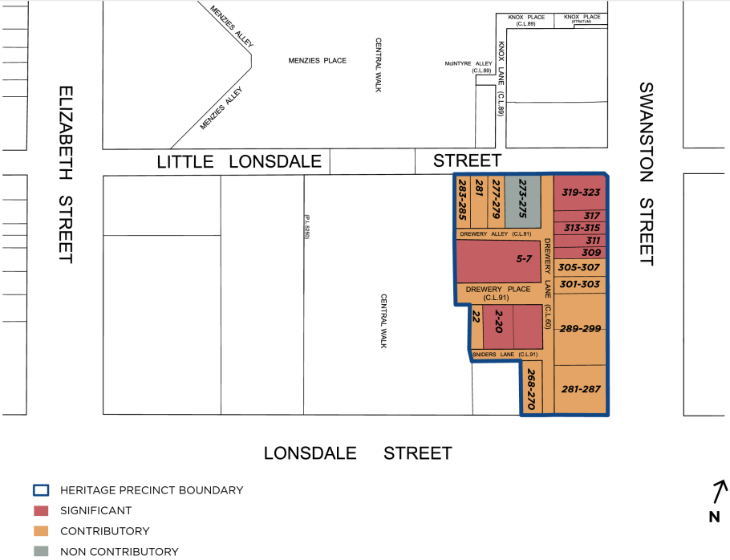
What is significant?
The Drewery Lane Precinct including 268-270 Lonsdale Street, 281-323 Swanston Street, 273-285 Little Lonsdale Street, 2-22 Drewery Place, 5-7 Drewery Lane, Drewery Alley, Drewery Lane, Drewery Place & Sniders Lane, Melbourne, is significant.
Elements that contribute to the significance of the precinct include (but are not limited to):
- The small-scale commercial buildings constructed from c1850 to c1922, as shown on the precinct map.
- The pattern of development in the precinct which comprises mixed streetscapes of Victorian, Federation and interwar commercial and warehouse buildings, and the key features and original detailing characteristic of their respective styles.
- The high-quality commercial frontages to Swanston, Lonsdale and Little Lonsdale Street, and industrial streetscapes throughout the laneway network, with rear aspects and some frontages to Drewery Place, Drewery Alley, Drewery Lane and Sniders Lane.
The buildings at 22 Drewery Place, 277-279, 281, 283-285 Little Lonsdale Street, 268-270 Lonsdale Street, 281-287, 289-299, 301-303 and 305-307 Swanston Street are contributory.
The buildings at 2-20 and 5-7 Drewery Place, and 309-311, 313-315, 317 and 319-323 Swanston Street are significant.
Non-original alterations and additions to the contributory buildings, including cantilevered verandahs, are not significant.
273-275 Little Lonsdale Street is non-contributory to the precinct.
How it is significant?
The Drewery Lane Precinct is of local historic, representative and aesthetic significance to the City of Melbourne.
Why it is significant?
The Drewery Lane Precinct is historically significant for its demonstration of manufacturing and commercial activity from the nineteenth and early twentieth centuries. The area retains places associated with both large and small manufacturing enterprises that demonstrate a wide variety of work once available in the central city. The precinct has a strong association with the cigar and cigarette manufacturing firm Sniders & Abrahams who erected several large buildings in the locality including the warehouses at 2-20 Drewery Place and 5-7 Drewery Lane and their administrative building at 268-270 Lonsdale Street. Other large enterprises associated with the precinct include the Barnet Glass Rubber Company Ltd (until 1940), whose premises at 289-299 Swanston Street was later occupied by Red Cross and Legacy. (Criterion A)
The Drewery Lane Precinct, while physically quite diverse, demonstrates the way in which the Hoddle Grid incorporates large and small streets and laneways within a larger grid of streets. It is notable for its legacy of small and large buildings with frontages to Drewery Lane, Drewery Place, Drewery Alley and Sniders Lane. The precinct is also notable for its individual buildings designed by architects and engineers including Hugh Ralston Crawford (5-7 Drewery Lane, HO905, VHR H902), Nahum Barnet (289-299 Swanston Street) and Sydney Smith & Ogg (268-270 Lonsdale Street). The row of Victorian shops at 309-323 Swanston Street is notable for its considerable length and integrity. (Criterion D)
The Drewery Lane Precinct is aesthetically significant for the range of spatial experiences in its laneway network. Drewery Lane, Sniders lane, Drewery Place and Drewery Alley provide a notable public realm and setting for the individually significant and contributory places that border them. Predominantly of brick construction, buildings within the laneway network of the precinct exhibit both vernacular and high style architecture. Long commercial streetscapes including 301-323 Swanston Street and 277-285 Lonsdale Street demonstrate a visually cohesive and predominantly two-storey scale urban morphology with a consistent material palette of stuccoed masonry. (Criterion E)
Key characteristics include:
- The VHR-listed warehouse at 5-7 Drewery Lane constructed in 1909-10 to the design of engineer/architect Hugh Ralston Crawford.
- A significant factory built for Sniders & Abrahams and designed by Nahum Barnet in 1890 at 2-20 Drewery Place (HO1014).
- A contributory Romanesque revival Pacific House at 268-270 Lonsdale Street designed by Sydney Smith & Ogg in 1903.
- Contributory small scaled commercial premises at 277-285 Lonsdale Street built between the 1880s and 1930s.
- A significant row of Victorian shops and residences between 309-323 Swanston Street (HO1081).
- The former Barnet Glass Company retail premises (now Legacy House) designed by Nahum Barnet in 1909.
- Two storey shops at 301-307 Swanston Street.
- The Britannia Hotel at 281-287 Swanston Street, the only remaining hotel of three previously in this part of Swanston Street.
- A contributory building c1900 at 22 Drewery Place.
- The laneway network and its industrial buildings of Drewery Place, Drewery Lane and Drewery Alley and Sniders Lane.
- Commercial buildings fronting to Swanston, Lonsdale and Little Lonsdale Streets.
Primary source
Hoddle Grid Heritage Review (Context & GJM Heritage, 2020)

