STATEMENT OF SIGNIFICANCE
Heritage Place: Former Factory  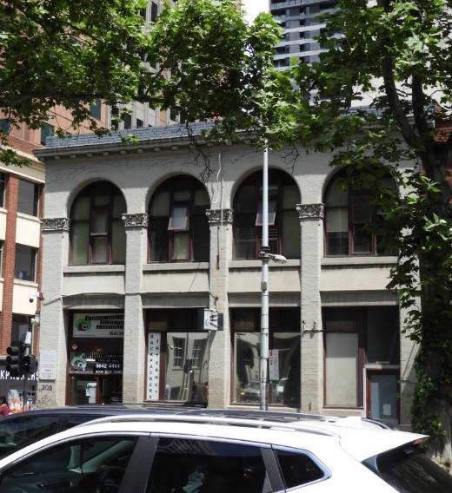 | PS ref no: HO1340  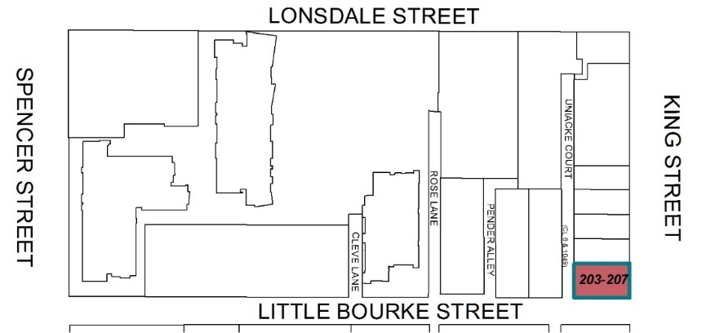
What is significant?
203-207 King Street, Melbourne, a two-storey factory/ warehouse building built in 1912-13.
Elements that contribute to the significance of the place include (but are not limited to):
- The original building form and scale;
- The original fenestration, including brick pilasters (some with Art Nouveau capitals), semicircular arches, recessed spandrels, cornice, parapet and pattern of window openings; and
- The original timber frame windows.
Later alterations made to the street level facades are not significant.
How it is significant?
203-207 King Street, Melbourne, is of local historic and representative significance to the City of Melbourne.
Why it is significant?
The two-storey factory building at 203-207 King Street is historically significant for the evidence it provides of a key phase in Melbourne's manufacturing history during the first decades of the twentieth century when most residents moved out of the city to the suburbs, and the retail and manufacturing sectors rapidly took up city properties. Multi-storey workshops, factories and warehouses, many designed by architects, were increasingly established in the city centre. The factory building at 203-207 King Street was constructed in 1912-13 to a design by notable architect J A B Koch. Constructed for printer and stationery manufacturer, Thomas George Ramsay, it is also significant as it is indicative of the historical concentration of businesses connected to the printing, publishing and paper goods industry in the west of the city. Ramsay’s business, named T G Ramsay & Co, was associated with the Ramsay family, Melbourne printers and publishers since 1888. T G Ramsay & Co occupied the building for 22 years, until 1935. (Criterion A)
203-207 King Street is significant as a largely intact example of a two-storey Federation period factory/warehouse building featuring some elements influenced by Romanesque architecture. It is one of several such buildings that survive from the period, which are generally low scale and use simple construction of loadbearing face brick walls with either a steel post and beam or reinforced concrete internal structure. It retains its original form and scale, and exhibits key characteristics of its type and style, such as brick pilasters (some with Art Nouveau capitals) terminating in semicircular arches, recessed spandrels, cornice, parapet and pattern of window openings and, at first floor level, timber-framed Diocletian pattern windows. The significance is enhanced by retention at street level of the original refined configuration of masonry and openings. Despite the overpainting, the original form and detailing of the building remain clearly legible. (Criterion D)
Primary source
Hoddle Grid Heritage Review (Context & GJM Heritage, 2020)

