STATEMENT OF SIGNIFICANCE
Heritage Place: Former Gothic Chambers and warehouse  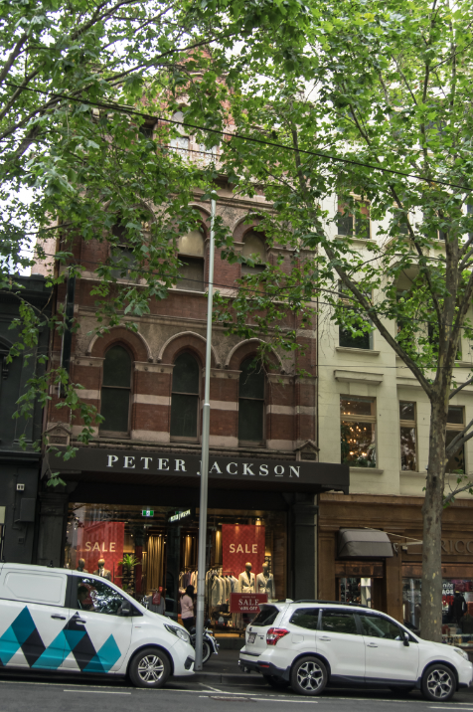 | PS ref no: HO1005  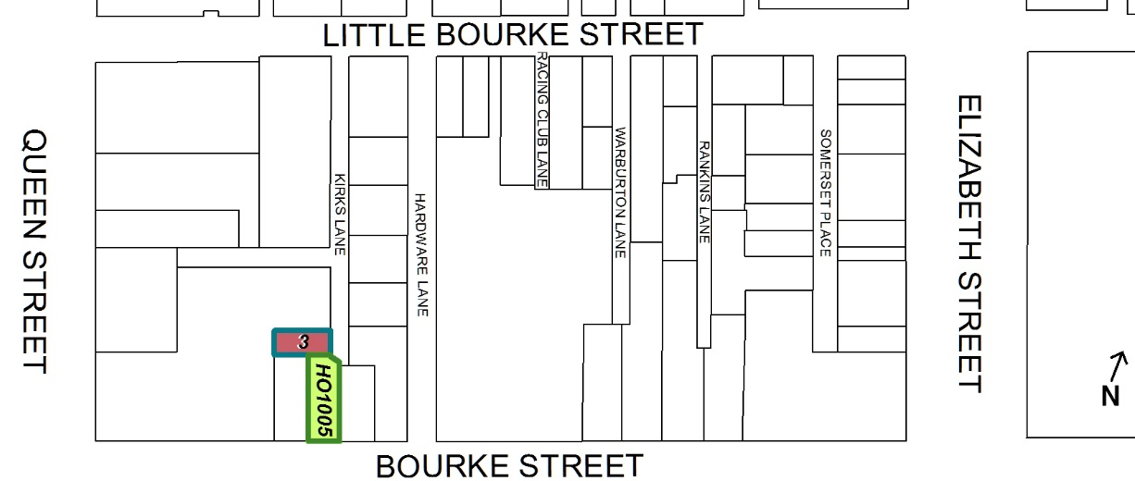
What is significant?
The former Gothic Chambers and its warehouse at 418-420 Bourke Street and 3 Kirks Lane, Melbourne, a pair of four-storey warehouses built in 1890 for the City Property Company.
Elements that contribute to the significance of the place include (but are not limited to):
- The original building form and scale (Bourke Street & Kirks Lane);
- The original face brick principle and rear façades and pattern and size of original openings (Bourke Street and Kirks Lane);
- Original roof form to both buildings including the transverse gable roof to the front section of Bourke Street;
- Gabled parapet;
- The distinctive façade with Venetian Gothic Revival elements and other ornamental detailing to the façade (Bourke Street);
- The original timber double-hung sash windows (Bourke Street and Kirks Lane) and full height glazed timber loading doors (Kirks Lane); and
- Evidence of original warehouse details including central projecting hoist beam and suspended loading platforms, as well as other refined detailing including the use of curved bricks around the openings (rear of Bourke Street and Kirks Lane).
More recent alterations, including those to the ground floor shopfronts in Bourke Street and changes to openings to the rear of 418-420 Bourke Street, are not significant.
How it is significant?
The former Gothic Chambers and warehouse at 418-420 Bourke Street and 3 Kirks Lane, Melbourne, is of local historic, representative and aesthetic significance to the City of Melbourne.
Why it is significant?
The Gothic Chambers and warehouse are historically significant for their association with a key phase in Melbourne's development when, during the economic boom of the 1880s and the early 1890s, an increasing number of investors constructed architect-designed multi-storey factory and warehouse premises in the city to house the growing manufacturing and retail industry. Built in 1890 in an industrial area near the famous Kirks’ Horse Bazaar as an investment property of the City Property Company, the place is distinguished for its long-term industrial use and association with Melbourne’s small-scale manufacturers. The City Property Company developed a number of key city properties in the 1880s and early 1890s during Melbourne’s land boom, including the former nearby Clarke’s Buildings (demolished in the 1960s), and a number of landmark city properties. The Kirks Lane warehouse’s longstanding and continued use as a low scale warehouse/factory building into the present day contributes to its significance. (Criterion A)
The Gothic Chambers and warehouse are significant as a highly intact example of a pair of warehouses built in the late Victorian period. Constructed in 1890 to a design by architect Charles D’Ebro, the buildings provide tangible evidence of the industrial expansion in central Melbourne during this period. Their function and structure represent the warehouse typology once very common across the city blocks within the Hoddle Grid. The Gothic Chambers’ Bourke Street frontage features Gothic Revival style elements. The Kirks Lane elevations of both buildings have very high integrity externally with minimal changes and display highly utilitarian elements such as face brickwork and loading doors on upper floors. This combination of stylistic devices is representative of a type of building complex associated with manufacturing and wholesaling built within Hoddle Grid. The location of the Kirks Lane warehouse in a minor street or laneway with side access to facilitate the movement of goods and materials in and out of the building is also characteristic of its type. (Criterion D)
The Gothic Chambers at 418-420 Bourke Street is of aesthetic significance for its use of Venetian Gothic Revival style elements, which was unusual for a small-scale warehouse. The construction of Gothic or Medieval Revival style buildings in central Melbourne predominantly occurred in the period between 1880 and 1893, mostly built for financial institutions and organisations. The use of detailing inspired by Venetian Gothic and Romanesque architecture in the Bourke Street building distinguishes it from other contemporary warehouses that more commonly utilised the widely popular Italianate style. The Venetian Gothic and Romanesque inspired elements include the transverse gable roof behind a gabled parapet with corbel table and arcade and pointed-arched openings on either side of the gable end; pointed-arched openings set between pilasters with decorative capping and base at the building’s edges. Other highly refined detailing to the façade includes the letters `CPC' (City Property Company) entwined on a moulded cement shield between a pair of equilaterally arched windows; rendering over the windows debossed with a leaf motif; a band of brickwork laid in chequerboard pattern between the first and second floors; the Romanesque inspired frieze within the iron balustrade and on post moulding; splayed or chamfered edges of the openings; and the two pilasters with simple capital, finished in painted render on the ground floor. (Criterion E)
Primary source
Hoddle Grid Heritage Review (Context & GJM Heritage, 2020

