STATEMENT OF SIGNIFICANCE
Heritage Place: Former Markillie’s Prince of Wales Hotel  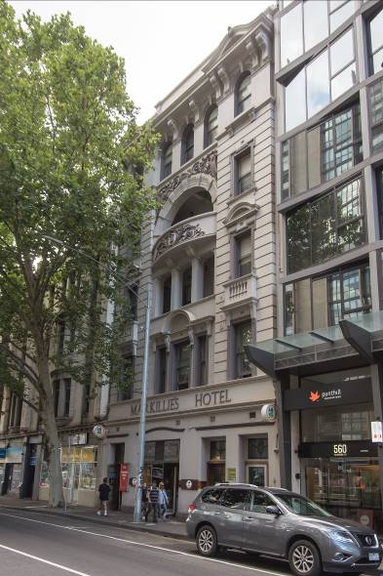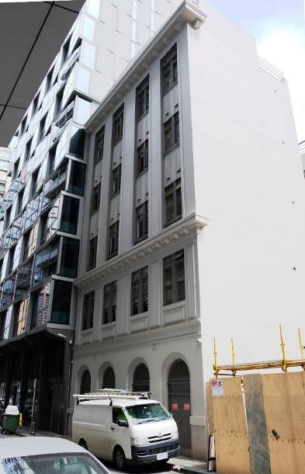 | PS ref no: HO1041  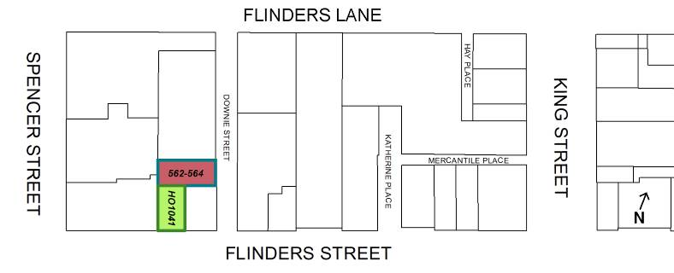
What is significant?
The former Markillie’s Prince of Wales Hotel at 562-564 Flinders Street, Melbourne, an Edwardian hotel built in 1915, including a rear extension of reinforced concrete built in 1927 and further extended in 1936.
Elements that contribute to the significance of the place include (but are not limited to):
- The original building form and detail (Flinders Street and Downie Street);
- The pattern of fenestration and elaborate decorative work to the Flinders Street façade, including the stylised Prince of Wales feathers;
- The early or original ‘Markillie’s Hotel’ metal lettering on the Flinders Street façade;
- The original and early (1927 and 1936) building form and detail, including street level arches to Downie Street;
- The original and early (1927 and 1936) pattern of fenestration; and
- The external wall surfaces of painted cement render.
Its longstanding use as a residential hotel since 1915 is also significant.
Later alterations, including those made to the street level façades, are not significant.
How it is significant?
The former Markillie’s Prince of Wales Hotel site at 562-564 Flinders Street, incorporating its rear annexe facing Downie Street, Melbourne, is of local historic and representative significance to the City of Melbourne.
Why it is significant?
The site at 562-564 Flinders Street is of historical significance for its longstanding use as a residential hotel since the 1870s. The present-day building, known as the former Markillie’s Prince of Wales Hotel, was developed on this site in 1915 for the Carlton & United Breweries Ltd, with a rear extension constructed in two phases in 1927 and 1936 during Arthur Markillie’s time as the licensee. It provides evidence of both the success of the hotel business under Markillie’s licence and of changes in Victorian licencing legislation in the 1920s and 1930s that required the provision and upgrade of hotel accommodation. (Criterion A)
The former Markillie’s Prince of Wales Hotel also represents the early twentieth century development of this area near the corner of Spencer and Flinders streets, formerly reliant on port activities on the northern bank of Yarra River. With the demise of the port activities by the 1910s, the shift in character of this area was stimulated by the significant growth of railway and motor traffic into central Melbourne. The hotel’s expansions over the early decades of the twentieth century evidence the area’s continued importance as one of the main access points into central Melbourne, prompted by major infrastructure-related projects such as Spencer Street Station (now Southern Cross Station) in 1924 and construction of the Spencer Street Bridge in 1929-30. (Criterion A)
The former Markillie’s Prince of Wales Hotel is of representative and aesthetic significance as an excellent example of the work of Melbourne architects, Sydney Smith & Ogg and P J O’Connor. The earlier 1915 building fronting Flinders Street is a result of the collaboration between Carlton & United Breweries Ltd and Sydney Smith & Ogg, through which many notable hotel buildings around Melbourne and its surrounding suburbs were produced. The principle elevation of 562-564 Flinders Street features Edwardian Baroque style elements, with a rendered façade that is deeply modelled with bas relief detail, heavy mouldings and a skilful combination of mass and void. The fine detailing to this façade includes a wide central bow-fronted balcony and broad opening arch, decorative mouldings such as sizeable parapet cornice and brackets, ostrich feathers on the central balcony which were traditionally used as a symbol of the Prince of Wales. To the rear of this 1915 building, the Downie Street building (built as an annex in 1927 and added in 1936) is a substantial and highly intact example of an interwar residential hotel. Built to a design by hotel and church architect P J O’Connor, it demonstrates key characteristics of the restrained interwar Commercial Palazzo style, expressed through a strong vertical emphasis resulting from projecting pilasters and mullions, a substantial cornice, and large horizontally proportioned windows separated by articulated spandrels at each floor. (Criteria D and E)
Primary source
Hoddle Grid Heritage Review (Context & GJM Heritage, 2020)

