STATEMENT OF SIGNIFICANCE
Heritage Place: Former Melbourne Shipping Exchange  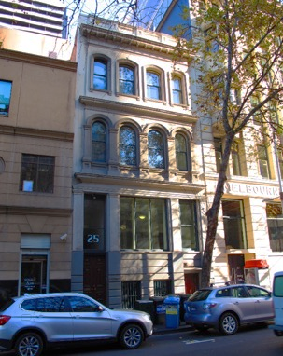 | PS ref no: HO1250  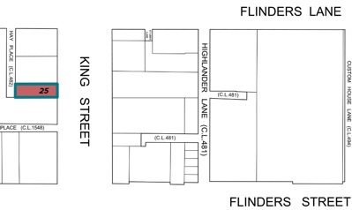
What is significant?
The commercial building at 25 King Street, Melbourne, designed by Frederick Williams and completed in 1889.
Elements that contribute to the significance of the place include (but are not limited to):
- The building’s original form, materials and detailing;
- The building’s high level of integrity to its original design;
- Detailing of the façade including rusticated ground floor, engaged pilasters with entablature above, deep cornices, moulded architraves, sills and sill brackets; and
- Pattern and size of original fenestration, and original window joinery.
Later alterations, including a non-original window centrally located at the first level, are not significant.
How it is significant?
25 King Street, Melbourne is of local historic, representative and aesthetic significance to the City of Melbourne.
Why it is significant?
25 King Street is of historic significance for its association with Melbourne's foremost late nineteenth and early twentieth century shipping company, the Melbourne Coal, Shipping and Engineering Co, known as the Shipping Exchange and from 1895 as the Melbourne Steamship Company. The present building at 25 King Street served as the company headquarters from 1889-1913 before it relocated next door to 27-31 King Street. (Criterion A)
25 King Street is a fine example of an Italianate commercial building from the late Victorian era. Designed by architect and Sandridge mayor and councillor, Frederick Williams, it is significant for its somewhat unusual feature of a half basement which is also employed at Williams’ other building at 384-386 Flinders Lane. The Italianate façade is of high quality featuring moulded stucco work to the façade. (Criterion D)
25 King Street is aesthetically significant, demonstrating key characteristics of the Italianate style, including a scholarly arrangement of classical elements such as a decorated parapet, deeply moulded cornices, a variety of windows with segmented, round arched and squared heads and a rusticated ground level with engaged pilasters. 25 King Street is notable for its high degree of integrity to the façade. (Criterion E)
Primary source
Hoddle Grid Heritage Review (Context & GJM Heritage, 2020)

