STATEMENT OF SIGNIFICANCE
Heritage Place: Former Printcraft House  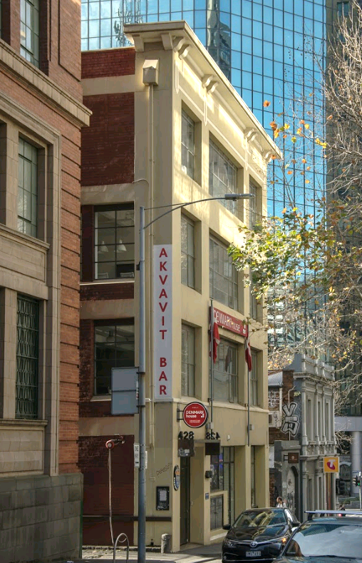 | PS ref no: HO1346  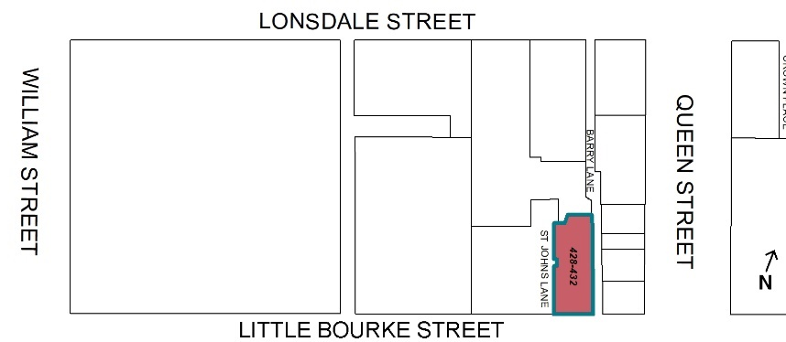

What is significant?
The former Printcraft House building at 428-432 Little Bourke Street, Melbourne, a four storey brick and concrete former warehouse building built in 1923 to a design by architects Gawler & Drummond for the printers Brown, Prior & Co.
Elements that contribute to the significance of the place include (but are not limited to):
- The original built form and scale;
- The original painted render and face brick walls and pattern of fenestration including cornice, continuous painted render lintels and pattern of window openings;
- The substantial decorative cornice surmounting the façade; and
- The original steel frame windows.
Later alterations made to the street level façade, such as the insertion of new shopfronts, are not significant.
How it is significant?
428-432 Little Bourke Street, Melbourne, is of local historic and representative significance to the City of Melbourne.
Why it is significant?
The former Printcraft House building at 428-432 Little Bourke Street, built in 1923 for the Melbourne firm of printers, Brown, Prior & Co, is historically significant for the evidence it provides of the long-term industry and warehouse concentration in this part of the city, and as a remnant of printing industry buildings located in proximity to the 1926 Argus Building at the Elizabeth and Latrobe streets corner. The historical grouping of buildings for similar uses has characterised the city’s development.
The building is historically significant for its association with the Melbourne firm of printers and bookbinders, Brown Prior & Co, established by Francis A Brown and Henry E Prior in Queen Street by 1902. Brown Prior & Co printed most of book seller and publisher Robertson & Mullens's (forerunner to Angus & Roberston) publications from 1922 at a time when Australian publishers rarely owned their own print houses. Brown, Prior & Co became Brown, Prior, Anderson Pty Ltd in 1937 and occupied 428-432 Little Bourke Street for more than 40 years from 1923 until 1966. The company continued as a printing house until 2013. (Criterion A)
The former Printcraft House building at 428-432 Little Bourke Street is significant as a relatively intact example of an early interwar warehouse/factory building constructed in 1923 as a component of the industrial expansion in central Melbourne during this period. The building is an example of the many low scale warehouse/factory buildings of a simple utilitarian character, that were located in minor streets and laneways with rear lane access to facilitate the movement of goods and materials in and out of the building. These buildings are now becoming increasingly rare in the area around the central sector of the Hoddle Grid, where its broader streetscape context has been considerably affected by later twentieth century redevelopment.
Like other examples of its type, it utilises loadbearing face brick external wall with a reinforced concrete internal structure, and painted render and face brick walls. Built to a design by architects Gawler & Drummond, and like other examples of its type, 428-432 Little Bourke Street demonstrates a refined yet highly functional aesthetic with symmetrical facade with simple parapet, a regular pattern of large efficient steel framed windows with painted render lintels. The lack of superfluous decoration reinforces this simple and disciplined industrial aesthetic. (Criterion D)
Primary source
Hoddle Grid Heritage Review (Context & GJM Heritage, 2020)

