STATEMENT OF SIGNIFICANCE
Heritage Place: Former Thomas Warburton Pty Ltd complex  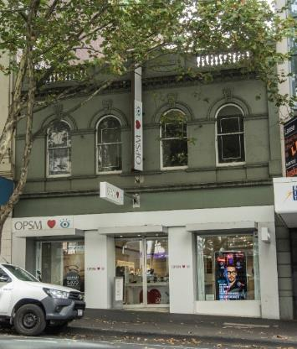  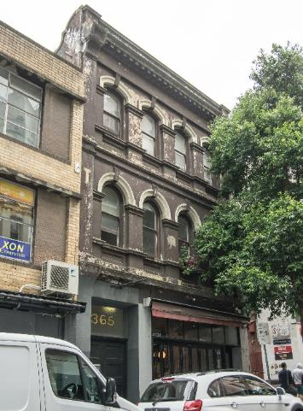 | PS ref no: HO1052  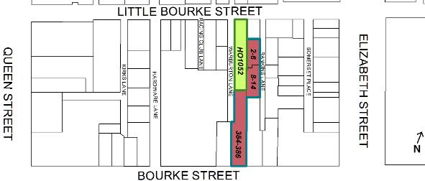
What is significant?
384-386 Bourke Street, 365-367 Little Bourke Street and 2-6 and 8-14 Rankins Lane, Melbourne, the former Thomas Warburton Pty Ltd complex comprising buildings constructed over stages in 1865, 1887 and 1912.
Elements that contribute to the significance of the place include (but are not limited to):
- original two-storey form and scale, original loadbearing brick walls finished with painted render, and pattern of openings on the upper level, as well as the Italianate style decorative details including pilaster, cornices, parapet with open balustrade, central pediment and key stones (384-386 Bourke Street);
- original three-storey form and scale incorporating rear warehouses, original loadbearing brick walls finished with painted render (street frontage), original loadbearing face brick walls with bichrome detailing (along Warburton Lane), pattern of openings on the upper level façade, pattern of openings on the Warburton Lane elevation including the cement sills with brackets and splayed edges (except for the altered ground level openings and rectangular upper level openings) as well as the Italianate style decorative details including pilasters, cornices, flat parapet with dentilation below, alternated windows shapes with rendered surrounds and key stones (365-375 Little Bourke Street); and
- original three-storey form and scale, original loadbearing face brick walls, and patterns of openings on the upper level, bays divided by plain pilasters and terminated with semi-circular arches, recessed spandrels, corbel heads, reinforced concrete lintels, and other original or early details such as hoists, any original timber or steel window frames and sets of double doors including those on the loading doors (rear of 384-386 Bourke Street in Warburton Lane, and 2-6 and 8-14 Rankins Lane).
Later changes, including alterations to the ground-level shopfronts (365-367 Little Bourke Street), new projected signages (384-386 Bourke Street), and infill of ground-level openings (rear of 384-386 Bourke Street), are not significant.
How it is significant?
The complex of buildings at 384-386 Bourke Street, 365-367 Little Bourke Street and 2-6 and 8-14 Rankins Lane, Melbourne, is of local historic and representative significance to the City of Melbourne.
Why it is significant?
The complex of buildings at 384-386 Bourke Street, 365-367 Little Bourke Street, 2-6 and 8-14 Rankins Lane, constructed over stages in 1865, 1887 and 1912 by Thomas Warburton Pty Ltd is historically significant. Developed and owned by a single company, the group of adjoining buildings provide important tangible evidence of the evolution of a prominent business in this area of central Melbourne that was known for horse bazaars, ironmongery and hardware merchants from the 1840s. A notable ironmonger and hardware supplier, Thomas Warburton established his business at 384-386 Bourke Street in 1865, buying a block running through to Little Bourke Street, on which the Warburton family gradually developed their business and other warehouses creating an extensive complex that comprised 11 buildings by the mid-1920s. Thomas Warburton Pty Ltd was directly associated with the site for more than 100 years. Thomas Warburton Pty Ltd was one of the key manufacturing and wholesaling businesses that once thrived in the immediate area. The company survives today as Thomas Warburton Pty Ltd, owned by the multinational Wurth Group. (Criterion A)
The former Thomas Warburton Pty Ltd complex is significant as a representative example of a building complex associated with manufacturing and wholesaling, which was once common in central Melbourne but is now unusual. Developed for the same owner, the complex retains a substantial cluster of buildings that are reflective of their respective types (shops with residences above, storage and warehouses) and time periods (mid- and late Victorian and Federation/Edwardian periods). The design aesthetics of each respective time period is reflected in the designs of each building in the complex. The 1865 building at 384-386 Bourke Street is an early example of Italianate style shop and residence building in central Melbourne. Sharing similar stylistic elements, The design of 365-367 Little Bourke Street represents a shift in preference towards highly ornamented designs over the more plainly decorated variations of the earlier decades. The rear three-storey warehouses fronting Warburton and Rankins lanes are representative of Federation-era face red brick warehouses with utilitarian characteristics. Overall, the former Thomas Warburton Pty Ltd complex is highly important as a collection of substantially intact buildings that provide tangible evidence of an important pattern of development in central Melbourne. (Criterion D)
Primary source
Hoddle Grid Heritage Review (Context & GJM Heritage, 2020)

