STATEMENT OF SIGNIFICANCE
Heritage Place: Warehouse  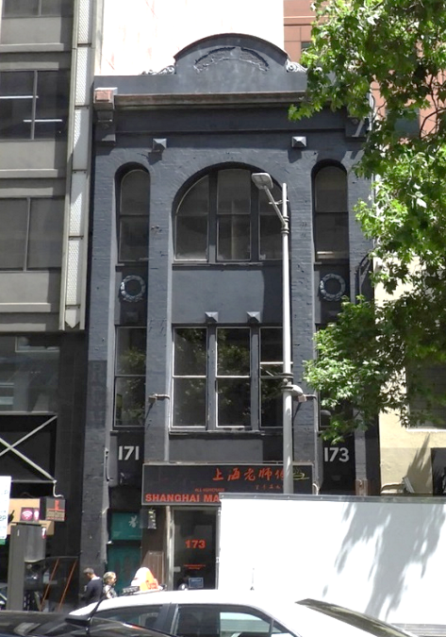 | PS ref no: HO1339  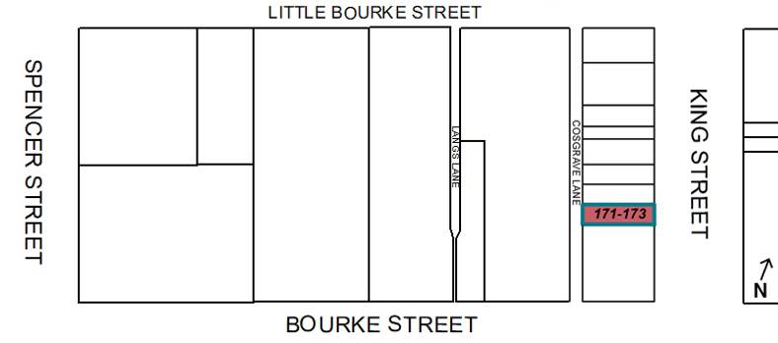
What is significant?
171-173 King Street, Melbourne, a three-storey factory/warehouse building built in 1922.
Elements that contribute to the significance of the place include (but are not limited to):
- The original building form and scale;
- The original fenestration, including brick pilasters, semicircular arches (King Street and Cosgrave Lane elevations), recessed spandrels, cornice, parapet and pattern of window openings; and
- The original timber frame windows.
Later alterations made to the street level façade, such as the aluminium framed shopfronts, are not significant.
How it is significant?
171-173 King Street, Melbourne is of local historic, representative and associative significance to the City of Melbourne.
Why it is significant?
The three-storey warehouse building at 171-173 King Street, Melbourne, constructed in 1922 for J Creffield Pty Ltd, map mounters, heliographers and printers, and occupied by that firm until c1985, is historically significant for representing key phase in Melbourne's manufacturing development: the 1920s recovery period (after the 1890s economic depression) when factory and warehouse premises were in increasing demand in the city to house the growing manufacturing industry. 171-173 King Street demonstrates the historical concentration of businesses connected to the printing, publishing and paper goods industry in the west of the city. (Criterion A)
171-173 King Street is of representative significance, being a highly intact example of an early interwar period factory/warehouse building. Its restrained use of classical and Romanesque details and loadbearing brick construction demonstrate typical characteristics of the early interwar factory/warehouse building constructed in the period immediately before reinforced concrete became the preferred material for warehouse construction, replacing brick. Modestly-scaled factory/warehouses constructed during this period were typically built of loadbearing brick, with the restrained architectural detailing exhibiting classical influences. (Criterion D)
The building is significant for its long association with J Creffield Pty Ltd (1923 to c1985), a prominent firm of map mounters, heliographers and printers, established in Melbourne 35 years earlier in 1888. J Creffield Pty Ltd held a number of government contracts and produced maps for the Allied forces during World War One, as well as maps and plans for educational purposes and for architects. (Criterion H)
Primary source
Hoddle Grid Heritage Review (Context & GJM Heritage, 2020)

