STATEMENT OF SIGNIFICANCE
Heritage Place: Great Western Hotel  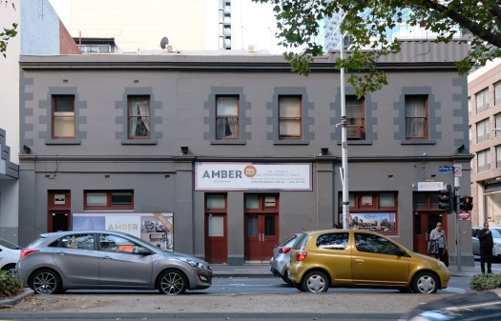 | PS ref no: HO1341  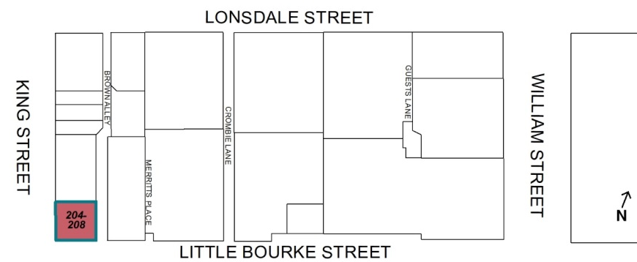
What is significant?
The two-storey hotel building at 204-208 King Street, Melbourne, built in 1864 and extended in c1920.
Elements that contribute to the significance of the place include (but are not limited to):
- The original building form and scale
- The c1920s addition
- The original loadbearing brick walls (later rendered and painted) and pattern of fenestration including pilasters, corner quoins, cornices and parapet, window openings with quoins and projecting sills and rear wings to Brown Alley; and
- The original or early double hung timber frame windows.
Later alterations made to the street level facades and the steel profile sheeting above the parapet are not significant.
How it is significant?
204-208 King Street is of local historic, representative and social significance to the City of Melbourne.
Why it is significant?
The former Great Western Hotel is historically significant as a substantial early-Victorian purpose-built hotel in Melbourne. It operated continuously as a hotel for 153 years, from 1864 to 2017, initially under the name the Star of the West Hotel, and from 1892 to 2017 as the Great Western Hotel. Additions in the c1920s were associated with and provide evidence of the continued operation of the hotel under new liquor licensing requirements that required provision of adequate accommodation and other facilities. (Criterion A)
The former Great Western Hotel at 204-208 King Street is significant as a largely intact example of a substantial early Victorian hotel building on a prominent corner site. The building façades retain characteristic architectural features of the Victorian Italianate style, albeit in a restrained and rustic manner with minimal decoration or design sophistication. Extended and modified in the 1920s, the addition replicated the building’s original form and detail to create a ‘seamless’ extension to the north along King Street, while the original building remains legible. The former Great Western Hotel is comparable with other examples of HO listed hotels in central Melbourne with similarly early construction dates and long history of use as a hotel. (Criterion D)
The former Great Western Hotel is of social significance for its long connections with the city, serving as a social meeting place for a diverse clientele for more than 150 years. For city workers, and the legal and media fraternity, the Great Western Hotel served as a place to meet, socialise and share stories. Regarded as ‘old-fashioned’, it attracted a clientele seeking the simple traditional pub-style – a bar, good beer, and simple, modestly-priced food. Closure of the hotel in October 2017 was marked by many regulars with farewell visits and online posts expressing a strong sense of connection to the hotel and an appreciation of its ambience, offering a traditional pub style then rare amongst city hotels. (Criterion G)
Primary source
Hoddle Grid Heritage Review (Context & GJM Heritage, 2020)

