STATEMENT OF SIGNIFICANCE
Heritage Place: Hoyts Mid City Cinemas  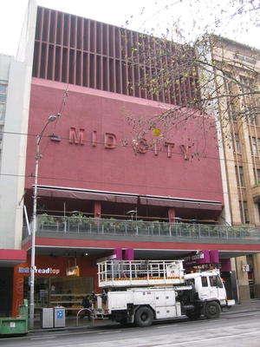 | PS ref no: HO1002  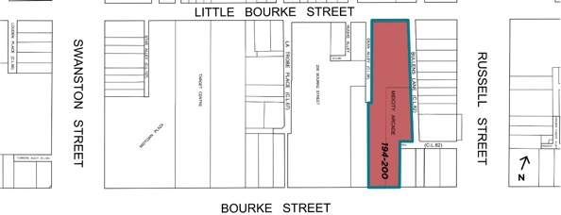
What is significant?
Hoyts Mid City Cinemas at 194-200 Bourke Street, Melbourne, built 1969-70 and designed by Bogle & Banfield architects.
Elements that contribute to the significance of the place include (but are not limited to):
- The building’s original external form, materials and detailing; and
- The building’s high level of integrity to its original design.
Later alterations made to the street and first floor levels are not significant.
How it is significant?
Hoyts Mid City Cinemas at 194-200 Bourke Street is of historical, representative and aesthetic significance to the City of Melbourne.
Why it is significant?
Hoyts Mid City Cinema is historically significant as part of the increase in leisure and tourism provided in Melbourne, as the city became a place of entertainment made possible by higher disposable incomes and more leisure time from the 1960s. The establishment of Mid City and the Cinema Centre marked a turning point to more modern and intimate cinemas, following the closure of the large picture theatres of the interwar period. The Bourke Street location of the cinema followed over 120 years of the traditional siting of theatres in Melbourne. (Criterion A)
Hoyts Mid-City Cinemas is a representative example of a small class of brutalist buildings in the City of Melbourne. Popularised by architects in the mid-1960s, brutalism as a movement persisted until the late 1980s. Architects Bogle & Banfield Associates provided two of the best examples of brutalism in Melbourne with Total House and the Mid City Cinemas. With Peter Muller’s Hoyts Cinema Centre as an early and particularly large-scale example, these three buildings provide an excellent record of this movement. Both the Mid City and the Hoyts Cinema Centre are stylistically distinctive designs among the small number of new cinemas built in the postwar period. (Criterion D)
Hoyts Mid-City Cinemas is significant for its sculptural form that is highlighted by the red-oxide colour that contrasts with the off-form concrete of the side walls. As a building requiring little natural light, the brutalist architecture of the cinema complex relies primarily on an articulation of solid form. The slim concrete vertical louvres in front of the glazing are a contrast to the solid mass of the main part of the building. (Criterion E)
Primary source
Hoddle Grid Heritage Review (Context & GJM Heritage, 2020

