STATEMENT OF SIGNIFICANCE
Heritage Place: Former Melbourne City Council Power Station  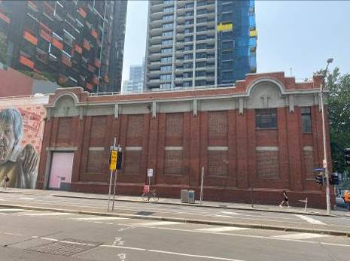  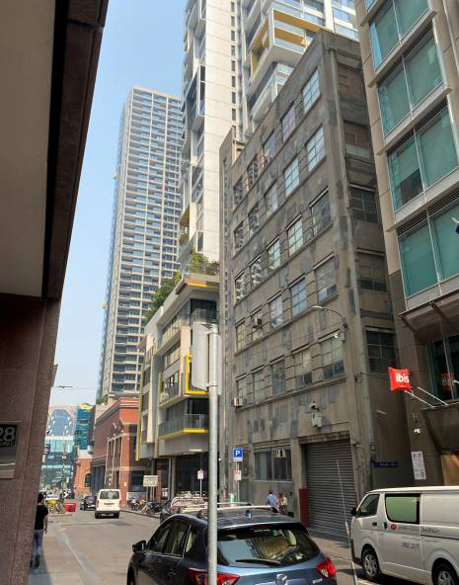 | PS ref no: HO737  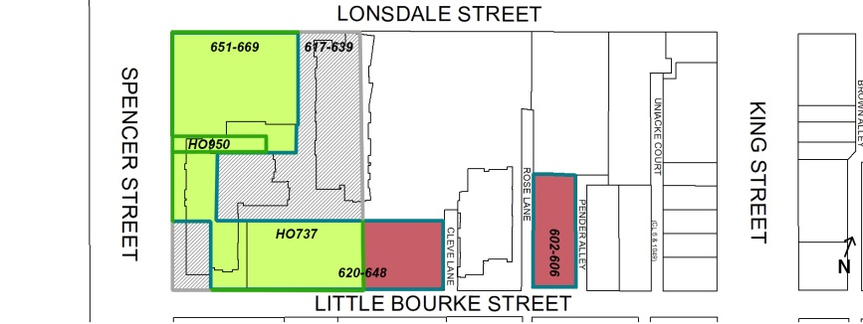
What is significant?
The former Melbourne City Council Power Station buildings, 617-639 (part) and 651-669 Lonsdale Street, 602-606 and 620-648 Little Bourke Street Melbourne, located across the block bounded by Little Bourke, Lonsdale and Spencer streets, built between 1908 and 1985.
Elements that contribute to the significance of the place include:
- CitiPower substation (Substation J) at 651-669 Lonsdale Street, which comprises the brick substation from 1920, and the reinforced concrete additions to the south from 1950s and to the east in 1953 (former Control Building);
- External walls to the façade and north and south elevations of the Office Building, now part of 617-639 Lonsdale Street (with frontages to Spencer Street);
- Economiser Building, now part of 617-639 Lonsdale Street (with frontages to Little Bourke Street), built in 1908;
- Overhead Water Tank, fashioned out of prefabricated cast-iron panels in 1888 and relocated to this site in 1927;
- Substation JA at 620-648 Little Bourke Street, which comprises the post-1925 substation (built as a workshop and later converted to a substation) adjacent to Cleve Lane and a large substation constructed in 1985 on the site of the former 1903 Boiler House; and
- Melbourne City Council Archives building (former Store Building) at 602-606 Little Bourke Street.
Recent changes, including the interventions to the original fabric during redevelopment works after 2006 and associated apartment towers, are not significant.
How it is significant?
The former Melbourne City Council Power Station buildings, (part of) 617-639 Lonsdale Street, 651-669 Lonsdale Street, 602-606 Little Bourke Street, and 620-648 Little Bourke Street Melbourne, are of historic, rarity and representative significance to the City of Melbourne. The overhead water tank (VHR H2117) is of historic, rarity and technical significance to the City of Melbourne.
Why it is significant?
The former Melbourne City Council Power Station buildings, built between 1908 and 1985, are historically significant for their association with the development of Melbourne's electricity supply network established in 1894 and for their ability to demonstrate the provision of electricity to metropolitan Melbourne by Melbourne City Council from 1894 into the early 1980s. In 1894, Melbourne City Council was the first metropolitan council in Victoria to establish its own electricity supply and distribution network, which in turn facilitated the residential, commercial and industrial expansion of the city. The form, scale and fabric of the individual buildings provides physical evidence of the system’s expansion during the early decades of the twentieth century into the postwar era and a range of the power station’s component parts.
The surviving physical fabric of the former power station site is significant as rare surviving evidence of the infrastructure built by the Melbourne City Council Electricity Supply Department as part of Melbourne’s expanding electricity network, and as a substantial remnant of the former Melbourne City Council Power Station, which was closed in 1982. Following the closure of the power station, the extant Substation J (651-669 Lonsdale Street) and Substation JA (620-648 Little Bourke Street) operated under the ownership of Melbourne City Council in conjunction with the State Electricity Commission of Victoria (SECV) until the privatisation of the electricity industry saw it transferred to CitiPower Ltd in 1998. Substation JA represents the continued use of the site for the supply of electricity into the 1980s, before the privatisation of the electricity industry. (Criteria A and B)
The overhead water tank at the former MCC Power Station is of historic significance as the only surviving element of the original nineteenth-century system that generated and supplied hydraulic power across the City of Melbourne until the 1960s. (Criteria A and B)
The former Melbourne City Council Power Station site comprises individual buildings that are significant as representative examples of their type. Substation J (part of 651-699 Lonsdale Street), a three-storey brick substation built in 1920, is a representative example of a Melbourne City Council substation designed by its own architects’ branch. Utilitarian in its design, it incorporates stripped back classical elements and natural materials. Details used in Substation J are consistent with the architectural character of other later interwar substations built by Melbourne City Council. The post-1925 CitiPower substation at the eastern part of 620-648 Little Bourke Street is a largely intact example of an interwar factory building, consistent in form, scale and materiality with the many low-scale warehouse/factory buildings of similar utilitarian character. The lack of superfluous decoration reinforces the building’s disciplined industrial aesthetic. (Criterion D)
The overhead water tank at the former MCC Power Station is of scientific (technical) significance for its early and rare use of prefabricated cast iron panels. This type of construction allowed for its reuse at the former MCC Power Station site, albeit at a reduced scale to suit the different pumping arrangements. (Criterion F)
Primary source
Hoddle Grid Heritage Review (Context & GJM Heritage, 2020)

