STATEMENT OF SIGNIFICANCE
Heritage Place: Shops and dwellings  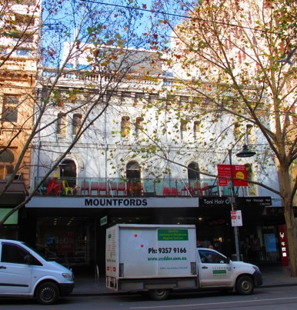 | PS ref no: HO1240  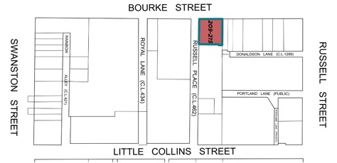
What is significant?
The row of four three-storey shops/dwellings at 209-215 Bourke Street built in 1876.
Elements that contribute to the significance of the place include (but are not limited to):
- The building’s original external form, materials and detailing;
- The building’s high level of integrity to its original design;
- Balustraded parapet;
- Engaged pilasters that demarcate each shop;
- Upper façade detailing including cornice with elaborate scroll brackets; paired segmented arch windows with moulded arch cornice to upper edges (upper level); single round arched window with decorative moulded arched cornice (mid-level);
- Original chimneys;
- Pattern and size of fenestrations to side elevation (Russell Place); and
- Side and rear walls of face brick (overpainted).
Later alterations made to the street level facades are not significant.
How it is significant?
209-215 Bourke Street is of local historic and representative significance to the City of Melbourne.
Why it is significant?
209-215 Bourke Street is historically significant as a mid-Victorian building that represents a key phase in the development of Melbourne when increasing numbers of investors developed retail premises in the city during the building boom of the 1870s and 1880s. Built in 1876 for investment partners F B Clapp and W G Sprigg, who developed up to 12 similar properties along Bourke Street between 1873 and 1885, 209-215 Bourke Street is typical of retail buildings of the Victorian era that housed retail outlets at ground level with residences and workspaces for business-owners provided on the floors above. (Criterion A)
209-215 Bourke Street, built in the mid-Victorian era and characterised by rich decoration is significant for its Italianate influences and unified composition across the upper façade. The first floor level of the four shops retains the classical architectural styling typical of the period, featuring decorative stucco elements including engaged pilasters, deep cornicing, scrolled brackets, window mouldings and a balustraded parapet. (Criterion D)
Primary source
Hoddle Grid Heritage Review (Context & GJM Heritage, 2020)

