STATEMENT OF SIGNIFICANCE
Heritage Place: Swanston Street South Precinct | PS ref no: HO1289  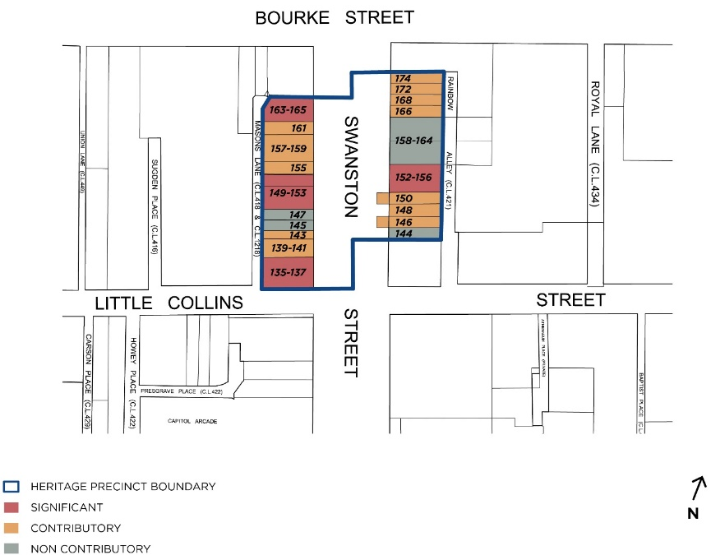
What is significant?
The Swanston Street South precinct comprising commercial buildings including 135-165 Swanston Street, 144-174 Swanston Street, Melbourne, is significant. This section of Swanston Street is distinguished by its almost continuous run of buildings from the nineteenth and early twentieth century on the west side, including two individually significant seven-storey landmark places; and its two rows of Victorian-era buildings on the east side.
Elements that contribute to the significance of the precinct include (but are not limited to):
- The small scale commercial buildings constructed from c1888 to c1938, as shown on the precinct map;
- The pattern of development in the precinct which comprises a mixed streetscape of Victorian, Federation and interwar commercial buildings, and the key features and original detailing characteristic of their respective styles;
- The overall consistency of built form (predominately two- to three-storey scale), materials and detailing (masonry construction, stucco detailing), and siting (narrow allotments, predominately low-rise streetscape bookmarked at each end by two landmark buildings on the west side);
- The Edwardian shopfront at 161 Swanston Street; and
- The laneway rear aspects of the buildings to Mason Lane and Rainbow Alley.
The buildings at 139-141, 143, 155, 157-159, 161 and 146, 148, 150, 166, 168, 172, 174 Swanston Street are contributory.
The buildings at 135-137, 149-153, 163-165 and 152-156 Swanston Street are significant.
Non-original alterations and additions to the contributory buildings, including cantilevered verandahs, are not significant.
The buildings at 144, 145, 147 and 158-164 Swanston Street are non-contributory to the precinct.
How it is significant?
The Swanston Street South Precinct is of local historic, representative and aesthetic significance.
Why it is significant?
The Swanston Street South Precinct is within the retail area of the central city. It demonstrates the predominant land use of retailing that was established quite early in the development of the central city between Swanston and Elizabeth Streets.
Historically the Swanston Street South Precinct demonstrates the small allotment size that was created by the subdivision patterns of the 1870s and 1880s and that established the urban density of the Hoddle Grid until the 1950s. The Swanston Street South Precinct is significant for its demonstration of retailing from the 1870s to the 1930s. Varied retail uses existed within the precinct including a strong emphasis on clothing and footwear (Ezywalkin, 163 Swanston Street, Faul’s hosiery at no.139-141, millinery and drapery at no.135-137). These uses are evident in the individual buildings, the streetscape, in Masons Lane and in documentary evidence in plans and photographs. (Criterion A)
The Swanston Street South Precinct is significant for its demonstration of two distinctive urban morphologies, that of the one to three-storey building and that of the six to eight-storey building that formed the next phase once building heights were lifted to allow a maximum height of 40 metres.
The particular characteristics of the low scale buildings include masonry walls generally faced with stucco at the front, a regular pattern of small windows, parapets that disguise the roof form and a variety of classically derived façade details. 135-137 and 163-165 Swanston Street (Nahum Barnet, 1919 and 1922) are notable examples of this second type. The two-three storey buildings that form the remainder of the precinct illustrate the earlier representation of the city.
Within the precinct are fine examples of Edwardian architecture at 149-153 Swanston Street (1900, Reed Smart and Tappin) and 161 Swanston Street (c.1900, no designer identified). Other places within the precinct are representative examples from each of the Victorian (1850-1900), Edwardian (1900-1919) and interwar (1919-1935) periods. Together these elements comprise a distinctive low scaled and fine-grained group within the retail heart of the city, bookended by notable taller buildings. (Criterion D)
The Swanston Street South Precinct is aesthetically significant for the upper floors of the buildings that demonstrate the different periods and styles in which they were built. Whilst the street level has generally been modified, the upper floors have retained architectural characteristics of the period including parapets, original window openings, moulded stucco decoration to the masonry walls and stylistic detail and elements common to each period. The precinct is characterised by some individual buildings that express exceptionally fine façades with floors of bow-fronted windows and large arch-headed windows that enliven the streetscape. These include nos. 135-137, 139-141, 149-153, 161 and 163-165 Swanston Street. Nos 149 and 161 are notable for their upper floor windows, and for no.161 the curved shopfront is unusual. The interwar classical revival style is notable at 152-156 Swanston Street.
Nos.155 and 157-159 Swanston exhibit fairly austere classical revival façades. The Victorian period is well represented on the east side of Swanston Street with the typical Victorian stucco facades of nos.146-150 and 166-174 Swanston Street and their rhythmic pattern of arch-headed windows with mouldings. The recessed entry with curved glass ground floor shopfront is an important element of no.161.
The views provided along Masons Lane are also aesthetically significant, framing views of tall buildings to the north and south. The rear elevations of the buildings abutting the laneways especially nos.143-165 Swanston Street are aesthetically significant for their scale, form and brick and stucco walls with a pattern of window and loading bay openings. (Criterion E)
Key attributes of the precinct include:
Victorian-era buildings:
- 146, 148 and 150 Swanston Street, two-storey Victorian shops built by 1877
- 166, 168, 172 and 174 Swanston Street, three-storey Victorian shops built by 1888
Edwardian era buildings:
- 135-137 Swanston Street, 1919 seven-storey building by Nahum Barnet and Marcus Barlow
- 143 Swanston Street, built by c1910 as two-storey and extended in the postwar period
- 149-153 Swanston Street, three-storey shops and studios by Reed Smart and Tappin, 1900
- 161 Swanston Street including the shopfront, c1900, no designer identified
- 163-165 Swanston Street, 1922 seven-storey building Nahum Barnet
Interwar era buildings:
- 139-141 Swanston Street, 1924, no designer identified
- 155 and 157-159 Swanston Street, c1920s, no designer identified
- 152-156 Swanston Street, 1938, A & K Henderson remodelling
The laneway rear aspects of the buildings, particularly those on Masons Lane and the northern part of Rainbow Alley.
Primary source
Hoddle Grid Heritage Review (Context & GJM Heritage, 2020)

