STATEMENT OF SIGNIFICANCE
Heritage Place: Warehouse  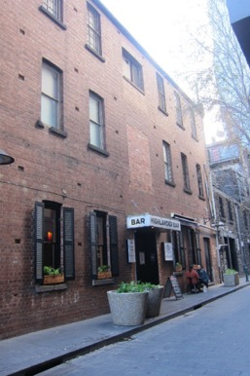 | PS ref no: HO1269  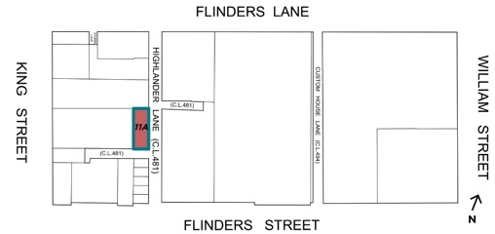
What is significant?
11A Highlander Lane, a brick warehouse built between 1903 and 1910.
Elements that contribute to the significance of the place include (but are not limited to):
- The building’s original external form, materials and detailing;
- Loadbearing face brickwork; and
- Pattern and size of original fenestration and original projecting sills (Highlander Lane elevation).
Later alterations including replacement windows and doors, metal window grilles, timber shutters at ground level ad cantilevered verandah are not significant.
How it is significant?
11A Highlander Lane is of local historic and representative significance to the City of Melbourne.
Why it is significant?
The warehouse building at 11A Highlander Lane is historically significant for its association with warehousing in the City of Melbourne. The former warehouse, located near Melbourne’s wharf trade and formerly part of Zander’s Bonded Stores, was built between 1903 and 1910 on land owned by Patrick John Doyle. (Criterion A)
11A Highlander Lane is part of a distinctive warehouse streetscape in Highlander Lane. It is a representative example of a utilitarian brick warehouse, once more common around Highlander Lane and Stubbs Lane during the nineteenth and the early twentieth century. Despite some alterations to window and door openings it remains legible as a warehouse as a result of its building form, face brick walls and window arrangement, including the narrow vertical loading opening with projecting beam. (Criterion D)
Primary source
Hoddle Grid Heritage Review (Context & GJM Heritage, 2020)

