STATEMENT OF SIGNIFICANCE
Heritage Place: Warehouse  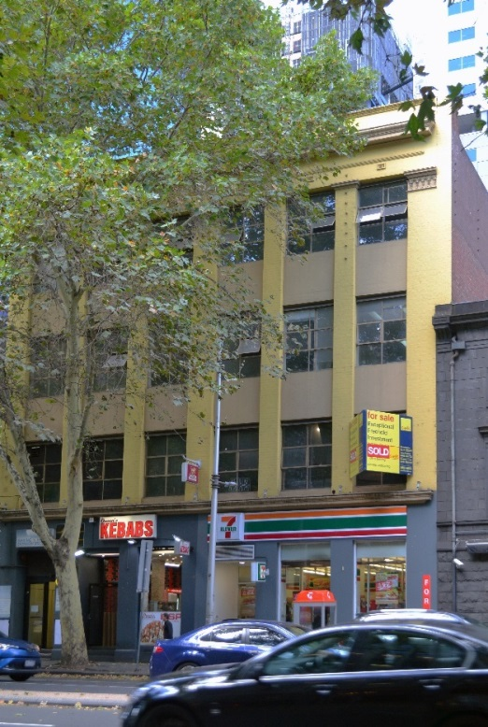 | PS ref no: HO1338  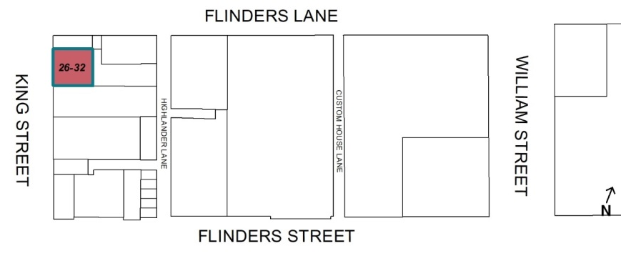
What is significant?
26-32 King Street, Melbourne, a four-storey warehouse building built in 1911 with the principal elevation refaced in c1923.
Elements that contribute to the significance of the place include (but are not limited to):
- The 1911 built form and scale;
- The original pattern of fenestration and c1923 decorative elements;
- The external wall surfaces of painted cement render; and
- The early multipane steel framed windows (c1923) to the upper floors.
Later alterations made to the street level facades are not significant.
How it is significant?
26-32 King Street, Melbourne, is of local historic and representative significance to the City of Melbourne.
Why it is significant?
The warehouse at 26-32 King Street is historically significant as surviving evidence of warehousing in this part of the city of Melbourne. Located near Melbourne's early transport infrastructure, the first port and Spencer Street Railway Station (opened 1859), it was built to service Melbourne’s trading port. From 1877 until c1950s, Zander’s Bonded Stores was located on this site; the current five-storey building (built 1911, refaced in c1923), was known as Zander’s Bonded Stores No 4 and No 5, and replaced the earlier Zander’s two-storey warehouse that existed on the site. 26-32 King Street was part of an extensive store complex owned by produce merchant and wholesale shipper, Patrick John Doyle. Used for storage from 1911 to the 1950s, the building remains as evidence of the importance of warehousing in this part of the city, which was integral to the economic activity of the original port that continued into the 1950s. (Criterion A)
26-32 King Street is significant as a substantially intact example of the wave of warehouse development in the western port area of Melbourne during the late Edwardian and early interwar period that replaced the low scale masonry warehouses of the nineteenth century. The more substantial warehouses from the early interwar period of development commonly utilised the interwar Chicagoesque style. The King Street façade (refaced in c1923) which features a strong vertical emphasis from projecting pilasters with large windows separated by recessed spandrels at each floor), is an intact and representative example of this Chicagoesque stylistic tendency. (Criterion D)
Primary source
Hoddle Grid Heritage Review (Context & GJM Heritage, 2020)

