Melbourne Planning Scheme
Incorporated Document
Guildford and Hardware Laneways Heritage Study 2017: Statements of Significance, November 2018 (Amended July 2020)

This document is an incorporated document in the Melbourne Planning Scheme pursuant to Section 6(2)(j) of the Planning and Environment Act 1987

Contents
ELIZABETH STREET WEST PRECINCT…………………………………………………………………….3
GUILDFORD & HARDWARE LANEWAYS PRECINCT…………………………………………………...12
388-90 BOURKE STREET, MELBOURNE………………..………………………………………………..24
414-16 BOURKE STREET, MELBOURNE………..………………………………………………………..26
421 BOURKE STREET, MELBOURNE……………………………………………………………………..28
245-69 ELIZABETH STREET, MELBOURNE………………...……………………………………………30
287-9 ELIZABETH STREET, MELBOURNE………………………………………………………………..33
307-11 ELIZABETH STREET, MELBOURNE………………………………………………………………35
32-34 GUILDFORD LANE, MELBOURNE…………………...……………………………………………..37
17-19 HARDWARE LANE, MELBOURNE…………………...……………………………………………..39
55-7 HARDWARE LANE, MELBOURNE…………………...……………………..………………………..41
63-77 HARDWARE LANE, MELBOURNE…………………...……………………………………………..43
337-9 LA TROBE STREET, MELBOURNE……………..…...……………………………………………..45
386-92 LITTLE BOURKE STREET, MELBOURNE………………………………………………………..47
387 LITTLE BOURKE STREET, MELBOURNE……………………………………………………………49
401-5 LITTLE BOURKE STREET, MELBOURNE…………………………………………………………51
358-60 LITTLE COLLINS STREET, MELBOURNE………………………………………………………..53
362-64 LITTLE COLLINS STREET, MELBOURNE………………………………………………………..55
359 LITTLE LONSDALE STREET, MELBOURNE…………………………………………………………57
369-71 LONSDALE STREET (REAR), MELBOURNE…………………………………………………….59
377-81 LONSDALE STREET, MELBOURNE………………………………………………………………61
15, 17 & 19 MCKILLOP STREET, MELBOURNE………………………………………………………….63
18-22 MCKILLOP STREET, MELBOURNE…………………………………………………………………65
128-146 QUEEN STREET, MELBOURNE………………………………………………………………….67
17 SOMERSET PLACE, MELBOURNE…………………………………………………………………….69
15 SUTHERLAND STREET, MELBOURNE………………………………………………………………..71

Elizabeth Street West Precinct (HO1204)
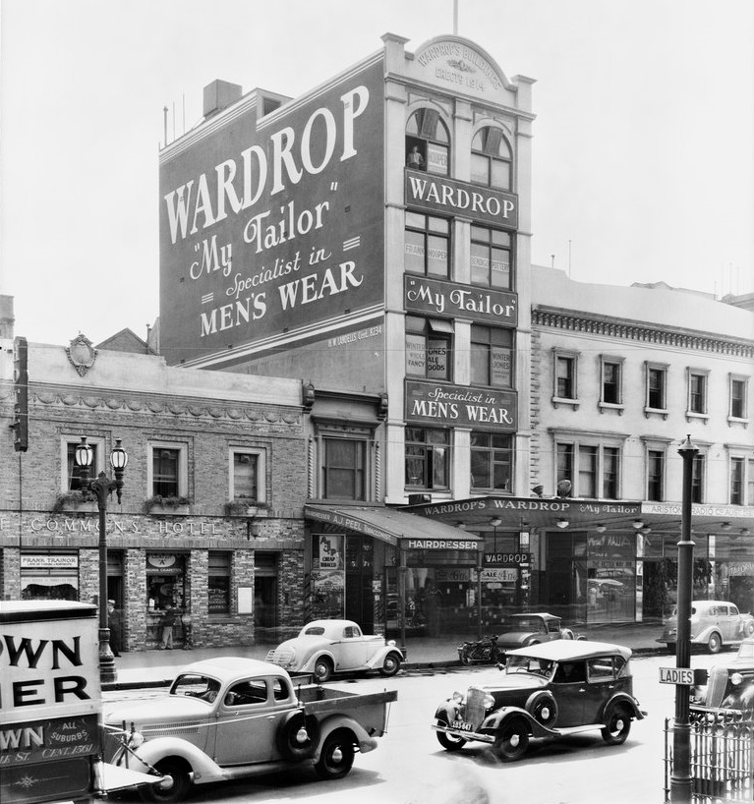

Statement of Significance

What is Significant?
The Elizabeth Street West Precinct is located in the Melbourne Central Business District, concentrated on the west side of Elizabeth Street between La Trobe Street in the north and Bourke Street in the south. The precinct is not fully contiguous, comprising two separate sections of Elizabeth Street, with the separate southern section below Little Bourke Street. It also extends to the west to include the laneways, and properties abutting the laneways, of Zevenboom Lane, Heape Court and Somerset Place. While the northern and southern sections of the precinct are independently legible, they come together as two parts of a larger whole, being the broader retail and commercial precinct, complemented by the historically related laneways. Significant and contributory buildings in the precinct were constructed from the early 1850s through to the interwar period. This date range reflects the historical development and evolution of Elizabeth Street generally, and that of the sections of street included in the precinct particularly. The significant and contributory buildings also vary in their form, scale and footprint, which again reflects their dates of construction and original and historical uses.

How is it Significant?
The Elizabeth Street West Precinct is of local historical and aesthetic/architectural significance.

Why is it Significant?
The Elizabeth Street West Precinct is of historical significance. Elizabeth Street was an early north-south thoroughfare of the Hoddle Grid, built on the general alignment of the former Townend Creek. It was also historically at the low-lying centre of the Grid, marking the division between the east and west halves of the city. Elizabeth Street was the main north route out of the city, and the start of the road to Sydney and the goldfields, the Bendigo diggings in particular. The onset of the gold rush was in fact the catalyst for the rise of the street, at least in a commercial sense. It is now a physically evolved street, including within the precinct. Valued development ranges from the mid-nineteenth century, when smaller scale shops and businesses were established to service the north-bound traffic out of the city, and residents living in the western part of the CBD; through to the later nineteenth century and interwar period, when larger showrooms and grander commercial buildings were constructed. The later development variously accommodated motor bicycle and motor related businesses, garment and other manufacturers, and banks. For its first half century, Elizabeth Street was poorly managed in civic terms, and the subject of public derision and ridicule due to its poor drainage and frequent flooding. The poor drainage remained until the 1880s, when an underground brick drain was finally constructed, extending from Therry Street in the north to the Yarra River in the south. The laneways running parallel to Elizabeth Street are also of historical significance. While they provide evidence of a typical Melbourne laneway’s role in servicing the rears of properties to the main street, they also retain evidence of their own nineteenth and early twentieth century development, including former factories and warehouses which were independent of Elizabeth Street and not of a retail nature. (Criterion A)
The Elizabeth Street West Precinct is of aesthetic/architectural significance. It includes a range of two and three storey Victorian, Edwardian and interwar commercial and retail buildings, anchored by some key corner buildings of individual significance, often designed by well-regarded architects. While many of the contributory buildings are typical rather than exceptional in terms of form and detailing, they nevertheless provide evidence of the physical evolution and function of the precinct, including the earlier buildings as evidenced in the fine grained terrace rows. Shopfronts have generally been replaced, but upper levels and parapets are largely intact to their early states. Boxed awnings extend over footpaths. Brick, rendered masonry and concrete are common materials. Moving away from Elizabeth Street, the associated Zevenboom Lane, Heape Court and Somerset Place are also of aesthetic/architectural significance. These retain historic buildings which address the lanes, as well as those which contribute to the heritage character through their side or rear elevations. Valued development to the laneways ranges from the mid-nineteenth century through to the interwar period, and is evident in a rich and diverse collection of factories, warehouses and workshops. Face red brick is the dominant material in the lanes, complemented by bluestone, rendered masonry and concrete. Heape Court in particular is distinguished by its Victorian buildings and early fabric, and retains original bluestone kerbs, channels and flagstones. (Criterion E)
The Elizabeth Street West Precinct is additionally significant for retaining evidence of the typical retail and commercial buildings which were established in many commercial streets of inner Melbourne from the mid-nineteenth century. It has the principal characteristics of such development, and early retail strips, as seen in the fine grained terrace rows with shops at ground floor level, and office or residential spaces above. The upper levels are typically more intact than the ground floor shopfronts. Larger buildings, including banks and showrooms, also commonly anchor the street corners. (Criterion D)

Key characteristics
The following are the key characteristics of the precinct, which support the assessed significance:
- Density of development to both Elizabeth Street and the related laneways, including the fine grain of development with boundary to boundary construction, and no setbacks.
- Building heights to Elizabeth Street in the two-three storey range, with larger buildings such as the former Union Bank, Mitchell House and Wardrop’s Building being notable exceptions.
- Variety of building forms and footprints, including some buildings of narrow proportions to the both Elizabeth Street and the laneways.
- Diverse architectural expression of buildings in Elizabeth Street in particular, denoting development from the mid-nineteenth century – when the street accommodated small scale businesses which serviced residents in the western part of the city and north-bound traffic – through to the late nineteenth century and interwar period when larger showrooms and banks were established.
- On Elizabeth Street, some buildings of individual significance are constructed to the street corners, with addresses to both street frontages.
- The distinctive character of each of the three laneways: Heape Court with a number of Victorian buildings, and original bluestone kerbs, channels and flagstones; Zevenboom Lane with its narrow dimensions and largely interwar character; and Somerset Place with its wider dimensions and more activated contemporary streetscape.
- Contributory building materials to Elizabeth Street include brick, rendered masonry and concrete; while to the laneways it is face red brick (most elevations are not overpainted), rendered masonry and concrete, and some bluestone.
- Contributory components of buildings to Elizabeth Street include intact upper levels, with detailed facades, punched window openings, and diverse parapet forms. Roof forms are typically not visible, but some original chimneys remain and can be seen from the street.
- Contributory components of buildings to the laneways include original side and rear elevations, as well as property frontages and facades; simple brick elevations denote the back-of-house activities of the Elizabeth Street premises.
- Other contributory components of the laneway buildings include some original window and door openings and timber joinery; fenestration expressed as punched openings in masonry walls rather than large expanses of glazing, with steel windows being more typical of the interwar buildings; chamfered corners; and hoists and crane beams which provided access to upper levels of warehouses.
- There is a general absence of vehicle parking arrangements.

Elizabeth Street West Precinct (HO1204)
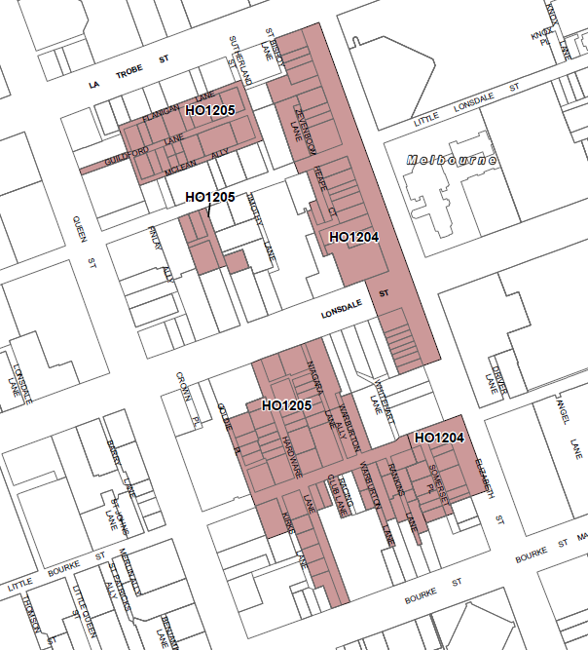

Elizabeth Street West Precinct Property Schedule
Address | Current name | Grading | Description | Comment*
195 Elizabeth Street | Freechoice Tobacconist | Significant | Two storey Victorian shop, 1853 | Also significant to Somerset Place.
197-199 Elizabeth Street (16 Somerset Place) | Molony’s Apartments | Contributory | Five storey garment manufactory, 1914 | Formerly Wardrop’s Tailors.
201-207 Elizabeth Street (20 Somerset Place) |  | Contributory | Three storey Victorian offices | Also contributory to Somerset Place; relates to bluestone elements only.
209-213 Elizabeth Street | Melbourne Tattoo Company | Contributory | Three storey interwar retail premises | Also contributory to Somerset Place.
215 Elizabeth Street (34 Somerset Place) | Pen City | Significant | Two storey Victorian retail premises | Also contributory to Somerset Place.
217 Elizabeth Street | Show & Tell Creative | Significant | Two storey Victorian retail premises | Also contributory to Somerset Place.
245-247 Elizabeth Street | Cuisine World | Contributory | Three-storey Victorian building in terrace row; façade has been altered
249-251 Elizabeth Street | Outre Gallery | Significant | Three-storey Victorian building in terrace row
253 Elizabeth Street | Gretel and Gretel | Significant | Three-storey Victorian building in terrace row
255 Elizabeth Street | Great Earth Super Discount Health Shop | Significant | Three-storey Victorian building in terrace row
257 Elizabeth Street | 24Seven Convenience | Significant | Three-storey Victorian building in terrace row
259 Elizabeth Street | JB Hi-Fi Mobile Phones | Significant | Three-storey Victorian building in terrace row with ornamental gable end
261 Elizabeth Street |  | Significant | Three storey Edwardian retail building
263-269 Elizabeth Street | Michaels Camera Video and Digital | Significant | There are two buildings at this address:  Three storey Edwardian retail building, originally of two storeys (263); and three storey Edwardian retail building with corner tower, of 1915 (265-269) | The building at 263 Elizabeth Street is contributory.
273-281 Elizabeth Street (refer 352-362 Lonsdale Street below) | Discount Notebooks, Metro PC | (refer 352-362 Lonsdale Street) | (refer 352-362 Lonsdale Street)
283-285 Elizabeth Street | Aussie Disposals | Contributory | Two storey Victorian shop, altered
287-289 Elizabeth Street | JB Hi-Fi | Significant | Two storey Victorian shop, very ornate; to the rear is an interwar addition/workshop | Also contributory to Heape Court.
291-293 Elizabeth Street | Oriental Spoon | Contributory | Two storey Edwardian shop | Also contributory to Heape Court.
295-297 Elizabeth Street | Mitchells Adventures | Contributory | Two storey c. 1920s shop | Also contributory to Heape Court.
299 Elizabeth Street | Modak Motorcycles | Significant | Three storey Victorian shop | Also contributory to Heape Court.
301 Elizabeth Street | G2 Korean BBQ | Contributory | Two storey c. 1970s principal elevation, with an early brick two-storey wall to the rear | The 1970s component to Elizabeth Street is non-contributory; with the rear contributory to Heape Court.
303-305 Elizabeth Street | Old Town White Coffee | Significant | Two storey Edwardian shop to Elizabeth Street, with earlier bluestone component to rear | The significant component is to the rear to Heape Court, with a contributory component to Elizabeth Street.
307-311 Elizabeth Street |  | Significant | Two storey interwar retail premises, 1926 | Also contributory to Heape Court.
315-321 Elizabeth Street | The Meeting Place | Non-contributory | Three storey pub/entertainments venue (incorporating former interwar factory) remodelled c.1980s
323 Elizabeth Street | Mars Leathers | Contributory | Two storey Victorian shop | Also contributory to Zevenboom Lane.
325-327 Elizabeth Street | Melbourne Convenience Store | Contributory | Two storey Victorian shop | Also contributory to Zevenboom Lane.
329-335 Elizabeth Street | Ithaca House | Contributory | Three storey c.1960s commercial building, with three/four-storey interwar building to rear | The 1960s component to Elizabeth Street is non-contributory; with the rear contributory to Zevenboom Lane.
337-339 Elizabeth Street | Peter Stevens Motorcycles | Non- contributory | Two storey altered interwar
341-345 Elizabeth Street | Peter Stevens Motorcycles | Significant | Three storey interwar shop with unusual neoclassical design
347 Elizabeth Street | City KTM | Contributory | Three storey interwar shop
349 Elizabeth Street |  | Contributory | Two storey Edwardian shop
351-357 Elizabeth Street | Resource Architecture | Significant | Five storey banking chambers, 1926
349-351 Little Bourke Street |  | Contributory | Two storey interwar shop | Also contributory to Somerset Place
274-278 Little Lonsdale Street | Phillips Shirts | Contributory | Three storey interwar factory | Also contributory to Zevenboom Lane
359 Little Lonsdale Street | H D Development | Significant | Two storey interwar commercial and factory building with Victorian warehouse at rear | The significant component is the Victorian warehouse to the rear; with contributory component to Little Lonsdale Street and Heape Court.
361-365 Little Lonsdale Street | 1000 Pound Bend | Significant | Early Victorian store to rear of two storey building to Little Lonsdale Street. | The property as it addresses Little Lonsdale Street is located outside the proposed precinct. Only the rear (VHR-listed) part of the property addressing Heape Court is included in the precinct, and it is significant.
352-362 Lonsdale Street (also 273, 277 and 279-381 Elizabeth Street) | Mitchell House | Significant | Six storey interwar Moderne offices to the corner, with a four storey connected western component across Mitchell Lane, which is a Victorian warehouse with mid-twentieth century alterations | Corner building is included in the VHR, and is significant. The component west of Mitchell Lane is not in the VHR, and is contributory.
13 Somerset Place | Gallery One Three | Contributory | Four storey c.1920s warehouse
17 Somerset Place |  | Significant | Three storey Edwardian warehouse
19 Somerset Place |  | Contributory | Two storey mid-twentieth century
21-27 Somerset Place | The Foundation for Young Australians | Contributory | Three storey interwar former warehouse
29-31 Somerset Place |  | Contributory | Three storey Victorian former warehouse

*This column indicates where the rear or side of a building contributes to the historic character and significance of a laneway. In some cases, the front of a property has been modified or replaced, and has lost its heritage value, but the historic rear or side component to the laneway is retained. Unless otherwise stated in this column, the front or principal component of the subject property has heritage value.

Guildford & Hardware Laneways Precinct (HO1205)

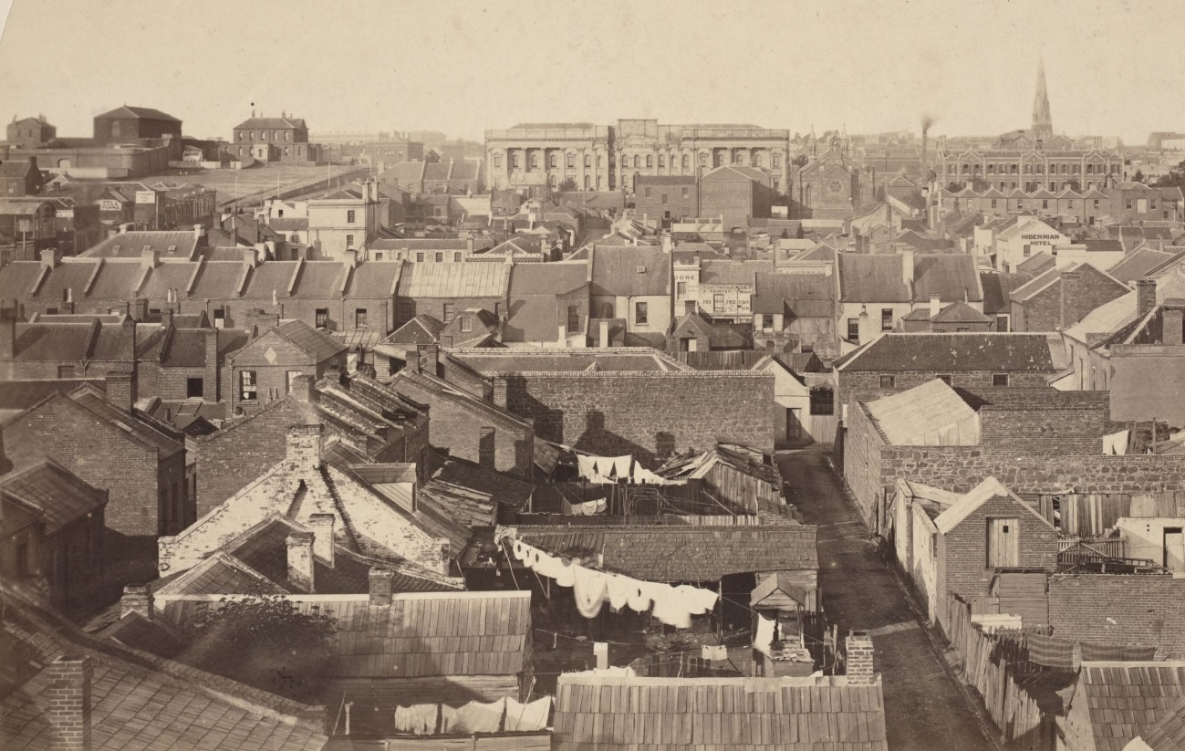

Statement of Significance

What is Significant?
The Guildford and Hardware Laneways Precinct is located in the Melbourne Central Business District. The precinct occupies parts of four city blocks bounded by La Trobe Street to the north, Bourke Street to the south, Queen Street to the west and Elizabeth Street to the east. The precinct has a comparatively high proportion of buildings of heritage value, and significant and contributory buildings in the precinct date from the 1850s through to the interwar period. While precinct development is diverse, many of the graded buildings are former factories and warehouses, with some more modest workshops, of the late nineteenth and early twentieth centuries. The precinct boundary is not contiguous, and in some cases the laneways stop at little streets or main streets and thoroughfares, before recommencing on the other side. The side and rear elevations of buildings of significant and contributory heritage value, can also be important precinct contributors. Where there is historic development to both sides of a laneway or street, including the fronts, sides or rears of properties, the precinct boundary generally incorporates the subject laneway or street. Laneways also provide a setting to the properties, again including property sides or rears. Lanes within the precinct also retain, to a greater or lesser degree, original bluestone kerbs, channels and flagstones.

How is it Significant?
The Guildford and Hardware Laneways Precinct is of historical, social and aesthetic/architectural significance to the City of Melbourne.

Why is it Significant?
The Guildford and Hardware Laneways Precinct is of historical significance. The laneway network within the precinct provides evidence of the evolution and growth of the central city within the structure of the large city blocks and rigid geometry of the 1837 Hoddle Grid. While the grid plan included main streets, and east-west running little streets, the lanes proliferated off this framework, generally in a north-south direction, as the city evolved and developed. The precinct and its laneways and little streets also demonstrate changing historical land uses, and retain building types which reflect these uses and evolving patterns of occupation and development in central Melbourne. The number and extent of lanes in the precinct is reflective of their significant growth in the CBD from the mid-nineteenth to the mid-twentieth century, with 235 named lanes in the broader city by 1935. The precinct’s lanes historically serviced the rears of properties fronting other streets, and acted as thoroughfares through large city blocks. Their typical north-south alignment is reflective of the boundaries of the late 1830s and 1840s large Crown allotments. With increasing subdivision, density and changing land use patterns, many early lanes also evolved into distinct streets with their own character and property frontages. The changing names of some lanes attests to their evolving histories and land uses. Throughout much of the second half of the nineteenth century, small scale residential development and commercial activity was the overriding precinct land use. The former included modest cottages and dwellings, sometimes of sub-standard construction; while the latter included Melbourne’s famous horse bazaars, numerous hotels and small scale workshops. From the late nineteenth century and into the early twentieth century, many earlier small buildings were demolished and replaced by larger factories and warehouses. The precinct’s location, away from the main commercial areas to the south and east, also enabled this next phase of development, due to the relatively cheaper land values. Diverse businesses occupied the buildings, and included printers, publishers and stationers, bulk stores, manufacturing businesses, and light industry. Many of these buildings remain in the precinct. In the later twentieth century, a new wave of residents and businesses were attracted back to the precinct, as part of the City of Melbourne’s revitalisation of the central city laneways. (Criterion A)
The Guildford and Hardware Laneways Precinct is of social significance. This largely derives from the popularity of the revitalised and vibrant laneways of the precinct, with residents and visitors attracted by the activated laneway streetscapes, street art, and numerous bars, cafes, night clubs, galleries and boutique retail outlets. The laneways are also valued by the community as unique public spaces within the CBD. (Criterion G)
The Guildford and Hardware Laneways Precinct is of aesthetic/architectural significance. The laneways in particular form distinctive streetscapes within the central city, their significant heritage character enhanced by the diverse collection of historic buildings, including former factories and warehouses, with some workshops, and their rich materiality. Face red brick is the dominant material, complemented by bluestone, rendered masonry and concrete. The heritage character also derives from the narrow footprint and dimensions of the lanes, given emphasis by the bordering buildings with tall and/or long facades and walls, with no setbacks. Some warehouses have elevated ground floors, and visible sub-basements, which while being illustrative of original loading arrangements, also contribute to the distinctive aesthetic of some lanes. Lanes within the precinct retain to a greater or lesser degree original bluestone kerbs, channels and flagstones, which also contribute to the materiality and heritage character of the precinct. (Criterion E) The precinct is additionally important for demonstrating the principal characteristics of the laneway network of the broader city. The alignment and layout of the precinct’s lanes reflects their origin within the formal Hoddle Grid, their proliferation within the original large city blocks, and their historic servicing and right-of-way roles. Importantly, the laneways of the precinct also largely retain their original arrangement, as evident in nineteenth century sources. (Criterion D)

Key characteristics
The following are the key characteristics of the precinct, which support the assessed significance:
- Laneways predominantly follow a north-south alignment, reflective of the boundaries of the large Hoddle Grid (Crown land) allotments of the late 1830s and 1840s.
- Density of laneways is reflective of their proliferation within the large city blocks from the mid-nineteenth century, following increased subdivision and changing land use patterns.
- Laneways include those which are distinct streets with property frontages; and those which have formed to the sides or rears of properties.
- Narrow proportions, emphasised by walls of buildings, provide a unique character to the laneways as public spaces.
- Contributory components of buildings to the precinct include side and rear elevations, as well as property frontages and facades.
- Contributory building materials include face red brick, bluestone, rendered masonry and concrete. Of note is the limited overpainting of original external walls.
- Windows and doors expressed as punched openings in masonry walls rather than large expanses of glazing.
- Original window and (to a lesser degree) door joinery, including nineteenth century timber elements, and more commonly steel windows from the interwar period.
- Buildings are typically constructed from boundary to boundary, with no setbacks.
- Heights of buildings vary but are generally within the one to four storey range, with some exceeding this.
- Other notable built form characteristics include elevated ground floors and visible basements; high parapets and very little visibility of roof forms; original signage and building names; chamfered corners; hoists and crane beams to warehouses, providing access to upper levels; and timber and concrete buffers.
- There is a general absence of vehicle parking arrangements.
- Contributory laneway materials include bluestone kerbs, channels and flagstones.
Guildford and Hardware Laneways Heritage Precinct (HO1205)
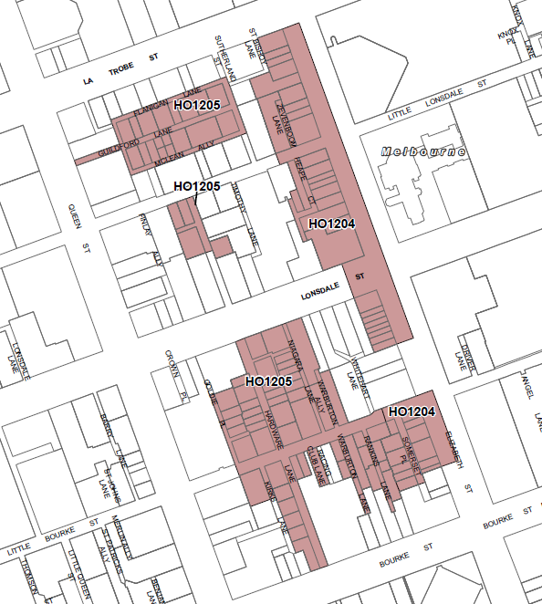

Guildford and Hardware Laneways Precinct Property Schedule
Block 1
Address | Name | Grading | Description | Comment*
8-10 Guildford Lane |  | Non-contributory | Three storey c.1980s apartments
12-14 Guildford Lane |  | Contributory | Single storey interwar factory
16-18 Guildford Lane |  | Contributory | Three storey interwar factory | Also contributory to Flanigan Lane.
20-24 Guildford Lane |  | Contributory | Four storey interwar factory | Also contributory to Flanigan Lane.
26-28 Guildford Lane |  | Contributory | Two single storey interwar workshops | Also contributory to Flanigan Lane.
30 Guildford Lane |  | Contributory | Two storey interwar warehouse | Also contributory to Flanigan Lane.
32-34 Guildford Lane |  | Significant | Single storey Edwardian bluestone workshop with interwar brick addition above | Also contributory to Flanigan Lane.
5-13 Guildford Lane |  | Contributory | There are four building components at this address. From east to west: two storey c. 1970s dwelling; two storey interwar factory; single storey interwar workshop; and single storey interwar workshop | The front of the c. 1970s dwelling is non-contributory.  All the buildings are also contributory to McLean Alley, excluding the 1970s dwelling.
15-21 Guildford Lane |  | Contributory | Three storey interwar factory | Also contributory to McLean Alley.
23-25 Guildford Lane |  | Non-contributory | Part three storey c. 1980s apartments
27 Guildford Lane |  | Non-contributory | Part three storey c. 1980s apartments
29 Guildford Lane |  | Contributory | Three storey interwar warehouse | Also contributory to McLean Alley.
31 Guildford Lane |  | Contributory | Three storey interwar warehouse | Also contributory to McLean Alley.
33-35 Guildford Lane | Regency House | Contributory | Three storey interwar factory | Also contributory to McLean Alley.
24-26 McLean Alley |  | Non-contributory | Part three storey c. 1980s apartments
28 McLean Alley |  | Non-contributory | Part three storey c. 1980s apartments
15-21 Sutherland Street | Probuild Constructions (Aust) | Significant | Bluestone former Bucks Head Hotel stables, 1853 | This building is assessed as being of State significance.  Corner building with significant elevations to three building frontages.
25-31 Sutherland Street |  | Contributory | Two/three storey warehouses, c.1900 | Corner building with contributory elevations to three frontages.

Block 2
Address | Name | Grading | Description | Comment*
106-112 Hardware Street |  | Significant | Pair of four storey Victorian warehouses
115-123 Hardware Street | Bianca Apartments | Contributory | Three storey Edwardian warehouse | Also contributory side elevation.
391 Little Lonsdale Street | CJ Lunchbar | Contributory | Two storey interwar factory | Also contributory to Hardware Street.
395-397 Little Lonsdale Street |  | Contributory | Three storey brick building with tilework to facade | Also contributory to rear lane (accessed off Hardware Street).

Block 3
Address | Name | Grading | Description | Comment*
4-6 and 8 Goldie Place | Breathe Yoga & Pilates | Significant | Pair of two storey Victorian warehouses | Note: the current Heritage Overlay map for HO1044 covers the address of 4-6 Goldie Place (one building). 8 Goldie Place is the other building in the pair, and should be included in the mapping for HO1044.  Also significant elevation to side lane (accessed off Goldie Place).
10-12 Goldie Place | Rare Steakhouse | Contributory | Two storey 1930s factory
14-20 Goldie Place | Word Warehouse | Contributory (both buildings) | No. 14: two storey interwar factory  No 18-20: Two storey Edwardian factory
54-58 Hardware Lane |  | Contributory | Three storey 1939-40 commercial building, with alterations
60-66 Hardware Lane |  | Significant | Three two storey Victorian warehouses
68-78 Hardware Lane |  | Non-contributory | Two storey c.1980s building
51-53 Hardware Lane |  | Non-contributory | Three storey offices constructed 1974
55-57 Hardware Lane |  | Significant | Three storey Victorian factory
59-61 Hardware Lane |  | Contributory | Three storey Victorian factory with alterations
63-77 Hardware Lane |  | Significant | Row of four storey Victorian warehouses | Note: there are four buildings in the row. The current Schedule to the Heritage Overlay lists the address as 63-67, which is incorrect; and the current HO667 mapping only applies to 63-67. It should be amended to cover all four building components.
362-364 Little Bourke Street (also 4 Warburton Alley) |  | Significant | Four storey Victorian offices, interwar addition to rear with c. 2000 alterations | Also significant to Warburton Alley, associated with Victorian building, and not the interwar rear addition.
370 Little Bourke Street |  | Contributory | Five storey interwar offices, with earlier components at rear | Also contributory to Warburton Alley.
372-378 Little Bourke Street |  | Non-contributory | Six storey interwar former factory/warehouse/office and shops to Little Bourke Street.
380-384 Little Bourke Street (46 Hardware Lane) |  | Contributory | Two storey Victorian hotel, 1869, with alterations | Includes single storey north wing which is not contributory.  Also contributory to Hardware Lane.
386-392 Little Bourke Street (43-49 Hardware Lane) | Hardware House | Significant | Six storey interwar offices | Also significant to Hardware Lane.
394-400 Little Bourke Street |  | Contributory | Two building components, including three storey Victorian warehouse (398-400 and c. 1925 three-storey warehouse/factory (394-396)
377-381 Lonsdale Street (30 Niagara Lane) |  | Significant | Four storey Victorian commercial building | Note: the current mapping of HO716 is incorrect, with the HO map covering the non-contributory building to the east. The mapping should be amended to cover this building at the corner of Niagara Lane.  Significant to Niagara Lane; and also contributory to Warburton Alley.
383-387 Lonsdale Street |  | Contributory | Three storey interwar hotel
389-395 Lonsdale Street |  | Contributory | Four storey interwar offices | The principal facade is not contributory, but the side to Hardware Lane is contributory, as is the rear to the lane off Hardware Lane.
15-17 Niagara Lane |  | Contributory | Four storey interwar factory
19-21 Niagara Lane |  | Contributory | Three storey interwar factory
23-31 Niagara Lane |  | Significant | Row of four two storey Victorian warehouses | Also significant to laneway off Niagara Lane.

Block 4
Address | Name | Grading | Description | Comment*
408 Bourke Street (9 Hardware Lane) |  | Contributory | Two storey post-war retail premises with three storey interwar office wing to rear/north side | Previous D grading applies to the whole of the building, including the post-war building component to the corner of Bourke Street, and the interwar three storey office wing to its north to Hardware Lane.  The building to corner of Bourke Street is non-contributory; three storey interwar office wing to north on Hardware Lane is contributory.
13-15 Hardware Lane | Roll’d | Contributory | Four storey interwar offices
17-19 Hardware Lane | Cyclone House | Significant | Three storey interwar offices
21-25 Hardware Lane | Campari House | Contributory | Three storey interwar offices
27-31 Hardware Lane |  | Contributory | Three storey interwar offices
353-359 Little Bourke Street |  | Contributory | Three storey Victorian factory/retail premises | Also contributory to Rankins Lane.
361-363 Little Bourke Street |  | Significant | Three storey interwar factory/commercial building | Also significant to Rankins Lane.
365-367 Little Bourke Street |  | Significant | Three storey Victorian warehouse and commercial building | Also significant to Warburton Lane.
369-371 Little Bourke Street | Grill’d Healthy Burgers | Contributory | Two storey interwar retail premises | Also contributory to Warburton Lane.
377-379 Little Bourke Street | O’Donahue’s Building | Contributory | Three storey c.1922 shops and factory
383-385 Little Bourke street |  | Non-contributory | Two storey brick c. 1940 shop and warehouse
387 Little Bourke Street | Farrant’s Building | Significant | Three storey interwar retail/manufacturing building | Also significant to Hardware Lane.
393-397 Little Bourke Street | Kirks Building | Contributory | Three storey interwar offices, substantially altered c. 1980s | Also contributory to Hardware Lane.
401-405 Little Bourke Street | Day & Sons warehouse | Significant | Four/five storey 1911-1936 red brick warehouse
1-3 Rankins Lane |  | Contributory | Two storey Victorian factory
5-7 Rankins Lane |  | Contributory | Three storey interwar factory
9-15 Rankins Lane |  | Contributory | Three storey interwar factory
2-6 Rankins Lane |  | Significant | Four storey interwar warehouse
8-14 Rankins Lane |  | Significant | Three storey interwar warehouse
15-19 Warburton Lane |  | Contributory | Two storey interwar factory

*This column indicates where the rear or side of a building contributes to the historic character and significance of a laneway. In some cases, the front of a property has been modified or replaced, and has lost its heritage value, but the historic rear or side component to the laneway is retained. Unless otherwise stated in this column, the front or principal component of the subject property has heritage value.

Former Pellegrini & Co premises (HO1206)
388-390 Bourke Street, MELBOURNE
Grading: Significant
Place type: Commercial building
Date(s): 1929-30
Survey Date: April 2016
Intactness: Good
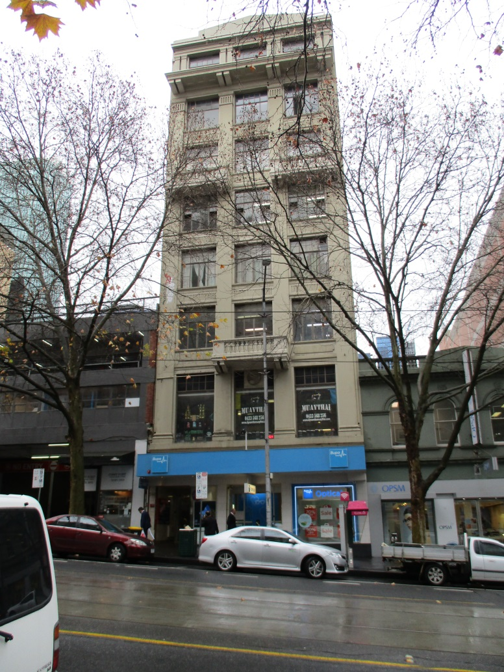

Statement of Significance

What is Significant?
The building at 388-390 Bourke Street, Melbourne was constructed in reinforced concrete, apparently in two stages from May to November 1929. The initial owner was Pellegrini & Co, a company involved in the publishing and selling of Catholic literature and associated material. The architect was AA Fritsch. It is an eight storey building in the Commercial Palazzo style, with a high level of external intactness. It also displays key elements of the style including a vertical tripartite arrangement of base, shaft and capital, complemented by finely worked detailing.

How is it Significant?
The building at 388-390 Bourke Street, Melbourne is of aesthetic/architectural significance to the City of Melbourne.

Why is it Significant?
The building at 388-390 Bourke Street, Melbourne is of local aesthetic/architectural significance. It is a highly externally intact eight storey building which has been capably rendered in the Commercial Palazzo style. The key elements of the style are all on display, including a vertical tripartite arrangement of base, shaft and capital as evidenced in the massive ground floor base, with pilasters rising through the upper sections of the building to a stylised triangular parapet above a massive cornice. The design is invigorated by the incorporation of balconies at the third and sixth levels, and a free approach to classicized detailing. The architectural character of the building draws strength from the interplay of these elements above street level. The subject building is also an example of a taller commercial building constructed on a modest site in Melbourne in the interwar period. The group are typified by tall proportions deriving from their narrow sites, and reflect the increasing value of upper storeys brought about by the increased availability of elevators. (Criterion E)
414-416 Bourke Street, MELBOURNE (HO1207)
Grading: Significant
Place type: Commercial building
Date(s): 1928
Survey Date: April 2016
Intactness: Good
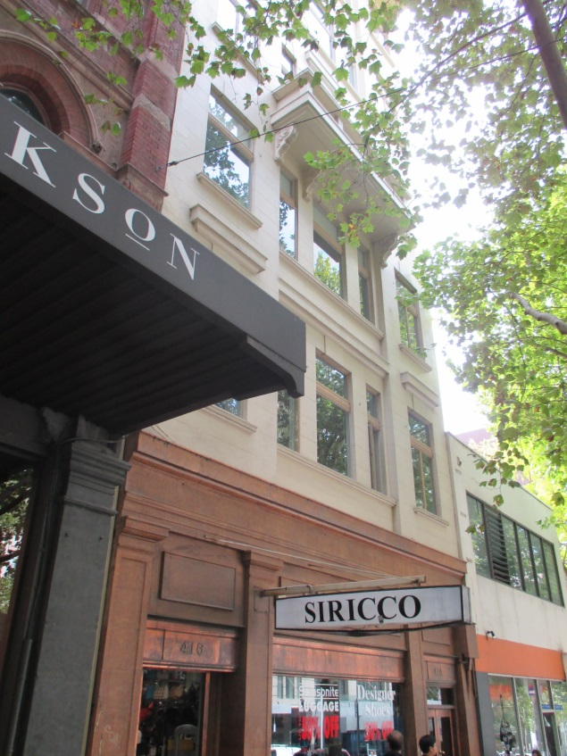

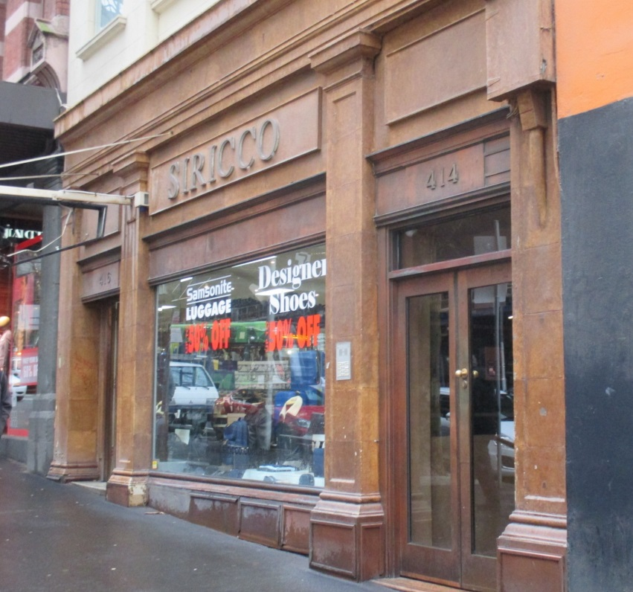

Statement of Significance

What is Significant?
The building at 414-416 Bourke Street, Melbourne was constructed in 1927-8, as a six-storey reinforced concrete building, with an additional two levels added in 1937-39. The building’s occupants have varied over time, and have included hardware merchants, tailors and electrical goods manufacturers. It is a tall and narrow building in the interwar Palazzo style, where the heavy shopfront forms a base to five, largely unornamented levels above. The ‘capital’ takes the form of two ornate crowning levels with a deep, bracketed cornice below a simple stylised pediment. Windows are largely free of detailing with balconies to the street providing interest, with the upper and lower balconies deriving from different building programmes. The ground floor is also largely intact to its original state, and retains separate entries to the ground and upper levels, and original joinery.

How is it Significant?
The building at 414-416 Bourke Street, Melbourne is of aesthetic/architectural significance to the City of Melbourne.

Why is it Significant?
The building at 414-416 Bourke Street, Melbourne is of local aesthetic/architectural significance. Despite its construction in two phases almost 15 years apart, the building is a remarkably coherent example of an Interwar Palazzo building. It is distinguished by the ground floor shopfront which forms a base to the five, largely unornamented levels above. The top two more ornate crowning levels, with a deep bracketed cornice below a simple stylised pediment, form the ‘capital’. The façade’s understated references to classical architecture reflect the then contemporary trend towards stripped classical and other, more Modern, forms of expression. The building is also noteworthy for the intactness of the ground floor façade, with separate entrances and a large display window, the whole being handsomely resolved in an understated classicised manner with pilasters rising to an entablature at first floor level. (Criterion E) It is additionally significant as an example of a taller commercial building constructed on a modest site in Melbourne in the interwar period. These buildings are typified by tall proportions deriving from their narrow sites, and are characteristic of the period prior to the consolidation of modest sites to form more generous development parcels, on which larger multi-storey buildings were later constructed. (Criterion D)

Former Kaye, Butchart & Co offices (HO546)
421 Bourke Street, MELBOURNE
Grading: Significant
Place type: Commercial building
Date(s): c.1863, 1919-1920
Survey Date: April 2016
Intactness: Good
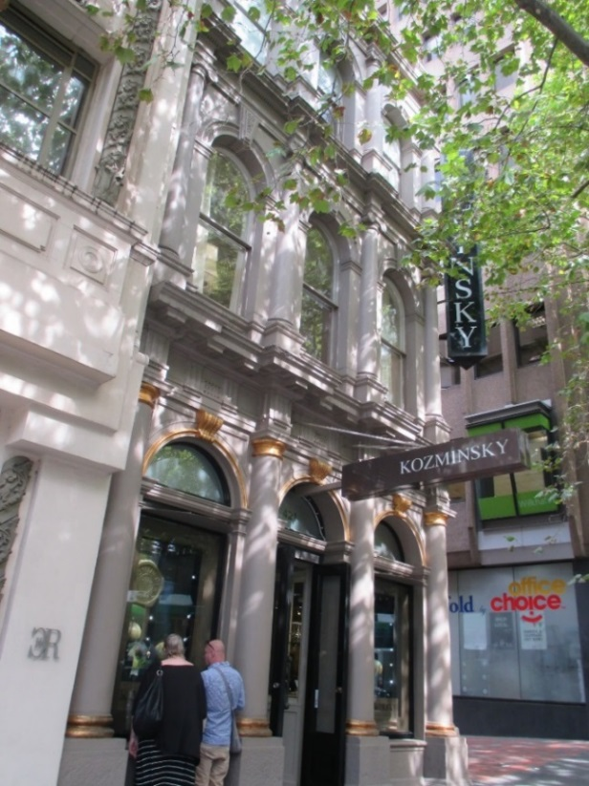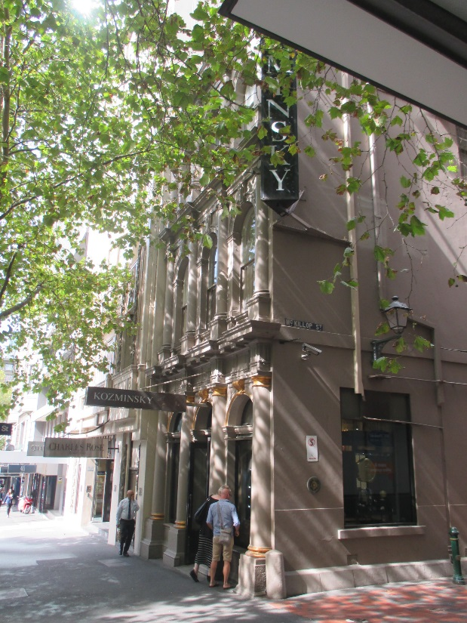

Statement of Significance

What is Significant?
The subject building at 421 Bourke Street was constructed as a two-storey building in c.1863, with the third level added in 1919-20. The first owners were Kaye, Butchart & Co., stock and station agents, and since 1975 Kozminski jewellers have occupied the building. It is a three-storey rendered masonry building, on a long rectilinear plan. The Bourke Street façade has a classical form and order, with the floor levels emphasised by bracketed cornicing and each level exhibiting different but complimentary detailing. The long west elevation addresses McKillop Street and, although more simply detailed than the façade to Bourke Street, has window openings to all levels including original fenestration above the ground floor. The façade has been overpainted, but is broadly sympathetic to the early character of the building.

How is it Significant?
No 421 Bourke Street, Melbourne, is of historical and aesthetic/architectural significance to the City of Melbourne.

Why is it Significant?
The subject building is of local historical significance. It was constructed in c.1863 for Kaye, Butchart & Co., one of Melbourne’s earliest stock and station agents. Described as a house and offices, the combination of residence and commercial use in a single building was common in the city in this early period. The classical form and detailing of the building was reflective of the success of the early stock agents, and of the stature of the first owners, one of whom, William Kaye, was a member of the Legislative Council. Horse breeder George Petty was another early owner, and his association with the property demonstrates the importance of historical localised activity in this area of the central city, which was the focus of Melbourne’s horse bazaars and horse trading. The historical significance also derives from an association with renowned jewellery retailers, Kozminski, who moved into the premises in 1975 and continue to operate from the property today. [Criterion A] The subject building is also of local aesthetic/architectural significance. It is substantially externally intact to its 1919-20 form, and is an elegantly proportioned and well resolved commercial building in the Classical Revival mode. It is notable for its use of superposed orders in which different systems of classical ornament (known as orders) are used at each floor level. While not on a grand scale, the expression to Bourke Street including the imposing ground floor entrance, combined with the building’s depth to McKillop Street, imbue the building with some prominence. Other significant details and elements include the high plinth, symmetrically arranged ground floor façade, arched fenestration to all levels, and heavy horizontal cornicing to each floor. [Criterion E]

Shops and residences (HO618)
245-269 Elizabeth Street, MELBOURNE
Grading: Contributory (245-7 & 263) & Significant (249-61 & 265-269)
Place type: Shops and residences
Date(s): 245-59 - 1897
261 -1898
263, 1913
269, 1915
Survey Date: April 2016
Intactness: Good
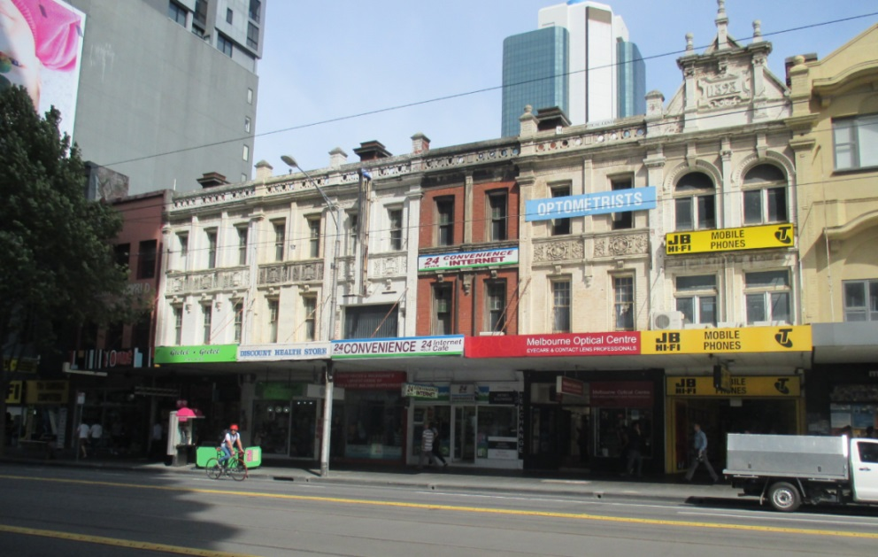

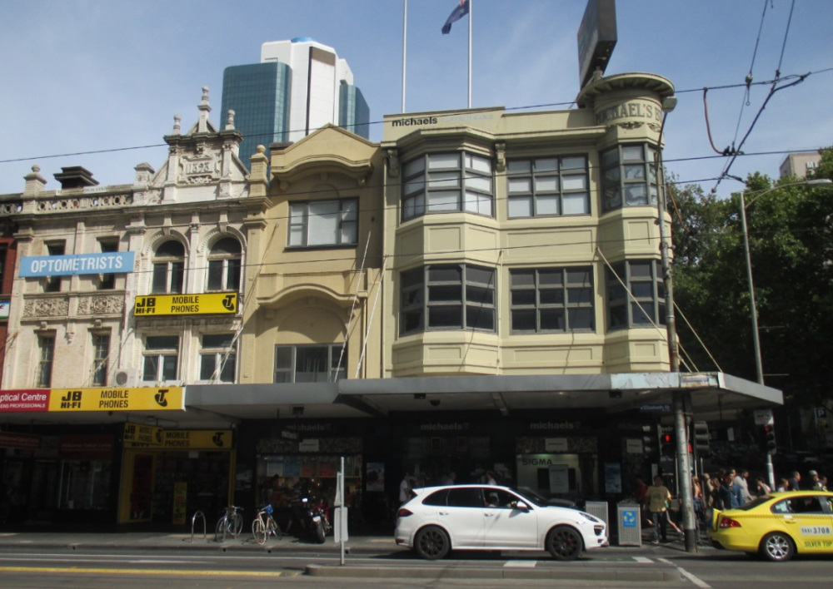

Statement of Significance

What is Significant?
The buildings at 245-269 Elizabeth Street, Melbourne, comprise a collection of shop and retail premises dating from 1897 to 1915. The buildings, save for 245-7 and 263 Elizabeth Street are generally externally intact, albeit with changes to the ground floor facades and shopfronts, and some over-painting. The terrace row at 245-259 Elizabeth Street, was constructed in 1897 and includes six highly ornamented three-storey masonry buildings in the English Queen Anne or Elizabethan revival manner. The building at 261 Elizabeth Street dates from 1898, is also highly ornate and in the English Queen Anne or Elizabethan manner, distinguished by a high Elizabethan gable. No 263 Elizabeth Street dates from 1913, and was originally two storeys, with a later generally sympathetic extra level added. It is a simply detailed rendered masonry building. Michael’s Building at 269 Elizabeth Street, is a 1915 three-storey corner building of stuccoed reinforced concrete. It has an oriel bay to the corner and multiple window bays to the adjoining facades. Overall, the buildings present with a generally consistent three-storey scale to Elizabeth Street.

How is it Significant?
The buildings at 245-269 Elizabeth Street, Melbourne, are of historical and aesthetic/architectural significance to the City of Melbourne.

Why is it Significant?
The buildings at 245-269 Elizabeth Street, Melbourne, as a group are of local historical significance. Dating from 1897 to 1915, the group demonstrates the historical evolution of shop and retail premises in this area of Elizabeth Street, in the late nineteenth through to the early twentieth centuries. Prior to that, from the early 1850s, Elizabeth Street had accommodated small scale businesses which serviced travellers to Sydney and the Bendigo goldfields, before evolving by the mid-1860s into a retail and service street for the city. In the 1880s, the subject properties were all occupied by two-storey buildings, but by the late 1890s, some of the current more substantial and ornate three-storey buildings were under construction. This change can in part be attributed to civic improvements to the street’s drainage and flooding problems, and the consequent increase in the street’s status and reputation. (Criterion A) The subject buildings are also of local aesthetic/architectural significance. As a group, they represent a generally externally intact collection of ornate late Victorian commercial and retail buildings, augmented by early twentieth century development. The former comprises the 1897 terrace row at 245-259 Elizabeth Street, being three-storey masonry buildings in the English Queen Anne or Elizabethan revival manner, with highly ornamented and handsome facades and original detailing including parapeted balustrades, raised piers, a main cornice entablature of vermiculated panels, and a broad foliated frieze with alternating motifs between first and second floors. The slightly later 1898 building at 261 Elizabeth Street is also highly ornate and particularly striking, distinguished by its prominent Elizabethan gable, bayed cornice line, extended cement parapet piers and orbs, date panel to the parapet (‘1898’), and tall arched fenestration at the third level. From the later period, the 1915 Michael’s Building is a prominent corner development, enhanced by its oriel corner bay with round cupola-like tower, and large multi-paned window bays. It is also a somewhat austere building in its appearance, and devoid of the applied ornamentation and decoration of earlier commercial buildings. The involvement of noted architects is additionally significant, including David Askew in the design of 261 Elizabeth Street, and Arthur Purnell in 269 Elizabeth Street. The buildings’ collective presentation and appearance to Elizabeth Street gain strength from the generally consistent three-storey scale, bookended by the highly articulated corner building. (Criterion E)

287-9 Elizabeth Street, MELBOURNE (HO1204)
Grading: Significant
Date(s): c1894
Survey Date: April 2016
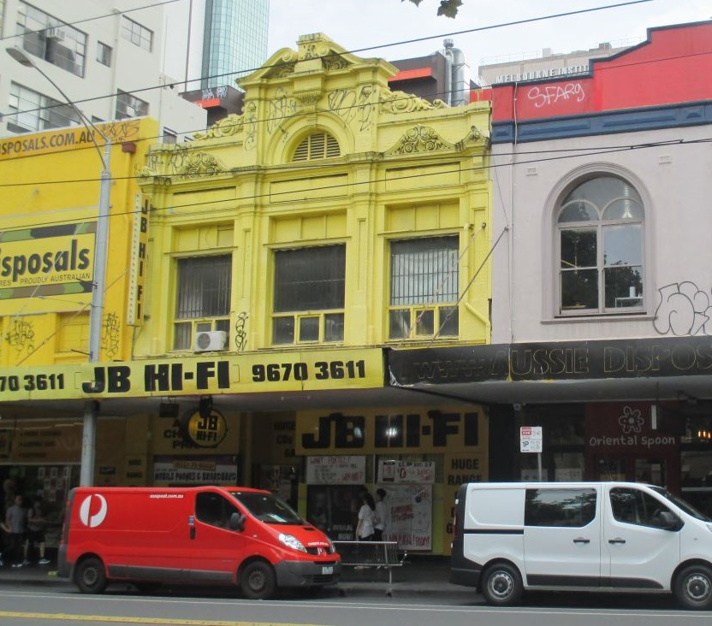

Statement of Significance

What is Significant?
The premises at 287-9 Elizabeth Street was constructed in c. 1894 and occupied by ironmongers John Cooper & Sons until the 1930s. The ironmongery of John Cooper & Sons was established in Elizabeth Street from as early as 1880, with Cooper possibly having previously traded in a partnership on Bourke Street which dissolved in 1879. In 1889 John Cooper was killed in a road accident, but the firm continued under his name. His estate papers noted that as well as the premises in Elizabeth Street, he was in occupation of a stable and shed in Guildford Street and a building in a lane off Little Lonsdale Street, the 1850s warehouse in Heape Court (rear 361-365 Little Lonsdale Street, also in the subject precinct). By the mid-1890s, the company listing in the Sands & McDougall Directory described the business as ‘iron, steel, timber and cement merchants [and] general ironmongers, wholesale and retail.’ The ironmongery continued to operate through the early decades of the twentieth century, and were known for their Bunyip Forest Devil plough.
In the mid-1880s, Cooper & Co. were listed in the rate books as being in occupation of a brick warehouse and shop, valued at a NAV £300 at the subject site, then known as 191 Elizabeth Street. In 1893, it was reported that a fire had broken out in the single-storey brick offices and store, causing considerable damage. The rate books are somewhat unclear about the construction of the existing building, but it is likely to have been soon after this fire. In 1894, the year after the fire, the property was valued in the rate books at a NAV of £400, an increase from £300 the previous year. In 1900, the building is described as a brick shop of two flats (floors). In 1915, the property was again described, as a brick shop and store, of two floors, with a NAV of £325. John Cooper & Sons grew to have agents in Sydney and Brisbane, and an engineering works in Alexandria. The company operated in New South Wales into the 1970s.
The subject building is a comparatively early example of the revival of Baroque architectural expression. This style emerged in the last decades of the nineteenth century and reached an early high water mark locally in the design of the former Teachers’ College building, University of Melbourne (Public Works Department, under JH Marsden, 1888). However, the recession of the 1890s suppressed further experiments in the mode. The style would re-emerge after 1900 as the fully-formed Edwardian Baroque of the Melbourne City Baths (J Clark with EJ Clark, 1903-4) and the Flinders Street Station (JW Fawcett & HPC Ashworth, 1901-11).
The subject building, constructed in c. 1894 as a two-storey ironmonger’s shop with storerooms at the upper level, was designed by, little-known architect, Henry J Henderson. The verandah and shopfronts at ground floor level have been substantially altered and currently retain little original fabric; however, at its upper levels the building is more intact to its late Boom-period style. As constructed, the building adopted an understated Baroque expression, incorporating panels of face brick offset against, occasionally florid, architectural detailing realised in render. The building has been overpainted which limits the extent to which the original play of materials remains legible. Nonetheless, the upper façade continues to generate architectural interest through a layering of architectural detail. Four pilasters sit proud of the façade rising and flaring to terminate at a string course below the parapet. These divide the upper facade into three distinct bays. The outer (northern and southern bays) are capped by complex floriated panels at the parapet. The central section rises to a massive par enroulement pediment flanked by complex scrolls and incorporating a semicircular ornamental ventilator to the attic space. Window joinery at first floor level has been altered although the upper highlight windows of the original arrangement appear to survive. An interwar addition/workshop is located to the rear.

How is it Significant?
The building at 287-9 Elizabeth Street, constructed in c. 1894s for ironmongers John Cooper & Sons, is of local aesthetic/architectural significance.

Why is it Significant?
The building is of aesthetic/architectural significance. While the ground floor and verandah have been altered, the façade to Elizabeth Street is more intact to its upper levels. It is here that the building displays its understated Baroque expression, representing an early example of the mode which is notable for its association with a commercial rather than an institutional use. Significantly the facade incorporates a rich collection of architectural details, some quite florid in their expression, and finished at the top by a massive pediment.
307-11 Elizabeth Street, MELBOURNE (HO1204)
Grading: Significant
Date(s): 1927
Survey Date: April 2016
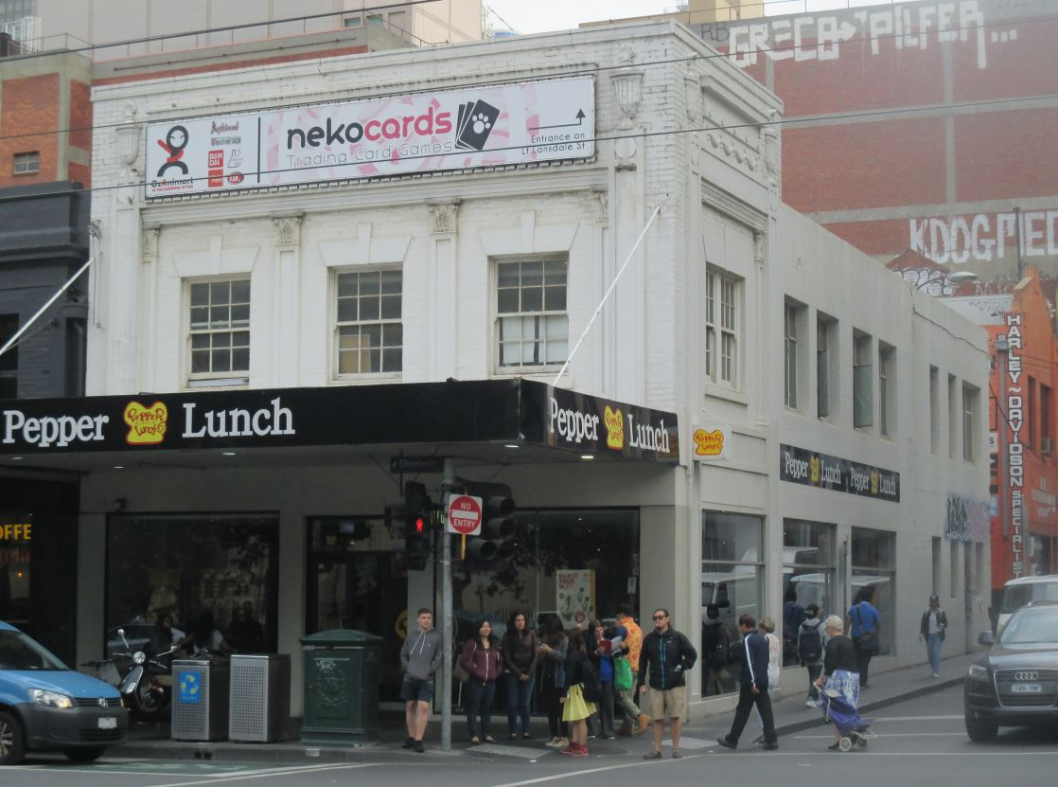

Statement of Significance

What is Significant?
The building at 307-311 Elizabeth Street was constructed in 1927, at the corner of Little Lonsdale Street. Prior to this, the property was occupied by two nineteenth century buildings, including a brassworking operation, and a watchmaker. These incorporated a brick shop and a brick shop and store, both owned by James O’Leary. The watchmaker continued into the early 1910s, accompanied by a leather manufacturer. The Sands & McDougall directory of 1910 also lists the rear building as being occupied by a pawnbroker, Joshua Langley. In 1919, motor cycle manufacturers, Stillwell & Parry moved onto the property. The partnership of Walter Stillwell and George Stillwell, which had operated from 378 Lonsdale Street, was dissolved in 1916, with Leslie Parry joining George Stillwell to form Stillwell & Parry. During this period, an increasing number of motor car and motor cycle related businesses began occupying premises in Elizabeth Street to the north of Little Bourke Street.
In 1926, an application was made to the City of Melbourne for a permit to construct a motor showroom, to the value of £3,200. At this time, the property was owned by H & E Kinnear. The new showroom was for the use of Stillwell & Parry, and was designed by architect, Leslie M Perrott, who was an enthusiastic advocate for the use of concrete, having written the book, Concrete Homes, in 1925. The building was illustrated in the Argus in October 1926, which noted that ‘the elevation in concrete and brick adds a distinctive note to this rapidly advancing section of the city.’ The company installed a petrol pump at the premises. In 1927 the property, still owned by Kinnear, was valued at a NAV of £1,000. Stillwell & Parry also managed a competitive motorcycle racing team, and remained at the Elizabeth Street premises until the company was dissolved in 1940. In 1944, the building was occupied as an army depot, and from the 1950s, by an electrical appliance retailer. Its use by defence services included as a ‘hospitality bureau’ for American service personnel in 1942 and as an office for the War Graves Service in 1946. While the association with George Stillwell is not confirmed, the Stillwell family generally were prominent in Australian motor racing and motor car circles through the twentieth century.
The former Stillwell & Parry showrooms comprises a substantial, two-storey showroom with large areas of glazing to Elizabeth and Little Lonsdale streets. The building is distinguished by abstracted classical detailing in bas relief to its upper façade. The side elevation extends the classicised approach along Little Lonsdale Street before reverting to a more conventional warehouse form, incorporating plain face brick and steel-framed windows, towards its rear. Both street elevations have been overpainted in white although the contrasting textures of face brick and concrete remain legible. At the shopfront, original window joinery, notably, leadlight to highlight windows, has been removed, although the original arrangement is evident in an early illustration of the building. Nonetheless, low sills and open areas of modern glazing survive allowing the early appearance and use to be understood. The original form and materiality of the building also remains legible from the rear laneway where brickwork, concrete lintels and steel-framed windows survive unpainted and largely unaltered. Despite some changes and over-painting of key facades, the building remains substantially intact and legible to its original state.

How is it Significant?
The building at 307-311 Elizabeth Street, constructed in 1927, is of local historical and aesthetic/architectural significance.

Why is it Significant?
Historically, the building is associated with Stillwell & Parry, motor cycle manufacturers, who used the premises as their showroom. This association and use occurred in the period when an increasing number of motor car and motor cycle related businesses began occupying premises in this area of Elizabeth Street, a use which largely remains. Architecturally, the subject building is a large corner building which, although overpainted, legibly retains the contrasting textures of face brick and concrete as intended by its concrete enthusiast architect, Leslie M Perrott. Early descriptions complimented its elevations in concrete and brick. The building is otherwise substantially externally intact, and distinguished by its abstracted classical detailing in bas relief to the upper façade, and large ground floor showroom windows, albeit modified.
32-34 Guildford Lane, MELBOURNE (HO1205)
Grading: Significant
Date(s): 1908, c1920
Survey Date: April 2016
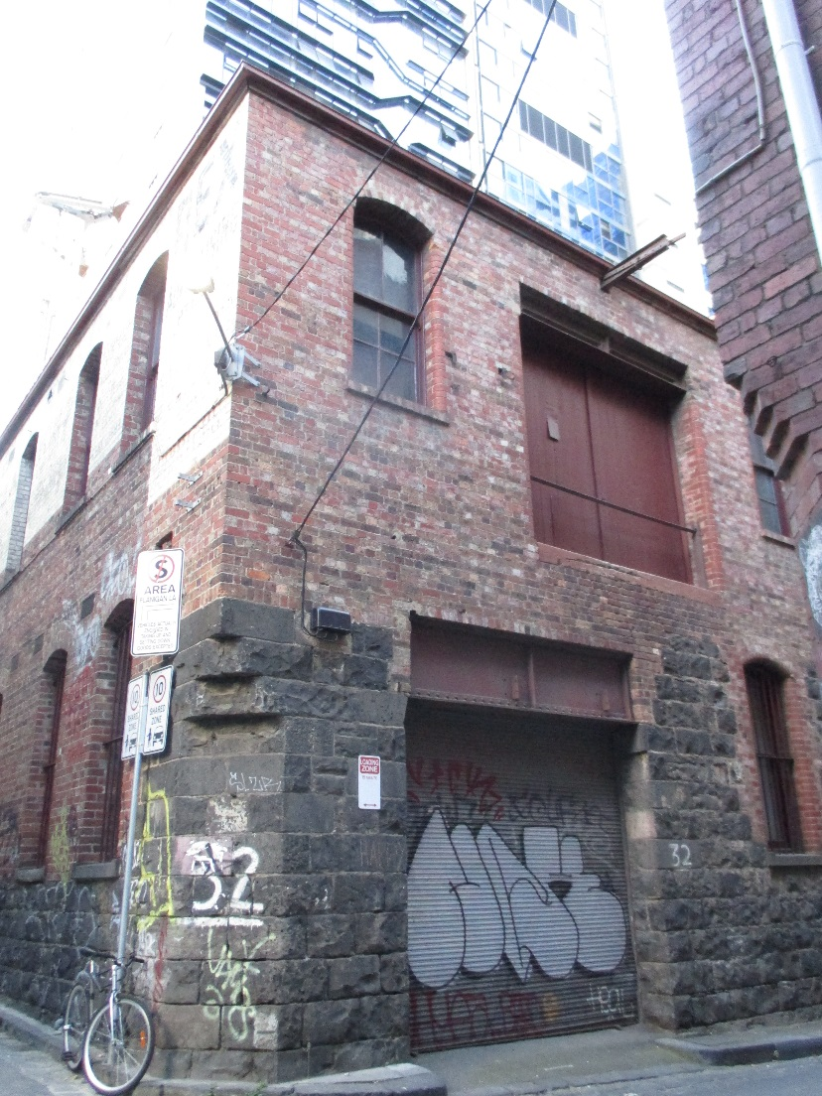

Statement of Significance

What is Significant?
The 1894 MMBW detail plan no 1017 shows this corner site as being no 44 Guildford Lane, and occupied by a small brick building, described as a brick house occupied by James Marsh in the 1896 municipal rate books. Within ten years, this building had been demolished, and the rate books record the then unnumbered property as ‘land’. In 1908, a permit was obtained by prominent builder Clements Langford for the construction of a ‘stone factory’ at the site. Langford was the builder of a number of significant buildings in Melbourne, including the former Gollin & Company Building in Bourke Street, of 1902; the former E S & A Bank in Swanston Street, of 1928; and the final stages of St Patricks Cathedral, including the towers and spire, in 1926-33.
The 1910 municipal rate books list this stone factory building, with Langford also the owner of the brick house at no 30 and the occupier of the stone house at no 33. Both properties at nos 30 and 32 were valued at a NAV of £16. In 1915, the property was described as a brick workshop and store at no 30-34 Guildford Lane, valued at NAV of £20. Five years later, the brick workshop was valued at a NAV of £100, indicating that improvements had been undertaken at the site. These works likely include the construction of the brick second level to what appears to have been a single-storey stone building. Although Langford is listed as the owner and occupier of the building in 1920, by 1924, electrical engineers Nilsen Cromie were at the site.
The two building programmes – 1908 construction and c.1920 second floor addition - remain legible in the factory building. The ground floor façade and lower sections of the side and rear elevations to Flanigans Lane, survive from the original construction. These are of random dressed bluestone laid in courses. An original ground floor window to Guildford Lane, incorporating red brick quoins and segmental-arched head windows, also survives. The adjacent entry has been altered, largely through the introduction of a deep steel lintel to support the upper level. Bluestone walls to the corner of Guildford and Flanigan Lanes incorporate a canted corner with a corbel detail above, intended to reduce the damage from vehicle impacts. Above these original elements, face brick walls in English bond were constructed in c.1920. Early features, including upper level windows and landing doors to Guildford Lane, survive. Windows from the second programme of works also survive along the Flanigan Lane elevation. Segmental-arched ground floor windows retain c.1920 cast iron bars and joinery over bluestone sills from 1908. Windows to the upper level addition are similar but incorporate brick sills. The upper level of the side elevation has been painted and some early signage survives but the building is largely intact and legible to its c.1920 state.

How is it Significant?
No 32 Guildford Lane is of local historical and aesthetic/architectural significance.

Why is it Significant?
The building is historically significant for its association with prominent builder Clements Langford. He constructed the building in 1908 as a factory, undertook later improvements, and owned it and an adjoining property until at least 1920. This was in the period when Langford was a sought-after Melbourne builder, and it is assumed that the subject building supported his construction activities, as a workshop or store. Aesthetically, while the building has been modified and extended, albeit at an early period, it is a robust and prominent corner building in the precinct, marking the western entry to the historic part of Guildford Lane. Its corner position is emphasised by the chamfered detail to the stonework at ground floor level in the south-west corner of the building. The ad hoc combination of materials and details, including the unusual coming together of face stonework and brick walling is another distinguishing feature of the building. The resulting character and architectural expression is evolved, rather than designed, but nevertheless has resulted in a distinctive building in the precinct.

Cyclone House (HO1205)
17-19 Hardware Lane, MELBOURNE
Grading: Significant
Date(s): 1930
Survey Date: April 2016
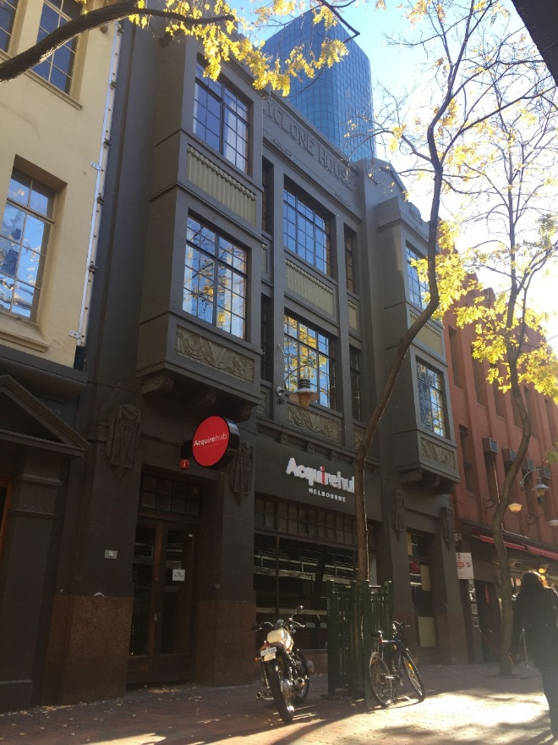

Statement of Significance

What is Significant?
Cyclone House was constructed for the Cyclone Fence and Gate Co. in 1930 after the sale and subdivision of the former Kirk’s Bazaar land and creation of the extension of Hardware Lane in the mid-1920s. The company relocated to the new offices and showrooms, along with Chambers and Bennetts. The Cyclone Woven Wire Fence Company was established in 1898 by Leonard Tasman Chambers and William Eastwood Thompson, who had obtained the rights to manufacture American ‘cyclone’ fencing. In addition to manufacturing the American designs, the company also designed products for Australian customers. Such was the growth of the company, that by the 1920s it had established factories in Melbourne, Adelaide, Sydney and Perth. The company was known for woven wire and wrought iron gates, which became common in Australian suburbs in the mid-twentieth century.
The company’s occupation of its building, however, was short-lived, with the company putting it up for auction in 1935. It appears that the building was not sold at this time, but the Australian Broadcasting Corporation (ABC) took up a lease for part of the building for use as temporary studios ‘for the broadcasting of plays and other entertainments.’ Cyclone House was again put up for sale in 1946, and was described in the auction notice as ‘a modern, three-storey reinforced concrete office building’. The building sold for £11,000. The ABC continued to occupy Cyclone House into the 1970s, and the building housed its concert and production departments.
Description
Cyclone House is a formal three-storey building which is remarkably intact to its 1930 state, and combines a range of, occasionally diverse, features into a single, substantial whole. The building has a symmetrical, rendered façade, flanked by jettied bays rising through the upper levels to produce a tripartite expression. Each bay is capped by a stylised triangular pediment rising above a simple parapet. The name ‘Cyclone House’ is realised in rendered lettering to the parapet. Windows are largely original and multi-paned, with decorative panels to spandrels incorporating novel geometric devices. At its roof level, the building retains an early water tower, again featuring the ‘Cyclone’ name, and flagpole which would have formed a local landmark prior to taller and more intensive development east of Elizabeth Street during the later twentieth century. Overall, it displays an unusual composition with understated references to Scottish Baronial and Collegiate Gothic forms, overlaid with an applique of classical and Moderne motifs.

How is it Significant?

Cyclone House, constructed in 1930 at 17-19 Hardware Lane, is of local historical and aesthetic/architectural significance.

Why is it Significant?

The building is significant for its initial association with the highly successful Cyclone Fence and Gate Co, which had been established in 1898. The company produced the much sought after ‘cyclone’ wire fencing, a product which had been invented in America. The Cyclone Fence and Gate Co also manufactured the then popular woven wire and wrought iron gates. Despite its success, the company did not occupy the building for long, with the Australian Broadcasting Commission moving into the premises in the pre-WWII period and maintaining its association until the 1970s. Aesthetically, the scale and quality of the building is testament to the then success of the Cyclone Fence and Gate Co. It has an unusual architectural expression, with a composition drawing from a range of sources, including English, classical and Moderne antecedents. The building is also highly intact externally, and unusually retains an early named water tower at roof level.

Former Penman & Dalziel warehouse (HO665)
55-57 Hardware Lane, MELBOURNE
Grading: Significant
Place type: Warehouse
Date(s): 1887-8
Survey Date: April 2016
Intactness: Fair
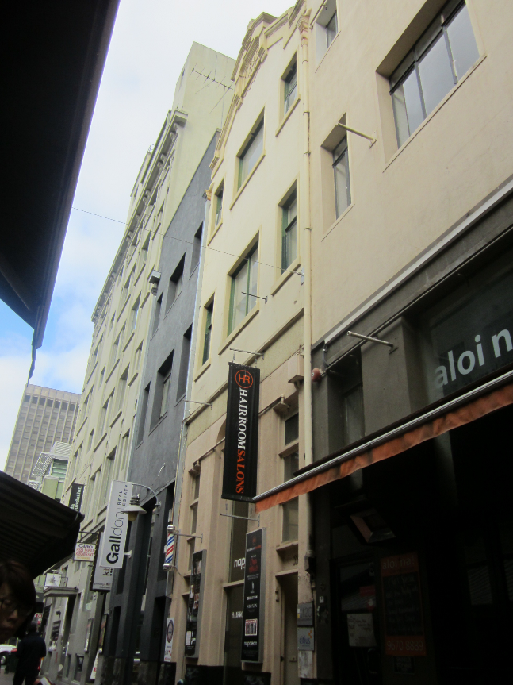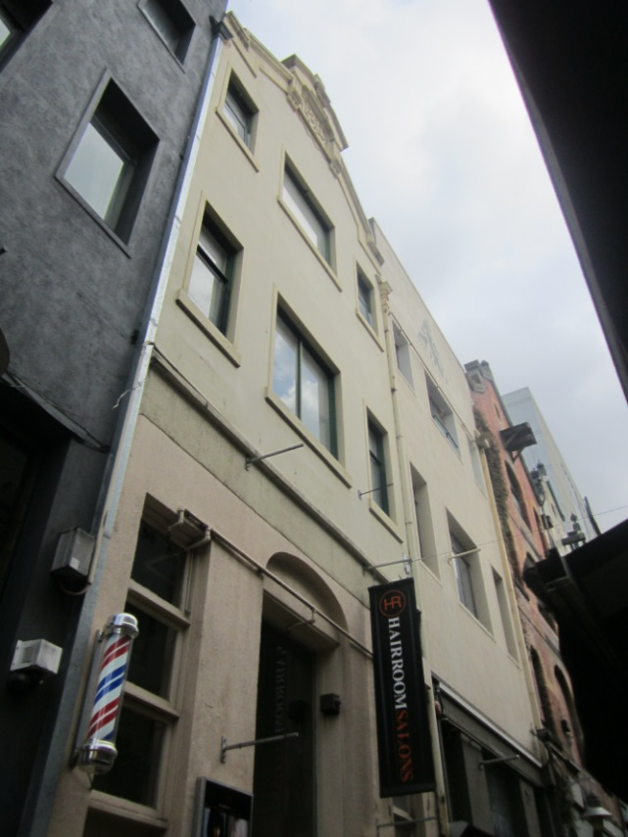

Statement of Significance

What is Significant?
The building at 55-57 Hardware Lane was built as part of a group of three warehouses in 1887-8, for furniture manufacturer Penman and Dalziel. It is a four-storey rendered masonry former warehouse, with a tall narrow massing on a long rectilinear plan, and a basement level. The façade has been modified, including through the application of render over original face brickwork, however the building retains its distinctive gabled and parapeted form, and rough face bluestone plinth at ground level. While the ground floor level has been altered, the original arrangement of lower floors with ground floor elevated to facilitate loading remains legible. Fenestration at the upper levels also remains broadly intact to its early state with large central landing doors to each level flanked by sliding sash windows. The rear of the building as seen from Goldie Place is more intact and retains its face brick exterior and original windows.

How is it Significant?
No 55-57 Hardware Lane, Melbourne, is of historical and aesthetic/architectural significance to the City of Melbourne.

Why is it Significant?
The building at 55-57 Hardware Lane is of local historical significance. It is one of an important collection of nineteenth century warehouse and mercantile buildings in Hardware Lane. Constructed in 1887-8, to a design by noted architect Alfred Dunn, the building was one of five warehouses built in Hardware Lane and the adjoining Goldie Place, for the furniture making company of Penman and Dalziel. The company remained associated with the warehouses until 1910, and in 1937 were noted as one of Melbourne’s early ‘skilled craftsmen’ and ‘leading names’ in fine furniture manufacture. (Criterion A) The subject building is also of local aesthetic/architectural significance. While it has been altered, the building retains its distinctive gabled and parapeted form, rough face bluestone plinth, broadly original arrangement of lower floors with elevated ground floor to facilitate loading, and broadly intact fenestration and openings to the upper levels. It is also one of a more extensive row of tall and gabled nineteenth century warehouse forms in Hardware Lane, and makes a significant contribution to the warehouse character of the lane. (Criterion E)

Dynon’s Buildings (HO667)
63-77 Hardware Lane, MELBOURNE
Grading: Significant
Place type: Warehouse
Date(s): 1889
Survey Date: April 2016
Intactness: Good
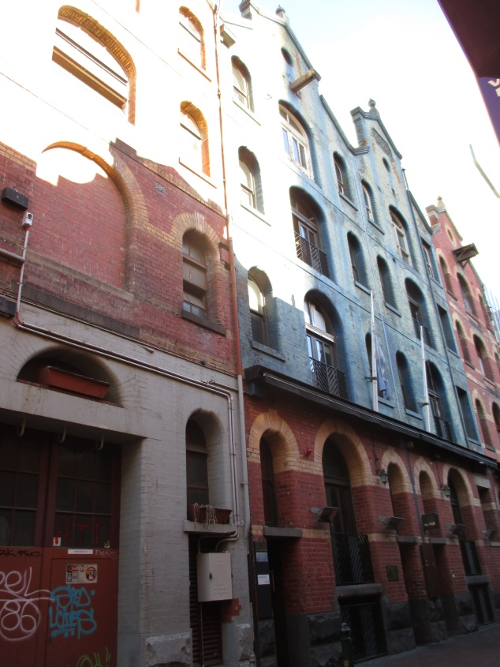

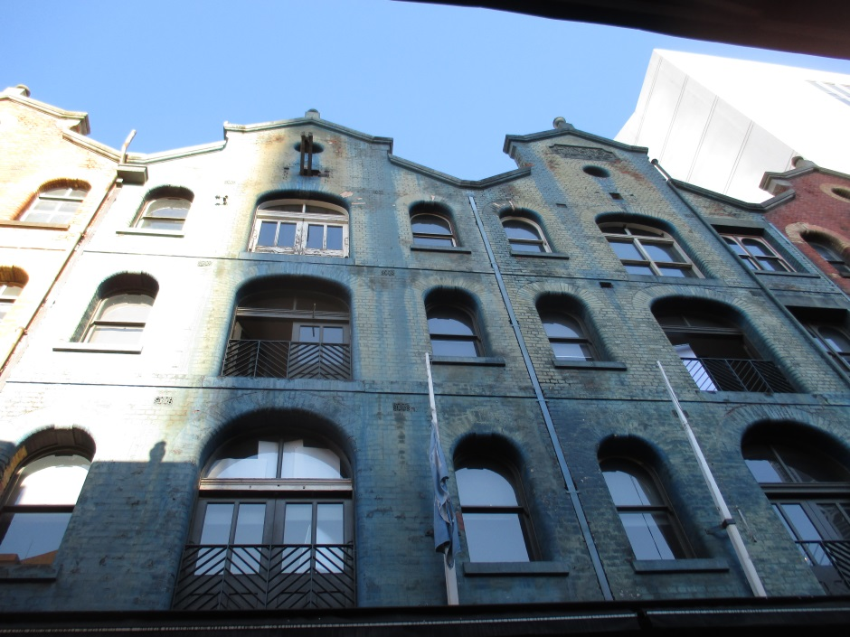

Statement of Significance

What is Significant?
The buildings at 63-77 Hardware Lane represent four out of the original five warehouses, which were designed by William Pitt for china and glass merchant, John Dynon, and constructed in 1889. The group of four, known as Dynon’s Buildings, are tall and narrow bichrome brick warehouses, notable for their arcuated facades and striking parapets, the latter with raised pedimental devices and oriels. The architectural detailing to the arched window heads and stringcourses is accentuated in cream face brick against a red brick base; and original bluestone plinths and the majority of window and door openings also survive.

How is it Significant?
The buildings at 63-77 Hardware Lane, Melbourne, are of historical and aesthetic/architectural significance to the City of Melbourne.

Why is it Significant?
The buildings at 63-77 Hardware Lane, Melbourne, known as Dynon’s Buildings, are of local historical significance. The buildings, constructed in 1889 to a design by William Pitt, are part of an important collection of nineteenth century warehouse and mercantile buildings in Hardware Lane. In replacing earlier and smaller buildings on the site, they are demonstrative of the late nineteenth century growth in warehousing activity in this part of Melbourne. Hardware Lane also assumed much of its current historic character during Melbourne’s Boom of the late 1880s. (Criterion A). Dynon’s Buildings are significant for their association with renowned architect, William Pitt. They were designed by Pitt at the height of his architectural output and influence, when he was responsible for some of the exemplars of the 1880s Boom Style in Melbourne. Pitt was known for eclectic designs and compositional flamboyance, and his industrial and mercantile commissions while typically more subdued were also very capably handled, as with the subject buildings. (Criterion H) Nos 63-77 Hardware Lane are also of local aesthetic/architectural significance. The buildings are substantially externally intact, and retain their original tall and narrow warehouse form and detailing, including arched window heads and stringcourses accentuated in cream face brick against a red brick base, heavy bluestone plinths, striking parapets with raised pedimental devices and oriels, and the majority of the original window and door openings. The groups also form part of a more extensive row of tall and gabled nineteenth century brick warehouses in Hardware Lane, and make a significant contribution to the warehouse character of the lane. (Criterion E)

