Former John Dickinson & Co warehouse (HO1208)
337-339 La Trobe Street, MELBOURNE
Grading: Significant
Place type: Warehouse
Date(s): 1923-24
Survey Date: April 2016
Intactness: Good
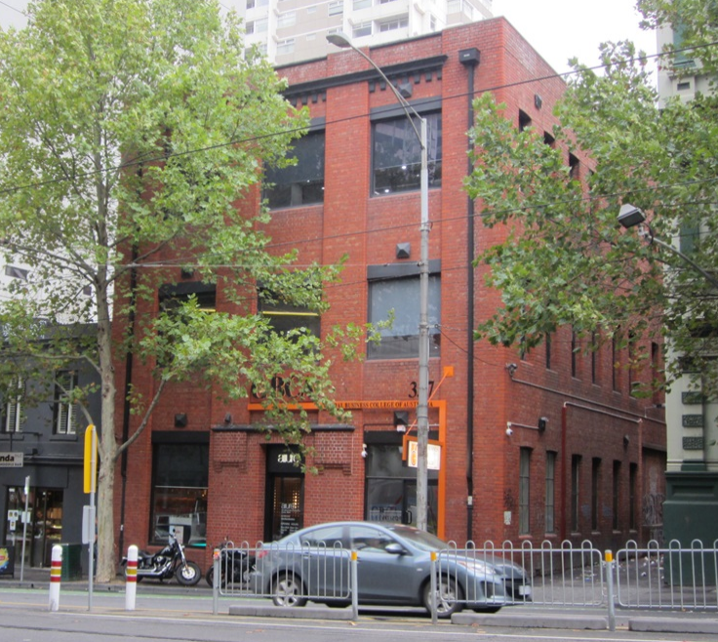

Statement of Significance

What is Significant?
The building at 337-339 La Trobe Street, Melbourne, was built in 1923-4, and is the former warehouse of stationers, John Dickinson & Co. It is a substantially externally intact three storey red brick building on a rectilinear plan, with a gablet roof in galvanised steel. While its character is largely utilitarian, and the La Trobe Street facade has understated detailing, the building retains key elements of its design including its face brick expression; broad pilasters with bull-nosed bricks to corners which rise the full height of the building to a simple parapet; a projecting cornice and dentils realised in overpainted concrete; and above the principle entry a shallow awning in painted concrete with broad corbelled brick brackets. The window frames and glazing to the principle façade have been modified, but the original pattern of large openings with concrete lintels and brick sills survives. The west elevation to Flanigan Lane has segmental arched window openings which largely retain original frames and sashes and brickwork details.

How is it Significant?
The building at 337-339 La Trobe Street, Melbourne, is of historical and aesthetic/architectural significance to the City of Melbourne.

Why is it Significant?
The building at 337-339 La Trobe Street, Melbourne, is of local historical significance. It was purpose built by the renowned stationary company, John Dickinson & Co. The company was a leading international paper and stationery brand, established in Britain in 1803 by John Dickinson, who made many pioneering discoveries in papermaking. The building provides evidence of the expansion of the company in the early twentieth century, into Australia and New Zealand, whereby they built warehouses and factories in Sydney, Melbourne, Wellington and Auckland. The building continued its association with the firm until 1958. (Criterion A) The subject building is also of aesthetic/architectural significance. While it is of largely utilitarian interwar character, the building is enhanced by its high level of external intactness, unpainted brick walled expression, understated architectural details and overall scale. The wide pilasters which rise through the principal façade, dentilated cornice to the top level, and unusual awning device above the principle albeit somewhat narrow entrance at ground floor level, enliven its appearance. It is also a mature example of late Edwardian warehouse design constructed in the period immediately before reinforced concrete would replace red brick as the preferred material for warehouse construction. (Criterion E) The building is additionally a good representative example of a warehouse, and a rare red brick building of this age in this area of La Trobe Street. (Criterion D)

Hardware House (HO1205)
386-392 Little Bourke Street, MELBOURNE
Grading: Significant
Date(s): c1926
Survey Date: April 2016
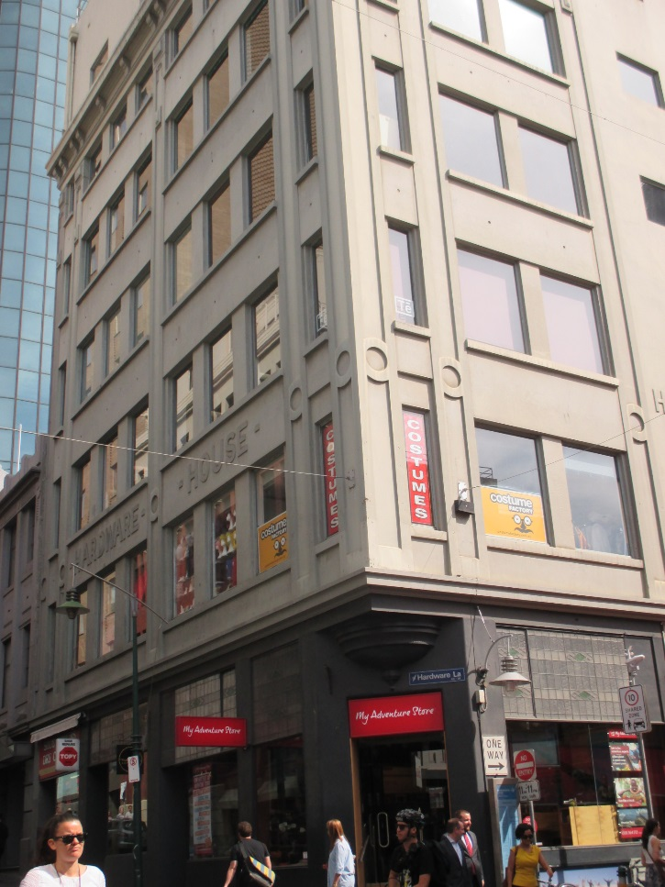

Statement of Significance

What is Significant?
In August 1924, the Hardware Club purchased the site of the Governor Arthur Hotel at 386-392 Little Bourke Street for £17,750. The hotel had been unlicensed since 1916. The Hardware Club was originally formed in the mid-1890s as a social club for members of the hardware trade. Within a year it had 148 members, and within ten years, it boasted over 1,000 members.
The new club premises, known as Hardware House, was designed by architect J V Ward and constructed by the Concrete Building Company. During excavations of the site, the adjoining building at 394 Little Bourke Street collapsed. The resulting demolition of what was known as Endicott’s Building saw textile workers in the adjoining White’s knitting and white work factory in Goldie Place temporarily out of work due to the risk of brick walls collapsing on the warehouse. The new club building was opened in October 1926 at a ceremony performed by the Lord Mayor, Sir William Brunton, a member of the Hardware Club. The six-storied Hardware House comprised ‘dining, card and reading rooms, bathrooms, billiard room, library, lounge and a suite of offices’, with ‘sample rooms’ on the sixth floor for use by members. In the mid-1980s, Hardware House became an exclusive and popular nightclub named, somewhat ironically, the Hardware Club.
Hardware Lane took its name from Hardware House. The lane was created as an extension of Wrights Lane, following subdivision of the former Kirks Horse Bazaar property. Hardware Lane was also at the forefront of contemporary laneway renewal in the central city, being a popular nightspot from the 1970s, with restaurants, bistros and clubs moving into its buildings.
Hardware House occupies a prominent corner in the precinct. Externally, the reinforced concrete building adopts a straightforward multi-storey composition with glazed shopfronts at ground floor level and five more massive floors above, capped by an overhanging bracketed cornice. The ground floor retains the broad form of its two original shopfronts with original leadlight glazing to highlight windows. Lower lights have been altered. The corner to the intersection is notable for a decorative canted corner and corbelled first floor designed to reduce vehicle impacts. The upper floors are largely without ornament, apart from rendered signage spelling ‘Hardware House’ to the Little Bourke Street façade accompanied by simple circular decorative devices to pilasters along to both frontages. Window joinery to the upper levels has been altered although the original pattern of fenestration and the broad character of the building survives. An additional level has been added to the building in the relatively recent past.

How is it Significant?
Hardware House at 386-392 Little Bourke Street is of local historical and aesthetic/architectural significance.

Why is it Significant?
The building, which dates from 1926, is historically significant as a purpose-built former club house associated with members of the hardware trade. Its scale is demonstrative of the importance of hardware traders to the City of Melbourne. Hardware House, together with Farrant’s Building across Little Bourke Street, also illustrates the redevelopment of this area of the precinct after the closure of Kirk’s Horse Bazaar, and is significant for bestowing its name on the adjacent Hardware Lane, an early and popular example of laneway renewal in central Melbourne. Aesthetically, the building is a large and prominent corner building in the precinct; it is also substantially externally intact. While a simple but well-resolved design, it provides evidence of the widespread adoption of concrete as the material of choice for multi-storey buildings during the interwar period. The ground floor façade retains original leaded highlight windows to the shopfronts, and a chamfered corner entrance.

Farrant’s Building (HO1205)
387 Little Bourke Street, MELBOURNE
Grading: Significant
Date(s): 1926
Survey Date: April 2016
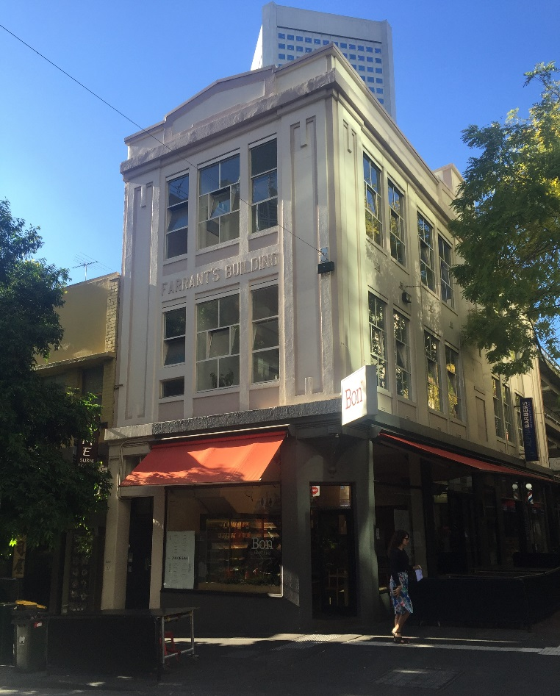

Statement of Significance

What is Significant?
Farrant’s Building was constructed in 1926 for saddle manufacturer Farrant’s, a firm which had been in operation since the late 1880s. The building was constructed after the closure and demolition of Kirks Horse Bazaar, although the company had occupied a small shop on the site from the mid-1890s. The business was one of many selling horse-related products and providing horse-related services, which were associated with this area of Melbourne and its proximity to the horse bazaars. The company advertised that it sold ‘riding saddles, bridles, harness [and] collars’, with ‘no factory made goods’.
With the subdivision and sale of land after the closure of the horse bazaar in 1925-1926, Farrant’s applied to the City of Melbourne to construct a three-storey building at the Little Bourke Street site, to the corner of Hardware Lane, to a value of £3,700. The building incorporated two ground floor shops fronting the newly created extension to Hardware Lane. Farrant’s remained at the site at least until the early 1950s, although parts of the building were variously occupied by other businesses including a leather goods merchant, manufacturers’ agents and embroiders.
Constructed in 1926, the three-storey Farrant’s Building comprises three-storey retail and manufacturing premises. Presumed to be of masonry construction, it is rendered to produce an understated interwar classical expression with corners realised as stylised columns rising to abstracted capitals below a shallow parapet and triangular pediment. The name, Farrant’s Building, is in realised rendered lettering at second floor level. At ground floor level, the forms of a canted corner entry (with the upper storeys forming a short cantilever) and of early shopfronts survive. However, original window joinery has typically been lost at ground floor level. At the upper levels, original window arrangements survive throughout and incorporate unusual and decorative arrangements of fixed and casement windows providing light and air to the manufacturing spaces. Despite alterations at ground floor level and overpainting more broadly, the form and character of Farrant’s Building survives.

How is it Significant?
Farrant’s Building at 387 Little Bourke Street, was constructed in 1926 for saddle manufacturer Farrant’s, and is of local historical and aesthetic/architectural significance.

Why is it Significant?
The building is historically significant for its association with the commercial horse-related products and services businesses which were concentrated in this area of the precinct. These businesses evolved in connection with the local horse bazaars, particularly in the nineteenth century. Unusually, Farrant’s opted to construct this building towards the end of that period, and subsequently maintained their operation into the 1950s. Together with Hardware House across Little Bourke Street, Farrant’s Building also illustrates the redevelopment of this area of the precinct after the closure of Kirk’s Horse Bazaar. Aesthetically, the building is a substantially externally intact and well-resolved corner commercial building. Its large original windows to the upper levels, with unusual and decorative arrangements of fixed and casement windows, were designed to provide light and air into the original manufacturing spaces. While it has an understated interwar classical expression, details of note include corners realised as stylised columns rising to abstracted capitals below a shallow parapet and triangular pediment, the rendering of the name ‘Farrant’s Building’ at second floor level, and the canted corner entry.

Former Day & Sons warehouse (HO1205)
401-405 Little Bourke Street, MELBOURNE
Grading: Significant
Place type: Warehouse
Date(s): 1911, 1936 modifications
Survey Date: April 2016
Intactness: Good
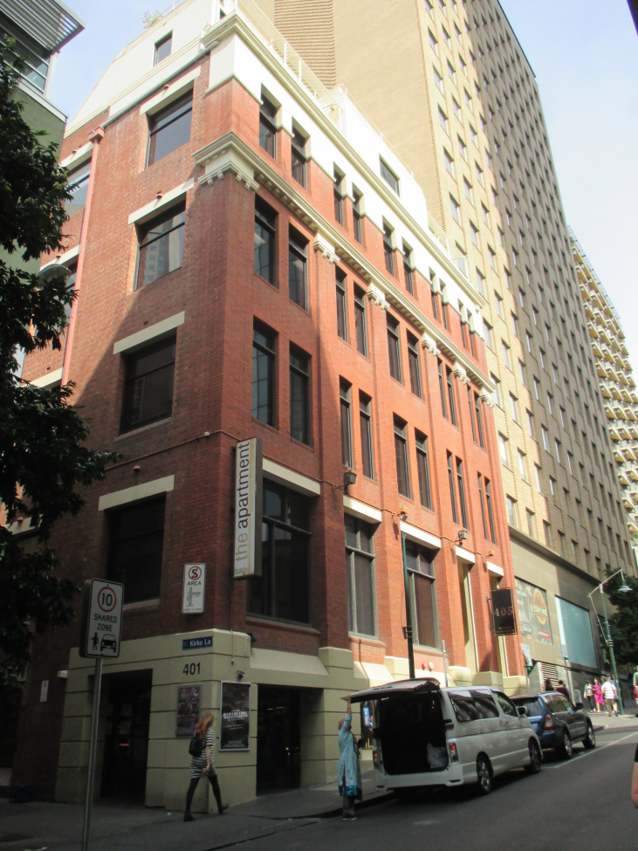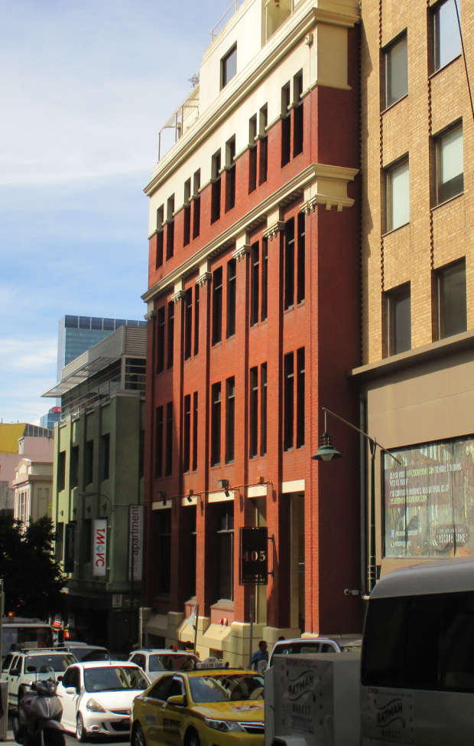

Statement of Significance

What is Significant?
The former Day & Sons warehouse at 401-405 Little Bourke Street, was constructed in 1911 and extended in 1936. It is located on the south side of Little Bourke Street, with the east elevation to Kirks Lane. The face brick building has a rectilinear plan, and is of four storeys with a semi-basement, and rooftop elements at a small setback. It presents an asymmetrical façade to Little Bourke Street reflecting the different structural arrangements of the two building components.
Consistent with commercial design of the period, the building is expressed as a tripartite arrangement, broadly modelled on fifteenth or sixteenth century palazzi with unornamented intermediate floors about a heavy base floor and below an overhanging cornice or ‘capital’ level. In Australia, buildings of this form are occasionally described as Commercial Palazzi, however the subject building is devoid of classical detailing and references to buildings of the Italian Renaissance largely derive from its tripartite form rather than its ornamentation.
The semi-basement level is rendered in a rusticated manner to produce a heavy base to the composition. Brick pilasters, broadly recalling classical columns rise to abstracted, dentilated capitals. The upper level sits over a rendered string course and is capped by an ornamental parapet. The cornice, parapet (and a section of the facade below the parapet) are rendered, providing the upper level with a contrast to the brick intermediate floors below, and giving emphasis to the building’s crown. Rooftop elements appear to date from the 1936 works (they are visible in 1940) but do not affect the façade composition. The eastern elevation is without ornament, presenting simple, punched window openings to the laneway. Original steel framed windows to this elevation have been replaced.
The current entry arrangement on the western side of the north façade appears to date from c.1980s, albeit the altered arrangements continue to utilise existing openings and the works have not affected the rhythm of the original fenestration. External rendered elements have been overpainted and timber windows to the façade have been altered,. The external expression of the façade otherwise survives with face brickwork and rendered detailing intact.

How is it Significant?
The warehouse at 401-405 Little Bourke Street, is of historical and aesthetic/architectural significance to the City of Melbourne.

Why is it Significant?
The warehouse at 401-405 Little Bourke Street, constructed in 1911 for saddlery merchants and ironmongers, William Day and Sons, with significant modifications undertaken in 1936, is of local historical significance. The building is significant for its historical association with the commercial horse-related products and services businesses which were concentrated in this area of the central city. The businesses were in historical proximity to the renowned horse bazaars, including the long running Kirk’s Bazaar, after which the adjoining lane is named. Day and Sons were one of a number of like-minded businesses in the area, which flourished from the nineteenth century, although unusually the company continued to operate from at least part of the building into the 1970s. The warehouse is also of aesthetic/architectural significance. While the original 1911 building was extended and modified in 1936, the works were relatively early in the history of the building, and undertaken by Day and Sons. The works were well resolved architecturally and in execution, with regard to the building’s form and understated stripped classical expression. The building balances a classical sense of composition with the use of limited and particularly stylised classical detailing. The face brickwork of the building also stands out in the Little Bourke Street context. Buildings of this type additionally demonstrate an affinity with the emergent Modern School while continuing to offer the familiarity of classically-based architecture.

Benjamin House (HO1210)
358-360 Little Collins Street, MELBOURNE
Grading: Significant
Place type: Commercial buildings
Date(s): Pre-1869, 1871, 1929
Survey Date: April 2016
Intactness: Good
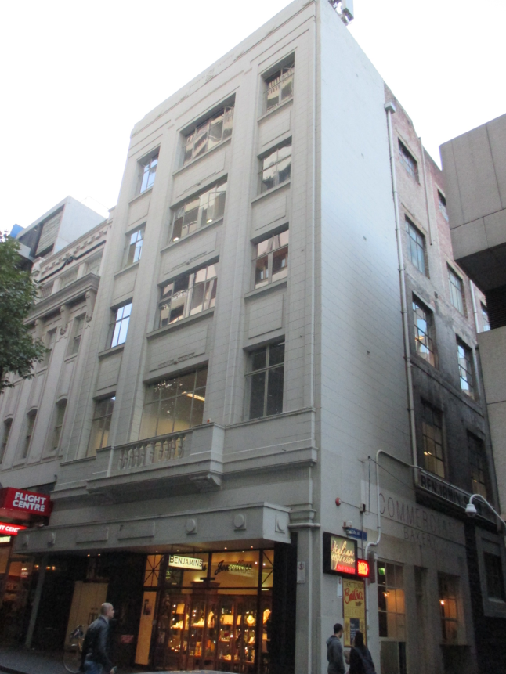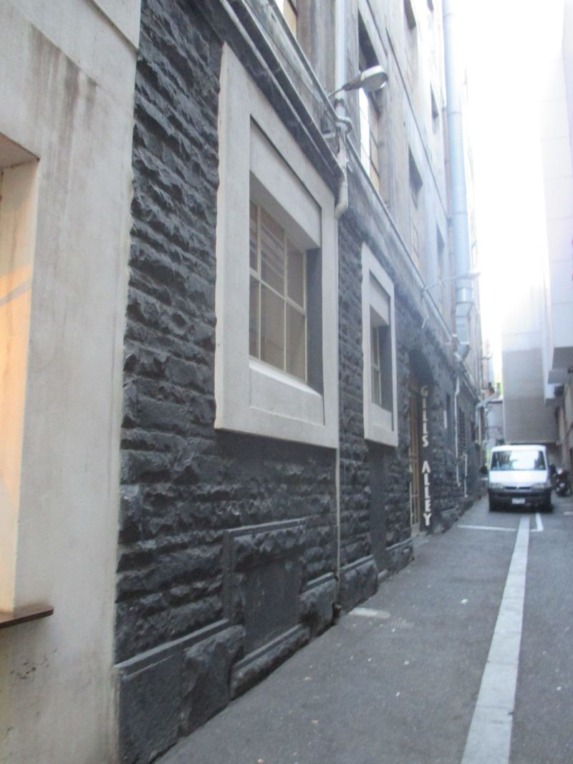

Statement of Significance

What is Significant?
The commercial building (former warehouse) at 358-360 Little Collins Street, incorporates building components from pre-1869, 1871 and 1929. The latter works are most evident in the current building form and expression, including the five-storey height, Moderne-style façade, and large windows to the east elevation above ground floor level. The earlier building is principally evidenced in the bluestone ground floor wall to the east elevation. The façade to Little Collins Street incorporates a balconette at first floor level, and wide but shallow pilasters softened by surface modelling and horizontal banding, which overlay the frame and rise through the upper storeys to a low parapet. The upper section of the façade has a gestural string course incorporating ovoid mouldings and a stylised suggestion of dentilation. The parapet is stepped at its ends, with fluting to its central section. This suite of decorative devices is repeated at a cantilevering ground floor verandah; spandrel incorporate further decorative panels. The remnant bluestone east wall, constructed before 1869, comprises rock-faced bluestone laid in random courses, and original openings and fenestration at ground floor level.

How is it Significant?
The commercial building at 358-360 Little Collins Street, is of aesthetic/architectural significance to the City of Melbourne.

Why is it Significant?
The commercial building at 358-360 Little Collins Street, incorporating building components from pre-1869, 1871 and 1929, is of local aesthetic/architectural significance. Although an evolved building, it is substantially intact to its 1929 form and expression, including the Moderne-style façade and detailing. The building is also a dominant historical form in this area of Little Collins Street. The design of the 1929 building was influenced by innovations coming out of Chicago through late nineteenth and early twentieth centuries. It draws on the then new form of fireproof building in which steel frames supported the upper levels, eliminating the need for thick, load-bearing brick walls; and an applique of understated classical or Art Deco detailing applied to the exterior. The building is typical of this form of fashionable ornamentation on a Chicagoan frame, as it emerged in Australia in the 1920s, with in this case a simple frame of reinforced concrete enlivened by a shallow applique of abstracted detailing to produce an understated, sculptural result. The earlier bluestone fabric to the east elevation, while not a prominent feature of the building as viewed from Little Collins Street, nevertheless contributes to an understanding of the evolved form and history of the building, and adds texture to the side wall to Gills Alley. Surviving bluestone sections of buildings, such as this, also provide important evidence in the central city context of early building practice and stonemasonry in particular. (Criterion E)

Former Rosenthal & Co premises (HO1211)
362-364 Little Collins Street, MELBOURNE
Grading: Significant
Place type: Commercial building
Date(s): 1868, 1872, 1882, 1923
Survey Date: April 2016
Intactness: Good
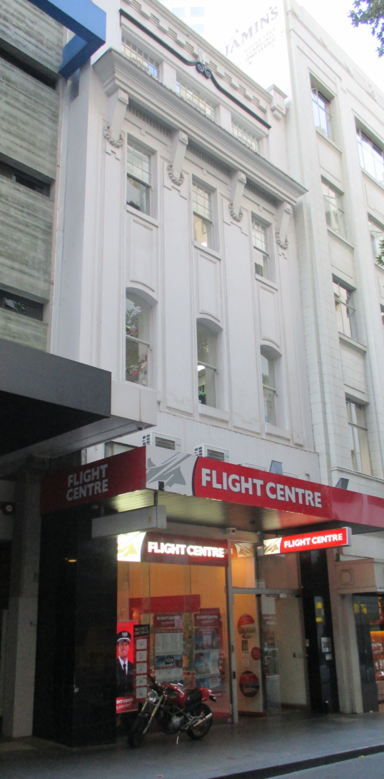

Statement of Significance

What is Significant?
The four-storey commercial building, and former warehouse, at 362-364 Little Collins Street, was constructed in stages commencing in 1868 with later works in 1872, 1882 and 1923. The latter works are most evident in the current four-storey form and Commercial Palazzo expression to Little Collins Street. The (albeit modified) shopfront and verandah provide a base for the middle component of the façade, where moulded panels rise through the upper sections subtly dividing the façade into three slender fenestrated bays. Segmental-arched windows are at first floor level, with rectangular windows with simple architraves at second floor level. The middle component of the façade terminates at a massive bracketed cornice, with the upper section in the form of an attic storey comprising three multi-paned windows beneath a string course and a stylised dentilated detail to the parapet.

How is it Significant?
The commercial building at 362-364 Little Collins Street, is of aesthetic/architectural significance to the City of Melbourne.

Why is it Significant?
The commercial building at 362-364 Little Collins Street, constructed in stages commencing in 1868 with later works in 1872, 1882 and 1923, is of local aesthetic/architectural significance. Although an evolved building, it is substantially intact to its 1923 form and expression to Little Collins Street, with an interwar façade in the Commercial Palazzo mode, and stylised Italianate detailing. While the building is more modest, and less architecturally ambitious than broadly comparable interwar Commercial Palazzo buildings in the central city, it shares the tendency for architectural enrichments which were occasionally flamboyant, and typically confined entirely to facades. The alterations at ground floor level have diminished the legibility of the tripartite arrangement, however the vigour of the design above the verandah remains evident in the largely intact façade. (Criterion E)

359 Little Lonsdale Street (Victorian factory/warehouse at rear only)
(HO1204)
Grading: Significant
Date(s): c1889
Survey Date: April 2016
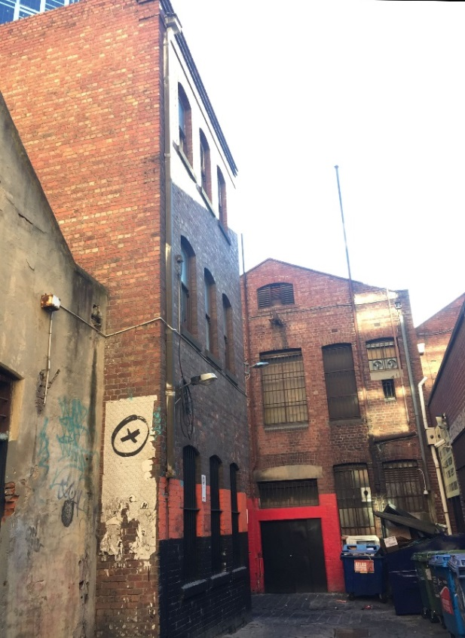
Statement of Significance

What is Significant?
The property at 359 Little Lonsdale Street comprises a 1920s commercial and factory/warehouse building fronting Little Lonsdale Street, and a c. 1889 three-storey brick warehouse at the rear, fronting Heape Court.
The whole of the property was owned by William Ryan, but originally comprised a number of buildings. The front half of the site to Little Lonsdale Street was previously occupied by the Letter Kenny Arms Hotel, which had operated from the site from as early as 1870. To the rear of the hotel building, and accessed from Heape Court, were two cottages. At the time of Ryan’s death in 1881, the site was described as comprising the brick and bluestone hotel and two brick cottages.
The cottages remained at the rear of the hotel until 1888, when they were demolished and replaced by a ‘brick store [of] 3 floors.’ This warehouse, which is the subject three-storey brick building, was owned and occupied by furniture makers Nunan Bros, and was used as their factory. The company produced dining tables, sideboards and chairs at Heape Court, for sale from their premises at 248-258 Swanston Street.
The warehouse and hotel to Little Lonsdale Street are shown on the MMBW detail plan of 1894. In 1916, the Letter Kenny Hotel was one of the over 1,000 hotels in Victoria which were closed as part of the work of the Licences Reduction Board, undertaken in the 1900s-1910s. The former hotel was sold as part of an executor’s realising auction in 1919. By 1923, the hotel building had been demolished and a two-storey motorcycle warehouse and showroom was constructed. Both the rear three-storey warehouse and the new building were occupied by occupied by motorcycle accessories retailers Bradshaw, Mitchell Pty Ltd.
The former c. 1889 Nunan Bros factory/warehouse survives as a remarkably externally-intact three-storey masonry building constructed to the boundaries of its laneway site (Heape Court). Its external expression derives from utilitarian face brick walls in English bond. Fenestration comprises a regular arrangement of simple segmental-arched head window openings with bluestone sills. Original sliding sash windows typically survive throughout. Generous segmental-arched landing doors at the southern end of the Heape Courte elevation provide access for goods to and from the internal floor levels. The movement of goods to upper levels was facilitated by an external hoist and an original crane beam survives at roof level. Cast iron bars to ground floor windows and original or early joinery to the principal entry also survive. Apart from corbelled brick detailing to upper levels at the south-eastern corner of the building, the warehouse is without ornament. Even this detail derives from the practical need to avoid vehicle impacts at ground floor level rather than a desire for decorative effect.
It is likely that the hipped roof of the warehouse was originally clad in slate. This has been replaced in modern steel. The building has been painted at ground floor level although the original face brick expression at the upper levels survives. Beyond this, the building survives, externally, in good condition and a high level of intactness and integrity to its original state.

How is it Significant?
The c. 1889 three-storey brick warehouse at the rear of 359 Little Lonsdale Street, which fronts Heape Court, is of local historical and aesthetic/architectural significance.

Why is it Significant?
Historically, the building dates from the late 1880s, and is a surviving example of an externally intact utilitarian building of this period, associated with historic laneway development to the west of Elizabeth Street. It is also a significant and prominent contributor to the surviving Victorian-era buildings of Heape Court.
Architecturally, while it is a utilitarian building, it is a representative example of a 1880s factory/warehouse in the central city. It is unembellished, but still retains the key elements associated with its original design and use, including regular segmental-arched head windows with bluestone sills and original sliding sashes; segmental-arched landing doors to provide access to and from the internal floors; external hoist and crane beam at roof level; cast iron bars to ground floor windows; and original or early joinery to the principal entry.

Former F Lowe & Co store (HO1212)
369-371 Lonsdale Street (rear), MELBOURNE
Grading: Significant
Place type: Warehouse/stores
Date(s): 1888
Survey Date: April 2016
Intactness: Fair
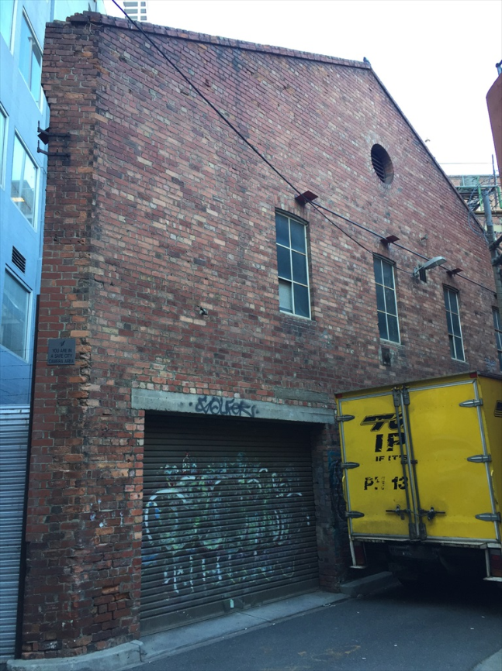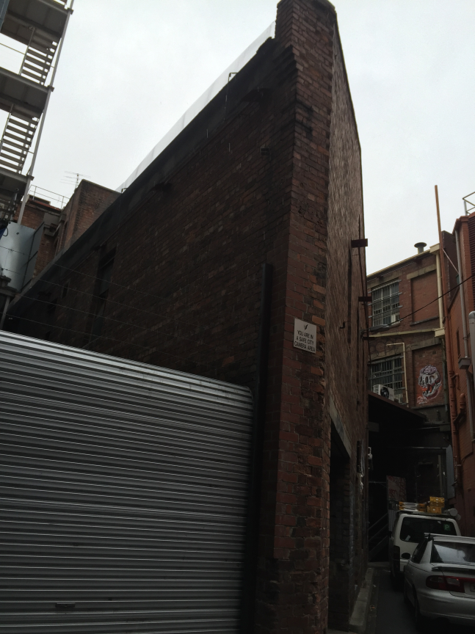

Statement of Significance

What is Significant?
The 1888 warehouse at the rear of 369-371 Lonsdale Street, Melbourne is a two-storey face brick building with a hipped roof form, where the front (east side) of the building addresses Whitehart Lane, and the rear (west side) backs onto Warburton Alley. Although of generally conventional construction and materials, the building has an acutely angled and distinctive form at its eastern end where it meets the Y-shaped alignment of Whitehart Lane. This has given rise to a building with a narrow vertical wall at the point of the angle; a return on the east side to the principal façade, expressed as a high gabled wall; and on the south side the side elevation. The building retains original window openings, but not original fenestration. The narrow wall at the point of the angle has been modified over time, showing evidence of repairs and rebuilding. The ground floor on the east elevation has also been modified, including through the introduction of a steel roller (garage) door.

How is it Significant?
The 1888 warehouse at the rear of 369-371 Lonsdale Street, Melbourne is of historical and aesthetic/architectural significance to the City of Melbourne.

Why is it Significant?
The 1888 warehouse at the rear of 369-371 Lonsdale Street, Melbourne is of local historical significance. Its unusual form is a direct result of the allotment’s long historical association with the Y-shaped alignment of the northern end of Whitehart Lane. The building has been ‘moulded’ to fit with the early subdivision pattern. Interestingly, the angled allotment is well documented in early historical sources, as is the Y-shaped alignment of Whitehart Lane. In this case, both the property and the historical sources also come together to shed light on an early and unusual subdivision within the laneways network. (Criterion A) The building, while not representing refined architectural design, is nevertheless locally significant for its physical form and expression. The sharply angled plan, with narrow vertical wall at the point of the angle, and the diagonal high gabled wall of the east façade, present a striking appearance to the laneway. Together with the subject allotment, the property also provides a contrast to the otherwise rigid geometry of the evolved Hoddle Grid. The distinction of the building within its context is readily apparent, and has long been the case, as is evident in the 1934 image at. (Criterion E)

Former Edward Keep & Co warehouse (HO716)
377-381 Lonsdale Street, MELBOURNE
Grading: Significant
Place type: Warehouse
Date(s): 1888-1889, substantially rebuilt 1899
Survey Date: April 2016
Intactness: Good
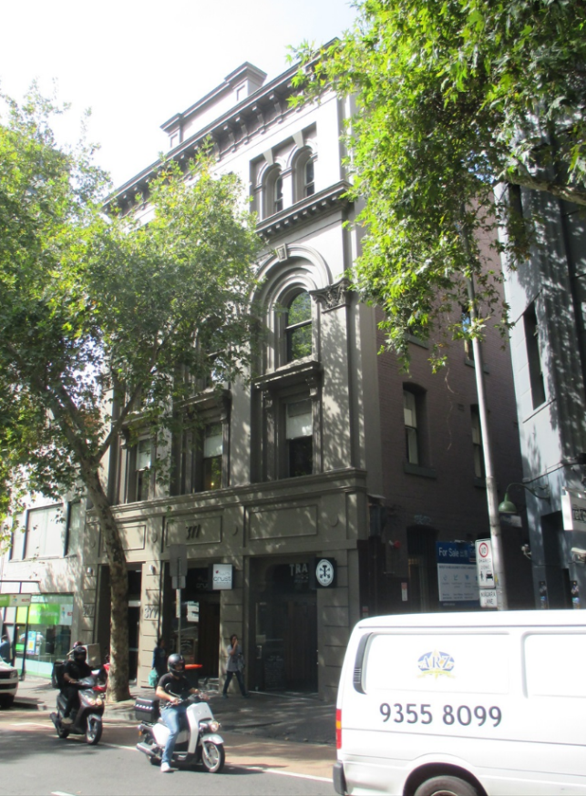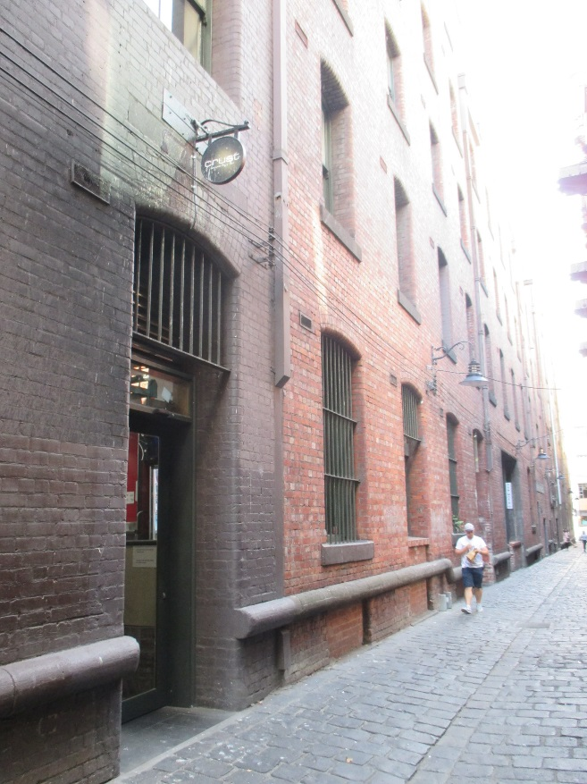

Statement of Significance

What is Significant?
The building at 377-381 Lonsdale Street, was originally constructed in 1889 for Edward Keep & Co, and substantially rebuilt in 1899 following a fire. The building is an imposing four-storey former warehouse, on a long rectilinear plan. It presents to Lonsdale Street with a four-storey rendered façade, incorporating boldly massed elements in a tripartite arrangement. The latter include a heavy base at ground floor level with smooth rusticated columns and bold trabeation above; giant-order pilasters rising through the first and second floor facades, to Corinthian order capitals and a decorated arch above second floor windows; a bracketed string course above the second floor, and an upper level attic storey crowned by another, more substantial cantilevering bracketed cornice. The less ornate but still highly intact western elevation to Niagara Lane comprises mostly red faced brickwork with concrete buffers (rubbing rails) at ground floor level; surviving crane beams and cat-heads over loading doors; and an elevated entablature and pediment at the mid-point of the elevation.

How is it Significant?
The building at 377-381 Lonsdale Street is of historical and aesthetic/architectural significance to the City of Melbourne.

Why is it Significant?
The building at 377-381 Lonsdale Street, originally constructed in 1889 for Edward Keep & Co and substantially rebuilt in 1899 following a fire, is of local historical significance. Keep, with his son and nephew, ran a prosperous hardware operation in the central city in the nineteenth century, with the success of their operation demonstrated in the imposing building they constructed, and then rebuilt, in the latter years of the century. They were also one of a number of hardware merchants historically located in this area of the city, as evidenced in the nearby Hardware Lane (and street) and Hardware House, purpose built for members of the hardware industry. The subsequent, and long-term use of the property by paper merchants, James Spicer & Sons, later Spicer & Detmold, followed by Rank Xerox from the 1960s, is another association with a local historical trend. Small-scale printers, publishers and stationers moved into the laneways and warehouses from the late nineteenth century, and continued well into the twentieth century. (Criterion A) The subject building is also of local aesthetic/architectural significance. It is a highly externally intact former warehouse of the late nineteenth century, with a handsome and skilfully resolved rendered façade to Lonsdale Street, presenting as an imposing and prominent building in an understated Mannerist expression. The Lonsdale Street façade retains its original tripartite arrangement and bold expressive elements including giant-order pilasters with Corinthian order capitals, decorated arches above second floor windows, and an upper level attic storey crowned by a substantial cantilevered bracketed cornice. The four-storey brick west elevation, to Niagara Lane, is also imposing. It too is highly intact, retaining original fenestration, basalt sills, concrete buffers at ground floor level, and surviving crane beams and cat-heads over loading doors. The elevation is strongly composed, with the juxta positioning of rectangular and arched forms and openings, and a raised entablature and pediment at an intermediate point.

Central Bonding Warehouses (HO724)
15, 17 & 19 McKillop Street, MELBOURNE
Grading: Significant
Place type: Warehouse
Date(s): 1854/1860
Survey Date: April 2016
Intactness: Fair
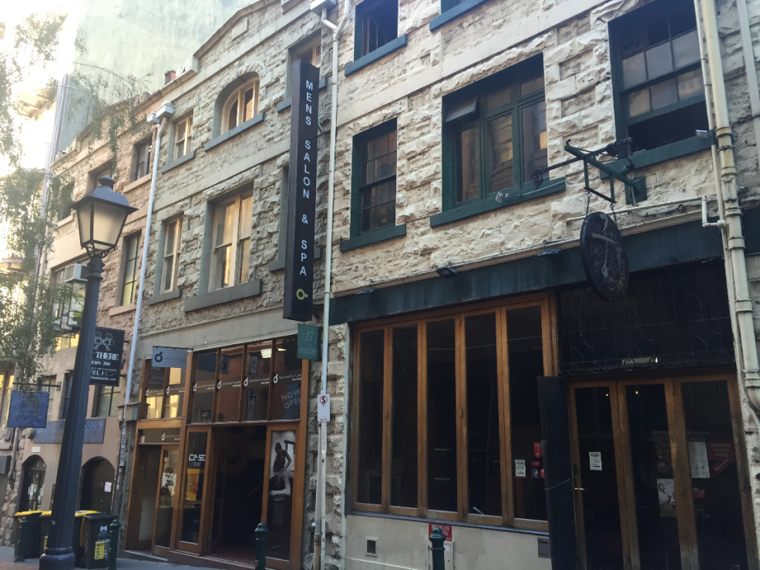

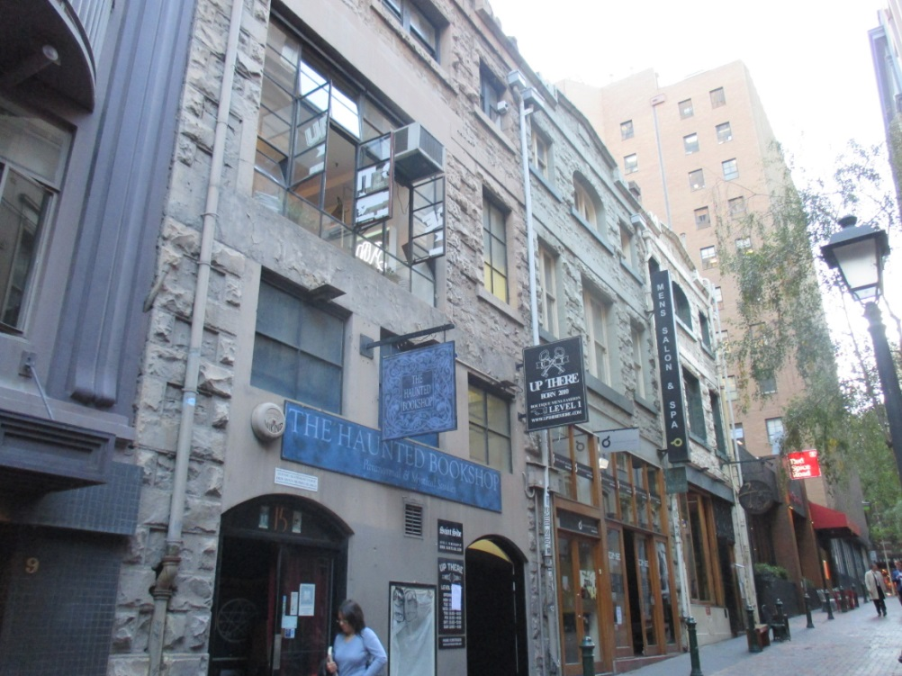

Statement of Significance

What is Significant?
The buildings at 15, 17 and 19 McKillop Street are a row of three 1850s/1860 warehouses. They are of stone construction, overpainted, with some brick walling; and of four storeys, or three storeys plus a semi-basement. The row present as simply detailed parapeted buildings constructed of basalt rubble, with string moulds delineating each level, and topped by a low pediment. Window openings decrease in size with the increasing façade height, although the windows have been modified from the original or early form. The ground floor facades vary in their form and treatment, but are all modern fabric, including large windows and folding glazed doors.

How is it Significant?
The buildings at 15, 17 and 19 McKillop Street are of historical and aesthetic/architectural significance to the City of Melbourne.

Why is it Significant?
The buildings at 15, 17 and 19 McKillop Street, constructed in 1854 for John Pinney Bear, and extended in 1860, are of local historical significance. They are among a relatively small number of 1850s stone warehouses which survive in the city, are demonstrably early buildings within the central city context, and important signifiers of early construction and mercantile activity. The association with Bear is also of note. He was a Member of the Legislative Council in Victoria, established the Melbourne Banking Corporation, was a Director of the National Bank, and also a successful vigneron with an association with the historic winery, Chateau Tahbilk. (Criterion A) The buildings are also of local aesthetic/architectural significance. Despite modifications, the former warehouses retain their overall early appearance and form, including their simply detailed parapeted basalt rubble facades, with string moulds delineating each level, and topped by a low pediment. Their presentation is enhanced by their primitive rubble construction. They are also robust building forms to McKillop Street, and enrich the heritage character of the street. (Criterion E)

Warehouse (HO725)
18-22 McKillop Street, MELBOURNE
Grading: Significant
Place type: Warehouse
Date(s): 1888-9
Survey Date: April 2016
Intactness: Good
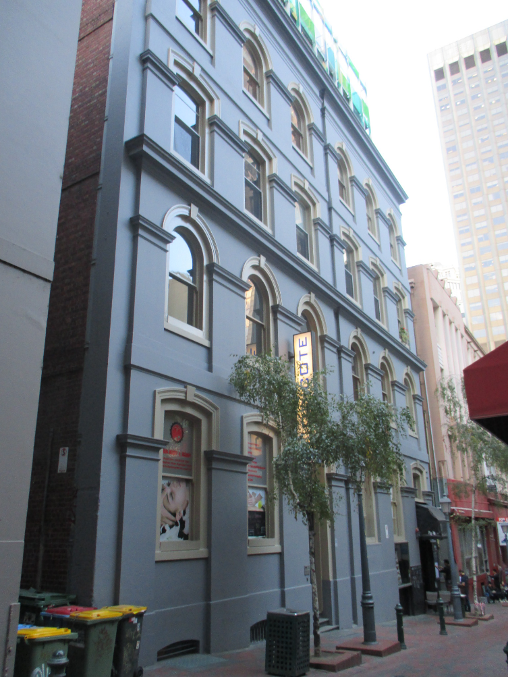

Statement of Significance

What is Significant?
The subject building (pair of warehouses) at 18-22 McKillop Street was constructed in 1888-9, over four floors with a semi-basement level. It has a rendered masonry façade to McKillop Street, and face brick side elevations. The building takes the broad form of an Italian palazzo with a base surmounted by a straightforward façade, capped by a cornice or attic storey. Fenestration across the four levels is deep-set and comprises alternating simple segmental-arched heads and arch-headed windows, with key stone mouldings. The base takes the form of a simple rendered plinth around basement windows. The two building components can be read via a narrow centrally located vertical recess to the façade. Window openings at ground floor level have been altered although the elevated arrangement, to facilitate the loading of carts, remains legible.

How is it Significant?
The subject building (pair of warehouses) at 18-22 McKillop Street is of historical and aesthetic/architectural significance to the City of Melbourne.

Why is it Significant?
The subject building (pair of warehouses) at 18-22 McKillop Street is of local historical significance. The building was constructed in 1889 for merchant firm, Alston & Payne, to a design by Thomas Watts & Sons. It is part of an important collection of late nineteenth century warehouse and mercantile buildings in this area of the central city. In replacing the earlier wood and iron stables that previously occupied the site, the subject building is demonstrative of the localised late nineteenth century growth in warehousing activity. Early occupants such as the Oriel Printing Company and Marcus Ward wholesale stationers, followed by letterpress and offset printers, Arbuckle, Waddell and Fauckner, who occupied the building from the early 1900s into the 1970s, is another important association with a local historical trend. Small-scale printers, publishers and stationers moved into the central city laneways and warehouses from the late nineteenth century, and continued well into the twentieth century. (Criterion A) The subject building is also of local aesthetic/architectural significance. It is a substantially externally intact and competently executed example of a late 1880s warehouse in the Italianate style. While conservative in design, it has subtle refinements in its understated ornamentation. When the building was constructed, the Italianate mode was well understood and had become the preferred mode for developers, speculators and builders. Commercial buildings such as this typically took the form of simple masonry boxes with a largely standardised applique of classical detail, which in the subject building is evidenced in the alternating simple segmental-arched headed and arch-headed windows; cornice level and attic storey; architraves, keystones and impost moulds; and deep-set fenestration. The typical warehouse function can also be read in the elevated arrangement of openings at ground floor level, which facilitated the loading of carts. (Criterion E)

Scottish Amicable Building (HO1213)
128-146 Queen Street, MELBOURNE
Grading: Significant
Place type: Offices
Date(s): 1964-65
Survey Date: April 2016
Intactness: Good
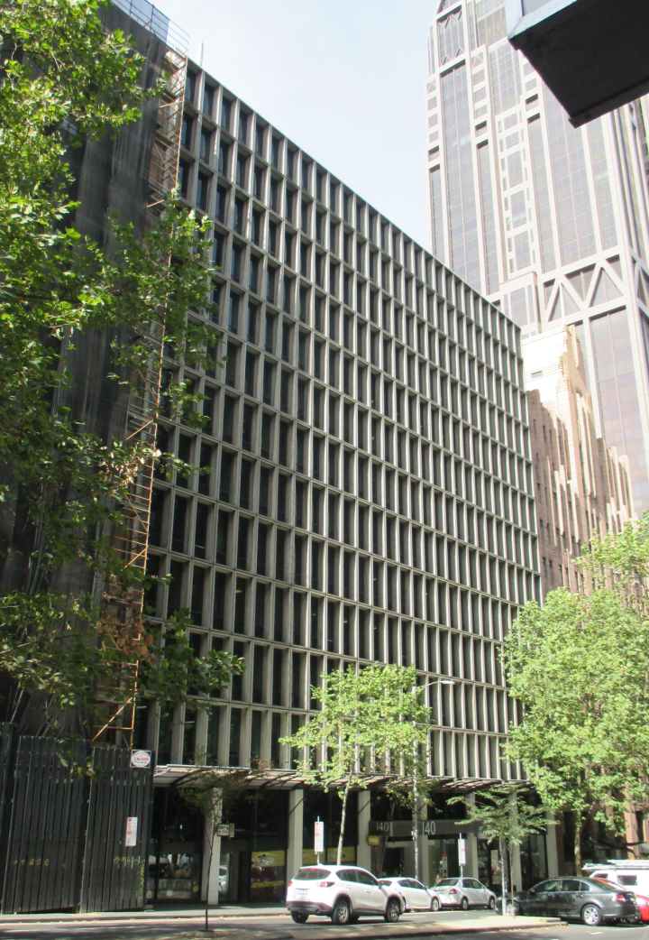

Statement of Significance

What is Significant?
The Scottish Amicable Life Assurance Building at 128-146 Queen Street, was constructed in 1964-5 to a design by Yuncken Freeman. It is a large 13-storey commercial office building on the east side of Queen Street, with a façade expressed as a slender concrete lattice elevated above the street on a collonade of pilotis. Above ground floor level, a strict geometry dominates, made up of repeating horizontal and vertical rows of narrow rectangular pre-cast concrete moulded panels, with glazing and spandrels set deep into the reveals. The deep set windows also provide integrated sun shading. At ground floor level, the building has been modified, but retains evidence of the original recessed and set down glazed wall which formed a shallow, covered and accessible collonade at the interface of the private and public realms. Although a canopy has been added at street level, the original design intent remains legible, and the building overall retains a high level of external intactness to its façade.

How is it Significant?
The Scottish Amicable Life Assurance Building at 128-146 Queen Street, is of historical and aesthetic/architectural significance to the City of Melbourne.

Why is it Significant?
The Scottish Amicable Life Assurance Building, constructed in 1964-5 for the Scottish Amicable Life Assurance Society is of local historical significance. The company, which was founded in Glasgow in 1826 and arrived in Australia in 1886, purchased the subject site in Queens Street in 1964, for the construction of their Australian head office. They commissioned architects, Yuncken Freeman, to design the new building, in the period when the practice was increasingly noted for their corporate and commercial designs, including buildings and company headquarters for a number of large insurance firms. Scottish Amicable remained in building until at least 1989. The building is also significant for its association with the historical post-war period in Melbourne, when commercial architecture began to recover after the war, and numerous multi-storey office buildings and headquarters were constructed. Successful firms embraced Modernist architecture, and sought expression through the new corporate towers which symbolised progress, modernity, efficiency and power. (Criterion A) The Scottish Amicable Building, which retains a substantially externally intact façade to Queens Street, is also of aesthetic/architectural significance. It is an innovative and early example of the return to more massive construction, and a departure from the wholly-glazed expression of office buildings of the previous decade. While its rigid geometry and the incorporation of an entry forecourt (the colonnade) reveal its roots in the International Style, its three dimensional quality, achieved through more assertive textures and the use of sculptural, moulded pre-cast concrete rather than a flat glass exterior, provides a successful Modernist outcome. It is also of aesthetic significance for its strong but ‘polite’ presentation to Queens Street, where the building was required to conform with local height restrictions. This is amply demonstrated in images from the 1960s, including in works by renowned architectural photographer, Wolfgang Sievers. (Criterion E)

17 Somerset Place, MELBOURNE (HO1204)
Grading: Significant
Date(s): c. 1907-8
Survey Date: April 2016
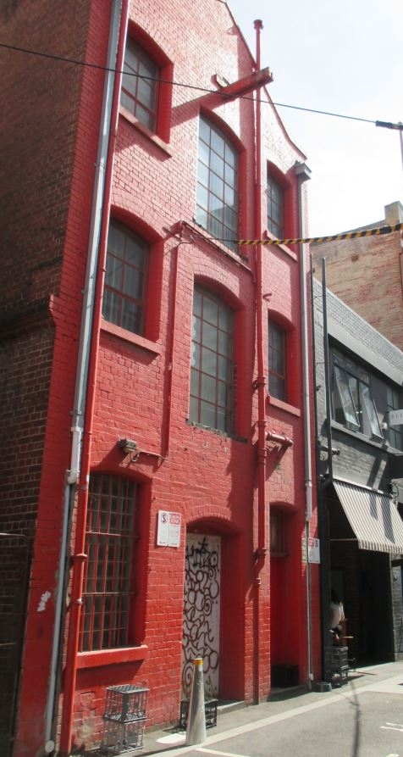
Statement of Significance

What is Significant?
The three-storey brick warehouse at 17 Somerset Place was built in c. 1907-8 for Joseph Kennedy by contractors Peters & Hetherington of King Street. The building replaced a single-storey brick foundry, which had occupied the site from as early as 1888. This foundry was owned by James Kennedy and occupied by James Stevenson until the mid-1890s, when the site was occupied by Robert McPherson and the brick building used as a workshop. In 1907 the site was owned by Joseph Kennedy, and described as a brick workshop, valued at a NAV of £24. In March 1907, a notice of intention to build was submitted to the City of Melbourne by Kennedy, to construct a three-storey brick store off Little Bourke Street.
The following year, although it was still described as a brick workshop, the value of the property had increased to a NAV of £116. The new building can be seen on the Mahlstedt fire insurance plan of 1910. The plan shows the building as having two doors on the front elevation, and two to the side elevation. The building was occupied by carpet and upholstery importers, Bradshaw and Allan who remained at the site into the 1950s.
The c. 1907-8 three-storey brick warehouse at 17 Somerset Place is built to the boundaries of its laneway site, and adopts an unusually small footprint presenting a frontage of less than seven metres to the street. Constructed in face brick, the façade retains its original pattern of fenestration. The original arrangement of segmental-arch headed windows and landing entries at each level generally survives, as does an original crane beam above central landing doors at each floor level. A second point of entry from the laneway allowing separate access to upper levels from the street also survives. Another pedestrian entry remains evident along a laneway to the south elevation of the warehouse.
Some door and window joinery has been replaced and other minor works have occurred. However, these alterations have had limited impact overall on the form and character of the building. The façade has been over-painted in red although the original hawthorn brick expression remains legible along the access way to its south. It is likely that the roof was originally clad in slate but is currently clad in modern corrugated steel. The former warehouse survives as a substantially intact but unusually narrow warehouse structure.

How is it Significant?
The three-storey brick warehouse at 17 Somerset Place, built in c. 1907-8, is of local aesthetic/architectural significance.

Why is it Significant?
The building is of aesthetic/architectural significance. While it is a utilitarian building, it is distinguished by its vertical proportions and unusually narrow footprint, for the building type. The large original segmental-arch headed windows to the Somerset Place elevation further distinguish the building, enlivening its presentation to the laneway. Despite some overpainting, the original hawthorn brick expression to the south elevation remains. The building also retains other key elements associated with its original design and use, including the original crane beam above the central landing doors at each floor level. A second point of entry in the façade is also original, and provided separate access to the upper levels from the street.

Bucks Head Hotel stables (HO1205)
15 Sutherland Street, MELBOURNE
Grading: Significant
Date(s): c. 1853
Survey Date: April 2016
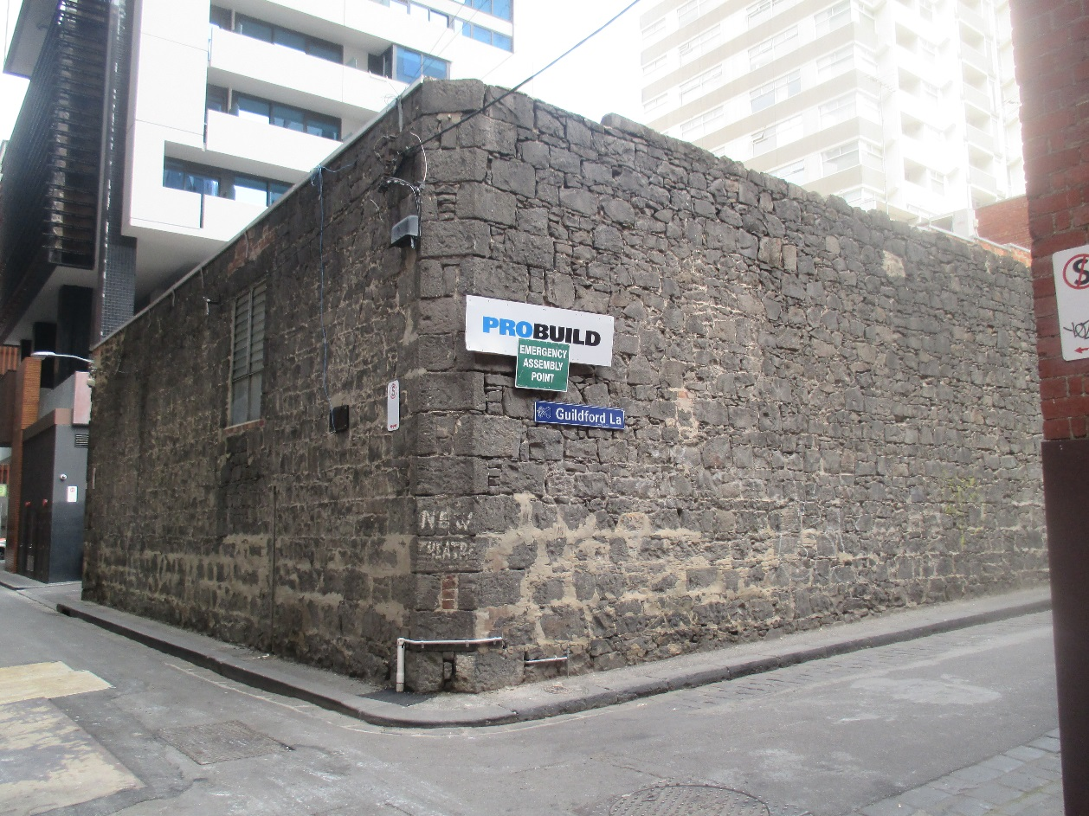

Statement of Significance

What is Significant?
The bluestone walled building at 15 Sutherland Street is a remnant of the former Bucks Head Hotel stables, constructed in c. 1853. The Bucks Head Hotel was established in Little Lonsdale Street in 1848. Eventually the evolved hotel complex spanned McLean Alley to the north of the hotel, and remained a linked site with the stables until the 1950s.
The ‘new and spacious hotel’ was opened by Roderick McKenzie, and attached to the premises were most ‘most excellent stables and bullock yards’. In 1851, William Lamont placed advertisements in the Argus newspaper to inform that he had ‘rented the stables at the rear of the Buck’s Head Hotel’ for operation as livery stables (not the current building). Lamont emphasised that ‘the attention paid to and the accommodation provided [for] horses will be first-rate’. Livery stables were commercial enterprises; horse owners paid to accommodate their horses on a short or long term basis. The form of Lamont’s livery stables is unknown, but it appears that the venture was successful enough to enable construction of a more substantial bluestone structure.
By 1852, the hotel was under the management of John McLean, after whom McLean Alley is named. In February 1853, McLean gave notice to the City of Melbourne of his intention to build public stables at the rear of the Bucks Head Hotel, near Little Lonsdale Street. The Bibbs plan of 1857) shows the layout of the stables, with the chamfered corner entry at the site’s south-east corner. The stables building and rear of the hotel can also be seen in a c. 1860 photograph by Charles Nettleton, with a high bluestone wall and ridged hipped roof visible. The 1861 municipal rate books describe the hotel complex as comprising ‘bar, cellar, 15 rooms, shed [and] stables.’ It appears the stables were not always used for livery purposes, and their operation as such likely depended on demand by hotel patrons. An auction notice for the hotel in 1872 noted the rear yard with its ‘stabling, outhouses’, and the ‘valuable property at the rear … with substantial bluestone buildings thereon, which might be adopted for storey or factory.’ A subsequent sale notice of 1881 described this rear building as a ‘brick and stone store, of three flats well and substantially built. Also stabling for 15 horses.’ It is unclear if alterations had been made to the building between 1872 and 1881, although the inclusion of brick and ‘three flats’ in the description indicates some change.
The 1894 MMBW detail plan identifies that the building was still a stable (denoted by an ‘S’), and also shows that it included loft spaces. The 1901 Sands & McDougall directory listing for Sutherland Street identifies William Gunn as occupying livery stables. Gunn operated the stables until c. 1905, when the building was taken over by ironmongers and merchants, John Cooper & Sons, as a store and stable. The hotel lost its license in 1913, during the period of the Licences Reduction Board (1900s-1910s). In the 1930s, a number of newspaper articles identified the bluestone building as an early stables, sometimes erroneously associating it with Cobb & Co. coaches. A somewhat nostalgic article in the article Argus of 1934 described the building:
Across the lane at the back of the house [hotel] is a small stable … still fitted with the original wood horse stalls, hay loft and iron rings in the wall for tethering horses. In spite of its modern use as a motor spraying shop it is one of the quaintest pieces of early Melbourne …
The hotel complex was put up for sale in 1951, and the hotel was demolished and replaced with a car park. The former livery stables survived and are now used as a site office. The former Bucks Head Hotel stables survive as a bluestone-walled volume with elevations to Sutherland Street, Guildford Lane and McLean Alley. Externally, the building is substantially intact to its c. 1853 state, with internal elements such as stabling and haylofts apparently removed and replaced with modern fabric. Original external walls survive and are largely comprised of random undressed bluestone. Some dressed stone has been used to create a canted corner at the intersection of Guildford Lane and Sutherland Street and the principle entry at the intersection of McLean Alley and Sutherland Street, although the masonry work is generally executed in a simple and unrefined manner. Some modest changes to the exterior have been undertaken, notably, the introduction of a wide window to the McLean Alley elevation and a more modest window to Sutherland Street. However, these changes have had little impact on the blunt and somewhat primitive expression of the building. Its original role as a rudimentary, walled compound of an unusually early construction date in the CBD remains legible.

How is it Significant?
The former Bucks Head Hotel livery stables at 15 Sutherland Street is of historical and aesthetic/architectural significance to the State of Victoria.

Why is it Significant?
The building is historically significant as a rare surviving mid-nineteenth century livery stables in the central city, with a construction date of 1853. It is the earliest building identified in the Guildford and Hardware Laneways Precinct; and an early surviving building in the CBD context. It was associated with the 1848 Bucks Head Hotel, which operated until 1913, and as such is a reminder of early commercial development in the city. It is also demonstrative of the significance of stables operations, including the commercial enterprise associated with livery stables. Unusually, the building’s importance as a ‘piece’ of old Melbourne was recognised in a 1934 newspaper article. Aesthetically, while a structure of simple cubic massing and monolithic appearance, it is nevertheless a robust building with a strong corner form to Guildford Lane and Sutherland Street, and a chamfered corner to Sutherland Street and McLean Alley. Its high bluestone walls make a significant contribution to the character of the adjacent laneways. The chamfered corner to the south-east of the building is also original, and denotes the entrance to the original pitched central yard. The entrance was in turn strategically located across the alley from the Bucks Head Hotel. Despite some alterations, notably the introduction of modern glazing, the building is remarkably externally intact to its original mid-1850s form.

