Hoddle Grid Heritage Review
Flinders Fabrics Self-Guided Walk
Tour Distance : 630m
Tour Time : Approx.45 minutes
Acknowledgement of Traditional Custodians
The City of Melbourne respectfully acknowledges the Traditional Custodians of the land, the Bunurong Boon Wurrung and Wurundjeri Woi Wurrung peoples of the Eastern Kulin Nation and pays respect to their Elders past, present and emerging. We are committed to our reconciliation journey, because at its heart, reconciliation is about strengthening relationships between Aboriginal and non-Aboriginal peoples, for the benefit of all Victorians.
Contents
The Review 4
Introduction 5
This Walk 6
Stop 1 7
Stop 2 10
Stop 3 13
Stop 4 15
Stop 5 17
Stop 6 19
Stop 7 22
Stop 8-9 24
Stop 10 28
Stop 11 30
Stop 12 32
Stop 13 34
Stops 14-15 36
Stop 16 39

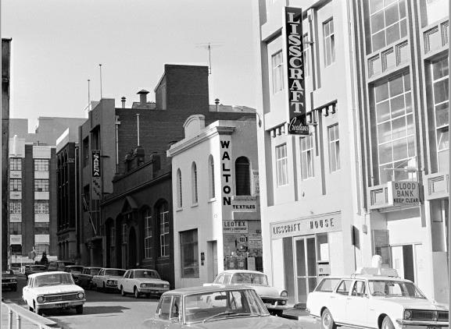

Front cover: Flinders Lane south, Melbourne, c1972. Photograph by K J Halla
(State Library of Victoria H36133/484)

The Review
The Hoddle Grid Heritage Review is the most comprehensive review of heritage buildings in the heart of the city since the 1990s. This walking tour takes you to some of the heritage places identified in the Review.
The recommendations in the Review are being implemented through Planning Scheme Amendment C387, which has been prepared by the City of Melbourne.
Find out more and have your say at Participate Melbourne.
Images with the copyright permission of the State Library of Victoria.

Introduction
This walk introduces you to the Flinders Lane East Precinct, significant for its association with manufacturing and warehousing for clothing and textile businesses, colloquially referred to as the ‘rag trade’, between the 1850s and the 1930s.
Far from dealing in rags, Flinders Lane was the hub of a fashion industry with its many small niche businesses that provided specialist finishing services to clothing manufacturers. The area provided employment in clothing manufacture, particularly for women. Flinders Lane was the epicentre of the textile and clothing industry and benefited from the Commonwealth tariffs that resulted in further construction of factories and warehouses throughout the 1920s and 1930s.

This Walk
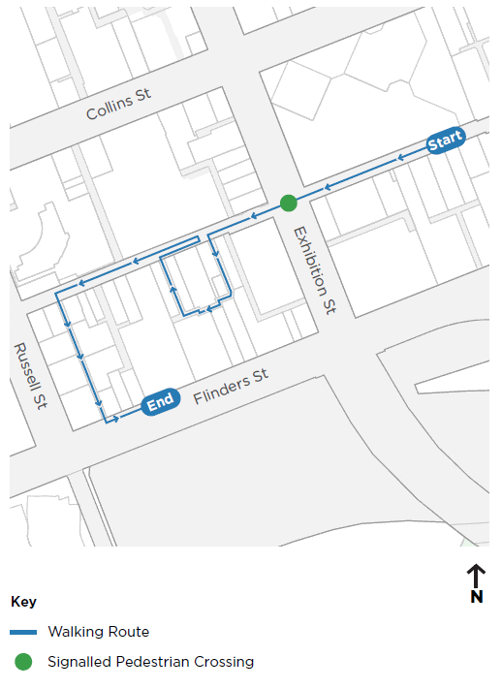

Stop 1

Warehouse at 37-45 Flinders Lane
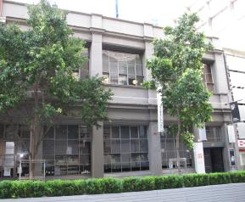
Warehouse at 37-45 Flinders Lane (City of Melbourne)
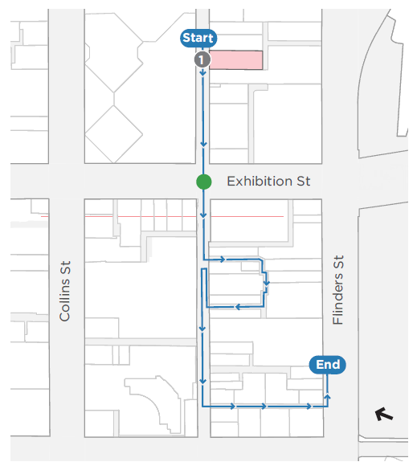

Architect(s): Unknown
Constructed: 1910s
This two storey Edwardian brick warehouse with basement was likely constructed for the J R Blencowe clothing factory in operation at this address from 1911. J R Blencowe won a number of contracts for the manufacture of clothing for the Australian military forces during World War One between 1915-1917.
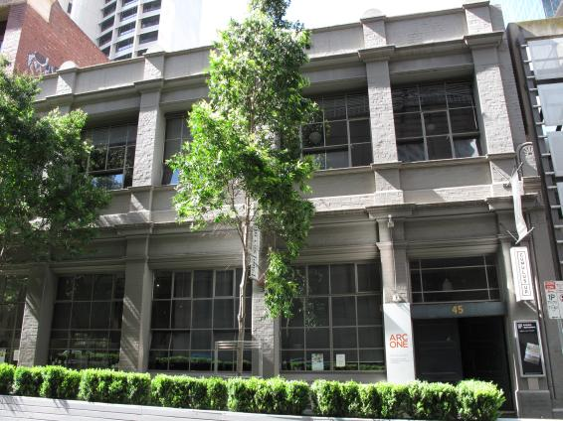
37-45 Flinders Lane (City of Melbourne)
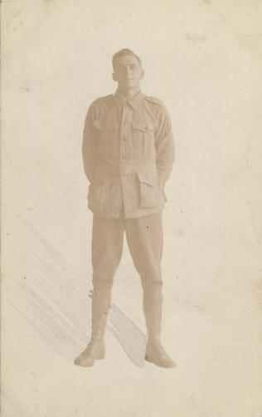
Corporal Alexander Dickie is shown wearing a World War I uniform, perhaps including garments manufactured by J R Blencowe (State Library of Victoria H2012.59/63)
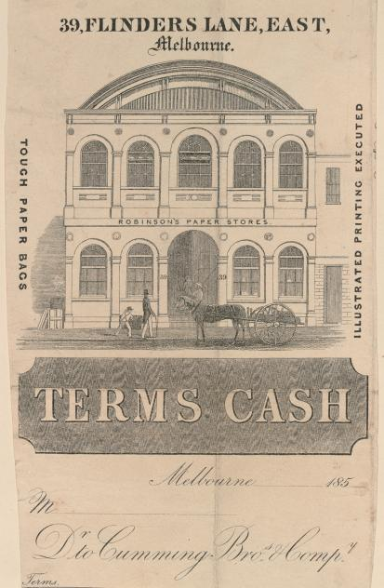
Invoice for a paper company prior to construction of the Edwardian warehouse. The invoice to the gives you a sense of what the former building looked like (State Library of Victoria H32088/114 and H32088/118)
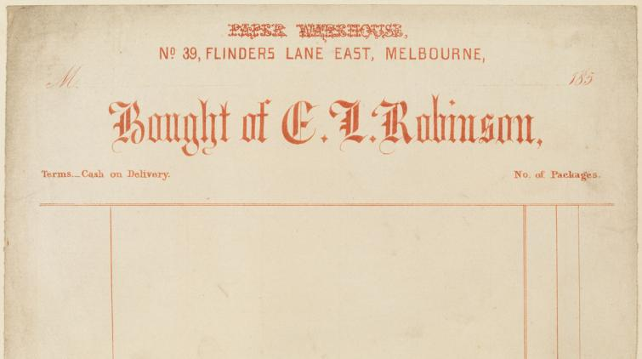
Invoice for a paper company prior to construction of the Edwardian warehouse. (State Library of Victoria H32088/114 and H32088/118)

Stop 2

Dominion House at 57-59 Flinders Lane
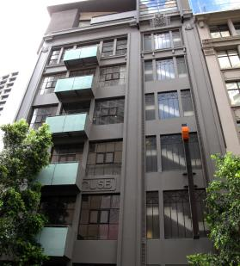
Dominion House at 57-59 Flinders Lane (City of Melbourne)
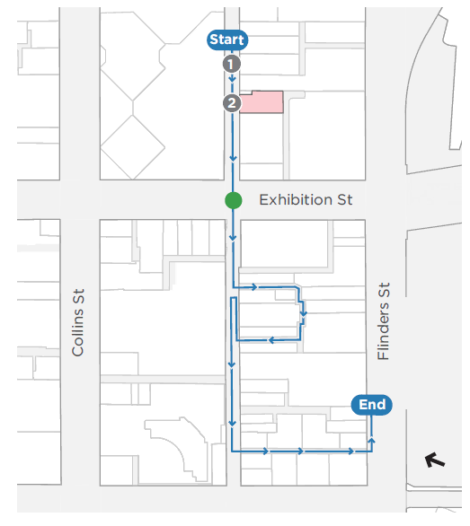
Architect(s): Henry Hare and Hare
Constructed: 1925-26 and 1929
Dominion House was designed as a nine-storey modern factory building to ‘meet the requirements of the better-class factory [with] particular attention to detail in lighting, construction, escapes and convenience of employees’ (Herald 4 November 1925:4). Only three storeys were constructed on the Flinders Lane frontage and six storeys at the rear. A further three floors of reinforced concrete, designed by the same architects, were added in 1929.
Innovative features of the building include its fire resistance, separate passenger and goods elevators, wide column spacings to provide unobstructed work areas, a flat roof for the recreation use of tenants, 14 inch brick walls without windows to the west to provide improved insulation, and steel window frames on reversible pivots filled with ribbed prismatic glass to facilitate the distribution of diffused light. Each floor was capable of carrying 100 persons.
In 1930, Dominion House was occupied by a number of businesses related to the ‘rag trade’ including manufacturers of children’s clothing, mantles (a type of loose cloak usually worn over indoor clothing) and knitted goods.
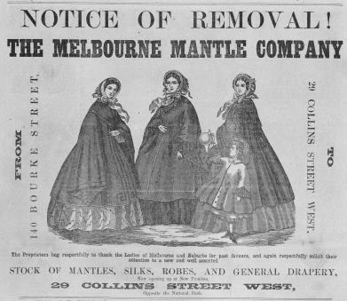
Mantles were once a common garment. Advertisement for the Melbourne Mantle Company, July, 1862
(State Library of Victoria IAM21/07/62/142; A/S10/02/86/21; IAN02/09/95/14a)
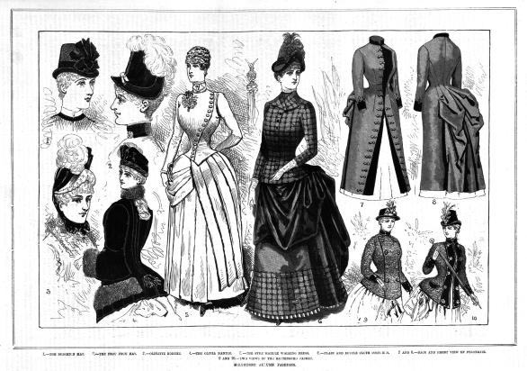
Melbourne autumn fashions, February, 1886
(State Library of Victoria IAM21/07/62/142; A/S10/02/86/21; IAN02/09/95/14a)
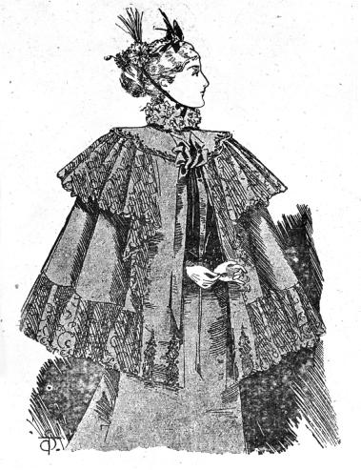
Summer wrap for a lady, September, 1895
(State Library of Victoria IAM21/07/62/142; A/S10/02/86/21; IAN02/09/95/14a)

Stop 3

Sargood House at 61-73 Flinders Lane
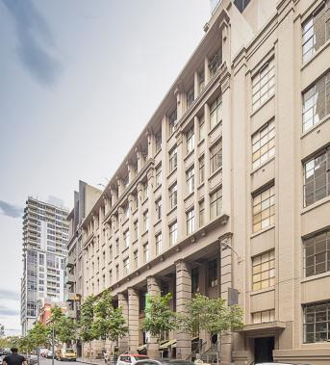
Sargood House at 61-73 Flinders Lane (David Simmonds)
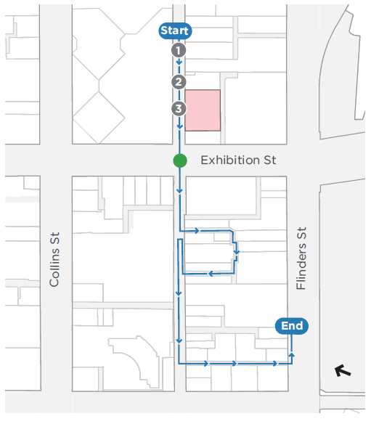
Architect(s): Godfrey & Spowers
Constructed: 1929 and 1936
Sargood House is an eight storey concrete interwar warehouse built for Sargood Gardiner Ltd softgoods manufacturers, importers and wholesalers by Hansen & Yunken in 1929; the top storey was added in 1936.
When the building opened in 1930, it was described as `dazzling white’ and conspicuous, rising high above the adjoining Alley Building (Stop 4). This dazzling appearance was achieved by using Goliath cement and selected sand of a`Sydney stone’ colour. There was a rooftop staff dining room with magnificent views to the gardens and river. Eventually the building appears to be have been used as an office for the Herald and Weekly Times.
The firm, Sargood Gardiner Ltd, was established in 1926 through the amalgamation of Sargood Bros and W Gardiner & Son. Sir Frederick Sargood, principal of the business 1871- 1903, built the Melbourne mansion Rippon Lea.
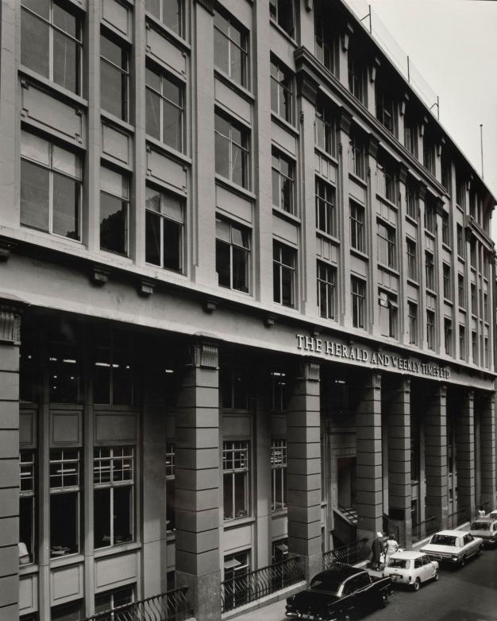
The Herald and Weekly Times offices, 61-73 Flinders Lane. Photograph by Wolfgang Sievers
(State Library of Victoria H99.50/51)

Stop 4

The Alley Building at 75-77 Flinders Lane
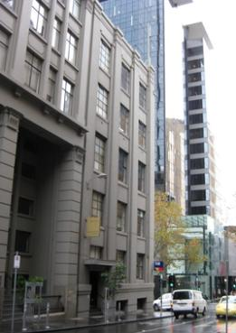
The Alley Building at 75-77 Flinders Lane (City of Melbourne)
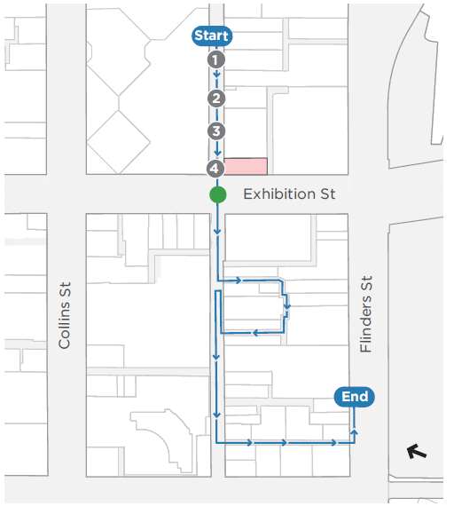
Architect(s): Percy Oakley
Constructed: 1925 and 1934
The Alley Building is a six storey brick and concrete former warehouse and clothing factory built in 1925 for the Alley Brothers. Originally constructed as a four storey building, the top two floors were added in 1934. This appears a typical approach to industrial buildings in Flinders Lane, allowing businesses to grow their premises according to expanding businesses and changing needs.
Interwar warehouses such as the Alley Building reflect the continued demand in the 1920s for factory and warehouse space in the city centre for the growing manufacturing sector. Over time, the Alley Building was occupied by a range of businesses related to the ‘rag trade’, including costume and frock manufacturers, mantle manufacturers, fabric makers and importers of cosmetics.

Stop 5

Swiss Club of Victoria at 87-89 Flinders Lane
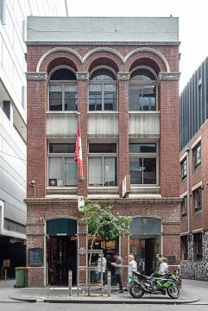
Swiss Club of Victoria at 87-89 Flinders Lane (David Simmonds)
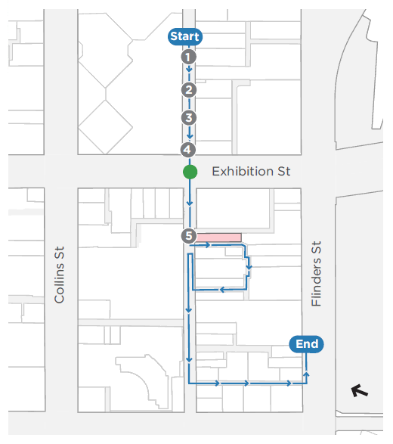
Architect(s): H W and F B Tompkins
Constructed: 1906
This three-storey American Romanesque style building was built in 1906 for P Warland Pty Ltd, a ladies underclothing importer and manufacturer who leased the top floor to the Britannia Tie Company. Designed with impressive giant order arches by the Myer architects H W and F B Tompkins it was constructed was by Henry Henningsen, whose office was located on the neighbouring site at 91 Flinders Lane (now 11-15 Duckboard Place, Stop 6).
From 1922 the building was leased to other garment or industrial manufacturers including Parisian Mantle Manufacturers, clothing manufacturers J Sackville, and machinery indenters Dyer and Phillips (S&Mc 1923-1935). The building is now occupied by the Swiss Club of Victoria, one of a number of private clubs located in the city centre.
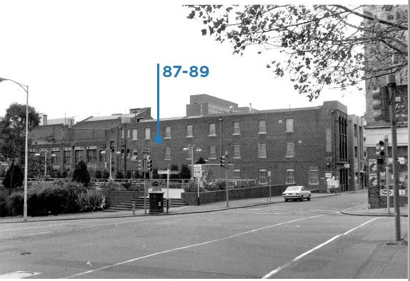
Corner Exhibition Street and Flinders Lane, showing the Swiss Club of Victoria Building in the background, 1977. Photograph by John T Collins (State Library of Victoria H98.252/635)

Stop 6

Warehouse at 11-15 Duckboard Place
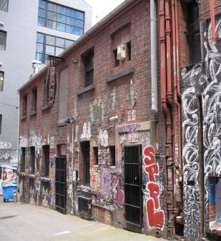
Warehouse at 11-15 Duckboard Place (City of Melbourne)
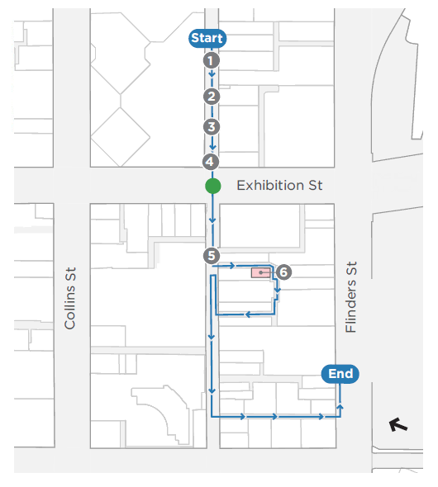
Architect(s): Unknown
Constructed: c1880s
This two-storey brick building was constructed in c1885-87 as a storage facility for the City of Melbourne Corporation Yard on the site.
Between 1906 and 1914 the site was occupied by Henry Henningsen, a Hawthorn builder who constructed a number of warehouses in Melbourne, including the brick warehouse on the adjacent land at 87-89 Flinders Lane (Stop 5). From the mid-1920s to the 1940s, the building was used as a factory for the clothing and textile company Denniston and Co Pty Ltd.
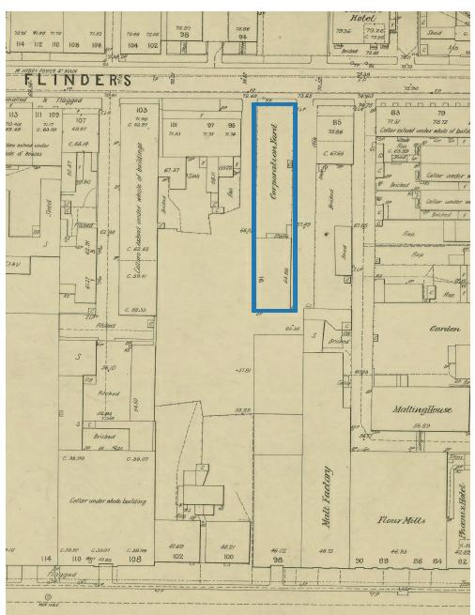
11-15 Duckboard Place and Corporation Yard, 1890s. Melbourne and Metropolitan Board of Works detail plan, No. 1008 (State Library of Victoria 1161766)
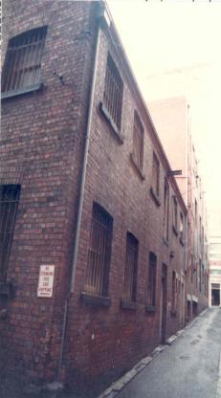
11-15 Duckboard Place in 1985 (City of Melbourne)
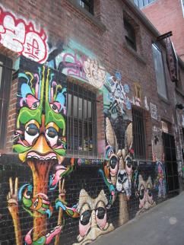
11-15 Duckboard Place in 2020 with street art (City of Melbourne)
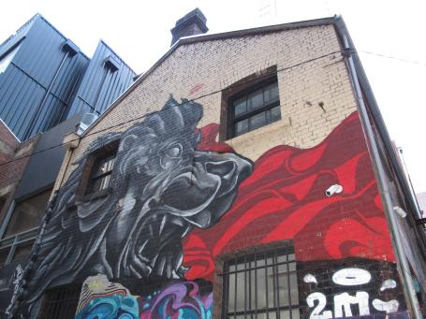
11-15 Duckboard Place in 2020 with street art (City of Melbourne)

Stop 7

Warehouse at 103-105 Flinders Lane
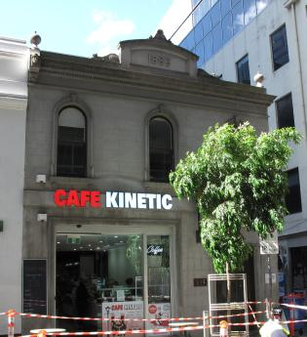
Warehouse at 103-105 Flinders Lane (City of Melbourne)
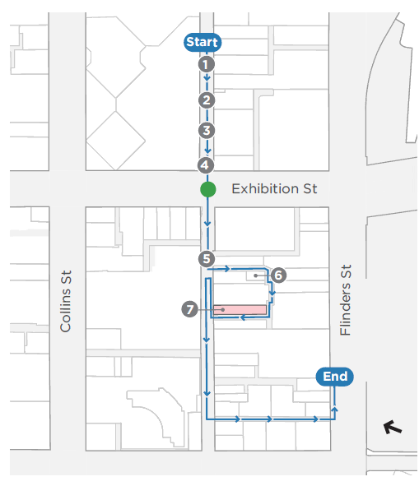
Architect(s): Unknown
Constructed: 1886
The former coach factory at 103-105 Flinders Lane (numbered 136 Flinders Lane until c1891) was built in 1886 by James Anderson for carriage builders Samwells and Reeves who occupied the building until at least 1905.
The coach factory was built next to H Samwells’ residence at 107-109 Flinders Lane, which was constructed by James Nation and Co c1881.
From the first decades of the twentieth century, the building housed mainly clothing manufacturers through until at least the 1950s when lingerie manufacturers, Fachon Pty Ltd, occupied the premises.
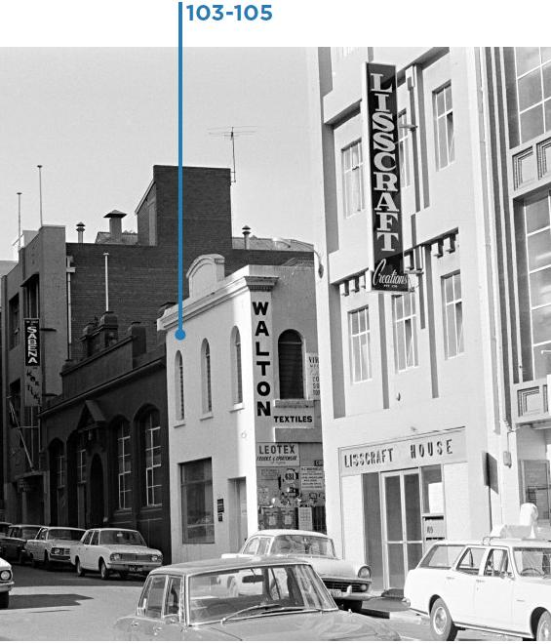
Flinders Lane south, c1972. Photograph by K J Halla (State Library of Victoria H36133/484)

Stop 8-9

Denniston at 91-93 and 95-101 Flinders Lane
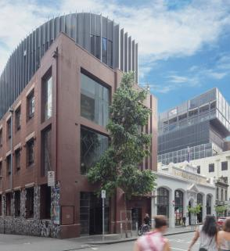
Denniston at 91-93 and 95-101 Flinders Lane (David Simmonds)
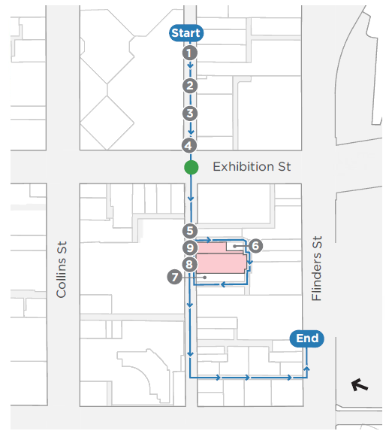
Architect(s):
91-93 - Unknown
95-101 - Sydney Herbert Wilson (1907); A S & R A Eggleston (1938)
Constructed:
91-93 - 1925
95-101 - 1907 and 1938
The factory/warehouse buildings at 91-93 and 95-101 Flinders Lane were once both owned by clothing manufacturer, Denniston and Co who manufactured men’s woollen clothing using material supplied by Doveton Woollen Mills in Ballarat.
The buildings at 91-93 comprised a three-storey brick factory constructed in 1925, with a single storey store at the rear. At 95-101 there was a single storey brick factory that had been built in c1907 for Denniston and Co The façade of this building remains today with embellishments, but most of the building dates from 1938, due to a disastrous fire that required the rear building to be reconstructed.
In 1938-39, the three-storey brick building at the rear at 91 Flinders Lane was refurbished and renamed ‘Duckboard House’ to create new club premises for the Melbourne branch of the Returned Sailors and Soldiers Imperial League, associated with the South African and Active Service Association.
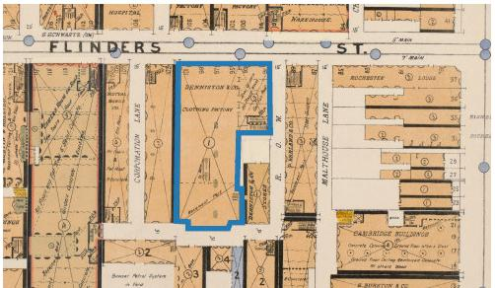
Detail Fire Survey, Section 1, Map 6, in 1925, showing the two sites operating as Denniston. Map by Mahlstedt’s (Vic) Pty (State Library of Victoria 2037630 and 2065768)
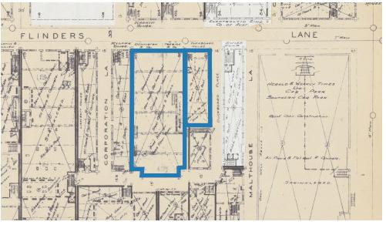
Detail Fire Survey, Section 1, Map 6 in 1948, showing 95-101 as Denniston and 91-93 as Duckboard House. Map by Mahlstedt’s (Vic) Pty (State Library of Victoria 2037630 and 2065768)
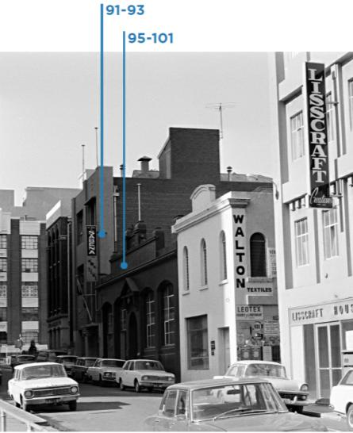
91-93 and 95-101 Flinders Lane, c1972. Photograph by K J Halla (State Library of Victoria H36133/484)
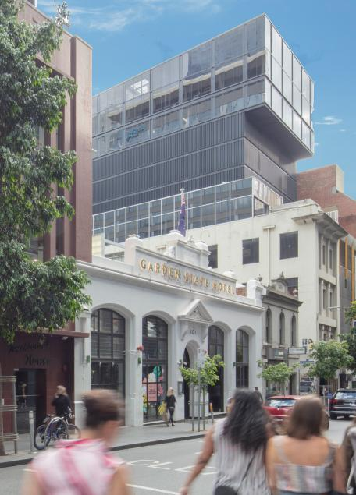
95-101 Flinders Lane (David Simmonds)
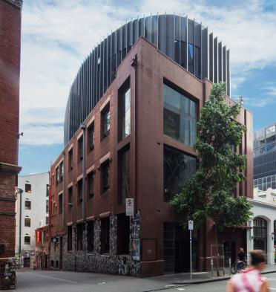
Duckboard House at 91-93 Flinders Lane (David Simmonds)

Stop 10

Warehouse at 107-109 Flinders Lane
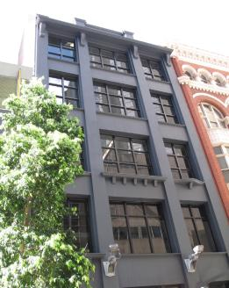
Warehouse at 107-109 Flinders Lane (City of Melbourne)
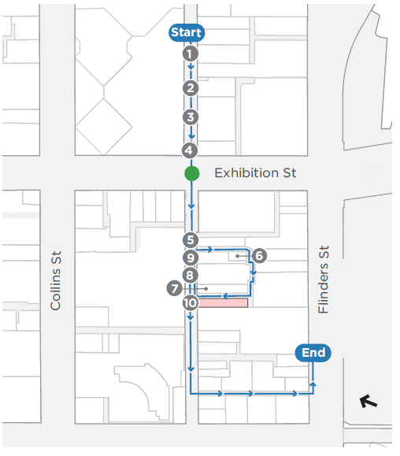
Architect(s): Stone and Siddeley
Constructed: c1920
In 1920 this three-storey factory building with basement housed makers of fancy leather goods in the basement. Beehive Wools were on the ground floor, and underclothing and children’s garments manufacturers on the first floor. Blouse makers and knitters, the Mutual Manufacturing Company, occupied the second and third floors.
By 1923, two storeys had been added. The building was later named Lisscraft House when it housed ladies clothing manufacturer, Lisscraft Creations.
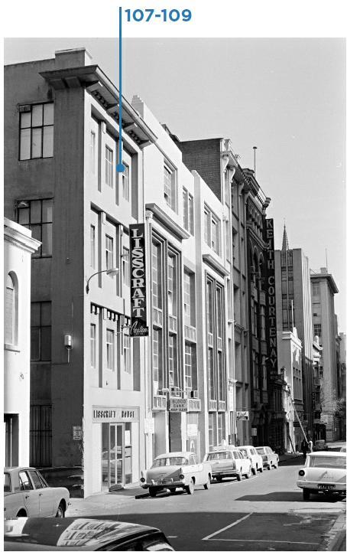
Flinders Lane south, c1972. Photograph by K J Halla (State Library of Victoria H36133/485)

Stop 11

Higson Building at 125-127 Flinders Lane (David Simmonds)
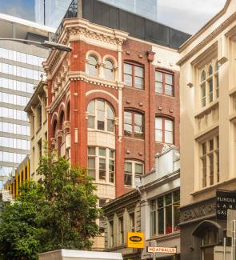
Higson Building at 125-127 Flinders Lane (David Simmonds)
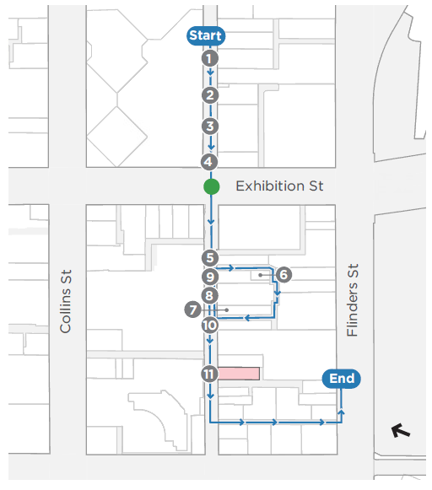
Architect(s): Billing Peck & Kempter
Constructed: 1912-1913
This ornate five-storey warehouse with basement was built in 1912 for John Higson and Sons, whose original premises were at 129-131 Flinders Lane.
Established in 1885, John Higson and Sons made harness, collars, trunks, portmanteaux, travelling bags, taggings and all descriptions of leather goods, particularly saddles. They also provided tents and tarpaulins, whip thongs and laces, fishing lines and cricketing materials. In short, they serviced the pursuits of a vigorous outdoors existence.
American Romanesque revival in style, the building features a giant arcade, attic arcade level and foliated column capitals. Bayed and bellied windows and a distinctive segment arch trio at ground level combine with its overall high integrity to make this a successful example of the style. It was designed by notable architects Billing, Peck and Kempter also known for their work on the Capitol Theatre and Heidelberg Town Hall.
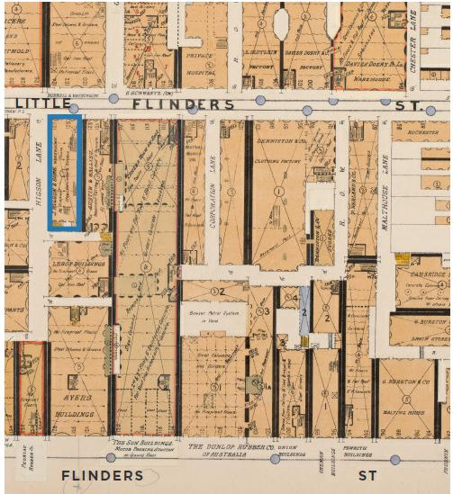
Detail Fire Survey, Section 1, Map 6, 1925, showing 125-127 Flinders Lane as Higons. Map by Mahlstedt’s (Vic) Pty. Note that Flinders Lane was once called Little Flinders Street (State Library of Victoria 2065768)

Stop 12

Bank of New South Wales at 137-139 Flinders Lane
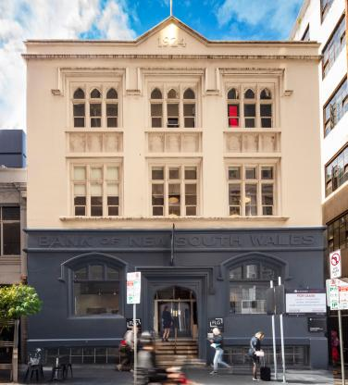
Bank of New South Wales at 137-139 Flinders Lane (David Simmonds)
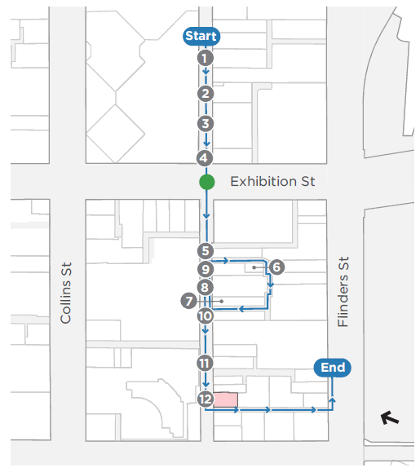
Architect(s): Unknown
Constructed: 1924-25
This Gothic Revival bank building was constructed in 1924-25 for the English, Scottish & Australian Bank (ES&A). Expressed through the Gothic arched windows on the ground and second floors, this style was deemed highly appropriate for banks in the nineteenth and twentieth centuries.
In 1927, the first floor was occupied by Mutual Manufacturing Co Pty Ltd, knitted goods manufacturers, and the second floor by Young & Co mantles and robes manufacturers. In this same year, the property was sold to the Bank of New South Wales, becoming their eastern branch, which operated here until February 1984.
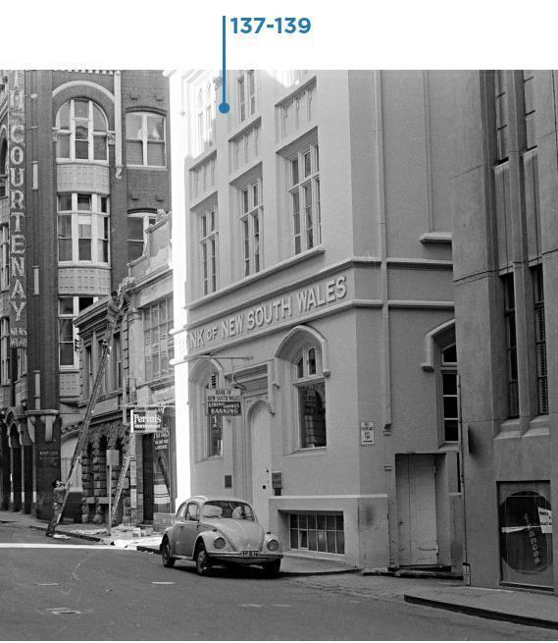
Flinders Lane south, c1972. Photograph by K J Halla (State Library of Victoria H36133/475)

Stop 13

Pawson House at 141-143 Flinders Lane
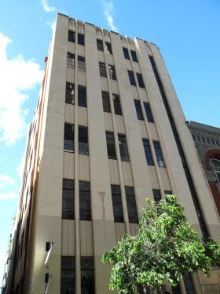
Pawson House at 141-143 Flinders Lane (City of Melbourne)
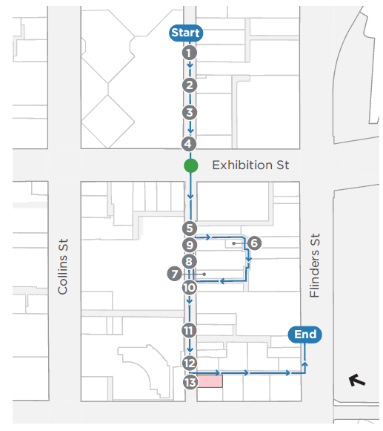
Architect(s): Tompkins, H R & F B
Constructed: 1935
Pawson House was built for clothing manufacturers Pawson and Company in 1935. This moderne style building demonstrates the later work of Myer architects H R and F B Thompkins (See Stop 5 for their earlier work). Constructed of reinforced concrete, its structure was designed by the pioneering reinforced concrete engineer, H R Crawford. In 1935 it was promoted as `This splendid building is the last word in modern construction perfect natural light central heating and hot water service. Floors 2400 sq ft or subdivide to suit tenants’.
Typical of this part of Flinders Lane, the tenants included Alexander Eastaugh and Co Pty Ltd, manufacturing specialists in hosiery, underwear and knitwear who took over the entire building in 1938.

Stops 14-15

The Bond Store at 22-30 Oliver Lane, and Warehouse at 10-20 Oliver Lane
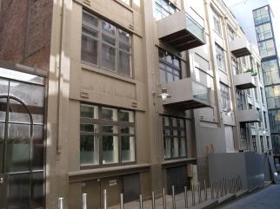
The Bond Store at 22-30 Oliver Lane, and Warehouse at 10-20 Oliver Lane (City of Melbourne)
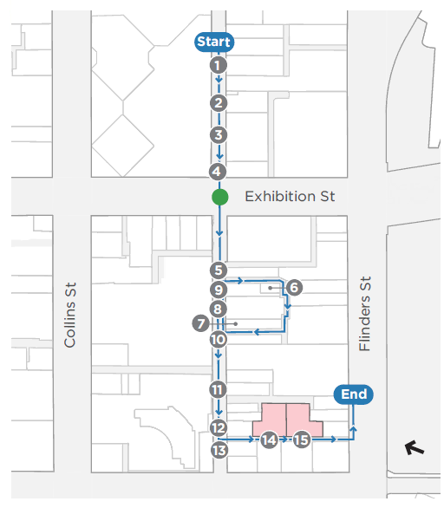
Architect(s): John Monash
Constructed: 1907
The two warehouses at 10-20 and 22-30 Oliver Lane were constructed in 1907 and are notable as the first buildings in Australia to be built wholly of reinforced concrete. They were designed by John Monash who was a leading figure in the field of engineering, particularly in reinforced concrete.
In 1925, the buildings appear to have accommodated manufacturers of leather goods, blouses, mantles and robes. Twenty years later, mantle and leather goods manufacturers still existed, and there was a pleating company. In 1965, there were manufacturers of frocks, ladies coats, belts, mantles and the pleating company remained.
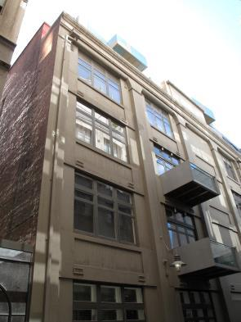
22-30 Oliver Lane (City of Melbourne)
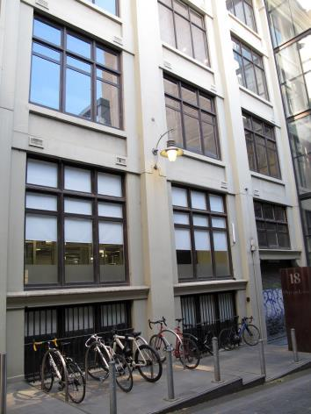
10-20 Oliver Lane (City of Melbourne)

Stop 16

Epstein House at 134-136 Flinders Street
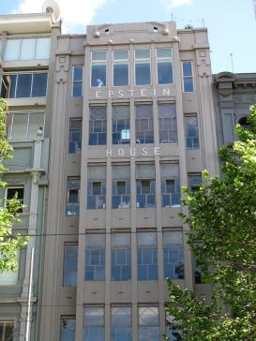
Epstein House at 134-136 Flinders Street (City of Melbourne)
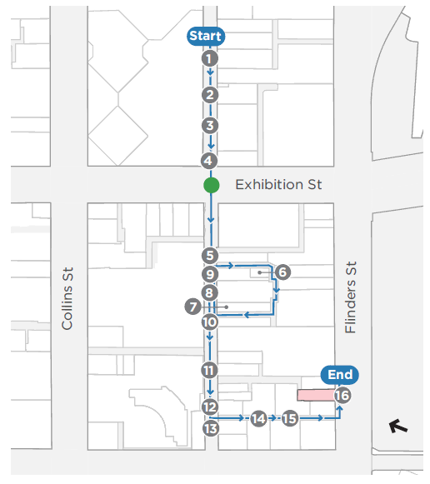
Architect(s): James A Wood
Constructed: 1926
Epstein House is a fine example of the Interwar Classical Revival style. It was constructed in 1926 for Louis Epstein to house his growing clothing manufacturing business, Louis Epstein and Co and operated from this site until 1994. The business gained a reputation as bespoke tailors and manufacturers of uniforms and equestrian clothing. They made most of the uniforms for the Victorian Police Force. Louis Epstein was the first importer and retailer of Levi Strauss jeans in Australia and became a chain of fashion stores in the 1990s.
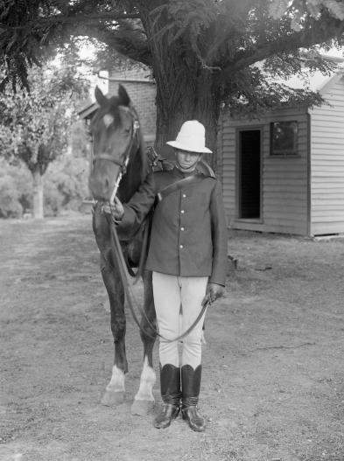
Mounted trooper at Alexandra, Vic, c1926. Photograph by Lindsay Cumming. This trooper’s uniform is an example of what Epstein may have manufactured (State Library of Victoria H2011.136/10)

We hope you enjoyed the Flinders Fabrics self-guided walk, which was prepared as part of the Hoddle Grid Heritage Review.
The Hoddle Grid Heritage Review recommends heritage protection for more than 100 new places, some of which you have visited today.
Visit Participate Melbourne1 by 17 December 2020 to find out more and have your say.
For full details of the sources used in this walk, visit Participate Melbourne.

https://participate.melbourne.vic.gov.au/AmendmentC387
https://participate.melbourne.vic.gov.au/

