Hoddle Grid Heritage Review
Swanston Stores Self-Guided Walk

Walking Distance: 700 metres

Walking Time: Approx. 45 minutes

Acknowledgement of Traditional Custodians
The City of Melbourne respectfully acknowledges the Traditional Custodians of the land, the Bunurong Boon Wurrung and Wurundjeri Woi Wurrung peoples of the Eastern Kulin Nation and pays respect to their Elders past, present and emerging. We are committed to our reconciliation journey, because at its heart, reconciliation is about strengthening relationships between Aboriginal and non-Aboriginal peoples, for the benefit of all Victorians.

Contents
Start 5
Stop 1 6
Stop 2 10
Stop 3 14
Stop 4 17
Stop 5 19
Stop 6 22
Stop 7 25
Stop 8 27
Stop 9 29
Stop 10 32
Stop 11 35

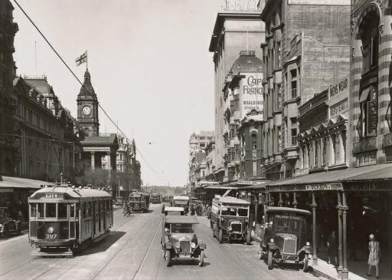
Front Cover: View of Swanston Street looking south, Melbourne Town Hall on the left, 1926
(Image credit: State of Victoria)

The Hoddle Grid Heritage Review is the most comprehensive review of heritage buildings in the heart of the city since the 1990s. This walking tour takes you to some of the heritage places identified in the review.

The recommendations in the review are being implemented through Planning Scheme Amendment C387, which has been prepared by the City of Melbourne.

Find out more and have your say at Participate Melbourne.

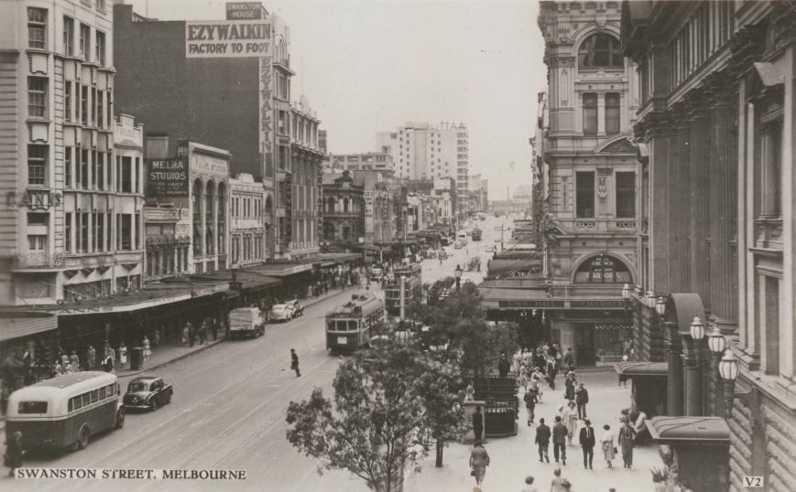

View of Swanston Street looking north, Melbourne Town Hall on the right, c1950
(Image credit: Valentine’s photographer, State Library Victoria)

Start
Melbourne Town Hall just north of the entry porch and look across Swanston Street.
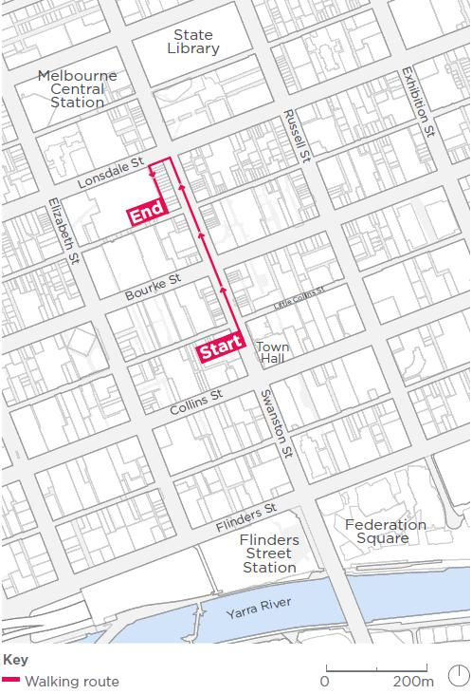

Stop 1
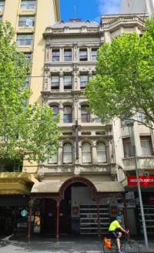
In front of you is the Talma Building, built 1885, which housed Buxton’s art emporium
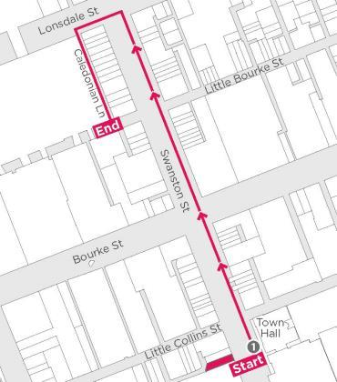
The ornate Talma Building (Hoddle Grid Heritage Review June 2018 only) was designed by renowned renaissance revivalist style architect Walter Scott Law. It was constructed at the height of Melbourne’s boom era in 1885 for stationer James Buxton to house his artistic stationery emporium, art gallery, classrooms and photographic studios.
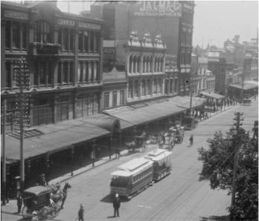
View of Swanston Street showing the Talma and Melba photographic studios, 1890s (Image credit: State Library Victoria)
The Talma Building was described in 1885 as “of colossal height: 110 feet and is one of the most conspicuous buildings of which Melbourne boasts” (Table Talk, 20 November 1885: 11). It was one of the first buildings in Melbourne to be equipped with hydraulic lifts allowing its exceptional height for the time.

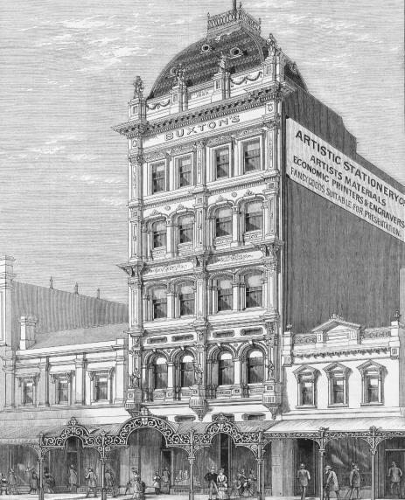
Buxton’s new premises as depicted in the Australian Sketcher in 1885
(Image credit: AC Cooke, State Library of Victoria)
This was the site of the landmark 9 by 5 Impressionism Exhibition of 1889 by members of the Heidelberg School of Australian art, including Tom Roberts, Charles Conder, Frederick McCubbin and Arthur Streeton. This was a milestone in the development of Australian Impressionism where paintings depicting the unique light and colours of the landscape were displayed for the first time.
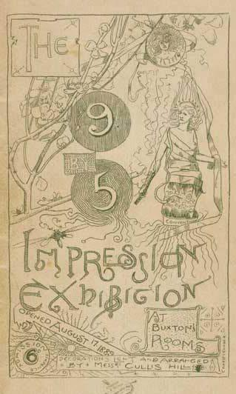
Cover of the 9 by 5 catalogue by Charles Conder, 1889
(Image credit: National Gallery of Victoria)
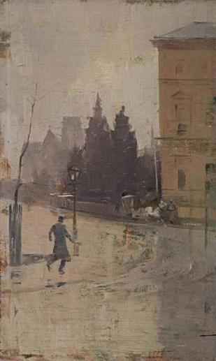
One of the painting in the exhibition, By the Treasury by Tom Roberts, 1889
(Image credit: National Gallery of Victoria)

Stop 2
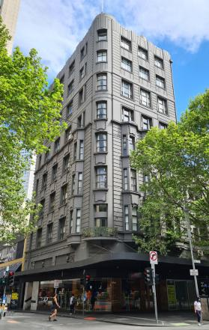
Cross Little Collins Street to face what was Cann’s department store, built 1919
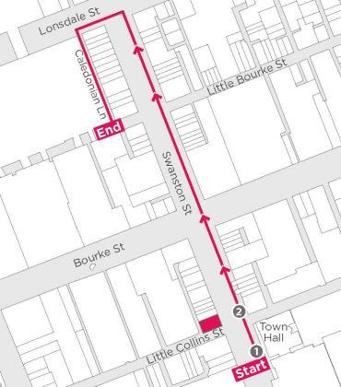

This corner building demonstrates evolving architectural fashions from the Edwardian to the interwar eras. The first five levels were constructed in 1919 and were designed by Nahum Barnet in the Neo-Baroque style featuring decorative features inspired by nature, such as vertical floral garlands. Four levels designed by Marcus Barlow were added in 1935 featuring Jazz Moderne elements inspired by the geometry of the machine age.
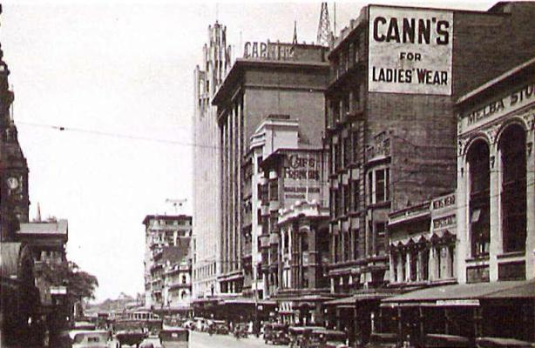
Swanston Street looking south, 1930s, showing two levels of the Marcus Barlow designed addition
(Image credit: State Library of Victoria)
Advertising for Cann’s in The Age newspaper across the decades – the department store was located at this corner for much of the 20th century.
1923
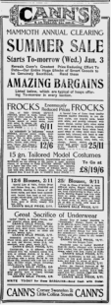

1939
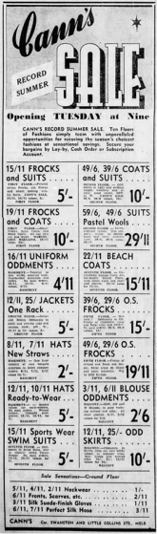
1942
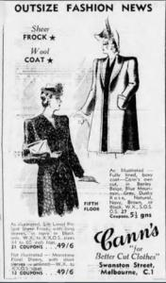
1962
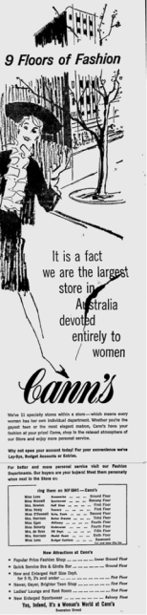
1971
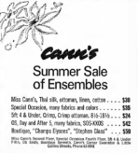
(Image credits: news.google.com/newspapers, newspapers.com, National Library of Australia)

Stop 3
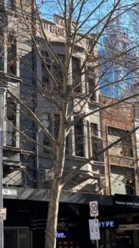
Next door is Faul’s Building, built 1924
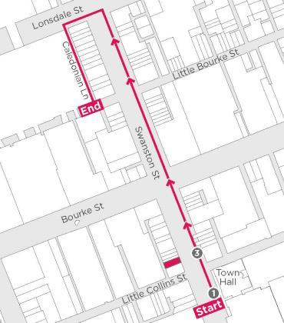

Faul’s Building is another example of the clothing and footwear shops along Swanston Street. It was constructed in 1924 for hosiery manufacturer J L Faul. It is a substantial building reflecting the economic boom of the 1920s.
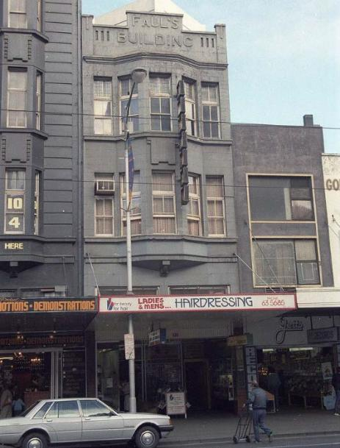
Faul’s Building, Swanston Street, 1984
(Image credit: Graeme Butler)
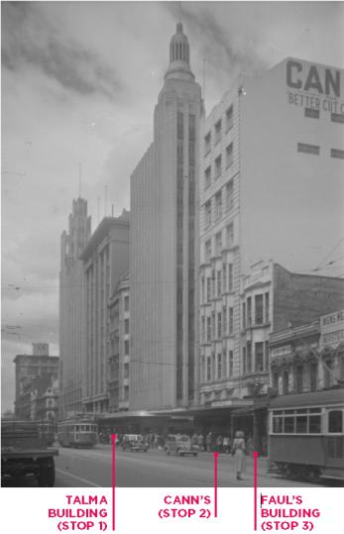
Swanston Street looking south west from Bourke Street, c1940-1954
(Image credit: Rose Stereograph Co., State Library of Victoria)

Stop 4
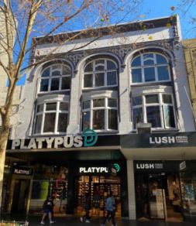
Keep walking north, until you are opposite the Sanders and Levy store, built 1900
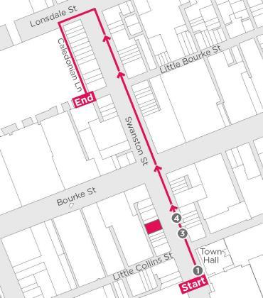

The Sanders and Company retail emporium appears to have its origins in the 1850s when Levy Brothers established a fancy goods and importing business. The Levy family business occupied many sites throughout the central city, culminating in the impressive Leviathan Stores which was built in 1913 at the corner of Swanston and Bourke streets.
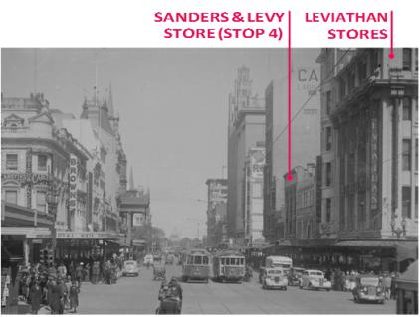
Swanston Street looking south from Bourke Street, c1920-1954
(Image credit: Rose Stereograph Co., State Library of Victoria)
The Sanders and Levy store is a fine example of Edwardian architecture. It is in the American Romanesque style, with giant masonry arches on the upper levels banded in face brick and render featuring ornate Art Nouveau motifs.
It was designed by one of Melbourne’s most prominent architectural firms Reed Smart Tappin (now Bates Smart) who are known for many of Victoria’s celebrated buildings including the State Library and Exhibition Buildings.
The building was constructed for Sanders and Company in 1900 and replaced shops built in 1876 which they had also occupied.
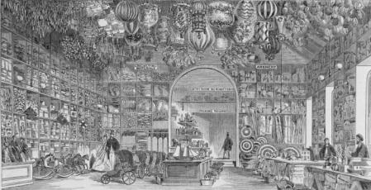
Interior of Levy Brothers’ Warehouse, Bourke Street as depicted in the Illustrated Melbourne Post, 1865
(Image credit: S Calvert, State Library of Victoria)

Stop 5
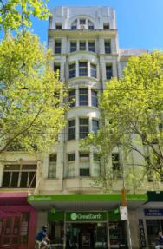
Next stop is Swanston House, built 1922, which housed the Ezywalkin shoe store
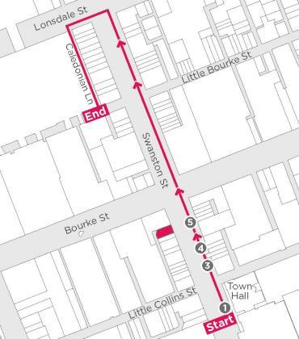

This seven storey reinforced concrete building was constructed in 1922 for footwear retailer Ezywalkin. The excerpt below from the 1925 Sands and McDougall street directory shows the variety of businesses it housed, including a wine cafe in the basement.
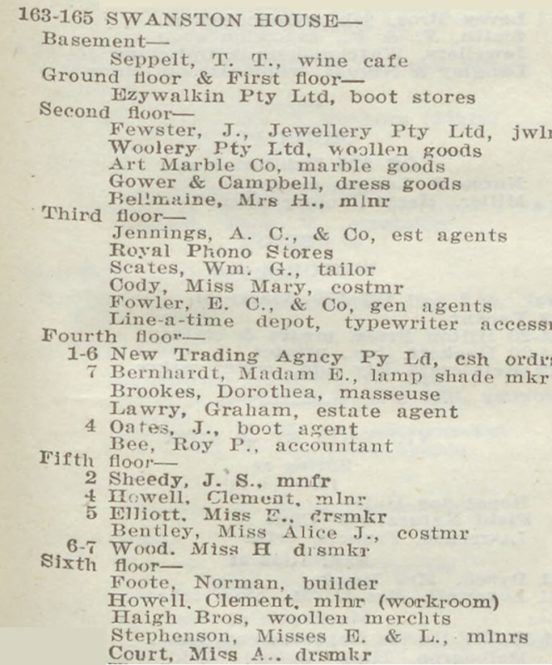
Sands and McDougall’s Directory of Victoria for 1925
(Image credit: State Library of Victoria)

Swanston House is comparable to Cann’s department store building as both were designed by Nahum Barnet in a Neo- Baroque style. Barnet (1855-1931) was one of Melbourne’s most prominent architects and is most well known for Her Majesty’s Theatre, Exhibition Street. He is distinguished by his bold compositions and for incorporating local flora and fauna into his decorative schemes.
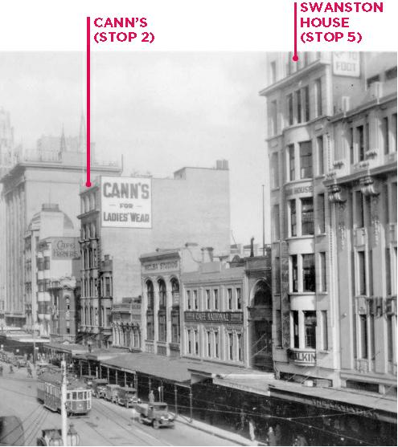
Swanston Street looking south west, c1940s
(Image credit: State Library of Victoria)

Stop 6
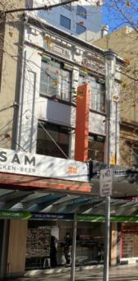
Walk north past Bourke Street until you get to the former Homecrafts store, built c1927
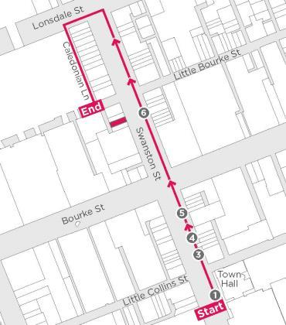

This three storey interwar building has a classical revival facade with large square steel framed windows on the two upper floors. It was constructed in around 1927 for Homecrafts Pty Ltd which was by then operating as a wireless firm. Homecrafts had previously established a toy shop in this location in 1918. Homecrafts also operated out of the two storey Victorian building next door at stop 7.
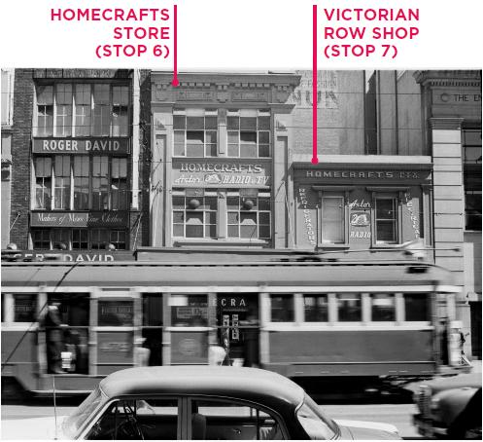
Homecrafts stores, Swanston Street, 1940
(Image credit: Mark Strizic, State Library of Victoria)
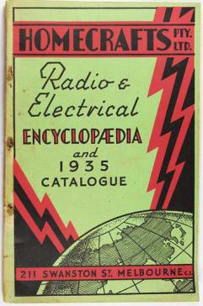
Homecrafts catalogue cover page from 1935
Image credit : Flagstaff Hill Maritime Village, Victorian Collections
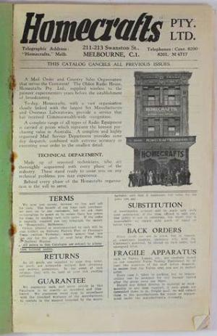
Homecrafts catalogue title page from 1935.
Image credit: Flagstaff Hill Maritime Village, Victorian Collections
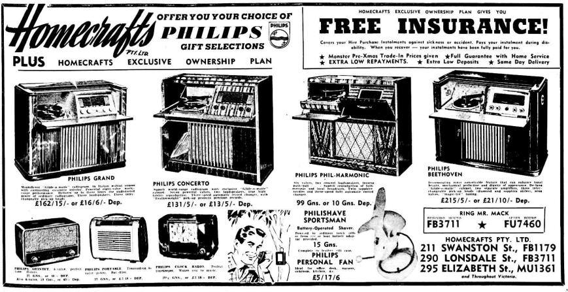
Advertising grand radios in The Argus newspaper in 1955.
Image credit: National Library of Australia

Stop 7
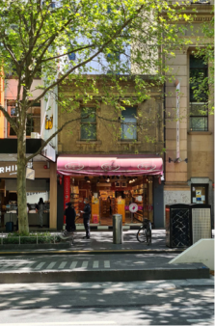
Next door is the last of a row of Victorian shops, built 1856
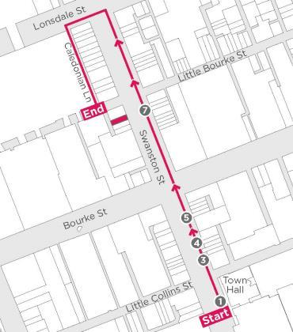

This two storey building was originally constructed as part of a row of shop and- dwellings and is one of the earliest remaining shops in the Hoddle Grid. It has a simple, austere facade which is typical of early Victorian buildings and its upper floor is relatively unchanged. The building was occupied by merchants= in the 19th century, including coopers (makers or repairers of casks and barrels), a boot and shoe maker and a hosiery business.
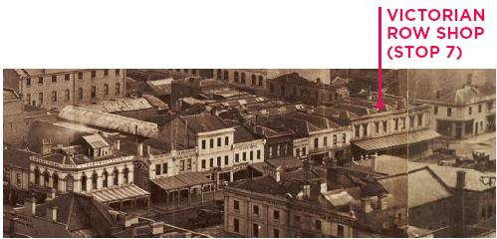
Swanston Street between Bourke and Little Bourke Streets looking north west, from a panorama taken from the spire of Scot’s Church, Collins Street, 1875
(Image credit: Paterson Brothers, photographer, State Library of Victoria)
This excerpt of the Melbourne Metropolitan Board of Works detail plan from 1895 shows some of the surrounding land uses in Victorian times.
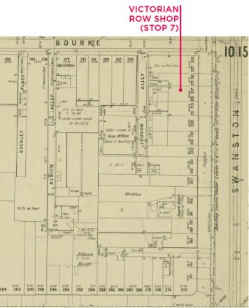
Excerpt of 1895 plan, Little Bourke Street at top, Swanston Street at right, Bourke Street at bottom
(Image credit: Melbourne Metropolitan Board of Works, State Library of Victoria)

Stop 8
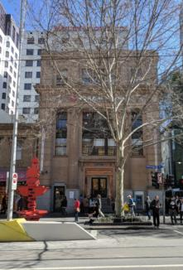
The corner building is the former English, Scottish and Australian Bank, built 1928
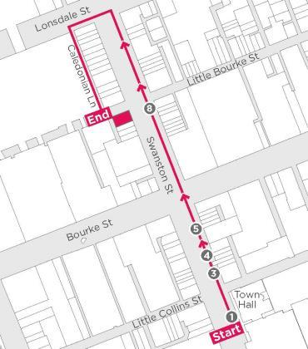

This prominent bank building was designed by architect Henry Ware and constructed in 1928. It features Greek Revival stylistic features such as Ionic pilasters (columns with scroll-like ornament at their top). A number of English, Scottish and Australian Bank branches were built in this style but this is one of the most intact and best examples. The English, Scottish and Australian Bank was founded in the 1850s and had about 570 branches before it became part of the ANZ bank in 1970.
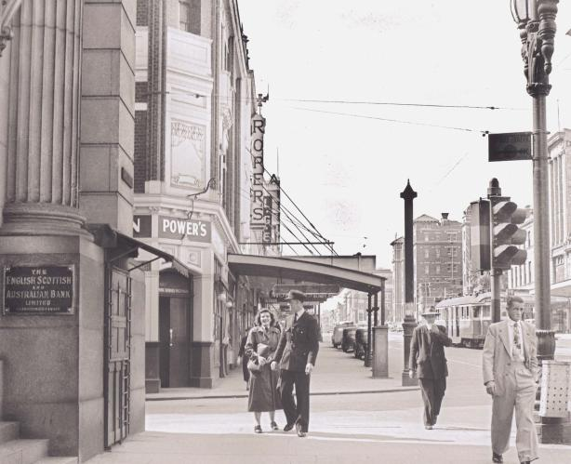
View north along Swanston Street, English, Scottish and Australian Bank on the left, 1952
(Image credit: D Thompson, State Library of Victoria)

Stop 9
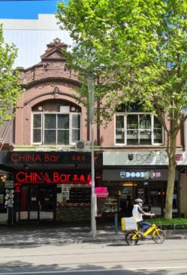
Continue until you are opposite the former Swift and Rothberg showrooms, built 1912
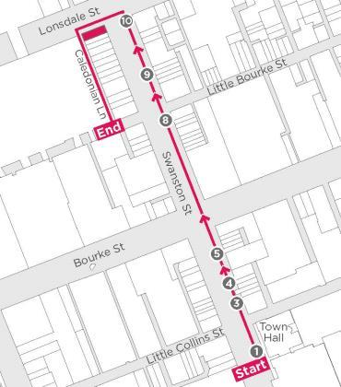

This pair of two storey shops was constructed in 1912 as the Swift and Rothberg show rooms and furniture warehouse. They are notable for their elaborate upper floor with flamboyant parapets with triangular pediments and large arch-headed windows.
The Herald newspaper of 30 May 1912 reported the new show rooms as a “distinct advance in the appearance of the northern section” of Swanston Street. They were built to a design by architect R G Webb and involved placing an upper storey over the existing two shops on the site, which were modernised with a “handsome show window, kauri fittings and metal ceilings” (Herald, 30 May 1912: 3).
The former Swift and Rothberg showrooms are part of a row of Victorian (1840-1900) and Edwardian (1900-1915) era buildings. The changes in the street over time can be seen below.
1950s
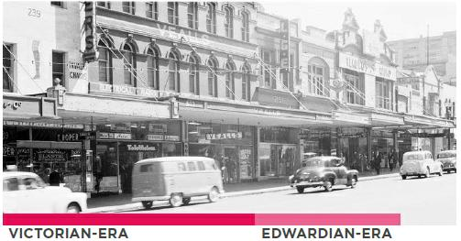
Victorian and Edwardian-era buildings along Swanston Street
(Image credits: top: Mark Strizic, State Library of Victoria, middle: Graeme Butler)

1984
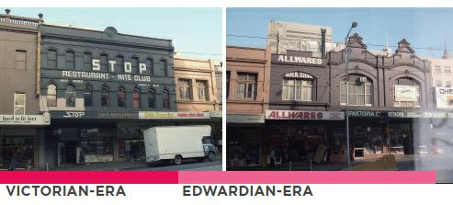
Victorian and Edwardian-era buildings along Swanston Street
(Image credits: top: Mark Strizic, State Library of Victoria, middle: Graeme Butler)

Now
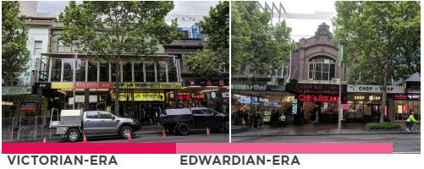
Victorian and Edwardian-era buildings along Swanston Street
(Image credits: top: Mark Strizic, State Library of Victoria, middle: Graeme Butler)

Stop 10
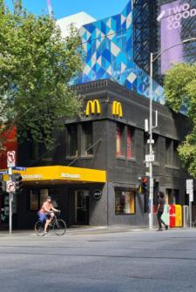
Continue north until you reach Coreglia House at Lonsdale Street, built 1926

This building was designed originally for the Catholic Church as a six storey building. A two storey building was constructed perhaps due to the economic depression of the time. It was known as Coreglia House and incorporated ground floor shops and offices and clubrooms upstairs.
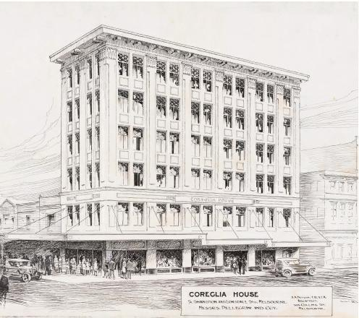
Illustration of Coreglia House from a collection of architectural drawings for the Catholic Church
(Image credit: A Fritsch, undated, State Library of Victoria)
The National Australia Bank occupied this building from 1937 until the 2000s.

1950s
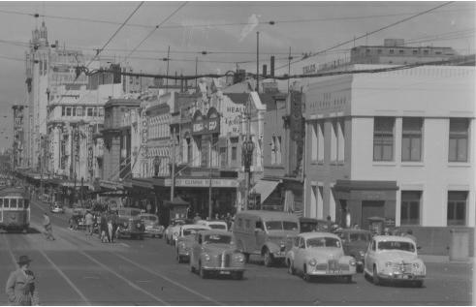
Swanston Street looking south from Lonsdale Street
Image credit: Rose Stereograph Co., State Library of Victoria
1984
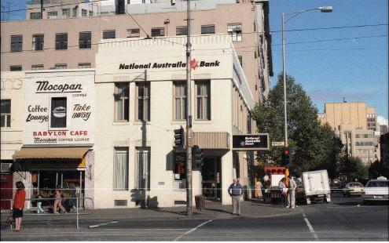
Corner Swanston and Lonsdale streets
Image credits Graeme Butler

Stop 11
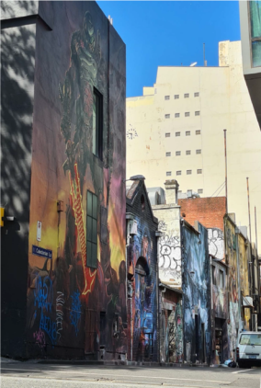
Head west along Lonsdale Street and then down Caledonian Lane
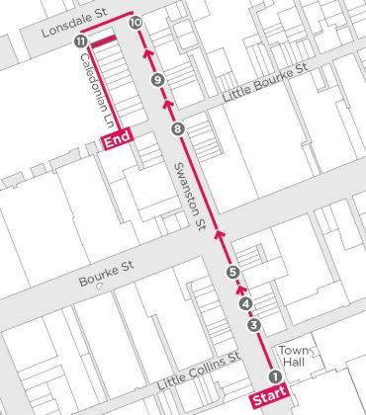
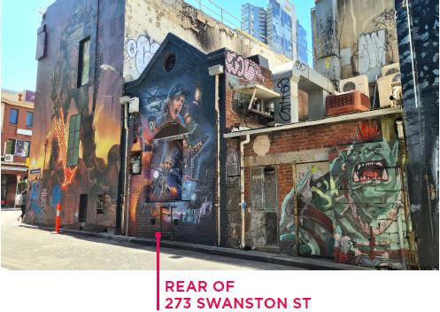
The buildings you walked past on Swanston Street back onto Caledonian Lane. The rear and sides of buildings are often where the oldest fabric can be seen, providing clues to original or early materials and occupants.
The rear of the buildings fronting Swanston Street have two and three storey brick facades with small windows and flat or gabled roofs. The rear of number 273 is notable for its small scale, arched opening, blue stone loading threshold and circular vent to the brick gable. Next door there are remnants of a blue stone wall.
Caledonian Lane is now twice its original width after being widened as part of the Emporium development in 2010-2013. The photos on this page give a glimpse of the character of Caledonian Lane over the years. They show postwar buildings under construction on Little Bourke Street in the 1960s and the St Jerome’s Laneway Festival in 2007.
1960s
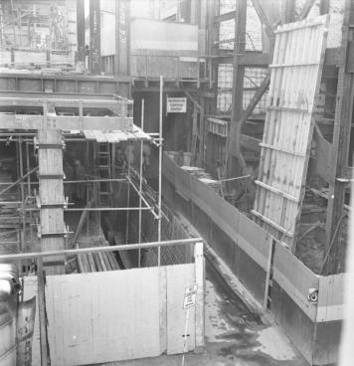
Caledonian Lane looking north from Little Bourke Street
Image credit: City of Melbourne Art and Heritage Collection
2007
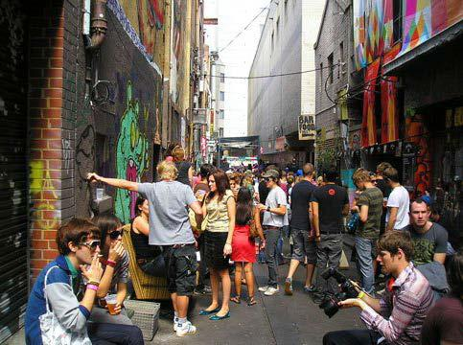
Caledonian Lane looking south (retained heritage buildings on the left of image)
Image credit: Sandra Konrad
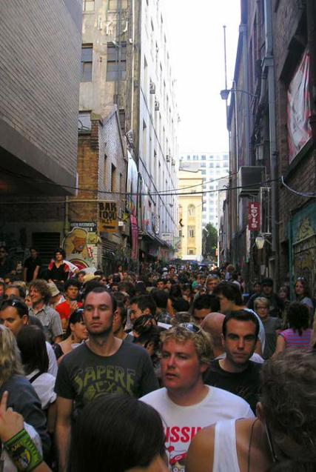
Caledonian Lane looking north
Image credit: Sandra Konrad

We hope you enjoyed the Swanston Stores self-guided walk, which was prepared as part of the Hoddle Grid Heritage Review.
The Hoddle Grid Heritage Review recommends heritage protection for more than 100 new places, some of which you have visited today.
Visit Participate Melbourne1 by 17 December 2020 to find out more and have your say.
For full details of the images and sources used in this walk, visit Participate Melbourne.

https://participate.melbourne.vic.gov.au/AmendmentC387
https://participate.melbourne.vic.gov.au/

