Hoddle Grid Heritage Review
The Changing Skyline Self-Guided Walk
Tour Distance: 2.5km
Tour Time: Approx. 1.5 hours
Acknowledgement of Traditional Custodians
The City of Melbourne respectfully acknowledges the Traditional Custodians of the land, the Bunurong Boon Wurrung and Wurundjeri Woi Wurrung peoples of the Eastern Kulin Nation and pays respect to their Elders past, present and emerging. We are committed to our reconciliation journey, because at its heart, reconciliation is about strengthening relationships between Aboriginal and non-Aboriginal peoples, for the benefit of all Victorians.
Contents
The Review 4
Introduction 5
Terms 6
Start 7
Stop 1 8
Stop 2 10
Stop 3 12
Stop 4 14
Stop 5 16
Stop 6 18
Stop 7 20
Stop 8 22
Stop 9 24
Stop 10 26
Stop 11 28
Stop 12 30
Stop 13 32
Stop 14 34
Stop 15 36
Stop 16 38
Stop 17 40
Stop 18 42
Stop 19 44
Stop 20 46
Stop 21 48
Stop 22 50
Stop 23 52
Stop 24 54
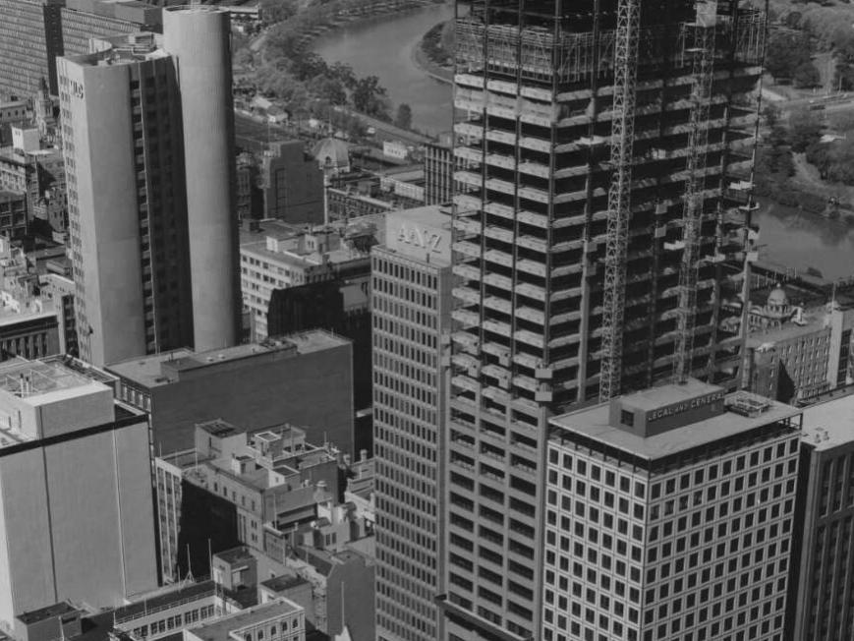
Front cover: View of central Melbourne, corner of Collins and Queen Streets, 1973. Photograph by Wolfgang Sievers
(National Library of Australia PIC WS 4298D LOC PIC Album 1032/105)

The Review
The Hoddle Grid Heritage Review is the most comprehensive review of heritage buildings in the heart of the city since the 1990s. This walking tour takes you to some of the postwar heritage places identified in the Review.
The recommendations in the Review are being implemented through Planning Scheme Amendment C387, which has been prepared by the City of Melbourne.
Find out more and have your say at Participate Melbourne.
Images with the copyright permission of the National Library of Australia.
Images with the copyright permission of the State Library of Victoria.

Introduction
Melbourne was Australia’s fastest growing city in the postwar period, becoming the leading centre of modernist innovation in art, architecture and design exemplified by the postwar buildings featured in this walk.
Most of the historic photos within this walk are the work of German émigré photographer Wolfgang Sievers and are provided with the permission of the National Library of Australia.
Commissioned by architectural firms to capture these buildings at their completion, Sievers’ photos celebrate their purity of design in keeping with his direct experience of European modernism (Ennis, 2011:2). A free online exhibition of these and many more Wolfgang Sievers’ photos of the postwar buildings to be protected under Amendment C387 is available at Participate Melbourne1
The following is a walk you can dive into for a long, immersive tour, or dip in and out of for particular sections, as time allows. We recommend walking on the opposite side of the street to the buildings you wish to see for a more expansive view, and please always cross the street at signalled pedestrian crossing.

Terms
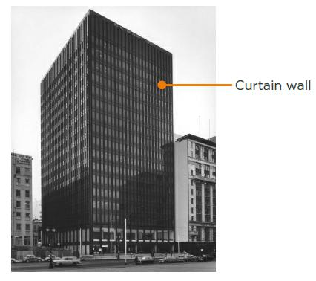
(National Library of Australia PIC WS 3670 BBa LOC PIC Album 1032/181)

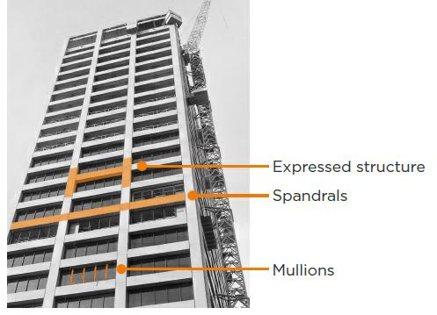
(State Library of Victoria H2009.50/262)

Start
Start at 468-478 Collins Street
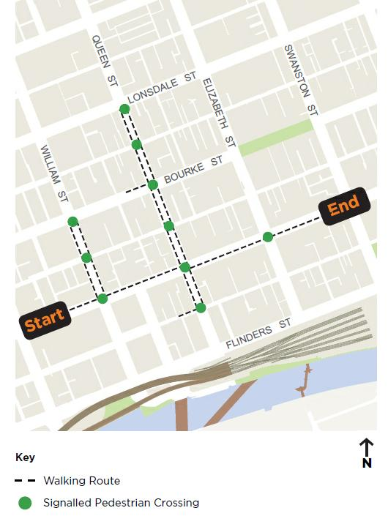

Stop 1

Australia-Netherlands House at 468-478 Collins Street
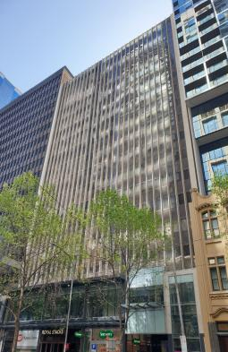
Australia-Netherlands House at 468-478 Collins Street (City of Melbourne)
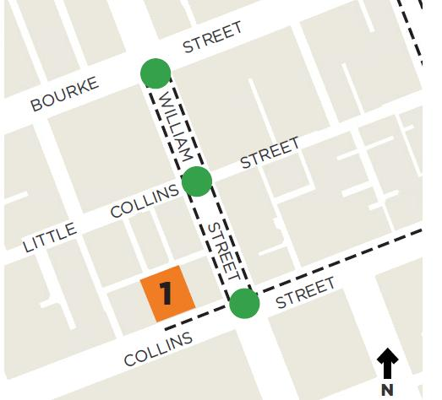
Architect(s): Peddle Thorp & Walker in association
with Meldrum & Partners
Constructed: c1968-1970
Australia-Netherlands House is evidence of the building boom that transformed central Melbourne into a modern high-rise city. The design of such commercial buildings from the late 1950s to the mid-1970s – many of which were architect designed – was driven by commercial demands and the prestige afforded by a dominant city presence.
Constructed as a 17-storey building, Australia-Netherlands House features a glass curtain wall but also incorporates structural components typical of 60s buildings. The façade is a grid composed of distinctive vertical mullions and contrasting horizontal bands of glazing with dark spandrels, incorporating granite and marble cladding with aluminium window frames.
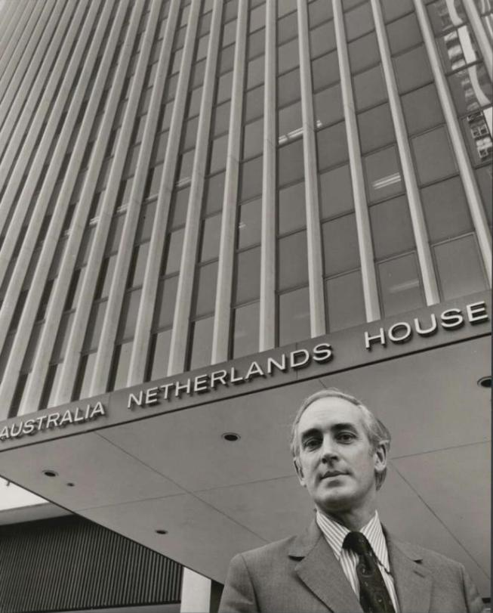
Employee of Richard Ellis, Sallman & Seward in front of Australia Netherlands House, 1973. Photograph by Wolfgang Sievers
(National Library of Australia PIC WS 4281-A LOC PIC Album 1032/131)

Stop 2

Guardian Building at 454-456 Collins Street
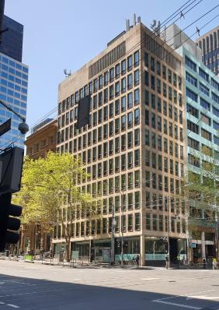
Guardian Building at 454-456 Collins Street (City of Melbourne)
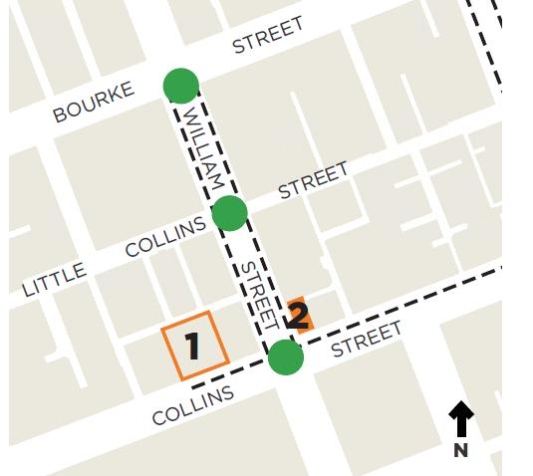
Architect(s): Bates Smart & McCutcheon
Constructed: 1960-1961
The Guardian Building was constructed as a 10-storey building on a prominent corner site. It includes two grid-like curtain walls of regularly spaced rectangular windows set in plain façades, a contrasting upper level of closely spaced mullions, and the use of materials such as stone-faced precast concrete panels. These features demonstrate important aspects of the Post-War Modernist style as it evolved to replace the glazed spandrels of the 1950s with solid external cladding.
The journal, Cross-Section, published an article on the newly completed building in April 1962, providing the opinion that: ‘This is prestige-type architecture, conservative, dignified, sober, and rather stuffy. Handsomely proportioned windows sit in a natural stone façade’.
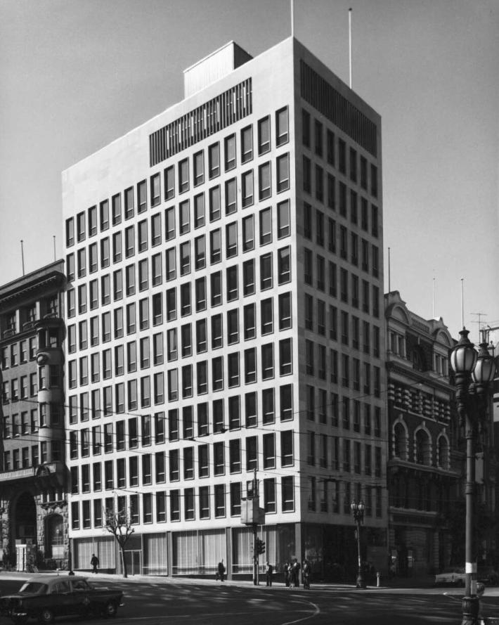
Guardian Assurance Company Building, 1961. Photograph by Wolfgang Sievers
(National Library of Australia PIC WS 3093Ca LOC PIC Album 1032/16)

Stop 3

Dillingham Estates House at 114-128 William Street
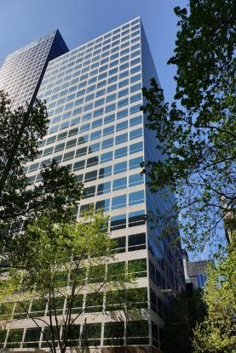
Dillingham Estates House at 114-128 William Street (City of Melbourne)
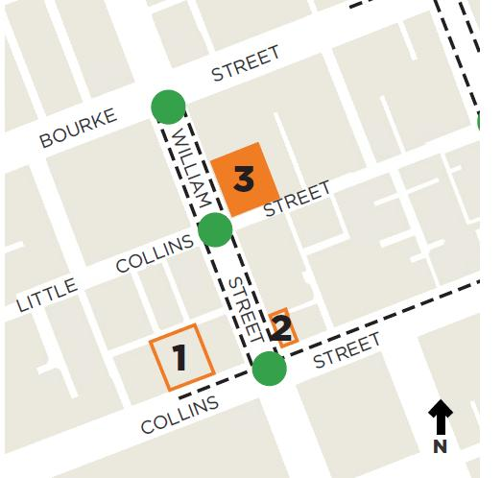
Architect(s): Yuncken Freeman
Constructed: 1975-1976
Dillingham Estates House is associated with the financial investment driven by the mineral and energy boom that fuelled office building in the city. It also demonstrates the reduced importance of British and American capital in favour of large Australian companies, during the 1970s.
The site on which the building was constructed was consolidated to optimise the development yield allowed by plot ratio controls. Creation of ‘superblocks’ such as this one fundamentally altered the subdivision pattern of the CBD in the postwar era (Marsden, 200:60-61).
The building was the work of influential modernist architects Yuncken Freeman, who played a significant role in re-shaping the city from the 1960s and 1970s. Yuncken Freeman had an unequalled national reputation for superb architectural detailing and classically simple forms. Dillingham Estates House presents a clarity of architectural expression with a sophisticated curtain wall featuring windows set in aluminium clad panels on a strict module. The building is technically significant for achieving floor to ceiling glazing and fire separation between floors, as well as a central service core that allowed the cladding to be expressed on all four sides.
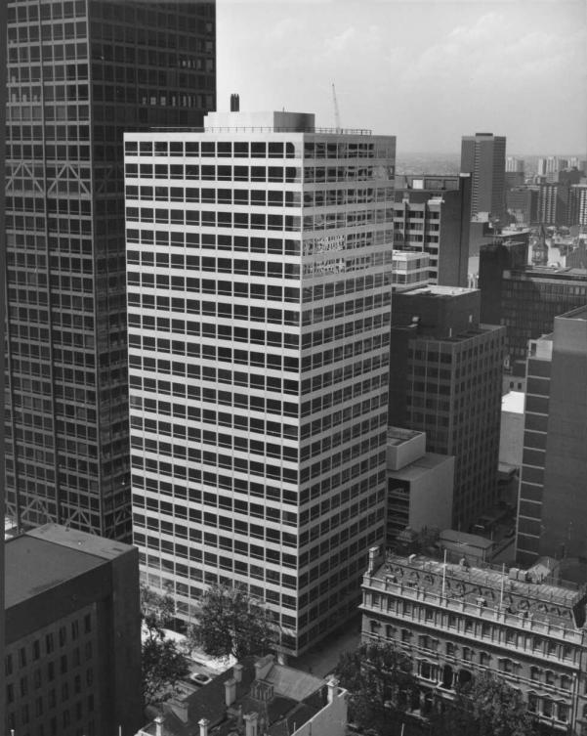
Dillingham Estates House, 1975. Photograph by Wolfgang Sievers
(National Library of Australia PIC WS V4495 VD LOC PIC Album 1032/183)

Stop 4

AMP Tower and St James Building Complex at 527-555 Bourke Street
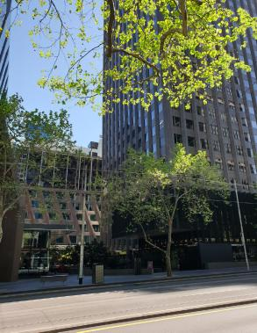
AMP Tower and St James Building Complex at 527-555 Bourke Street (City of Melbourne)
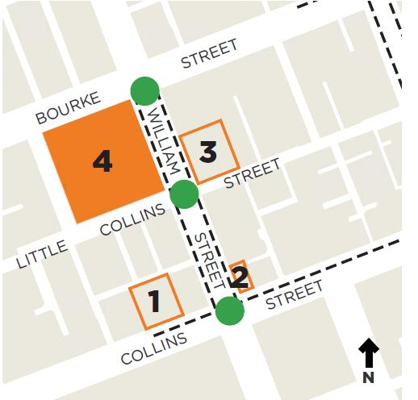
Architect(s): Skidmore Owings & Merrill in association with Bates Smart & McCutcheon
Constructed: 1965-1969
Comprising the 26 storey AMP Tower and six storey St James Building, this complex was the first to enclose space with a mix of building types around a public plaza. It was designed by internationally renowned US architects Skidmore Owings & Merrill in association with prominent Melbourne firm Bates Smart & McCutcheon.
According to the journal Cross-Section: the most outstanding visible feature is the unusual angled façade to the St James building. This is sloped away from the tower block to permit maximum sunlight to the plaza and lower floors. It is also angled 45 degrees towards Bourke and William Streets to provide maximum daylight in offices.
Accommodating shops at the plaza level and offices above, the entire site below ground incorporated a car park and staff amenities, including a 248-seat theatrette, cafeteria, executive dining room, a gymnasium, squash court and games room. Clement Meadmore’s corten steel sculpture ‘Awakening’ specifically commissioned for the plaza was removed in 2010 and is now at TarraWarra Museum of Art in Yarra Glen (twma.com.au).
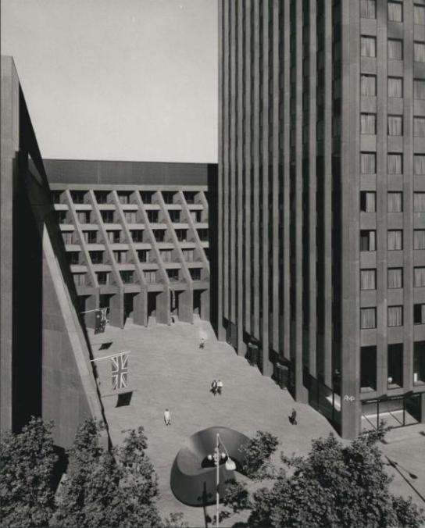
Courtyard of AMP offices, 1970. Photograph by Wolfgang Sievers. Note the sculpture in the foreground by Clement Meadmore (now removed)
(National Library of Australia PIC WS 4146CC LOC PIC Album 1032/16)

Stop 5

The Royal Insurance Group Building at 430-442 Collins Street
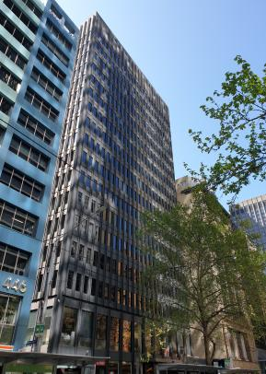
The Royal Insurance Group Building at 430-442 Collins Street (City of Melbourne)
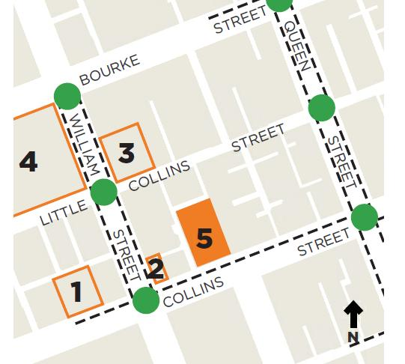
Architect(s): Yuncken Freeman
Constructed: 1966
The Royal Insurance Group building is significant for its association with the rapid growth of high-rise offices in the 1960s-mid 1970s postwar period, and with the expansion of large companies undertaking construction and naming rights of new office buildings as a form of promotion and investment.
Designed by prominent architectural practice of Yuncken Freeman it was awarded the Victorian Architecture Medal in 1967 and is included on the Australian Institute of Architects Twentieth Century Buildings Register. In the 1960s, this Melbourne-based practice was one of the largest architectural firms in Australia, with a reputation for modern, high quality design and meticulous detailing. The firm originated in 1933, at first concentrating on hospital and residential projects, with the commercial and corporate side of the business built by Barry Patten and John Gates when they joined as partners in 1951.
The aesthetic value of the building is in its highly repetitive façade that expresses the construction system, exploiting this through refined detailing of the jointing design, and the black granite pre-glazed concrete panels.
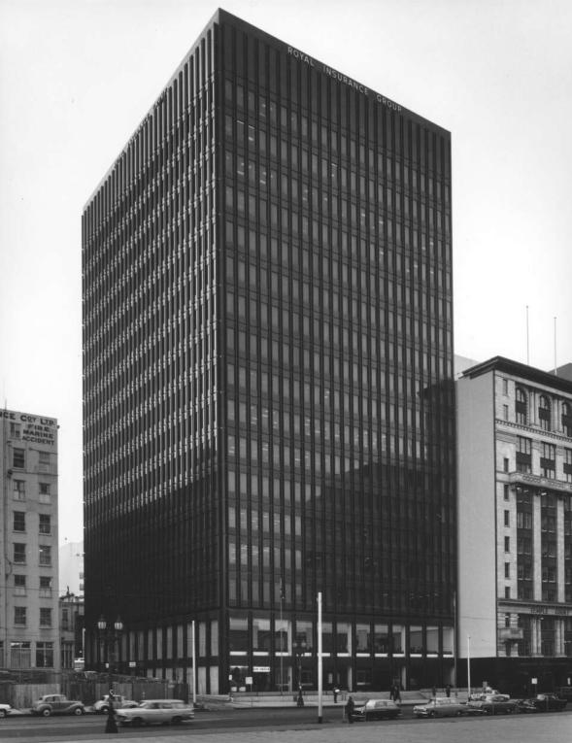
Royal Insurance Group Building, 1965. Photograph by Wolfgang Sievers
(National Library of Australia PIC WS 3670 BBa LOC PIC Album 1032/181)

Stop 6

Atlas Assurance Building at 404-406 Collins Street
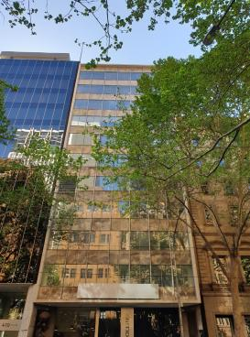
Atlas Assurance Building at 404-406 Collins Street (City of Melbourne)
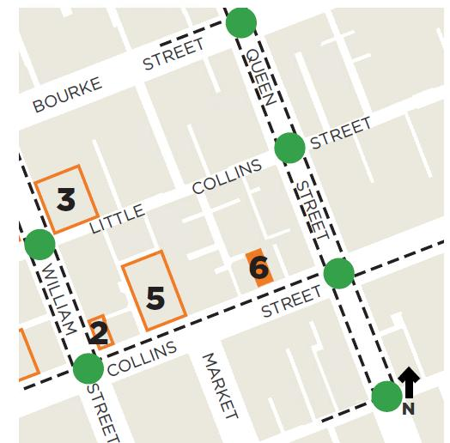
Architect(s): H Garnet Alsop & Partners
Constructed: 1958-1961
The Atlas Assurance Building demonstrates the curtain wall style embraced by architects by the late 1950s. Constructed just a few years after Australia’s first ‘glass box’ (Gilbert Court at 100 Collins Street, 1955) it shows the evolution from all glass façades to combinations of solid spandrels of masonry, coloured glass or enamelled metal sheeting.
The use of marble spandrels on the curtain wall, and granite at the base of the Atlas Assurance Building, emulate in a modern manner the stone clad classical façades favoured previously by financial institutions.
A bronze statue of Atlas is at the front of the building, a remnant of the Mutual Assurance Society of Victoria that once occupied the site.
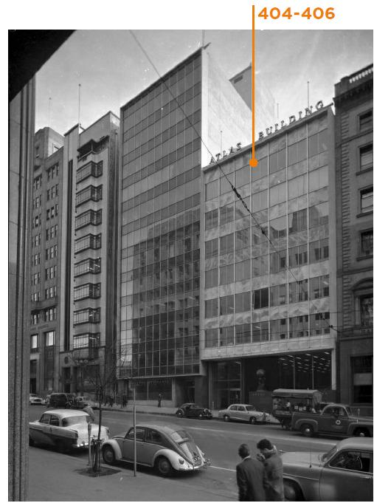
Atlas Building, 1959. Photograph by Wolfgang Sievers
(National Library of Australia PIC WS 2723F LOC Cold store PIC Siev B&WN-F)

Stop 7

National Bank of Australasia Stock Exchange at 85-91 Queen Street
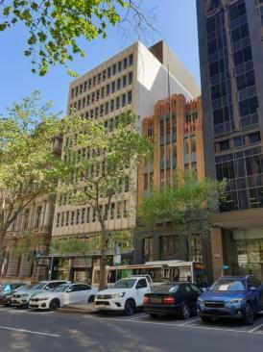
National Bank of Australasia Stock Exchange at 85-91 Queen Street (City of Melbourne)
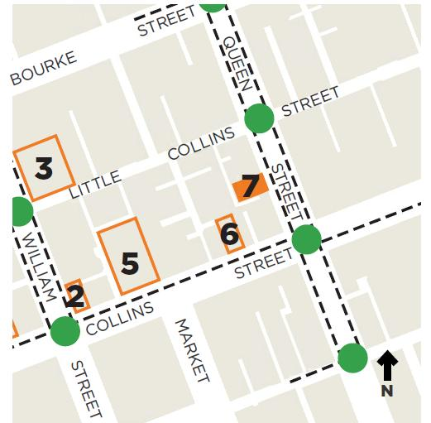
Architect(s): Meldrum & Partners
Constructed: 1973
The National Bank of Australasia Stock Exchange Branch, is evidence of the rapid growth of corporate architecture of the 1950s-1970s. Located in the financial and commercial precinct of Queen Street, the building reflects the growth of banks in Victoria following deregulation of the financial sector from the mid-1960s, cementing Melbourne’s pre-eminent role for financial institutions.
Its design represents a new modernism through a modular, industrial, Bauhaus inspired aesthetic incorporating features such as consistent access to daylight and open floor plans to meet new standards for office accommodation. The building is an example of the later development in curtain wall design using precast concrete to create moulded and curved façade modules incorporating window openings while maintaining the rigid modular Bauhaus inspired appearance.
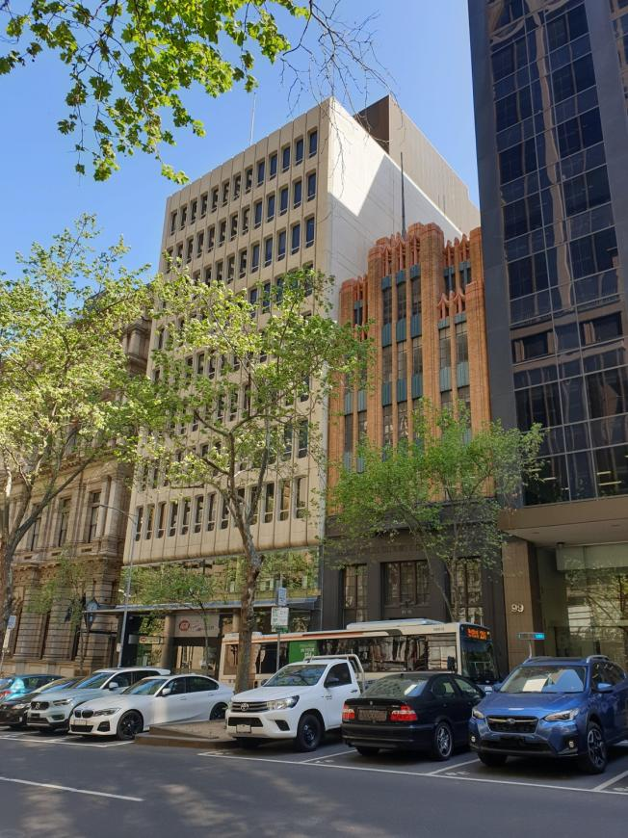
National Bank of Australasia Stock Exchange Branch (City of Melbourne)

Stop 8

Ajax House at 103-105 Queen Street
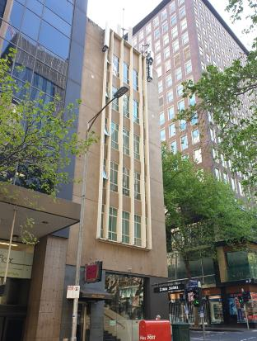
Ajax House at 103-105 Queen Street (City of Melbourne)
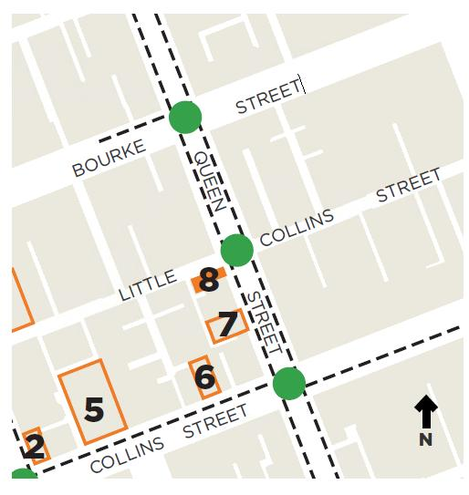
Architect(s): H D Berry
Constructed: 1956
Ajax House was purpose-built in 1956 for Australian company Ajax Insurance Company Limited to house the company’s head office and Victorian Branch.
The building was constructed on a site formerly occupied by the Temple Court Hotel, which had been at 103-105 Queen Street 118 years. The site was auctioned in 1953, with its location described as ‘a magnificent corner site in the hub of the insurance, commercial and financial world, suitable for immediate development’ (Age 11 November 1953:6; Argus 22 January 1954:7).
Ajax House retains its original form, scale and stylistic details including the heavily articulated fenestration with projecting frames around and separating the panels of window openings.
Ajax House is an example of a building constructed to comply with the 40 metre (132 foot) height limit enforced in Melbourne between 1916 and 1956. The first city building to exceed this height limit was the 20 storey ICI House at 1 Nicholson Street, East Melbourne.
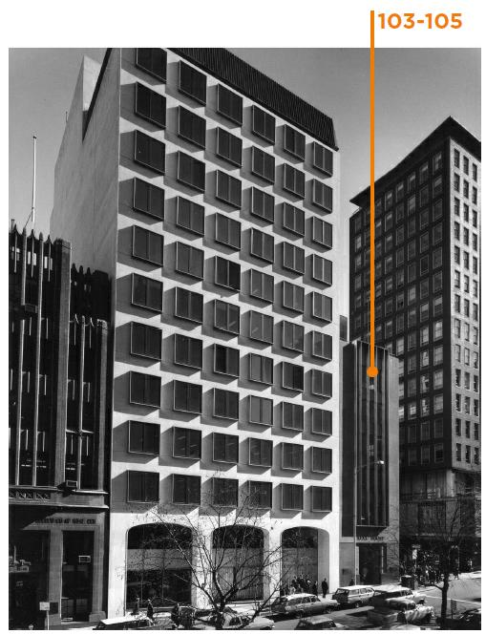
Ajax House, 1967. Photograph by Wolfgang Sievers
(State Library of Victoria H99.50/318)

Stop 9

RACV Club at 111-129 Queen Street
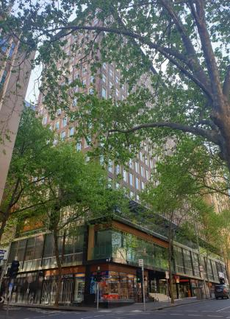
RACV Club at 111-129 Queen Street (City of Melbourne)
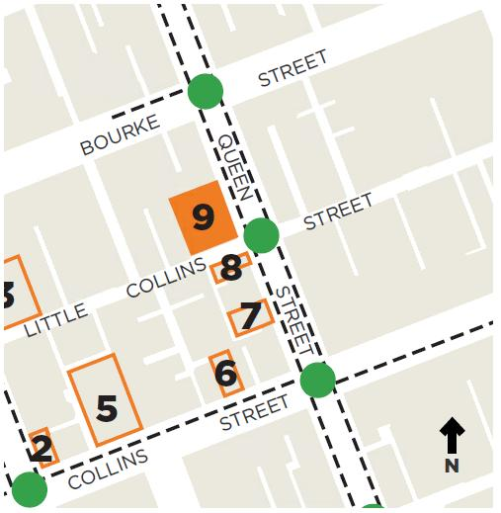
Architect(s): Bates Smart McCutcheon
Constructed: 1959-1961
This building was constructed as the headquarters of the Royal Automobile Club of Victoria (RACV). Formed in 1903, RACV was intended as a social club for car and motorcycle owners to enjoy motor sports and touring (RACV 2018). Its first car rally was held at Aspendale Park Racecourse in 1904.
RACV created opportunities for its members to engage with ‘motoring’ as a leisure activity, and advocated for the rights of motorists, including the spending of significant public money on infrastructure for motorised transport. In the 1950s and 60s, RACV was highly influential in the promotion of tourism in Victoria.
111-129 Queen Street is significant for its strong and long-standing association with the RACV Club members, staff and board. Designed as a central city meeting place for members, the club facilities served as a place of social congregation for members for more than 45 years.
The building is a fine example of a recreational club that expresses its function through the glazed lower floors for public use and the masonry-clad residential tower above. In design it is a relatively early example of a modern tower departing from the curtain wall of the 1950s.
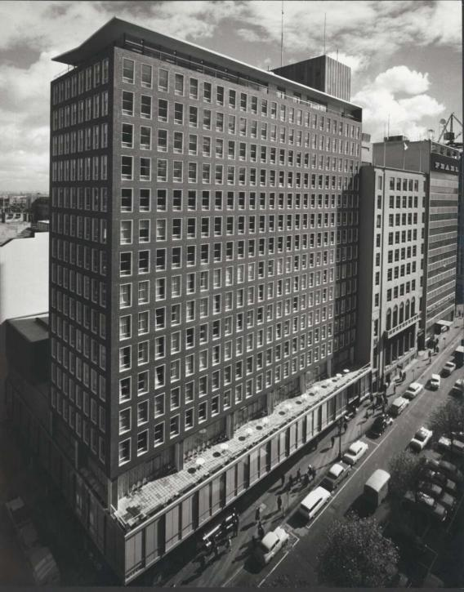
Royal Automobile Club of Victoria, 1961. Photograph by Wolfgang Sievers
(National Library of Australia PIC WS 3000 BW LOC PIC Album 1032/16)

Stop 10

South British Insurance Company Ltd Building at 155-161 Queen Street
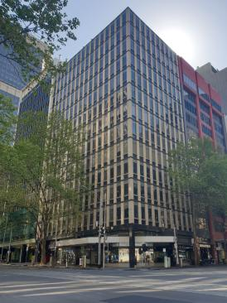
South British Insurance Company Ltd Building at 155-161 Queen Street (City of Melbourne)
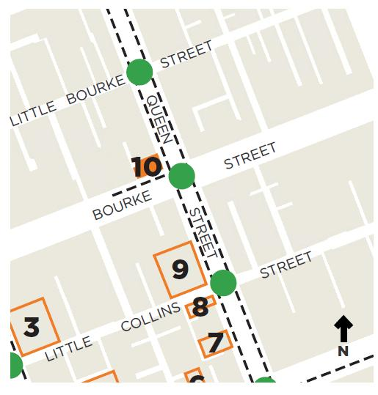
Architect(s): Bates Smart & McCutcheon
Constructed: 1961-1962
Located in the financial and commercial precinct of Queen Street, the South British Insurance Company Building is evidence of the growth of insurance and assurance companies during 1950s-1960s Melbourne.
The building exhibits the key characteristics of the Post-War Modernist style, including non-loadbearing precast concrete curtain wall cladding, recessed window openings and transom panels set between concrete ‘pilasters’. It demonstrates the later development in curtain wall design constructed during the 1960s, when a mix of materials was utilised to create a greater modularity and three-dimensional quality to the façades.
The South British Insurance Company Building along with several of the buildings featured in this walk was designed by Bates Smart McCutcheon. Still operating today as Bates Smart its history can be traced back to Reed and Barnes (Goad 2012:72), who designed the Royal Exhibition Building and Scots Church. By the 1950s Bates, Smart & McCutcheon had become Australia’s expert in glass curtain wall high rise office building design (Goad, 2012:73). In the 1960s and 1970s the firm’s design approach shifted to façades of artificial stone or prefabricated concrete panels such as this building.
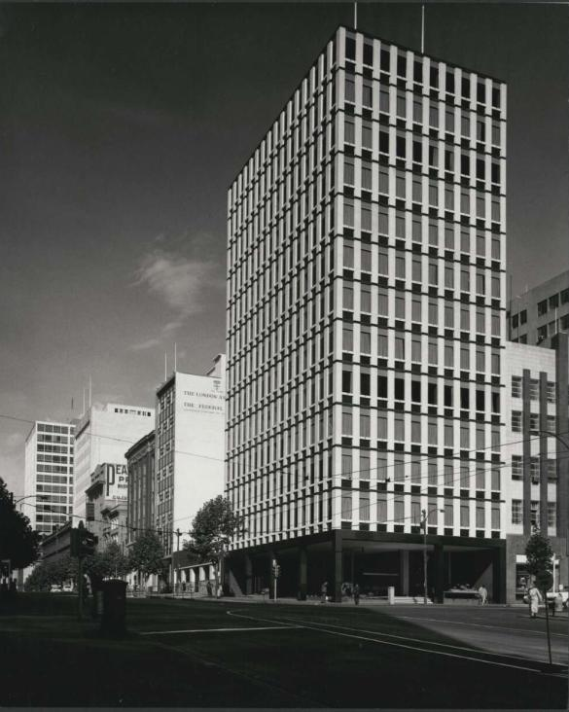
South British Insurance Building, 1961. Photograph by Wolfgang Sievers
(National Library of Australia PIC WS 3116AKa LOC PIC Album 1032/16)

Stop 11

London Assurance House at 468-470 Bourke Street
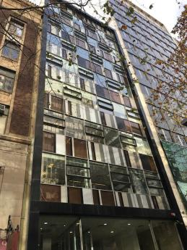
London Assurance House at 468-470 Bourke Street (Context)
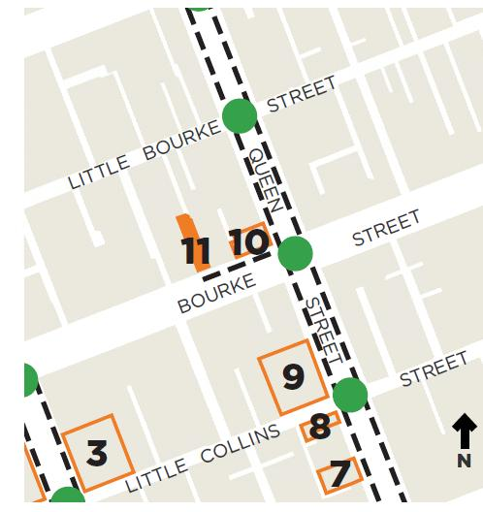
Architect(s): Bernard Evans
Constructed: 1960
The former London Assurance House was designed by Bernard Evans who was also a Melbourne City Councillor (1949-1973) and former Lord Mayor (1959-1960). It is one of many city buildings designed by Evans in his long career as a city developer, architect and principal of the architectural practice Bernard Evans, Murphy, Berg & Hocking.
It was constructed on the site of St Patrick’s Hall where the first Victorian parliament met in 1851 and now houses the Victorian Law Institute.
The building is a curtain-walled office building demonstrating the style embraced by architects by the late 1950s. It employs a glass curtain-wall set back within the building’s façade to create a picture frame effect, boarded by stone facing to the perimeter frame. The building’s lightness of structure, elegant transparency and curtain wall glazing of unusual pattern makes it distinctive. The building has been identified by at least two key architectural publications including Architecture and Arts and in Melbourne’s best architecture guide of 1965.
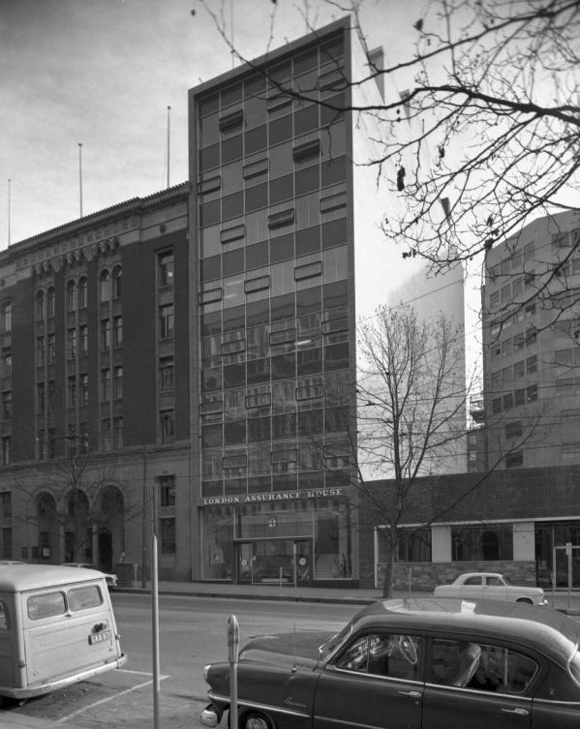
London Assurance House, Melbourne, June 1959. Photograph by Wolfgang Sievers
(National Library of Australia PIC WS 2723E LOC Cold store PIC Siev B&WN-F)

Stop 12

Law Department’s Building at 221-231 Queen Street
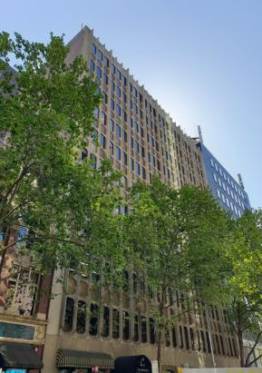
Law Department’s Building at 221-231 Queen Street (City of Melbourne)
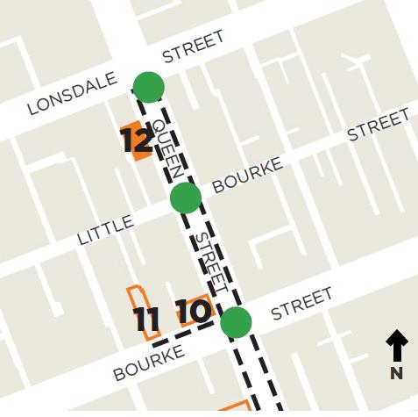
Architect(s): Fischer Group Architects
Constructed: 1972
The Law Department’s Building is evidence of the broadening of state government powers after World War Two, which led to increased occupation of buildings by public offices in Central Melbourne. The state government’s law offices were housed in the subject building from 1972 until c1987.
The building exhibits key characteristics of later examples of the Post-War Modernist style, with a precast concrete curtain wall used to achieve variety of expression and flexibility of form. The building features unusual detailing in the form of curved windows and elaborate brass spandrel panels (designed by architects A V Pupedis & Associates) to achieve a more organic aesthetic. It is also notable for its unusual and highly intact street level colonnade, with corbelling and curved corners, and set back shopfronts and entry lobby.
The building’s precast concrete façade was made using moulds from an earlier building at 95-99 York Street, Sydney, a highly unusual practice in the postwar era.
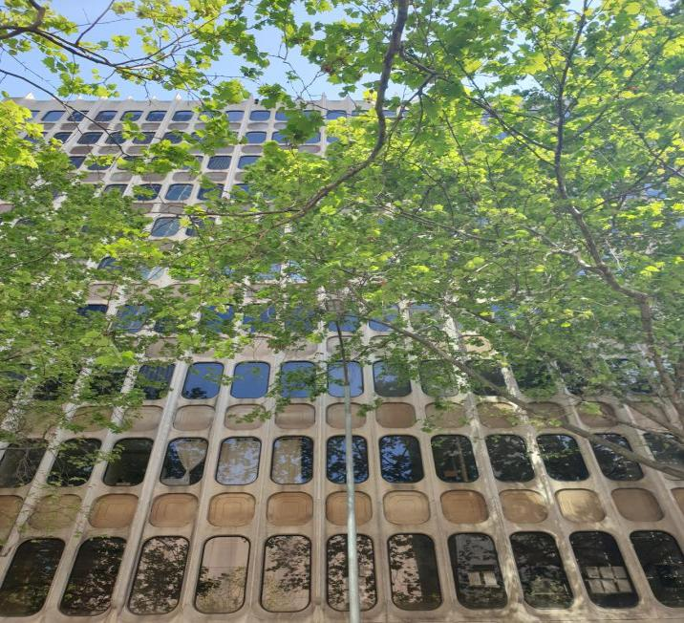
Façade detail of the Law Department’s Building (City of Melbourne)

Stop 13

State Savings Bank of Victoria at 233-243 Queen Street
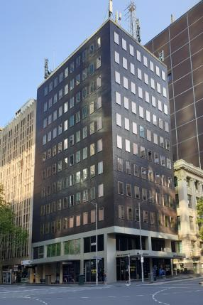
State Savings Bank of Victoria at 233-243 Queen Street (City of Melbourne)
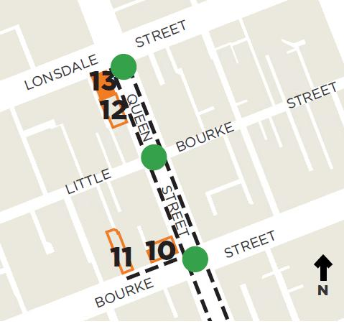
Architect(s): Godfrey & Spowers Hughes, Mewton and Lobb
Constructed: 1967-1968
This building was constructed for the State Savings Bank of Victoria to house the bank’s titles office branch. The Bank was founded in 1842 in Melbourne as the Port Phillip Savings Bank and merged within the Commonwealth Bank in 1991.
Constructed as a 10-storey building, it incorporates typical characteristics of a 1960s to mid-1970s structure, including solid grid-like curtain wall façades of regularly spaced, frameless glazed openings set in dark brick façades and a highly prominent, contrasting podium base. It is also evidence of the return of face brickwork as a cladding material during the 1960s and 1970s.
Architects Godfrey & Spowers Hughes, Mewton and Lobb designed other notable buildings within this walk including the AMP Building (Stop 19), the Allans Building (Stop 22) and the Bank of Adelaide Building (Stop 23).
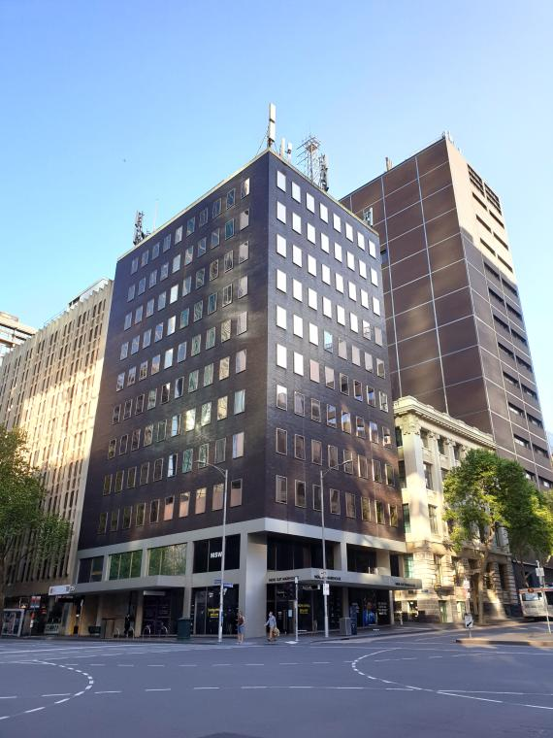
State Savings Bank of Victoria (City of Melbourne)

Stop 14

Sleigh Buildings at 158-172 Queen Street
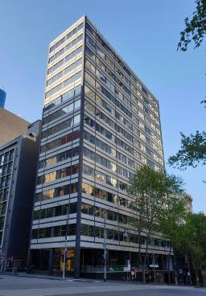
Sleigh Buildings at 158-172 Queen Street (City of Melbourne)
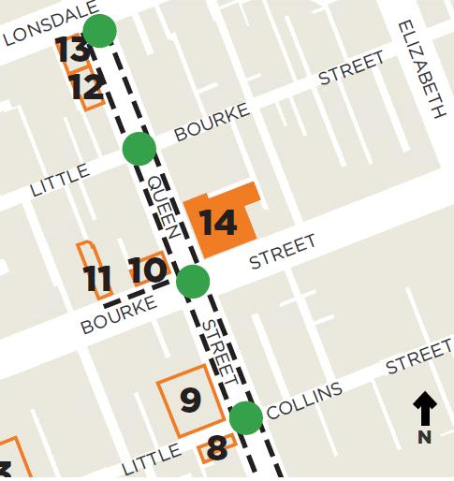
Architect(s): Bates Smart & McCutcheon
Constructed:
1953-1955 (166-172 Queen Street)
1964 (158-164 Queen Street)
The Sleigh Buildings comprise the H C Sleigh Building at 166-172 Queen Street, and the former Sleigh Corner at 158-164 Queen Street, both designed by notable architectural firm Bates, Smart & McCutcheon. These buildings were constructed for Australian company H C Sleigh Ltd (established 1895), founder of Golden Fleece petrol and service stations. Sleigh owned and occupied the building at 166-172 Queen Street from 1955 to 1964, before moving to their new, purpose-built premises next door at 158-164.
The building at 166-172 Queen Street is notable as the first postwar city office block to be constructed in Melbourne for a private company. It is a very early example of a curtain-walled office building, which predates the earliest fully glazed example (Gilbert House, constructed in 1955).
Viewed together, the Sleigh Buildings highlight the shift away from the earlier use of uniform glass curtain wall systems in the 1950s to a greater three dimensional quality in the 1960s, achieved through the use of assertive textures and precast concrete cladding panels. The two buildings illustrate the rapid development of the Post-War Modernist style over a decade.
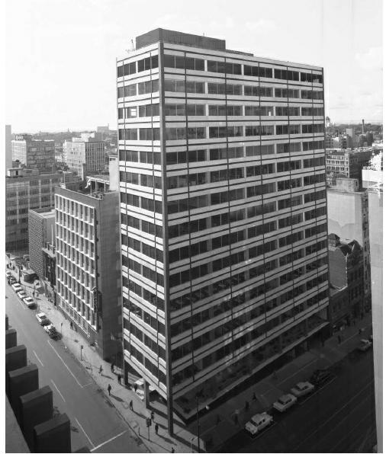
View of the H C Sleigh Building, 1964. Photograph by Wolfgang Sievers
(National Library of Australia PIC WS 3550CG LOC Cold store PIC Siev B&WN-F)

Stop 15

Union House at 43-51 Queen Street
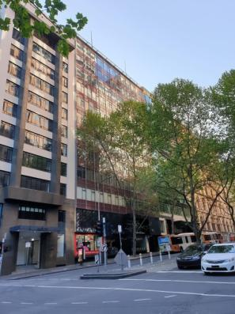
Union House at 43-51 Queen Street (City of Melbourne)
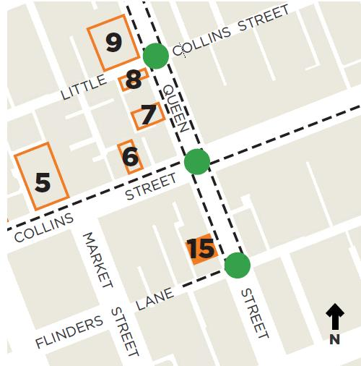
Architect(s): Bates Smart & McCutcheon
Constructed: 1957
Union House was constructed for the international company Union Insurance Society of Canton, who owned and occupied the building from 1958 to 1970.
Prior to construction of Union House, 43-51 Queen Street was occupied by a four-storey building named the York Chambers. This was auctioned in February 1952, an advertisement describing the site’s ‘valuable position on the west side of Queen Street, south of Collins Street. Situated as it is in the heart of the financial centre of Melbourne, should be of special interest to insurance companies’ (Age 20 February 1952:10).
Union House was designed by Bates Smart & McCutcheon, the architectural practice responsible for the design of many notable buildings in Melbourne. This building demonstrates the firm’s glass curtain wall work in the 1950s, also exemplified in East Melbourne by ICI House (1958).
Union House retains defining characteristics of the Post-War Modernist style, including the lightweight aluminium framed, fine-graded modular curtain wall façade.
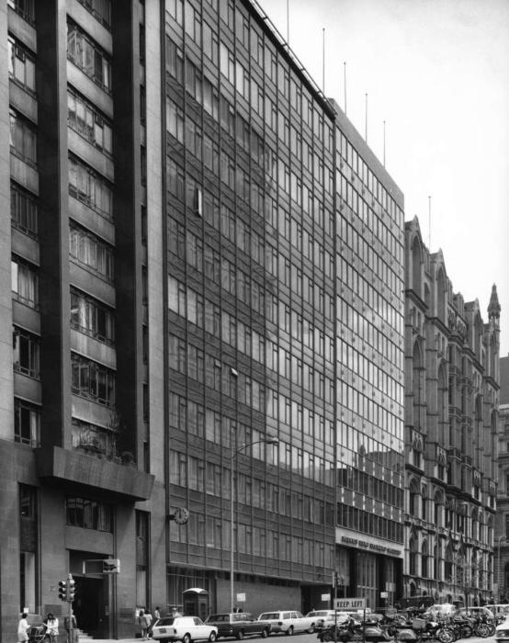
Union House and Norwich Union (Yuncken Freeman Architects), 1970. Photograph by Wolfgang Sievers
(National Library of Australia PIC WS 4172C LOC PIC Album 1032/181)

Stop 16

Batman Automatic Telephone Exchange at 376-382 Flinders Lane
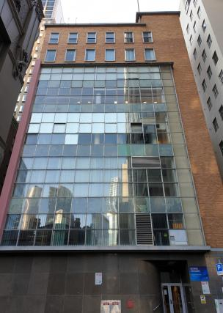
Batman Automatic Telephone Exchange at 376-382 Flinders Lane (City of Melbourne)
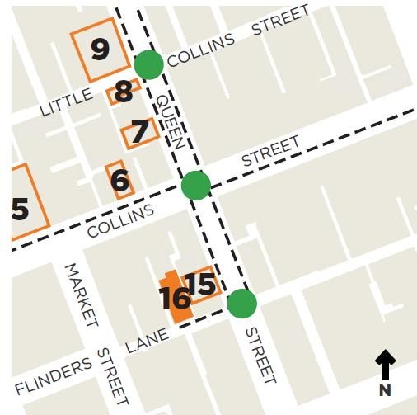

Architect(s): Commonwealth Department of Works
Constructed: 1957
The former Batman Automatic Telephone Exchange is a Post-War Modernist building that also features characteristics of the earlier Inter-War Functionalist style. This demonstrates the building’s lengthy planning and design phase typical of construction soon after World War Two, which was protracted by the inflated costs of building materials and labour.
The building is representative of the modern purpose-built telephone exchange buildings, designed by the Commonwealth Department of Works in the early postwar period to accommodate growth in telecommunications and an expanding workforce. The internal technical requirements of telephone exchange buildings are evident in the variations between floor to ceiling heights across levels.
The Batman Telephone Exchange was built to accommodate administrative staff of the Postal Department and to replace the City West automatic exchange on Little Bourke Street which, built in 1937, had reached its capacity for line allocations (Age 12 April 1946:8). It is comparable to the Russell Street Automatic Telephone Exchange and Postal Building on the corner of Russell Street and Little Collins Street (Now the Hero Apartments), which is also identified for protection within the Review.
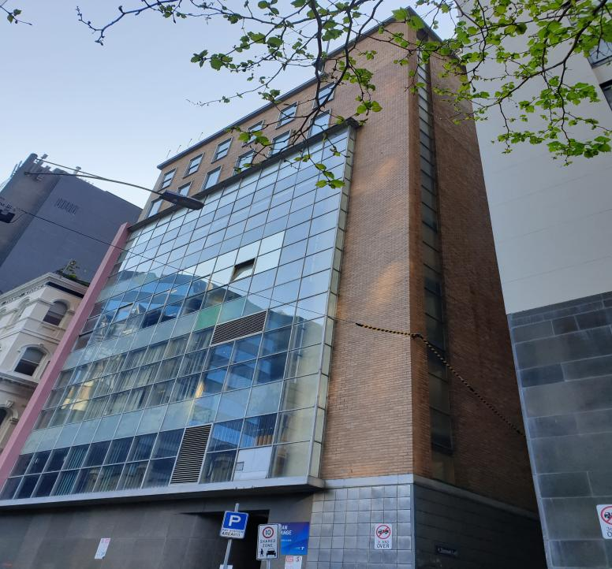
Batman Automatic Telephone Exchange (City of Melbourne)

Stop 17

Legal & General House at 375-383 Collins Street
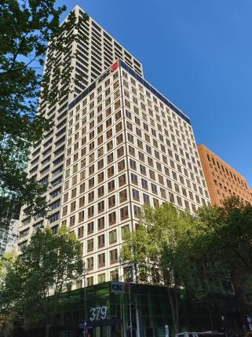
Legal & General House at 375-383 Collins Street (City of Melbourne)
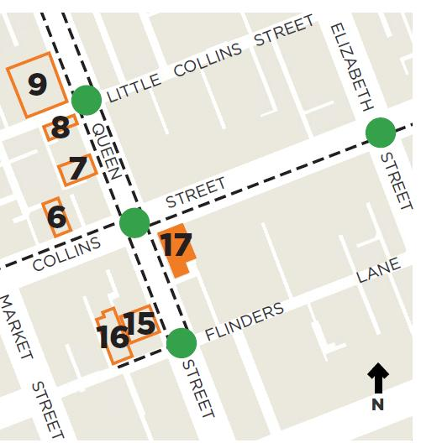
Architect(s): Bernard Evans, Murphy, Berg & Hocking
Constructed: 1967
Legal & General House provides evidence of the increased economic activity that facilitated the construction of new bank buildings and headquarters of national and international companies and corporations in Melbourne.
In Melbourne this activity was concentrated west of Elizabeth Street in Queen and Collins streets from the late 19th century.
Legal and General House features concrete post and slab construction, a non-loadbearing precast concrete panel façade with a repetitive modular geometry, and a double height street level undercroft and colonnade (since altered).
Original detailing includes the mosaic-tiled wall surfaces and copper tinted glazing. The glazing was noted at the time as innovative because it was designed for sun and glare protection. The building’s height and the aesthetic effect of the glazing were key factors contributing to the building’s distinctive aesthetic prominence in Melbourne’s changing skyline.
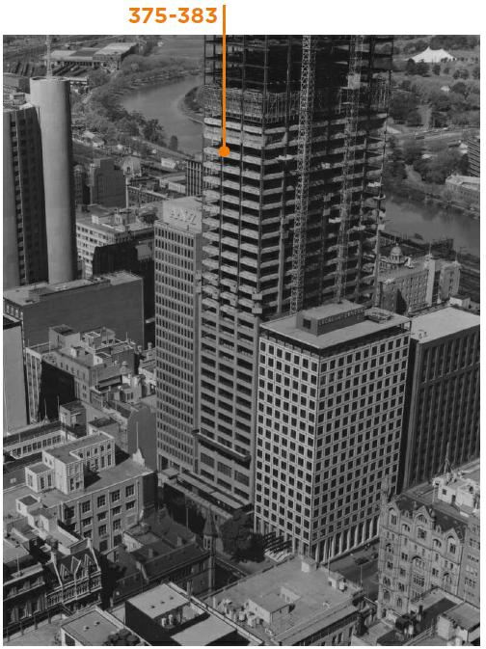
View of corner of Collins and Queen Streets, 1973. Photograph by Wolfgang Sievers
(National Library of Australia PIC WS 4298D LOC PIC Album 1032/105)

Stop 18

Commonwealth Banking Corporation Building at 359-373 Collins Street
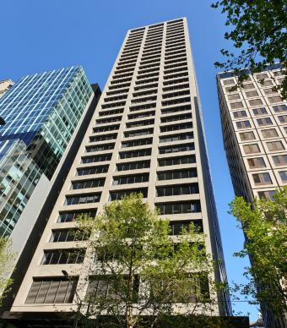
Commonwealth Banking Corporation Building at 359-373 Collins Street (City of Melbourne)
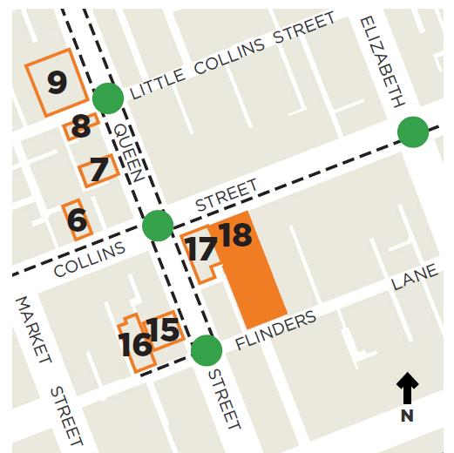
Architect(s): Bates Smart & McCutcheon
Constructed: c1972-1975
At 33 storeys this is the tallest building featured in this walk. The Commonwealth Banking Corporation Building demonstrates typical characteristics of a later postwar building, including three grid-like walls of clearly expressed structural elements, and the use of granite-faced precast concrete panel cladding.
At ground level, the tower broke the line of the ‘street wall’ in favour of the Melbourne City Council’s building regulations for the provision of mini-plazas. The multi-level banking chamber ‘took advantage of pedestrian movement between Flinders Lane and Collins Street’, essentially continuing Melbourne’s network of lanes and arcades within the building itself (Goad 2004:205).
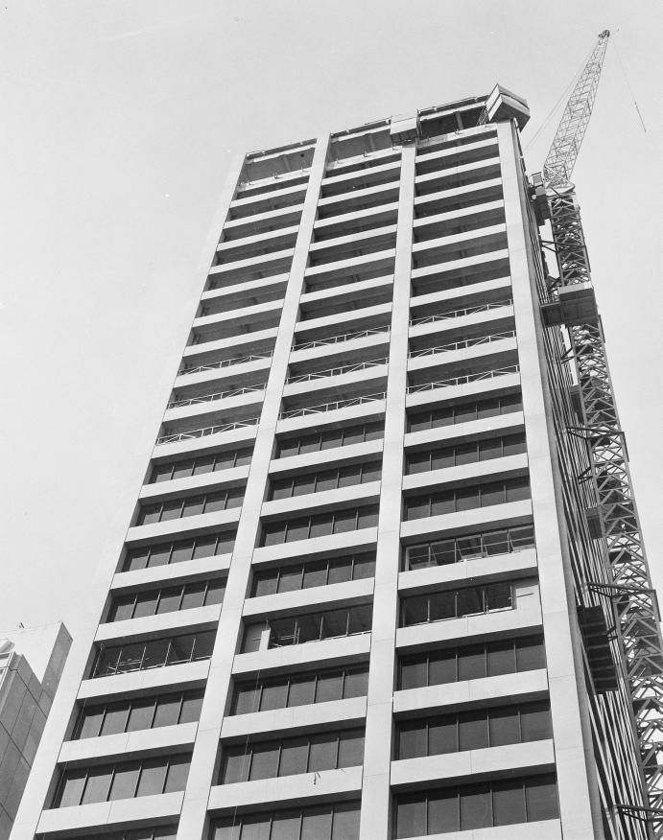
Commonwealth Bank Corporation Building. Photograph by Hans Bonney
(State Library of Victoria H2009.50/262)

Stop 19

AMP Building at 344-350 Collins Street
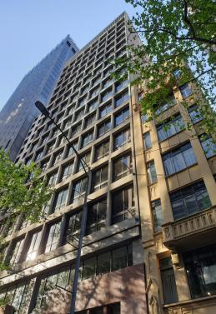
AMP Building at 344-350 Collins Street (City of Melbourne)
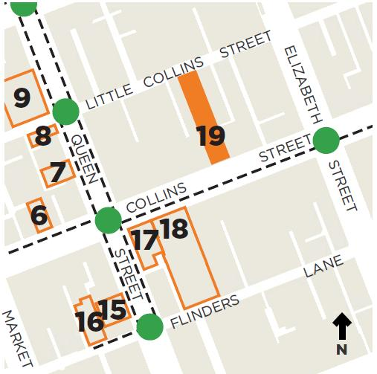
Architect(s): Godfrey & Spowers, Hughes, Mewton and Lobb
Constructed: 1966-1968
Constructed as a 16-storey building, the AMP Building presents two contrasting curtain walls to its two street frontages.
The front façade to Collins Street is a grid like curtain wall formed by generously spaced, slim precast concrete spandrels and mullions. To Little Collins Street, the rear north facing façade incorporates rows of projecting precast concrete balconies, which provide shade to the glazed curtain wall and creates a dominant horizontal emphasis.
The dominant glass box design of the late 1950s was challenged in the 1960s as the poor thermal performance of the fully glazed curtain wall became apparent. Sun screening such as that employed on the northern elevation of the AMP Building provided additional patterning to modernist façades, in this case in the form of balconies.
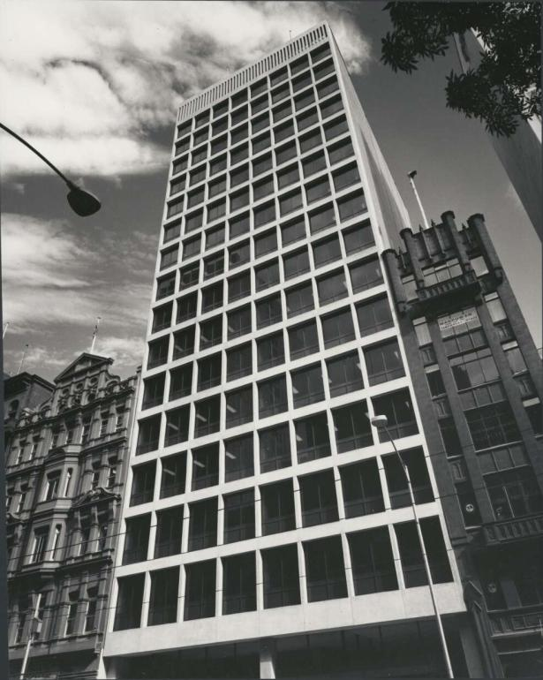
AMP Building, 1968. Photograph by Wolfgang Sievers
(National Library of Australia PIC WS 4033D LOC PIC Album 1032/106)

Stop 20

Colonial Mutual Life Assurance Building at 308-336 Collins Street
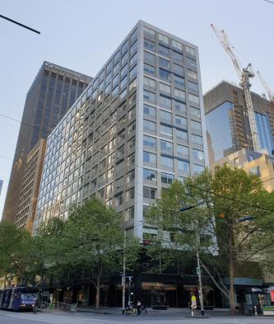
Colonial Mutual Life Assurance Building at 308-336 Collins Street (City of Melbourne)
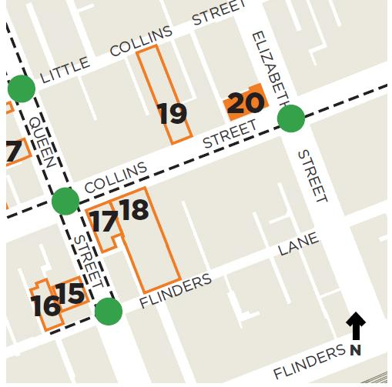
Architect(s): Stephenson & Turner (building)
Artist: Tom Bass (sculpture)
Constructed: 1963
The property at 308-336 Collins Street was purchased by Colonial Mutual Life Assurance in 1923 and demolished 1963 to construct the company’s new offices.
The Colonial Mutual Life Assurance Society Building features a regular grid pattern of windows above ground level and a double height building base clad in granite. It demonstrates one of the key aspects of postwar corporate buildings by retaining its original plaza to Elizabeth Street with bronze sculpture ‘Children’s Tree’ created in 1963 by Tom Bass specifically for this space.
Plot ratio bonuses allowing additional building height provided a regulatory driver for the provision of public plazas, which created a specific urban form in the central city. Many postwar office towers such as the Colonial Mutual Life Assurance Building played a gallery role through the installation of sculpture, paintings and tapestries in their foyers, meeting rooms and forecourts. When Tom Bass was commissioned to provide a children’s sculpture for this plaza he initially thought it to be an inappropriate location, realising later it was important to have something that would remind people of their childhood in the bustling heart of the city.
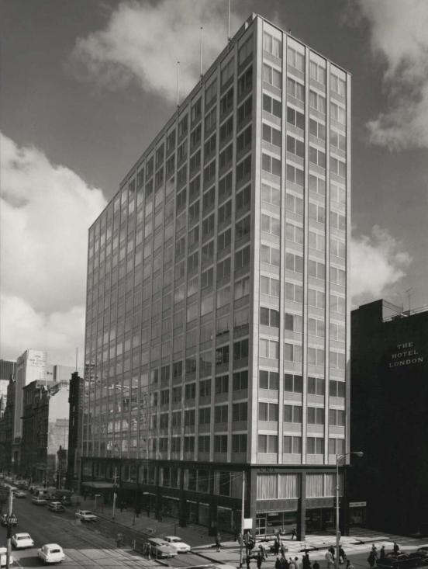
The Colonial Mutual Life Building, 1965. Photograph by Wolfgang Sievers
(National Library of Australia PIC WS 3669 Ha LOC PIC Album 1032/36)

Stop 21

MLC Building (IOOF) at 303-317 Collins Street
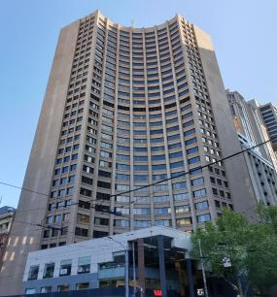
MLC Building (IOOF) at 303-317 Collins Street (City of Melbourne)
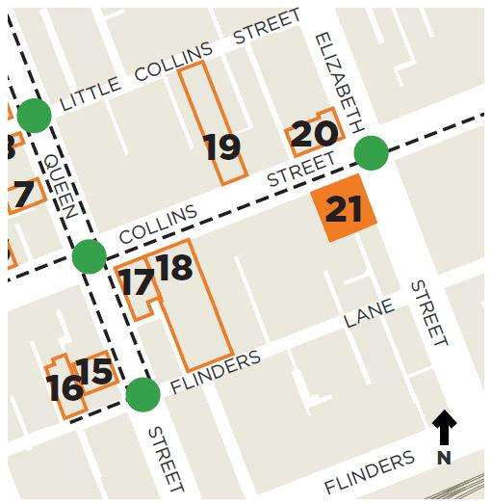

Architect(s): Civil and Civic Pty Ltd in association with Demaine, Russell, Trundle, Armstrong & Orton
Constructed: c1970-1973
Constructed as a 30-storey structure, the MLC Building demonstrates typical characteristics of a later postwar commercial building including grid-like walls of clearly expressed structure, and the use of materials such as granite-faced precast concrete panel cladding. The adoption of a curved form to clearly display the trabeated system of construction is unusual and distinctive.
The insurance company MLC was established in Victoria in 1888 as The Citizens’ Life Assurance Company, providing life assurance with low premiums to the ‘working man’. Previously, life assurance benefits were restricted to the wealthy in Victoria.
MLC acquired the corner property in 1936, occupying an earlier building on the site from 1938.
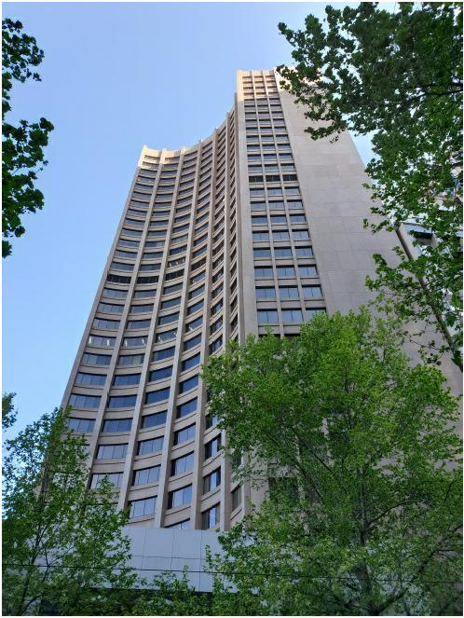
MLC Building (City of Melbourne)

Stop 22

Allans Building at 276-278 Collins Street
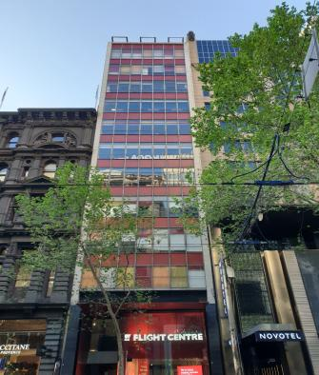
Allans Building at 276-278 Collins Street (City of Melbourne)
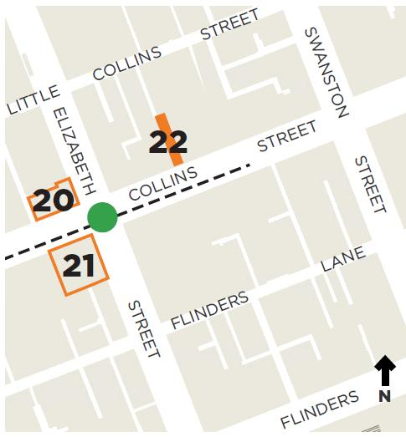
Architect(s): Godfrey & Spowers, Hughes, Mewton and Lobb with Charles N Hollinshed
Constructed: 1956-1957
The Allans Building was constructed to the height limit of 40 metres (132 feet) enforced between 1916 and 1956. It demonstrates typical characteristics of a 1950s Post-War Modernist structure with a curtain wall façade featuring alternating rows of glazing and red opaque glass spandrels. Contrasting vertical mullions divide the façade into the grid-like pattern that characterises early postwar buildings.
The site has strong and enduring associations with Melbourne’s music industry. Allans Music continuously occupied this site from at least 1876 to c1982, and was noted as being the largest musical warehouse in the southern hemisphere by 1877. It was founded by George Leavis Allan, a London singing teacher who came to Melbourne in 1852 for the Gold Rush and went on the establish Australia’s best known music brand Allans.
The current building was constructed after the original building burnt down in 1955. The ground and first floor were to have a full glass front and include acoustically treated ceilings, a grand piano showroom and television display centre (Argus, 5 May 1956).
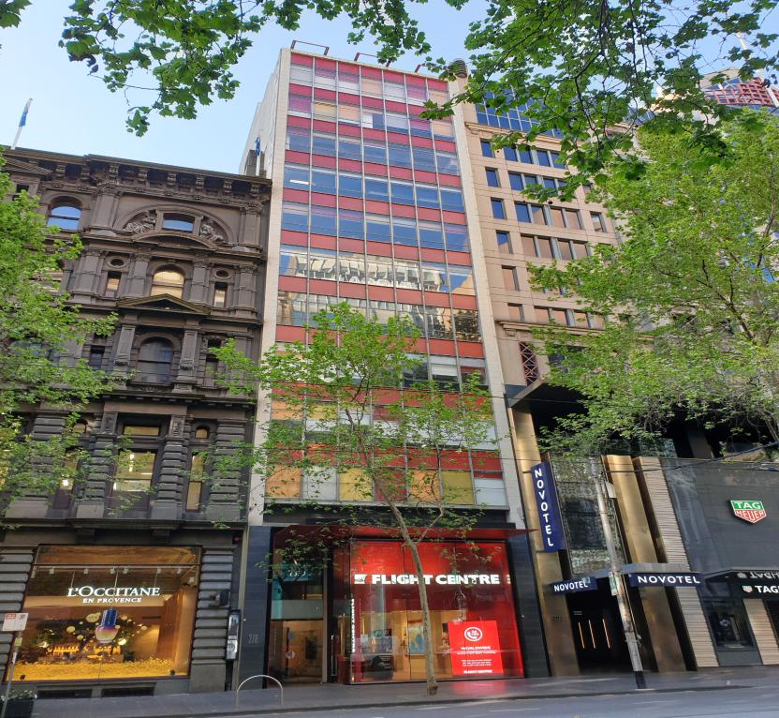
Allans Building (City of Melbourne)

Stop 23

Bank of Adelaide Building at 265-269 Collins Street
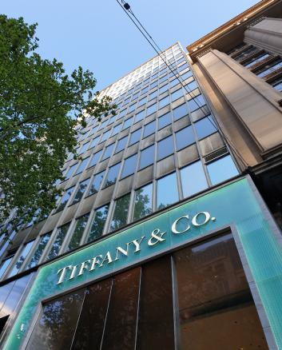
Bank of Adelaide Building at 265-269 Collins Street (City of Melbourne)
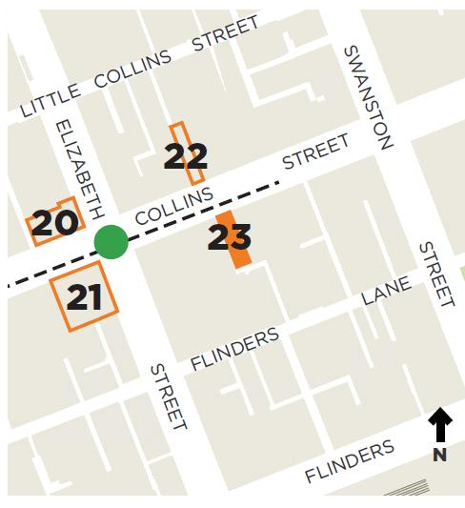
Architect(s): Godfrey & Spowers, Hughes, Mewton and Lobb
Constructed: 1959-1960
The Bank of Adelaide Building was one of the first buildings to exceed the 40 metre (132 foot) height limit within the Melbourne CBD, which applied from 1916.
The building incorporates a curtain wall street façade that features alternating rows of aluminium-framed glazing and opaque spandrels. Vertical mullions divide the façade into a grid-like pattern, demonstrating a key aspect of the Post-War Modernist style. The incorporation of two contrasting grids in the front façade is unusual and distinctive.
The Bank of Adelaide had occupied 265-269 Collins Street from 1920 (S&Mc; Age, 8 Apr 1959:1). In May 1959, the publication Cross-Section reported on the new Bank of Adelaide Building under construction, noting it would be Victoria’s first major building using concrete with a new light-weight aggregate called ‘Shalite’, which produced structural concrete to a specified strength at almost half the weight (May 1959:3).
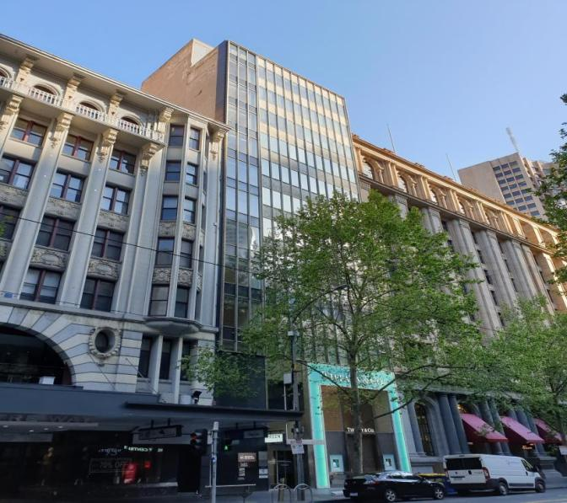
Bank of Adelaide Building (City of Melbourne)

Stop 24

Commercial Banking Company of Sydney at 251-257 Collins Street
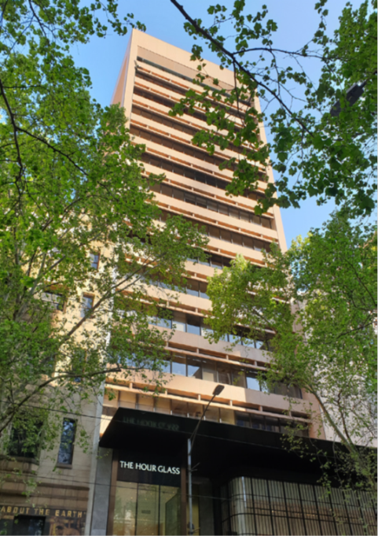
Commercial Banking Company of Sydney at 251-257 Collins Street (City of Melbourne)
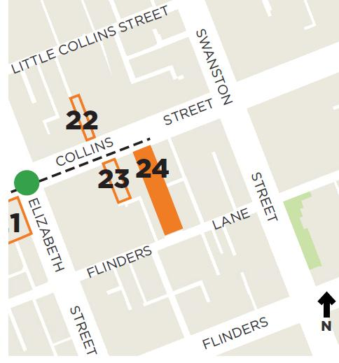
Architect(s): Bates Smart & McCutcheon
Constructed: 1971-1973
The Commercial Banking Company of Sydney (CBCS) Building was constructed as a 15-storey building with typical characteristics of a later postwar structure. These features include identically detailed front and rear structural façades that clearly express the structure externally, wall cladding with integral suspended sunhoods shading deeply recessed bands of continuous glazing on the northern side of the building, strong horizontal lines across the façades and the use of materials such as precast concrete panels.
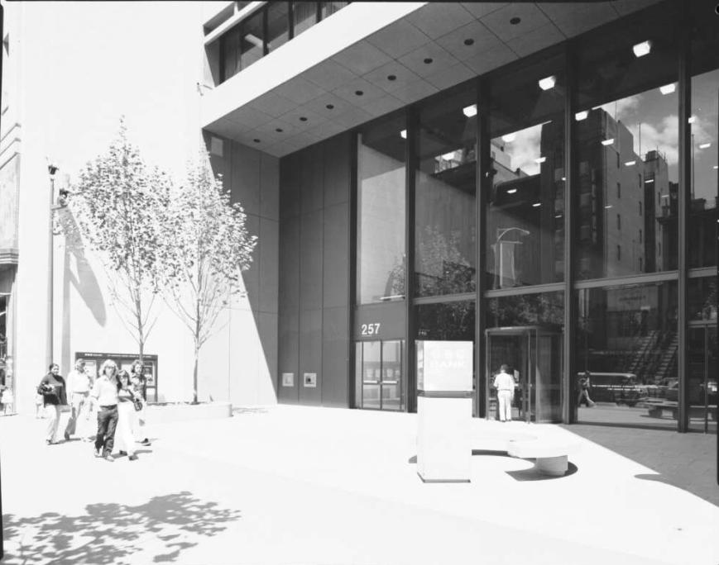
Front entrance of 251-257 Collins Street. Photograph by Wolfgang Sievers
(National Library of Australia PIC WS 4307-A LOC Cold store PIC Siev B&WN)

We hope you enjoyed The Changing Skyline self-guided walk, which was prepared as part of the Hoddle Grid Heritage Review.
The Hoddle Grid Heritage Review recommends heritage protection for more than 100 new places, some of which you have visited today.
Visit Participate Melbourne1 by 17 December 2020 to find out more and have your say.
For full details of the sources used in this walk, visit Participate Melbourne.

https://participate.melbourne.vic.gov.au/AmendmentC387
https://www.twma.com.au/
https://participate.melbourne.vic.gov.au/

