Focus area 3: heritage, urban change and economic growth

Heritage as an enabler of change and growth in Melbourne
Melbourne is an economic driver for the metropolitan region, Victoria and Australia. It is a vibrant, multicultural, global city, and its historic precincts, streetscapes and buildings, public spaces, parks and gardens are some of its strongest assets. Previous analysis has shown that heritage conservation in City of Melbourne can lead to:
- net gains in cultural tourism, as heritage values can act as a cultural attractor
- pride in our unique heritage places and stronger connection to place for our residents
- the growth of sought-after heritage skills and trades
- retained residential amenity and liveability.

Opportunities to take a people-centred approach
We have an opportunity to celebrate heritage as an important feature of the sustainable development and economic growth of our city. City of Melbourne’s heritage policies set out how the sensitive evolution of heritage places and neighbourhoods should occur. There can be challenges in delivering the right outcomes, but there are many examples where heritage has facilitated high quality designs.
The public benefit of retaining heritage fabric can far exceed that of demolition. New developments that incorporate heritage buildings or fabric have a stronger sense of distinctiveness and place. Heritage buildings can be adapted and complemented by modern additions, giving places another life and meaning – ensuring they continue to contribute to our city’s culture and story. Their adapted forms often also have better environmental performance and better relate to their local context and the public realm.
Heritage tourism can improve people’s understanding and engagement with heritage, as well as drive economic growth and job creation, ensuring the long-term conservation of heritage places.

Case study: Abermale Street, Kensington, designed by Fieldwork for Assemble Communities
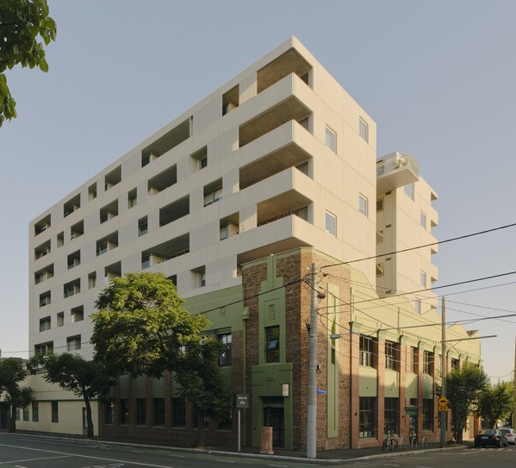  Image 9 Courtesy of archdaily.com | Heritage protection: Significant in Heritage Overlay  New use and scale: High-density residential and zero-waste café.  Key features:  - Renovated wool store and cassette factory.  - Increased affordable housing supply in a build-to-rent-to-own development with one in ten dwellings for key workers at a 20 per cent discount.  - Shared and communal spaces.  - ESD features include retention of building fabric, cross-flow ventilation, reverse-cycle heating and cooling, and new energy-efficient windows.

Case study: Quay Quarter, Sydney
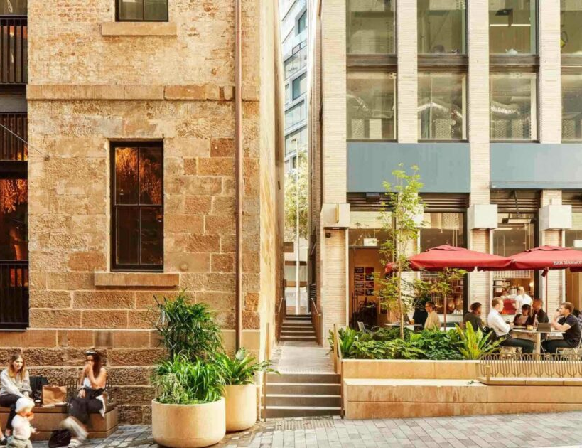  Image 10 Courtesy of aspect-studios.com | Heritage protection: local and state heritage items  New use and scale: Two city blocks incorporating restaurants, office buildings, stores and apartments.  Key features:  - Re-establishes old laneway network of Sydney, with new development complementary to historic sandstone wool stores.  - Public art and interpretive design throughout reveal the legacy of the wool stores and the histories and stories of the Gadigal people.  - Quay Quarter Tower retrofit retained 60 per cent of the existing core structure.

How could City of Melbourne lead by example?
We could demonstrate how heritage can facilitate urban change and growth, by:
- working with Traditional Owners and Aboriginal Communities to develop a principles framework to guide the design and life of a project – see focus area 1
- identify and promote examples where heritage has enabled sustainable development and economic activity
- working with business groups and expert heritage bodies on how heritage can assist in achieving social and economic objectives
- working with Experience Melbourne to leverage the potential of heritage places for visitors
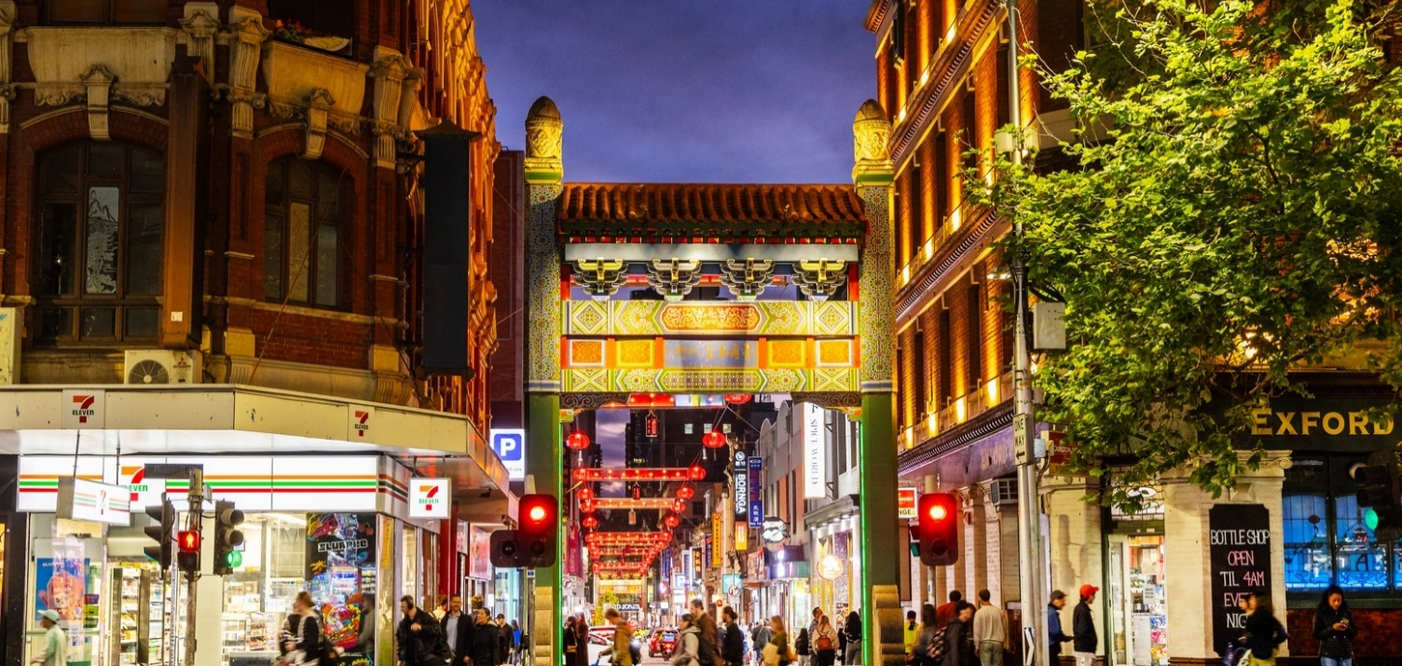
- identifying opportunities to repurpose underutilised heritage buildings to provide housing, such as our Make Room project, which converted a Council-owned heritage building into supported housing.
Image 11 Chinatown, Little Bourke Street

