Focus area 1: reflecting Aboriginal heritage as central to the history of Melbourne
As we develop a new strategy, we have an opportunity to acknowledge and celebrate Melbourne as an Aboriginal city. Aboriginal heritage, culture and knowledge are central to Melbourne’s identity. Truth-telling about our heritage is vital as we strive for reconciliation. The places and stories of the Traditional Owners, the Wurundjeri Woi-wurrung and Bunurong Boon Wurrung peoples of the Kulin Nation, as well as people from other Aboriginal communities who have a connection to the city, should be told as part of our living history and identity.
Focus area 1 will enable us to consider developing a framework in consultation with relevant Aboriginal communities and Traditional Owners. This could inform how Aboriginal history and perspectives, and its impact on Melbourne, should be reflected across the entire Strategy. In doing so, Aboriginal culture, heritage and knowledge could become central to Melbourne’s heritage planning and help change our standard approaches.

Opportunities to take a people-centred approach
Aboriginal heritage values are aligned with people-centred heritage in emphasising social and spiritual values.
All heritage places in the City of Melbourne are on Country and may be linked to colonisation. Acknowledging this can inspire new ways of identifying, protecting, understanding and managing places.
This Discussion Paper will be used to start conversations. By creating opportunities to share knowledge about Aboriginal heritage and places with Aboriginal and non-Aboriginal heritage significance, we will help the community connect with our built environment and natural landscapes and better reflect an inclusive and diverse heritage.
Case study: The University of Melbourne student precinct
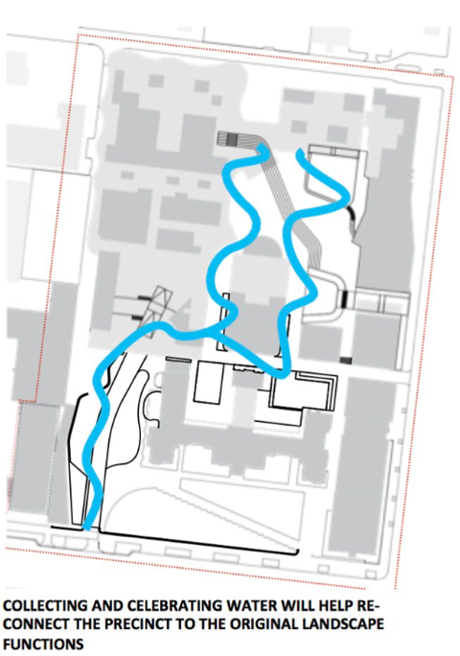  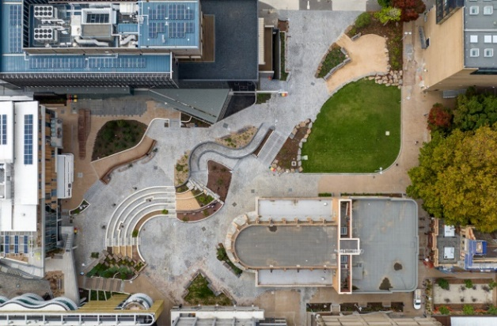  Image 3 Courtesy of kane.com.au | Heritage protection:  Incorporates a significant building (Frank Tate Building) in an individual Heritage Overlay.  New use and scale:  A large, tiered public square for students, staff and the broader public.  Key features:  - Unearths histories and layers of place through the tracing of the now-submerged Bouverie Creek through a public landscape.  - Integrates Aboriginal knowledge into modern design through a design response led by principles of “primacy of Country” and “reveal and remember place”.  - Undertook extensive engagement with 20,000 staff, students and alumni to create a design that encourages connections.  - Led by Indigenous architect, knowledge broker and interpreter Jefa Greenaway. The design is informed through cultural mapping undertaken with Traditional Owners and research into the university’s colonial foundations on site.
Case study: Connecting with Country Framework, Government Architect of NSW (GANSW)
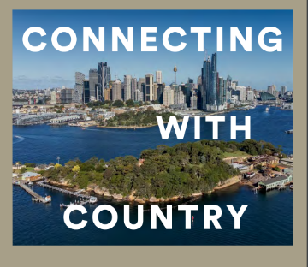  Image 4 Courtesy of planning,nsw.gov,au | Project description:  The Connecting with Country Framework is a guide for good practice to help respond to Country and empower Aboriginal voices when planning, designing and delivering built environment projects.  Key features:  - Outlines a framework that guides and suggests how to connect with Country to guide more sustainable, resilient and culturally responsive development.  - Seeks to reframe the design process using a Country-centred approach, which looks to the connections between people, nature and design and meaningful engagement with local Aboriginal communities.  - Developed in consultation with Aboriginal and Torres Strait Islander people.

How could City of Melbourne lead by example?
We could work with Traditional Owners and the broader Aboriginal community to develop a principles framework for managing and promoting Aboriginal heritage in the municipality, for example with reference to the GANSW Connecting with Country Framework. These principles could guide the delivery of priorities under the other four focus areas.

City of Melbourne projects already underway that align with focus area 1
Image 5 Mapping Aboriginal Melbourne interface | Mapping Aboriginal Melbourne
 | In collaboration with Traditional Owners and Aboriginal communities, City of Melbourne has developed an interactive digital map of places of Aboriginal historical and cultural significance within the municipality. The map can be explored by theme or timeline and reveals something of Aboriginal peoples’ deep connection to this Country and significant events since colonisation. This tool will inform projects across City of Melbourne, including the new Heritage Strategy.

