Focus area 2: heritage interpretation

Sharing our stories and acknowledging the layers of heritage
In order for heritage places to remain meaningful and supported by the community, their importance needs to be understood. Heritage interpretation aims to strengthen the relationship between people and heritage places by sharing the stories and connections that a place holds with those who live or work in, or visit the city. It can take many forms, including signage, wayfinding, events, artwork, digital media and building and public realm design.

Opportunities to take a people-centred approach
A people-centred approach would make interpretation a key component of heritage processes. Heritage interpretation helps to reveal and celebrate the different layers of history associated with a place. Sometimes this can include contested or difficult histories that should not be forgotten. Interpretation is not simply about celebration, but also experiences of pain, trauma and loss. Importantly, it can acknowledge experiences of Aboriginal people since colonisation, and their ongoing strength, resilience and survival.
City of Melbourne could look beyond traditional modes of interpretation. This could include exploring how new technologies can be harnessed to create engaging and exciting ways of communicating through place activation or digital media to provide unique and memorable experiences.
Case study: Yalinguth, immersive audio experience
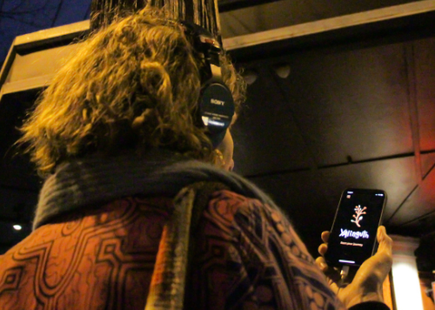  Image 6 Courtesy of yarracity.vic.gov.au | Project description:  Seeks to connect all communities to historical first-hand accounts of place through sharing oral storytelling of Aboriginal and Torres Strait Islander peoples.  Key features:  - Augmented audio experience app.  - Uses geolocated stories and sounds to take the listener on a journey through history.  - Connects the listener to spoken stories, songs, poems and sounds that tell the Aboriginal and Torres Strait Islander history of Gertrude Street, Fitzroy and along the Birrarung/Yarra River.

Case study: Guidelines for hoardings and scaffolding, City of Sydney
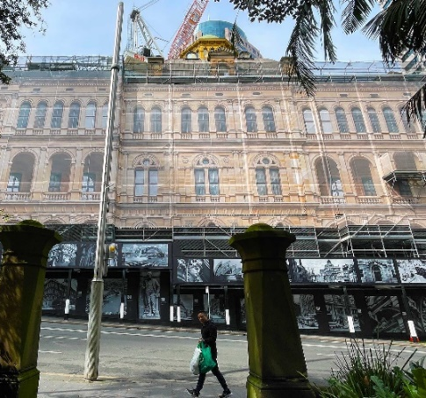  Image 7 Courtesy of cityofsydney.nsw.gov.au | Project description:  The Hoardings and Scaffolding Policy for City of Sydney regulates the design, approval, installation and use of temporary structures on or above roads.  Key features:  - Seeks to reduce the impact of alterations and development on the city’s appearance.  - Requires temporary structures in heritage conservation areas to display high-quality historic images of buildings and streetscapes.  - Works with City of Sydney’s historian to interpret heritage buildings to encourage education and celebration.

How could City of Melbourne lead by example?
- developing an interpretation strategy to inform when and where heritage interpretation should be done, and encourage interpretation to inform the design of new developments
- working with Traditional Owners and the broader Aboriginal community to interpret places and stories in the municipality.
- reviewing the history and placement of the city’s public art and monuments, and ensuring new works reflect our diverse heritage
- implementing a heritage hoardings program using images that show important parts of Melbourne’s history, where appropriate
- instating a city historian to work with developers and the community to find and guide opportunities to share stories, and inform City policies and projects.
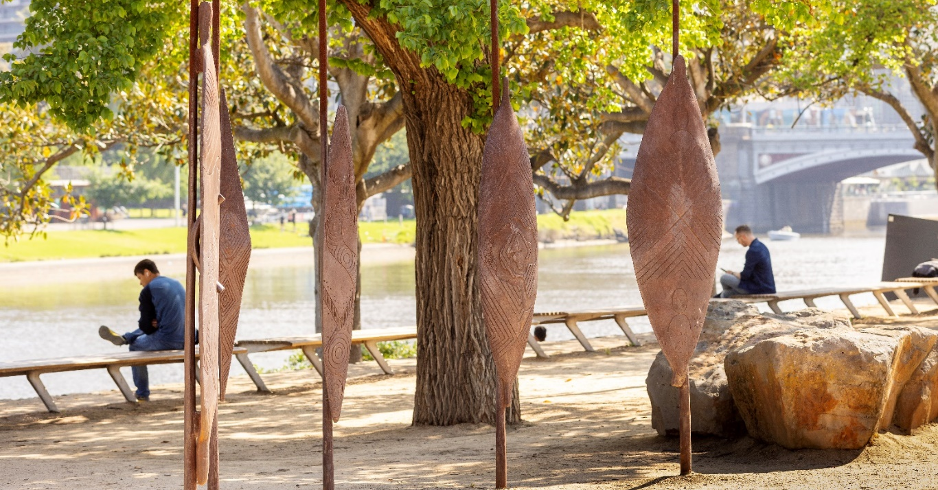
Image 8 Birrarung Wilam (Common Ground) sculpture at Birrarung Marr

