Focus area 5: innovative heritage planning and processes
Heritage has traditionally been closely linked to statutory heritage planning and authorities’ legislative obligations. There are however many ways that heritage (including unlisted heritage) and its contribution to local character, place and distinctiveness, amenity, and community values can be acknowledged and celebrated.

Opportunities to take a people-centred approach
People-centred heritage enables greater community collaboration that can lead to celebration of more diverse historical themes and eras/ periods.
It could recognise the broader social values and associations of heritage places and important unlisted places, beyond the built fabric. It could engage new and diverse communities while also strengthening relationships with existing heritage stakeholders.
A people-centred approach could lead to greater tolerance for physical changes to a heritage place when it provides community benefit, while retaining the significant parts of a building – particularly when it enables traditional uses to continue.

Case study: The Holocaust Museum, Elsternwick, designed by Kerstin Thompson Architects
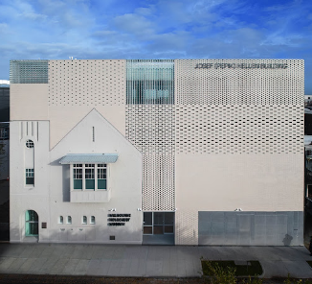  Image 14 Courtesy of mhm.org.au | Heritage protection: Contributory in a Heritage Overlay.  New use and scale: An expanded and renovated museum that houses an extensive collection of sensitive materials relating to the Holocaust.  Key features:  - Incorporates the original heritage fabric in the new design, uniting the past and present into one façade.  - The distinctive heritage façade with an iconic turret is encompassed by glass and clay brick into a new building envelope that improves energy efficiency and welcomes light throughout the interiors.  - The innovative design integrates old and new rather than using the traditional setback approach for additions, creating distance or rebuilding entirely.

Case study: Los Angeles African American Historic Places, Getty Conservation Institute
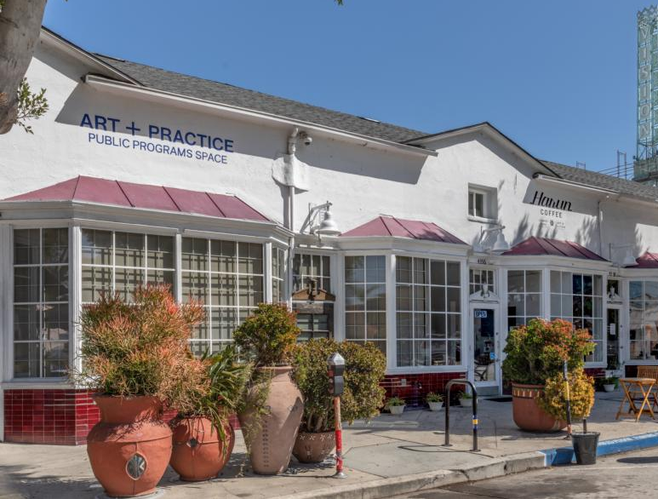  Image 15 Courtesy of getty.edu | Project description: A three-year partnership between the City of Los Angeles and Getty Conservation Institute that seeks to preserve sites that represent Black heritage.  Key features:  - Worked with local communities and cultural institutions to recognise and understand African American experiences in Los Angeles.  - Seeks to examine preservation methods for systemic bias due to the low representation of African-American historic landmarks protected in the city.

How could City of Melbourne lead by example?
We can foster innovation in heritage processes by:
- investigating new ways of engaging with parts of the community whose stories are not told or are underrepresented
- considering the development of a community collaboration approach to make cultural heritage more diverse, accessible and inclusive for all
- considering a municipal-wide review to identify significant places for people and periods that are not well-recognised or represented. This could also include under-explored building interiors, typologies, precincts and historic laneways
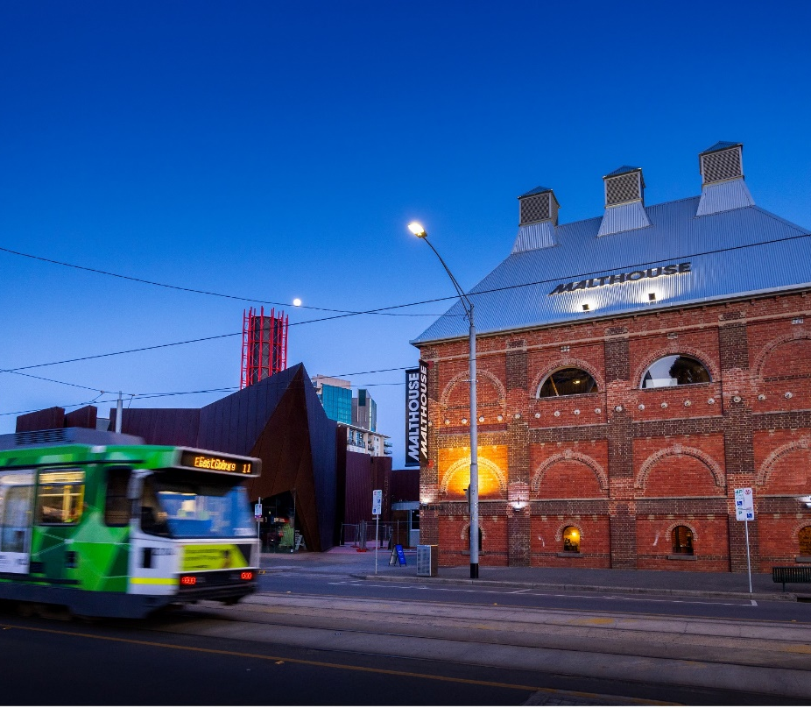
- consider forming an expert panel to review the tolerance for physical material change when cultural significance – and historical or social use – is strengthened by an exemplary development.

Image 16 Tram driving past the Malthouse Theatre, Southbank

