Focus area 4: heritage and climate change

Heritage places and our zero-carbon future
“The greenest building is the one that already exists.”
Carl Elefante – former president of the American Institute of Architects

City of Melbourne is committed to mitigating and adapting to climate change. We aim to achieve net-zero emissions by the year 2040. The construction and operation of buildings account for more than two-thirds of energy consumption and emissions.
Heritage protection is an opportunity to act on climate change by retaining the energy and carbon embodied in heritage building fabric. Retrofitting and adapting heritage buildings causes fewer emissions than a knock down rebuild approach, and can improve their environmental performance and liveability.
We also recognise the risk climate change poses to heritage places through damage from extreme weather events. The Heritage Council of Victoria has prepared principles for climate change risk management for heritage places.

Opportunities to take a people-centred approach
A people-centred approach recognises the critical importance of climate change and its impact on community perceptions of heritage places. We protect heritage for the benefit of future and current generations. We must also face the climate crisis and ensure heritage places are sustainable, efficient and resilient in the future.
The United Kingdom recognises the relationship between heritage and climate change. In many cities, applicants must demonstrate that it is not feasible to retain existing fabric before a permit can be issued for demolition. The City of London has released the Heritage Building Retrofit Toolkit, which provides detailed guidance to property owners about maximising the retention of existing fabric and minimising the environmental impacts of retrofitting a building. City of Melbourne has also developed Retrofit Melbourne, a framework to guide how we support and facilitate investment to retrofit Melbourne’s valued mid-tier commercial buildings to make them zero carbon ready, including those with heritage protection.
Where heritage buildings need improved thermal performance, modest retrofit mechanisms such as improving heating and cooling systems, glazing and insulation can vastly improve their comfort and operational costs, and may not require a planning permit.

Case study: Willam Ngarrang retrofit, Fitzroy, Kennedy Nolan, Finding Infinity and Wilderness Building Co
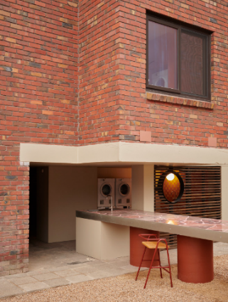  Image 12 Courtesy of kennedynolan.com.au | Heritage protection: Non-contributory in Heritage Overlay.  New use and scale: Medium density residential.  Key features:  - The entire 1970s building was retained, except for windows and doors, which were replaced to improve airtightness – resulting in a large reduction in embodied carbon emissions compared with a new building.  - Net-positive energy output with improved amenity for the tenants – solar systems, efficient water fittings and a heat recovery ventilation unit estimated to provide up to an 80 per cent reduction in bills for tenants.

How could City of Melbourne lead by example?
We could seek to reduce emissions and improve the climate resilience of heritage places by:
- exploring an approach that considers the relationship between people, nature and design to deliver sustainable outcomes – see focus area 1
- exploring flexibility in heritage controls to support building alterations for improved environmental performance, including the installation of visible solar panels without a permit
- reviewing sustainability issues and appropriate policy responses for buildings from particular periods, such as post-war buildings
- considering how landscapes can be adapted for climate resilience by reflecting elements of the original Indigenous landscape
- forming an advisory group to amplify the Retrofit Melbourne plan and to provide education and support to address the specific challenges of retrofitting heritage buildings
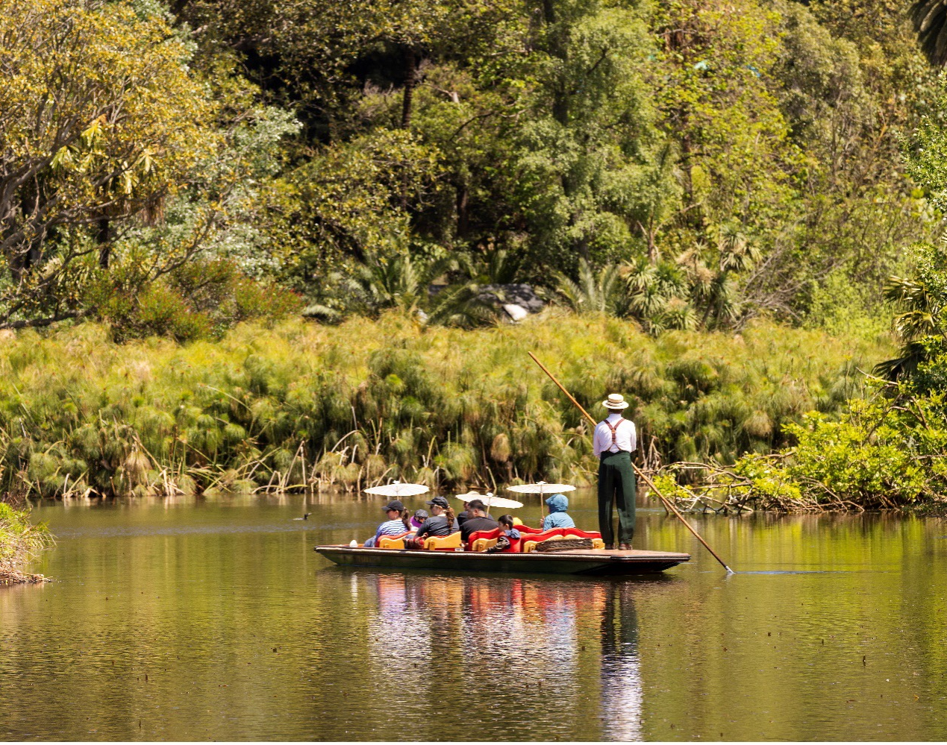
- advocating for the Victorian Government to deliver on its Built Environment Climate Change Adaptation Action Plan 2022-2026, which includes developing policies guiding the sensitive retrofitting of heritage buildings and adaptive reuse as an alternative to new construction.
Image 13 People on a punt at the Royal Botanic Gardens

