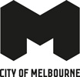
Heritage, People and Place
Discussion Paper 2024

Acknowledgement of Traditional Owners
The City of Melbourne respectfully acknowledges the Traditional Owners of the land we govern, the Wurundjeri Woi-wurrung and Bunurong / Boon Wurrung peoples of the Kulin Nation and pays respect to their Elders past and present. We acknowledge and honour the unbroken spiritual, cultural and political connection they have maintained to this unique place for more than 2000 generations.
We accept the invitation in the Uluru Statement from the Heart and are committed to walking together to build a better future.

Contents
Acknowledgement of Traditional Owners 2
Purpose 5
What is heritage and why is it important? 5
Why are we reviewing the Heritage Strategy? 6
Current challenges and opportunities to be addressed 6
New strategic context 7
Heritage places in the City of Melbourne 7
Developing a people-centred approach 7
What is people-centred heritage? 7
Focus areas 9
Delivering a people-centred approach through our focus areas 9
Focus area 1: reflecting Aboriginal heritage as central to the history of Melbourne 10
Opportunities to take a people-centred approach 10
How could City of Melbourne lead by example? 11
City of Melbourne projects already underway that align with focus area 1 11
Focus area 2: heritage interpretation 12
Sharing our stories and acknowledging the layers of heritage 12
Opportunities to take a people-centred approach 12
How could City of Melbourne lead by example? 13
Focus area 3: heritage, urban change and economic growth 14
Heritage as an enabler of change and growth in Melbourne 14
Opportunities to take a people-centred approach 14
Case study: Abermale Street, Kensington, designed by Fieldwork for Assemble Communities 14
Case study: Quay Quarter, Sydney 15
How could City of Melbourne lead by example? 15
Focus area 4: heritage and climate change 16
Heritage places and our zero-carbon future 16
Opportunities to take a people-centred approach 16
Case study: Willam Ngarrang retrofit, Fitzroy, Kennedy Nolan, Finding Infinity and Wilderness Building Co 16
How could City of Melbourne lead by example? 17
Focus area 5: innovative heritage planning and processes 18
Opportunities to take a people-centred approach 18
Case study: The Holocaust Museum, Elsternwick, designed by Kerstin Thompson Architects 18
Case study: Los Angeles African American Historic Places, Getty Conservation Institute 19
How could City of Melbourne lead by example? 19
Next steps 20
Bibliography 21
How to contact us 23
Online: 23
In person: 23
Telephone: 23
Fax: 23
In writing: 23
Interpreter services: 23
National Relay Service: 23

Purpose
This Discussion Paper is the start of a conversation about how we shape our new Heritage Strategy. We want to understand how we should protect, manage and celebrate heritage in contemporary Melbourne.
The current Heritage Strategy 2013 is an ambitious and innovative strategy that has provided a sound framework to protect and enhance Melbourne’s heritage places. Much has changed since 2013: our city now faces unprecedented pressure for growth and change alongside economic and social challenges and a rapidly escalating climate crisis. Our approaches to heritage places may need to evolve in our changing city.
As we develop a new strategy, we have the opportunity to consider how we can better understand, communicate and interpret people’s heritage values and the buildings, landscapes and other items that carry our stories into the future. This includes acknowledging and celebrating Melbourne’s rich Aboriginal heritage. We are shifting our focus onto why we protect and how we can better acknowledge or celebrate heritage, including heritage that is not well recognised or can’t be protected through the planning scheme.
The ideas and topics in this paper are a prompt for conversation, not an outline of an adopted approach. We want to explore and test them with the diverse voices of the community, business and government. Your feedback will inform the development of our new Heritage Strategy and, therefore, how we connect with our heritage over the next 10 years.

What is heritage and why is it important?
Heritage is our inherited traditions and culture expressed through the layout of the city, including its buildings, objects, collections, landscapes, public parks and gardens, infrastructure, monuments and public art. Some heritage is harder to see, including the city’s archaeology,
our traditions and memories, and Aboriginal intangible heritage, including ceremony, practises, stories, skills, knowledge, dance and song.
Heritage is dynamic and changes with our society over time. It is at the heart of community identity and helps sustain Melbourne’s rich and diverse communities. It is an essential part of the present we live in and the future we will build. It is passed on to us and it is the inheritance we pass on to future generations.

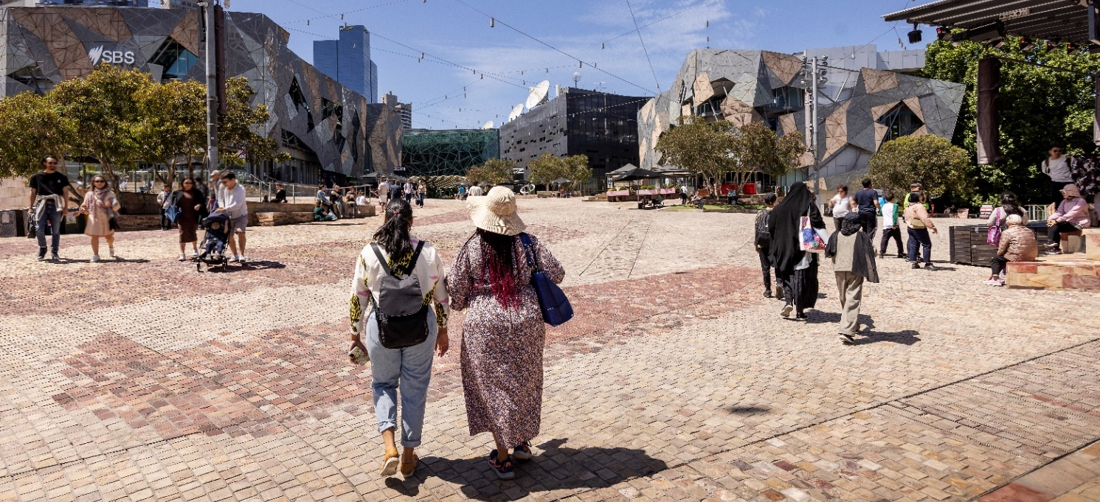
Image 1 People walking through Fed Square

Why are we reviewing the Heritage Strategy?
The current Heritage Strategy 2013 was developed to provide a framework and actions to protect and enhance Melbourne’s heritage. Since then, we have:
- completed seven heritage reviews for individual neighbourhoods and implemented associated Heritage Overlays in the Melbourne Planning Scheme including:
  - City North Heritage Review, 2013
  - West Melbourne Heritage Review, 2016
  - Southbank Heritage Review, 2017
  - Fishermans Bend Heritage Review, 2022
  - Hoddle Grid Heritage Review, 2022
  - Carlton Heritage Review, 2023
  - North Melbourne Heritage Review, 2023
- progressed two further neighbourhood heritage reviews for South Yarra and Parkville
- changed how we categorise heritage buildings, bringing our policies in line with best practice
- renewed our heritage grants program through the Melbourne Heritage Restoration Fund
- improved local heritage policies in the Melbourne Planning Scheme, guiding how heritage places can be developed.
Most existing Aboriginal history and heritage initiatives sit within the Aboriginal Heritage Action Plan 2015-18, the Indigenous Heritage Study Stage 1 and the Reconciliation Action Plan June 2021 – June 2023. Work on many of these actions has progressed.

Current challenges and opportunities to be addressed
Since 2013, Melbourne has experienced rapid population growth and a changing economy. There is immense pressure for more affordable, secure and well-located housing. The municipality’s residential population is over 150,000 and is projected to double in the next 20 years. Greater Melbourne is expected to increase from 5 million to more than 8 million people by 2040. House prices continue to rise as supply is not keeping up with demand.
Heritage places can complement more affordable, high-density housing by playing a role in shaping high quality design and planning of better quality and denser housing. Heritage places also create the character that makes our neighbourhoods more desirable.
Australia and the world are also experiencing a changing climate. Victoria is becoming warmer and drier. City of Melbourne declared a climate and biodiversity emergency in 2019 in recognition of the urgent action required to address climate change.
Heritage places can play an important role in climate change mitigation. Retrofitting existing buildings, rather than demolishing them, improves their efficiency, reduces building waste and conserves their embodied energy. We need further research to determine the most efficient
and sensitive ways of adapting heritage and other existing buildings for climate resilience and lower emissions.

New strategic context
Since the development of the previous Heritage Strategy in 2013, local, state, national and international policy has changed in response to the context we live in. This includes new State heritage and Aboriginal heritage legislation, and updated City of Melbourne plans and strategies.
At an international level, Transforming Our World: the 2030 Agenda for Sustainable Development adopted by all United Nations member states in 2015, introduced 17 Sustainable Development Goals, and in 2020, the International Council on Monuments and Sites (ICOMOS) resolved to promote people-centred approaches to heritage management (ICOMOS Resolution 20GA/19). In this discussion paper, we consider how City of Melbourne could adopt this approach.

Heritage places in the City of Melbourne
The City of Melbourne currently has 1080 listed heritage places that include precincts, buildings, trees and gardens, monuments and bridges. The buildings listed range from dwellings to major sports venues, art galleries, libraries, railway stations, offices and pubs. Most are protected through a local Heritage Overlay, and 331 are included on the Victorian Heritage Register. We have eight places on the National Heritage list and the Royal Exhibition Building and Carlton Gardens are included on the UNESCO World Heritage List.
Melbourne’s history and unique heritage places are a key feature of our identity and distinctiveness.

Developing a people-centred approach
As part of the development of this paper, we commissioned a scoping paper prepared by Dr James Lesh of Heritage Workshop. This explored how a people-centred heritage framework could be implemented and has informed this paper.

What is people-centred heritage?
When a people centred approach is taken, places are considered significant because of people’s relationship with them. This relationship is at the heart of heritage conservation. Social and spiritual values are as important as those directly related to the physical fabric. Other values, such as environmental and economic, should also be considered. People-centred heritage aims to empower the community to help shape cultural heritage.
Under a people-centred approach, the work done by heritage experts evolves through a process of community collaboration. It encourages community involvement wherever practical and promotes varied ways for people’s views to be included without excluding expert knowledge.
There are challenges with taking this approach within the existing system, such as balancing the diverse views of the community and other stakeholders, but these must be considered alongside the significant opportunities that a people-centred approach could present. We know from engagement responses that many people in our communities see heritage as an essential part of the identity of our neighbourhoods and the municipality. We have an opportunity to harness this interest, enabling people to influence how we understand our history and the contribution it makes to our future.
Over the past 10 years, we have received thousands of community comments on heritage in response to hundreds of consultation questions on many projects. A summary of these comments in Table 1 below indicates what heritage means to our community.

Table 1: Community feedback on heritage
Our community
City of Melbourne’s Community Vision shows that the community’s aspirations include.  - We celebrate and protect Melbourne’s unique places.  - Aboriginal cultures are central to Melbourne’s identity.  Understanding the city’s history is also important to visitors, who are often interested in experiencing history through our places and people. Many tourists visit a heritage building, site or monument during their stay. | 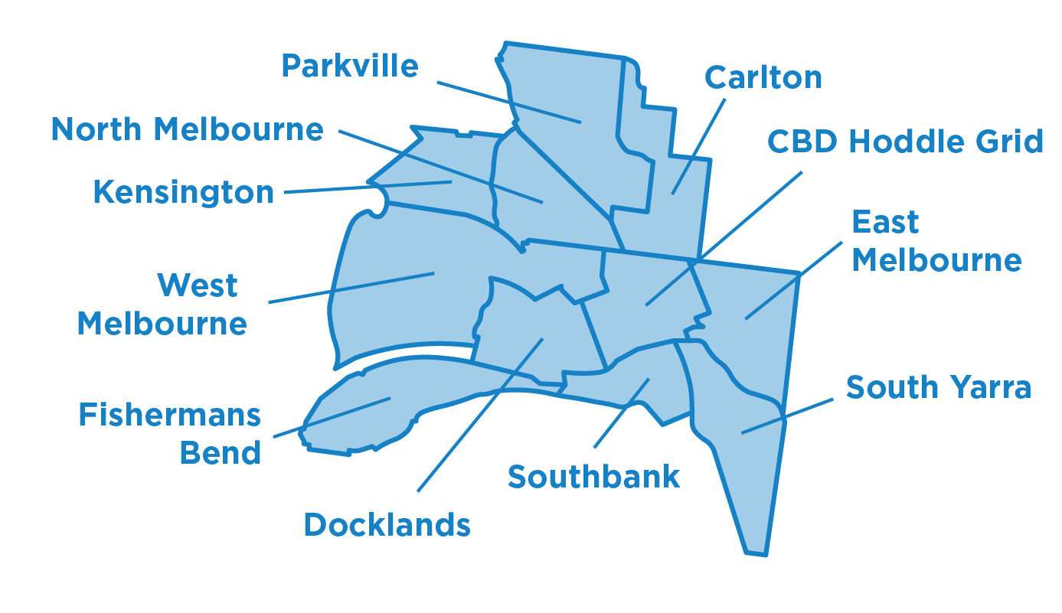
City of Melbourne has six historical societies.
We have 16 other resident and community groups across the municipality.
West Melbourne  The continued liveability and character of West Melbourne rely on future development that produces high-quality, sustainable buildings that respect the neighbourhood’s highly valued and unique heritage. | Melbourne CBD  Residents identified heritage buildings as crucial parts of the city’s character that should be protected.
North Melbourne  The area hosts some of Melbourne’s oldest buildings alongside new developments. Residents believe North Melbourne needs better promotion for its unique character and identity. | Carlton  Many residents have pointed to Carlton’s rich history of multiculturalism, which can be found in the diversity of shops and residences throughout the suburb.
Parkville  Residents highly value the protection and retention of Parkville’s unique character as one of Melbourne’s most intact neighbourhoods. | Docklands  As a newer suburb, Docklands is still developing. There are many projects underway to make the area a connected, activated and welcoming place for visitors and residents.
South Yarra  Residents are seeking greater protection of the eclectic mix of building typologies, as well as Aboriginal culture and stories that are represented in the area. | East Melbourne  As one of Melbourne’s oldest suburbs, East Melbourne is home to many iconic heritage buildings that many residents believe add to its charm, character and village-like feel.
Southbank  There is limited heritage protection in this area. Many residents believe that Aboriginal heritage identification, protection and interpretation should be a key neighbourhood priority. | Kensington  Many residents value the existing heritage homes in the area and hope growth will respect the village-like feel, maintain the green streets and protect views of the city.

Focus areas

Delivering a people-centred approach through our focus areas
We have chosen five focus areas for this Discussion Paper, highlighting key themes or issues that could frame a people-centred approach. By acknowledging the needs and values of the people and communities of Melbourne, we can better plan for heritage places through:
- Reflecting Aboriginal heritage – acknowledging and celebrating the central role of Aboriginal history which links to all other focus areas in this paper.
- Heritage interpretation – better understanding the history of the city, its heritage places and values by creating experiences that connect people with the stories of place.
- Heritage, urban change and the economy – accommodating growth and change while ensuring that Melbourne’s distinctive places remain a prominent feature of its evolution and ongoing economic prosperity.
- Heritage and climate change – adapting to climate change and providing environmentally sustainable heritage buildings and places for people to live, work and enjoy.
- Innovative heritage planning and processes – exploring the future of heritage protection, alternative processes that enable more community involvement, and how the heritage of different parts of our community can be better understood and protected.
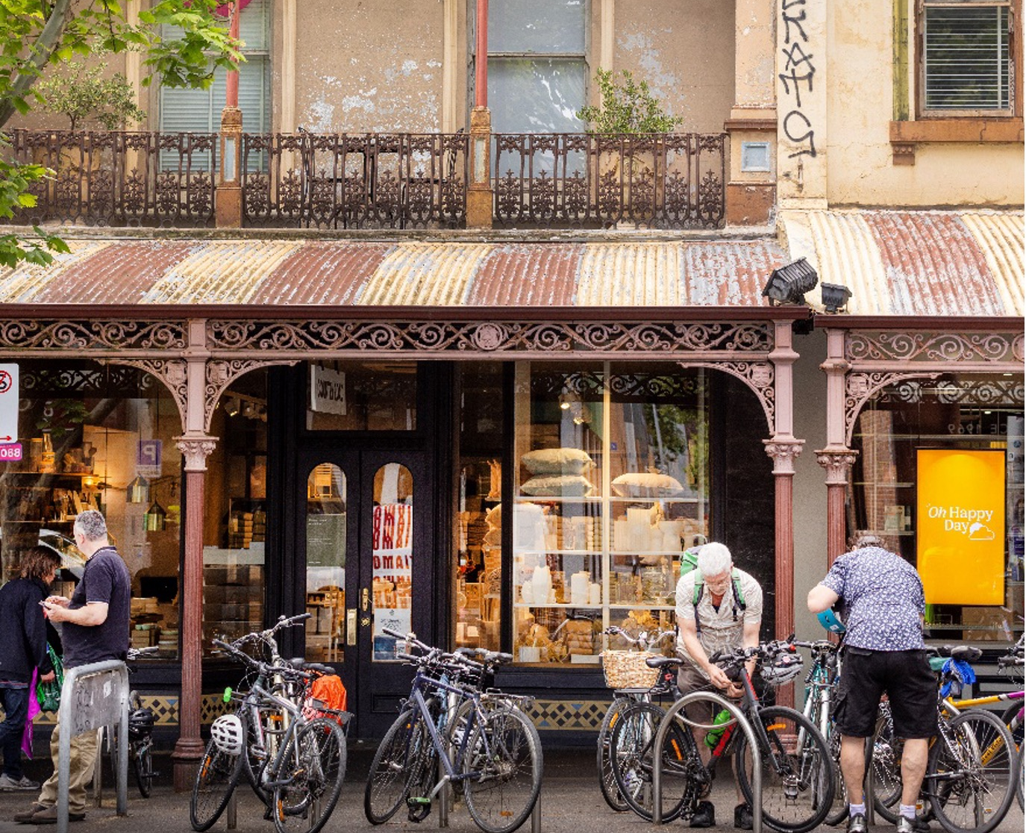
Image 1 People parking bikes at a heritage shopfront on Lygon Street, Carlton

