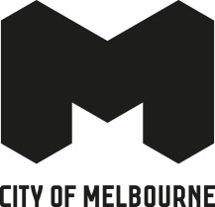
Additional resources on Bandung, Indonesia
Open Innovation Competition 2019

Indonesia information
AusTrade – ICT trends and opportunities in Indonesia
AusTrade – Infrastructure trends and opportunities in Indonesia
AsiaLink Business – Doing business in Indonesia
Indonesia’s Traffic Woes

Bandung information
Data sources from City of Bandung competition (some are in English, some are in Bahasa Indonesia)
The Smart City Vision and Green Growth in Bandung PDF (512KB)
Bandung: Transformed by connectivity PDF (1.95MB)
Liveable and Sustainable Cities - Bandung: City as a happiness project (Page 54 has case study of Bandung) PDF (4.27MB)

Australia-Indonesia organisations
Australia Indonesia Centre (at Monash)
Australia Indonesia Business Council
Australia Indonesia Youth Association
University of Melbourne Indonesian Alumni Association

