Background

The community of Provost Street has been advocating to the City of Melbourne to undertake changes to their street since 2016. The community has identified priorities for improvement such as increasing greenery, providing safer traffic conditions and aspirations for communal street gardening.
A Provost and Little Provost Street Greening Proposal was developed by Council, in response to the community support for a greener, cooler street and a desire for open space to expand on the existing community street garden.
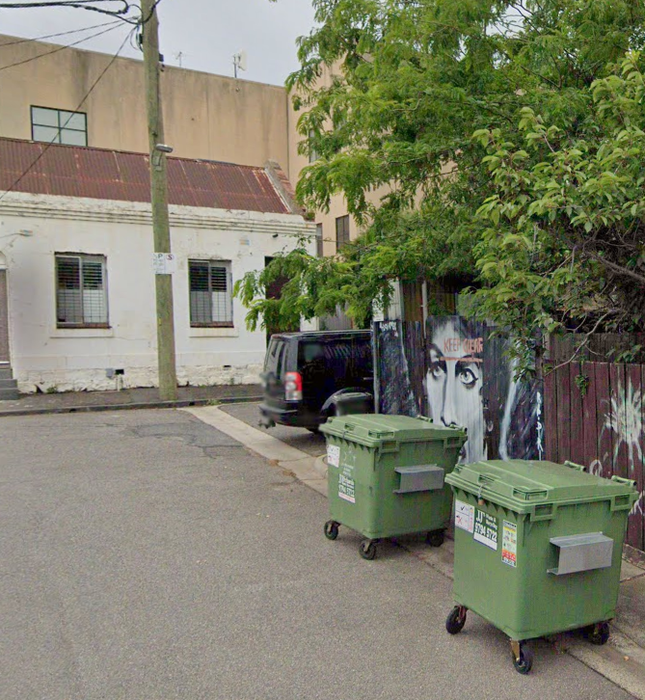
Little Provost Street has been identified for priority street tree planting in the North and West Melbourne Urban Forest Precinct Plan.
Little Provost Street offers good opportunities for in-road, street-tree planting due to the narrow nature of the street and because it is relatively clear of underground utility services.
The Provost Street and Little Provost Street, Street Greening Proposal looks to balance the provision of new street trees with local car parking needs.

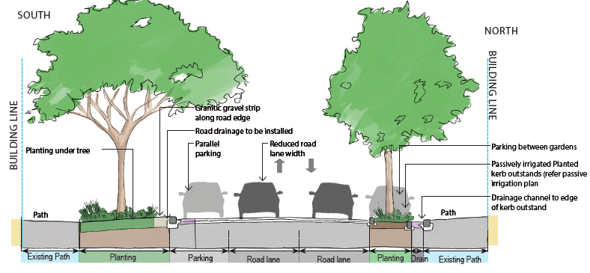

Who we reached
The Provost and Little Provost Street Greening Proposal was developed for community consultation in September 2020 to seek feedback on the proposed changes to Provost and Little Provost streets. Letters were posted to all property owners, residential and retail tenants, including properties that adjoined Provost Street and Little Provost Street, inviting conversation about the proposed improvements to repurpose part of the paved road space to create canopy tree and groundcover planting areas.
Council received feedback from twenty-nine community members who responded to a simple online survey published at participate.melbourne.vic.gov.au/improving-provost-streets. Fifteen residents also participated in a 90 minute online briefing and facilitated workshop with Council’s landscape designers and urban greening specialists, exploring local experiences and aspirations for the streets.

Feedback we received from the community

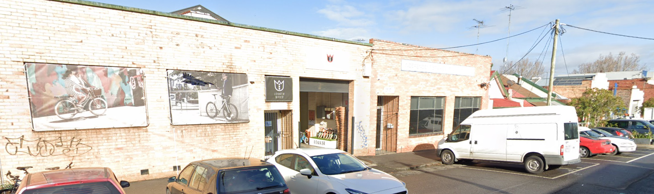

Of the 29 online survey respondents, more than half (65%) live on Provost or Little Provost Streets, a further 17% live in the neighbouring area. Some work in the area (7%), have a general interest in the project (7%), or travel through the area regularly (4%).

What do you like most about the street greening proposal?
When asked to describe the features of the Provost Street and Little Provost Street, Street Greening Proposal that appealed most, survey and workshop respondents shared many highlights.
The most common of these centred around trees, reduced traffic speed, more green space and an increased sense of community.

You said
“More grass and garden areas for my family and children. Reduced traffic speed. Areas for community and neighbour interaction. Finally we can be proud of what the street looks like. It has been neglected for a long time. Very excited.”

“This street has always looked industrial and sparse - it desperately needs more greenery. I really like the choice of trees, and I hope this plan goes ahead without any compromise to their placement. Also, this street was prone to flooding in the past, so it's good that there'll be a net benefit to drainage and irrigation.”

“I love the incorporation of native species, and the provision of extra walking space.”

“The safety upgrades will provide for the residents and our family on the street. The larger footpath and green space will separate the road from homes. Extra green space. Canopying trees. No negatives.”

“Discourages non-residential car drivers to use Provost Street as a short cut and speed.”

We heard
- Greener streets, with large canopy trees and understory planting are a priority to attract birds and cool the street.

- The speed that cars currently travel through Provost Street makes the street feel unsafe, we need to introduce traffic calming elements to slow the flow.

- A streetscape that encourages community interaction would be something to look forward to.

Is there anything missing that would help inform our planning?
When asked to point out whether there was anything further that we should consider in our planning, several suggestions were made through the survey and workshop to enhance the design, so as to strengthen the community outcomes sought.

You said
“The existing trees have not grown well at all. Is there any plan to make sure the new trees will grow well?”

“Grass and other surface treatments that have the ability to influence activations of greenspace”

“Some permit-only parking. Grass areas. Speed bumps on Provost Street”

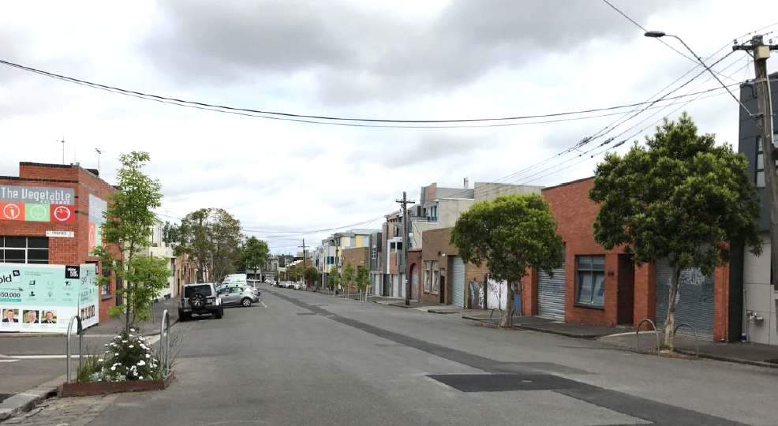
We heard
- Trees are not growing very well in the current conditions.

- Residents’ ability to park vehicles close to their property remains a priority, and they do not want to lose any more parking places than necessary.

- Grass is preferred to gravel or other paving materials for the surface of the nature strip.

- Introducing speed-humps could be an effective way to manage the speed of vehicles here.

How your feedback has influenced our proposal
Based on your feedback, we have updated the Street Greening Proposal to:

- Introduce kerb outstands and speed bumps at each end of Provost Street to further narrow the road and slow down through-traffic.

- Include a trial of lawn for the nature strip crossovers.

- Review the car parking proposition in Little Provost Street to ensure that no parking spaces are removed unnecessarily.

- Improved soil volumes and conditions for optimal tree growth for long term greening outcomes.

- Explore whether 2P resident priority car parking changes along Provost and Little Provost are supported.

Next steps
We will complete design documentation in preparation for construction in mid–late 2021.
We will notify all affected households and businesses of the final designs, expected construction timelines, road closures, tree removals or other disruptions. Follow the Participate Melbourne page to register for online notifications as the project meets progressive milestones.
Should you have questions, concerns or ideas about this exciting project, you are welcome to contact Erica Read, Project Officer, Parks and City Greening by calling 9658 8421 or emailing erica.read@melbourne.vic.gov.au.

